

The International Committee on Taxonomy of Viruses
Taxonomy Proposal Form, 2026

Part 1a: Details of taxonomy proposals

Title: | Create five new species in the genera Tequintavirus, Epseptimavirus, Kuttervirus and Cornellvirus
Code assigned: | 2026.017B

Author(s), affiliation and email address(es):
Given name (+middle initial(s)) | Surname | Affiliation | Email address | Corr. author(s)
Jinquan | Li | Huazhong Agricultural University, Wuhan, China | lijinquan2017@163.com | X
Yating | Guo | Huazhong Agricultural University, Wuhan, China | guoyating0626@126.com
Yang | Zhou | Huazhong Agricultural University, Wuhan, China | zhouyang@mail.hzau.edu.cn
Shan | Wang | Huazhong Agricultural University, Wuhan, China | shanwang@mai.hzau.edu.cn
Weiwei | Feng | Huazhong Agricultural University, Wuhan, China | fengweiweihzau@163.com
Wenhao | Miao | Huazhong Agricultural University, Wuhan, China | miaowenhao27@gmail.com
Meijun | Jin | Huazhong Agricultural University, Wuhan, China | jinmeijun0745@163.com
Part 1b: Taxonomy Proposal Submission
ICTV Subcommittee:
Animal DNA Viruses and Retroviruses |  | Bacterial viruses | X
Animal minus-strand and dsRNA viruses |  | Fungal and protist viruses
Animal positive-strand RNA viruses |  | Plant viruses
Archaeal viruses |  | General -

List the ICTV Study Group(s) that have seen or have been involved in creating this proposal:
Optional – complete only if formally voted on by an ICTV Study Group:
Study Group | Number of members
Study Group | Votes in support | Votes against | No vote

Submission date: | 14/05/2026

Part 1c: Feedback from ICTV Executive Committee (EC) meeting
Executive Committee Meeting Decision code: | X
A – Accept
Ac – Accept subject to revision by relevant subcommittee chair. No further vote required
U – Accept without revision but with re-evaluation and email vote by the EC
Uc – Accept subject to revision and re-evaluation and email vote by the EC
Ud – Deferred to the next EC meeting, with an invitation to revise based on EC comments
J - Reject
W - Withdrawn

Comments from the Executive Committee:

Part 1d: Revised Taxonomy Proposal Submission
Response of proposer:
Revision date:

Part 3: TAXONOMIC PROPOSAL
https://ictv.global/taxonomy/templates
Taxonomic changes proposed:
Establish new taxon | X | Split taxon
Abolish taxon |  | Merge taxon
Move taxon |  | Promote taxon
Rename taxon |  | Demote taxon
Move and rename

Etymology (origin) of proposed taxonomic names:
Taxon name | Etymology of the term
Tequintavirus LPSC10 | The species name Tequintavirus LPSC10 is composed of the genus name Tequintavirus and the species epithet LPSC10, which is derived from the isolate designation of the exemplar phage, Salmonella phage LPSC10.
Epseptimavirus LPSP94 | The species name Epseptimavirus LPSP94 is composed of the genus name Epseptimavirus and the species epithet LPSP94, which is derived from the isolate designation of the exemplar phage, Salmonella phage LPSP94.
Kuttervirus LPST160 | The species name Kuttervirus LPST160 is composed of the genus name Kuttervirus and the species epithet LPST160, which is derived from the isolate designation of the exemplar phage, Salmonella phage LPST160.
Cornellvirus LPSP53 | The species name Cornellvirus LPSP53 is composed of the genus name Cornellvirus and the species epithet LPSP53, which is derived from the isolate designation of the exemplar phage, Salmonella phage LPSP53.
Kuttervirus LPST159 | The species name Kuttervirus LPST159 is composed of the genus name Kuttervirus and the species epithet LPST159, which is derived from the isolate designation of the exemplar phage, Salmonella phage LPST159.

Permission for use of names derived from a living person:
Taxon name | Full name of person from whom the name is derived | Attached

Abstract of Taxonomy Proposal:
Description of current taxonomy:
The genera Tequintavirus and Epseptimavirus are recognized in Demerecviridae; Cornellvirus in Sarkviridae; and Kuttervirus in Ackermannviridae, all within the class Caudoviricetes.

Proposed taxonomic change(s):
Create five new species: “Tequintavirus LPSC10”, “Cornellvirus LPSP53”, “Epseptimavirus LPSP94”, “Kuttervirus LPST159” and “Kuttervirus LPST160”.

Demarcation criteria for new taxon/taxa:
Species demarcation: Two phages are assigned to the same species if their genomes are more than 95% identical over their genome length for isolates. These values can be calculated by a number of tools, such as BLASTn – usually calculated using intergenomic distance calculator VIRIDIC [1].
Genus demarcation: The Bacterial Viruses Subcommittee has established 70% nucleotide identity of the genome length as the cut-off for genera. Genus-level groupings should always be monophyletic in the signature genes, as tested with a phylogenetic tree. [2]

Justification:
ViPTree placed LPSC10 with Tequintavirus, LPSP53 with Cornellvirus, LPSP94 with Epseptimavirus, and LPST159/LPST160 with Kuttervirus-related phages. VIRIDIC analysis showed that LPSC10, LPSP94, LPST159, and LPST160 share 90.1%, 90.8%, 90.5%, and 91.8% nucleotide identity with their closest recognized relatives, Salmonella phages Spc35, Seafire, dinky, and BSP101, respectively. LPSP53 is closely related to phage ST104, which is not currently listed as an ICTV species exemplar, and shares 73.4% nucleotide identity with the recognized Cornellvirus representative phage SE1. These values are below the 95% species demarcation threshold and support the establishment of five distinct species.

- Text of Taxonomy proposal:

Description of current taxonomy:
The genera Tequintavirus and Epseptimavirus are recognized in Demerecviridae; Cornellvirus in Sarkviridae; and Kuttervirus in Ackermannviridae, all within Caudoviricetes.

Proposed taxonomic change(s):
Create five new species: Tequintavirus LPSC10 in the genus Tequintavirus, Cornellvirus LPSP53 in the genus Cornellvirus, Epseptimavirus LPSP94 in the genus Epseptimavirus, Kuttervirus LPST159 and Kuttervirus LPST160 in the genus Kuttervirus.

Demarcation criteria for new taxon/taxa:
Species demarcation: Two phages are assigned to the same species if their genomes are more than 95% identical over their genome length for isolates. These values can be calculated by a number of tools, such as BLASTN – usually calculated using intergenomic distance calculator VIRIDIC [1].
Genus demarcation: The Bacterial Viruses Subcommittee has established 70% nucleotide identity of the genome length as the cut-off for genera. Genus-level groupings should always be monophyletic in the signature genes, as tested with a phylogenetic tree. [2]

Justification:
A TBLASTX distance tree of the five candidate Salmonella phages was constructed using ViPTree [3,4] (Fig. 1). The analysis placed LPSC10 with phages related to the genus Tequintavirus, LPSP53 with phages related to the genus Cornellvirus, LPSP94 with phages related to the genus Epseptimavirus, and LPST159 and LPST160 with phages related to the genus Kuttervirus. Based on the ViPTree phylogenetic results, reference phages clustering within the same evolutionary clades as each candidate phage were selected for VIRIDIC analysis (Fig. 2). VIRIDIC computed pairwise intergenomic distances and similarities among these phage genomes and showed that the candidate phages are distinct from their closest recognized species-level relatives [1].
LPSC10 was most similar to Tequintavirus Spc35 (NC_015269), with 90.1% nucleotide similarity. LPSP53 showed 100% similarity to Salmonella phage ST104 (NC_005841), which is not currently included as an ICTV-listed species exemplar; among recognized Cornellvirus species, LPSP53 was most similar to Cornellvirus SE1 (NC_011802), with 73.4% nucleotide similarity. LPSP94 was most similar to Epseptimavirus Seafire (NC_048110), with 90.8% nucleotide similarity. LPST159 was most similar to Kuttervirus dinky (NC_049504), with 90.5% nucleotide similarity. LPST160 was most similar to Kuttervirus BSP101 (NC_049382), with 91.8% nucleotide similarity. These values are below the 95% species demarcation threshold relative to recognized species-level relatives and support the establishment of five distinct species.
In conclusion, we propose the creation of five species; Tequintavirus LPSC10, Cornellvirus LPSP53, Epseptimavirus LPSP94, Kuttervirus LPST159, and Kuttervirus LPST160.
References:
1. Moraru C, Varsani A, Kropinski AM (2020) VIRIDIC-A Novel Tool to Calculate the Intergenomic Similarities of Prokaryote-Infecting Viruses. Viruses 12(11):1268. PMID: 33172115 / PMCID: PMC7694805 doi: 10.3390/v12111268.
2. Turner D, Kropinski AM, Adriaenssens EM (2021) A Roadmap for Genome-Based Phage Taxonomy. Viruses 13(3):506. PMID: 33803862 / PMCID: PMC8003253 doi: 10.3390/v13030506.
3. Nishimura Y, Yoshida T, Kuronishi M et al (2017) ViPTree: the viral proteomic tree server. Bioinformatics 33(15):2379-2380. PMID: 28379287. doi: 10.1093/bioinformatics/btx157.
4. Rohwer F, Edwards R (2002) The Phage Proteomic Tree: a genome-based taxonomy for phage. J Bacteriol 184(16):4529-35. PMID: 12142423 / PMCID: PMC135240. doi: 10.1128/jb.184.16.4529-4535.2002.

Accompanying files:
Filename | Description of contents

Tables, Figures:

<Start here>

Tables, Figures:
ViPTree analysis: ViPTree analysis (https://www.genome.jp/viptree/; [3]) is based upon Rohwer and Edwards (2002) Phage Proteomic Tree [4]. The candidate phages are indicated by red stars, and the phylogenetically related phages selected for VIRIDIC analysis are enclosed in red boxes.
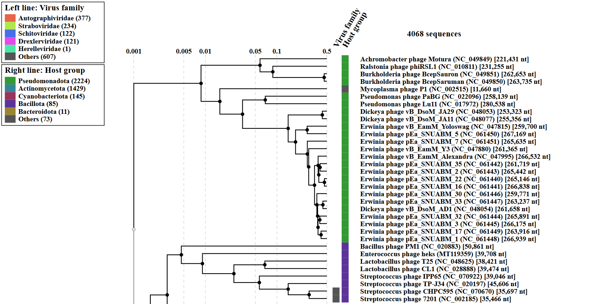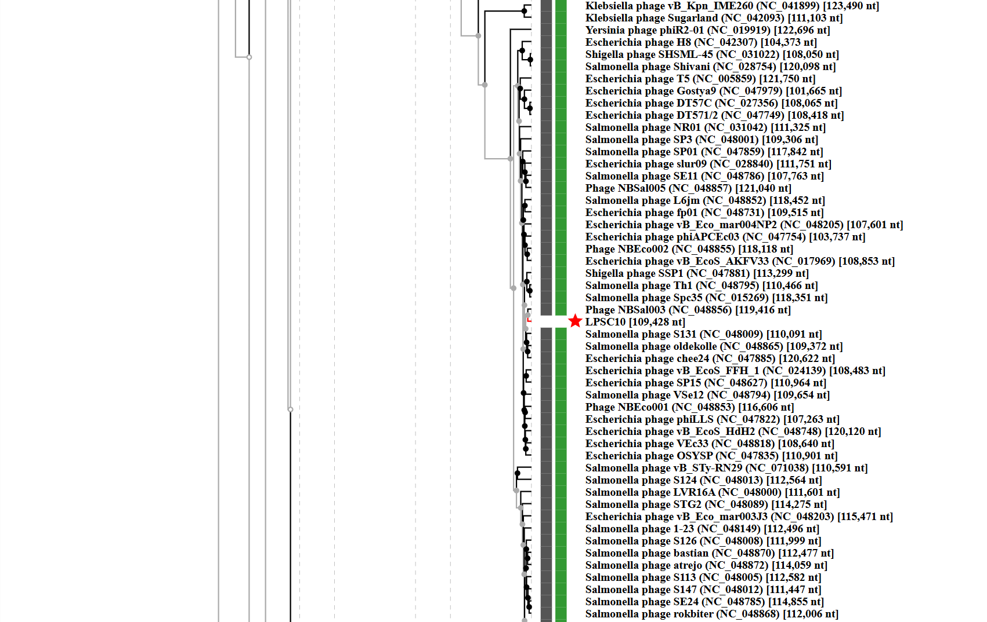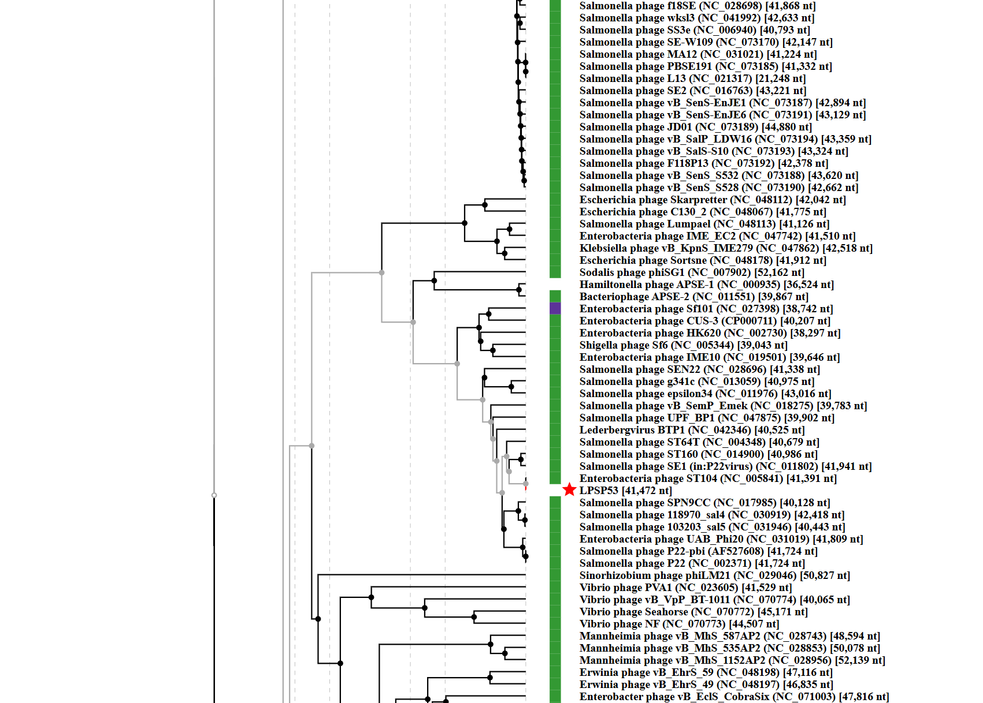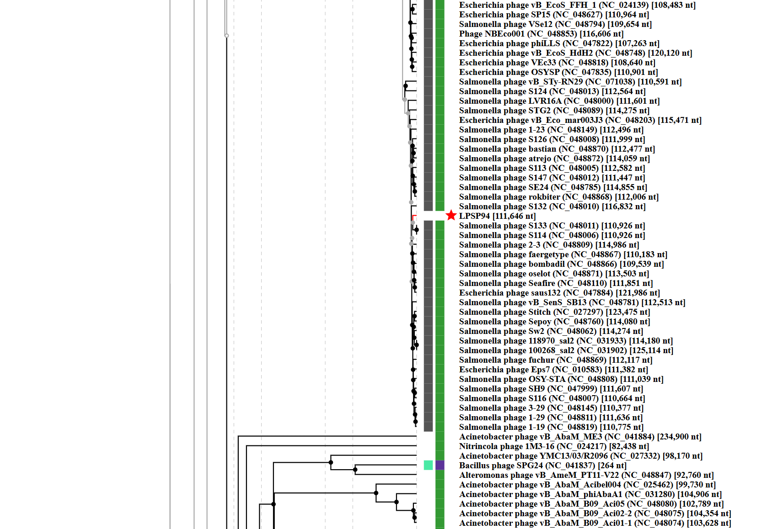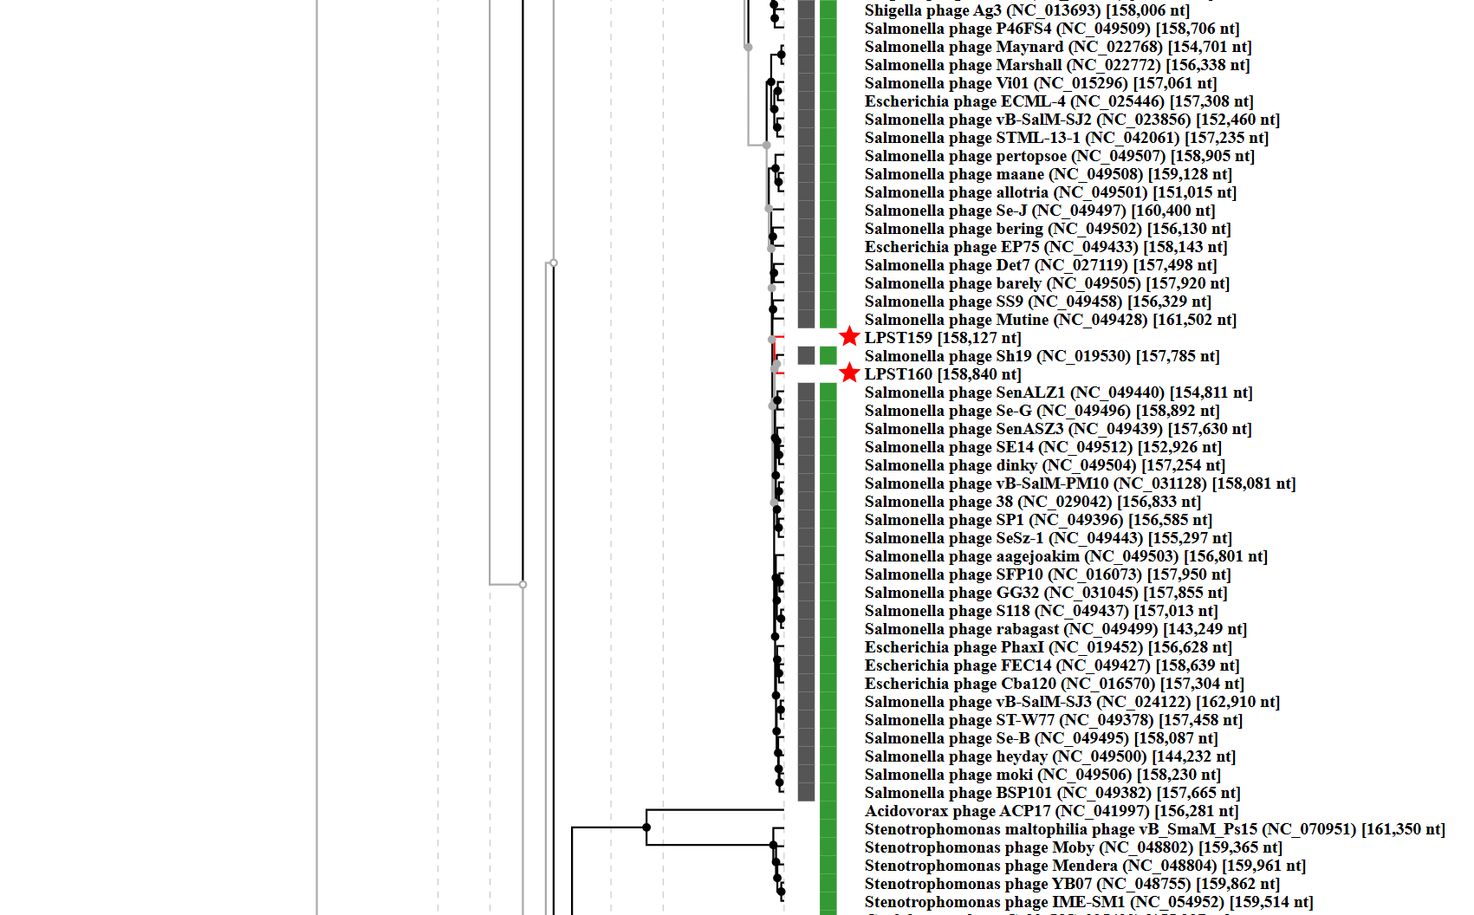Fig. 1. ViPTree-based phylogenetic placement of Salmonella phages LPSC10, LPSP53, LPSP94, LPST159 and LPST160.
Genome-wide proteomic tree analysis was performed using ViPTree. Candidate phages are indicated by red stars, and phylogenetically related reference phages selected for subsequent VIRIDIC analysis are enclosed in red dashed boxes.

VIRIDIC heat map: VIRIDIC (Virus Intergenomic Distance Calculator [1]; http://rhea.icbm.uni-oldenburg.de/VIRIDIC/) computes pairwise intergenomic distances/similarities amongst phage genomes. Candidate phages are indicated with red stars.
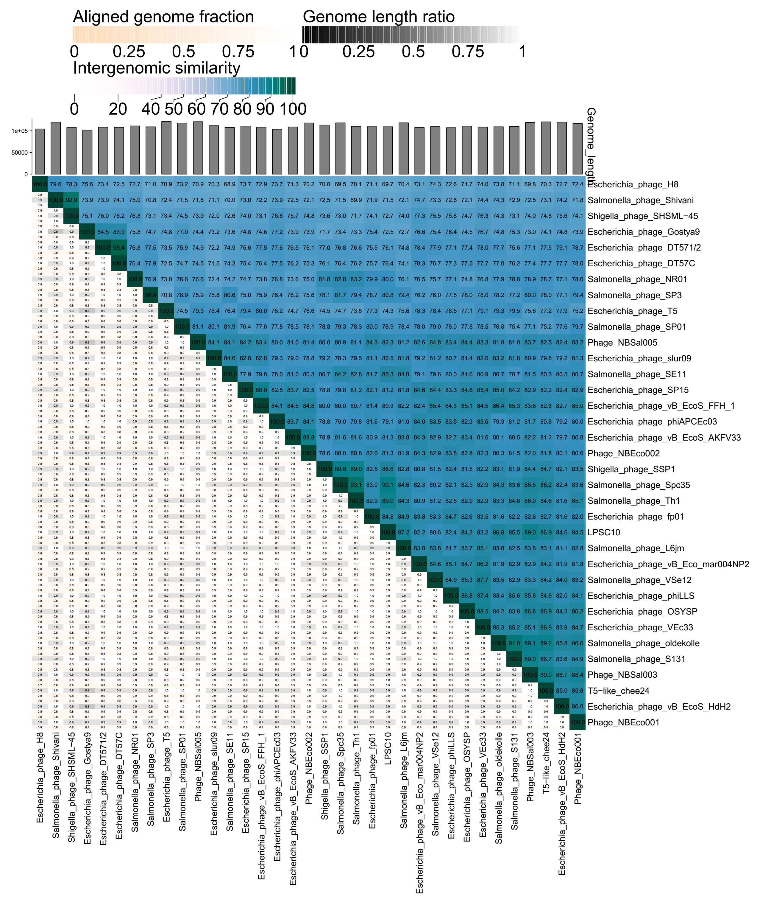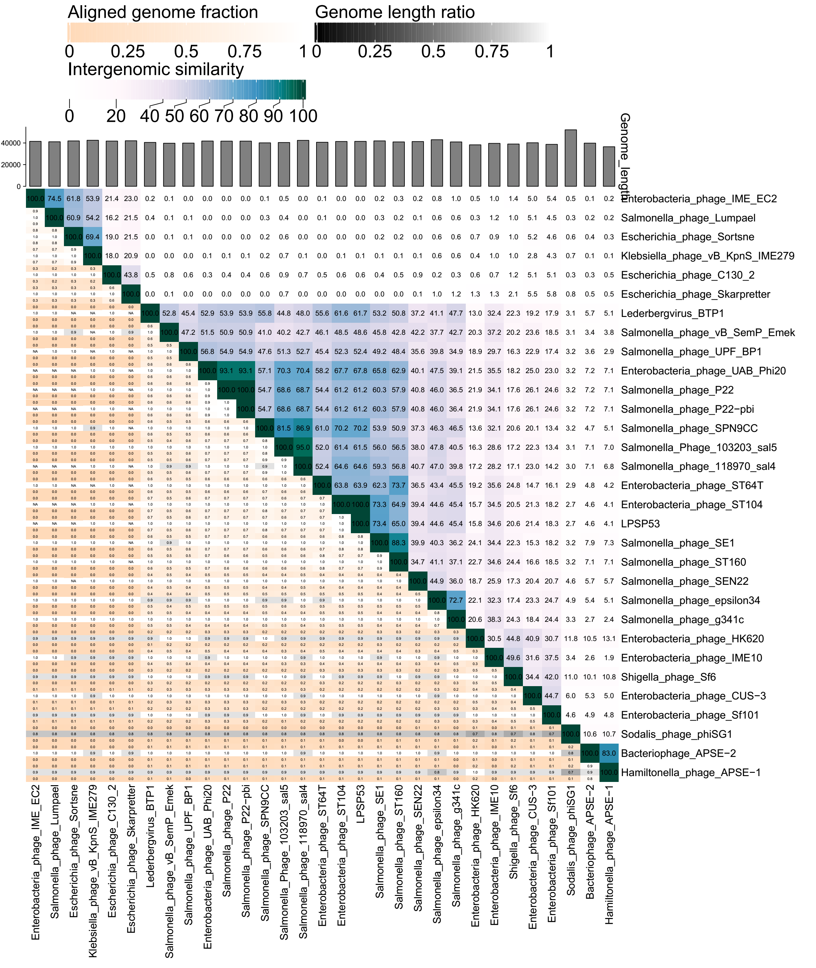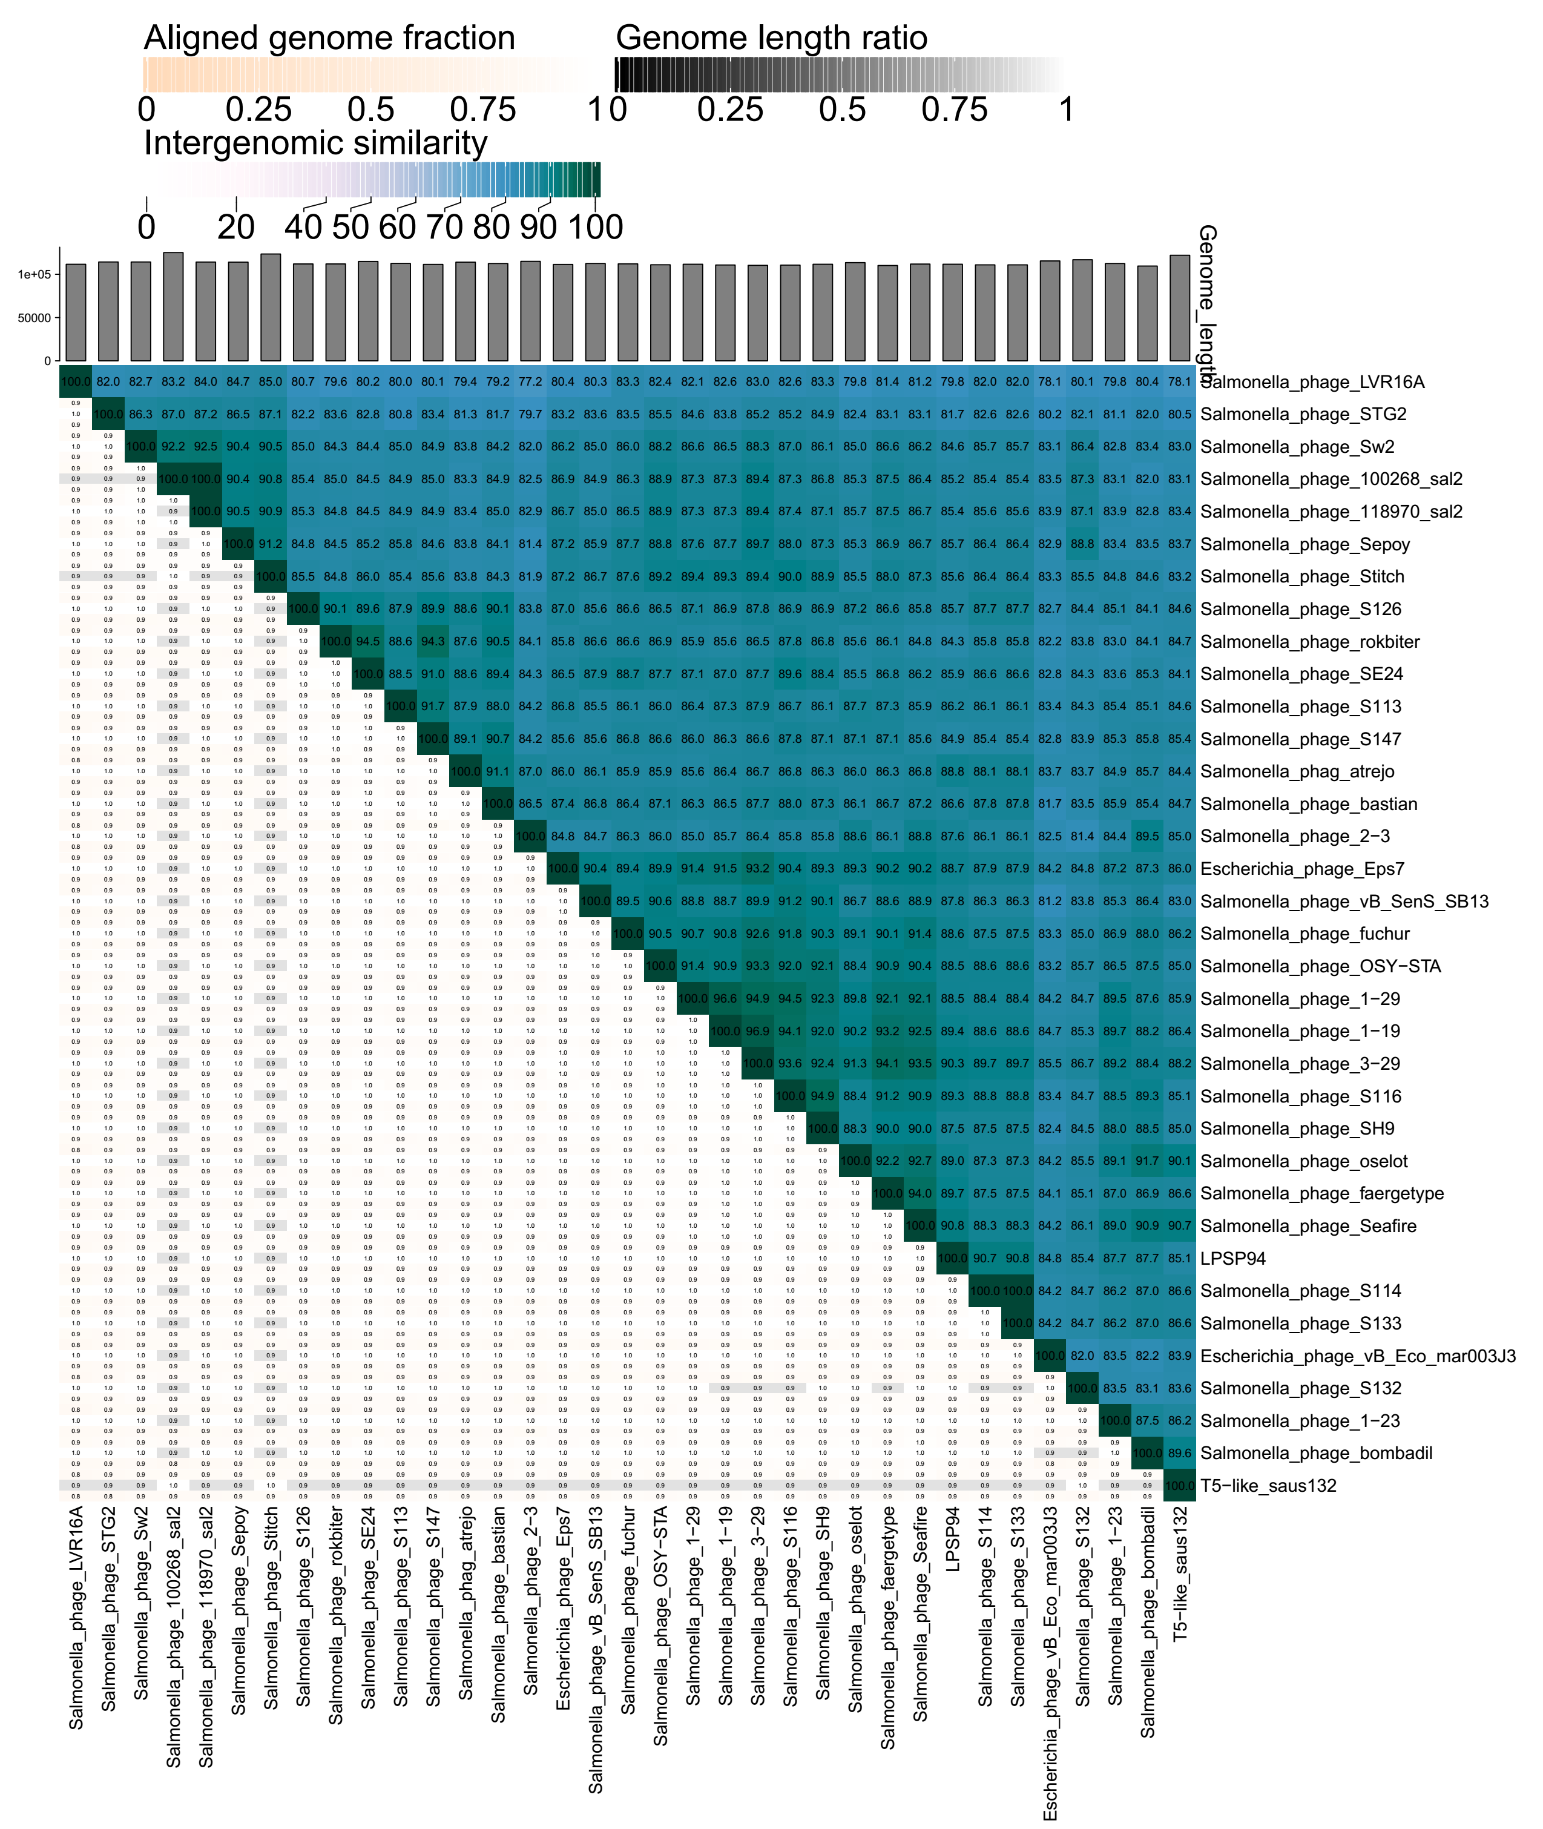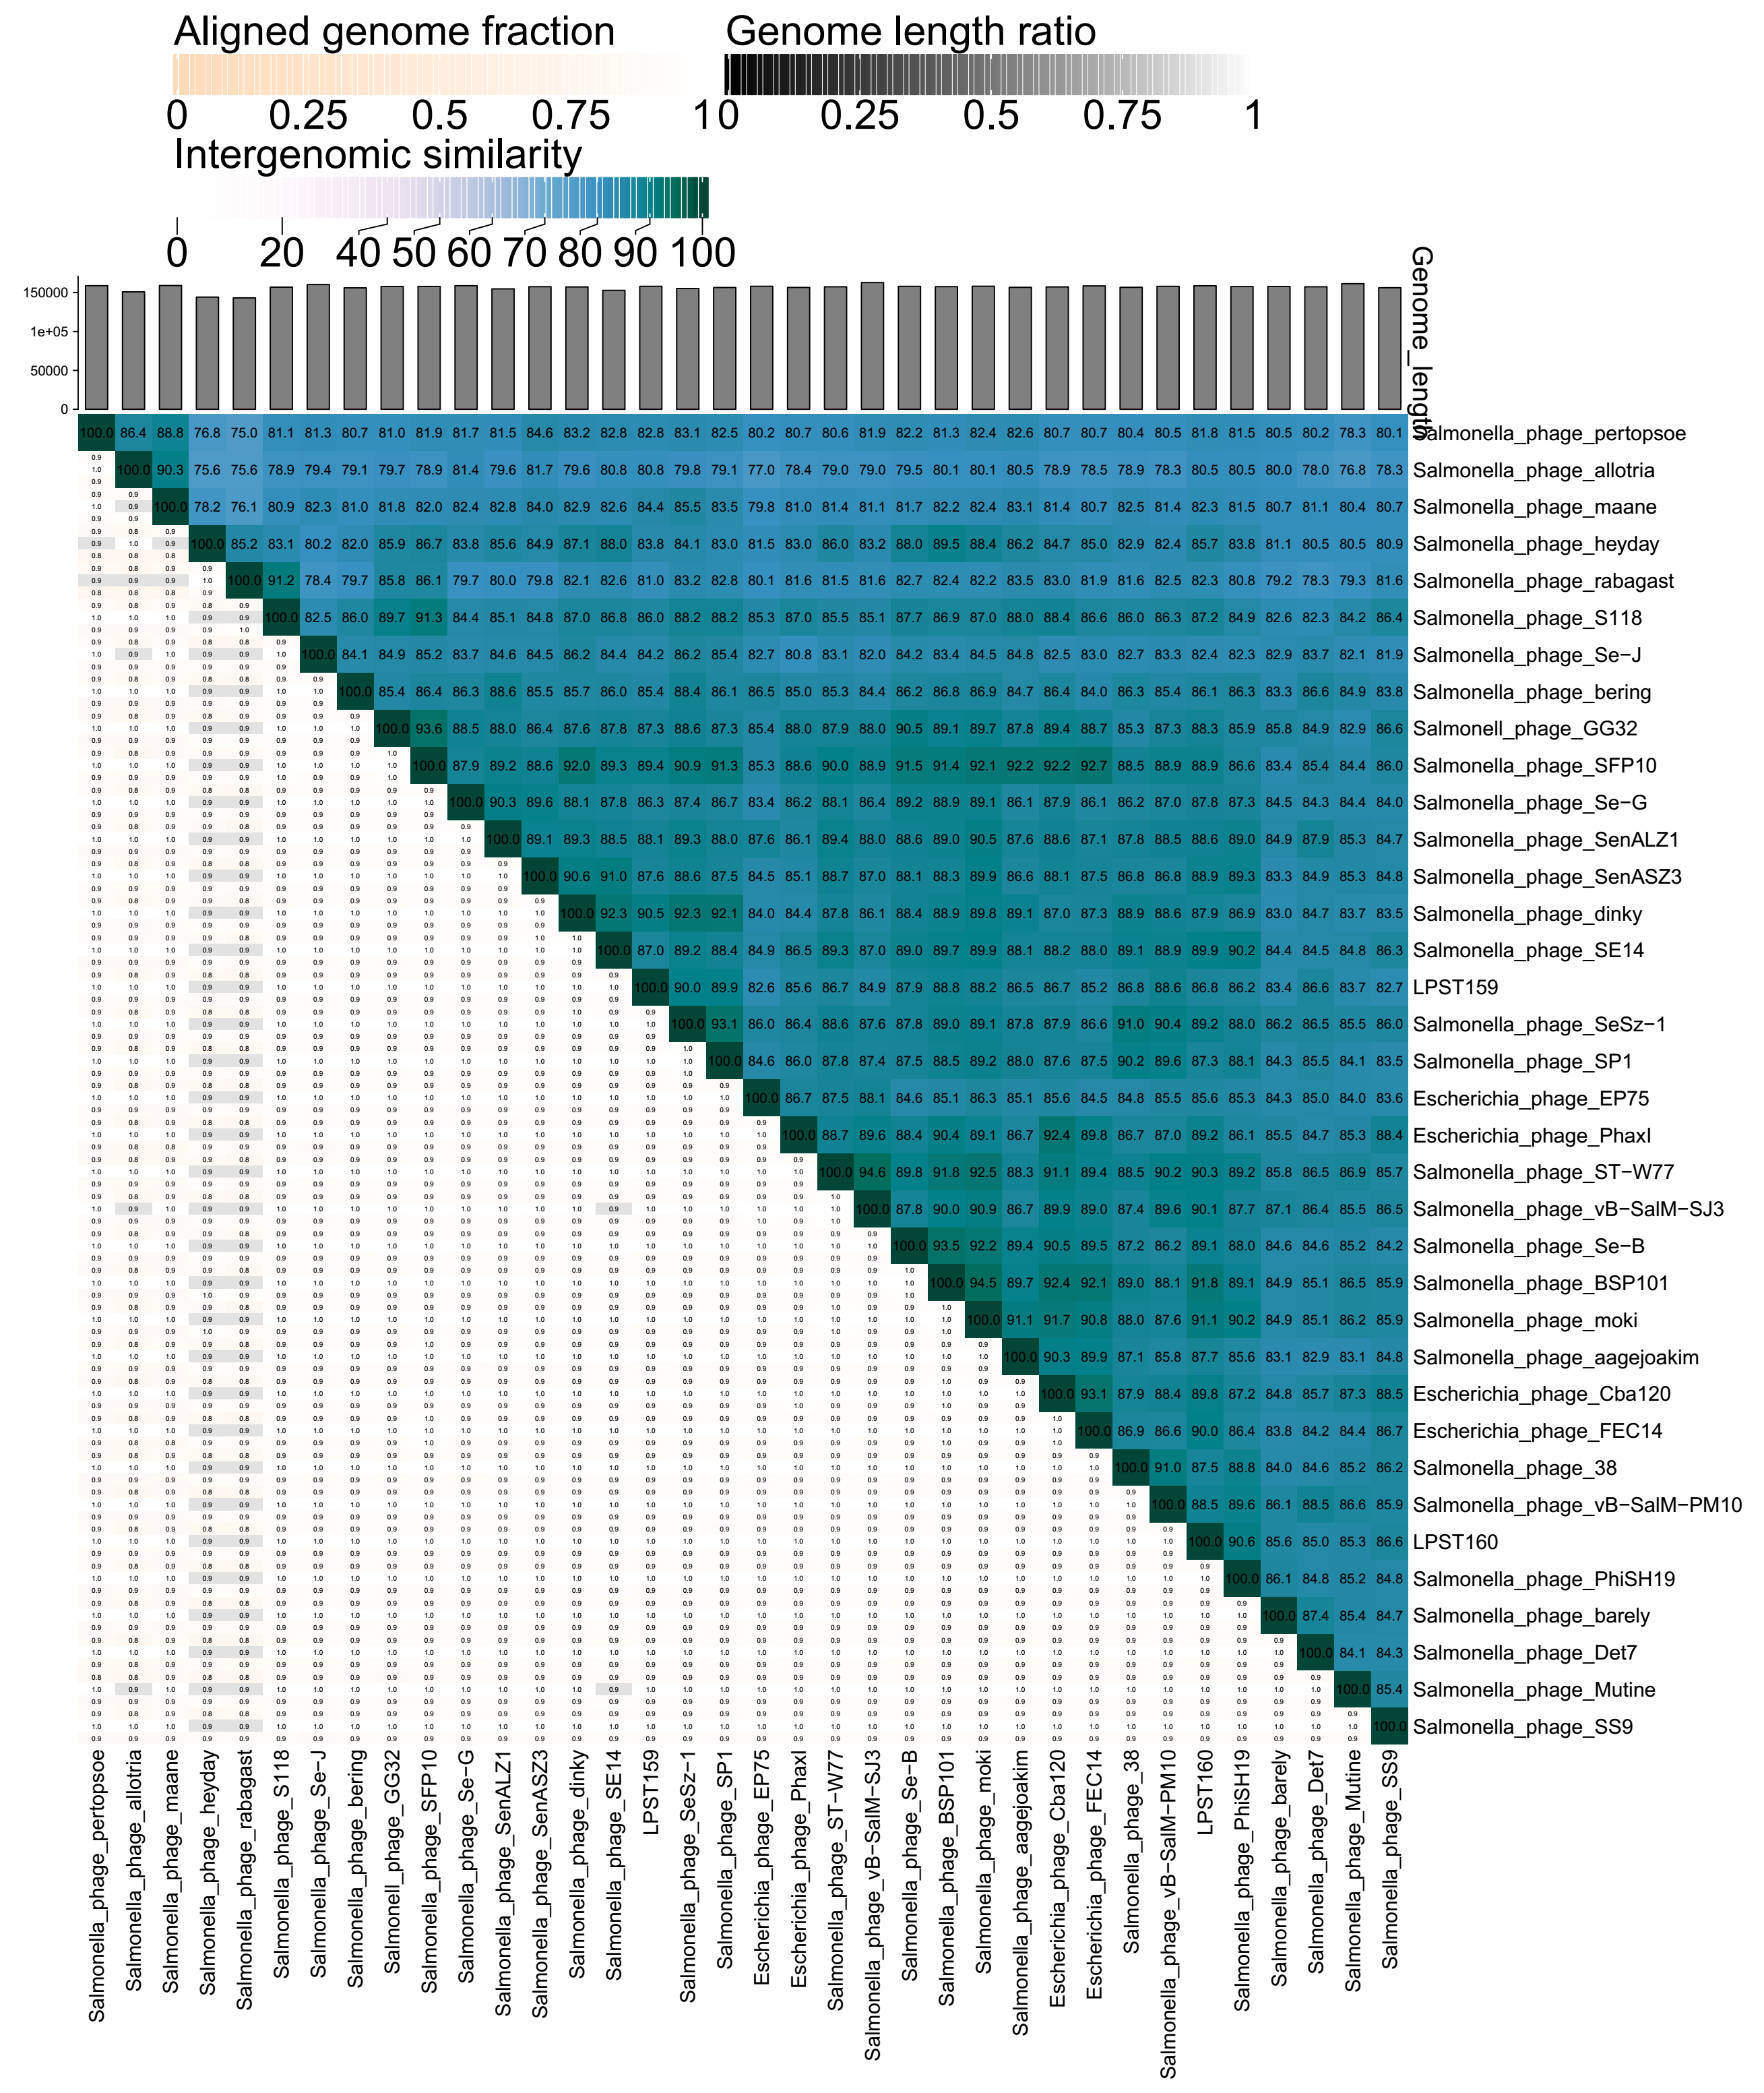Fig. 2. VIRIDIC heat maps showing pairwise intergenomic similarities between the five candidate Salmonella phages and related reference phages selected based on ViPTree analysis.
Candidate phages, including LPSC10, LPSP53, LPSP94, LPST159 and LPST160, are indicated by red stars. The similarity values support the separation of the candidate phages from their closest species-level relatives using the 95% species demarcation threshold.
Origin of the name of this taxon: The proposed species names are derived from the genus names and the isolate designations of the corresponding exemplar phages.

Historical aspects: Salmonella phages LPSC10, LPSP53, LPSP94, LPST159 and LPST160 were isolated by Huazhong Agricultural University between 2016 and 2019 from lake water samples collected in Wuhan, Hubei, China.

Genome summary:
Phage name | INSDC | Size (Kb) | GC% | Protein | tRNA
Salmonella phage LPSC10 | PZ366309 | 109.43 | 39.25% | 199 | 19
Salmonella phage LPSP53 | PZ383622 | 41.47 | 47.43% | 78 | 0
Salmonella phage LPSP94 | PZ366308 | 111.65 | 39.97% | 199 | 25
Salmonella phage LPST159 | PZ383623 | 158.13 | 44.58% | 230 | 5
Salmonella phage LPST160 | PZ383624 | 158.84 | 44.51% | 233 | 4

Pairwise intergenomic similarity summary:
Proposed species | Exemplar phage | Assigned genus | Closest related phage (GenBank) | VIRIDIC similarity / interpretation
Tequintavirus LPSC10 | Salmonella phage LPSC10 | Tequintavirus | Tequintavirus Spc35 (NC_015269) | 90.1%; below 95% species threshold and above 70% genus threshold
Cornellvirus LPSP53 | Salmonella phage LPSP53 | Cornellvirus | Salmonella phage ST104 (NC_005841); Cornellvirus SE1 (NC_011802) | 100% to ST104, which is not ICTV-listed; 73.4% to recognized Cornellvirus representative SE1
Epseptimavirus LPSP94 | Salmonella phage LPSP94 | Epseptimavirus | Epseptimavirus Seafire (NC_048110) | 90.8%; below 95% species threshold and above 70% genus threshold
Kuttervirus LPST159 | Salmonella phage LPST159 | Kuttervirus | Kuttervirus dinky (NC_049504) | 90.5%; below 95% species threshold and above 70% genus threshold
Kuttervirus LPST160 | Salmonella phage LPST160 | Kuttervirus | Kuttervirus BSP101 (NC_049382) | 91.8%; below 95% species threshold and above 70% genus threshold

