

The International Committee on Taxonomy of Viruses
Taxonomy Proposal Form, 2026

Part 1a: Details of taxonomy proposals

Title: | Create eighteen new species in existing genera within the class Caudoviricetes
Code assigned: | 2026.015B

Author(s), affiliation and email address(es):
Given name (+middle initial(s)) | Surname | Affiliation | Email address | Corr. author(s)
Napakhwan | Imklin | Department of Biotechnology, Silpakorn University, Nakhon Pathom, Thailand.  Department of Research and Development, Phagrogent CO., LTD., Bangkok, Thailand. | faiimklin@gmail.com | x
Rujikan | Nasanit | Department of Biotechnology, Silpakorn University, Nakhon Pathom, Thailand.  Department of Research and Development, Phagrogent CO., LTD., Bangkok, Thailand. | rnasanit@gmail.com | x

Part 1b: Taxonomy Proposal Submission
ICTV Subcommittee:
Animal DNA Viruses and Retroviruses |  | Bacterial viruses | X
Animal minus-strand and dsRNA viruses |  | Fungal and protist viruses
Animal positive-strand RNA viruses |  | Plant viruses
Archaeal viruses |  | General -

List the ICTV Study Group(s) that have seen or have been involved in creating this proposal:
Optional – complete only if formally voted on by an ICTV Study Group:
Study Group | Number of members
Study Group | Votes in support | Votes against | No vote

Submission date: | 29/05/2026

Part 1c: Feedback from ICTV Executive Committee (EC) meeting
Executive Committee Meeting Decision code: | X
A – Accept
Ac – Accept subject to revision by relevant subcommittee chair. No further vote required
U – Accept without revision but with re-evaluation and email vote by the EC
Uc – Accept subject to revision and re-evaluation and email vote by the EC
Ud – Deferred to the next EC meeting, with an invitation to revise based on EC comments
J - Reject
W - Withdrawn

Comments from the Executive Committee:

Part 1d: Revised Taxonomy Proposal Submission
Response of proposer:
Revision date:

Part 3: TAXONOMIC PROPOSAL
https://ictv.global/taxonomy/templates

Taxonomic changes proposed:
Establish new taxon | x | Split taxon
Abolish taxon |  | Merge taxon
Move taxon |  | Promote taxon
Rename taxon |  | Demote taxon
Move and rename

Etymology (origin) of proposed taxonomic names:
Taxon name | Etymology of the term
ecopha | Each new phage species is named based on its respective isolate designation and genus prefix.
salpha | Each new phage species is named based on its respective isolate designation and genus prefix.
RPN | Each new phage species is named based on its respective isolate designation.
Kayfunavirus biotsu | The combination of department (Biotechnology) and university (Silpakorn University) abbreviation.
Berlinvirus sanamchandra | The name of the university campus where we performed the work
Tequatrovirus sutha | The combination of university (Silpakorn University) and country (Thailand) abbreviation.
Berlinvirus silpakorn | The name of the main university (Silpakorn University).
Berlinvirus pathom | A part of the province name (Nakhon Pathom) where the phage was isolated.
Krischvirus suisiam | Sui means pig and Siam was the previous name of Thailand. This phage was isolated using E. coli originated from an infected pig specimen.
Wifcevirus kaset | The name of the partner university (Kasetsart University).

Permission for use of names derived from a living person:
Taxon name | Full name of person from whom the name is derived | Attached

Abstract of Taxonomy Proposal:
Description of current taxonomy:
These phage genomes display sufficient nucleotide variation to be classified as new species within the existing genera Gamaleyavirus, Mosigvirus, Chivirus, Cornellvirus, Moonvirus, Berlinvirus, Kayfunavirus, Tequatrovirus, Krischvirus, and Wifcevirus

Proposed taxonomic change(s):
This work proposes the addition of one new species to each of the genera Chivirus, Cornellvirus, Moonvirus, Agtrevirus, Kayfunavirus, Krischvirus, Gamaleyavirus and Wifcevirus. Additionally, we propose the creation of two new species within the genus Mosigvirus and Tequatrovirus, and and six new species for the genus Berlinvirus, respectively.

Demarcation criteria for new taxon/taxa:
A phage nucleotide identity between 70% and 95% compared to existing reference phages serves as the boundary for novel species demarcation. Isolates within this sequence identity range are classified as new individual species within their respective genera.

Justification:
Whole-genome intergenomic nucleotide similarity comparison using taxMyPhage revealed that these phages share 78.2% to 93.7% sequence identity with reference genomes, indicating that they represent new phage species.

- Text of Taxonomy proposal:

Description of current taxonomy:
These phage genomes display sufficient nucleotide variation to be classified as new species within the existing genera Chivirus, Cornellvirus, Moonvirus, Agtrevirus, Kayfunavirus, Krischvirus, Wifcevirus, Mosigvirus, Tequatrovirus, Gamaleyavirus, and Berlinvirus.

Proposed taxonomic change(s):
A new species will be added to each of the genera: “Chivirus salpha85”, “Cornellvirus salpha91”, “Moonvirus salpha100”, “Agtrevirus RPN242”, “Kayfunavirus biotsu”, “Krischvirus suisiam”, and “Wifcevirus kaset”. Additionally, two new species will be introduced to the genus Mosigvirus, Tequatrovirus, and Gamaleyavirus including “Mosigvirus ecopha54”, “Mosigvirus RPN187”, “Tequatrovirus RPN226”, “Tequatrovirus sutha” and “Gamaleyavirus ecopha24”. For the genus Berlinvirus, these six phages will be added which are “Berlinvirus ecopha45”, “Berlinvirus salpha38”, “Berlinvirus salpha39”, “Berlinvirus sanamchadra”, “Berlinvirus silpakorn”, and “Berlinvirus pathom”.

Demarcation criteria for new taxon/taxa:
For species demarcation within each genus, the established nucleotide identity threshold is set at 95%. Novel isolates are designated as separate species if they exhibit more than 70% genome-wide identity to current members but fall below the 95% similarity cutoff relative to their closest phage counterpart [1].

Justification:
From the whole genome intergenomic nucleotide similarity analysis using taxMyPhage [3], it was found that the studied phages share a nucleotide identity ranging from 78.2% to 93.7% with existing phages in the database. This similarity range satisfies the criteria for identifying new species (70%–95%). Therefore, these phages are presented as novel species within existing genera.

References:
[1] Turner D, Kropinski AM, Adriaenssens EM. A Roadmap for Genome-Based Phage Taxonomy. Viruses. 2021 Mar 18;13(3):506. doi: 10.3390/v13030506.
[2] Turner D, Adriaenssens EM, Tolstoy I, Kropinski AM. Phage Annotation Guide: Guidelines for Assembly and High-Quality Annotation. Phage (New Rochelle). 2021 Dec 1;2(4):170-182. doi: 10.1089/phage.2021.0013.
[3] Millard A, Denise R, Lestido M, Nicholas MT, Webster D, Turner D, Sicheritz-Pontén T. taxMyPhage: Automated Taxonomy of dsDNA Phage Genomes at the Genus and Species Level. Phage (New Rochelle). 2025 Mar 3;6(1):5-11. doi: 10.1089/phage.2024.0050.

Accompanying files:
Filename | Description of contents

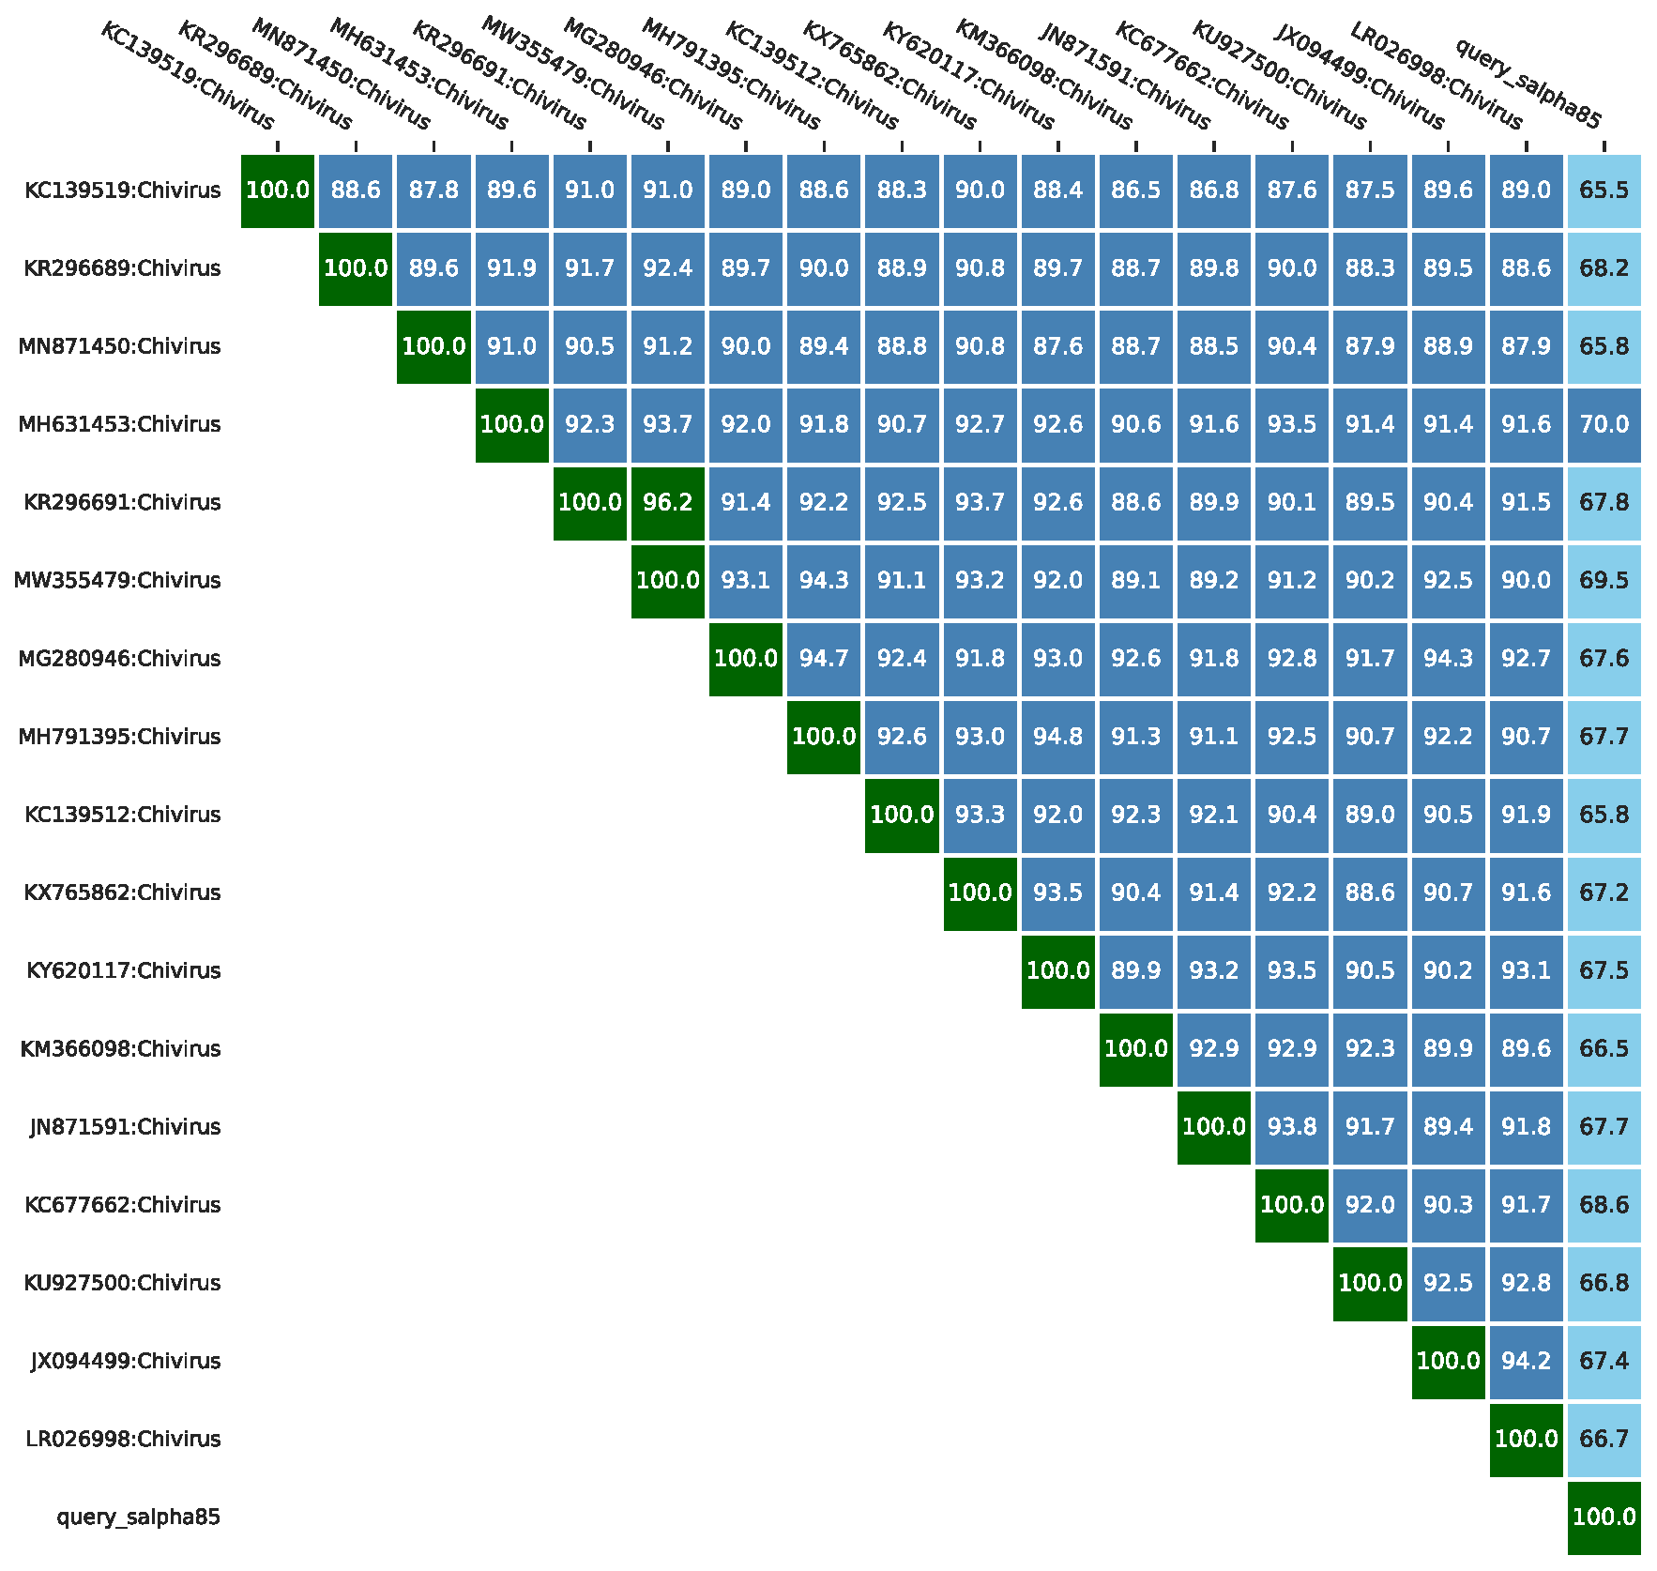
Tables, Figures:

Figure 1 The heatmap of genomic similarity of phage Chivirus salpha85 derived from taxMyPhage.

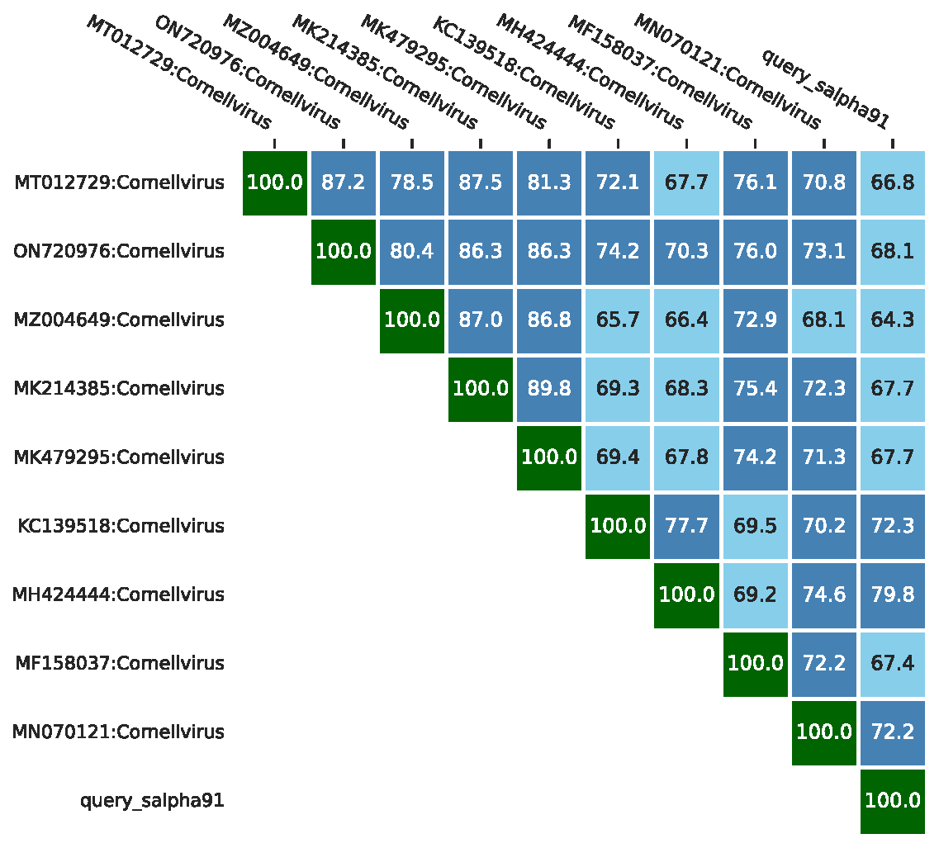
Figure 2 The heatmap of genomic similarity of phage Cornellvirus salpha91 derived from taxMyPhage.

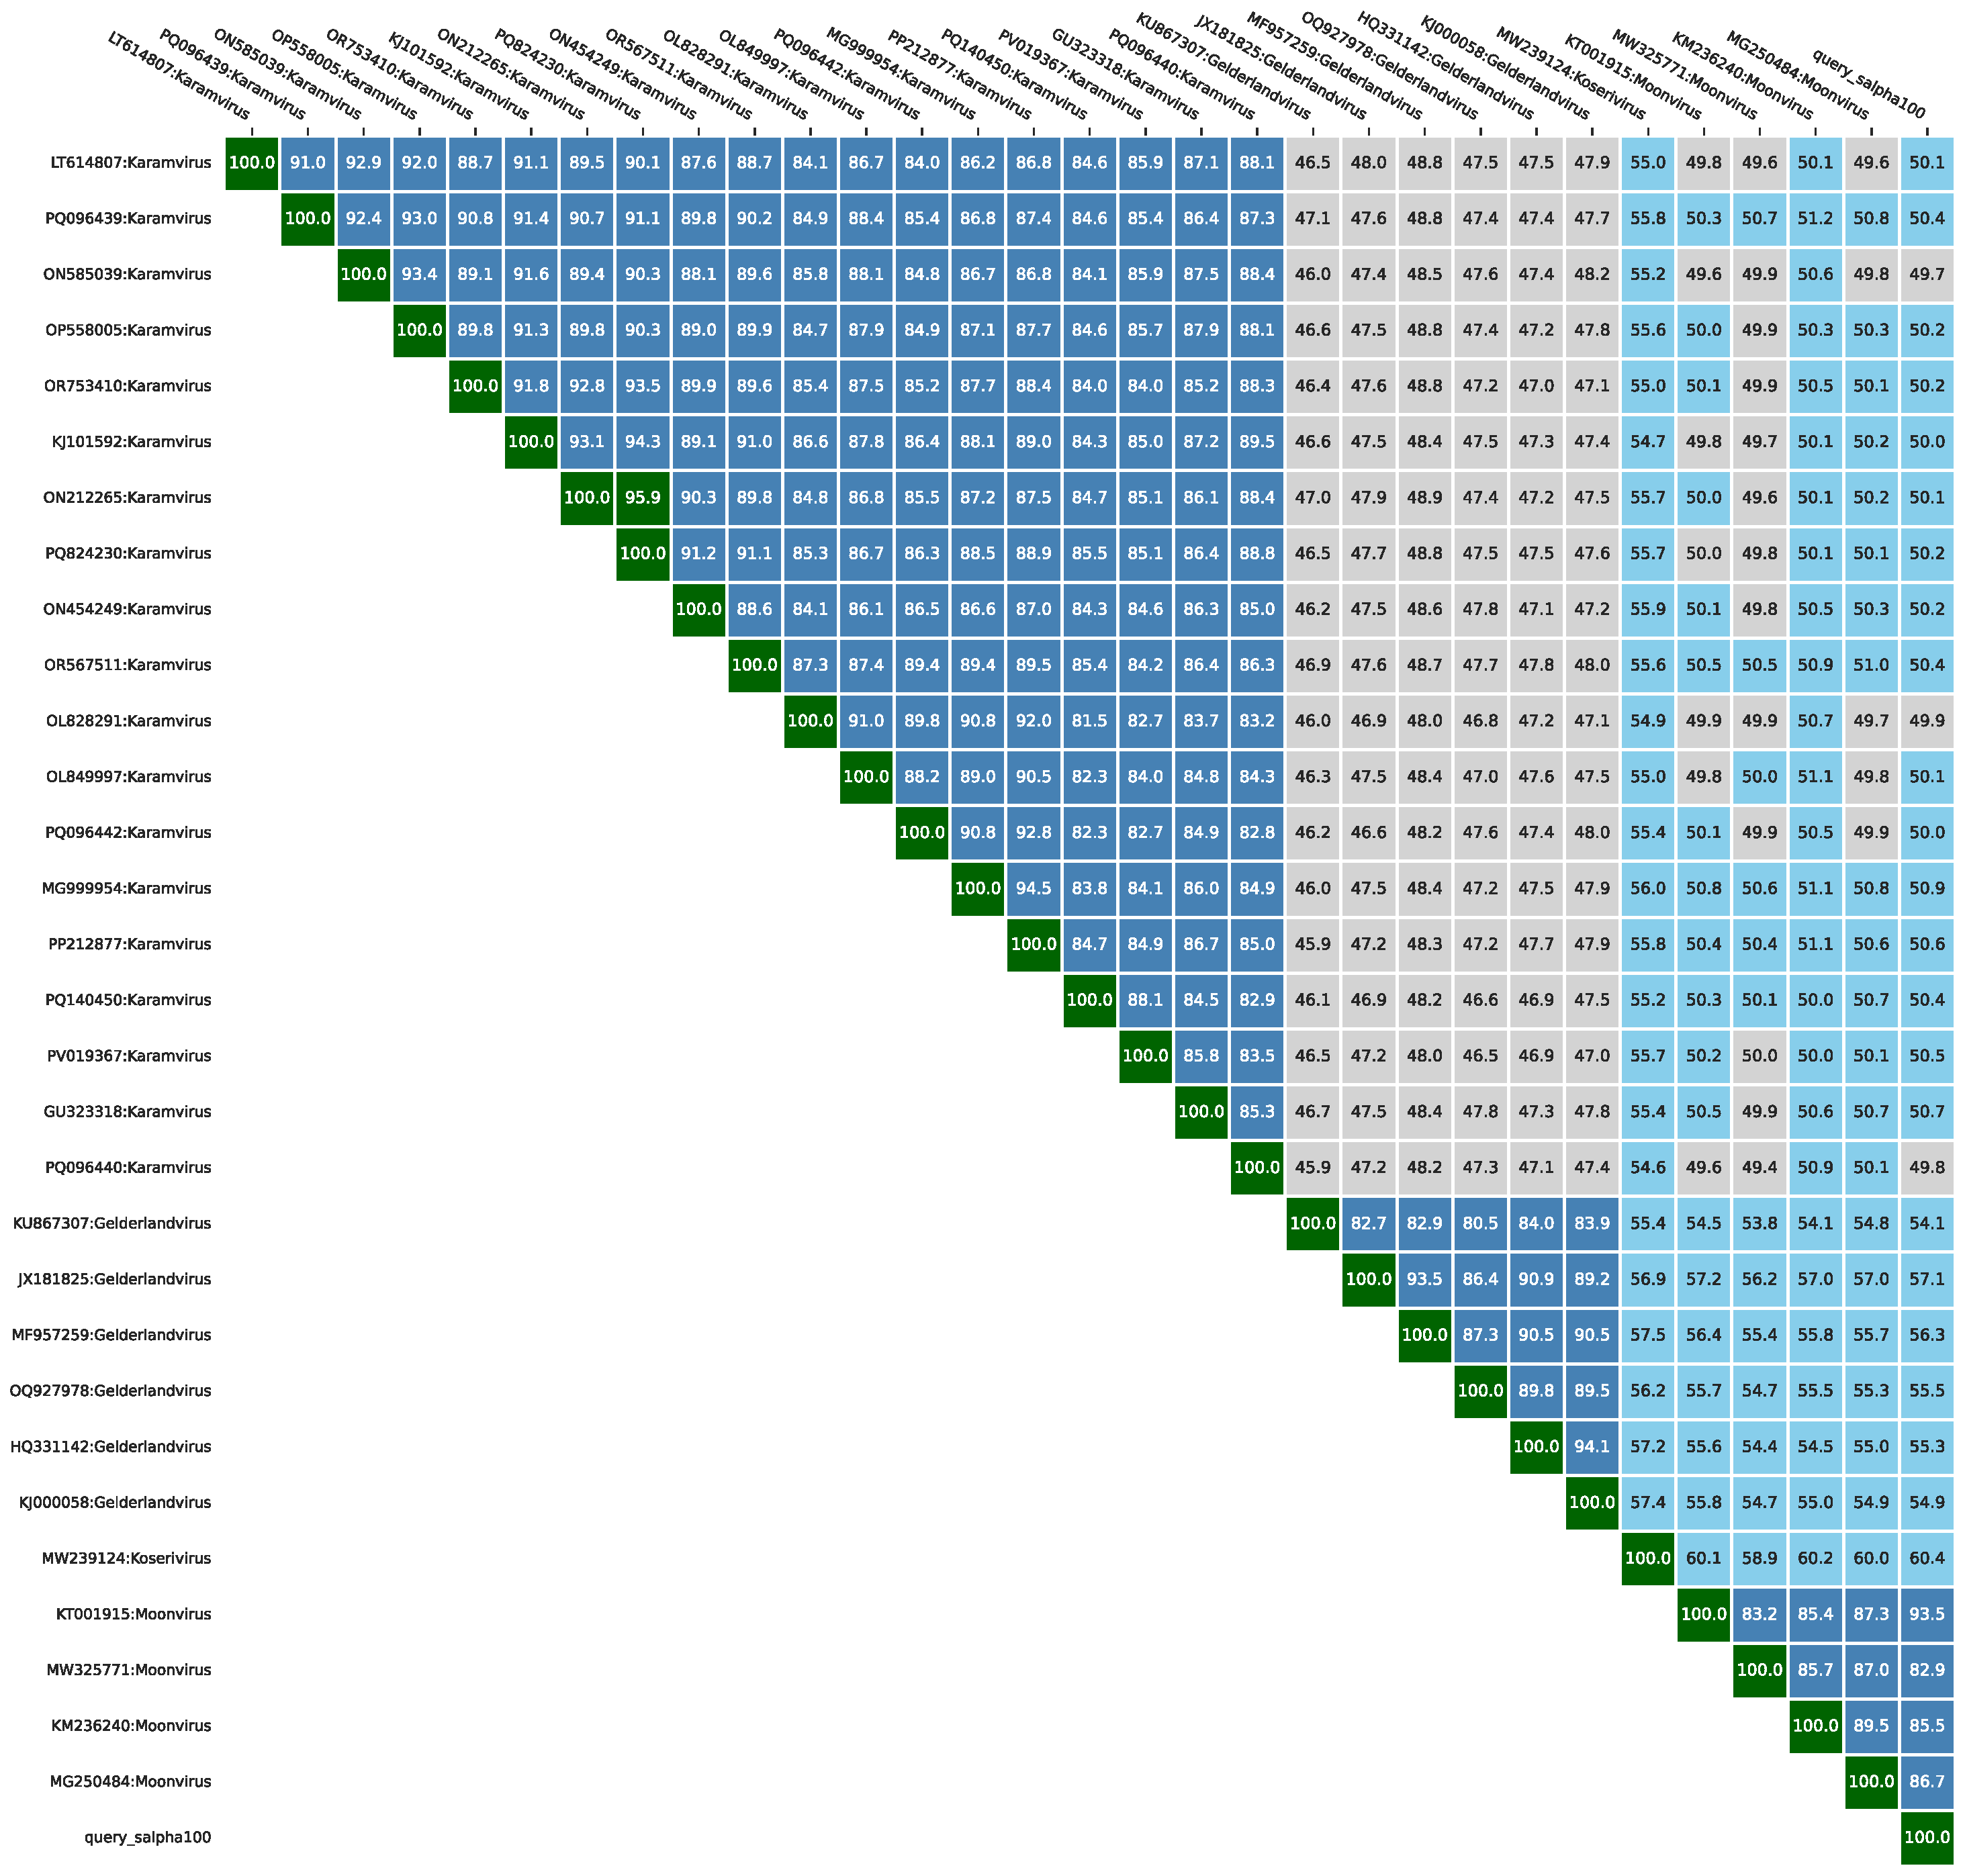
Figure 3 The heatmap of genomic similarity of phage Moonvirus salpha100 derived from taxMyPhage.

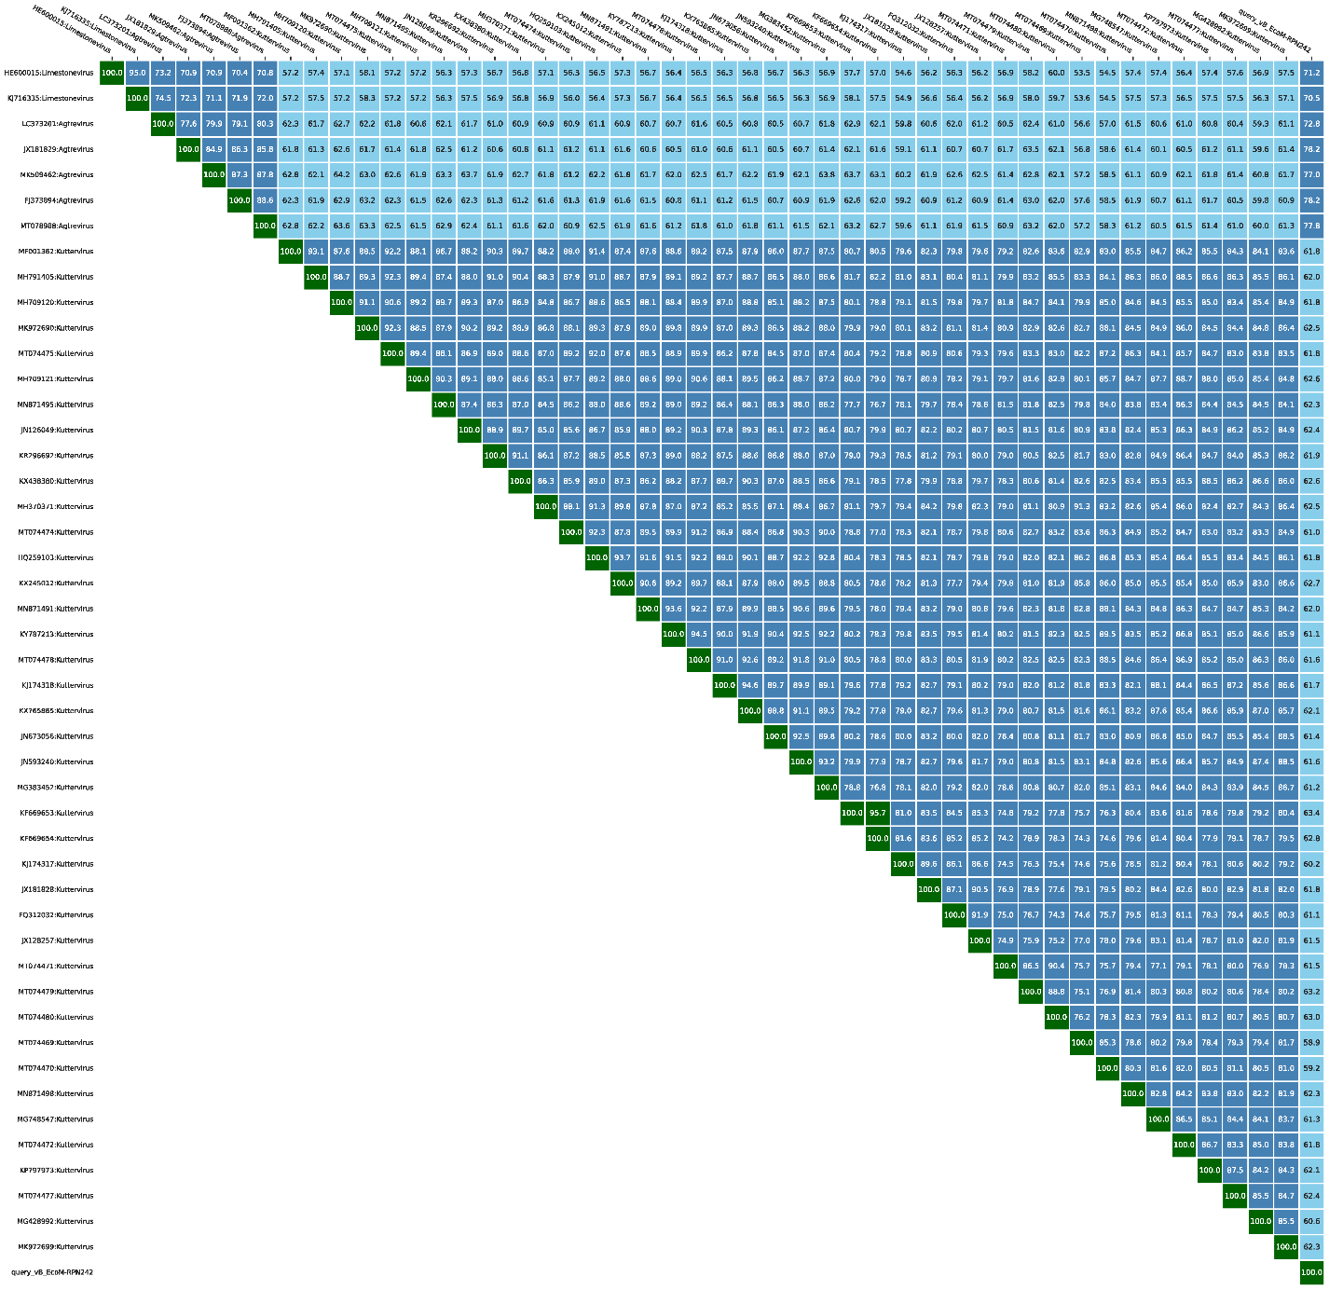
Figure 4 The heatmap of genomic similarity of phage Agtrevirus RPN242 derived from taxMyPhage.

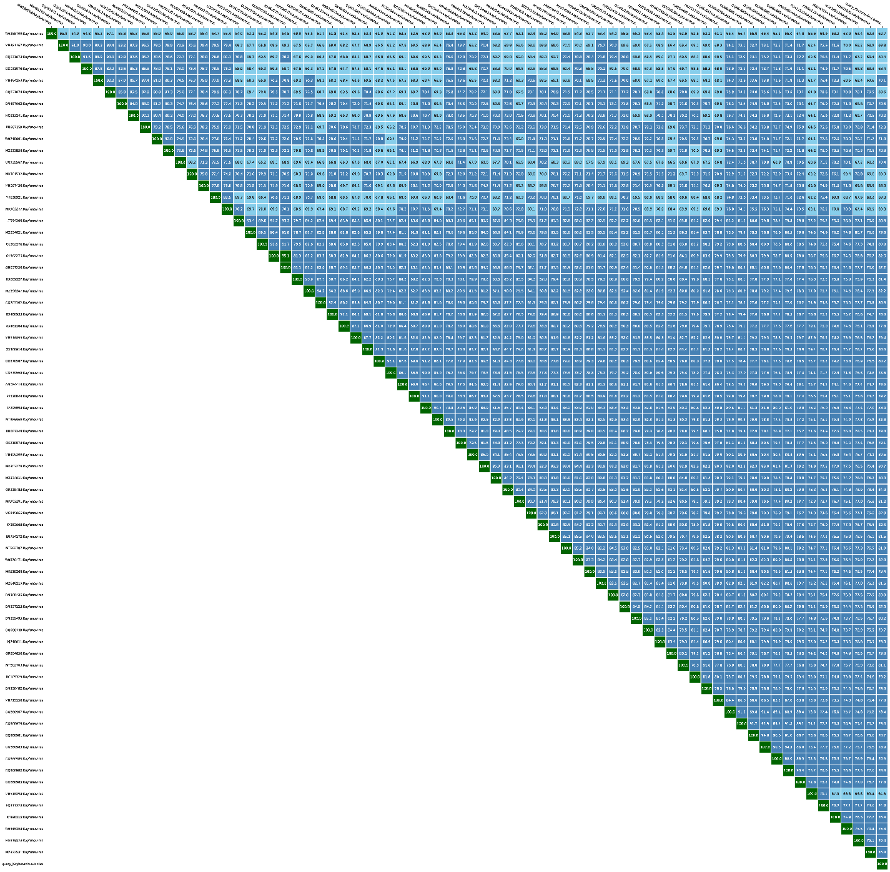
Figure 5 The heatmap of genomic similarity of phage Kayfunavirus biotsu derived from taxMyPhage.

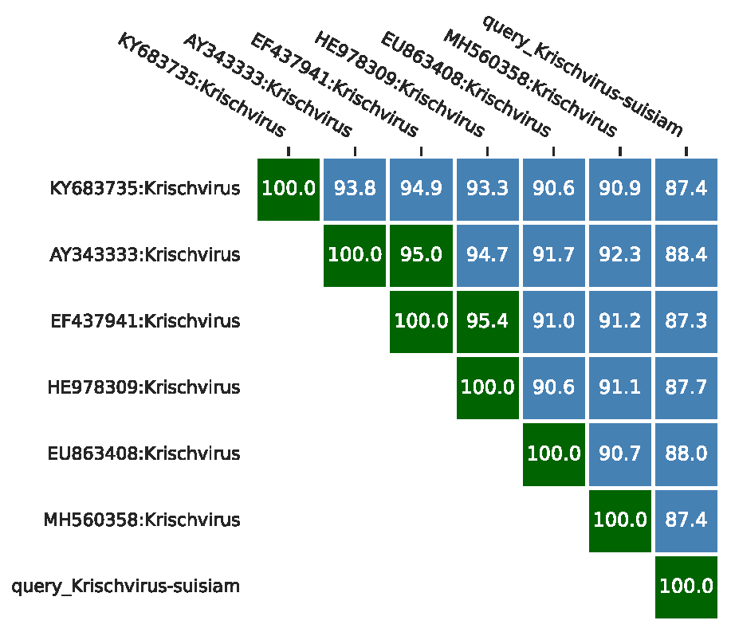
Figure 6 The heatmap of genomic similarity of phage Krischvirus suisiam derived from taxMyPhage.

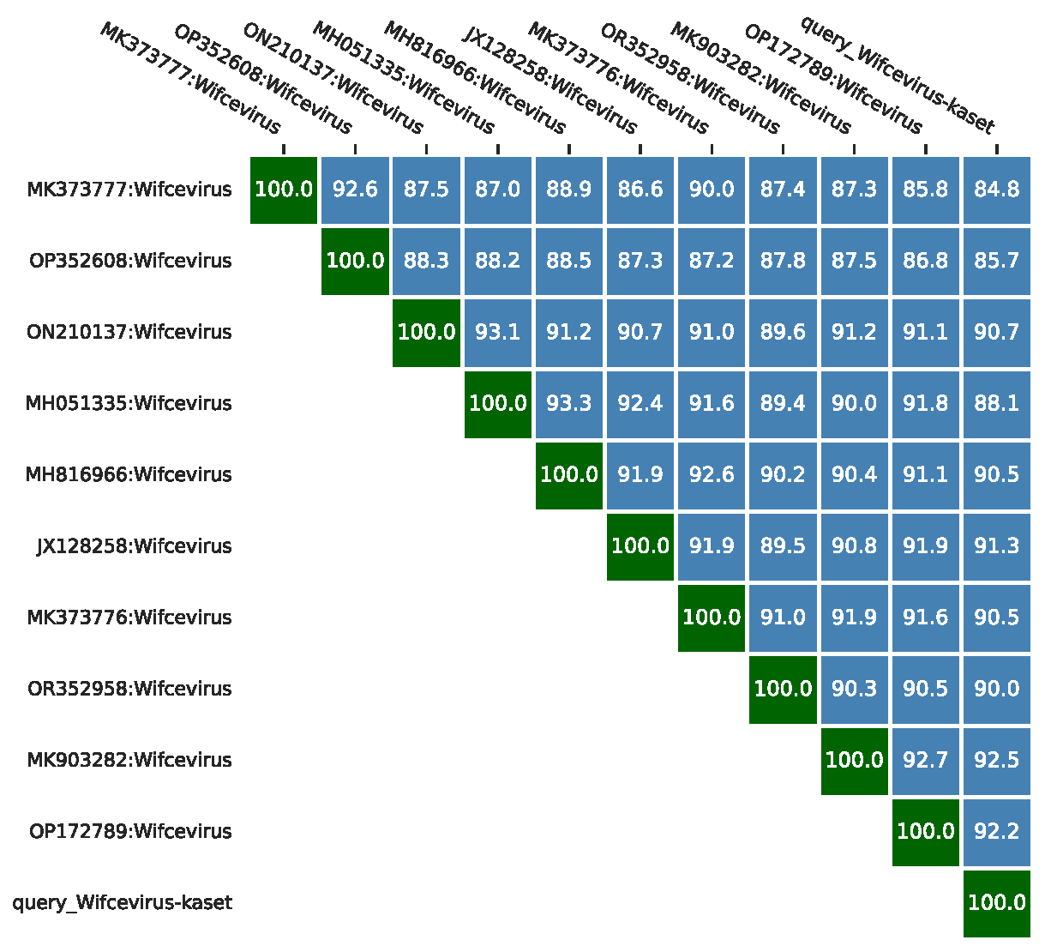
Figure 7 The heatmap of genomic similarity of phage Wifcevirus kaset derived from taxMyPhage.

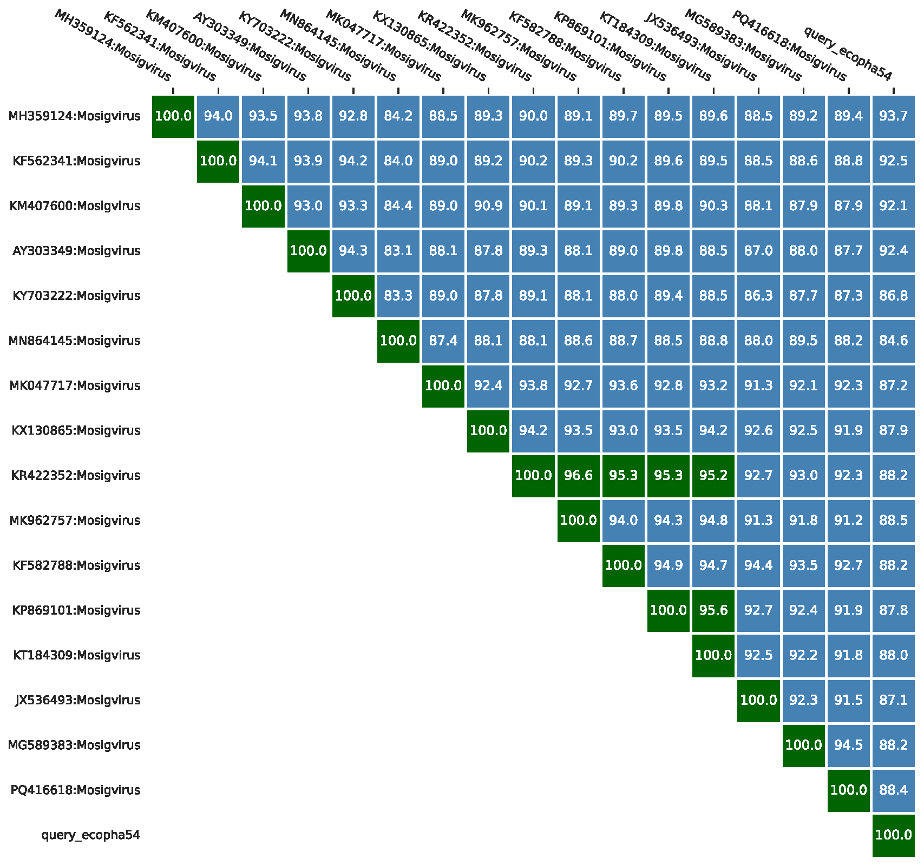
Figure 8 The heatmap of genomic similarity of phage Mosigvirus ecopha54 derived from taxMyPhage.

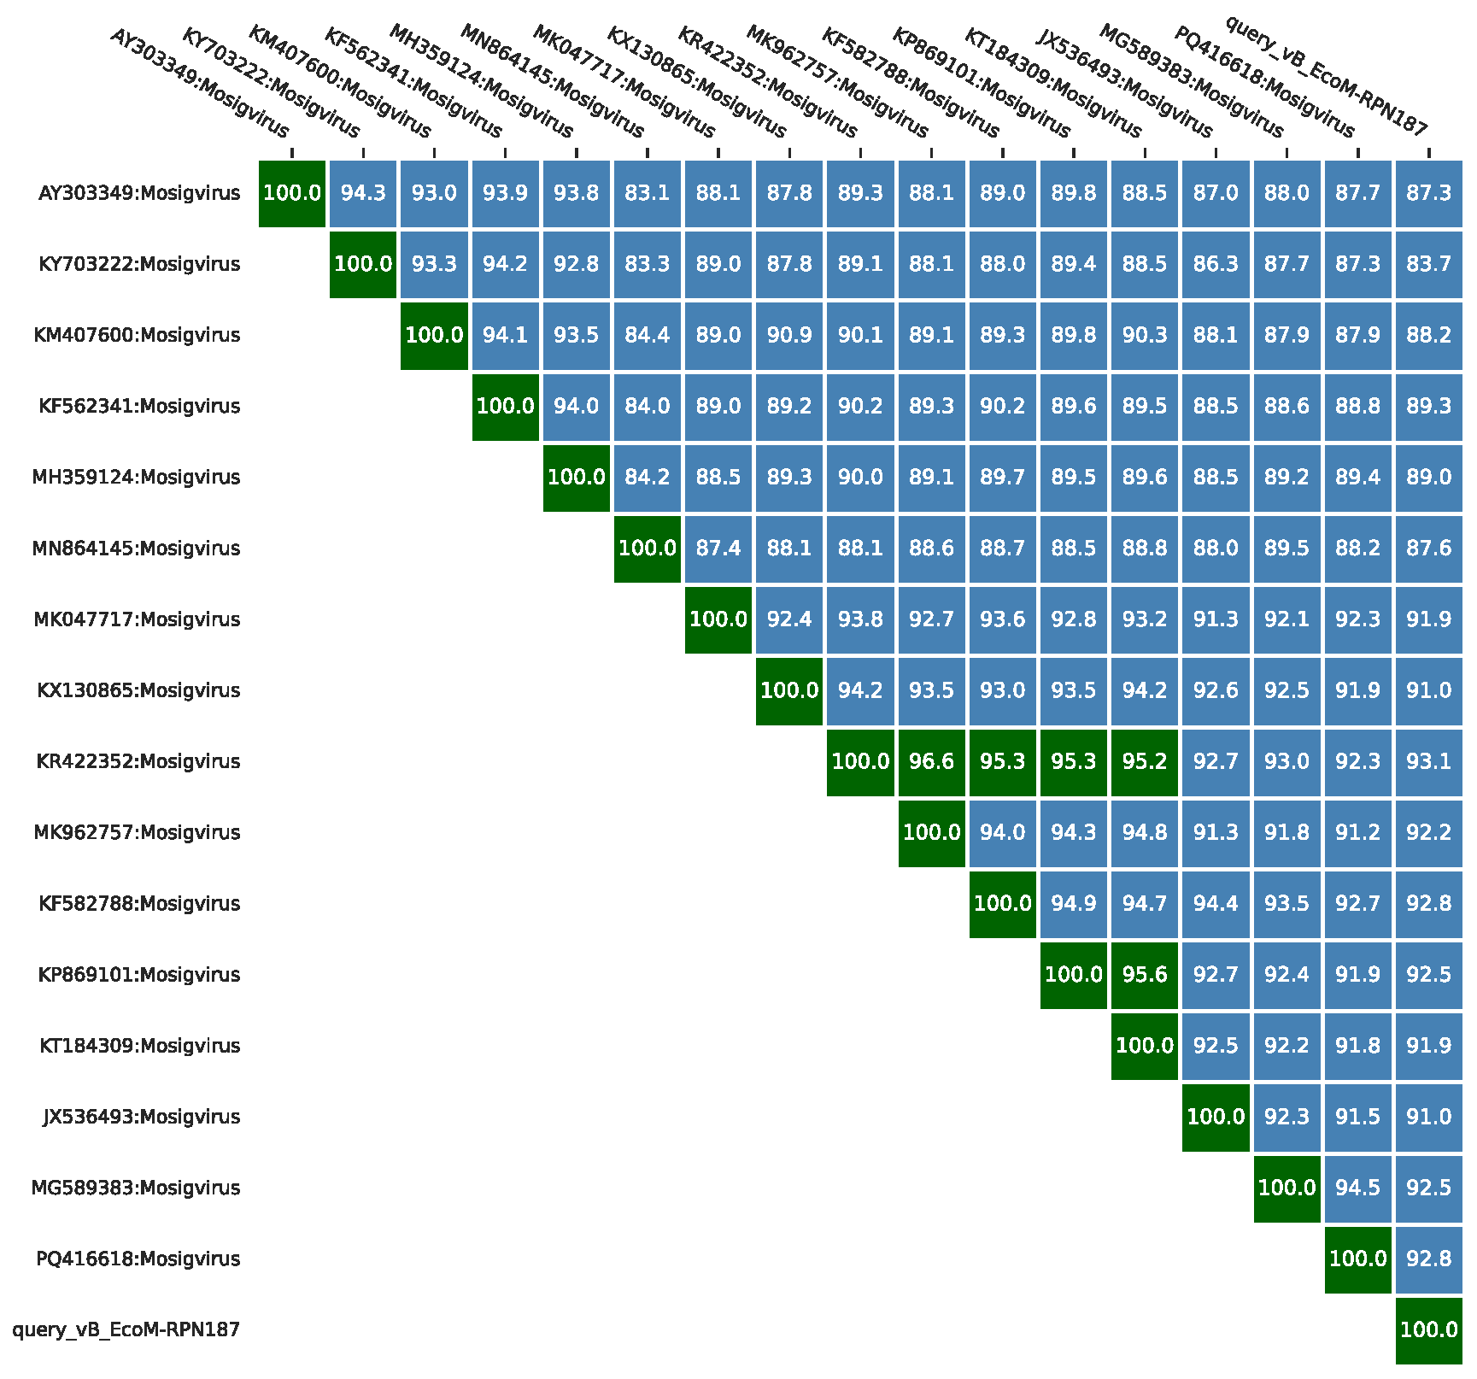

Figure 9 The heatmap of genomic similarity of phage Mosigvirus RPN187 derived from taxMyPhage.

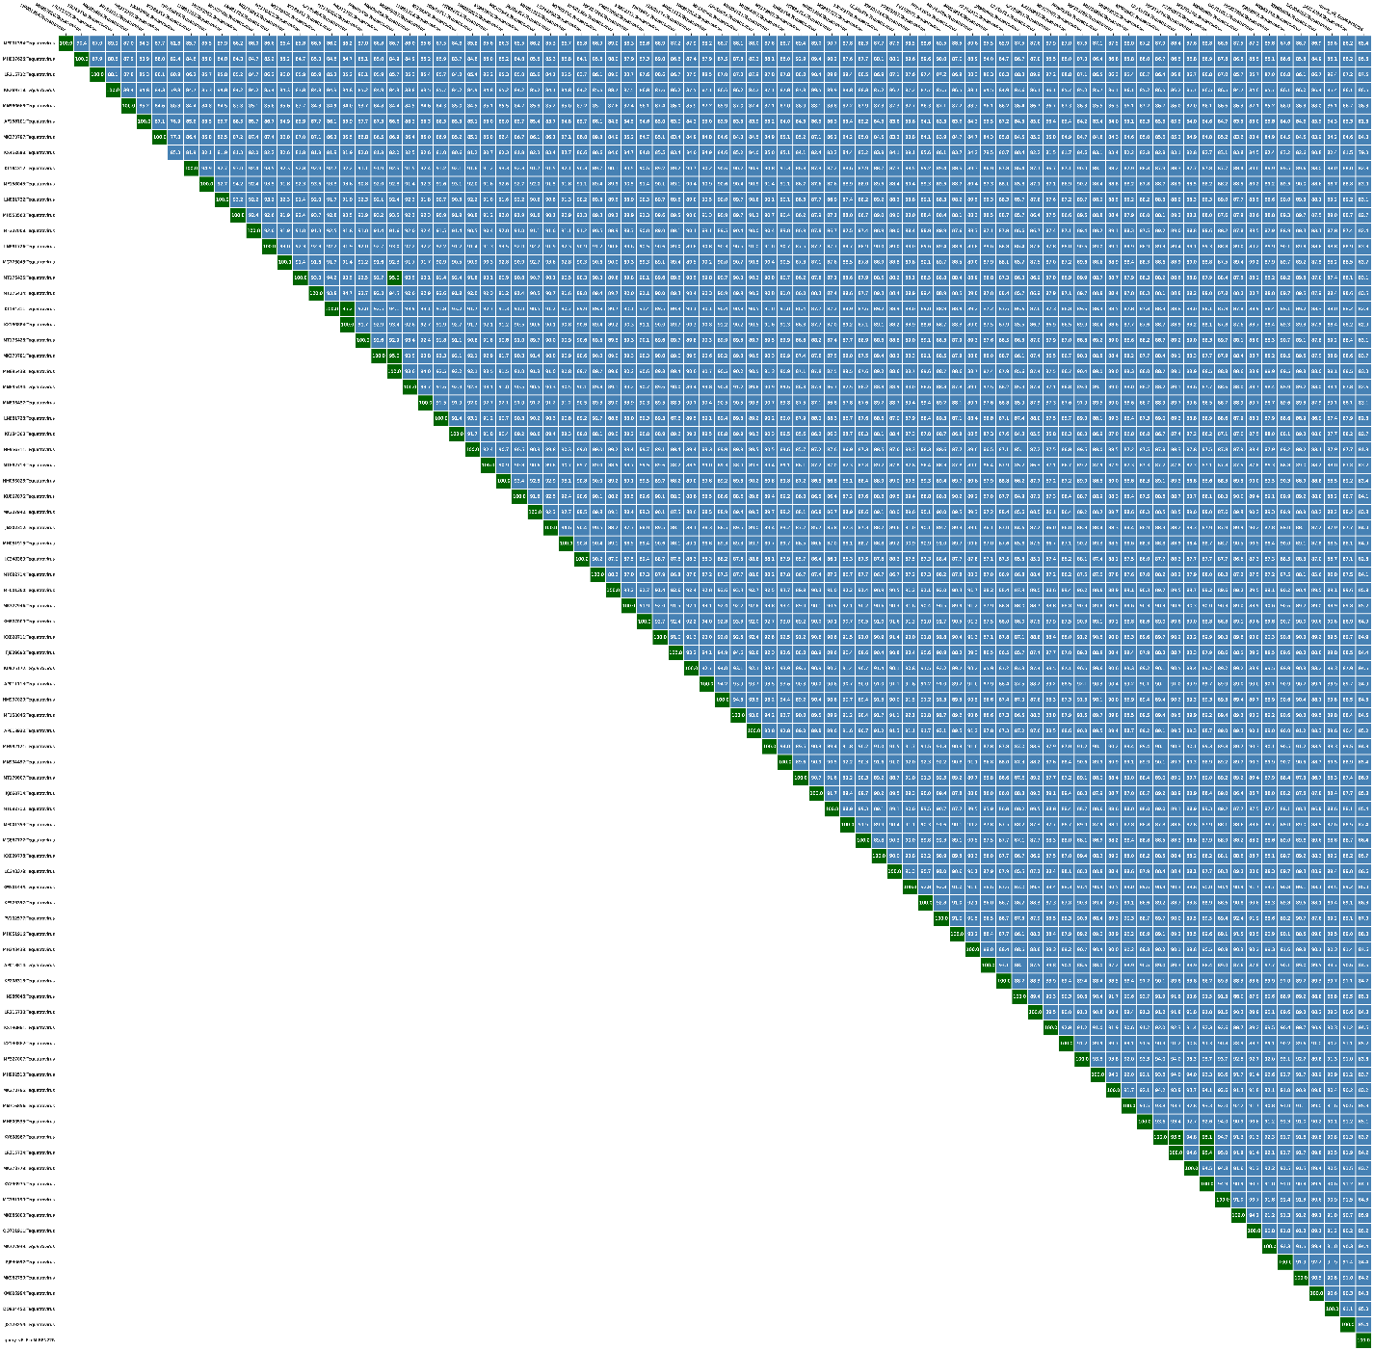

Figure 10 The heatmap of genomic similarity of phage Tequatrovirus RPN226 derived from taxMyPhage.

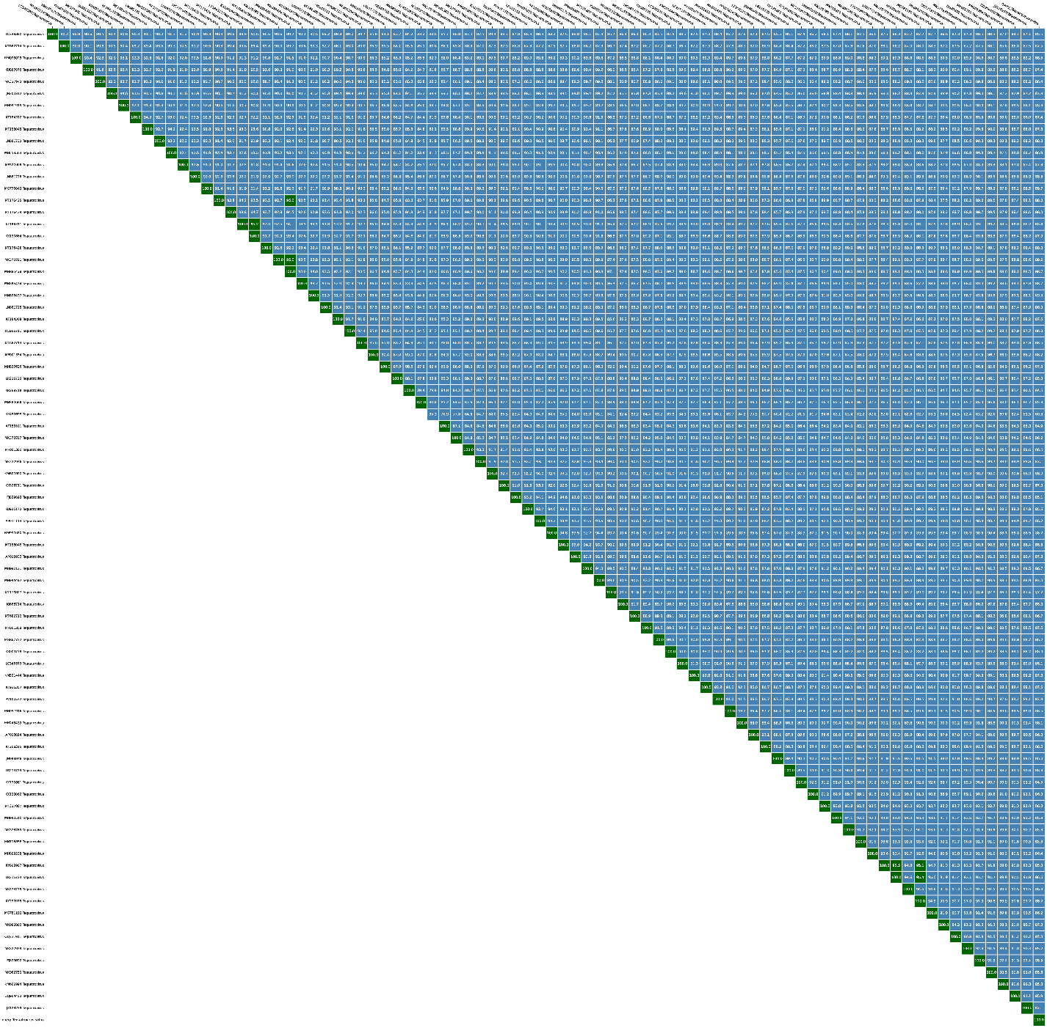
Figure 11 The heatmap of genomic similarity of phage Tequatrovirus sutha derived from taxMyPhage.

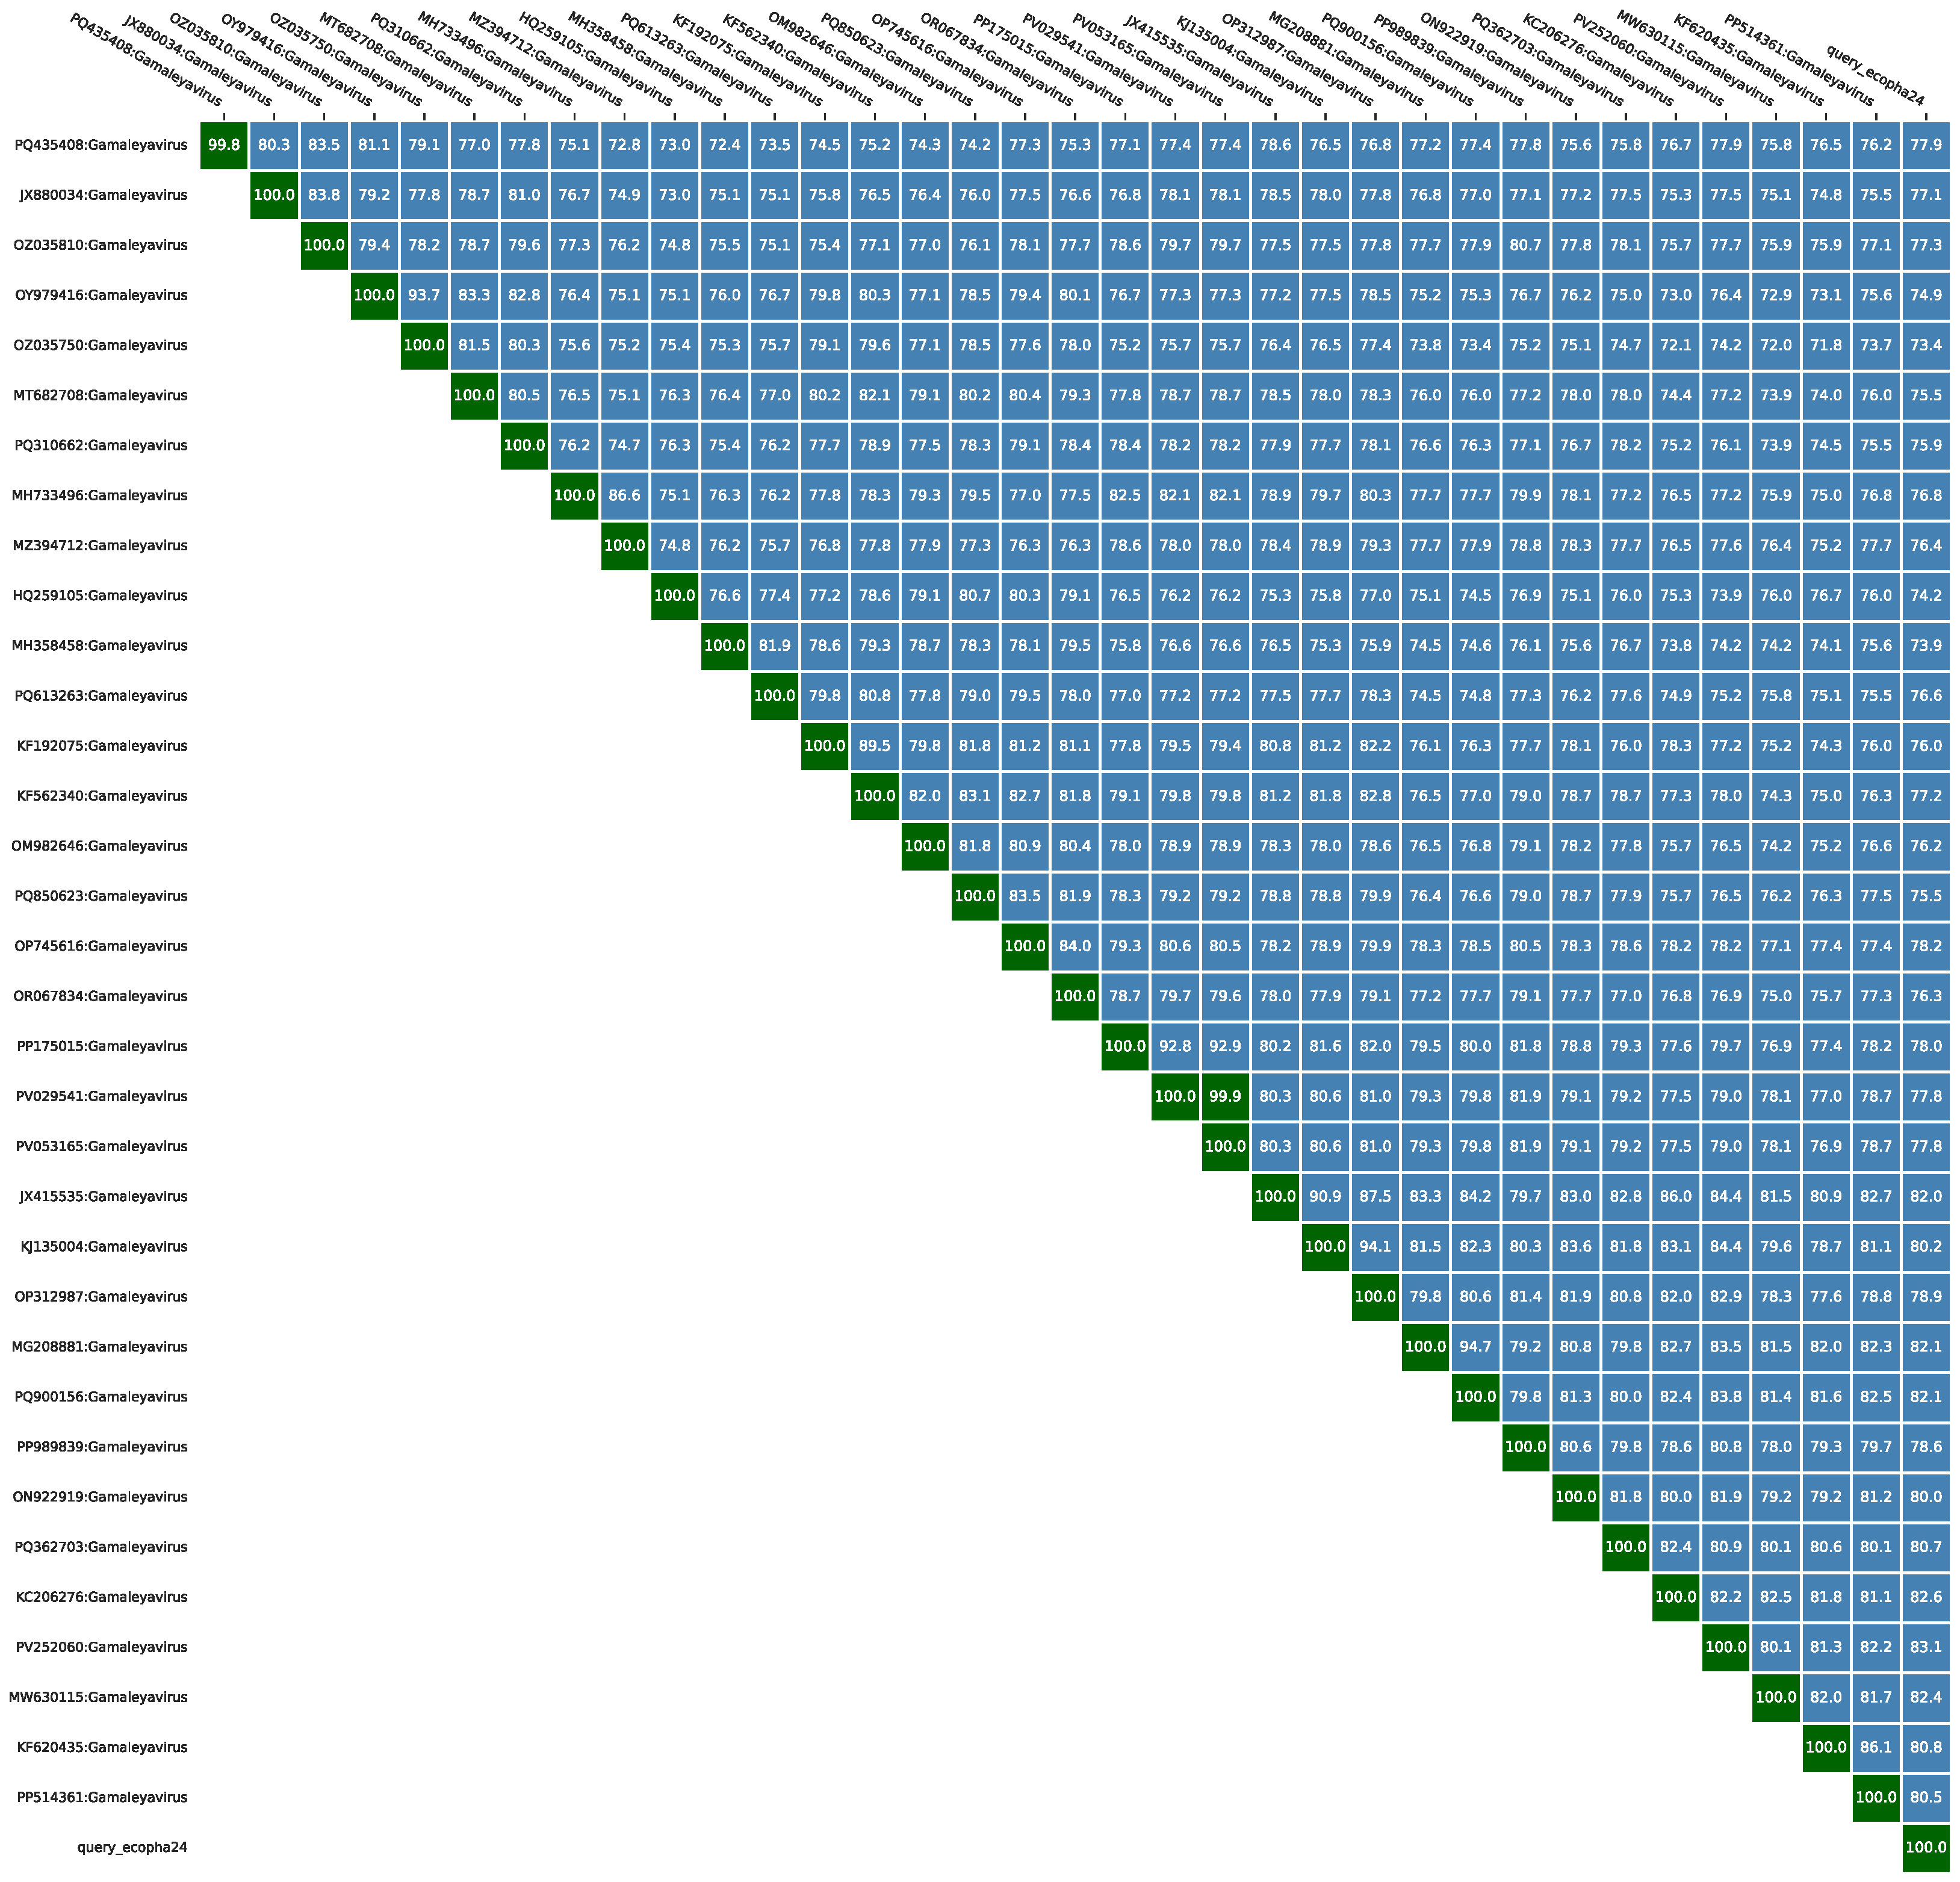
Figure 12 The heatmap of genomic similarity of phage Gamaleyavirus ecopha24 derived from taxMyPhage.

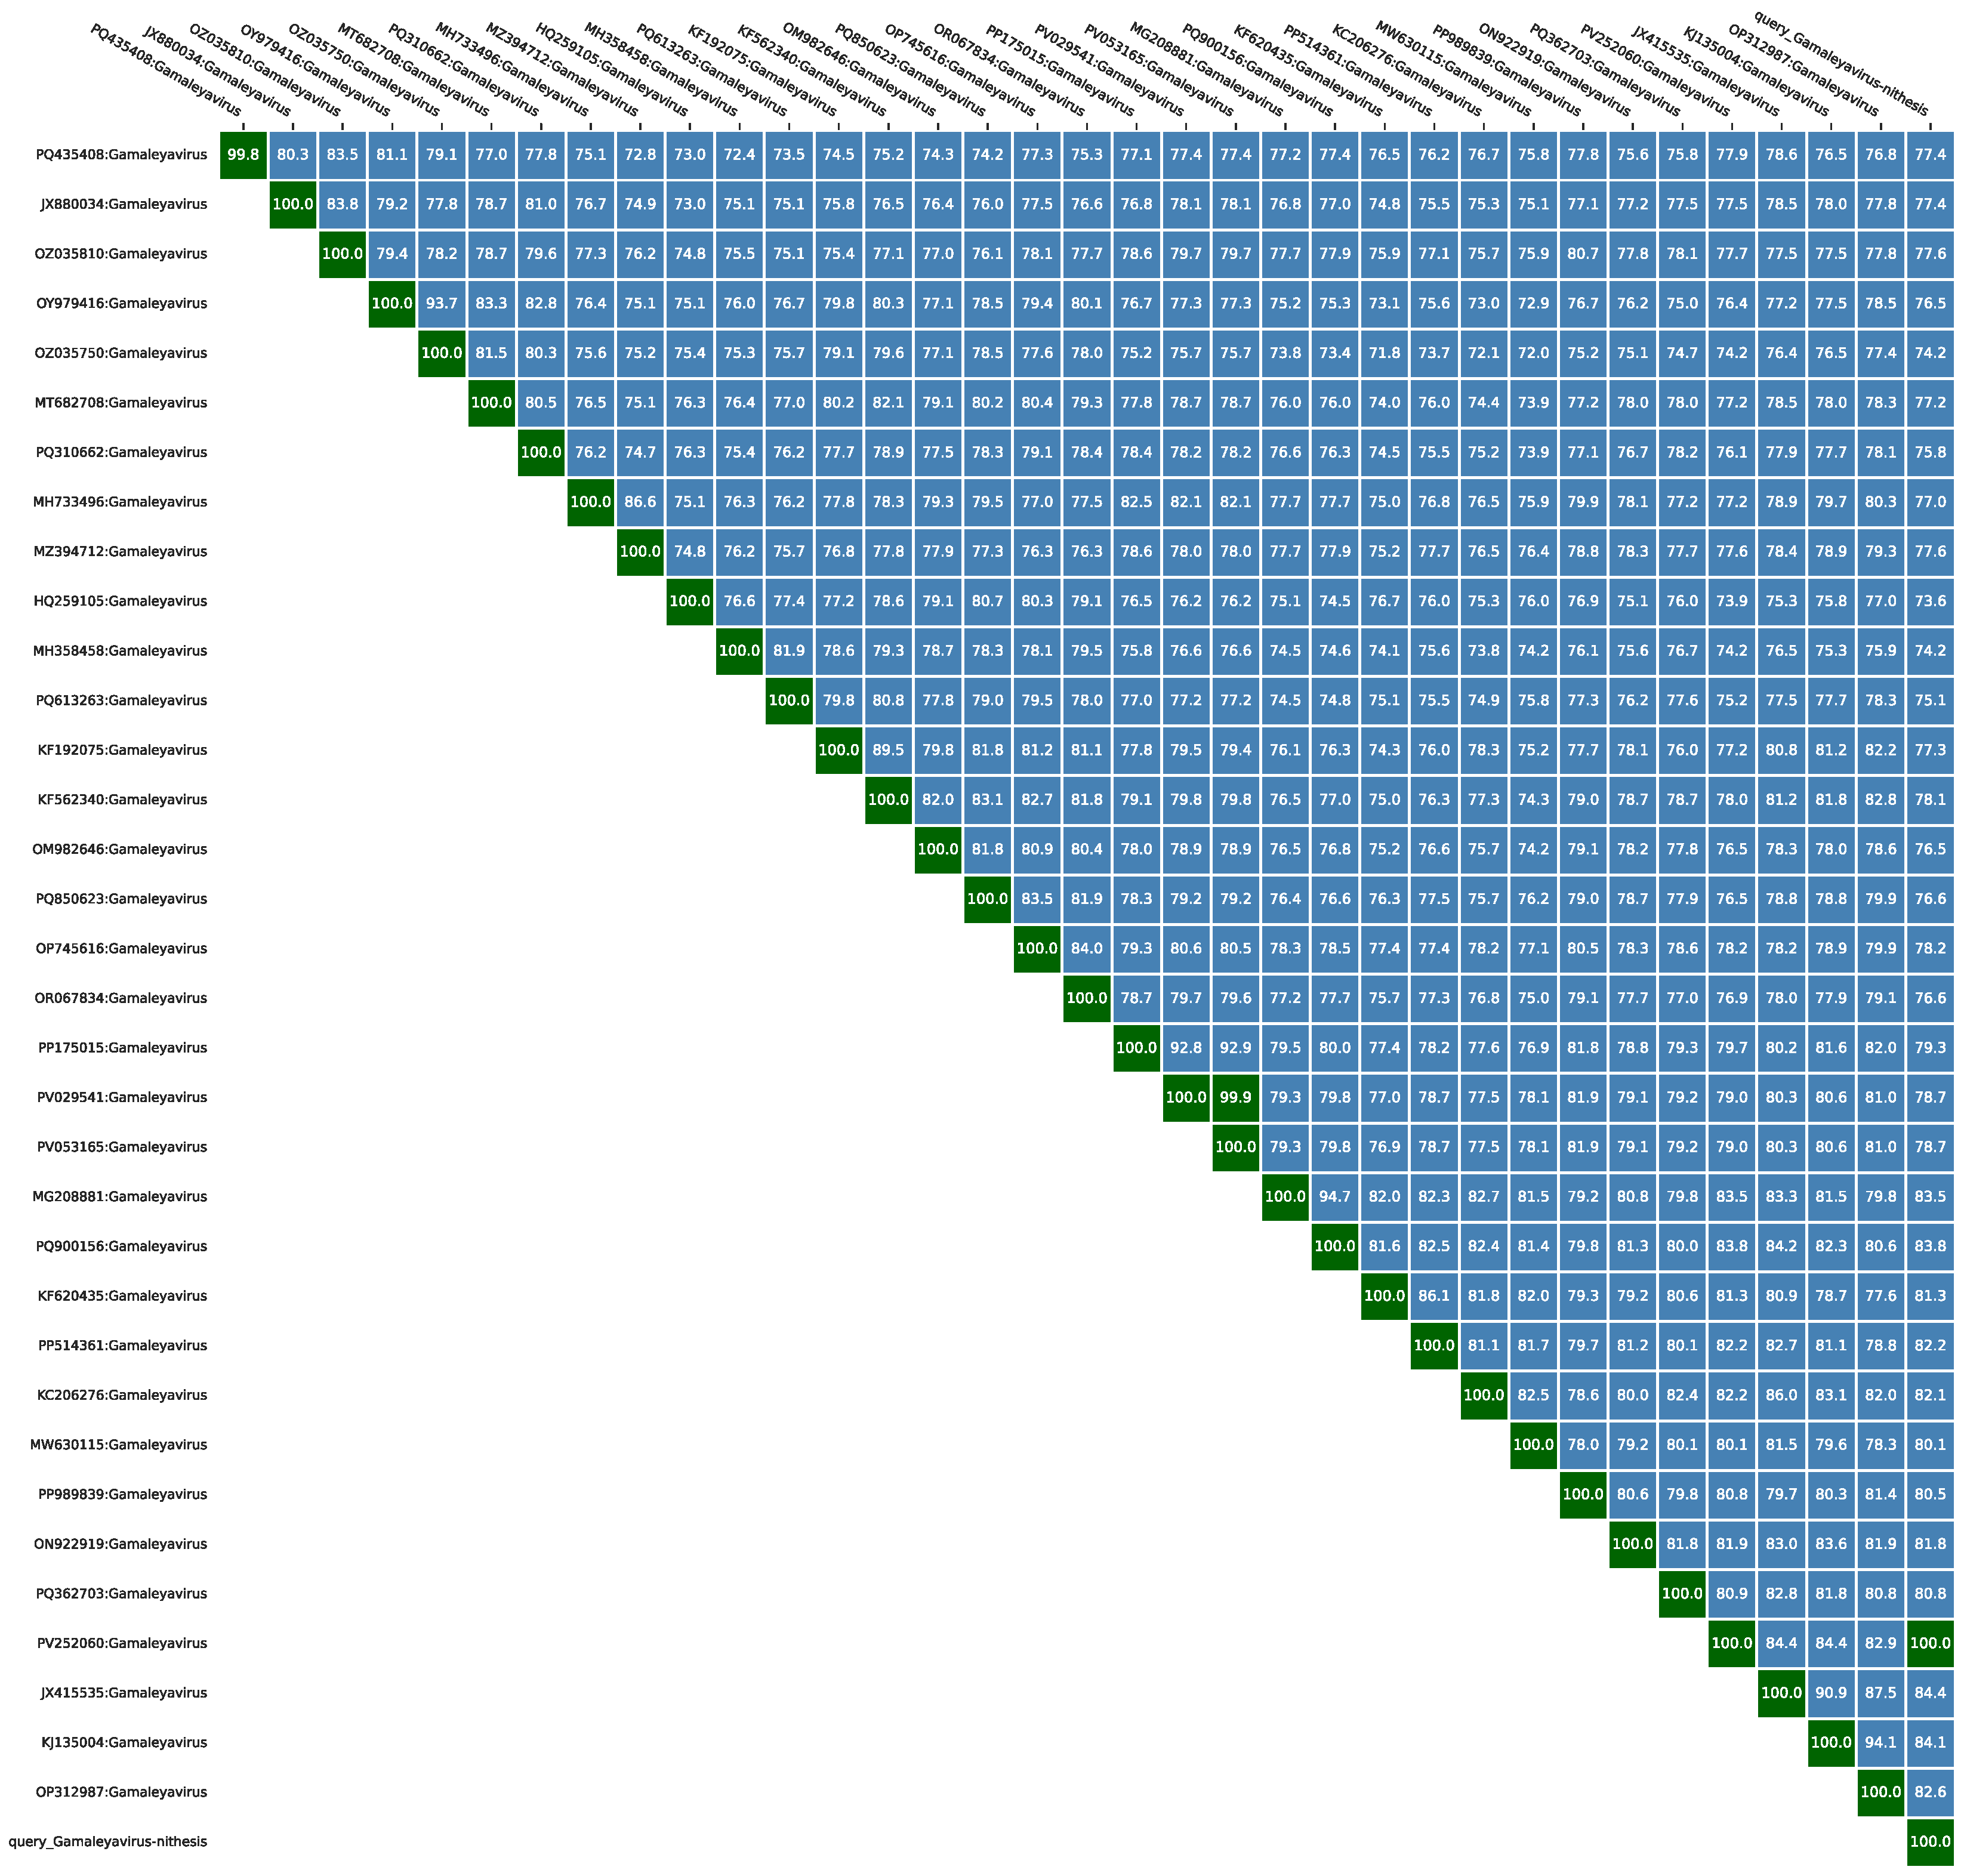
Figure 13 The heatmap of genomic similarity of phage Gamaleyavirus nithesis derived from taxMyPhage.

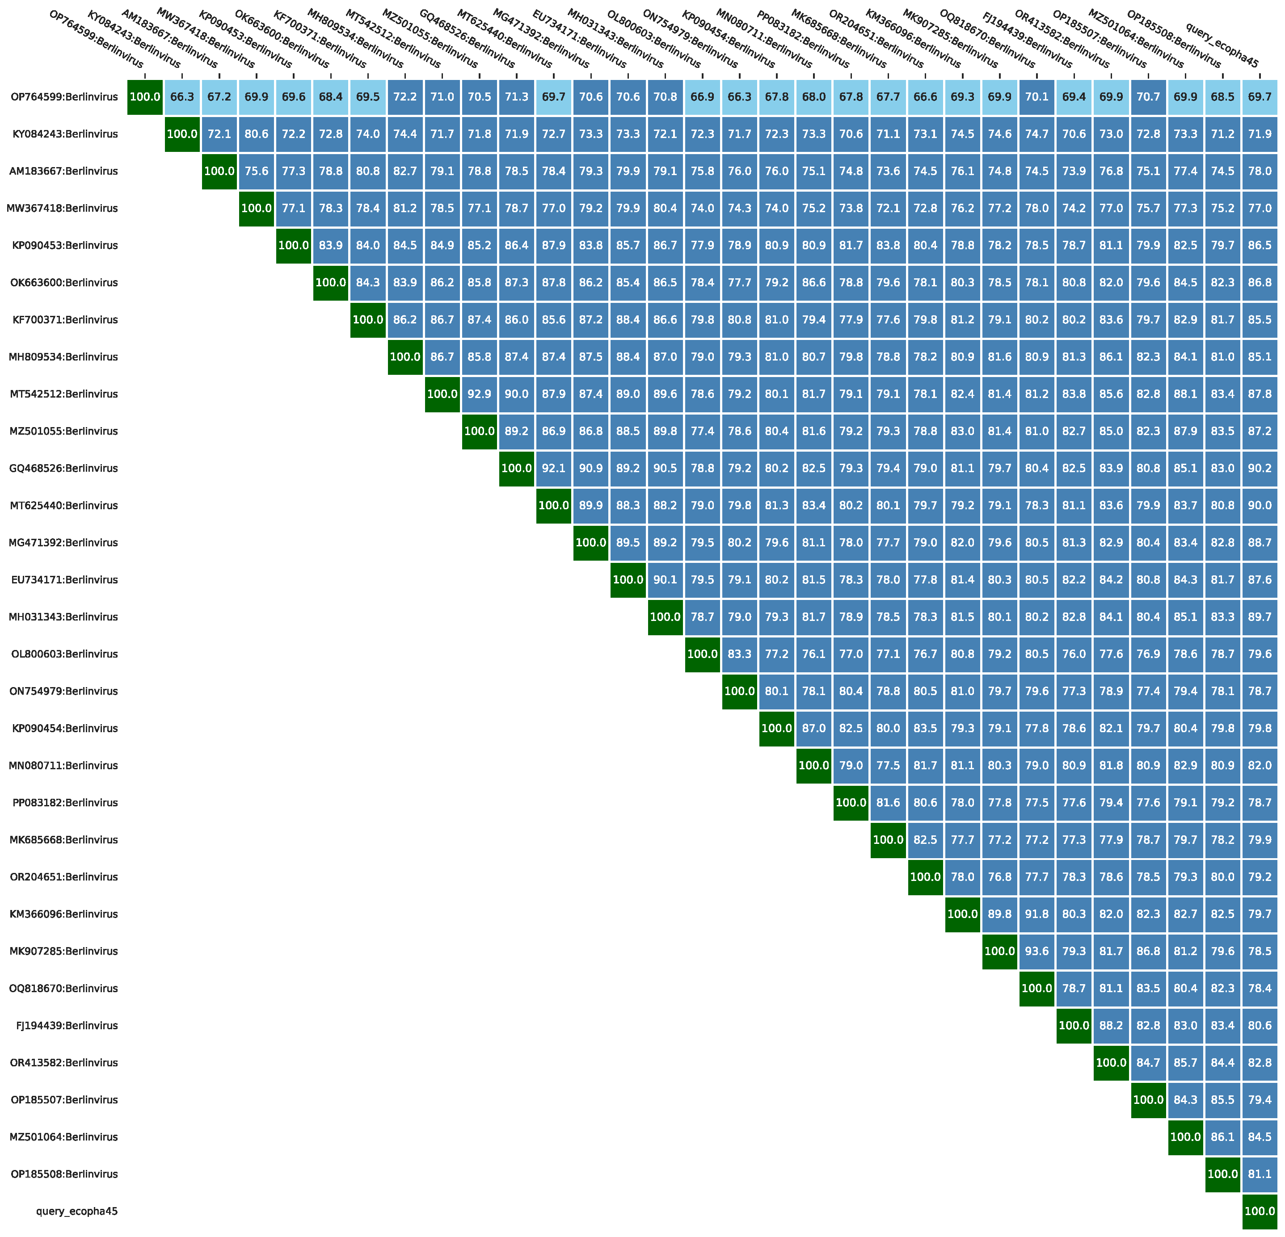
Figure 14 The heatmap of genomic similarity of phage Berlinvirus ecopha45 derived from taxMyPhage.

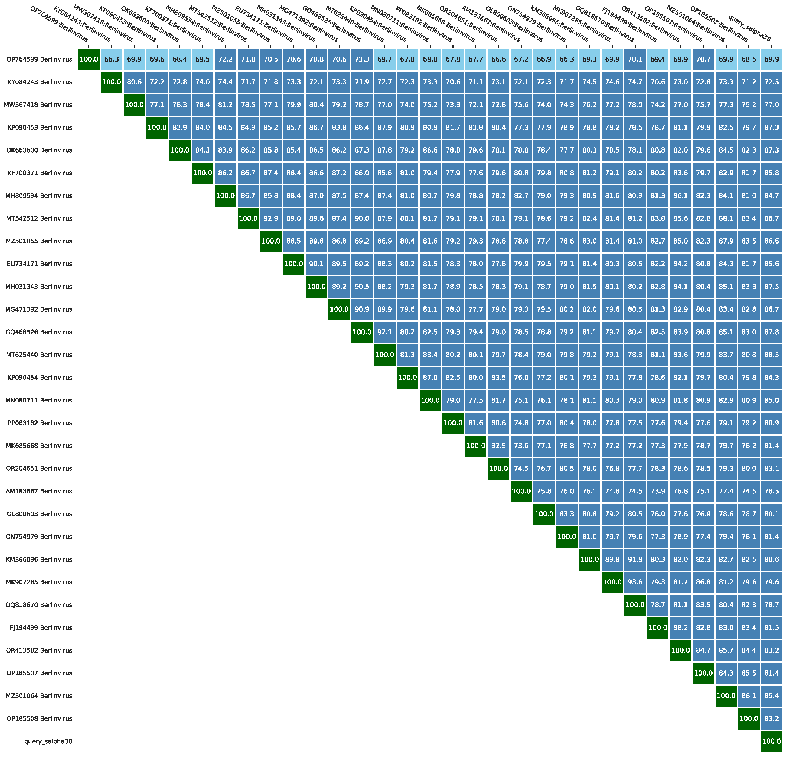
Figure 15 The heatmap of genomic similarity of phage Berlinvirus salpha38 derived from taxMyPhage.

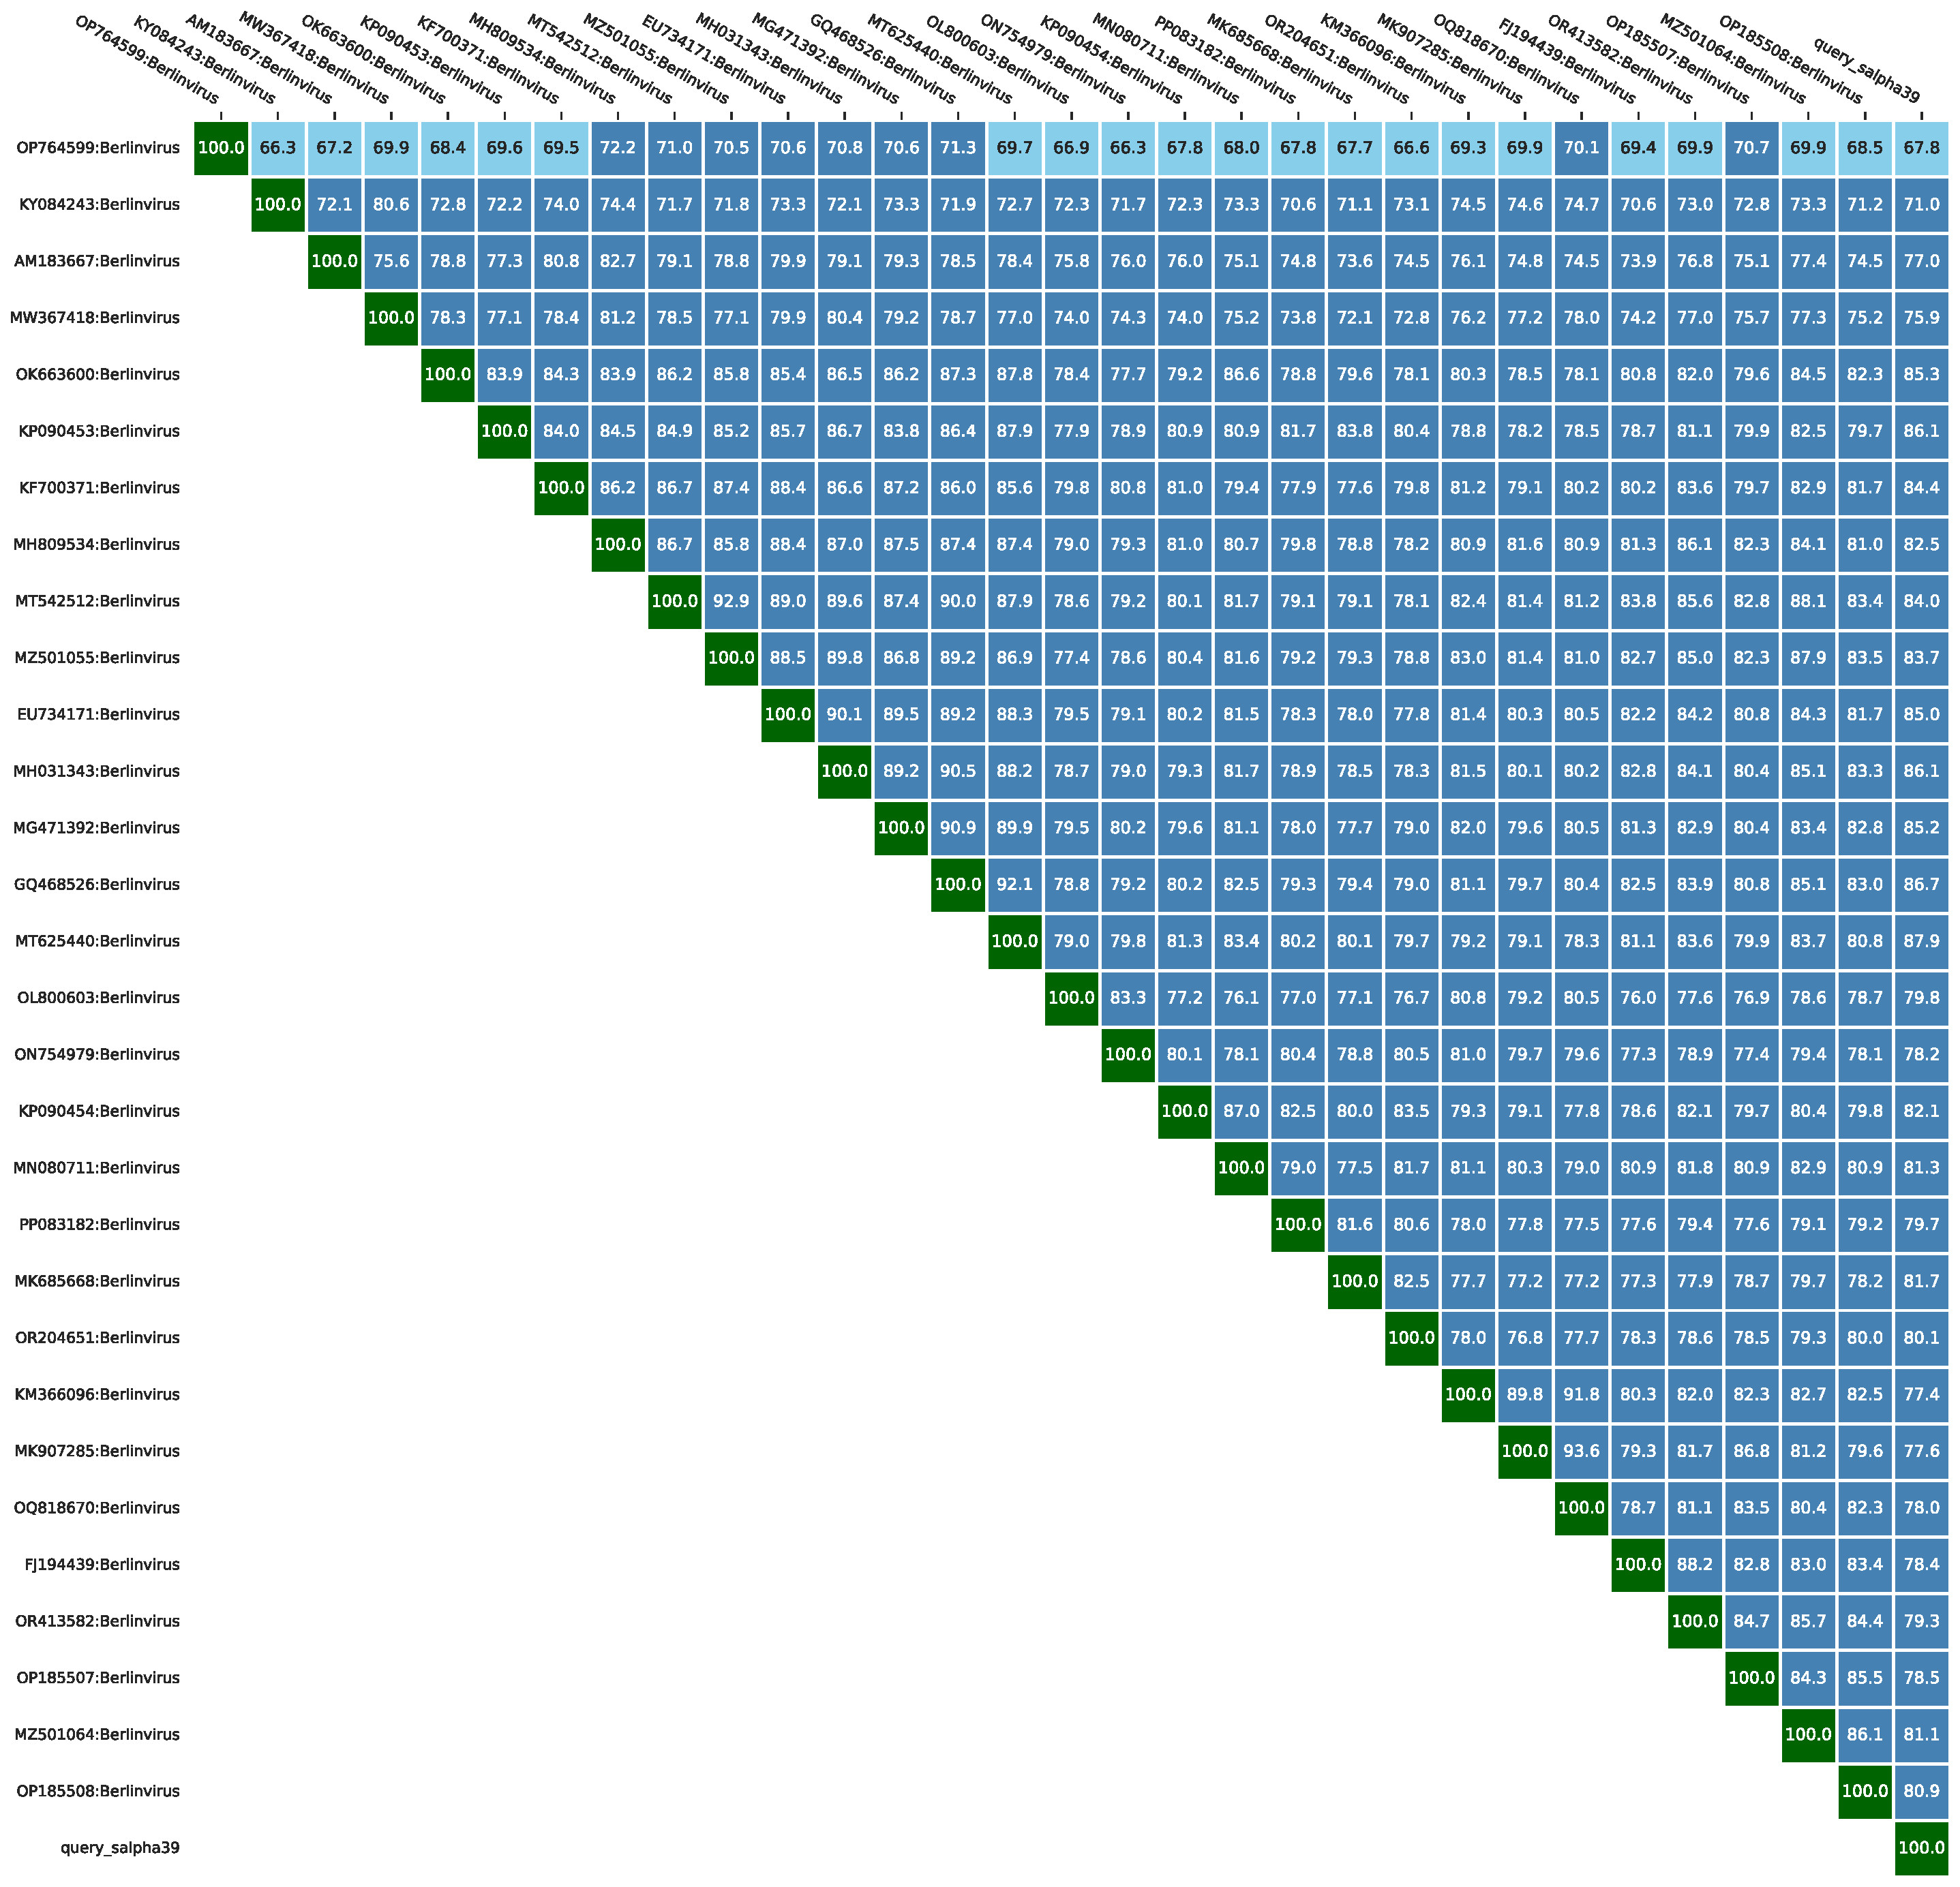
Figure 16 The heatmap of genomic similarity of phage Berlinvirus salpha39 derived from taxMyPhage.

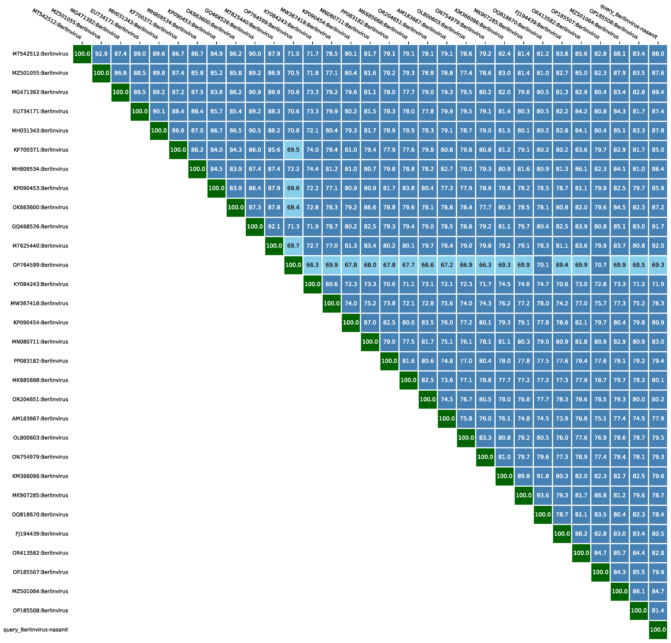
Figure 17 The heatmap of genomic similarity of phage Berlinvirus sanamchadra (Escherichia phage nasanit) derived from taxMyPhage.

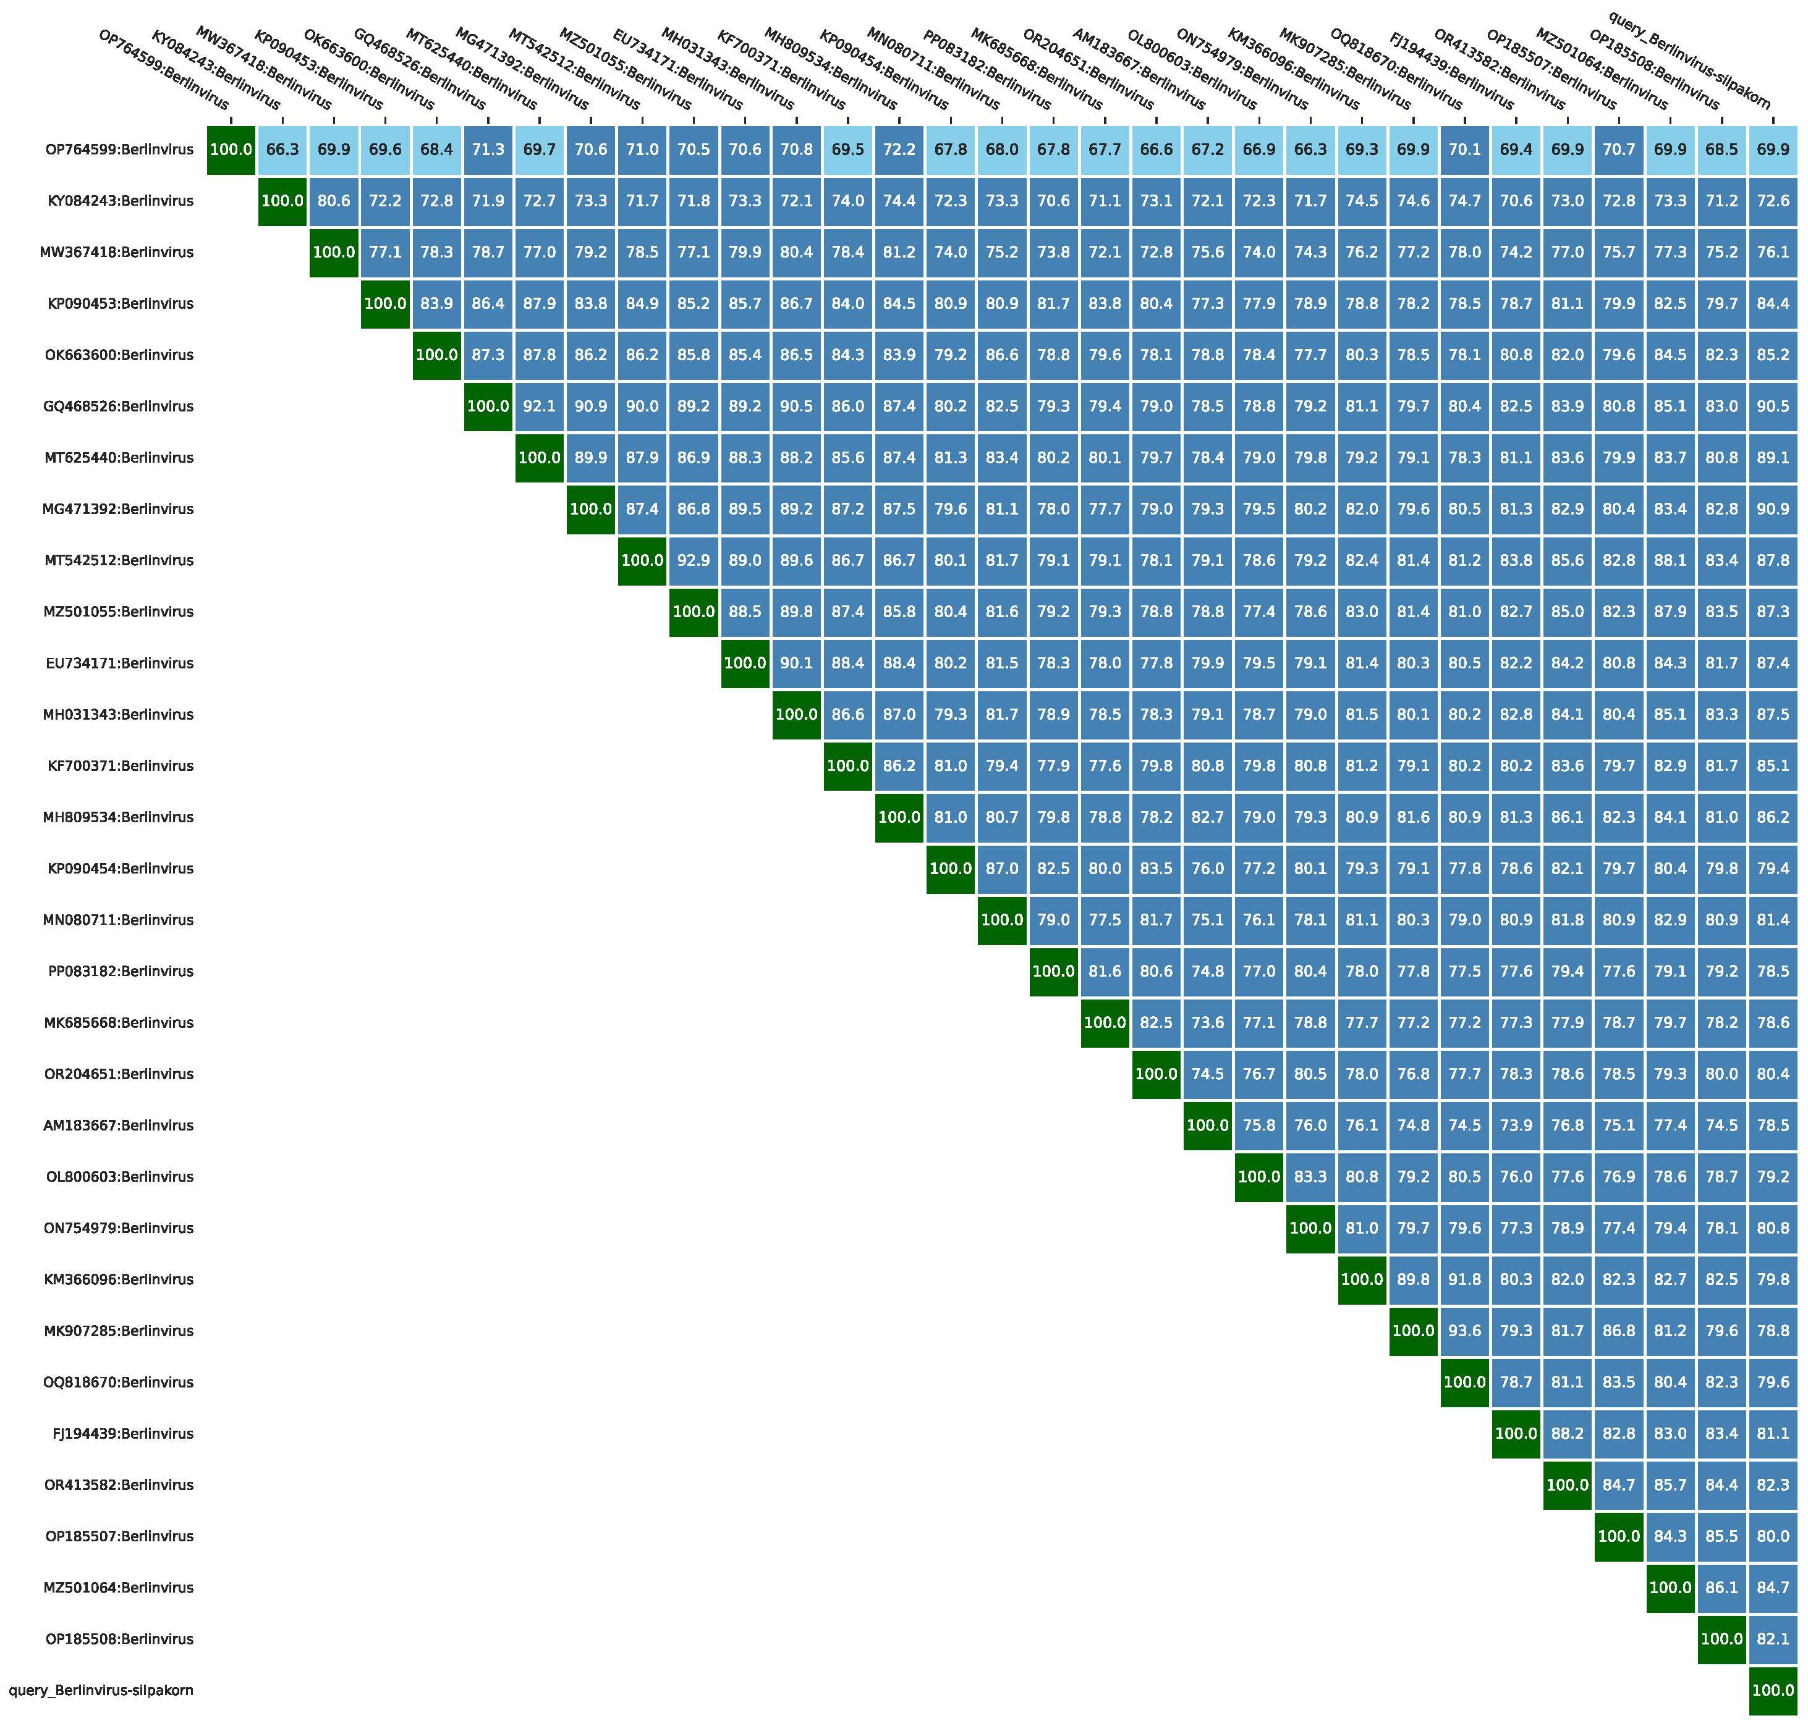
Figure 18 The heatmap of genomic similarity of phage Berlinvirus silpakorn derived from taxMyPhage.

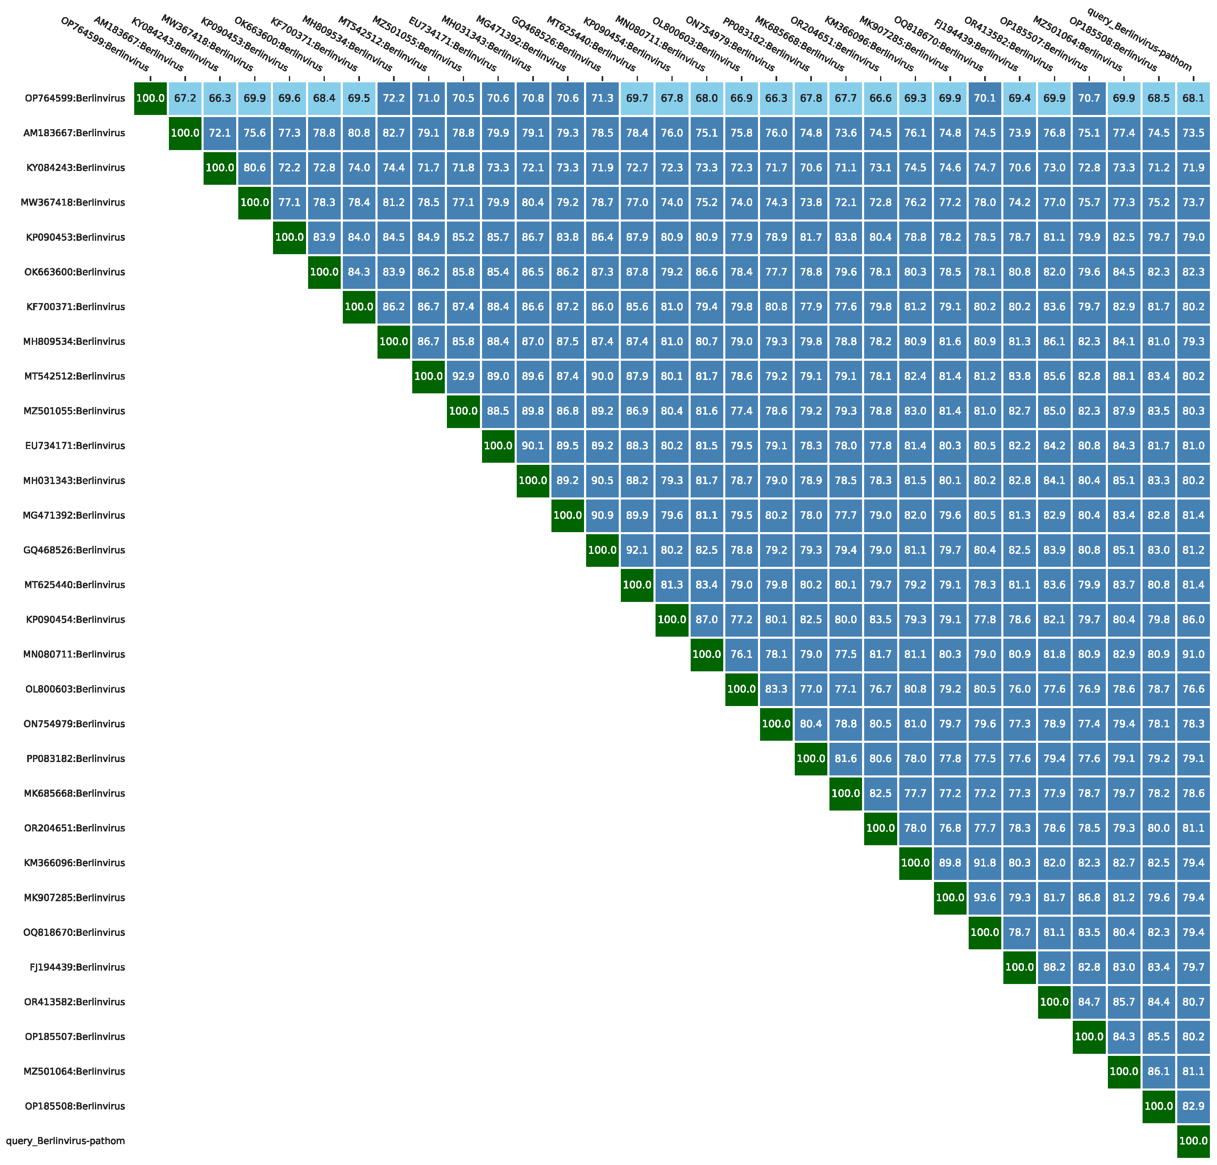
Figure 19 The heatmap of genomic similarity of phage Berlinvirus pathom derived from taxMyPhage.

