

The International Committee on Taxonomy of Viruses
Taxonomy Proposal Form, 2026

Part 1a: Details of taxonomy proposals

Title: | To create a new subfamily (Cagvirinae) with two genera and three species (class Caudoviricetes)
Code assigned: | 2026.014B

Author(s), affiliation and email address(es):
Given name (+middle initial(s)) | Surname | Affiliation | Email address | Corr. author(s)
Ipek | Kurtböke | Environmental Microbiology, University of the Sunshine Coast,  School of Science, Technology and Engineering,  Maroochydore DC, Australia | IKurtbok@usc.edu.au
Cristina M. | Moraru | Department of Chemistry, Environmental Metagenomics,  University of Duisburg-Essen,  D-45141 Essen,  Germany | lilianacristina.moraru@uni-due.de
Andrew M. | Kropinski | University of Guelph, Guelph, Ontario, Canada N1G2W1 | Phage.Canada@gmail.com | x

Part 1b: Taxonomy Proposal Submission
ICTV Subcommittee:
Animal DNA Viruses and Retroviruses |  | Bacterial viruses | x
Animal minus-strand and dsRNA viruses |  | Fungal and protist viruses
Animal positive-strand RNA viruses |  | Plant viruses
Archaeal viruses |  | General -

List the ICTV Study Group(s) that have seen or have been involved in creating this proposal:
Actinophage

Optional – complete only if formally voted on by an ICTV Study Group:
Study Group | Number of members
Study Group | Votes in support | Votes against | No vote

Submission date: | 12/04/2026

Part 1c: Feedback from ICTV Executive Committee (EC) meeting
Executive Committee Meeting Decision code: | X
A – Accept
Ac – Accept subject to revision by relevant subcommittee chair. No further vote required
U – Accept without revision but with re-evaluation and email vote by the EC
Uc – Accept subject to revision and re-evaluation and email vote by the EC
Ud – Deferred to the next EC meeting, with an invitation to revise based on EC comments
J - Reject
W - Withdrawn

Comments from the Executive Committee:

Part 1d: Revised Taxonomy Proposal Submission
Response of proposer:
Revision date:

Part 3: TAXONOMIC PROPOSAL

Taxonomic changes proposed:
Establish new taxon | x | Split taxon
Abolish taxon |  | Merge taxon
Move taxon |  | Promote taxon
Rename taxon |  | Demote taxon
Move and rename

Etymology (origin) of proposed taxonomic names:
Taxon name | Etymology of the term
Calvinvirus | Named after Calvin University where the first virus of its type was isolated
Cagvirinae | Named after the Actinobacteriophage Database Cluster CG which harbors these phages
Dorinvirus | Named directly after Rhodococcus phage Dorin

Permission for use of names derived from a living person:
Taxon name | Full name of person from whom the name is derived | Attached

Abstract of Taxonomy Proposal:

Description of current taxonomy:
None of these phages have been classified by ICTV.

Proposed taxonomic change(s):
We propose to create a new subfamily with two genera (Calvinvirus and Dorinvirus).

Demarcation criteria for new taxon/taxa:
Subfamily demarcation criteria: Subfamilies are to be created when two or more genera are related below the family level. In practical terms, this usually means that they share a low degree of sequence similarity (usually about 40-50%) and that the genera form a clade in a marker tree phylogeny [6].

Genus demarcation criteria: An intergenomic similarity cut-off of 70%, a combination of average nucleotide identity and alignment fraction, is used to determine genera demarcation. Members of the same genus have >70% intergenomic similarity and cluster tightly in marker gene phylogenies.

Species demarcation criteria: A demarcation value of 95% intergenomic similarity was used to define different species according to intergenomic similarity. Members of the same genus have >95% intergenomic similarity [6].

Justification:
We propose a new subfamily with two new genera of bacterial viruses. These bacteriophages all exhibit a siphovirus morphology and show lytic replication on Rhodococcus sp. Analysis of intergenomic nucleotide similarities between the exemplar phages support the creation of two new genera and three species based on the current ICTV BVS demarcation criteria. These assignments are further supported by TBLASTX distance analysis with ViPTree and phylogenetic analysis of the the large terminase subunit. Pangenome analysis with CoreGenes identifies the presence of 189 common proteins.

Text of Taxonomy proposal:
Description of current taxonomy:
None of these phages have been classified by ICTV.

Proposed taxonomic change(s):
We propose to create a new subfamily with two genera (Calvinvirus and Dorinvirus).

Demarcation criteria for new taxon/taxa: Subfamily demarcation criteria: Subfamilies are to be created when two or more genera are related below the family level. In practical terms, this usually means that they share a low degree of sequence similarity (usually about 40-50%) and that the genera form a clade in a marker tree phylogeny [6].

Genus demarcation criteria: An intergenomic similarity cut-off of 70%, a combination of average nucleotide identity and alignment fraction, is used to determine genera demarcation. Members of the same genus have >70% intergenomic similarity and cluster tightly in marker gene phylogenies.

Species demarcation criteria: A demarcation value of 95% intergenomic similarity was used to define different species according to intergenomic similarity. Members of the same genus have >95% intergenomic similarity [6].

Justification:
We propose a new subfamily with two new genera of bacterial viruses. These bacteriophages all exhibit a siphovirus morphology and show lytic replication on Rhodococcus sp. Analysis of intergenomic nucleotide similarities between the exemplar phages support the creation of two new genera and three species based on the current ICTV BVS demarcation criteria (Fig. 1). These assignments are further supported by TBLASTX distance analysis with ViPTree (Fig. 2) and phylogenetic analysis of the large terminase subunit (Fig. 3). Pangenome analysis with CoreGenes identifies the presence of 189 common proteins.

References:
1. Moraru C, Varsani A, Kropinski AM. VIRIDIC-A Novel Tool to Calculate the Intergenomic Similarities of Prokaryote-Infecting Viruses. Viruses. 2020 Nov 6;12(11):1268. doi: 10.3390/v12111268. PMID: 33172115; PMCID: PMC7694805. http://kronos.icbm.uni-oldenburg.de/viridic/
2. Nishimura Y, Yoshida T, Kuronishi M, Uehara H, Ogata H, Goto S. ViPTree: the viral proteomic tree server. Bioinformatics. 2017; 33(15):2379-2380. doi:10.1093/bioinformatics/btx157. PubMed PMID: 28379287. https://www.genome.jp/viptree/
3. Rohwer F, Edwards R. The Phage Proteomic Tree: a genome-based taxonomy for phage. J Bacteriol. 2002 Aug;184(16):4529-35. PubMed PMID: 12142423
4. Turner D, Reynolds D, Seto D, Mahadevan P. CoreGenes3.5: a webserver for the determination of core genes from sets of viral and small bacterial genomes. BMC Res Notes. 2013;6:140. doi: 10.1186/1756-0500-6-140. PMID: 23566564.
5. Davis P, Seto D, Mahadevan P. CoreGenes5.0: An Updated User-Friendly Webserver for the Determination of Core Genes from Sets of Viral and Bacterial Genomes. Viruses. 2022 Nov 16;14(11):2534. doi: 10.3390/v14112534. PMID: 36423143; PMCID: PMC9693508.
6. Turner D, Kropinski AM, Adriaenssens EM. A Roadmap for Genome-Based Phage Taxonomy. Viruses. 2021 Mar 18;13(3):506. doi: 10.3390/v13030506. PMID: 33803862; PMCID: PMC8003253.
Lemoine F, Correia D, Lefort V, Doppelt-Azeroual O, Mareuil F, Cohen-Boulakia S, Gascuel O. NGPhylogeny.fr: new generation phylogenetic services for non-specialists. Nucleic Acids Res. 2019 Jul 2;47(W1):W260-W265. doi: 10.1093/nar/gkz303. PMID: 31028399; PMCID: PMC6602494.
7. Letunic I, Bork P. Interactive Tree Of Life (iTOL): an online tool for phylogenetic tree display and annotation. Bioinformatics. 2007 Jan 1;23(1):127-8. doi: 10.1093/bioinformatics/btl529. Epub 2006 Oct 18. PMID: 17050570.
8. Zhou T, Xu K, Zhao F, Liu W, Li L, Hua Z, Zhou X. itol.toolkit accelerates working with iTOL (Interactive Tree of Life) by an automated generation of annotation files. Bioinformatics. 2023 Jun 1;39(6):btad339. doi: 10.1093/bioinformatics/btad339. PMID: 37225402; PMCID: PMC10243930
9. Dereeper A, Guignon V, Blanc G, Audic S, Buffet S, Chevenet F, Dufayard JF, Guindon S, Lefort V, Lescot M, Claverie JM, Gascuel O. Phylogeny.fr: robust phylogenetic analysis for the non-specialist. Nucleic Acids Res. 2008 Jul 1;36(Web Server issue):W465-9. doi: 10.1093/nar/gkn180. Epub 2008 Apr 19. PMID: 18424797; PMCID: PMC2447785.

Accompanying files:
Filename | Description of contents

Tables, Figures:

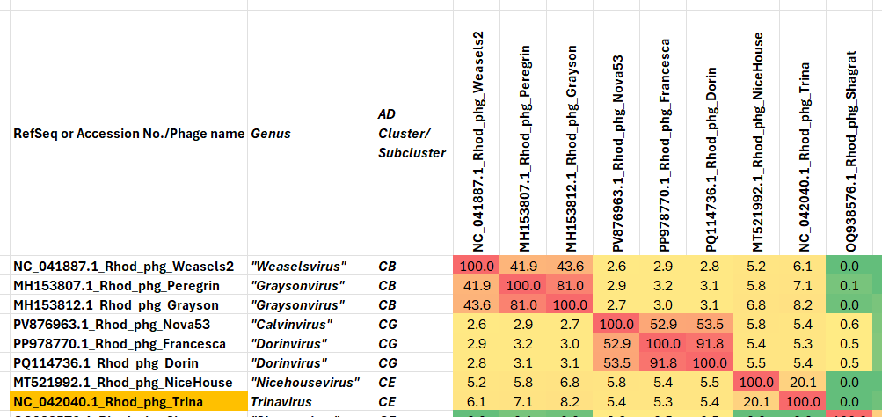

Figure 1. VIRIDIC heatmap of this group of phages. VIRIDIC (Virus Intergenomic Distance Calculator; VIRIDIC (Virus Intergenomic Distance Calculator; [1]; http://rhea.icbm.uni-oldenburg.de/VIRIDIC/) computes pairwise intergenomic distances/similarities amongst phage genomes. Abbreviations: phg = phage; Rhod = Rhodococcus

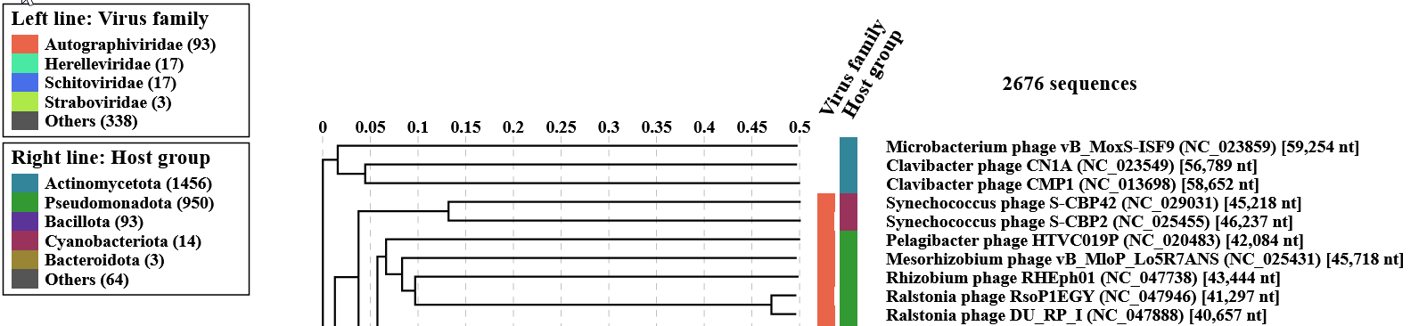


Figure 2. ViPTree analysis: ViPTree analysis (https://www.genome.jp/viptree/; [2]) is based upon Rohwer and Edwards (2002) Phage Proteomic Tree [3]. The taxa under discussion are indicated with red bars and stars. Abbreviations: phg = phage; Rhod = Rhodococcus.
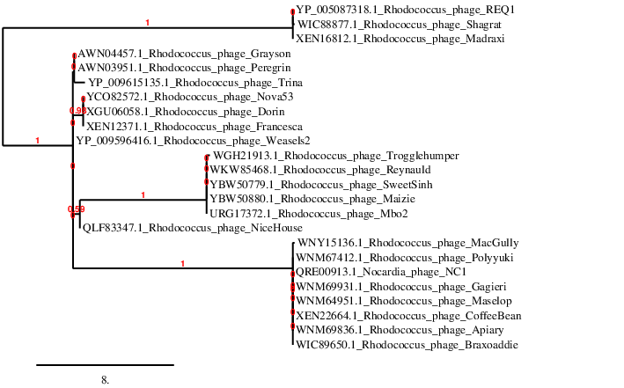Figure 3. Phylogenetic tree constructed with the large subunit terminase proteins from these and related phages using “One Click” Phylogeny.fr [9] at https://www.phylogeny.fr using the TerL protein from Rhodobacter phage REQ1 as an outgroup.

Table 1. Characteristics of the only phage in the genus Calvinvirus

Phage name | Host | Morphotype | Lifestyle | Accession No. | Genome size | %G+C | Termini | No. proteins | No. tRNA
Rhodococcus phage Nova53 | Rhodococcus equi NRRL B-16538 | Siphovirus | Lytic | PV876963 | 137941 bp | 48.5 | DTR 5222 bp | 219 | 31

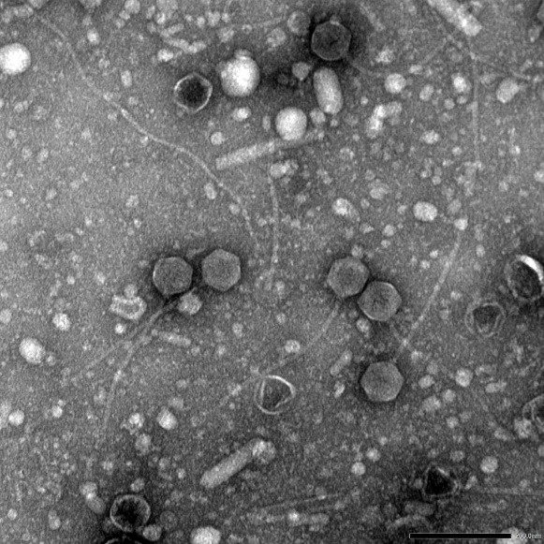

Figure 4. Electron micrograph: Electron micrograph of negatively stained Rhodococcus phage Nova53 (https://phagesdb.org/phages/Nova53/). Limited permission was granted by The Actinobacteriophage Database (https://phagesdb.org/), funded by the Howard Hughes Medical Institute, to use this electron micrograph for this taxonomy proposal; it cannot be reused without permission of The Actinobacteriophage Database.

Table 2. Characteristics of the two phages in the genus Dorinvirus

Phage name | Host | Morphotype | Lifestyle | Accession No. | Genome size | %G+C | Termini | No. proteins | No. tRNA
Rhodococcus phage Dorin | Rhodococcus equi NRRL B-16538 | Siphovirus | Lyic | PQ114736 | 136968 bp | 48.0 | DTR 4720 bp | 216 | 33
Rhodococcus phage Francesca | Rhodococcus equi NRRL B-16538 | Siphovirus | Lytic | PP978770 | 137748 bp | 48.0 | DTR 4862 bp | 215 | 33

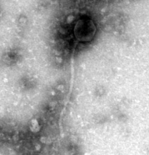
Figure 4. Electron micrograph: Electron micrograph of negatively stained Rhodococcus phage Francesca (https://phagesdb.org/phages/Francesca/). Limited permission was granted by The Actinobacteriophage Database (https://phagesdb.org/), funded by the Howard Hughes Medical Institute, to use this electron micrograph for this taxonomy proposal; it cannot be reused without permission of The Actinobacteriophage Database.

CoreGenes5.0 analysis [5] revealed 189 protein homologs (87% common proteins) including: 2 glycosylases, 2 Lsr2-like DNA bridging proteins, 2 lysins, hydrolase, thymidine synthase, methyltransferase, serine hydrolase, serine protease, glucosyltransferase, ribonucleotide reductase, portal protein, capsid maturation protease, major capsid protein, head-to-tail adaptor, head-to-tail stopper, tail terminator, major tail protein, 2 tail assembly chaperones, tape measure protein, 4 minor tail proteins, metallo-phosphoesterase, helix-turn-helix DNA binding protein, DNA helicase, DNA primase, SSB protein, endonuclease VII, DnaE-like DNA polymerase III alpha, MazG-like nucleotide pyrophosphohydrolase, RecA-like DNA recombinase, Holliday junction resolvase, Cas4 exonuclease, RuvC-like resolvase, helix-turn-helix DNA binding domain protein, thymidylate kinase, terminase, HNH endonuclease, rIIA-like protein, rIIB-like protein, nucleotidyltransferase, thioredoxin, RNA ligase, polynucleotide kinase, WhiB family transcription factor, and DprA-like DNA processing chain A

