

The International Committee on Taxonomy of Viruses
Taxonomy Proposal Form, 2026

Part 1a: Details of taxonomy proposals

Title: | To create two new genera; Chavichvilyvirus and Harriscountyvirus of Streptococcus phages in the class Caudoviricetes
Code assigned: | 2026.013B

Author(s), affiliation and email address(es):
Given name (+middle initial(s)) | Surname | Affiliation | Email address | Corr. author(s)
Sylvain | Moineau | Département de biochimie, de microbiologie et de bio-informatique  Faculté des sciences et de génie, Université Laval  Québec, Canada | sylvain.moineau@bcm.ulaval.ca | x
Cristina M. | Moraru | Department of Chemistry, Environmental Metagenomics,  University of Duisburg-Essen,  D-45141 Essen,  Germany | lilianacristina.moraru@uni-due.de
Andrew M. | Kropinski | University of Guelph, Guelph, Ontario, Canada N1G2W1 | Phage.Canada@gmail.com | x

Part 1b: Taxonomy Proposal Submission
ICTV Subcommittee: Enter an "X" against the subcommittee(s) most appropriate to deal with the taxonomy proposal. If in doubt, contact the appropriate subcommittee chair for clarification (see https://ictv.global/sc).
Animal DNA Viruses and Retroviruses |  | Bacterial viruses | x
Animal minus-strand and dsRNA viruses |  | Fungal and protist viruses
Animal positive-strand RNA viruses |  | Plant viruses
Archaeal viruses |  | General -Submit to Proposals Secretary

List the ICTV Study Group(s) that have seen or have been involved in creating this proposal: A list of study groups and their members is provided at https://ictv.global/sc.
Caudoviricetes Study Group

Optional – complete only if formally voted on by an ICTV Study Group: <To be completed by Study Group>
Study Group | Number of members
Study Group | Votes in support | Votes against | No vote

Submission date: | May 22, 2026

Part 1c: Feedback from ICTV Executive Committee (EC) meeting
Executive Committee Meeting Decision code: | X
A – Accept
Ac – Accept subject to revision by relevant subcommittee chair. No further vote required
U – Accept without revision but with re-evaluation and email vote by the EC
Uc – Accept subject to revision and re-evaluation and email vote by the EC
Ud – Deferred to the next EC meeting, with an invitation to revise based on EC comments
J - Reject
W - Withdrawn

Comments from the Executive Committee:

Part 1d: Revised Taxonomy Proposal Submission
Response of proposer: Please describe in detail how you have responded to the EC meeting feedback
Revision date:

Part 3: TAXONOMIC PROPOSAL

Taxonomic changes proposed: Enter an "X" against one or more actions
Establish new taxon | x | Split taxon
Abolish taxon |  | Merge taxon
Move taxon |  | Promote taxon
Rename taxon |  | Demote taxon
Move and rename

Etymology (origin) of proposed taxonomic names: Briefly describe the origin and rationale for each proposed taxonomic name in the proposal. A longer explanation can be provided in the main section of the taxonomy proposal if required. Use one row for each taxonomic name; additional rows can be inserted where needed. See examples for existing names in https://ictv.global/taxonomy/etymology.
Taxon name | Etymology of the term
Chavichvilyvirus | Named in honour of Isabelle Chavichvily upon the recommendation of Sylvain Moineau, Horst Neve, Philippe Horvath, and Christophe Fremaux, all coauthors on the article on the characterization of phages P738 and D4446 (PMID 32303549)
Harriscountyvirus | Named directly after the county where many of these viruses were identified by Sentinel International

Permission for use of names derived from a living person: If you propose taxon name(s) which are derived from the name of a living person or persons, you must attach documents to verify that permission has been obtained from those persons and that they agree to the form in which their name or an element of it is to be used. These documents should be listed in the Accompanying Files table below. The documents will not be posted online but will be retained by ICTV as evidence of authorization.
Taxon name | Full name of person from whom the name is derived | Attached X
“Chavichvilyvirus” | Isabelle Chavichvily | x

Abstract of Taxonomy Proposal:

Description of current taxonomy:
While none of these phages have been classified by ICTV the members of the proposed genus “Harriscountyvirus” are related to the Moineauvirus

Proposed taxonomic change(s): We propose to create two genera: “Chavichvilyvirus” and “Harriscountyvirus”

Genus demarcation criteria: An intergenomic similarity cut-off of 70%, a combination of average nucleotide identity and alignment fraction, is used to determine genera demarcation. Members of the same genus have >70% intergenomic similarity and cluster tightly in marker gene phylogenies.

Species demarcation criteria: A demarcation value of 95% intergenomic similarity was used to define different species according to intergenomic similarity. Members of the same genus have >95% intergenomic similarity.

Justification:
We identified two groups of lytic Streptococcus siphoviruses with genomes of 39.5 kbp (“Harriscountyvirus”) and 35.6 kbp (“Chavichvilyvirus”). Analysis of intergenomic nucleotide sequence similarity with VIRIDIC, a whole genome TBLASTX distance tree calculated with VIPTREE and phylogenetic analyses of the large terminse subunit confirmed these phages comprise two distinct genera.

Text of Taxonomy proposal:
Description of current taxonomy:
While none of these phages have been classified by ICTV the members of the proposed genus “Harriscountyvirus” are related to the Moineauvirus

Proposed taxonomic change(s): We propose to create two genera: “Chavichvilyvirus” and “Harriscountyvirus”

Genus demarcation criteria: An intergenomic similarity cut-off of 70%, a combination of average nucleotide identity and alignment fraction, is used to determine genera demarcation. Members of the same genus have >70% intergenomic similarity and cluster tightly in marker gene phylogenies.

Species demarcation criteria: A demarcation value of 95% intergenomic similarity was used to define different species according to intergenomic similarity. Members of the same genus have >95% intergenomic similarity [6].

Justification:
We identified two groups of lytic Streptococcus siphoviruses with genomes of 39.5 kbp (“Harriscountyvirus”) and 35.6 kbp (“Chavichvilyvirus”). Analysis of intergenomic nucleotide sequence similarity with VIRIDIC (Figure 1) [1], a whole genome TBLASTX distance tree calculated with VIPTREE (Figure 2) [2,3] and phylogenetic analyses of the large terminse subunit (Figure 3) [9] confirmed these phages comprise two distinct genera.

References:
1. Moraru C, Varsani A, Kropinski AM. VIRIDIC-A Novel Tool to Calculate the Intergenomic Similarities of Prokaryote-Infecting Viruses. Viruses. 2020 Nov 6;12(11):1268. doi: 10.3390/v12111268. PMID: 33172115; PMCID: PMC7694805. http://kronos.icbm.uni-oldenburg.de/viridic/
2. Nishimura Y, Yoshida T, Kuronishi M, Uehara H, Ogata H, Goto S. ViPTree: the viral proteomic tree server. Bioinformatics. 2017; 33(15):2379-2380. doi:10.1093/bioinformatics/btx157. PubMed PMID: 28379287. https://www.genome.jp/viptree/
3. Rohwer F, Edwards R. The Phage Proteomic Tree: a genome-based taxonomy for phage. J Bacteriol. 2002 Aug;184(16):4529-35. PubMed PMID: 12142423
4. Turner D, Reynolds D, Seto D, Mahadevan P. CoreGenes3.5: a webserver for the determination of core genes from sets of viral and small bacterial genomes. BMC Res Notes. 2013;6:140. doi: 10.1186/1756-0500-6-140. PMID: 23566564.
5. Davis P, Seto D, Mahadevan P. CoreGenes5.0: An Updated User-Friendly Webserver for the Determination of Core Genes from Sets of Viral and Bacterial Genomes. Viruses. 2022 Nov 16;14(11):2534. doi: 10.3390/v14112534. PMID: 36423143; PMCID: PMC9693508.
6. Turner D, Kropinski AM, Adriaenssens EM. A Roadmap for Genome-Based Phage Taxonomy. Viruses. 2021 Mar 18;13(3):506. doi: 10.3390/v13030506. PMID: 33803862; PMCID: PMC8003253.
Lemoine F, Correia D, Lefort V, Doppelt-Azeroual O, Mareuil F, Cohen-Boulakia S, Gascuel O. NGPhylogeny.fr: new generation phylogenetic services for non-specialists. Nucleic Acids Res. 2019 Jul 2;47(W1):W260-W265. doi: 10.1093/nar/gkz303. PMID: 31028399; PMCID: PMC6602494.
7. Letunic I, Bork P. Interactive Tree Of Life (iTOL): an online tool for phylogenetic tree display and annotation. Bioinformatics. 2007 Jan 1;23(1):127-8. doi: 10.1093/bioinformatics/btl529. Epub 2006 Oct 18. PMID: 17050570.
8. Zhou T, Xu K, Zhao F, Liu W, Li L, Hua Z, Zhou X. itol.toolkit accelerates working with iTOL (Interactive Tree of Life) by an automated generation of annotation files. Bioinformatics. 2023 Jun 1;39(6):btad339. doi: 10.1093/bioinformatics/btad339. PMID: 37225402; PMCID: PMC10243930
9. Dereeper A, Guignon V, Blanc G, Audic S, Buffet S, Chevenet F, Dufayard JF, Guindon S, Lefort V, Lescot M, Claverie JM, Gascuel O. Phylogeny.fr: robust phylogenetic analysis for the non-specialist. Nucleic Acids Res. 2008 Jul 1;36(Web Server issue):W465-9. doi: 10.1093/nar/gkn180. Epub 2008 Apr 19. PMID: 18424797; PMCID: PMC2447785.

Accompanying files:

Filename | Description of contents
Streptococcus phages_2ng_6nsp | Excel spreadsheet associated with this TaxoProp

Tables, Figures:

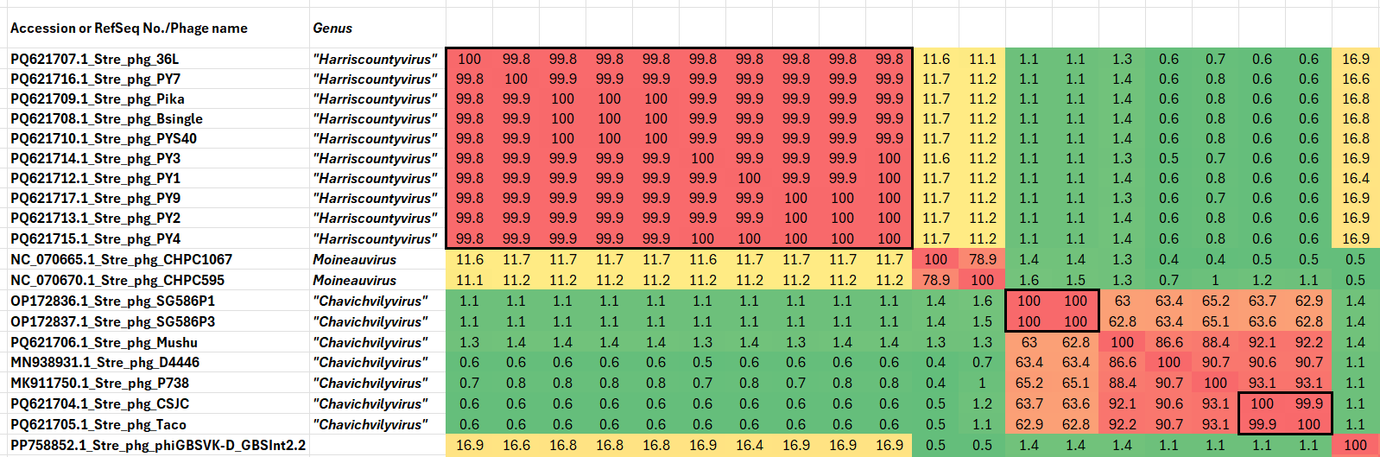

Figure 1. VIRIDIC heatmap of this group of phages. VIRIDIC (Virus Intergenomic Distance Calculator; VIRIDIC (Virus Intergenomic Distance Calculator; [1]; http://rhea.icbm.uni-oldenburg.de/VIRIDIC/) computes pairwise intergenomic distances/similarities amongst phage genomes. Data values which are bordered in black correspond to strains. Abbreviations: phg = phage; Stre = Streptococcus.

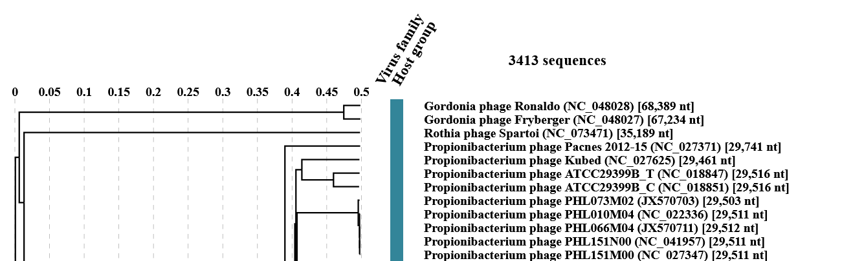
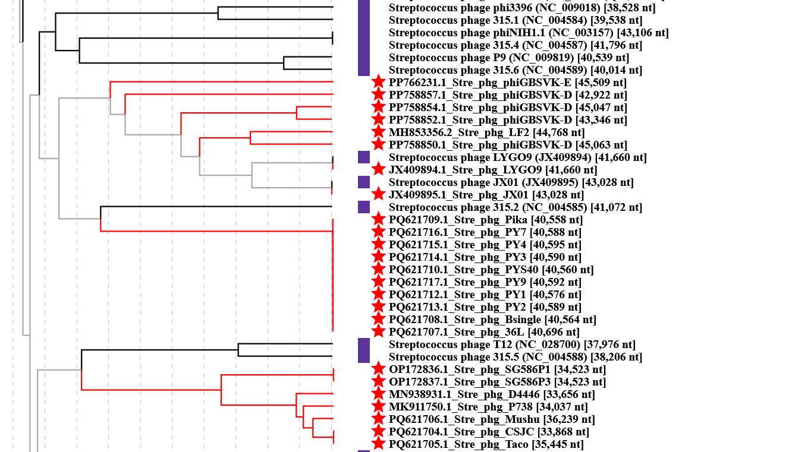

Figure 2. ViPTree analysis: ViPTree analysis (https://www.genome.jp/viptree/; [2]) is based upon Rohwer and Edwards (2002) Phage Proteomic Tree [3]. The taxons under discussion are indicated with red bars and stars, and blue arrowheads. Abbreviations: phg = phage; Stre = Streptococcus.

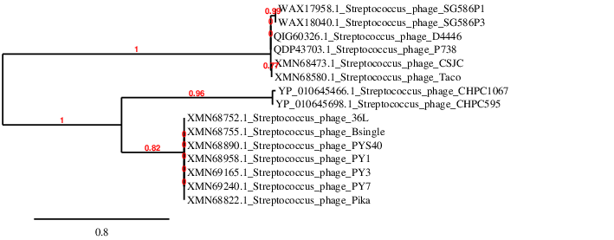
Figure 3. Phylogenetic tree constructed with the large subunit terminase proteins from these and related phages using “One Click” Phylogeny.fr [9] at https://www.phylogeny.fr using the TerL proteins from Streptococcus phages CHPC1067 and CHPC595 as outliers.

Table 1. Characteristics of the only phage in the genus “Harriscountyvirus.”

Phage name | Host | Morphotype | Lifestyle | Accession No. | Genome size | %G+C | No. proteins | No. tRNA
Streptococcus phage 36L | Streptococcus equinus MEM36 | Siphovirus | Lytic | PQ621707 | 40696 bp | 39.5 | 67 | 0

Table 2. Characteristics of the five phages in the genus “Chavichvilyvirus.”

Phage name | Host | Morphotype | Lifestyle | Accession No. | Genome size | %G+C | No. proteins | No. tRNA
Streptococcus phage SG586P1 | Streptococcus pasteurianus DA586 | Siphovirus | Lytic | OP172836 | 34523 bp | 35.8 | 50 | 0
Streptococcus phage D4446 | Streptococcus thermophilus | Siphovirus | Lytic | MN938931 | 33656 bp | 37.0 | 46 | 0
Streptococcus phage P738 | Streptococcus thermophilus S4 | Siphovirus | Lytic | MK911750 | 34037  bp | 37.0 | 48 | 0
Streptococcus phage Taco | Streptococcus equinus OC1D | Siphovirus | Lytic | PQ621705 | 35445 bp | 37.2 | 66 | 0
Specific reference: Philippe C, Levesque S, Dion MB, Tremblay DM, Horvath P, Lüth N, Cambillau C, Franz C, Neve H, Fremaux C, Heller KJ, Moineau S. Novel Genus of Phages Infecting Streptococcus thermophilus: Genomic and Morphological Characterization. Appl Environ Microbiol. 2020 Jun 17;86(13):e00227-20. doi: 10.1128/AEM.00227-20. PMID: 32303549; PMCID: PMC7301855.

Biographie: Isabelle Chavichvily (n. 1965, Soyaux, France) est 'Associate Scientist' chez IFF à Dangé-Saint-Romain, France. Elle a été diplômée en microbiologie à l'Université de La Rochelle (France, 1985), puis au Conservatoire National des Arts et Métiers de Tours (France, 1996). Isabelle Chavichvily a débuté sa carrière en août 1986 chez Lacto-Labo à Dangé-Saint-Romain, France, où elle a passé cinq ans au service Contrôle Qualité, avant de rejoindre le service Recherche & Développement, employée successivement par Texel, Rhodia Food, Danisco, DuPont, et finalement IFF.
Depuis plus de 35 ans, Isabelle Chavichvily a constitué et entretenu une collection de presque 8000 bactériophages de bactéries lactiques, établi leur caractérisation génétique et physiologique, et étudié leurs relations avec leurs hôtes bactériens. Ces caractérisations ont visé à mieux lutter contre l'impact de ces virus sur la performance des ferments lactiques utilisés dans l'industrie agroalimentaire, en particulier par la sélection de souches résistantes aux phages. Cette activité de recherche a notamment jeté les bases qui ont permis la découverte du système immunitaire CRISPR-Cas chez Streptococcus thermophilus. Elle a aussi fourni l'opportunité d'isoler de nouveaux taxons phagiques, tel que le phage D4446.
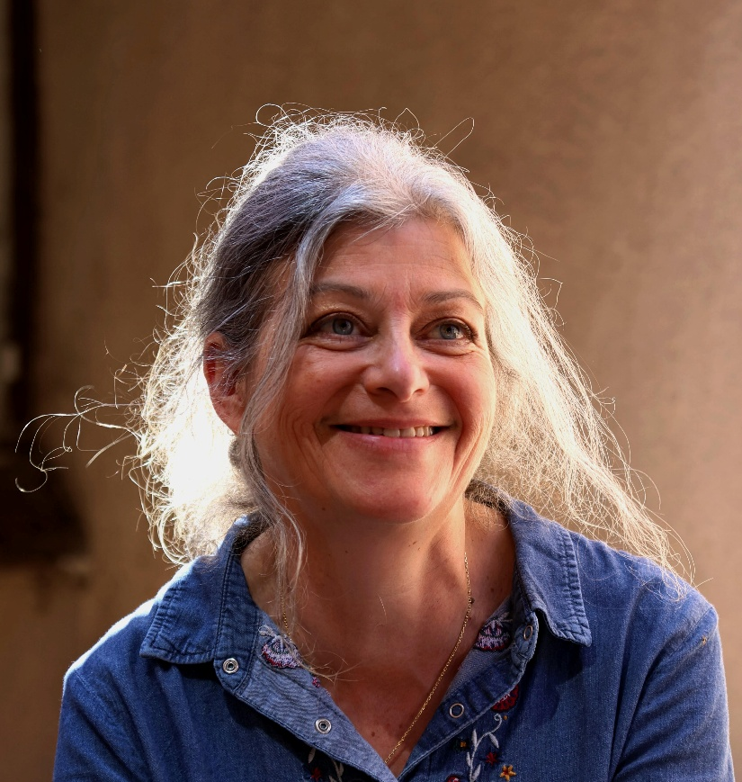
Biography: Isabelle Chavichvily (b. 1965, Soyaux, France) is Associate Scientist at IFF in Dangé-Saint-Romain, France. She graduated in microbiology from the University of La Rochelle (France, 1985), and later from the 'Conservatoire National des Arts et Métiers' in Tours (France, 1996). Isabelle Chavichvily began her career in August 1986 at Lacto-Labo in Dangé-Saint-Romain, France, where she spent five years within the Quality Control service, before moving to Research & Development, successively employed by Texel, Rhodia Food, Danisco, DuPont, and finally IFF.
For over 35 years, Isabelle Chavichvily has built and maintained a collection of nearly 8,000 bacteriophages infecting lactic acid bacteria, established their genetic and physiological characterization, and studied their interactions with their bacterial hosts. These characterizations aimed to better control the impact of these viruses on the performance of starter cultures used in the food industry, particularly through the selection of phage-resistant strains. This research activity notably laid the groundwork that enabled the discovery of the CRISPR-Cas immune system in Streptococcus thermophilus. It has also provided opportunities to isolate new phage taxons, such as phage D4446.

