

The International Committee on Taxonomy of Viruses
Taxonomy Proposal Form, 2026

Part 1a: Details of taxonomy proposals

Title: | To create a new subfamily (Beeyevirinae) of Streptomyces phages with nine genera (Caudoviricetes)
Code assigned: | 2026.011B

Author(s), affiliation and email address(es):
Given name (+middle initial(s)) | Surname | Affiliation | Email address | Corr. author(s)
Ipek | Kurtböke | Environmental Microbiology, University of the Sunshine Coast,  School of Science, Technology and Engineering,  Maroochydore DC, Australia | IKurtbok@usc.edu.au
Cristina M. | Moraru | Department of Chemistry, Environmental Metagenomics,  University of Duisburg-Essen,  D-45141 Essen,  Germany | lilianacristina.moraru@uni-due.de
Andrew M. | Kropinski | University of Guelph, Guelph, Ontario, Canada N1G2W1 | Phage.Canada@gmail.com | x

Part 1b: Taxonomy Proposal Submission
ICTV Subcommittee:
Animal DNA Viruses and Retroviruses |  | Bacterial viruses | x
Animal minus-strand and dsRNA viruses |  | Fungal and protist viruses
Animal positive-strand RNA viruses |  | Plant viruses
Archaeal viruses |  | General -

List the ICTV Study Group(s) that have seen or have been involved in creating this proposal:
Optional – complete only if formally voted on by an ICTV Study Group:
Study Group | Number of members
Study Group | Votes in support | Votes against | No vote
Actinophage

Submission date: | 15/03/2026

Part 1c: Feedback from ICTV Executive Committee (EC) meeting
Executive Committee Meeting Decision code: | X
A – Accept
Ac – Accept subject to revision by relevant subcommittee chair. No further vote required
U – Accept without revision but with re-evaluation and email vote by the EC
Uc – Accept subject to revision and re-evaluation and email vote by the EC
Ud – Deferred to the next EC meeting, with an invitation to revise based on EC comments
J - Reject
W - Withdrawn

Comments from the Executive Committee:

Part 1d: Revised Taxonomy Proposal Submission
Response of proposer:
Revision date:

Part 3: TAXONOMIC PROPOSAL

Taxonomic changes proposed:
Establish new taxon | x | Split taxon
Abolish taxon |  | Merge taxon
Move taxon |  | Promote taxon
Rename taxon |  | Demote taxon
Move and rename

Etymology (origin) of proposed taxonomic names:
Taxon name | Etymology of the term
Beeyevirinae | This name is derived from The Actinobacteriophage Database cluster name (BI) for these phages
Scarifvirus | Named after Streptomyces phage Scarif
Crickovirus | Named after Streptomyces phage CricKo
Kardavirus | Derived from the name of the type phage of this genus Streptomyces phage Kardashian
Libertybellvirus | Named after Streptomyces phage LibertyBell
Clubpenguinvirus | Named after Streptomyces phage ClubPenguin
Rosaasantewaavirus | Named after Streptomyces phage RosaAsabtewaa

Permission for use of names derived from a living person:
Taxon name | Full name of person from whom the name is derived | Attached

Abstract of Taxonomy Proposal:
Description of current taxonomy:
The orphan genera Rimavirus, Scapunavirus and Bingvirus are currently recognized by ICTV.

Proposed taxonomic change(s):
We propose to create a new subfamily called “Beeyevirinae” to include the following new genera: “Scarifvirus”, “Crickovirus”, “Kardavirus”, “Libertybellvirus”, “Clubpenguinvirus”, “Rosaasantewaavirus” and the existing orphan genera Rimavirus, Scapunavirus & Bingvirus.

Demarcation criteria for new taxon/taxa:
Subfamily demarcation criteria: Subfamilies are to be created when two or more genera are related below the family level. In practical terms, this usually means that they share a low degree of sequence similarity (usually about 20-50%) and that the genera form a clade in a marker tree phylogeny [6].

Genus demarcation criteria: An intergenomic similarity cut-off of 70%, a combination of average nucleotide identity and alignment fraction, is used to determine genera demarcation. Members of the same genus have >70% intergenomic similarity and cluster tightly in marker gene phylogenies.

Species demarcation criteria: A demarcation value of 95% intergenomic similarity was used to define different species according to intergenomic similarity. Members of the same genus have >95% intergenomic similarity [6].

Justification:
Intergenomic nucleotide similarities calculated using VIRIDIC demonstrate that these phages share at minimum 37% similarity. Each of the proposed genera and species exhibit similarity which satisfy the demarcation criteria established by the Bacterial Viruses Subcommittee. Phylogenetic analyses and of the major tail protein and TBLASTX distance analysis using ViPTree demonstrate that these lytic Streptomyces siphoviruses form a cohesive clade at the subfamily level. CoreGenes 5 analysis revealed that representative species of this subfamily share 29 (37.6%) common proteins.

Text of Taxonomy proposal:
Description of current taxonomy:
The orphan genera Rimavirus, Scapunavirus and Bingvirus are currently recognized by ICTV.

Proposed taxonomic change(s):
We propose to create a new subfamily called Beeyevirinae containing the following genera: Scarifvirus, Crickovirus, Kardavirus, Libertybellvirus, Clubpenguinvirus, Rosaasantewaavirus and Rimavirus, Scapunavirus & Bingvirus.

Demarcation criteria for new taxon/taxa:
Subfamily demarcation criteria: Subfamilies are to be created when two or more genera are related below the family level. In practical terms, this usually means that they share a low degree of sequence similarity (usually about 40-50%) and that the genera form a clade in a marker tree phylogeny [6].

Genus demarcation criteria: An intergenomic similarity cut-off of 70%, a combination of average nucleotide identity and alignment fraction, is used to determine genera demarcation. Members of the same genus have >70% intergenomic similarity and cluster tightly in marker gene phylogenies.

Species demarcation criteria: A demarcation value of 95% intergenomic similarity was used to define different species according to intergenomic similarity. Members of the same genus have >95% intergenomic similarity [6].

Justification:
Intergenomic nucleotide similarities calculated using VIRIDIC demonstrate that these phages share at minimum 37% similarity (Fig. 1). Each of the proposed genera and species exhibit similarity which satisfy the demarcation criteria established by the Bacterial Viruses Subcommittee. Phylogenetic analyses (Fig. 3) and of the major tail protein and TBLASTX distance analysis using ViPTree (Fig. 2) demonstrate that these lytic Streptomyces siphoviruses form a cohesive clade at the subfamily level. CoreGenes 5 analysis revealed that representative species of this subfamily share 29 (37.6%) common proteins. These include the terminase large subunit, portal, major capsid protein, tail terminator, major tail protein, tape measure protein, two minor tail proteins, holin, DNA primase/polymerase, ssDNA binding protein, DNA helicase, HNH endonuclease, VRR-Nuc domain protein, Cas4 family exonuclease and helix-turn-helix DNA binding domain protein.

References:
1. Moraru C, Varsani A, Kropinski AM. VIRIDIC-A Novel Tool to Calculate the Intergenomic Similarities of Prokaryote-Infecting Viruses. Viruses. 2020 Nov 6;12(11):1268. doi: 10.3390/v12111268. PMID: 33172115; PMCID: PMC7694805. http://kronos.icbm.uni-oldenburg.de/viridic/
2. Nishimura Y, Yoshida T, Kuronishi M, Uehara H, Ogata H, Goto S. ViPTree: the viral proteomic tree server. Bioinformatics. 2017; 33(15):2379-2380. doi:10.1093/bioinformatics/btx157. PubMed PMID: 28379287. https://www.genome.jp/viptree/
3. Rohwer F, Edwards R. The Phage Proteomic Tree: a genome-based taxonomy for phage. J Bacteriol. 2002 Aug;184(16):4529-35. PubMed PMID: 12142423
4. Turner D, Reynolds D, Seto D, Mahadevan P. CoreGenes3.5: a webserver for the determination of core genes from sets of viral and small bacterial genomes. BMC Res Notes. 2013;6:140. doi: 10.1186/1756-0500-6-140. PMID: 23566564.
5. Davis P, Seto D, Mahadevan P. CoreGenes5.0: An Updated User-Friendly Webserver for the Determination of Core Genes from Sets of Viral and Bacterial Genomes. Viruses. 2022 Nov 16;14(11):2534. doi: 10.3390/v14112534. PMID: 36423143; PMCID: PMC9693508.
6. Turner D, Kropinski AM, Adriaenssens EM. A Roadmap for Genome-Based Phage Taxonomy. Viruses. 2021 Mar 18;13(3):506. doi: 10.3390/v13030506. PMID: 33803862; PMCID: PMC8003253.
Lemoine F, Correia D, Lefort V, Doppelt-Azeroual O, Mareuil F, Cohen-Boulakia S, Gascuel O. NGPhylogeny.fr: new generation phylogenetic services for non-specialists. Nucleic Acids Res. 2019 Jul 2;47(W1):W260-W265. doi: 10.1093/nar/gkz303. PMID: 31028399; PMCID: PMC6602494.
7. Letunic I, Bork P. Interactive Tree Of Life (iTOL): an online tool for phylogenetic tree display and annotation. Bioinformatics. 2007 Jan 1;23(1):127-8. doi: 10.1093/bioinformatics/btl529. Epub 2006 Oct 18. PMID: 17050570.
8. Zhou T, Xu K, Zhao F, Liu W, Li L, Hua Z, Zhou X. itol.toolkit accelerates working with iTOL (Interactive Tree of Life) by an automated generation of annotation files. Bioinformatics. 2023 Jun 1;39(6):btad339. doi: 10.1093/bioinformatics/btad339. PMID: 37225402; PMCID: PMC10243930
9. Dereeper A, Guignon V, Blanc G, Audic S, Buffet S, Chevenet F, Dufayard JF, Guindon S, Lefort V, Lescot M, Claverie JM, Gascuel O. Phylogeny.fr: robust phylogenetic analysis for the non-specialist. Nucleic Acids Res. 2008 Jul 1;36(Web Server issue):W465-9. doi: 10.1093/nar/gkn180. Epub 2008 Apr 19. PMID: 18424797; PMCID: PMC2447785.

Accompanying files:
Filename | Description of contents

Tables, Figures:

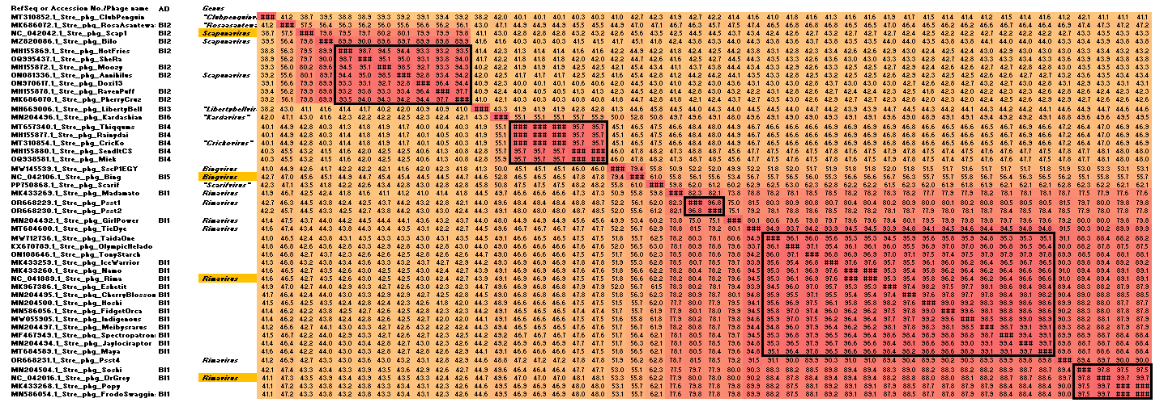

Figure 1. VIRIDIC heatmap of this group of phages. VIRIDIC (Virus Intergenomic Distance Calculator; VIRIDIC (Virus Intergenomic Distance Calculator; [1]; http://rhea.icbm.uni-oldenburg.de/VIRIDIC/) computes pairwise intergenomic distances/similarities amongst phage genomes. Data values which are bordered in black correspond to strains. AD Subcluster refers to the subcluster to which the phages belong as defined by the Actinobacteriophage Database. Abbreviations: phg = phage; Stre = Streptomyces; Arth = Arthobacter. These data are also available in the attached supplementary file (Beeyevirinae_VIRIDIC heatmap.xlsx).

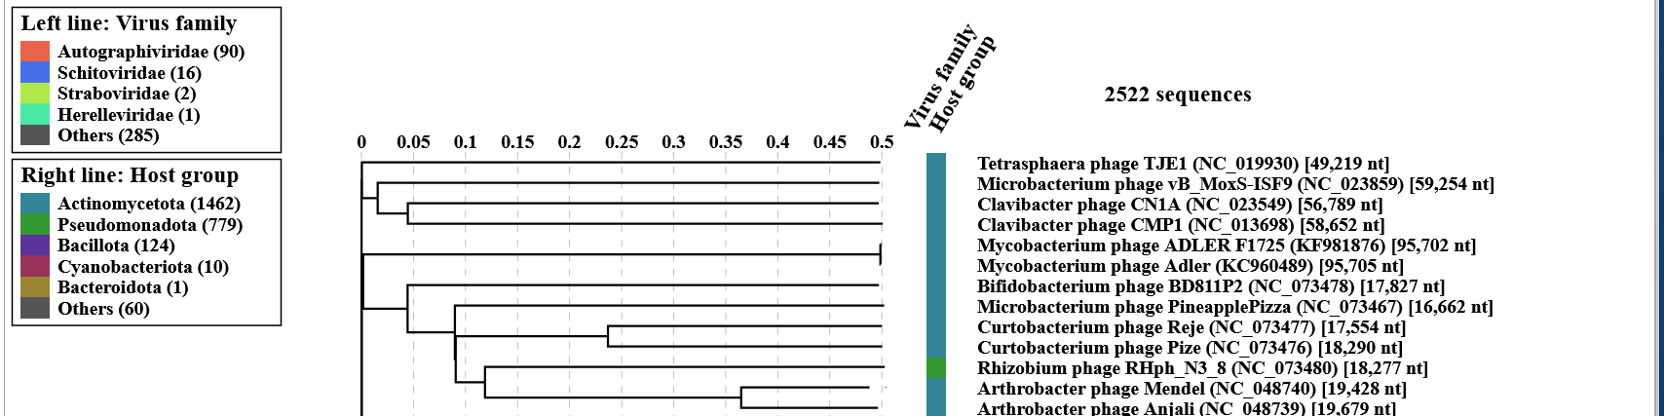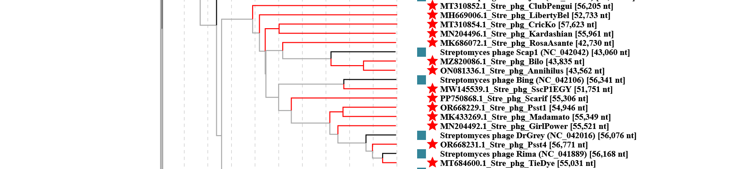
Figure 2. ViPTree analysis: ViPTree analysis (https://www.genome.jp/viptree/; [2]) is based upon Rohwer and Edwards (2002) Phage Proteomic Tree [3]. The taxa under discussion are indicated with red bars and stars. Abbreviations: phg = phage; Stre = Streptomyces.

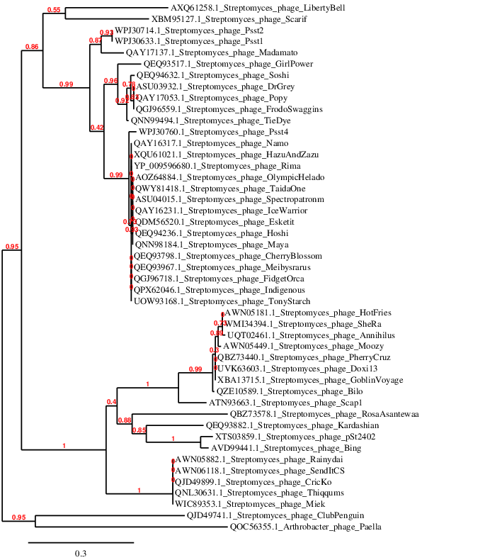

Figure 3. Phylogenetic tree constructed with the major tail proteins from these and related phages using “One Click” Phylogeny.fr [9] at https://www.phylogeny.fr using the MTP from Arthrobacter phage Paella as an outlier.

