
.

The International Committee on Taxonomy of Viruses
Taxonomy Proposal Form, 2026

Part 1a: Details of taxonomy proposals

Title: | Create four new genera Tumamocvirus, Jayanvirus, Younaduovirus & Deonjangvirus in the class Caudoviricetes
Code assigned: | 2026.010B

Author(s), affiliation and email address(es):
Given name (+middle initial(s)) | Surname | Affiliation | Email address | Corr. author(s)
Jakub | Barylski | Institute of Experimental Biology, Department of Molecular Virology, Adam Mickiewicz University,  Poznań, Poland | jakub.barylski@gmail.com | *
Cristina M. | Moraru | Department of Chemistry, Environmental Metagenomics,  University of Duisburg-Essen,  D-45141 Essen,  Germany | lilianacristina.moraru@uni-due.de
Andrew M. | Kropinski | University of Guelph, Guelph, Ontario, Canada N1G2W1 | Phage.Canada@gmail.com | x

Part 1b: Taxonomy Proposal Submission
ICTV Subcommittee:
Animal DNA Viruses and Retroviruses |  | Bacterial viruses | x
Animal minus-strand and dsRNA viruses |  | Fungal and protist viruses
Animal positive-strand RNA viruses |  | Plant viruses
Archaeal viruses |  | General -

List the ICTV Study Group(s) that have seen or have been involved in creating this proposal:
Herelleviridae Study Group

Optional – complete only if formally voted on by an ICTV Study Group:
Study Group | Number of members
Study Group | Votes in support | Votes against | No vote

Submission date: | 30/03/2026

Part 1c: Feedback from ICTV Executive Committee (EC) meeting
Executive Committee Meeting Decision code: | X
A – Accept
Ac – Accept subject to revision by relevant subcommittee chair. No further vote required
U – Accept without revision but with re-evaluation and email vote by the EC
Uc – Accept subject to revision and re-evaluation and email vote by the EC
Ud – Deferred to the next EC meeting, with an invitation to revise based on EC comments
J - Reject
W - Withdrawn

Comments from the Executive Committee:

Part 1d: Revised Taxonomy Proposal Submission
Response of proposer:
Revision date:

Part 3: TAXONOMIC PROPOSAL

Taxonomic changes proposed:
Establish new taxon | x | Split taxon
Abolish taxon |  | Merge taxon
Move taxon |  | Promote taxon
Rename taxon |  | Demote taxon
Move and rename

Etymology (origin) of proposed taxonomic names:
Taxon name | Etymology of the term
Tumamocvirus | Two of the phages of this type were isolated from Tumamoc Hill Desert Laboratory (Tucson, AZ)
Jayanvirus | Named after Bacillus phage Jayan
Younaduovirus | Named after Weizmannia phage Youna2
Deonjangvirus | Phage BSP7 was isolated from the Korean soybean-based fermented food Deonjang.

Permission for use of names derived from a living person:
Taxon name | Full name of person from whom the name is derived | Attached

Abstract of Taxonomy Proposal:

Description of current taxonomy:
The bacteriophages described in this proposal are currently unclassified.

Proposed taxonomic change(s):
We propose to create four genera; “Tumamocvirus”,” Jayanvirus”, “Younaduovirus” and “Deonjangvirus” for these predominantly temperate siphoviruses.

Demarcation criteria:
Genus demarcation criteria: An intergenomic similarity cut-off of 70%, a combination of average nucleotide identity and alignment fraction, is used to determine genera demarcation. Members of the same genus have >70% intergenomic similarity and cluster tightly in marker gene phylogenies. In the case of temperate phages we are more liberal in the similarity cutoff values.

Species demarcation criteria: A demarcation value of 95% intergenomic similarity was used to define different species according to intergenomic similarity. Members of the same genus have >95% intergenomic similarity [6].

Justification:
VIRIDIC analysis demonstrates that these phages form four distinct clades based on pairwise intergenomic nucleotide similarities. The clades are further supported by TBLASTX distances and phylogenetic analysis of the large terminase subunit.

Text of Taxonomy proposal:
Description of current taxonomy: None of these Bacillus phages have been classified by ICTV.

Proposed taxonomic change(s): We propose to create four genera; “Tumamocvirus”,” Jayanvirus”, “Younaduovirus” and “Deonjangvirus” for these predominantly temperate siphoviruses.

Demarcation criteria:
Genus demarcation criteria: An intergenomic similarity cut-off of 70%, a combination of average nucleotide identity and alignment fraction, is used to determine genera demarcation. Members of the same genus have >70% intergenomic similarity and cluster tightly in marker gene phylogenies. In the case of temperate phages we are more liberal in the similarity cutoff values.

Species demarcation criteria: A demarcation value of 95% intergenomic similarity was used to define different species according to intergenomic similarity. Members of the same genus have >95% intergenomic similarity [6].

Justification:
VIRIDIC analysis demonstrates that these phages form four distinct clades based on pairwise intergenomic nucleotide similarities (Figure 1). The clades are further supported by TBLASTX distances (VIPTree, Figure 2) and phylogenetic analysis of the large terminase subunit (Figure 3).

References:
1. Moraru C, Varsani A, Kropinski AM. VIRIDIC-A Novel Tool to Calculate the Intergenomic Similarities of Prokaryote-Infecting Viruses. Viruses. 2020 Nov 6;12(11):1268. doi: 10.3390/v12111268. PMID: 33172115; PMCID: PMC7694805. http://kronos.icbm.uni-oldenburg.de/viridic/
2. Nishimura Y, Yoshida T, Kuronishi M, Uehara H, Ogata H, Goto S. ViPTree: the viral proteomic tree server. Bioinformatics. 2017; 33(15):2379-2380. doi:10.1093/bioinformatics/btx157. PubMed PMID: 28379287. https://www.genome.jp/viptree/
3. Rohwer F, Edwards R. The Phage Proteomic Tree: a genome-based taxonomy for phage. J Bacteriol. 2002 Aug;184(16):4529-35. PubMed PMID: 12142423
4. Turner D, Reynolds D, Seto D, Mahadevan P. CoreGenes3.5: a webserver for the determination of core genes from sets of viral and small bacterial genomes. BMC Res Notes. 2013;6:140. doi: 10.1186/1756-0500-6-140. PMID: 23566564.
5. Davis P, Seto D, Mahadevan P. CoreGenes5.0: An Updated User-Friendly Webserver for the Determination of Core Genes from Sets of Viral and Bacterial Genomes. Viruses. 2022 Nov 16;14(11):2534. doi: 10.3390/v14112534. PMID: 36423143; PMCID: PMC9693508.
6. Turner D, Kropinski AM, Adriaenssens EM. A Roadmap for Genome-Based Phage Taxonomy. Viruses. 2021 Mar 18;13(3):506. doi: 10.3390/v13030506. PMID: 33803862; PMCID: PMC8003253.
Lemoine F, Correia D, Lefort V, Doppelt-Azeroual O, Mareuil F, Cohen-Boulakia S, Gascuel O. NGPhylogeny.fr: new generation phylogenetic services for non-specialists. Nucleic Acids Res. 2019 Jul 2;47(W1):W260-W265. doi: 10.1093/nar/gkz303. PMID: 31028399; PMCID: PMC6602494.
7. Letunic I, Bork P. Interactive Tree Of Life (iTOL): an online tool for phylogenetic tree display and annotation. Bioinformatics. 2007 Jan 1;23(1):127-8. doi: 10.1093/bioinformatics/btl529. Epub 2006 Oct 18. PMID: 17050570.
8. Zhou T, Xu K, Zhao F, Liu W, Li L, Hua Z, Zhou X. itol.toolkit accelerates working with iTOL (Interactive Tree of Life) by an automated generation of annotation files. Bioinformatics. 2023 Jun 1;39(6):btad339. doi: 10.1093/bioinformatics/btad339. PMID: 37225402; PMCID: PMC10243930
9. Dereeper A, Guignon V, Blanc G, Audic S, Buffet S, Chevenet F, Dufayard JF, Guindon S, Lefort V, Lescot M, Claverie JM, Gascuel O. Phylogeny.fr: robust phylogenetic analysis for the non-specialist. Nucleic Acids Res. 2008 Jul 1;36(Web Server issue):W465-9. doi: 10.1093/nar/gkn180. Epub 2008 Apr 19. PMID: 18424797; PMCID: PMC2447785.

Accompanying files:
Filename | Description of contents

Tables, Figures:

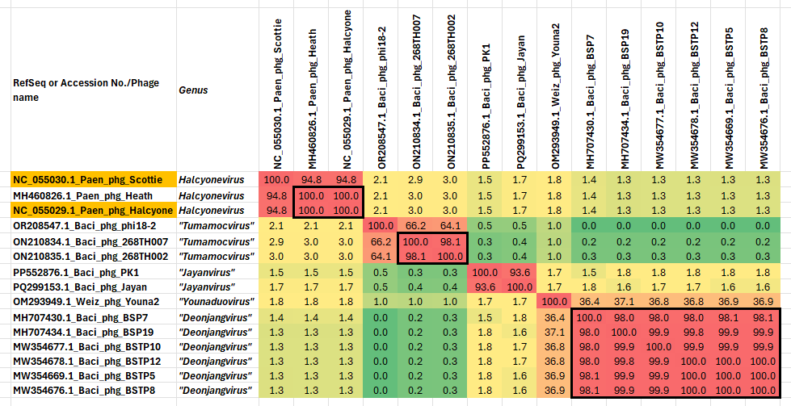
Figure 1. VIRIDIC heatmap of this group of phages. VIRIDIC (Virus Intergenomic Distance Calculator; VIRIDIC (Virus Intergenomic Distance Calculator; [1]; http://rhea.icbm.uni-oldenburg.de/VIRIDIC/) computes pairwise intergenomic distances/similarities amongst phage genomes. Data values which are bordered in black correspond to strains. The gold highlighted RefSeq numbers correspond to established species in the genus Halcyonevirus. Abbreviations: phg = phage; Baci = Bacillus; Weis = Weizmannia; Paen = Paenibacillus
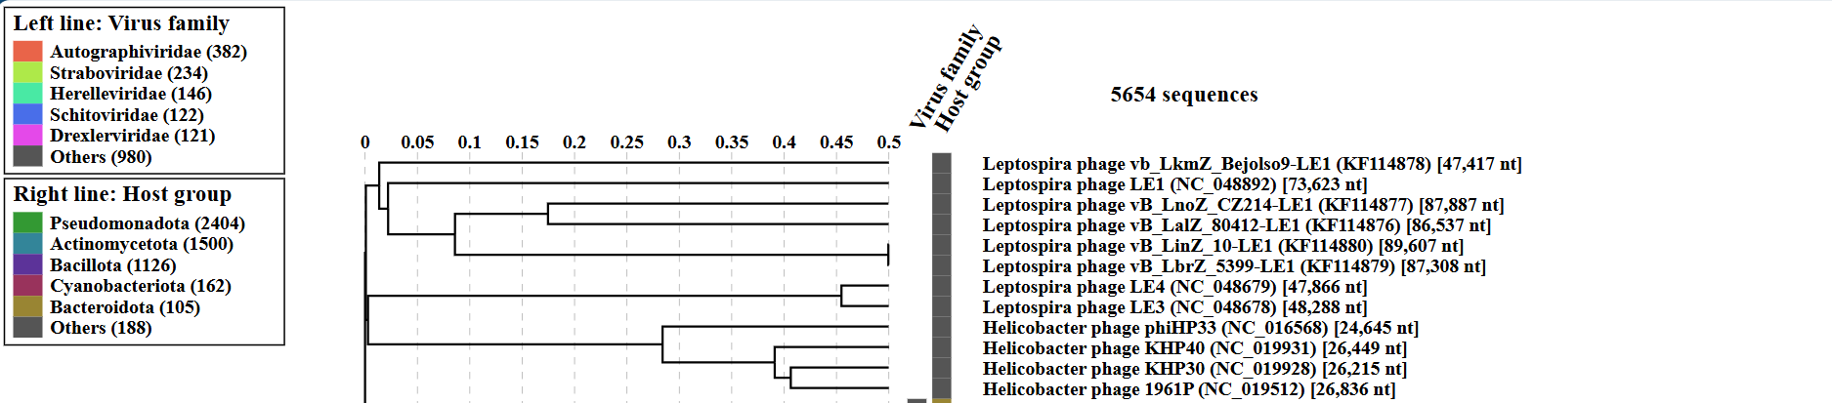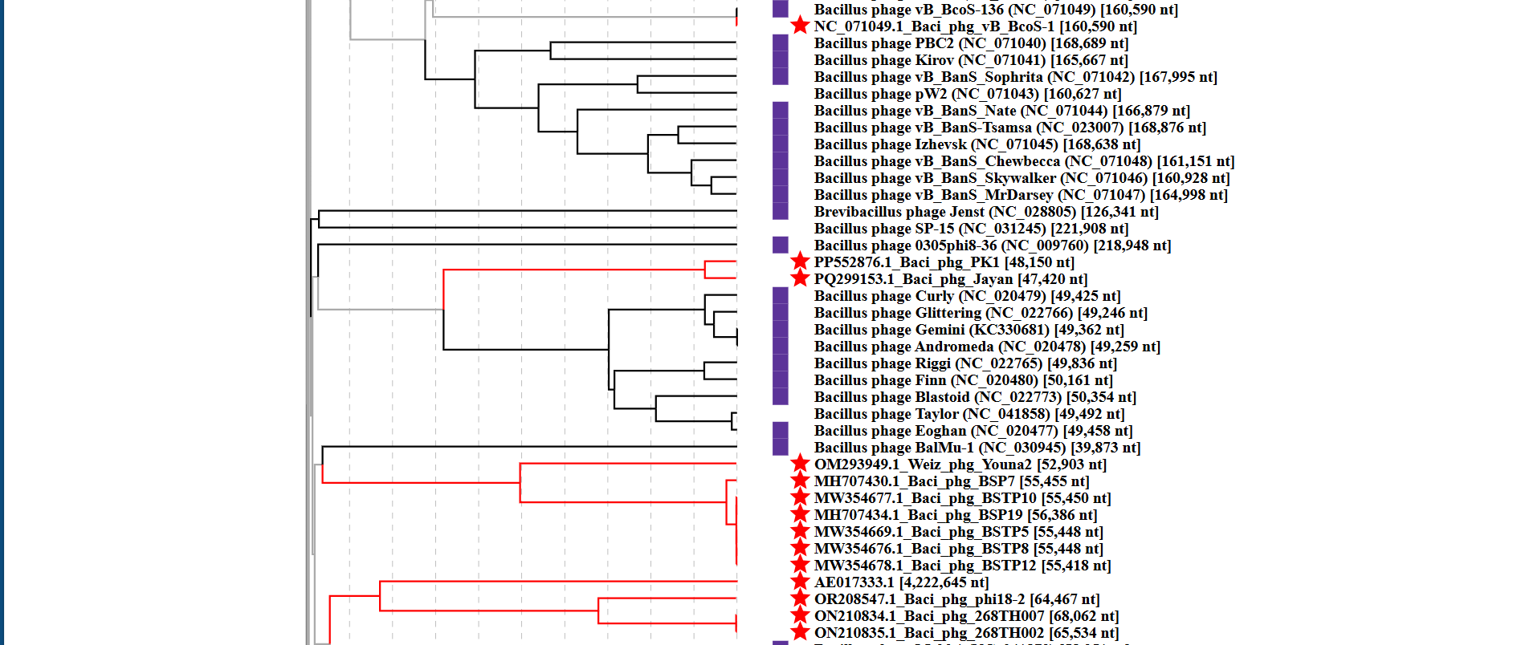
Figure 2. ViPTree analysis: ViPTree analysis (https://www.genome.jp/viptree/; [2]) is based upon Rohwer and Edwards (2002) Phage Proteomic Tree [3]. The taxons under discussion are indicated with red bars and stars. Abbreviations: phg = phage; Baci = Bacillus; Weis = Weizmannia; Paen = Paenibacillus

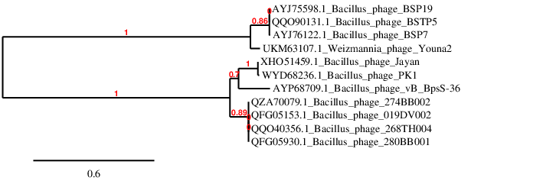Figure 3. Phylogenetic tree constructed with the large subunit terminase proteins from these and related phages using “One Click” Phylogeny.fr [9] at https://www.phylogeny.fr.

Table 1. Characteristics of the two phages in the genus "Tumamocvirus".
Phage name | Host | Morphotype | Lifestyle | Accession No. | Genome size | %G+C | No. proteins | No. tRNA
Bacillus phage phi18-2 | Bacillus subtilis | Siphovirus | Temperate | OR208547 | 64,467  bp | 47.5 | 93 | 0
Bacillus phage 268TH007 | Bacillus subtilis | Siphovirus | Temperate | ON210834 | 65,534 bp | 47.3 | 98 | 0

Specific references:
Li Y, Huo Y, Liang L, Li D, Zhang Z, Yang H. Bacillus phage phi18-2 is a novel temperate virus with an unintegrated genome present in the cytoplasm of lysogenic cells as a linear phage-plasmid. Arch Virol. 2024 Mar 23;169(4):81. doi: 10.1007/s00705-024-06014-6. PMID: 38519716.
Krukonis GP, Kemp AK, Storrie KF, Chavira VR, Lantrip HW, Perez VD, Reyes DA, Truax JA, Loney R, Delesalle VA. Complete Genome Sequences of Two Temperate Bacillus subtilis Phages Isolated at Tumamoc Hill Desert Laboratory. Microbiol Resour Announc. 2022 Sep 15;11(9):e0045522. doi: 10.1128/mra.00455-22. Epub 2022 Aug 17. PMID: 35976008; PMCID: PMC9476937.

Table 2. Characteristics of the two phages in the genus Jayanvirus.

Phage name | Host | Morphotype | Lifestyle | Accession No. | Genome size | %G+C | No. proteins | No. tRNA
Bacillus phage PK1 | Not given | Siphovirus | Temperate | PP552876 | 48,150 bp | 43.1 | 45 (*) | 0
Bacillus phage Jayan | Bacillus licheniformis DSM13 | Siphovirus | temperate | PQ299153 | 47420 bp | 43.3 | 73 | 0
(*) Underannotated
Table 3. Characteristics of the single phages in the genus Younaduovirus.

Phage name | Host | Morphotype | Lifestyle | Accession No. | Genome size | %G+C | No. proteins | No. tRNA
Weizmannia phage Youna2 | Weizmannia coagulans KACC 15983 | Siphovirus | Lytic | OM293949 | 52903 bp | 42.7 | 61 | 0
Specific reference: Son B, Kim Y, Yu B, Kong M. Isolation and Characterization of a Weizmannia coagulans Bacteriophage Youna2 and Its Endolysin PlyYouna2. J Microbiol Biotechnol. 2023 Aug 28;33(8):1050-1056. doi: 10.4014/jmb.2303.03021. Epub 2023 May 12. PMID: 37218442; PMCID: PMC10468668.
Table 4. Characteristics of the single phage in the genus Deonjangvirus.

Phage name | Host | Morphotype | Lifestyle | Accession No. | Genome size | %G+C | No. proteins | No. tRNA
Bacillus phage BSP7 | Bacillus subtilis ATCC 21336 | Siphovirus | Lytic | MH707430 | 55,455 bp | 39.9 | 70 | 0
Specific reference: Ghosh K, Choi Y, Lee JW, Baraki H, Kim KP. Complete nucleotide sequence analysis and identification of 7-cyano-7-deazaguanine (PreQ0) biosynthesis-related genes in the novel Bacillus subtilis-infecting Siphoviridae family phage BSP7. Arch Virol. 2021 Jun;166(6):1795-1799. doi: 10.1007/s00705-021-05056-4. Epub 2021 Apr 11. PMID: 33839920.

