

The International Committee on Taxonomy of Viruses
Taxonomy Proposal Form, 2026

Part 1a: Details of taxonomy proposals

Title: | To create three new genera, Zuckervirus, Aokavirus and Alatatovirus (Caudoviricetes)
Code assigned: | 2026.009B

Author(s), affiliation and email address(es):
Given name (+middle initial(s)) | Surname | Affiliation | Email address | Corr. author(s)
Ipek | Kurtböke | Environmental Microbiology, University of the Sunshine Coast,  School of Science, Technology and Engineering,  Maroochydore DC, Australia | IKurtbok@usc.edu.au
Cristina M. | Moraru | Department of Chemistry, Environmental Metagenomics,  University of Duisburg-Essen,  D-45141 Essen,  Germany | lilianacristina.moraru@uni-due.de
Andrew M. | Kropinski | University of Guelph, Guelph, Ontario, Canada N1G2W1 | Phage.Canada@gmail.com | x

Part 1b: Taxonomy Proposal Submission
ICTV Subcommittee:
Animal DNA Viruses and Retroviruses |  | Bacterial viruses | x
Animal minus-strand and dsRNA viruses |  | Fungal and protist viruses
Animal positive-strand RNA viruses |  | Plant viruses
Archaeal viruses |  | General -

List the ICTV Study Group(s) that have seen or have been involved in creating this proposal:
Actinophage Study Group

Optional – complete only if formally voted on by an ICTV Study Group:
Study Group | Number of members
Study Group | Votes in support | Votes against | No vote

Submission date: | 09/04/2026

Part 1c: Feedback from ICTV Executive Committee (EC) meeting
Executive Committee Meeting Decision code: | X
A – Accept
Ac – Accept subject to revision by relevant subcommittee chair. No further vote required
U – Accept without revision but with re-evaluation and email vote by the EC
Uc – Accept subject to revision and re-evaluation and email vote by the EC
Ud – Deferred to the next EC meeting, with an invitation to revise based on EC comments
J - Reject
W - Withdrawn

Comments from the Executive Committee:

Part 1d: Revised Taxonomy Proposal Submission
Response of proposer:
Revision date:

Part 3: TAXONOMIC PROPOSAL

Taxonomic changes proposed:
Establish new taxon | x | Split taxon
Abolish taxon |  | Merge taxon
Move taxon |  | Promote taxon
Rename taxon |  | Demote taxon
Move and rename

Etymology (origin) of proposed taxonomic names:
Taxon name | Etymology of the term
Zuckervirus | Named after Arthrobacter phage Zucker
Aokavirus | Named after Arthrobacter phage Aoka
Alatatovirus | Named after Arthrobacter phage Alatato

Permission for use of names derived from a living person:
Taxon name | Full name of person from whom the name is derived | Attached

Abstract of Taxonomy Proposal:

Description of current taxonomy:
The bacteriophages described within this proposal are currently unclassified.

Proposed taxonomic change(s):
We propose to create three new genera, “Zuckervirus”, “Aokavirus” & “Alatatovirus” to encompass these phages.

Demarcation criteria:
Genus demarcation criteria: An intergenomic similarity cut-off of 70%, a combination of average nucleotide identity and alignment fraction, is used to determine genera demarcation. Members of the same genus have >70% intergenomic similarity and cluster tightly in marker gene phylogenies.

Species demarcation criteria: A demarcation value of 95% intergenomic similarity was used to define different species according to intergenomic similarity. Members of the same genus have >95% intergenomic similarity [6].

Justification:
On the basis of VIRIDIC, VIPTREE and phylogenetic analyses these temperate Arthrobacter siphoviruses form three genera. These genomes show limited intergenomic nucleotide similarity to the genera Hestiavirus, Bauervirus, Majavirus, Kumottavirus, Shoyavirus and Sargevirus. They belong to a large group of temperate Arthrobacter phages classified into the FN, FB and FO clusters by the Actinobacteriophage Database.

Text of Taxonomy proposal:
Description of current taxonomy:
The bacteriophages described within this proposal are currently unclassified.

Proposed taxonomic change(s): We propose to create three new genera, Zuckervirus, Aokavirus & Alatatovirus to encompass these phages.

Demarcation criteria:
Genus demarcation criteria: An intergenomic similarity cut-off of 70%, a combination of average nucleotide identity and alignment fraction, is used to determine genera demarcation. Members of the same genus have >70% intergenomic similarity and cluster tightly in marker gene phylogenies.

Species demarcation criteria: A demarcation value of 95% intergenomic similarity was used to define different species according to intergenomic similarity. Members of the same genus have >95% intergenomic similarity [6].

Justification:
On the basis of VIRIDIC, VIPTREE and phylogenetic analyses these temperate Arthrobacter siphoviruses form three genera. These genomes show limited intergenomic nucleotide similarity to the genera Hestiavirus, Bauervirus, Majavirus, Kumottavirus, Shoyavirus and Sargevirus. They belong to a large group of temperate Arthrobacter phages classified into the FN, FB and FO clusters by the Actinobacteriophage Database.

References:
1. Moraru C, Varsani A, Kropinski AM. VIRIDIC-A Novel Tool to Calculate the Intergenomic Similarities of Prokaryote-Infecting Viruses. Viruses. 2020 Nov 6;12(11):1268. doi: 10.3390/v12111268. PMID: 33172115; PMCID: PMC7694805. http://kronos.icbm.uni-oldenburg.de/viridic/
2. Nishimura Y, Yoshida T, Kuronishi M, Uehara H, Ogata H, Goto S. ViPTree: the viral proteomic tree server. Bioinformatics. 2017; 33(15):2379-2380. doi:10.1093/bioinformatics/btx157. PubMed PMID: 28379287. https://www.genome.jp/viptree/
3. Rohwer F, Edwards R. The Phage Proteomic Tree: a genome-based taxonomy for phage. J Bacteriol. 2002 Aug;184(16):4529-35. PubMed PMID: 12142423
4. Turner D, Reynolds D, Seto D, Mahadevan P. CoreGenes3.5: a webserver for the determination of core genes from sets of viral and small bacterial genomes. BMC Res Notes. 2013;6:140. doi: 10.1186/1756-0500-6-140. PMID: 23566564.
5. Davis P, Seto D, Mahadevan P. CoreGenes5.0: An Updated User-Friendly Webserver for the Determination of Core Genes from Sets of Viral and Bacterial Genomes. Viruses. 2022 Nov 16;14(11):2534. doi: 10.3390/v14112534. PMID: 36423143; PMCID: PMC9693508.
6. Turner D, Kropinski AM, Adriaenssens EM. A Roadmap for Genome-Based Phage Taxonomy. Viruses. 2021 Mar 18;13(3):506. doi: 10.3390/v13030506. PMID: 33803862; PMCID: PMC8003253.
Lemoine F, Correia D, Lefort V, Doppelt-Azeroual O, Mareuil F, Cohen-Boulakia S, Gascuel O. NGPhylogeny.fr: new generation phylogenetic services for non-specialists. Nucleic Acids Res. 2019 Jul 2;47(W1):W260-W265. doi: 10.1093/nar/gkz303. PMID: 31028399; PMCID: PMC6602494.
7. Letunic I, Bork P. Interactive Tree Of Life (iTOL): an online tool for phylogenetic tree display and annotation. Bioinformatics. 2007 Jan 1;23(1):127-8. doi: 10.1093/bioinformatics/btl529. Epub 2006 Oct 18. PMID: 17050570.
8. Zhou T, Xu K, Zhao F, Liu W, Li L, Hua Z, Zhou X. itol.toolkit accelerates working with iTOL (Interactive Tree of Life) by an automated generation of annotation files. Bioinformatics. 2023 Jun 1;39(6):btad339. doi: 10.1093/bioinformatics/btad339. PMID: 37225402; PMCID: PMC10243930
9. Dereeper A, Guignon V, Blanc G, Audic S, Buffet S, Chevenet F, Dufayard JF, Guindon S, Lefort V, Lescot M, Claverie JM, Gascuel O. Phylogeny.fr: robust phylogenetic analysis for the non-specialist. Nucleic Acids Res. 2008 Jul 1;36(Web Server issue):W465-9. doi: 10.1093/nar/gkn180. Epub 2008 Apr 19. PMID: 18424797; PMCID: PMC2447785.

Accompanying files:
Filename | Description of contents

Tables, Figures:

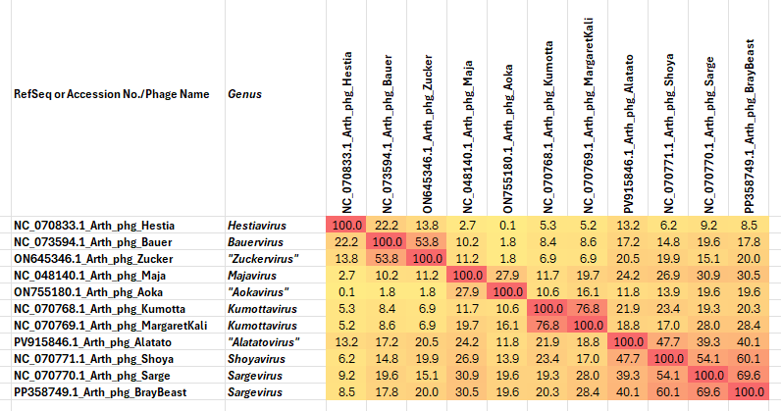

Figure 1. VIRIDIC heatmap of this group of phages. VIRIDIC (Virus Intergenomic Distance Calculator; VIRIDIC (Virus Intergenomic Distance Calculator; [1]; http://rhea.icbm.uni-oldenburg.de/VIRIDIC/) computes pairwise intergenomic distances/similarities amongst phage genomes. Abbreviations: phg = phage; Arth = Arthrobacter.

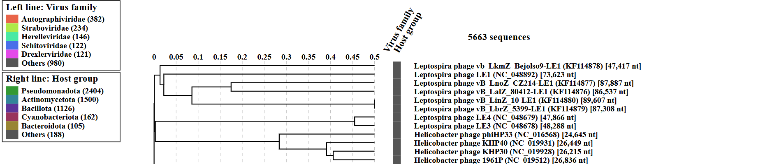
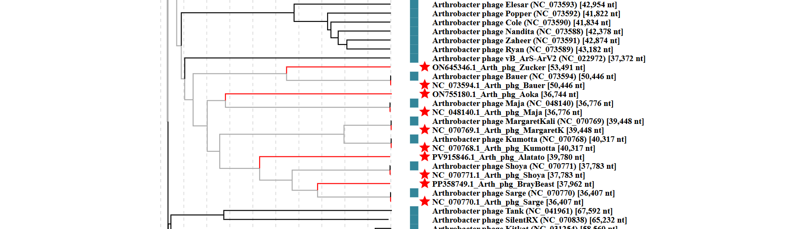

Figure 2. ViPTree analysis: ViPTree analysis (https://www.genome.jp/viptree/; [2]) is based upon Rohwer and Edwards (2002) Phage Proteomic Tree [3]. The taxa under discussion are indicated with red bars and stars. Abbreviations: phg = phage; Arth = Arthrobacter.
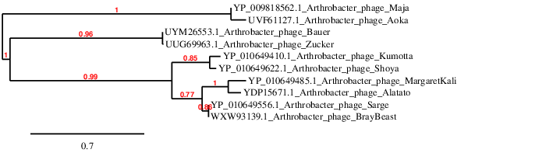
Figure 3. Phylogenetic tree constructed with the large subunit terminase proteins from these and related phages using “One Click” Phylogeny.fr [9] at https://www.phylogeny.fr .

Table 1. Characteristics of the only phage in the genus Zuckervirus.

Phage name | Host | Morphotype | Lifestyle | Accession No. | Genome size | %G+C | 3’-cohesive ends | No. proteins | No. tRNA
Arthrobacter phage Zucker | Arthrobacter globiformis B-2979 | Siphovirus | Temperate | ON645346 | 53491 bp | 62.8 | CCCCCGGGCAT | 96 | 2

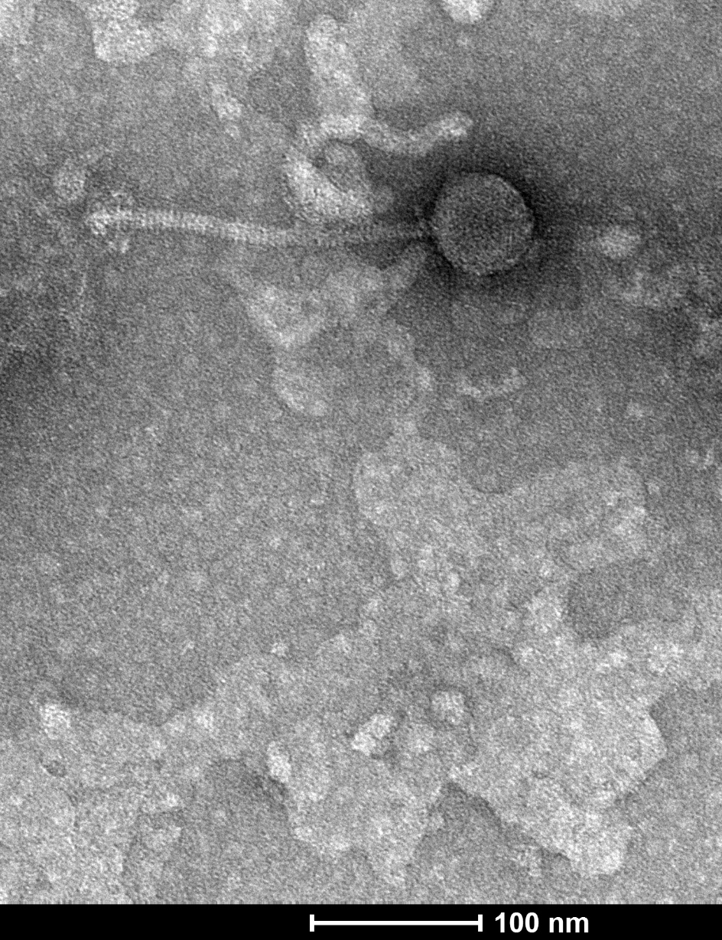
Figure 4. Electron micrograph: Electron micrograph of negatively stained Arthrobacter phage Zucker (https://phagesdb.org/phages/Zucker/). Limited permission was granted by The Actinobacteriophage Database (https://phagesdb.org/), funded by the Howard Hughes Medical Institute, to use this electron micrograph for this taxonomy proposal; it cannot be reused without permission of The Actinobacteriophage Database.

Table 2. Characteristics of the only phage in the genus Aokavirus.

Phage name | Host | Morphotype | Lifestyle | Accession No. | Genome size | %G+C | 3’-cohesive ends | No. proteins | No. tRNA
Arthrobacter phage Aoka | Arthrobacter globiformis B-2979 | Siphovirus | Temperate | ON755180 | 36744 bp | 68.8 | TTCGCCCGTTA | 54 | 0

Table 3. Characteristics of the only phage in the genus Alatatovirus.

Phage name | Host | Morphotype | Lifestyle | Accession No. | Genome size | %G+C | 3’-cohesive ends | No. proteins | No. tRNA
Arthrobacter phage Alatato | Arthrobacter globiformis B-2979 | Siphovirus | Temperate | PV915846 | 39780 bp | 63.8 | TGCCGCCCGGTA | 71 | 0

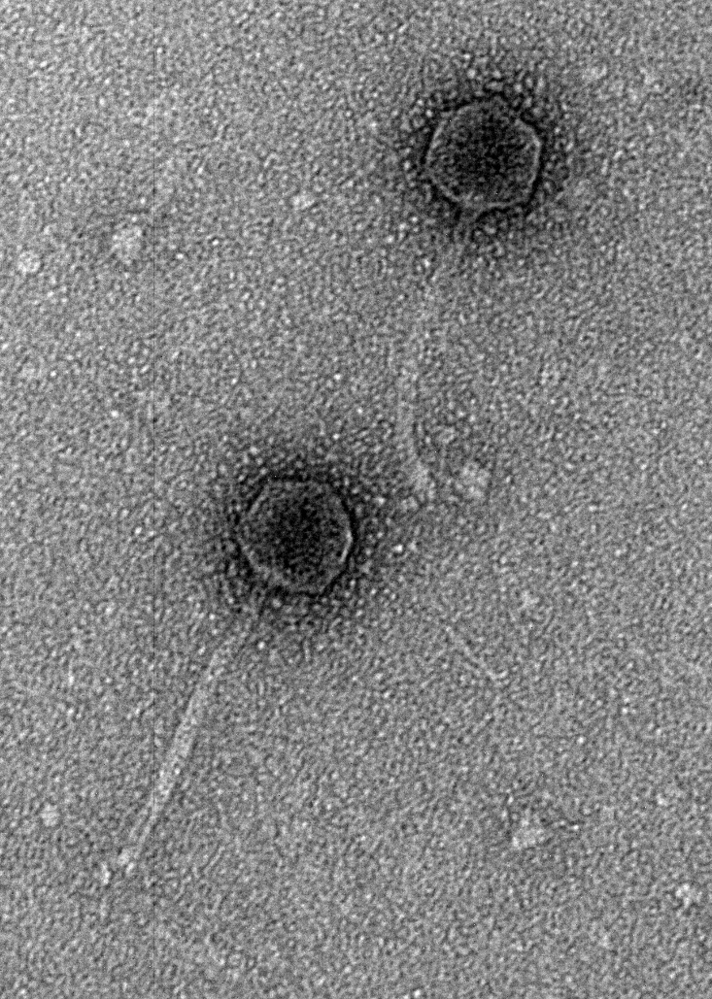
Figure 5. Electron micrograph: Electron micrograph of negatively stained Arthrobacter phage Alatato (https://phagesdb.org/phages/Alatato/). Limited permission was granted by The Actinobacteriophage Database (https://phagesdb.org/), funded by the Howard Hughes Medical Institute, to use this electron micrograph for this taxonomy proposal; it cannot be reused without permission of The Actinobacteriophage Database.

