

The International Committee on Taxonomy of Viruses
Taxonomy Proposal Form, 2026

Part 1a: Details of taxonomy proposals

Title: | Create one new species in the genus Ampunavirus.
Code assigned: | 2026.008B

Author(s), affiliation and email address(es):
Given name (+middle initial(s)) | Surname | Affiliation | Email address | Corr. author(s)
Jinquan | Li | Huazhong Agricultural University, Wuhan, China | lijinquan2017@163.com | X
Yang | Zhou | Huazhong Agricultural University, Wuhan, China | zhouyang@mail.hzau.edu.cn
Yating | Guo | Huazhong Agricultural University, Wuhan, China | guoyating0626@126.com
Huai | Liu | Huazhong Agricultural University, Wuhan, China
Shan | Wang | Huazhong Agricultural University, Wuhan, China | shanwang@mai.hzau.edu.cn
Yusheng | Lu | Guangdong Academy of Agricultural Sciences, Guangzhou, China
Part 1b: Taxonomy Proposal Submission
ICTV Subcommittee:
Animal DNA Viruses and Retroviruses |  | Bacterial viruses | X
Animal minus-strand and dsRNA viruses |  | Fungal and protist viruses
Animal positive-strand RNA viruses |  | Plant viruses
Archaeal viruses |  | General -

List the ICTV Study Group(s) that have seen or have been involved in creating this proposal:
Bacterial Viruses Subcommittee
Optional – complete only if formally voted on by an ICTV Study Group:
Study Group | Number of members
Study Group | Votes in support | Votes against | No vote

Submission date: | 14/05/2026

Part 1c: Feedback from ICTV Executive Committee (EC) meeting
Executive Committee Meeting Decision code: | X
A – Accept
Ac – Accept subject to revision by relevant subcommittee chair. No further vote required
U – Accept without revision but with re-evaluation and email vote by the EC
Uc – Accept subject to revision and re-evaluation and email vote by the EC
Ud – Deferred to the next EC meeting, with an invitation to revise based on EC comments
J - Reject
W - Withdrawn

Comments from the Executive Committee:

Part 1d: Revised Taxonomy Proposal Submission
Response of proposer:
Revision date:

Part 3: TAXONOMIC PROPOSAL
https://ictv.global/taxonomy/templates
Taxonomic changes proposed:
Establish new taxon | X | Split taxon
Abolish taxon |  | Merge taxon
Move taxon |  | Promote taxon
Rename taxon |  | Demote taxon
Move and rename

Etymology (origin) of proposed taxonomic names:
Taxon name | Etymology of the term
Ampunavirus LPRS20 | The species name Ampunavirus LPRS20 is composed of the genus name Ampunavirus and the species epithet LPRS20, which is derived from the isolate designation of the exemplar phage, Ralstonia phage LPRS20.

Permission for use of names derived from a living person:
Taxon name | Full name of person from whom the name is derived | Attached

Abstract of Taxonomy Proposal:
Description of current taxonomy:
The genus Ampunavirus is recognized in Autonotataviridae. ViPTree placed LPRS20 with Ampunavirus-related phages.

Proposed taxonomic change(s):
Create one new species, “Ampunavirus LPRS20”.

Demarcation criteria for new taxon/taxa:
Species demarcation: Two phages are assigned to the same species if their genomes are more than 95% identical over their genome length for isolates. These values can be calculated by a number of tools, such as BLASTn – usually calculated using intergenomic distance calculator VIRIDIC [1].
Genus demarcation: The Bacterial Viruses Subcommittee has established 70% nucleotide identity of the genome length as the cut-off for genera. Genus-level groupings should always be monophyletic in the signature genes, as tested with a phylogenetic tree [2].

Justification:
Based on the analysis of VIRIDIC and ViPTree, Ralstonia phage LPRS20 has the highest identity with 78.7% of intergenomic similarities with Burkholderia phage Bp-AMP3 of Ampunavirus genus. Ralstonia phage LPRS20 differs significantly enough from Burkholderia phage Bp-AMP3 (less than 95% intergenomic nucleotide sequence similarity) to classify it as a separate species of this genus. Thus, this proposal will place LPRS20 in the genus Ampunavirus as a new species.

- Text of Taxonomy proposal:

Description of current taxonomy:
The genus Ampunavirus is in the family Autonotataviridae and includes two species.

Proposed taxonomic change(s):
Create one new species, “Ampunavirus LPRS20”, in the genus Ampunavirus.

Demarcation criteria for new taxon/taxa:
Species demarcation: Two phages are assigned to the same species if their genomes are more than 95% identical over their genome length for isolates. These values can be calculated by a number of tools, such as BLASTn – usually calculated using intergenomic distance calculator VIRIDIC [1].
Genus demarcation: The Bacterial Viruses Subcommittee has established 70% nucleotide identity of the genome length as the cut-off for genera. Genus-level groupings should always be monophyletic in the signature genes, as tested with a phylogenetic tree [2].

Justification:
A tblastx distance tree of Ralstonia phage LPRS20 was constructed using VIPTree [3,4] (Fig. 1). LPRS20, along with 12 other phages were selected for VIRIDIC analysis to compare the pairwise intergenomic nucleotide similarity between the phage genomes. These data revealed that LPRS20 grouped with five other phage genomes at the level required for genus demarcation. LPRS20 exhibited less than 95% similarity to these genomes indicating that it represents a new species (Fig. 2). Furthermore, a maximum-likelihood (ML) tree was constructed using the major capsid protein of the 12 phages, with 500 bootstrap replicates [5,6] (Fig. 3). The topology of the ML tree supports the results of VIPTree. In summary, we propose a new species, Ampunavirus LPRS20, with the exemplar virus Ralstonia phage LPRS20, within the genus Ampunavirus.

References:
1. Moraru C, Varsani A, Kropinski AM (2020) VIRIDIC-A Novel Tool to Calculate the Intergenomic Similarities of Prokaryote-Infecting Viruses. Viruses 12(11):1268. PMID: 33172115 / PMCID: PMC7694805 doi: 10.3390/v12111268.
2. Turner D, Kropinski AM, Adriaenssens EM (2021) A Roadmap for Genome-Based Phage Taxonomy. Viruses 13(3):506. PMID: 33803862 / PMCID: PMC8003253 doi: 10.3390/v13030506.
3. Nishimura Y, Yoshida T, Kuronishi M et al (2017) ViPTree: the viral proteomic tree server. Bioinformatics 33(15):2379-2380. PMID: 28379287. doi: 10.1093/bioinformatics/btx157.
4. Rohwer F, Edwards R (2002) The Phage Proteomic Tree: a genome-based taxonomy for phage. J Bacteriol 184(16):4529-35. PMID: 12142423 / PMCID: PMC135240. doi: 10.1128/jb.184.16.4529-4535.2002.
5. Nishijima S, Nagata N, Kiguchi Y et al (2022) Extensive gut virome variation and its associations with host and environmental factors in a population-level cohort. Nat Commun 13(1):5252. PMID: 36068216 / PMCID: PMC9448778 doi: 10.1038/s41467-022-32832-w.
6. Kozlov AM, Darriba D, Flouri T et al (2019) RAxML-NG: a fast, scalable and user-friendly tool for maximum likelihood phylogenetic inference. Bioinformatics 35(21):4453-4455. PMID: 31070718 / PMCID: PMC6821337 doi: 10.1093/bioinformatics/btz305.

Accompanying files:
Filename | Description of contents

Tables, Figures:

<Start here>

Tables, Figures:
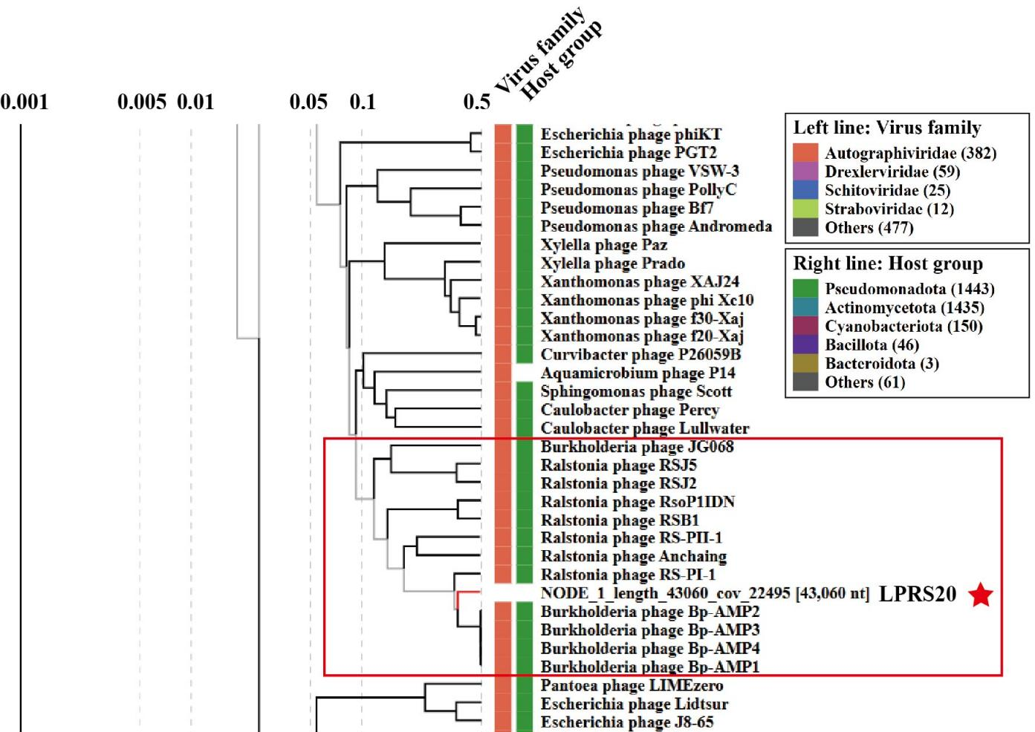

Fig. 1. ViPTree-based phylogenetic placement of Ralstonia phage LPRS20.
A Genome-wide tblastx distance analysis was performed using ViPTree [3], which is based upon Rohwer and Edwards Phage Proteomic Tree [4]. The candidate phage is indicated by a red star, and the phylogenetically related phages selected for VIRIDIC analysis are enclosed in a red box.

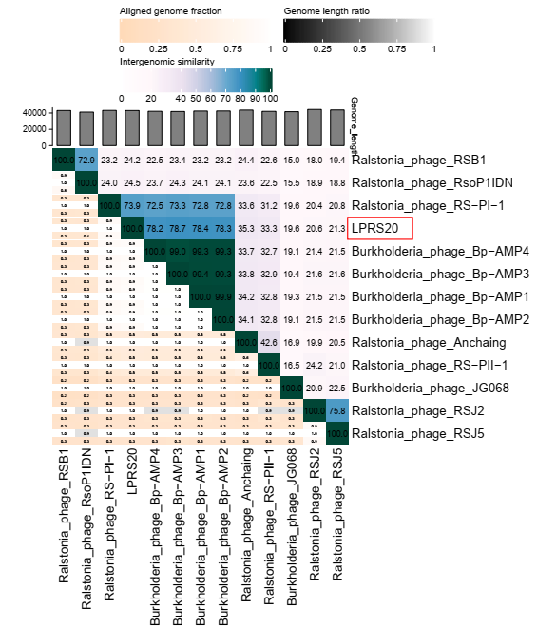

Fig. 2. VIRIDIC heat maps showing pairwise intergenomic similarities between the candidate Ralstonia phage LPRS20 and related reference phages selected based on ViPTree analysis. The candidate phage LPRS20 is indicated by red stars. The similarity values support the separation of the candidate phages from their closest species-level relatives using the 95% species demarcation threshold.

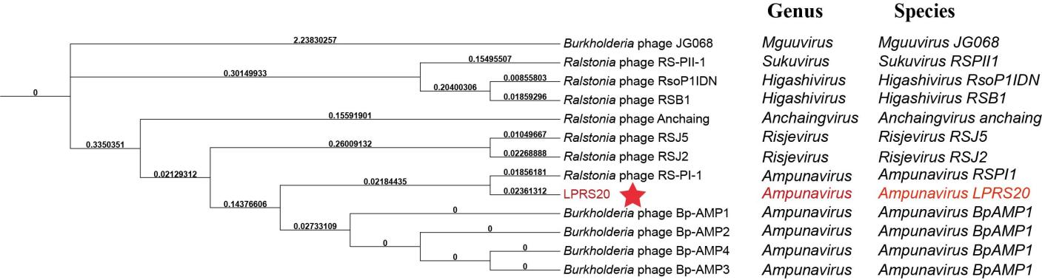
Fig. 3. Phylogenetic tree was constructed using the major capsid protein of phages selected based on ViPTree analysis. MUSCLE was used for multiple alignment and RAxML-NG was used for building phylogenetic tree using maximum-likelihood method with 500 bootstraps [6]. The candidate phage LPRS20 is indicated by a red star. LPRS20 and phages of genus Ampunavirus have been classified into the same clade.

Origin of the name of this taxon: The proposed species names are derived from the genus names and the isolate designations of the corresponding exemplar phages.

Historical aspects: Ralstonia phage LPRS20 was isolated by Jinquan Li’s group in 2022, Hubei, China.

Genome summary:
Phage name | INSDC | Size (kb) | GC% | Protein | tRNA
Ralstonia phage LPRS20 | PP895304 | 47.6 | 48.8 | 80 | 0

