

The International Committee on Taxonomy of Viruses
Taxonomy Proposal Form, 2026

Part 1a: Details of taxonomy proposals

Title: | Creating of one new genus, including one new species, in the family Hirszfeldviridae
Code assigned: | 2026.007B

Author(s), affiliation and email address(es):
Given name (+middle initial(s)) | Surname | Affiliation | Email address | Corr. author(s)
Marjan | Salahi | Laboratory Sciences Research Center, Golestan University of Medical Sciences, Gorgan,Iran | Marjansalahi1214@gmail.com
Ezzatollah | Ghaemi | Laboratory Sciences Research Center, Golestan University of Medical Sciences, Gorgan,Iran | eghaemi@yahoo.com | X
Samin | Zamani | Laboratory Sciences Research Center, Golestan University of Medical Sciences, Gorgan,Iran | samin.zamanii@gmail.com
Farhad | Nikkhahi | Medical Microbiology Research Center, Qazvin University of Medical Sciences, Qazvin, Iran | farhadnikkhahi@gmail.com

Part 1b: Taxonomy Proposal Submission
ICTV Subcommittee:
Animal DNA Viruses and Retroviruses |  | Bacterial viruses | X
Animal minus-strand and dsRNA viruses |  | Fungal and protist viruses
Animal positive-strand RNA viruses |  | Plant viruses
Archaeal viruses |  | General -

List the ICTV Study Group(s) that have seen or have been involved in creating this proposal:
Optional – complete only if formally voted on by an ICTV Study Group:
Study Group | Number of members
Study Group | Votes in support | Votes against | No vote

Submission date: | 24/08/2026

Part 1c: Feedback from ICTV Executive Committee (EC) meeting
Executive Committee Meeting Decision code: | X
A – Accept
Ac – Accept subject to revision by relevant subcommittee chair. No further vote required
U – Accept without revision but with re-evaluation and email vote by the EC
Uc – Accept subject to revision and re-evaluation and email vote by the EC
Ud – Deferred to the next EC meeting, with an invitation to revise based on EC comments
J - Reject
W - Withdrawn

Comments from the Executive Committee:

Part 1d: Revised Taxonomy Proposal Submission
Response of proposer:
Revision date:

Part 3: TAXONOMIC PROPOSAL

Taxonomic changes proposed:
Establish new taxon | X | Split taxon
Abolish taxon |  | Merge taxon
Move taxon |  | Promote taxon
Rename taxon |  | Demote taxon
Move and rename

Etymology (origin) of proposed taxonomic names:
Taxon name | Etymology of the term
Hyrcaniavirus | The name of the virus is derived from Hyrcanian, the Greek word for the historical name of present-day Gorgan, Golestan Province, Iran, where the sample virus was isolated.
gorganense | The suggested species name "gorganense" is derived from Gorgan, the city in Golestan Province, Iran, where the exemplar virus was isolated.

Permission for use of names derived from a living person:
Taxon name | Full name of person from whom the name is derived | Attached

Abstract of Taxonomy Proposal:
Description of current taxonomy:
The family Hirszfeldviridae consists of tailed double-stranded DNA bacteriophages classified under the class Caudoviricetes, which target bacteria belonging to the genus Acinetobacter. This family includes 22 genera and 49 species

Proposed taxonomic change(s):
We recommend the creation of a new genus, "Hyrcaniavirus", within the family Hirszfeldviridae, for one new species

Demarcation criteria for new taxon/taxa:
Genus demarcation criteria: An intergenomic similarity cut-off of 70%, a combination of average nucleotide identity and alignment fraction, was used to determine genera demarcation. Members of the same genus have >70% intergenomic similarity and cluster tightly in marker gene phylogenies.

Species demarcation criteria: A demarcation value of 95% intergenomic similarity was used to define different species according to intergenomic similarity. Members of the same genus have >95% intergenomic similarity

Justification:
On the basis of VIRIDIC, ViPTree, and Clinker analysis and in keeping with the demarcation criteria described above, we propose the creation of a new genus, “Hyrcaniavirus”, in the family Hirszfeldviridae for the new phage species “Hyrcaniavirus gorganense”. The species Obolenskvirus IME285 was identified as the closest currently classified taxon to the exemplar of “Hyrcaniavirus gorganense”, Acinetobacter phage Marjan1.

Text of Taxonomy proposal:
Description of current taxonomy:
The family Hirszfeldviridae consists of tailed double-stranded DNA bacteriophages classified under the class Caudoviricetes, which target bacteria belonging to the genus Acinetobacter. This family includes 22 genera and 49 species

Proposed taxonomic change(s):
We propose the establishment of a novel genus, "Hyrcaniavirus", within the family Hirszfeldviridae. The proposed genus currently contains a single species represented by the exemplar virus Acinetobacter phage Marjan1 (GenBank accession number PZ456952.1).

Demarcation criteria for new taxon/taxa:
Genus demarcation criteria: An intergenomic similarity cut-off of 70%, a combination of average nucleotide identity and alignment fraction, was used to determine genera demarcation. Members of the same genus have >70% intergenomic similarity and cluster tightly in marker gene phylogenies.

Species demarcation criteria: A demarcation value of 95% intergenomic similarity was used to define different species according to intergenomic similarity. Members of the same genus have >95% intergenomic similarity.

Justification:
The proposed genus assignment according to the genus demarcation criteria is supported by several independent genomic analyses. Comparative analyses identified different nearest neighbors, depending on the analytical approach. BLASTn retrieved Acinetobacter phages Staunch-TS1 and vB_AbaM_fThrA as the closest nucleotide matches [1]. The whole-genome phylogeny generated by VICTOR identified Staunch-TS1 as the closest relative to Marjan1 [2]. This relationship was supported by limited bootstrap values and was therefore analyzed alongside independent data from VIRIDIC, VipTree, TerL and MCP phylogenies as well as comparative genome organization.
VIRIDIC analysis identified IME285 as the classified virus with the highest inter-genomic nucleotide sequence similarity to Marjan1 (66.8%), while Staunch-TS1 and vB_AbaM_fThrA showed lower similarities of 48.3% and 51.4%, respectively [3]. Consequently, the current closest classified taxon is represented by Obolenskvirus IME285. Whole-proteome analysis using VipTree placed Acinetobacter phage Marjan1 within the family Hirszfeldviridae, clustering with its closest relatives while forming a distinct branch from currently recognized genera. Comparative tBLASTx genome visualization further demonstrated extensive protein-level homology between Acinetobacter phage Marjan1 and the closely related phages AB1 and Abp2, indicating conservation of the core genomic repertoire. However, numerous crossing alignments and discontinuous homologous blocks revealed substantial genome rearrangements and reduced synteny, reflecting extensive differences in gene order despite shared gene content. These observations indicate that Acinetobacter phage Marjan1 shares a conserved proteomic backbone with members of Hirszfeldviridae while possessing a distinct genomic organization, supporting its recognition as a separate evolutionary lineage [4].
Comparative genome organization generated using Clinker revealed conservation of the core structural and DNA-packaging modules together with multiple non-syntenic regions, genome rearrangements, and unique gene organizations relative to IME285 and the closely related unclassified phage Staunch-TS1[5]. These findings were independently supported by phylogenetic analyses of two conserved hallmark proteins, the large terminase subunit (TerL) and the major capsid protein (MCP), both of which recovered Acinetobacter phage Marjan1 as a distinct lineage [6, 7].
The complete annotated genome consists of Marjan1 is 44,957 base pairs with a GC content of 37.62% and encodes 85 predicted coding sequences (CDSs). Thirty-two proteins have been assigned putative biological functions, while fifty-three proteins are still considered hypothetical. No tRNA genes were detected (Table 1).
Collectively, evidence from BLASTn, VICTOR, VIRIDIC, VipTree, TerL and MCP phylogenies, together with comparative genome organization and the taxonomic delimitation criteria described above, support the establishment of the novel genus Hyrcaniavirus within the family Hirszfeldviridae to accommodate the proposed species Hyrcaniavirus gorganense.

References:
1.Sayers EW, Beck J, Bolton EE, Bourexis D, Brister JR, Canese K, et al. Database resources of the National Center for Biotechnology Information. Nucleic Acids Res. 2021;49(D1):D10-d7.
2.Meier-Kolthoff JP, Göker M. VICTOR: genome-based phylogeny and classification of prokaryotic viruses. Bioinformatics. 2017;33(21):3396-404.
3.Moraru C, Varsani A, Kropinski AM. VIRIDIC-A Novel Tool to Calculate the Intergenomic Similarities of Prokaryote-Infecting Viruses. Viruses. 2020;12(11).
4. Nishimura Y, Yoshida T, Kuronishi M, Uehara H, Ogata H, Goto S. ViPTree: the viral proteomic tree server. Bioinformatics. 2017;33(15):2379-80.
5. Gilchrist CLM, Chooi YH. clinker & clustermap.js: automatic generation of gene cluster comparison figures. Bioinformatics. 2021;37(16):2473-5.
6. Lemoine F, Correia D, Lefort V, Doppelt-Azeroual O, Mareuil F, Cohen-Boulakia S, Gascuel O. NGPhylogeny.fr: new generation phylogenetic services for non-specialists. Nucleic Acids Res. 2019;47(W1):W260-w5.
7.Minh BQ, Schmidt HA, Chernomor O, Schrempf D, Woodhams MD, von Haeseler A, Lanfear R. IQ-TREE 2: New Models and Efficient Methods for Phylogenetic Inference in the Genomic Era. Mol Biol Evol. 2020;37(5):1530-4.
- Turner D, Kropinski AM, Adriaenssens EM. A Roadmap for Genome-Based Phage Taxonomy. Viruses. 2021 Mar 18;13(3):506. doi: 10.3390/v13030506. PMID: 33803862; PMCID: PMC8003253.
- Siddell SG, Walker PJ, Lefkowitz EJ, Mushegian AR, Dutilh BE, Harrach B, Harrison RL, Junglen S, Knowles NJ, Kropinski AM, Krupovic M, Kuhn JH, Nibert ML, Rubino L, Sabanadzovic S, Simmonds P, Varsani A, Zerbini FM, Davison AJ. Binomial nomenclature for virus species: a consultation. Arch Virol. 2020 Feb;165(2):519-525. doi: 10.1007/s00705-019-04477-6. Erratum in: Arch Virol. 2020 May;165(5):1263-1264. doi: 10.1007/s00705-020-04555-0. PMID: 31797129; PMCID: PMC7026202.
- International Committee on Taxonomy of Viruses (ICTV). Taxonomy Proposal id=202523058: Obolenskvirus IME285. Approved ICTV Taxonomy Proposal. Available from: ICTV Approved Taxonomy Proposals.

Accompanying files:
Filename | Description of contents

Tables, Figures:

<Start here>

Table 1. Characteristics of the phages described in the proposal
Phage name | Host | Morphotype | Lifestyle | Accession No. | Genome size | No. proteins | No. tRNA
Acinetobacter phage Marjan1 | Acinetobacter baumannii | Siphovirus | Lytic | Pz459652.1 | 44957 | 85 | 0

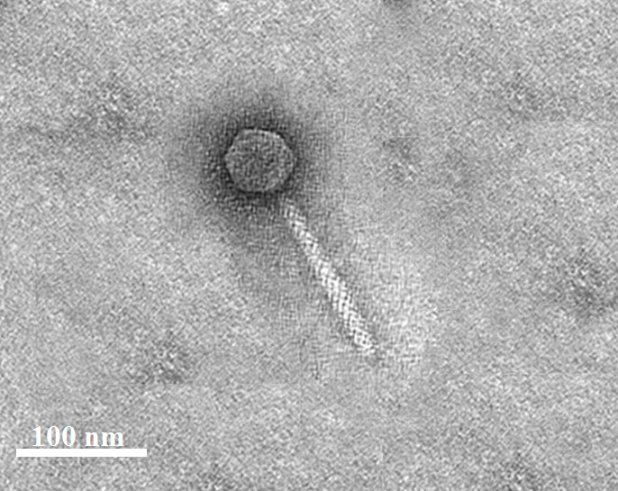

Figure 1. Transmission electron micrograph of Acinetobacter phage Marjan1. The virion displays an icosahedral head along with a contractile tail, which aligns with the morphological traits typical of the Caudoviricetes class. Scale bar = 100 nm.

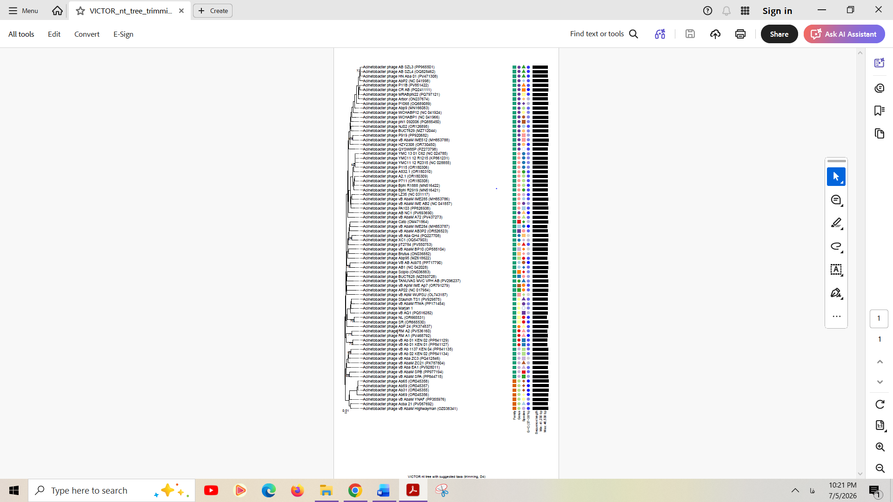
Figure 2. The whole-genome phylogeny of Acinetobacter phage Marjan1 and representative members of the family Hirszfeldviridae was inferred using the VICTOR pipeline, which is based on Genome-BLAST Distance Phylogeny (GBDP). Acinetobacter phage Marjan1 (highlighted in red) establishes a distinct lineage within the family, with Acinetobacter phage Staunch-TS1 being its closest sister lineage. The lengths of the branches are proportional to genomic distances, and the support values for the branches are indicated at the respective nodes. Colored bars represent the proposed taxonomic classifications at the family, genus, and species levels.
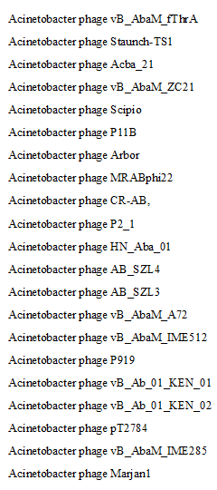
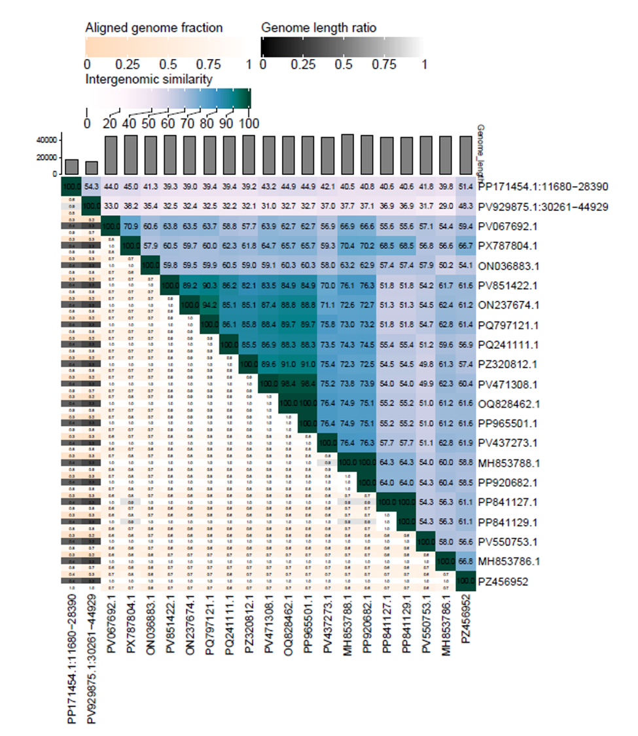
Figure 3. VIRIDIC heat map: VIRIDIC (Virus Intergenomic Distance Calculator; http://rhea.icbm.uni-oldenburg.de/VIRIDIC/). pairwise intergenomic similarity matrix was produced using VIRIDIC. The percentage of intergenomic similarities between Acinetobacter phage Marjan1 and representative closely related phages is presented based on the VIRIDIC genome-based comparison algorithm. Acinetobacter phage Marjan1 (GenBank accession number PZ456952.1).

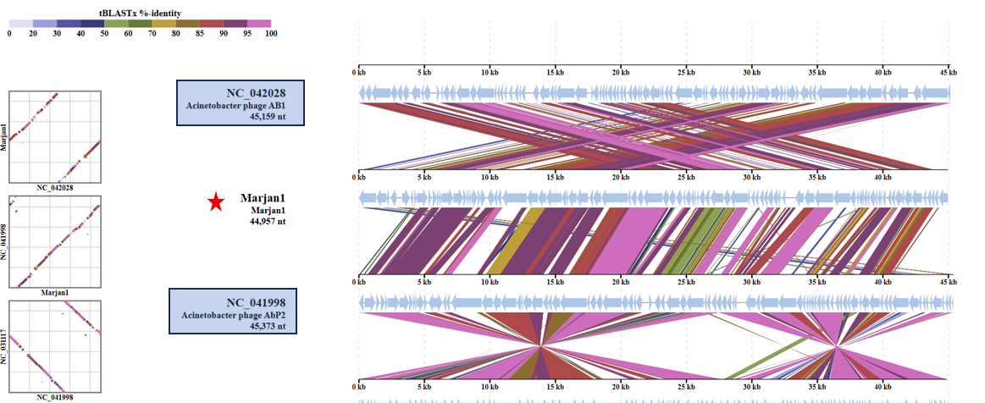
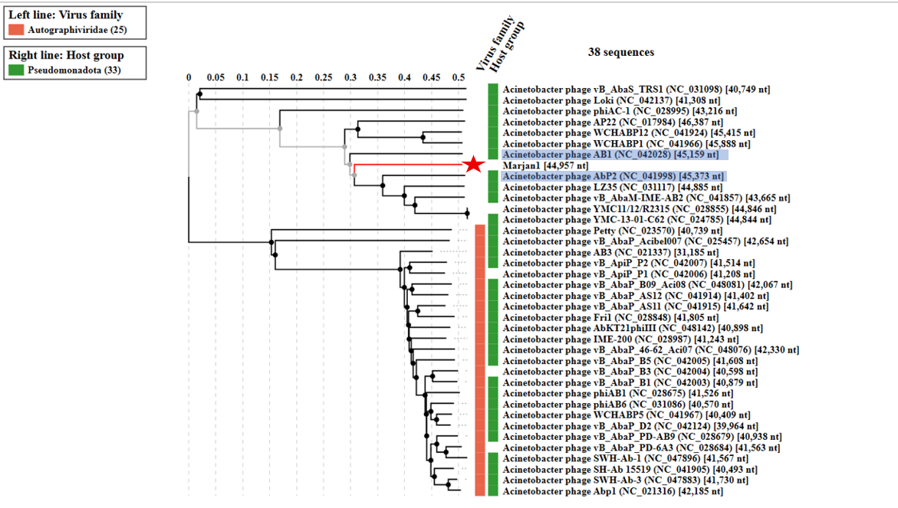

Figure 4. ViPTree analysis: ViPTree analysis (https://www.genome.jp/viptree/) is based upon Rohwer and Edwards (2002) Phage Proteomic Tree. The phage of interest is indicated with a red star. Current species in the Hirszfeldviridae family are marked in blue highlight.

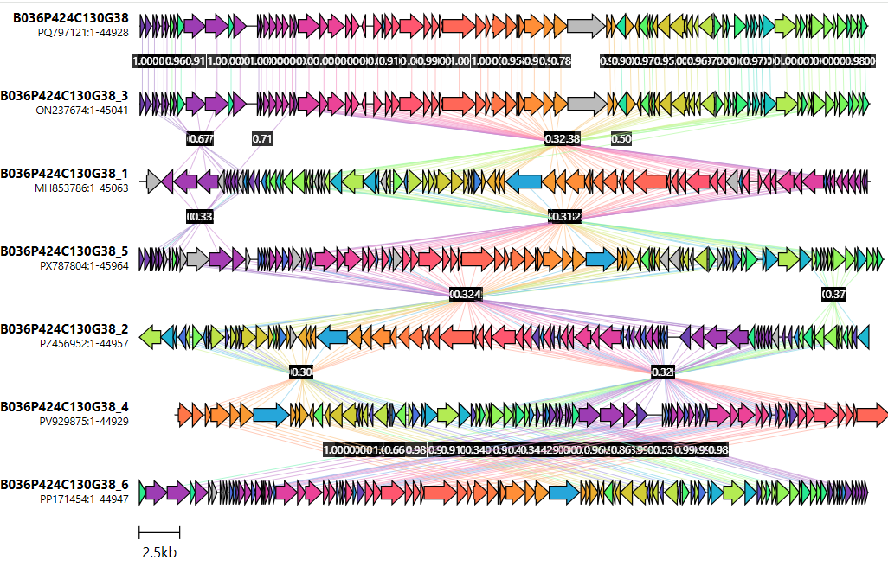
Acinetobacter phage Staunch-TS1
Acinetobacter phage Marjan1
Acinetobacter phage MRABphi22
Acinetobacter phage vB_AbaM_fThrA
Acinetobacter phage vB_AbaM_ZC21
Acinetobacter phage vB_AbaM_IME285
Acinetobacter phage Arbor

Figure 5. Comparative genome organization of Acinetobacter phage Marjan1 and representative closely related phages generated using Clinker. Conserved homologous proteins are connected by shaded links, with shading intensity corresponding to amino acid sequence identity.

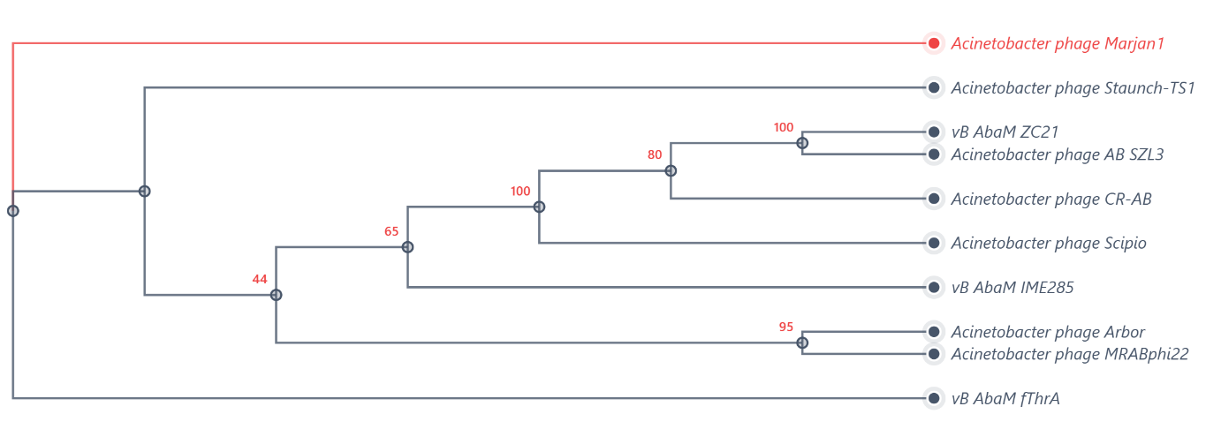
Figure 6. Phylogenetic tree inferred from the large terminase subunit (TerL) amino acid sequences of Acinetobacter phage Marjan1 and representative related phages. Bootstrap support values are indicated at the corresponding nodes.

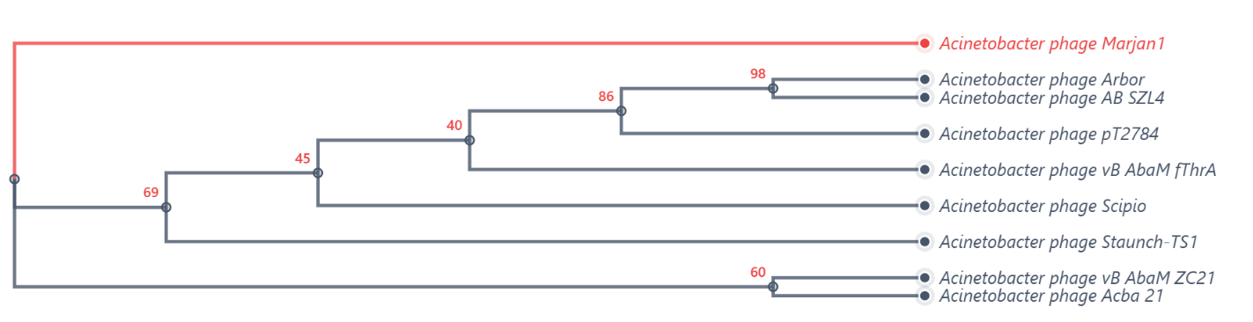

Figure 7. Phylogenetic tree inferred from the major capsid protein (MCP) amino acid sequences of Acinetobacter phage Marjan1 and representative related phages. Bootstrap support values are indicated at the corresponding nodes.

