

The International Committee on Taxonomy of Viruses
Taxonomy Proposal Form, 2026

Part 1a: Details of taxonomy proposals

Title: | Create two new families of bacterial viruses; Absconditiviridae and Methylophiliviridae, within the class Caudoviricetes
Code assigned: | 2026.006B

Author(s), affiliation and email address(es):
Given name (+middle initial(s)) | Surname | Affiliation | Email address | Corr. author(s)
Yifan | Zhou | Department of Marine Microbiology and Biogeochemistry, Royal Netherlands Institute for Sea Research (NIOZ), Texel, The Netherlands | yifan.zhou@nioz.nl | X
Ana | Gutiérrez-Preciado | Ecologie Systématique Evolution, CNRS, Université Paris-Saclay, AgroParisTech, Gif-sur-Yvette, France | ana.gutierrez@universite-paris-saclay.fr
David | Moreira | Ecologie Systématique Evolution, CNRS, Université Paris-Saclay, AgroParisTech, Gif-sur-Yvette, France | david.moreira@universite-paris-saclay.fr
Purificación | López-García | Ecologie Systématique Evolution, CNRS, Université Paris-Saclay, AgroParisTech, Gif-sur-Yvette, France | puri.lopez@universite-paris-saclay.fr
Mart | Krupovic | Institut Pasteur, Université Paris Cité, CNRS UMR6047, Cell Biology and Virology of Archaea Unit, Paris, France | mart.krupovic@pasteur.fr

Part 1b: Taxonomy Proposal Submission
ICTV Subcommittee:
Animal DNA Viruses and Retroviruses |  | Bacterial viruses | X
Animal minus-strand and dsRNA viruses |  | Fungal and protist viruses
Animal positive-strand RNA viruses |  | Plant viruses
Archaeal viruses |  | General -

List the ICTV Study Group(s) that have seen or have been involved in creating this proposal:
Optional – complete only if formally voted on by an ICTV Study Group:
Study Group | Number of members
Study Group | Votes in support | Votes against | No vote

Submission date:

Part 1c: Feedback from ICTV Executive Committee (EC) meeting
Executive Committee Meeting Decision code: | X
A – Accept
Ac – Accept subject to revision by relevant subcommittee chair. No further vote required
U – Accept without revision but with re-evaluation and email vote by the EC
Uc – Accept subject to revision and re-evaluation and email vote by the EC
Ud – Deferred to the next EC meeting, with an invitation to revise based on EC comments
J - Reject
W - Withdrawn

Comments from the Executive Committee:

Part 1d: Revised Taxonomy Proposal Submission
Response of proposer:
Revision date:

Part 3: TAXONOMIC PROPOSAL
https://ictv.global/taxonomy/templates

Taxonomic changes proposed:
Establish new taxon | X | Split taxon
Abolish taxon |  | Merge taxon
Move taxon |  | Promote taxon
Rename taxon |  | Demote taxon
Move and rename

Etymology (origin) of proposed taxonomic names:
Taxon name | Etymology of the term
Absconditiviridae | From Absconditicoccaceae, referring to the predicted host family.
Strigavirus | From Strigamonas, referring to the predicted host genus.
Strigavirus rivuli | Species epithet is derived from Latin rivulus, meaning “brooks” or “small streams of water”, source of isolation/sequencing.
Methylophiliviridae | From Methylophilaceae, referring to the predicted host family.
Stagnivirus | From Latin stagni, meaning “of the pond”, referring to the source of isolation/sequencing.
Stagnivirus temperatum | Species epithet is derived from “temperate”. The virus species encodes an integrase and an excisionase and thus is likely to be a temperate virus.

Permission for use of names derived from a living person:
Taxon name | Full name of person from whom the name is derived | Attached

Abstract of Taxonomy Proposal:
Description of current taxonomy:
Class Caudoviricetes comprises 129 families of head-tailed viruses of archaea and bacteria. Currently, there is no virus family established to classify head-tailed viruses infecting members of bacterial families Absconditicoccaceae and Methylophilaceae.

Proposed taxonomic change(s):
We propose creating two new families, “Absconditiviridae” and “Methylophiliviridae”, within the class Caudoviricetes, for classification of head-tailed bacteriophages predicted to infect bacteria of the family Absconditicoccaceae and the family Methylophilaceae, respectively.

Demarcation criteria for new taxon/taxa:
We propose using 95% nucleotide identity as a species demarcation threshold. For family demarcation, we suggest that viruses classified into the family “Absconditiviridae” or “Methylophiliviridae” share at least 50% of their proteins (≥30% identity) with the respective exemplar virus.

Justification:
Comparative genomics and viral proteomic tree analysis both showed the distinctiveness of Mare Gabard Methylophilaceae tailed phage 1 (MG-MTP1) and Ru Sainte Anne Absconditicoccaceae tailed phage 1 (RSA-ATP1), which are only remotely related to all other known head-tailed bacteriophages. Therefore, MG-MTP1 and RSA-ATP1 can be considered as founding representatives of two new families.

- Text of Taxonomy proposal:

Description of current taxonomy:
Class Caudoviricetes comprises 129 families of head-tailed viruses of archaea and bacteria. These viruses encode four hallmark genes: a HK97-fold major capsid protein (MCP), a capsid maturation protease, a portal protein, and the genome packaging terminase (Krupovic and Koonin 2026).

Proposed taxonomic change(s):
We propose creating two new families, “Absconditiviridae” and “Methylophiliviridae”, within the class Caudoviricetes, for classification of head-tailed bacteriophages predicted to infect bacteria of the family Absconditicoccaceae and the family Methylophilaceae, respectively. “Absconditiviridae” includes one genus “Strigavirus”, which has one virus species “Strigavirus rivuli”. “Methylophiliviridae” includes one genus “Stagnivirus”, which contains one virus species “Stagnivirus temperatum”.

Demarcation criteria for new taxon/taxa:
We propose using 95% nucleotide identity as a species demarcation threshold, to be consistent with the classification of other bacterial and archaeal viruses in the class Caudoviricetes. For family demarcation, we suggest that viruses classified into the family “Absconditiviridae” or “Methylophiliviridae” share at least 50% of their proteins (≥30% identity) with the respective exemplar virus. Both proposed families currently include only one virus representative, thus genus demarcation threshold is to be determined in the future as more members of “Absconditiviridae” or “Methylophiliviridae” are discovered.

Justification:
The methylotrophic bacteria from the family Methylophilaceae were found to be relative abundant in the prokaryotic communities of two small freshwater ecosystems, the Ru Sainte Anne brook (RSA) and the Mare Gabard pond (MG) (David, López-García et al. 2021). In addition, ultra small parasitic patescibacteria were found to co-occur with members of Methylophilaceae in these systems, suggesting potential parasite-host relationship (Bouderka, López-García et al. 2026). To explore the possible Patescibacteriota-Methylophilaceae interactions, water samples from RAS and MG were collected to establish enrichment cultures (Bouderka, López-García et al. 2026). As the enrichments could have contained many other bacteria, fluorescence-activated cell sorting (FACS) was performed to further enrich the potential patescibacteria-Methylophilaceae consortia from both MG and RSA samples. To identify the members of these consortia, whole genomic DNA amplification and Illumina-sequencing were carried out for five FACS-sorted samples (three from RSA and two from MG). Results showed that these five mini-metagenomes were dominated by sequences from bacterial families of Absconditicoccaceae (Patescibacteriota) and Methylophilaceae. Genome annotation suggested that the Absconditicoccaceae species lacked many essential biosynthetic pathways, including the complete biosynthesis of phospholipids, amino acids, and nucleic acids, implying that the MG and RSA Absconditicoccaceae members likely grow as parasites dependent on a Methylophilaceae host (Bouderka, López-García et al. 2026).

Besides the cellular genomes, the five mini-metagenomes yielded 84 putative viral contigs larger than 5 kb, with two (39,071 bp and 40,030 bp) being predicted as complete genomes of head-tailed bacteriophages (Bouderka, López-García et al. 2026). Phylogenomic analyses using ViPTree showed that the two bacteriophages (RSA-ATP1 and MG-MTP1, see below) are not closely related to any of the previously classified viruses and thus can be considered founding representatives of two new families (Fig. 1).

Family “Absconditiviridae”
This family includes one virus, RSA-ATP1, which we propose classifying into a species “Strigavirus rivuli” within a new genus “Strigavirus”. The complete RSA-ATP1 genome (39,071 bp, Fig. 2) was assembled from RSA mini-metagenomes. Interestingly, its Caudoviricetes-signature proteins, such as portal and the large terminase subunit, could be predicted only with code 25 (i.e., the regular stop codon UGA is translated to glycine), which is also used by members of Absconditicoccaceae (Campbell, O'Donoghue et al. 2013). In total, 60% (39/65) of ORFs in this genome contained internal UGA codons and, accordingly, were disrupted when translated using the genetic code 11 (Fig. 3), strongly suggesting that this virus is associated with an Absconditicoccaceae host. Consistently, RSA-ATP1 proteins yielded significant hits (>30% identity and E-value <1E-15) to Patescibacteriota proteins in the NCBI nr database (Bouderka, López-García et al. 2026). Genomic neighborhood analysis of the corresponding hits allowed identification of two intact prophages, integrated in the genomes of uncultured Absconditicoccaceae from the human oral microbiota (MPSQ01000001 and JABCNX020000008; Fig. 4). Notably, similar to RSA-ATP1, many genes in the two prophages contained the internal UGA codons, and thus, the corresponding proteins could be translated only using the genetic code 25 (Fig. 3). Together, the results suggest that RSA-ATP1 infects an Absconditicoccaceae host. Accordingly, this bacteriophage was designated as Ru Sainte Anne Absconditicoccaceae tailed phage 1 (RSA-ATP1).

Only ~30% of the RSA-ATP1 genes could be functionally annotated using sensitive profile-profile comparisons with HHsearch. Besides the core virion morphogenesis proteins, this virus encodes a number of proteins involved in homologous recombination, including homologs of phage lambda proteins NinB, NinG, Exo, and Bet (Casjens and Hendrix 2015). Although no potential auxiliary metabolic genes could be detected in the RSA-ATP1 genome, this virus carries four tRNA genes (Fig. 2). Remarkably, in addition to tRNA-Met(CAT), tRNA-Arg(TCT), and tRNA-Leu(TAA), it encodes the suppressor tRNA-Gly^{sup}(TCA), which reassigns the UGA stop codon to glycine. Notably, suppressor tRNAs have been previously described to be widespread in bacteriophages with large genomes (100–600 kb) that infect host with the standard genetic code (Borges, Lou et al. 2022). To our knowledge, RSA-ATP1 is the first patescibacterial phage encoding a tRNA-Gly^{sup}(TCA) gene reported so far.

Family “Methylophiliviridae”
This family is represented by one virus, MG-MTP1, which we propose classifying into the species “Stagnivirus temperatum” within a new genus “Stagnivirus”. The complete MG-MTP1 genome (40,030 bp; Fig. 5) was assembled from MG mini-metagenomes and found to be related to prophages present in the chromosomes of Pseudomonas chlororaphis and Sphingomonas oryzagri (Fig. 6), two proteobacterial species from the phylum Pseudomonadota, to which Methylophilaceae also belongs. The genome encodes the hallmark proteins of head-tailed bacteriophages (class Caudoviricetes), including the large terminase subunit, portal protein, and HK97-fold MCP. Therefore, this genome was denoted as Mare Gabard Methylophilaceae tailed phage 1 (MG-MTP1). Notably, MG-MTP1 also encodes homologs of the T7 and P22 tail proteins (Fig. 5), suggesting that it has a podovirus morphology, that is, icosahedral head and short tail. Besides, this phage encodes an integrase and an excisionase and thus is likely to be a temperate virus, similar to the related prophages (Fig. 5).

References:
Borges, A. L., Y. C. Lou, R. Sachdeva, B. Al-Shayeb, P. I. Penev, A. L. Jaffe, S. Lei, J. M. Santini and J. F. Banfield (2022). "Widespread stop-codon recoding in bacteriophages may regulate translation of lytic genes." Nat Microbiol 7(6): 918–927.
Bouderka, F., P. López-García, P. Deschamps, Y. Zhou, M. Krupovic, A. Gutiérrez-Preciado, M. Ciobanu, P. Bertolino, G. David, D. Moreira and L. Jardillier (2026). "Parasitic connections: a patescibacterial epibiont, its methylotrophic gammaproteobacterial host, and their phages." mBio 17(4): e0002526.
Campbell, J. H., P. O'Donoghue, A. G. Campbell, P. Schwientek, A. Sczyrba, T. Woyke, D. Söll and M. Podar (2013). "UGA is an additional glycine codon in uncultured SR1 bacteria from the human microbiota." Proc Natl Acad Sci U S A 110(14): 5540–5545.
Casjens, S. R. and R. W. Hendrix (2015). "Bacteriophage lambda: Early pioneer and still relevant." Virology 479-480: 310–330.
David, G. M., P. López-García, D. Moreira, B. Alric, P. Deschamps, P. Bertolino, G. Restoux, E. Rochelle-Newall, E. Thébault, M. Simon and L. Jardillier (2021). "Small freshwater ecosystems with dissimilar microbial communities exhibit similar temporal patterns." Mol Ecol 30(9): 2162–2177.
Krupovic, M. and E. V. Koonin (2026). "Organization and evolution of the virosphere and the replicator space." Comptes Rendus. Biologies 349: 35–75.
Liu, J., A. L. Jaffe, L. Chen, B. Bor and J. F. Banfield (2023). "Host translation machinery is not a barrier to phages that interact with both CPR and non-CPR bacteria." mBio 14(6): e0176623.
Pratama, A. A., O. Pérez-Carrascal, M. B. Sullivan and K. Küsel (2026). "Diversity and ecological roles of hidden viral players in groundwater microbiomes." Nat Commun 17(1).
Zhong, Q., B. Liao, J. Liu, W. Shen, J. Wang, L. Wei, Y. Ma, P. T. Dong, B. Bor, J. S. McLean, Y. Chang, W. Shi, L. Cen, M. Wu, J. Liu, Y. Li, X. He and S. Le (2024). "Episymbiotic Saccharibacteria TM7x modulates the susceptibility of its host bacteria to phage infection and promotes their coexistence." Proc Natl Acad Sci U S A 121(16): e2319790121.

Accompanying files:
Filename | Description of contents

Tables, Figures:

Table 1. Proposed new taxonomy and virus representatives
Family | Genus | Species | Virus name | GenBank accession | Genome size, bp
Absconditiviridae | Strigavirus | Strigavirus rivuli | RSA-ATP1 | PV524675 | 39071
Methylophiliviridae | Stagnivirus | Stagnivirus temperatum | MG-MTP1 | PV524676 | 40030
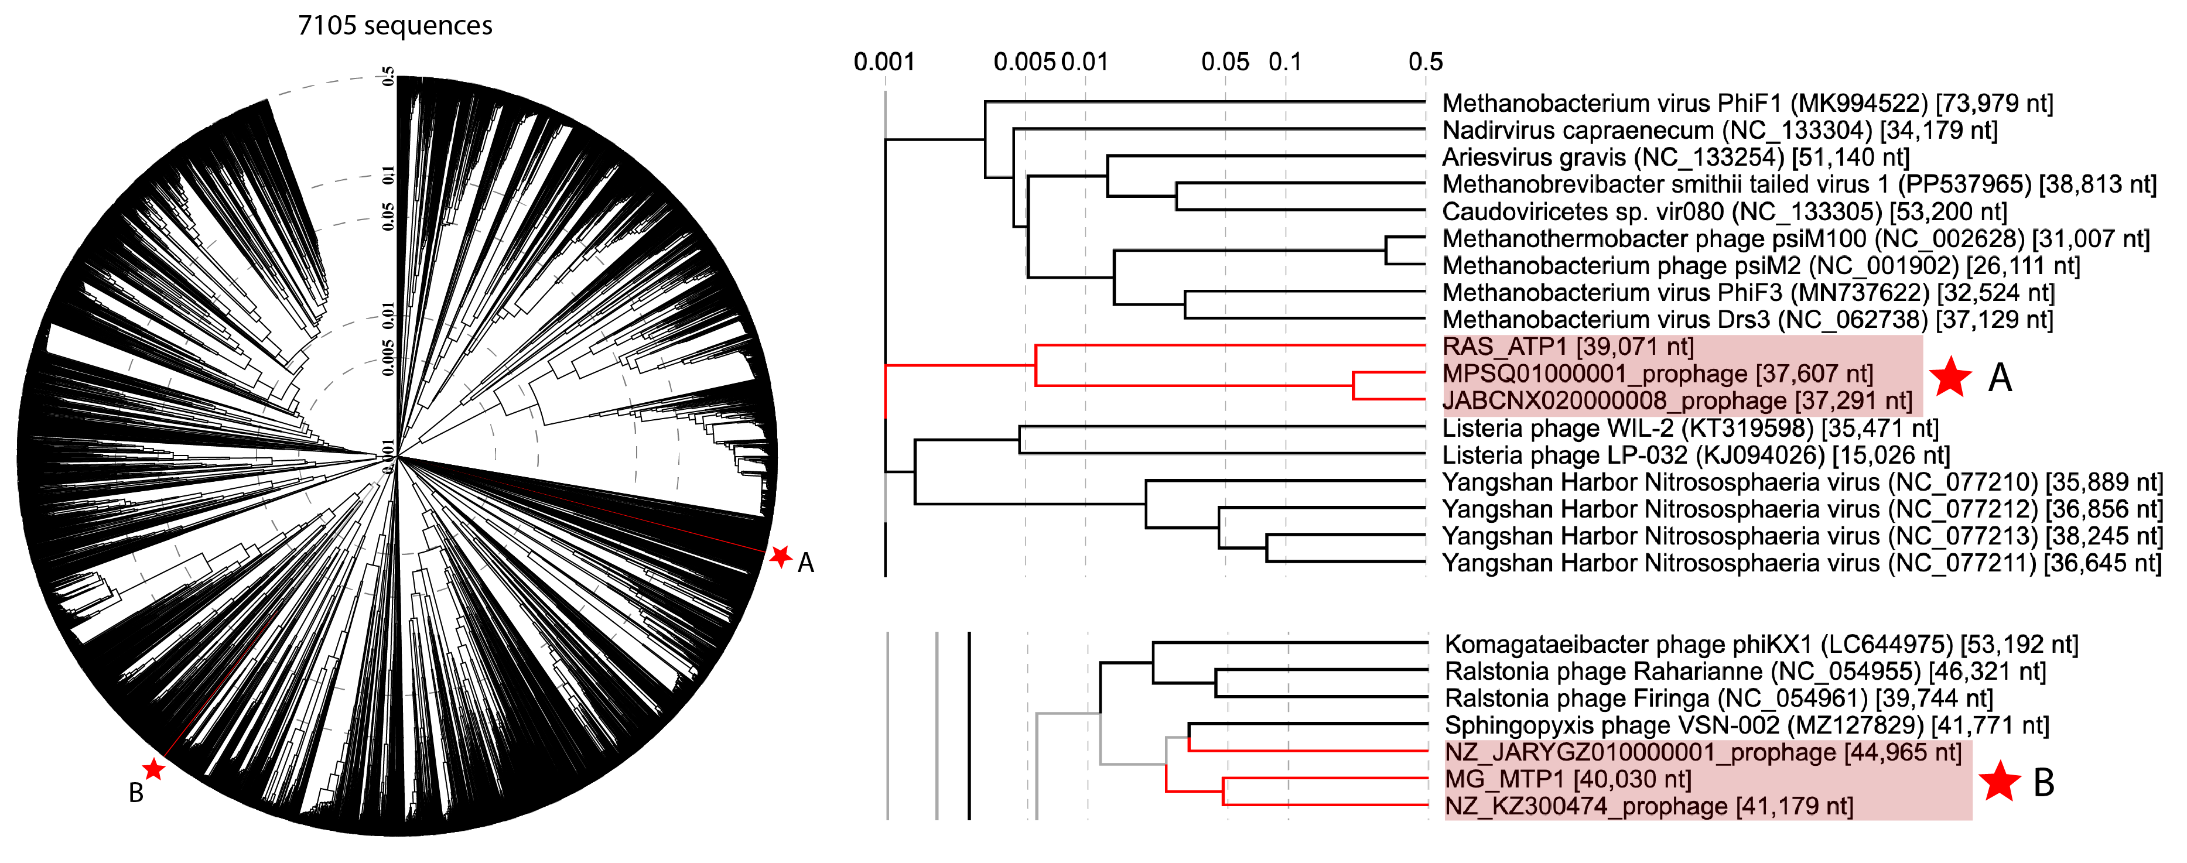Fig. 1. The left panel shows the whole genome-wide proteomic tree of 7105 sequences prokaryotic dsDNA viruses (including 7099 references from Virus-Host DB (genome.jp/virushostdb/) and RSA-ATP1, MG-MTP1 and related prophages (Bouderka, López-García et al. 2026). The right panel shows the zoom-in branches corresponding to RSA-ATP1 and its two related prophages (A) and MG-MTP1 and its two related prophages (B). The tree was based on all-versus-all proteomic similarity matrices and mid-point rooted. Branch lengths are log-scaled. In the case of Caudoviricetes, the branch length of 0.05 is commonly taken as a family-level demarcation.

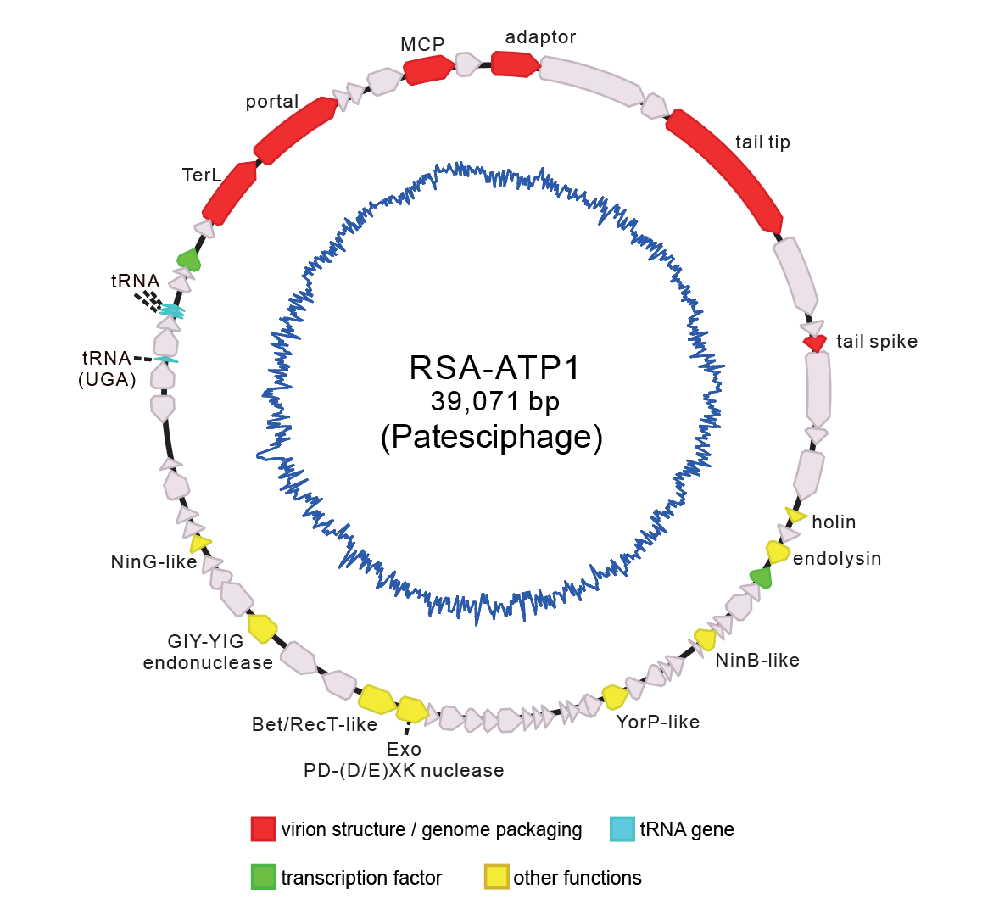
Fig. 2. Circular genome map of the bacteriophage RSA-ATP1. Genes with unknown functions are shown in gray. The inner blue lines show the GC skew of the genome.

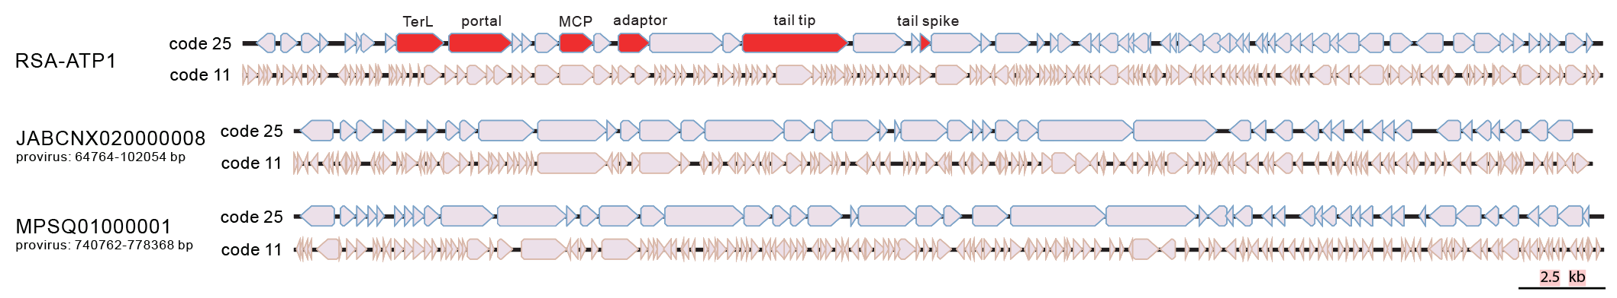
Fig. 3. Genome diagrams of RSA-ATP1 and two related prophages with genes predicted using code 25 (top) and 11 (bottom). RSA-ATP1 genes involved in virion morphogenesis are highlighted in red. The two prophages of Absconditabacteria are indicated with the GenBank accession numbers and the exact nucleotide coordinates.

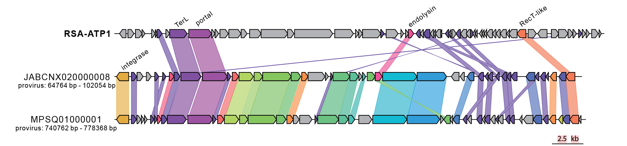Fig. 4. Gene content comparison between RSA-ATP1 and two related prophages of Patescibacteria found in the human oral microbiome. All prophages are indicated with the corresponding genome accession numbers and exact nucleotide coordinates. Genes sharing over 20% identity are linked by shadings of the matching colors.

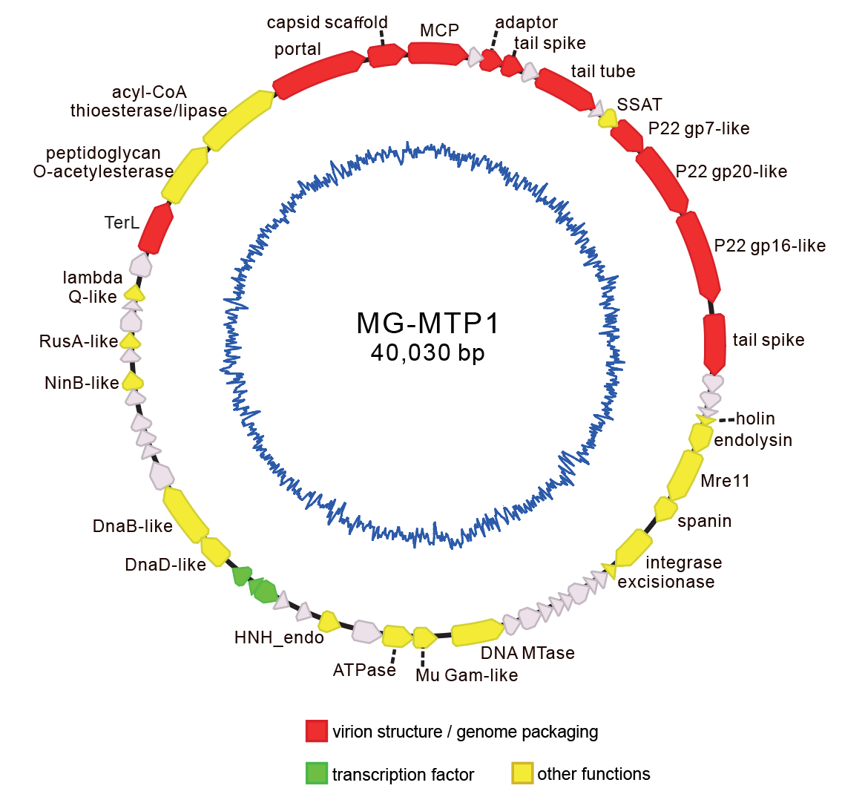
Fig. 5. Circular genome map of the bacteriophage MG-MTP1. Genes with unknown functions are shown in gray. The inner blue lines show the GC skew of the genome.

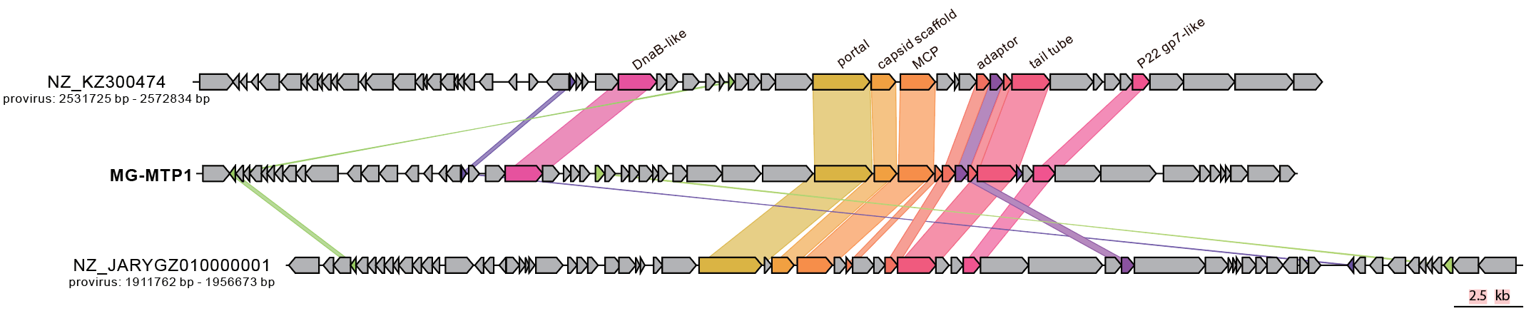
Fig. 6. Gene content comparison between MG-MTP1 and two closely related prophages of Pseudomonadota. All prophages are indicated with the corresponding genome accession numbers and exact nucleotide coordinates. Genes sharing over 20% identity are linked by shadings of the matching colors.

