

The International Committee on Taxonomy of Viruses
Taxonomy Proposal Form, 2026

Part 1a: Details of taxonomy proposals

Title: | Create one new species in the genus Serkorvirus (class Caudoviricetes, order Autographivirales, family Autotranscriptaviridae)
Code assigned: | 2026.005B

Author(s), affiliation and email address(es):
Given name (+middle initial(s)) | Surname | Affiliation | Email address | Corr. author(s)
Bo | Liu | Xiamen Canco Biotech Co., Xiamen, China | liubo143@qq.com | ×

Part 1b: Taxonomy Proposal Submission
ICTV Subcommittee:
Animal DNA Viruses and Retroviruses |  | Bacterial viruses | X
Animal minus-strand and dsRNA viruses |  | Fungal and protist viruses
Animal positive-strand RNA viruses |  | Plant viruses
Archaeal viruses |  | General -

List the ICTV Study Group(s) that have seen or have been involved in creating this proposal:
Bacterial Viruses Study Groups, Regional Representative

Optional – complete only if formally voted on by an ICTV Study Group:
Study Group | Number of members
Study Group | Votes in support | Votes against | No vote

Submission date: | 22/04/2026

Part 1c: Feedback from ICTV Executive Committee (EC) meeting
Executive Committee Meeting Decision code: | X
A – Accept
Ac – Accept subject to revision by relevant subcommittee chair. No further vote required
U – Accept without revision but with re-evaluation and email vote by the EC
Uc – Accept subject to revision and re-evaluation and email vote by the EC
Ud – Deferred to the next EC meeting, with an invitation to revise based on EC comments
J - Reject
W - Withdrawn

Comments from the Executive Committee:

Part 1d: Revised Taxonomy Proposal Submission
Response of proposer:
Revision date:

Part 3: TAXONOMIC PROPOSAL
https://ictv.global/taxonomy/templates

Taxonomic changes proposed:
Establish new taxon | X | Split taxon
Abolish taxon |  | Merge taxon
Move taxon |  | Promote taxon
Rename taxon |  | Demote taxon
Move and rename

Etymology (origin) of proposed taxonomic names:
Taxon name | Etymology of the term

Permission for use of names derived from a living person:
Taxon name | Full name of person from whom the name is derived | Attached

Abstract of Taxonomy Proposal:
Description of current taxonomy:
The bacteriophage described in this proposal is currently unclassified. The genus Serkorvirus was established in 2019 (proposal 2019.103B) and includes five species.

Proposed taxonomic change(s):
We propose one new species in the genus Serkorvirus to be named Serkorvirus canco.

Demarcation criteria for new taxon/taxa:
Species demarcation criteria: Two phages are assigned to the same species if their genomes are more than 95% identical over their genome length for isolates. These values can be calculated by a number of tools, such as BLASTn – usually determined using intergenomic distance calculator VIRIDIC.

Genus demarcation criteria: In search for criteria that create cohesive and distinct genera that are reproducible and monophyletic, the Bacterial Viruses Subcommittee has established 70% nucleotide identity of the genome length as the cut-off for genera. Genus-level groupings should always be monophyletic in the signature genes, as tested with a phylogenetic tree.

Justification:
We isolated a new Ralstonia phage from the soil of Xiamen named Ralstonia phage 10RS305A.
Analysis of the genome using ViPTree placed this phage within the genus Serkorvirus in the family Autotranscriptaviridae. Comparison of intergenomic nucleotide sequence similarity to existing species in this genus demonstrated that Ralstonia phage 10RS305A represents a new species in accordance with the current demarcation criteria. In summary, we propose Ralstonia phage 10RS305A represents a new species, Serkorvirus canco.

- Text of Taxonomy proposal:

Description of current taxonomy:
The bacteriophage described in this proposal is currently unclassified. The genus Serkorvirus was established in 2019 (proposal 2019.103B) and includes five species.

Proposed taxonomic change(s):
We propose one new species in the genus Serkorvirus to be named Serkorvirus canco.

Demarcation criteria for new taxon/taxa:
Species demarcation criteria: Two phages are assigned to the same species if their genomes are more than 95% identical over their genome length for isolates. These values can be calculated by a number of tools, such as BLASTn – usually determined using intergenomic distance calculator VIRIDIC.

Genus demarcation criteria: In search for criteria that create cohesive and distinct genera that are reproducible and monophyletic, the Bacterial Viruses Subcommittee has established 70% nucleotide identity of the genome length as the cut-off for genera. Genus-level groupings should always be monophyletic in the signature genes, as tested with a phylogenetic tree.

Justification:
We isolated a new Ralstonia phage from the soil of Xiamen named Ralstonia phage 10RS305A.
Analysis of the genome using ViPTree placed this phage within the genus Serkorvirus in the family Autotranscriptaviridae (Figure 1). Comparison of intergenomic nucleotide sequence similarity to existing species (Figure 2) in this genus demonstrated that Ralstonia phage 10RS305A represents a new species in accordance with the current demarcation criteria. This clustering is also reflected in the phylogenetic tree of the major capsid protein (Figure 3). In summary, we propose Ralstonia phage 10RS305A represents a new species, Serkorvirus canco.
References:
1: Moraru C, Varsani A, Kropinski AM. VIRIDIC-A Novel Tool to Calculate the Intergenomic Similarities of Prokaryote-Infecting Viruses. Viruses. 2020 Nov 6;12(11):1268. doi: 10.3390/v12111268. PMID: 33172115.
2: Turner D, Kropinski AM, Adriaenssens EM. A Roadmap for Genome-Based Phage Taxonomy. Viruses. 2021 Mar 18;13(3):506. doi: 10.3390/v13030506. PMID: 33803862.
3: Nishimura Y, Yoshida T, Kuronishi M, Uehara H, Ogata H, Goto S. ViPTree: the viral proteomic tree server. Bioinformatics. 2017 Aug 1;33(15):2379-2380. doi: 10.1093/bioinformatics/btx157. PMID: 28379287.
4: Rohwer F, Edwards R. The Phage Proteomic Tree: a genome-based taxonomy for phage. J Bacteriol. 2002 Aug;184(16):4529-35. doi: 10.1128/jb.184.16.4529-4535.2002. PMID: 12142423.
5: Dereeper A, Guignon V, Blanc G, Audic S, Buffet S, Chevenet F, Dufayard JF, Guindon S, Lefort V, Lescot M, Claverie JM, Gascuel O. Phylogeny.fr: robust phylogenetic analysis for the non-specialist. Nucleic Acids Res. 2008;36(Web Server issue):W465-9. doi: 10.1093/nar/gkn180. Epub 2008 Apr 19. PMID: 18424797.
6: Anisimova M, Gascuel O. Approximate likelihood-ratio test for branches: A fast, accurate, and powerful alternative. Syst Biol. 2006;55(4):539-52. doi: 10.1080/10635150600755453. PMID: 16785212.
7: Yingying Y ,Guixiang T ,Gonghao C , et al.The Characterization and Genome Analysis of a Novel Phage phiA034 Targeting Multiple Species of Aeromonas.[J].Virus research,2023,336199193-199193.

Accompanying files:
Filename | Description of contents
2026.042B.A.v1.Serkorvirus_canco_10RS305A.xlsx | Taxonomic information of the proposed new species

Tables, Figures:

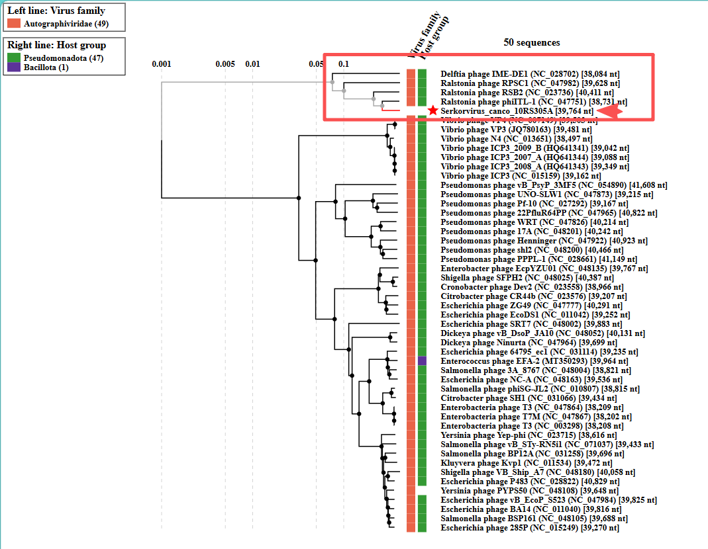
Figure 1. ViPTree analysis： ViPTree analysis (https://www.genome.jp/viptree/; [3]) is based upon Rohwer and Edwards (2002) Phage Proteomic Tree [4]. The phages of interest are indicated with red arrow and the family Autotranscriptaviridae is annotated with red boxes.

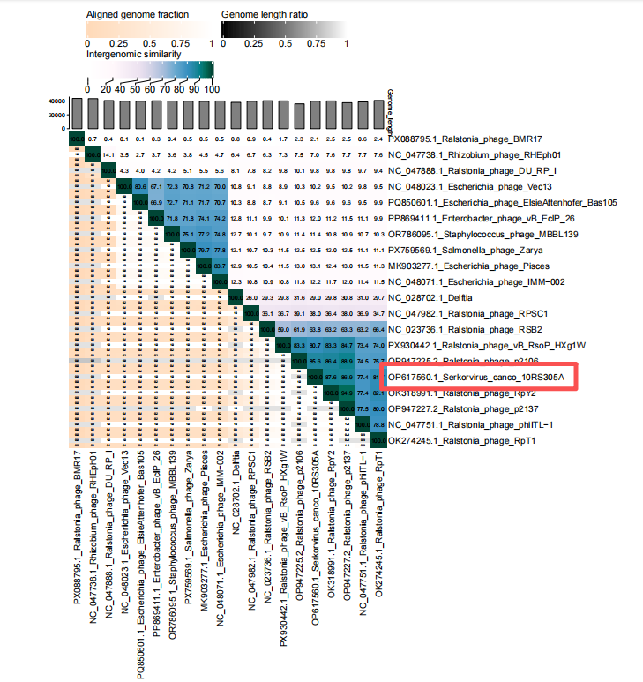
Figure 2. VIRIDIC heat map: VIRIDIC (Virus Intergenomic Distance Calculator; [1]; http://rhea.icbm.uni-oldenburg.de/VIRIDIC/) computes pairwise intergenomic distances/similarities amongst phage genomes.

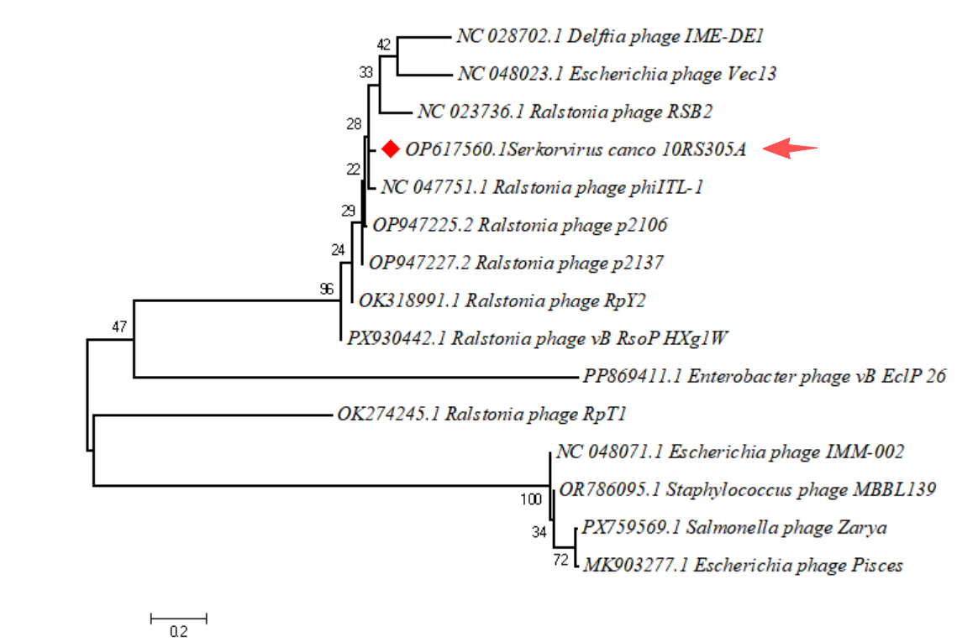
Figure 3. Phylogeny: The phylogenetic tree was constructed using the major capsid proteins of phages [5]. MUSCLE was used for multiple alignment and MEGA(v11.0.10) was used for building phylogenetic tree using maximum-likelihood method with 1000 bootstrap replicates [6]. The new species is indicated with red arrow.

Electron micrograph: TEM image revealed that the head of the phage was 110.1 nm ± 2.0 nm in length and 97.8 nm ± 2.0 nm in width, while the tail of 68.3 nm ± 2.0 nm in length.[7].

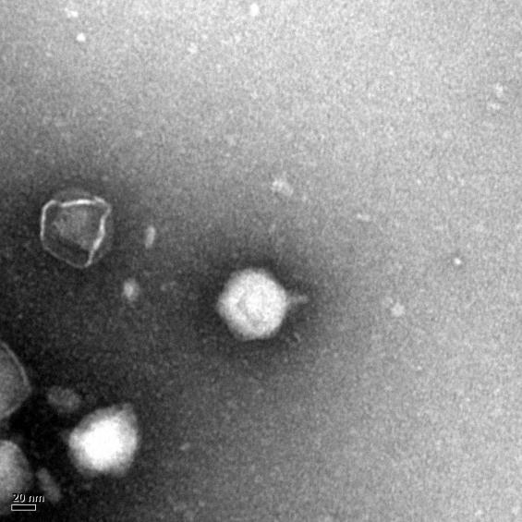
Historical aspects: The phage Serkorvirus canco 10RS305A was isolated in 2020 by our team from the soil of Xiamen, using Ralstonia solanacearum RS305 as the host bacterium.
Specific References: None
Genome summary:
Phage name | RefSeq No. | INSDC | Size (Kb) | GC% | Protein | tRNA | Overall % DNA sequence identity (*)
Serkorvirus canco 10RS305A |  | OP617560 | 39.7 | 63 | 52 | 0 | 100

