

The International Committee on Taxonomy of Viruses
Taxonomy Proposal Form, 2026

Part 1a: Details of taxonomy proposals

Title: | Create a new genus Aunosvirus with two new species within the subfamily Braunvirinae (family Drexlerviridae, class Caudoviricetes)
Code assigned: | 2026.004B

Author(s), affiliation and email address(es):
Given name (+middle initial(s)) | Surname | Affiliation | Email address | Corr. author(s)
Laura | Ribes-Martínez | MePRAM, Enfermedades Infecciosas, Centro de Investigación Biomédica en Red (CIBERINFEC), Madrid, Spain | lauraribes@outlook.com | X
Javier Enrique | Cañada-García | Laboratorio de Referencia e Investigación en Resistencia a Antibióticos e Infecciones Relacionadas con la Asistencia Sanitaria, Centro Nacional de Microbiología, Instituto de Salud Carlos III, Madrid, Spain. | jecanada@externos.isciii.es
María | Pérez-Vázquez | Laboratorio de Referencia e Investigación en Resistencia a Antibióticos e Infecciones Relacionadas con la Asistencia Sanitaria, Centro Nacional de Microbiología, Instituto de Salud Carlos III, Madrid, Spain. | mperezv@isciii.es
Gamaliel | López-Leal | Laboratorio de Biología Computacional y Virómica Integrativa, Centro de Investigación en Dinámica Celular, Universidad Autónoma del Estado de Morelos, Cuernavaca, México. | gamaliel.lopez@docentes.uaem.edu.mx
Jesús | Oteo | Laboratorio de Referencia e Investigación en Resistencia a Antibióticos e Infecciones Relacionadas con la Asistencia Sanitaria, Centro Nacional de Microbiología, Instituto de Salud Carlos III, Madrid, Spain. | jesus.oteo@isciii.es
Jaime | Esteban | Department of Clinical Microbiology, IIS-Fundación Jiménez Díaz, Madrid, Spain | jesteban@fjd.es
Meritxell | García-Quintanilla | Department of Clinical Microbiology, IIS-Fundación Jiménez Díaz, Madrid, Spain | meritxelldejesus@yahoo.es | X

Part 1b: Taxonomy Proposal Submission
ICTV Subcommittee:
Animal DNA Viruses and Retroviruses |  | Bacterial viruses | X
Animal minus-strand and dsRNA viruses |  | Fungal and protist viruses
Animal positive-strand RNA viruses |  | Plant viruses
Archaeal viruses |  | General -

List the ICTV Study Group(s) that have seen or have been involved in creating this proposal:
None, proposal submitted directly to the BVS Chair.

Optional – complete only if formally voted on by an ICTV Study Group:
Study Group | Number of members
Study Group | Votes in support | Votes against | No vote

Submission date: | 27/05/2026

Part 1c: Feedback from ICTV Executive Committee (EC) meeting
Executive Committee Meeting Decision code: | X
A – Accept
Ac – Accept subject to revision by relevant subcommittee chair. No further vote required
U – Accept without revision but with re-evaluation and email vote by the EC
Uc – Accept subject to revision and re-evaluation and email vote by the EC
Ud – Deferred to the next EC meeting, with an invitation to revise based on EC comments
J - Reject
W - Withdrawn

Comments from the Executive Committee:

Part 1d: Revised Taxonomy Proposal Submission
Response of proposer:
Revision date:

Part 3: TAXONOMIC PROPOSAL
https://ictv.global/taxonomy/templates

Taxonomic changes proposed:
Establish new taxon | X | Split taxon
Abolish taxon |  | Merge taxon
Move taxon |  | Promote taxon
Rename taxon |  | Demote taxon
Move and rename

Etymology (origin) of proposed taxonomic names:
Taxon name | Etymology of the term
Aunosvirus | Named after Aunos, the surname of the proposing author's late grandfather, honoring his legacy. Suffix -virus following ICTV convention for bacteriophage genera
Aunosvirus f63v | Freeform epithet derived from the name of the exemplar isolate (Escherichia phage F63V), following the convention established for other Braunvirinae species (e.g., Rtpvirus ime253, Loudonvirus ec3a).
Aunosvirus es10 | Freeform epithet derived from the name of the exemplar isolate (Escherichia phage ES10; Nawaz et al., 2024), following the same Braunvirinae naming convention.

Permission for use of names derived from a living person:
Taxon name | Full name of person from whom the name is derived | Attached

Abstract of Taxonomy Proposal:
Description of current taxonomy:
The bacteriophages described within this proposal are currently unclassified.

Proposed taxonomic change(s): Creation of a new genus, “Aunosvirus”, within Braunvirinae, with two new species: “Aunosvirus f63v” (proposed type species; exemplar Escherichia phage F63V) and “Aunosvirus es10” (exemplar Escherichia phage ES10, OR466728).

Demarcation criteria for new taxon/taxa:
Genus and species: Current ICTV BVS demarcation criteria are that species are defined as genomes exhibiting ≤95% similarity and genera as possessing ≥70% similarity over their genome length [4].

Justification:
Three complete genome sequences: Escherichia phage F63V (this study; PZ445149), Escherichia phage ES10 (OR466728; Nawaz et al., 2024) and Escherichia phage AN_ECEAS (PP944860) form a coherent cluster within the subfamily Braunvirinae (family Drexlerviridae, class Caudoviricetes) that has no counterpart among the eight genera currently recognised in that subfamily. NCBI lists all three as 'unclassified Braunvirinae'.

VIRIDIC intergenomic similarity [1] was calculated against a reference panel of 18 reference genomes spanning all eight recognised Braunvirinae genera plus two Drexlerviridae outgroups (Tempevirinae and Tunavirinae). F63V shares 78.7-78.8% intergenomic similarity with ES10 and AN_ECEAS, placing the three genomes within a single genus by the ICTV ≥70% threshold. The maximum similarity of F63V against any classified Braunvirinae genus is 61.8% (Guelphvirus), 8 percentage points below the genus boundary. ES10 and AN_ECEAS share 99.8% intergenomic similarity and are conspecific. The candidate clade is monophyletic in a whole-genome Neighbor-Joining tree built from VIRIDIC distances and rooted on Tempevirinae and Tunavirinae outgroups.

The 16-percentage-point gap between the lowest within-candidate-genus similarity (79%) and the highest against any classified genus (62%) is unambiguous under current ICTV criteria [4]. The proposed genus resolves the status of three complete genomes currently stranded as 'unclassified Braunvirinae' in public repositories.

- Text of Taxonomy proposal:

Description of current taxonomy:
The subfamily Braunvirinae (family Drexlerviridae, class Caudoviricetes) presently contains eight genera: Augustepiccardvirus, Christensenvirus, Guelphvirus, Inhoffenstrassevirus, Julespiccardvirus, Loudonvirus, Rtpvirus and Veterinaerplatzvirus. All characterised members are siphoviruses of 43–52 kb infecting Enterobacteriaceae. A growing number of 'unclassified Braunvirinae' deposits in GenBank have not yet been formally placed, among them Escherichia phage ES10 (OR466728; [2]) and Escherichia phage AN_ECEAS (PP944860).

Proposed taxonomic change(s):
We propose the creation of a new genus, “Aunosvirus”, within the subfamily Braunvirinae, containing two new species:
(i) “Aunosvirus f63v” - proposed type species, exemplar Escherichia phage F63V (this study; genome size 45,748 bp; complete annotated genome deposited in GenBank under accession number PZ445149).
(ii) “Aunosvirus es10” - exemplar Escherichia phage ES10 (GenBank OR466728; genome size 48,315 bp; first characterised by Nawaz et al., [2]. Escherichia phage AN_ECEAS (PP944860) shares 99.8% intergenomic similarity with ES10 and is treated as conspecific (second independent isolation of the same species).

Demarcation criteria for new taxon/taxa:
Genus and species thresholds followed ICTV recommendations for Caudoviricetes [4]: ≥95% for species, ≥70% for genus.

Justification:
Whole-genome intergenomic similarity was calculated with VIRIDIC v1.1 [1] against an 18-genome reference panel comprising: the exemplar genome of each of the eight recognised Braunvirinae genera (MSL #39); additional unclassified Braunvirinae deposits; three unclassified Caudoviricetes genomes recovered as BLASTn hits against F63V; and two representatives of sister subfamilies - Tempevirinae (Shigella phage pSf-1, NC_021331) and Tunavirinae (Escherichia phage T1, NC_005833) - as outgroups. Key results:
- F63V vs ES10 (OR466728): 78.7% intergenomic similarity
- F63V vs AN_ECEAS (PP944860): 78.8%
- ES10 vs AN_ECEAS: 99.8% (conspecific)
- F63V vs each classified Braunvirinae genus exemplar: 54.5% (Inhoffenstrassevirus) to 61.8% (Guelphvirus) - all below the 70% genus threshold
- F63V vs Tempevirinae outgroup (pSf-1): 15.9%; vs Tunavirinae outgroup (T1): 12.7%

The 16-percentage-point gap between the minimum within-candidate-genus similarity (78.8%) and the maximum against any classified Braunvirinae genus (61.8%) is unambiguous. The three genomes are complete, annotated and deposited in public repositories, satisfying ICTV evidential requirements. The proposal resolves the ambiguous status of ES10 and AN_ECEAS, which are listed in GenBank as 'unclassified Braunvirinae', and places F63V within a formally defined taxon.
References:
[1] Moraru, C., Varsani, A., Kropinski, A.M. (2020). VIRIDIC - A novel tool to calculate the intergenomic similarities of prokaryote-infecting viruses. Viruses 12, 1268. doi:10.3390/v12111268
[2] Nawaz, A., Zafar, S., Alessa, A.H., Khalid, N.A., Shahzadi, M., Majid, A., Badshah, M., Shah, A.A., Khan, S. (2024). Characterization of ES10 lytic bacteriophage isolated from hospital waste against multidrug-resistant uropathogenic E. coli. Frontiers in Microbiology 15, 1320974. doi:10.3389/fmicb.2024.1320974
[3] Ribes-Martínez, L. et al. (2026). Phage depolymerase specificity shapes treatment outcomes for preformed biofilms in ESBL-producing Escherichia coli. Under review.
[4] Turner, D., Shkoporov, A.N., Lood, C., Millard, A.D., Dutilh, B.E., Alfenas-Zerbini, P., van Zyl, L.J., et al. (2023). Abolishment of morphology-based taxa and change to binomial species names: 2022 taxonomy update of the ICTV bacterial viruses subcommittee. Archives of Virology 168, 74. doi:10.1007/s00705-022-05694-2

Accompanying files:
Filename | Description of contents

Tables, Figures:

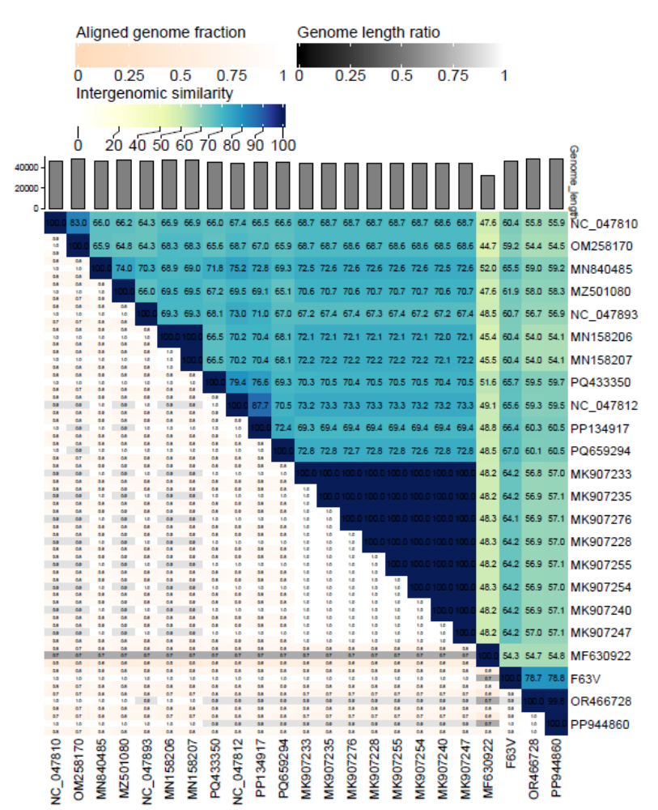Figure 1. Heatmap of pairwise intergenomic nucleotide similarities calculated using VIRIDIC.

