

The International Committee on Taxonomy of Viruses
Taxonomy Proposal Form, 2026

Part 1a: Details of taxonomy proposals

Title: | Create a new genus, Mokushimavirus, including four new species (class Caudoviricetes)
Code assigned: | 2026.003B

Author(s), affiliation and email address(es):
Given name (+middle initial(s)) | Surname | Affiliation | Email address | Corr. author(s)
Jacob | Albee | Faculty of Sciences, Brigham Young University-Hawaii, Laie, HI, USA | jacob.a.albee@gmail.com | x
Julianne | Grose | Department of Microbiology and Molecular Biology, Brigham Young University, Provo, UT, USA | julianne_grose@byu.edu
Colby | Weeks | Faculty of Sciences, Brigham Young University-Hawaii, Laie, HI, USA | colby.weeks@byuh.edu

Part 1b: Taxonomy Proposal Submission
ICTV Subcommittee:
Animal DNA Viruses and Retroviruses |  | Bacterial viruses | x
Animal minus-strand and dsRNA viruses |  | Fungal and protist viruses
Animal positive-strand RNA viruses |  | Plant viruses
Archaeal viruses |  | General -

List the ICTV Study Group(s) that have seen or have been involved in creating this proposal:
Optional – complete only if formally voted on by an ICTV Study Group:
Study Group | Number of members
Study Group | Votes in support | Votes against | No vote

Submission date: | 18/08/2026

Part 1c: Feedback from ICTV Executive Committee (EC) meeting
Executive Committee Meeting Decision code: | X
A – Accept
Ac – Accept subject to revision by relevant subcommittee chair. No further vote required
U – Accept without revision but with re-evaluation and email vote by the EC
Uc – Accept subject to revision and re-evaluation and email vote by the EC
Ud – Deferred to the next EC meeting, with an invitation to revise based on EC comments
J - Reject
W - Withdrawn

Comments from the Executive Committee:

Part 1d: Revised Taxonomy Proposal Submission
Response of proposer:
Revision date:

Part 3: TAXONOMIC PROPOSAL
https://ictv.global/taxonomy/templates

Taxonomic changes proposed:
Establish new taxon | X | Split taxon
Abolish taxon |  | Merge taxon
Move taxon |  | Promote taxon
Rename taxon |  | Demote taxon
Move and rename

Etymology (origin) of proposed taxonomic names:
Taxon name | Etymology of the term
Mokushimavirus satoshi | “Satoshi” is the name of the grandfather of Jacob Albee’s wife. Permission to use the name has been obtained.
Mokushimavirus kolob | The word “Kolob” derives from the Book of Abraham, a scriptural work in the Latter-day Saint tradition, and refers to a specific star. Brigham Young University-Hawaii is a Latter-day Saint university and so the name pays tribute to the religious history and traditions of the school.
Mokushimavirus ushijima | “Ushijima” is the surname of Dr. Blake Ushijima, who discovered the native Hawaiian V. coralliilyticus strains used in the study which identified these phages. Permission to use the name has been obtained.
Mokushimavirus ckbs2 | “CKB-S2” is the name used to describe a bacteriophage in the paper “Genome analysis of three novel lytic Vibrio coralliilyticus phages isolated from seawater, Okinawa, Japan” by Ramphul et al. The authors have not clarified the etymology of this phage designation.
Mokushimavirus | The genus name “Mokushimavirus” combines the Hawaiian word for island, “Moku”, with the Japanese word for island, “shima.” The first isolate from this genus, CKB-S2, was identified in Okinawa, while the next three were identified in Hawaii. The name is a reference to the known geographic range of the genus.

Permission for use of names derived from a living person:
Taxon name | Full name of person from whom the name is derived | Attached
Mokushimavirus satoshi | Satoshi Oda | X
Mokushimavirus ushijima | Blake Ushijima | X

Abstract of Taxonomy Proposal:
Description of current taxonomy: Vibrio phages Satoshi, Kolob, and Ushijima are three new phages isolated from seawater collected offshore of Lāʻie, Hawaii and found to infect the native Hawaiian Vibrio coralliilyticus strain OCN008. The phages are currently unassigned to any ICTV-recognized species or genus.

Proposed taxonomic change(s): We propose the creation of a new genus “Mokushimavirus” of class Caudoviricetes, which will contain the four new species “Mokushimavirus satoshi”, “Mokushimavirus kolob”, “Mokushimavirus ushijima” and “Mokushimavirus ckbs2”.

Demarcation criteria for new taxon/taxa:
In accordance with the demarcation criteria established by the ICTV Bacterial Viruses Subcommittee viruses assigned to the proposed genus Mokushimavirus should share at least 70% whole-genome intergenomic similarity with the exemplars of the four proposed species: Vibrio phage Satoshi, Vibrio phage Kolob, Vibrio phage Ushijima, and Vibrio phage CKB-S2. Viruses sharing at least 95% whole-genome intergenomic similarity with any of these four phages would be assigned to the same species.

Justification:
Vibrio pages Satoshi, Kolob and Ushijima cluster closely with the previously described bacteriophage CKB-S2, isolated from seawater near Okinawa, Japan (1). The authors of the paper characterizing CKB-S2 have not proposed an official genus or species with ICTV. Comparative genomic analyses confirmed that Satoshi, Kane, Kolob, and CKB-S2 represent a distinct genus-level clade within the class Caudoviricetes. No available comparison genome approached the 70% genus-level intergenomic-similarity threshold. Genome-wide gene-sharing analysis placed the three phages in a distinct predicted lineage and did not assign them to any currently recognized order, family, subfamily, or genus.

- Text of Taxonomy proposal:

Description of current taxonomy: Vibrio phages Satoshi, Kolob, and Ushijima are double-stranded DNA bacteriophages infecting the native Hawaiian Vibrio coralliilyticus strain OCN008. The phages are currently unassigned to any ICTV-recognized species or genus, but cluster closely with previously described bacteriophage CKB-S2, isolated from seawater near Okinawa, Japan (1). None of these four phages are assigned to any ICTV-recognized genus or species.

The annotated, complete genome of Vibrio phage Satoshi is 34,888 bp long, the genome of Vibrio phage Kolob is 34,556 bp long, the genome of Vibrio phage Ushijima is 34,423 bp long, and the genome of Vibrio phage CKB-S2 is 34,713 bp long (1). The genomes have been assigned GenBank accession numbers PZ716015 (Satoshi), PZ716016 (Kolob), PZ716018 (Ushijima), and AP014888 (CKB-S2).

Proposed taxonomic change(s):
We propose the creation of a new genus “Mokushimavirus”, within the class Caudoviricetes. The genus is proposed to remain unassigned at the order and family ranks.

The new genus would initially contain four species, “Mokushimavirus satoshi”, “Mokushimavirus kolob”, “Mokushimavirus ushijima”, and “Mokushimavirus ckbs2”, represented by exemplar viruses Vibrio phage Satoshi, Vibrio phage Kolob, Vibrio phage Ushijima, and Vibrio phage CKB-S2, respectively.

Demarcation criteria for new taxon/taxa:
Members of the proposed genus “Mokushimavirus” should form a coherent group with the Satoshi, Kolob, Ushijima, and CKB-S2. Viruses assigned to this genus should share at least 70% whole-genome intergenomic nucleotide similarity with these four species. Candidate members should also display conserved genome organization and form a monophyletic group in genome- or proteome-based phylogenetic analyses.

Viruses sharing less than 70% whole-genome intergenomic nucleotide similarity with all recognized members of “Mokushimavirus” would normally be excluded from the genus.

Viruses assigned to one of the four species within the genus should share at least 95% whole-genome intergenomic similarity with that species. Viruses sharing at least 70% but less than 95% intergenomic similarity with existing members of the genus would be assigned to separate species within “Mokushimavirus”.

Justification:
Whole-genome comparisons demonstrate that Satoshi, Kolob, Ushijima, and CKB-S2 are divergent from currently available bacteriophage genomes.

An intergenomic similarity matrix was calculated using VIRIDIC (2) and placed Satoshi, Kolob, Ushijima, and CKB-S2 in the same genus cluster, distinct from their closest BLAST (3) matches.

vConTACT3 (4) whole-genome gene-sharing analysis against reference database v232 (5) placed Satoshi, Kolob, Ushijima, and CKB-S2 within the class Caudoviricetes but in a novel order, family, subfamily, and genus.

A maximum-likelihood phylogenetic tree constructed in MEGA12 (6) using terminase large subunit amino acid sequences demonstrates that the four phages cluster into a monophyletic clade.

The absence of substantial whole-genome nucleotide similarity to recognized bacteriophage taxa supports the establishment of the new genus “Mokushimavirus” and the four new species “Mokushimavirus satoshi”, “Mokushimavirus kolob”, “Mokushimavirus ushijima”, and “Mokushimavirus ckbs2”.

References:
- Ramphul, C., Casareto, B. E., Dohra, H., Suzuki, T., Yoshimatsu, K., Yoshinaga, K., et al. (2017). Genome analysis of three novel lytic Vibrio coralliilyticus phages isolated from seawater, Okinawa, Japan. Marine Genomics 35, 69–75. doi: 10.1016/j.margen.2017.06.005
- Moraru, C., Varsani, A., and Kropinski, A. M. (2020). VIRIDIC—A Novel Tool to Calculate the Intergenomic Similarities of Prokaryote-Infecting Viruses. Viruses 12, 1268. doi: 10.3390/v12111268
- Camacho, C., Coulouris, G., Avagyan, V., Ma, N., Papadopoulos, J., Bealer, K., et al. (2009). BLAST+: architecture and applications. BMC Bioinformatics 10, 421. doi: 10.1186/1471-2105-10-421
- Bolduc, B., Zablocki, O., Turner, D., Bin Jang, H., Guo, J., Adriaenssens, E. M., et al. (2025). Machine learning enables scalable and systematic hierarchical virus taxonomy. Nat Biotechnol. doi: 10.1038/s41587-025-02946-9
- Bolduc, B. (2026). vConTACT3 Database v232. doi: 10.5281/zenodo.19198397
- Kumar S., Stecher G., Suleski M., Sanderford M., Sharma S., and Tamura K. (2024). Molecular Evolutionary Genetics Analysis Version 12 for adaptive and green computing. Molecular Biology and Evolution 41:1-9. doi: 10.1093/molbev/msae263

Accompanying files:
Filename | Description of contents
Mokushimavirus_Satoshi_Permission_To_Use_Name.pdf | Email correspondence demonstrating permission to use the first name of Satoshi Oda as the basis for the proposed virus species name “Mokushimavirus satoshi”.
Ushijima_ICTV_letter.pdf | Signed document demonstrating permission to use the surname of Dr. Blake Ushijima as the basis for the proposed virus species name “Mokushimavirus ushijima”.
Final_assignments_phages.xlsx | vConTACT3 whole genome gene-sharing analysis table.

Tables, Figures:

<Start here>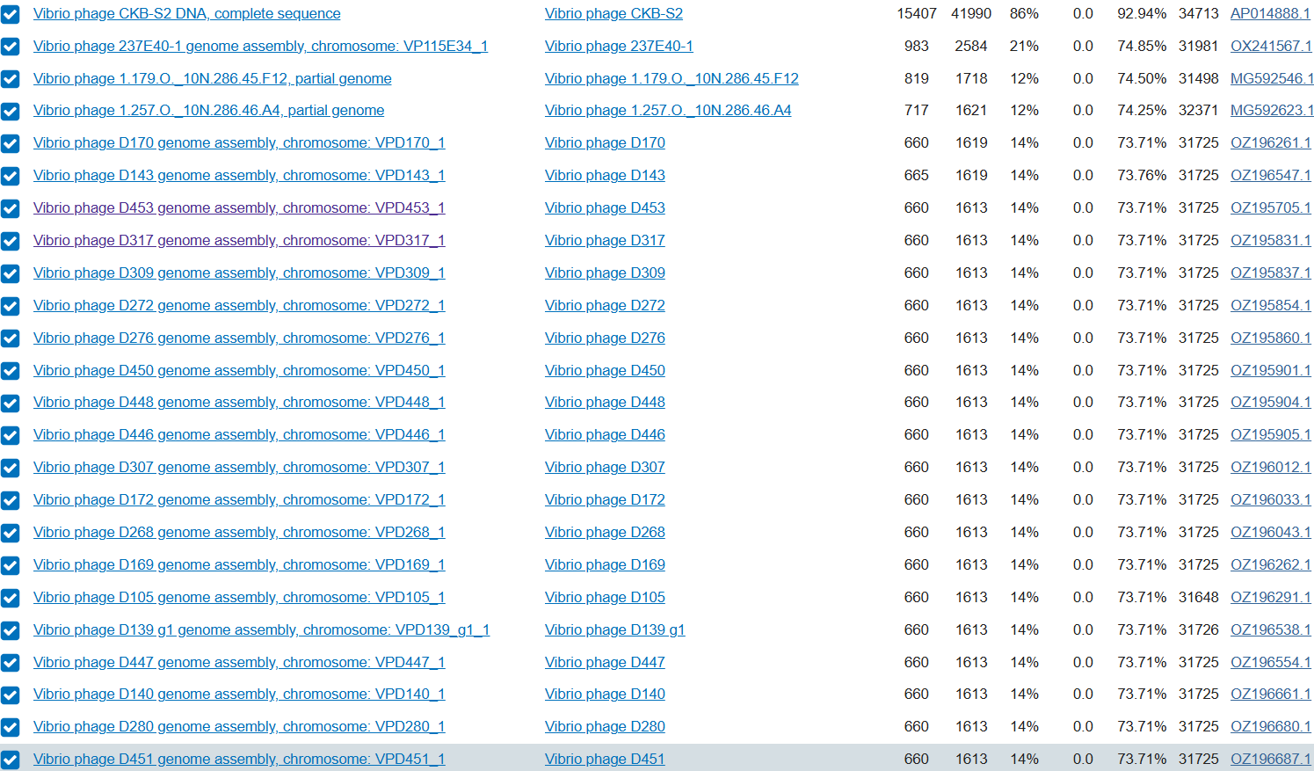
Figure 1. Similarity searches between Satoshi genome sequence and genomes available in NCBI database. Sequences were aligned using the megablast tool of BLASTn. A threshold total score of greater than or equal to 1613 was considered for selecting the most important alignments.

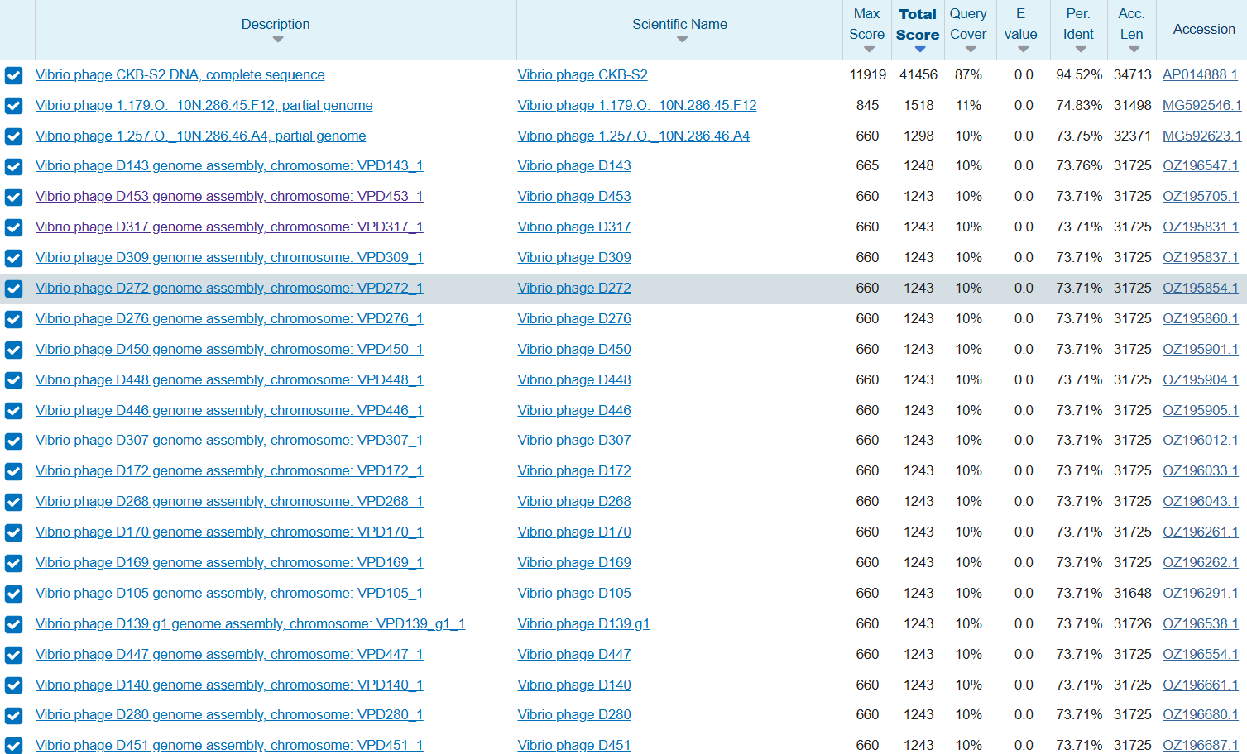
Figure 2. Similarity searches between Kolob genome sequence and genomes available in NCBI database. Sequences were aligned using the megablast tool of BLASTn. A threshold total score of greater than or equal to 1243 was considered for selecting the most important alignments.

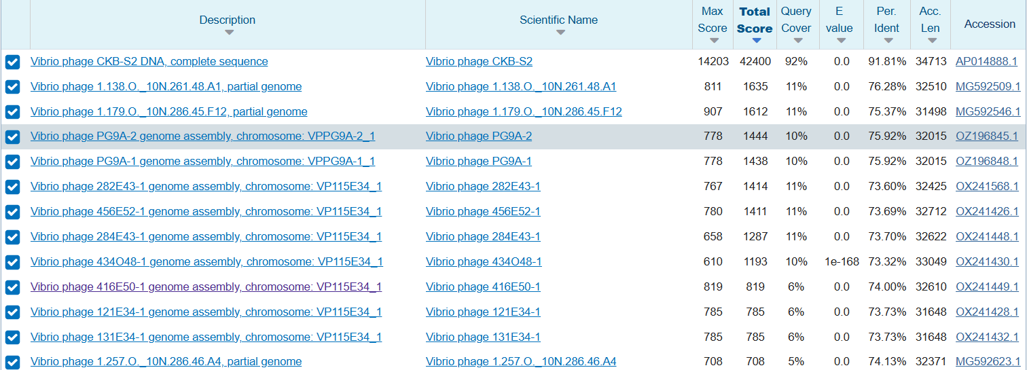
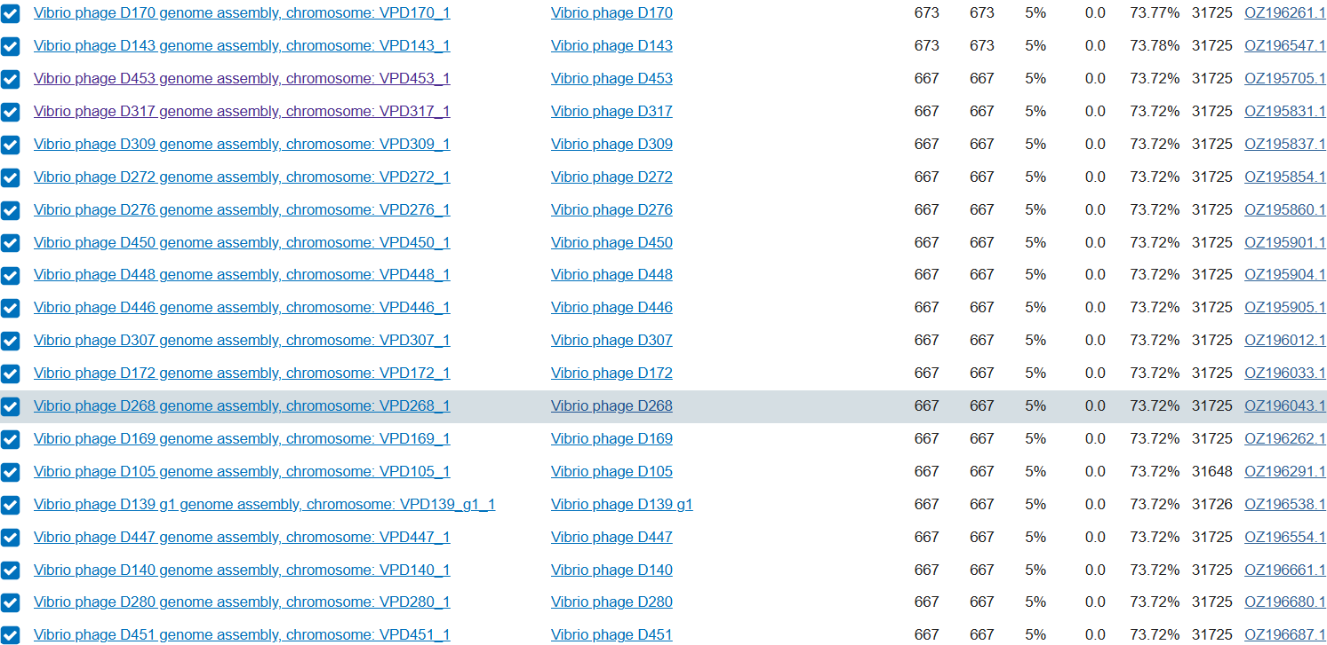
Figure 3. Similarity searches between Ushijima genome sequence and genomes available in NCBI database. Sequences were aligned using the megablast tool of BLASTn. A threshold total score of greater than or equal to 667 was considered for selecting the most important alignments.

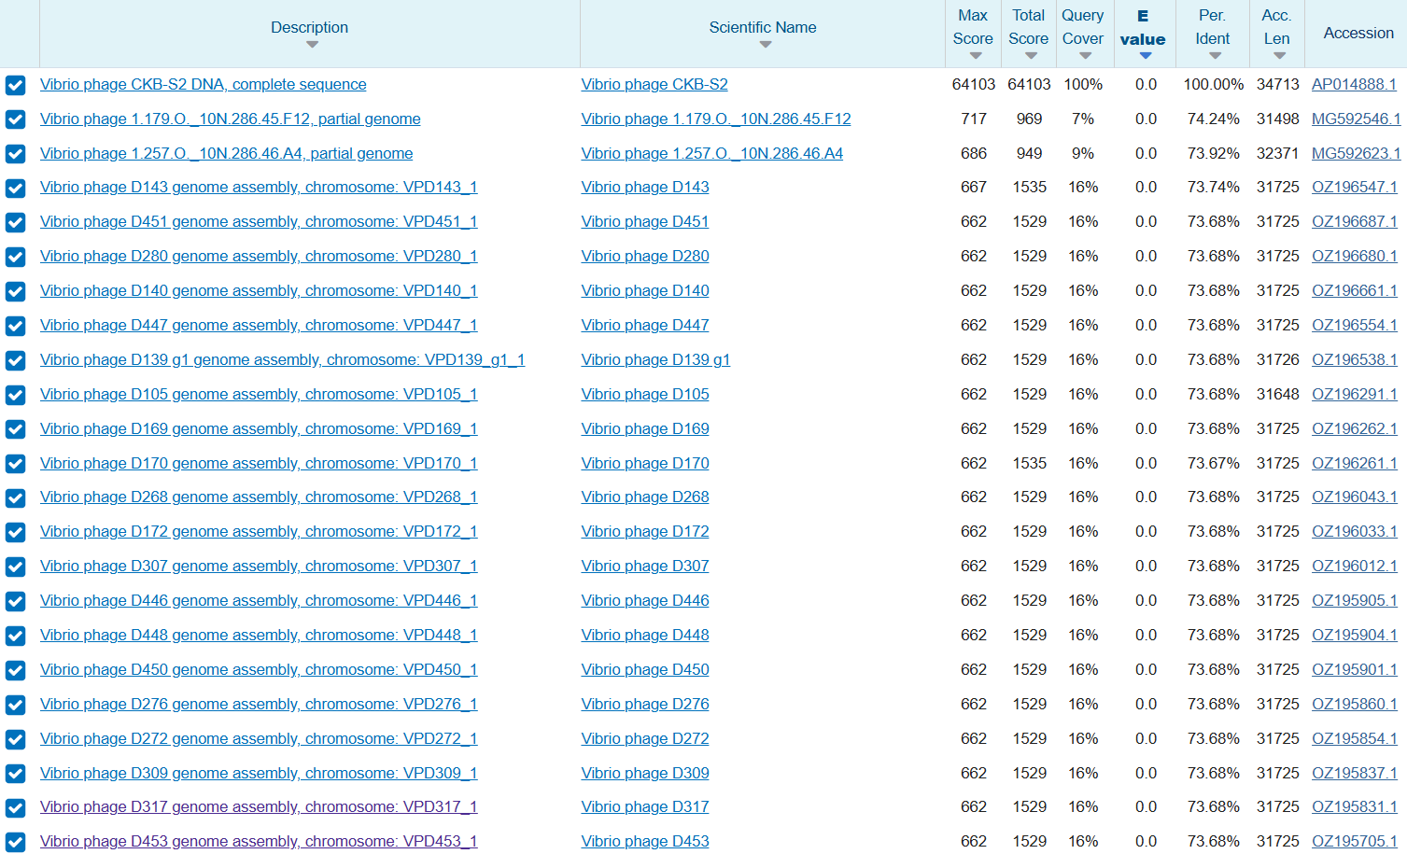
Figure 4. Similarity searches between CKB-S2 genome sequence and genomes available in NCBI database. Sequences were aligned using the megablast tool of BLASTn. A threshold total score of greater than or equal to 1529 was considered for selecting the most important alignments.

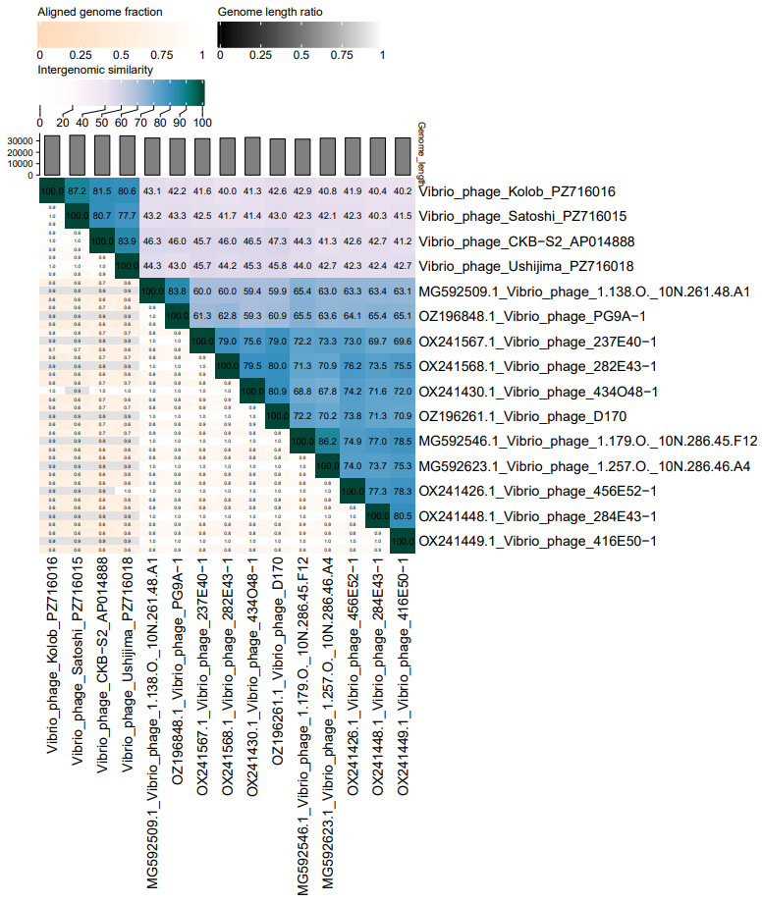
Figure 5. Genome sequences were compared by VIRIDIC and used to produce an intergenomic similarity heatmap. The top ten BLASTn matches were taken from each of the four viruses and then replicates were removed so that those that remained would be biologically meaningful.

Table 1. A VIRIDIC clustering table was generated, considering a genomic similarity threshold of 95% for species assignment and 70% for genus.
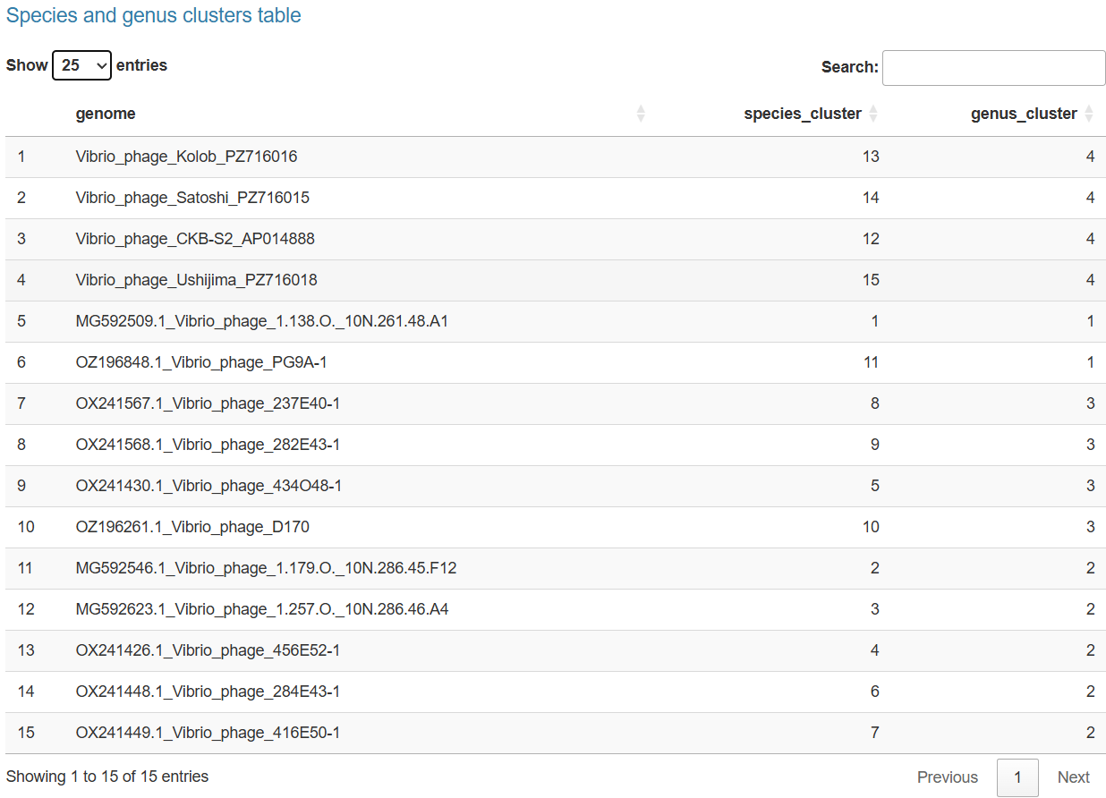

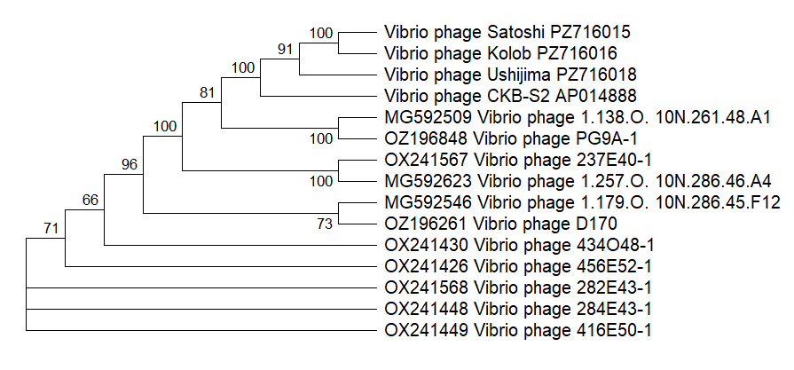
Figure 6. The bootstrap consensus tree inferred from 1,000 replicates is taken to represent the evolutionary history of the taxa analyzed where branches corresponding to partitions reproduced in less than 50% of replicate trees are collapsed. The percentage of replicate trees in which the associated taxa clustered together (1,000 replicates) is shown next to the branches. The initial tree for the heuristic search was selected by choosing the tree with the superior log-likelihood between a Neighbor-Joining (NJ) tree and a Maximum Parsimony (MP) tree. The NJ tree was generated using a matrix of pairwise distances computed using the Jones-Taylor-Thornton (1992) model. The MP tree had the shortest length among 10 MP tree searches, each performed with a randomly generated starting tree. The analytical procedure encompassed 15 amino acid sequences. The partial deletion was applied to eliminate all positions with less than 95% site coverage resulting in a final data set comprising 504 positions. Evolutionary analyses were conducted in MEGA12 utilizing up to 7 parallel computing threads.

