

The International Committee on Taxonomy of Viruses
Taxonomy Proposal Form, 2026

Part 1a: Details of taxonomy proposals

Title: | Create a new genus (Laievirus) with a single species (Laievirus kane)
Code assigned: | 2026.001B

Author(s), affiliation and email address(es):
Given name (+middle initial(s)) | Surname | Affiliation | Email address | Corr. author(s)
Jacob | Albee | Faculty of Sciences, Brigham Young University-Hawaii, Laie, HI, USA | jacob.a.albee@gmail.com | X
Julianne | Grose | Department of Microbiology and Molecular Biology, Brigham Young University, Provo, UT, USA | julianne_grose@byu.edu
Colby | Weeks | Faculty of Sciences, Brigham Young University-Hawaii, Laie, HI, USA | colby.weeks@byuh.edu

Part 1b: Taxonomy Proposal Submission
ICTV Subcommittee:
Animal DNA Viruses and Retroviruses |  | Bacterial viruses | x
Animal minus-strand and dsRNA viruses |  | Fungal and protist viruses
Animal positive-strand RNA viruses |  | Plant viruses
Archaeal viruses |  | General -

List the ICTV Study Group(s) that have seen or have been involved in creating this proposal:
None
Optional – complete only if formally voted on by an ICTV Study Group:
Study Group | Number of members
Study Group | Votes in support | Votes against | No vote

Submission date: | 18/08/2026

Part 1c: Feedback from ICTV Executive Committee (EC) meeting
Executive Committee Meeting Decision code: | X
A – Accept
Ac – Accept subject to revision by relevant subcommittee chair. No further vote required
U – Accept without revision but with re-evaluation and email vote by the EC
Uc – Accept subject to revision and re-evaluation and email vote by the EC
Ud – Deferred to the next EC meeting, with an invitation to revise based on EC comments
J - Reject
W - Withdrawn

Comments from the Executive Committee:

Part 1d: Revised Taxonomy Proposal Submission
Response of proposer:
Revision date:

Part 3: TAXONOMIC PROPOSAL
https://ictv.global/taxonomy/templates

Taxonomic changes proposed:
Establish new taxon | X | Split taxon
Abolish taxon |  | Merge taxon
Move taxon |  | Promote taxon
Rename taxon |  | Demote taxon
Move and rename

Etymology (origin) of proposed taxonomic names:
Taxon name | Etymology of the term
Laievirus kane | Kane is the middle name of Jacob Albee’s father, Jason Kane Albee. Permission to use the name has been obtained.
Laievirus | The name Laievirus is a tribute to the village of Lāʻie on the north shore of the island of Oʻahu, Hawaii. Vibrio phage Kane, the representative species, was isolated from seawater taken from Temple Beach, Lāʻie.

Permission for use of names derived from a living person:
Taxon name | Full name of person from whom the name is derived | Attached
Laievirus kane | Jason Kane Albee | X

Abstract of Taxonomy Proposal:
Description of current taxonomy:
Vibrio phage Kane is a novel temperate phage isolated from seawater collected offshore of Lāʻie, Hawaii and found to infect the native Hawaiian Vibrio coralliilyticus strain OCN008. The phage is currently unassigned to any ICTV-recognized species or genus.

Proposed taxonomic change(s):
We propose the creation of a new genus Laievirus of class Caudoviricetes, which will include a new species, Laievirus kane.

Demarcation criteria for new taxon/taxa:
Viruses assigned to the proposed genus Laievirus should share at least 70% whole-genome intergenomic similarity with the exemplar virus, Vibrio phage Kane. Viruses sharing at least 95% whole-genome intergenomic similarity with Vibrio phage Kane would be assigned to the same species, Laievirus kane.

Justification:
Comparative genomic analyses confirmed that Kane represents a distinct lineage within the class Caudoviricetes. No available comparison genome approached the 70% genus-level intergenomic-similarity threshold. Genome-wide gene-sharing analysis placed Kane in a distinct predicted lineage and did not assign it to any currently recognized order, family, subfamily, or genus.

- Text of Taxonomy proposal:

Description of current taxonomy:
Vibrio phage Kane is a double-stranded DNA bacteriophage infecting the native Hawaiian Vibrio coralliilyticus strain OCN008. Comparative genomic analyses support its placement in the class Caudoviricetes. However, Vibrio phage Kane is not currently assigned to an ICTV-recognized order, family, genus, or species.

Proposed taxonomic change(s):
We propose the creation of a new genus Laievirus, within the class Caudoviricetes. The genus is proposed to remain unassigned at the order and family ranks.

The new genus would initially contain one new species, Laievirus kane, represented by the exemplar virus Vibrio phage Kane.

Demarcation criteria for new taxon/taxa:
Members of the proposed genus Laievirus should form a coherent group with Vibrio phage Kane. Viruses assigned to this genus should share at least 70% whole-genome intergenomic nucleotide similarity with Vibrio phage Kane or another recognized member of the genus, as calculated using VIRIDIC or an equivalent whole-genome comparison method. Candidate members should also display conserved genome organization and form a monophyletic group in genome- or proteome-based phylogenetic analyses.

Viruses sharing less than 70% whole-genome intergenomic nucleotide similarity with all recognized members of Laievirus would normally be excluded from the genus.

Viruses assigned to the species Laievirus kane should share at least 95% whole-genome intergenomic nucleotide similarity. Viruses sharing at least 70% but less than 95% intergenomic similarity with existing members of the genus would be assigned to separate species within Laievirus.

Justification:
The annotated, complete genome of Vibrio phage Kane is 55,994 bp in length and has a G+C content of 44.7%. The genome has been assigned GenBank accession number PZ716017. Whole-genome comparisons demonstrate that Kane is highly divergent from currently available bacteriophage genomes. Alignments obtained using the discontiguous megablast task implemented in the BLAST+ (1) tool showed that the genome of Kane displays a maximum coverage of less than 1% with other viral genomes.

An intergenomic similarity matrix was calculated using VIRIDIC (2) and placed Kane in different species and genus clusters from its closest BLASTn matches.

vConTACT3 (3) whole genome gene-sharing analysis against reference database v232 (4) placed Kane within the class Caudoviricetes but in a novel order, family, subfamily, and genus.

The absence of substantial whole-genome nucleotide similarity to recognized bacteriophage taxa supports the establishment of the new genus Laievirus and the new species Laievirus kane.

References:
- Camacho, C., Coulouris, G., Avagyan, V., Ma, N., Papadopoulos, J., Bealer, K., et al. (2009). BLAST+: architecture and applications. BMC Bioinformatics 10, 421. doi: 10.1186/1471-2105-10-421
- Moraru, C., Varsani, A., and Kropinski, A. M. (2020). VIRIDIC—A Novel Tool to Calculate the Intergenomic Similarities of Prokaryote-Infecting Viruses. Viruses 12, 1268. doi: 10.3390/v12111268
- Bolduc, B., Zablocki, O., Turner, D., Bin Jang, H., Guo, J., Adriaenssens, E. M., et al. (2025). Machine learning enables scalable and systematic hierarchical virus taxonomy. Nat Biotechnol. doi: 10.1038/s41587-025-02946-9
- Bolduc, B. (2026). vConTACT3 Database v232. doi: 10.5281/zenodo.19198397

Accompanying files:
Filename | Description of contents
Laievirus_Kane_Permission_To_Use_Name.pdf | Email correspondence demonstrating permission to use the middle name of Jason Kane Albee as the basis for proposed virus species name Laievirus kane.
final_assignments_phages.xlsx | vConTACT3 whole genome gene-sharing analysis table.

Tables, Figures:

<Start here>
Table 1. Similarity searches between Kane genome sequence and genomes available in NCBI database. Sequences were aligned using the discontiguous megablast tool of BLASTn. An E-value threshold of less than or equal to 1e-10 was considered for selecting significant alignments.
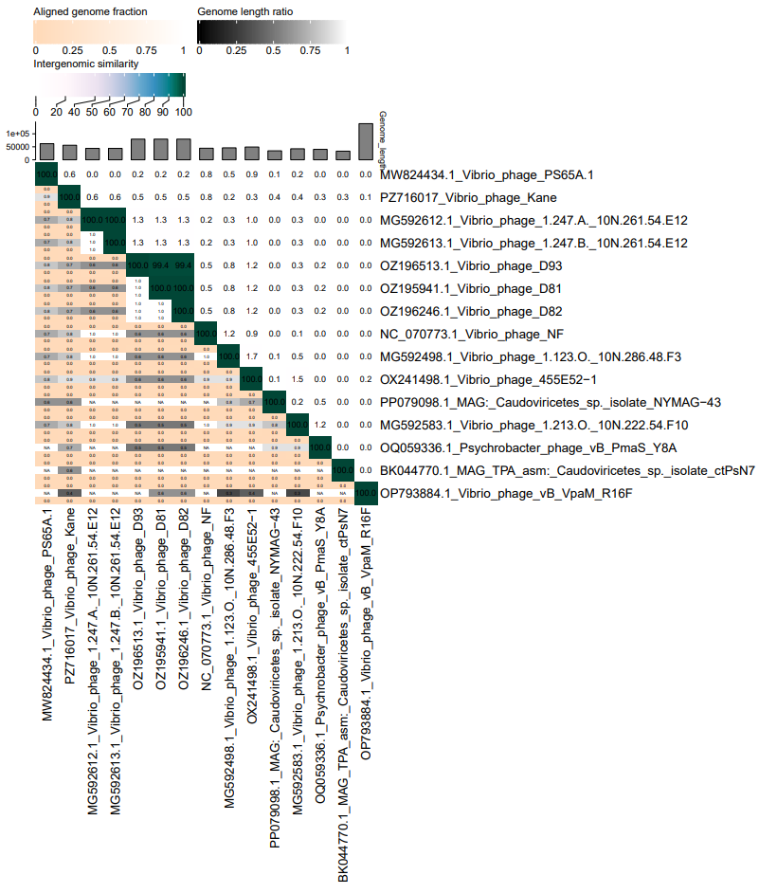Figure 1. Genome sequences were compared by VIRIDIC and used to produce an intergenomic similarity heatmap.
Table 2. A VIRIDIC clustering table was generated, considering a genomic similarity threshold of 95% for species assignment and 70% for genus.

