

The International Committee on Taxonomy of Viruses
Taxonomy Proposal Form, 2026

Part 1a: Details of taxonomy proposals

Title: | Create a new family, Edelweissviridae, including two new subfamilies, six new genera and 18 new species (Class Caudoviricetes)
Code assigned: | 2025.092B

Author(s), affiliation and email address(es):
Given name (+middle initial(s)) | Surname | Affiliation | Email address | Corr. author(s)
Elena | Gómez-Sanz | Division of Molecular Bacterial Epidemiology & Infectious Diseases, Institute of Veterinary Bacteriology, University of Bern, Bern, Switzerland | elena.gomezsanz@unibe.ch | X
Sandra | Pérez-Jiménez | Division of Molecular Bacterial Epidemiology & Infectious Diseases, Institute of Veterinary Bacteriology, University of Bern, Bern, Switzerland | sandra.perezjimenez@unibe.ch
Dominque | Lorgé | Division of Molecular Bacterial Epidemiology & Infectious Diseases, Institute of Veterinary Bacteriology, University of Bern, Bern, Switzerland | dominique.lorge@unibe.ch
Dann | Turner | School of Applied Sciences, College of Health, Science and Society, University of the West of England, Bristol, UK | dann2.turner@uwe.ac.uk

Part 1b: Taxonomy Proposal Submission
ICTV Subcommittee:
Animal DNA Viruses and Retroviruses |  | Bacterial viruses | X
Animal minus-strand and dsRNA viruses |  | Fungal and protist viruses
Animal positive-strand RNA viruses |  | Plant viruses
Archaeal viruses |  | General -

List the ICTV Study Group(s) that have seen or have been involved in creating this proposal:
Optional – complete only if formally voted on by an ICTV Study Group:
Study Group | Number of members
Study Group | Votes in support | Votes against | No vote

Submission date: | 20/06/2025

Part 1c: Feedback from ICTV Executive Committee (EC) meeting
Executive Committee Meeting Decision code: | X
A – Accept
Ac – Accept subject to revision by relevant subcommittee chair. No further vote required
U – Accept without revision but with re-evaluation and email vote by the EC
Uc – Accept subject to revision and re-evaluation and email vote by the EC
Ud – Deferred to the next EC meeting, with an invitation to revise based on EC comments
J - Reject
W - Withdrawn

Comments from the Executive Committee:

Part 1d: Revised Taxonomy Proposal Submission
Response of proposer:
Revision date:

Part 3: TAXONOMIC PROPOSAL
https://ictv.global/taxonomy/templates

Taxonomic changes proposed:
Establish new taxon | X | Split taxon
Abolish taxon |  | Merge taxon
Move taxon |  | Promote taxon
Rename taxon |  | Demote taxon
Move and rename

Etymology (origin) of proposed taxonomic names:
Taxon name | Etymology of the term
Edelweissviridae | Name of the iconic Alpine flower and Symbol of courage and love. It grows in the mountainous regions of the Alps, including Switzerland. It is considered a symbol of the Alpine environment and the purity of the mountains.
Aletschvirinae | Named after the Aletsch Glacier, the largest glacier in the Alps, located in the Bernese Alps of Switzerland. This iconic glacier is a UNESCO World Heritage Site and symbolizes resilience and the majestic natural beauty of the alpine environment.
Gornervirinae | Named after the Gorner Glacier, the second largest glacier in the Swiss Alps. Located near Zermatt and the Matterhorn, it is known for its impressive network of ice flows and dramatic alpine landscape, symbolizing power and complexity in nature.
Nesthornvirus | Named after the Nesthorn, a prominent mountain in the Bernese Alps of Switzerland. Rising to 3,822 meters, it is known for its remote location and rugged beauty.
Monterosavirus | Named after Monte Rosa, the second highest mountain in the Alps and the highest in Switzerland, reaching 4,634 meters. Located on the Swiss-Italian border, it symbolizes prominence, resilience, and alpine grandeur
Tournoirvirus | Named after the Tour Noir, a striking peak in the Mont Blanc Massif on the Swiss-French border. Rising to 3,835 meters, its name means Black Tower, reflecting its dark, rugged appearance. The name evokes mystery, strength, and the stark beauty of the high Alps.
Bouquetinsvirus | Named after Les Bouquetins, a group of peaks in the Pennine Alps on the Swiss-Italian border. The name, meaning ibex in French, reflects the wild, alpine terrain and resilience associated with these iconic mountain animals and the rugged peaks they inhabit.
Ruinettevirus | Named after La Ruinette, a prominent mountain in the Pennine Alps of Switzerland, rising to 3,875 meters. Overlooking the Mauvoisin valley, it is known for its sharp silhouette and commanding presence.
Aiguillevirus | Named after the Aiguille d’Argentière, a striking 3,901-meter peak in the Mont Blanc Massif on the Swiss-French border. Its name, meaning Silver Needle, reflects its sharp, elegant form and glaciated surroundings—symbolizing precision, beauty, and strength in the alpine environment.

Permission for use of names derived from a living person:
Taxon name | Full name of person from whom the name is derived | Attached

Abstract of Taxonomy Proposal:
Description of current taxonomy:
The genus Sextaecvirus was created in 2015 (2015.017a-dB.A.v3.Sextaecvirus) and currently includes two species. The remaining viruses in this proposal do not have a current taxonomic assignment.

Proposed taxonomic change(s):
Create a new family Edelweissviridae including two new subfamilies, Aletschvirinae and Gornervirinae, and six new genera; Nesthornvirus, Monterosavirus, Tournoirvirus, Bouquetinsvirus, Ruinettevirus and Aiguillevirus. Move the existing genus Sextaecvirus into the proposed subfamily Aletschvirinae. We also propose the creation of 18 new species within these genera.

Justification:
The evolutionary relationships between 46 bacteriophage genomes were investigated. Based on proteomic and intergenomic nucleotide similarity we propose a new family to encompass these phages that includes two new subfamilies, six genera and 12 new species. This assignment is supported by TBLASTX distance analysis, gene-sharing networks, and the presence of signature proteins shared by all member species.

- Text of Taxonomy proposal:

Description of current taxonomy:
The genus Rockefellervirus was created in 2020 (2020.135B.R.Rockefellervirus) and currently includes six species.

Proposed taxonomic change(s):
Create a new family Edelweissviridae including two new subfamilies, Aletschvirinae and Gornervirinae, and six new genera; Nesthornvirus, Monterosavirus, Tournoirvirus, Bouquetinsvirus, Ruinettevirus and Aiguillevirus. Move the existing genus Sextaecvirus into the proposed subfamily Aletschvirinae. We also propose the creation of 18 new species within these genera.

Demarcation criteria:
Family demarcation criteria: The proposed family shares 7 core genes at 50% amino acid identity and coverage. This is supported by clustering in the core genome phylogenetic tree, GRAViTy-v2 and vConTACT3 analyses.
Sub-family demarcation criteria: Robust clustering in the core genome phylogenetic tree with a suggested minimum shared core gene content of 25%. Members of the same subfamily typically share >25% nucleotide identity across the genome length.
Genus demarcation criteria: An intergenomic similarity cut-off of 70%, a combination of average nucleotide identity and alignment fraction is used to determine genera demarcation. Members of the same genus have >70% intergenomic similarity and cluster tightly in marker gene phylogenies.
Species demarcation criteria: A demarcation value of 95% intergenomic similarity was used to define different species according to intergenomic similarity. Members of the same species have >95% intergenomic similarity.

Justification:
Genomes representing this family were initially identified using vConTACT3 [18] with the INPHARED database [1-2, 8] as the input dataset (Figure 1). We then constructed a hierarchically clustered tBLASTx distance tree using the command line version of ViPTree [10] (Figure 2, Figure 3). The genomes of interest formed a deep-branching monophyletic clade, at a distance commensurate with the creation of a new family. The genomes were then analysed with GRAViTy-v2 [17] to provide further support for this predicted family based on shared PPHMMs and GOM signatures (Figure 4). A separate protein clustering approach (cluster-mode 0) using MMSeqs2 [3] was also employed using thresholds of 30% amino acid identity and 80% coverage to identify signature genes conserved in all genomes (Figure 5). This resulted in a total of seven signature protein clusters. Multiple sequence alignment was performed with MAFFT [5] and used to create a partitioned ML phylogenetic tree. Tree calculation was performed with IQTree3 [14] using ModelFinder [16] and ultra-fast bootstrapping [15] (Figure 6).

We note that the subfamily Aletschvirinae does exhibit a low minimum percentage of shared protein clusters (7.7%) and a mean of 53% shared proteins (Figure 7). This has been caused by the inclusion of OR354840. Inspection of the genome suggests that the assembly may be subject to frameshift errors, given the number of coding sequences that appear to have been split across multiple open reading frames. Removal of this genome increases the number of signature proteins to 10. We have chosen to follow the branching exhibited by the partitioned core genome phylogeny, but it is anticipated that genera included in this taxon may need revision in the future as more related genomes are deposited in the sequence databases. Comparisons of protein clusters at the genus level show that each of the proposed genera exhibit a minimum of 41.36% shared protein clusters between the included species when OR354840 is excluded from the analysis.

At the species and genus level, all genomes were assessed for inter-genomic similarity using taxmyPHAGE [19], supporting the creation of six new genera and 18 new species (Supplementary file 1) [1-2], using the recommended demarcation criteria [12]. Based on the evidence presented here, we propose the creation of a new family Edelweissviridae that includes two subfamilies and seven genera.

References:
- Sayers EW, Beck J, Bolton EE, Bourexis D, Brister JR, Canese K, Comeau DC, Funk K, Kim S, Klimke W, Marchler-Bauer A, Landrum M, Lathrop S, Lu Z, Madden TL, O'Leary N, Phan L, Rangwala SH, Schneider VA, Skripchenko Y, Wang J, Ye J, Trawick BW, Pruitt KD, Sherry ST. Database resources of the National Center for Biotechnology Information. Nucleic Acids Res. 2021 Jan 8;49(D1):D10-D17. doi: 10.1093/nar/gkaa892.
- O'Leary NA, Wright MW, Brister JR, Ciufo S, Haddad D, McVeigh R, et al. Reference sequence (RefSeq) database at NCBI: current status, taxonomic expansion, and functional annotation. Nucleic Acids Res. 2016;44(D1):D733-45. doi: 10.1093/nar/gkv1189.
- Steinegger M, Söding J. (2017) MMseqs2 enables sensitive protein sequence searching for the analysis of massive data sets. Nat Biotechnol. 35(11):1026-1028. doi: 10.1038/nbt.3988.
- Nakamura T, Yamada KD, Tomii K, Katoh K. (2018) Parallelization of MAFFT for large-scale multiple sequence alignments. Bioinformatics. 34(14):2490-2492. doi: 10.1093/bioinformatics/bty121.
- Katoh K, Standley DM. (2013) MAFFT multiple sequence alignment software version 7: improvements in performance and usability. Mol Biol Evol. 30(4):772-80. doi: 10.1093/molbev/mst010.
- Steinegger M, Meier M, Mirdita M, Vöhringer H, Haunsberger SJ, Söding J. (2019) HH-suite3 for fast remote homology detection and deep protein annotation. BMC Bioinformatics. 20(1):473. doi: 10.1186/s12859-019-3019-7.
- Van Dongen S. (2008). Graph clustering via a discrete uncoupling process, Siam Journal on Matrix Analysis and Applications 30(1), 121-141.
- Cook R, Brown N, Redgwell T, Rihtman B, Barnes M, Clokie M, Stekel DJ, Hobman J, Jones MA, Millard A. (2021) INfrastructure for a PHAge REference Database: Identification of Large-Scale Biases in the Current Collection of Cultured Phage Genomes. Phage 2(4):214-223. doi: 10.1089/phage.2021.0007.
- Eddy SR. (2011) Accelerated Profile HMM Searches. PLoS Comput Biol. 7(10):e1002195. doi: 10.1371/journal.pcbi.1002195.
- Nishimura Y, Yoshida T, Kuronishi M, Uehara H, Ogata H, Goto S. (2017) ViPTree: The viral proteomic tree server. Bioinformatics. 33(15):2379–80.
- Rohwer F, Edwards R. (2002) The Phage Proteomic Tree: a genome-based taxonomy for phage. Journal of Bacteriology. 184(16):4529–35
- Turner D, Kropinski AM, Adriaenssens EM. (2021) A Roadmap for Genome-Based Phage Taxonomy. Viruses. 13(3):506. doi: 10.3390/v13030506.
- Letunic I, Bork P. (2007) Interactive Tree Of Life (iTOL): An online tool for phylogenetic tree display and annotation. Bioinformatics.23(1):127–8.
- Nguyen LT, Schmidt HA, von Haeseler A, and Minh BQ (2015) IQ-TREE: A fast and effective stochastic algorithm for estimating maximum likelihood phylogenies. Molecular Biology and Evolution, 32:268-274. https://doi.org/10.1093/molbev/msu300
- Hoang DT, Chernomor O, von Haeseler A, Minh BQ, Vinh LS (2018) UFBoot2: Improving the ultrafast bootstrap approximation. Molecular Biology and Evolution, 35:518–522. https://doi.org/10.1093/molbev/msx281
- Kalyaanamoorthy S, Minh BQ, Wong TKF, von Haeseler A, and Jermiin JS (2017) ModelFinder: Fast Model Selection for Accurate Phylogenetic Estimates, Nature Methods, 14:587–589. https://doi.org/10.1038/nmeth.4285
- Mayne R, Aiewsakun P, Turner D, Adriaenssens EM, Simmonds P. (2024) GRAViTy-V2: a grounded viral taxonomy application. NAR Genom Bioinform. 18;6(4):lqae183. doi: 10.1093/nargab/lqae183
- Bolduc B, Zablocki O, Turner D, Jang H, Guo J, Adriaenssens EM, Dutilh B, Sullivan MB (2025) Scalable and systematic hierarchical virus taxonomy with vConTACT3. Manuscript under review
- Millard A, Denise R, Lestido M, Thomas M, Turner D, Turner D, Sircheritz-Ponten T (2025) taxmyPHAGE: Automated taxonomy of dsDNA phage genomes at the genus and species level. PHAGE. https://doi.org/10.1089/phage.2024.0050

Accompanying files:
Filename | Description of contents
2025.092B.Ac.v2,Edelweissviridae_taxMyPhage.xlsx | Intergenomic nucleotide similarity matrix

Tables, Figures:

<Start here>
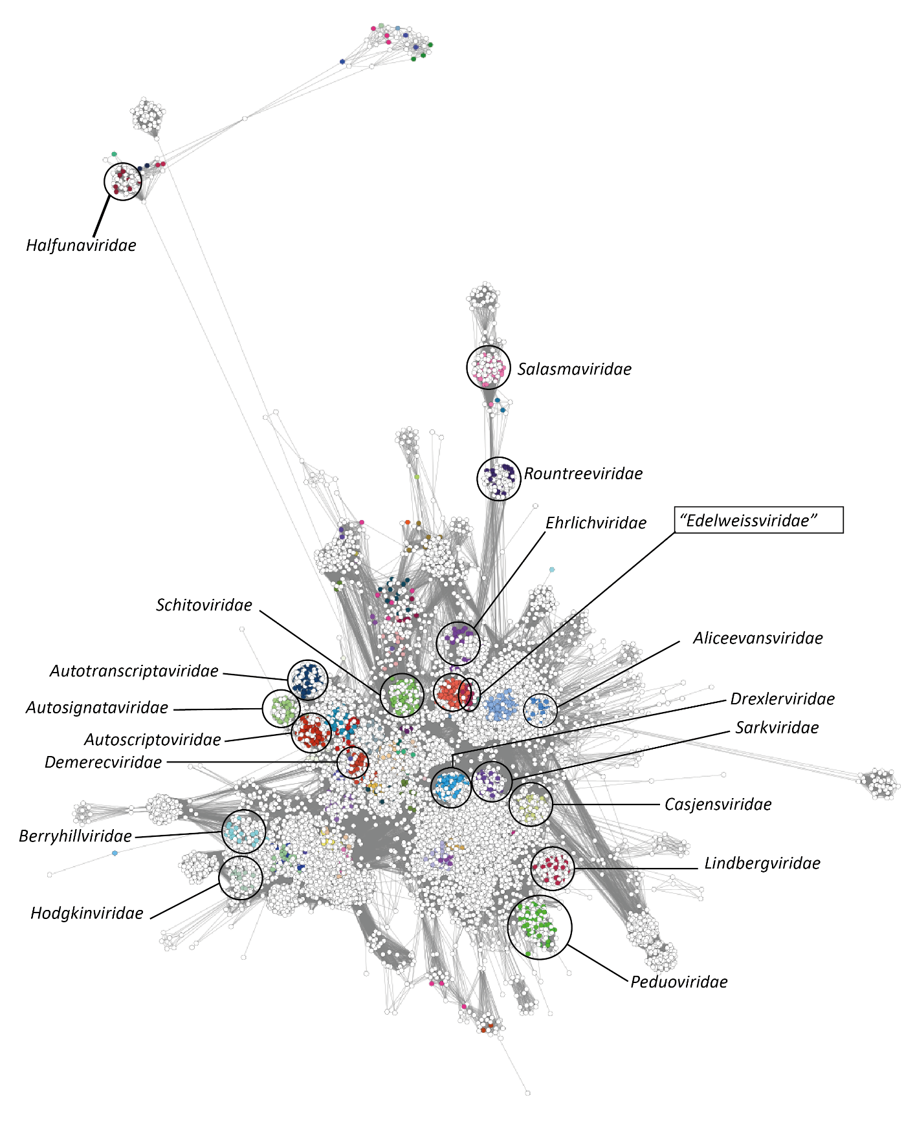
Figure 1. vConTACT3 network. Subset of a vConTACT3 network consisting of the major cluster of genomes belonging to the class Caudoviricetes. Genomes are represented as nodes in the network and are coloured according to their classification in the VMR_MSL40.v1. Select classified families of bacterial viruses are annotated by circles and labels on the network.

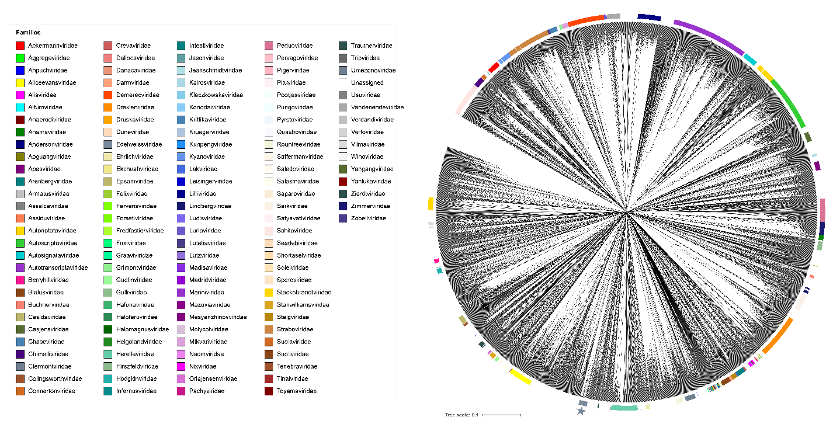
Figure 2. TBLASTX distance tree for 6,049 genomes classified within the class Caudoviricetes generated with ViPTreeGen version 2. The tree was calculated from pairwise distances between each genome and hierarchically clustered. The proposed family Edelweissviridae is marked with a star.

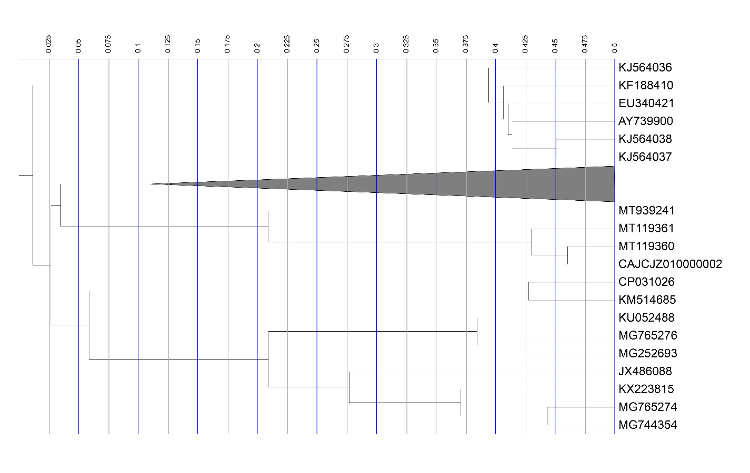
Figure 3. Pruned TBLASTX distance tree illustrating the proposed family Edelweissviridae alongside neighboring clades of bacterial viruses.
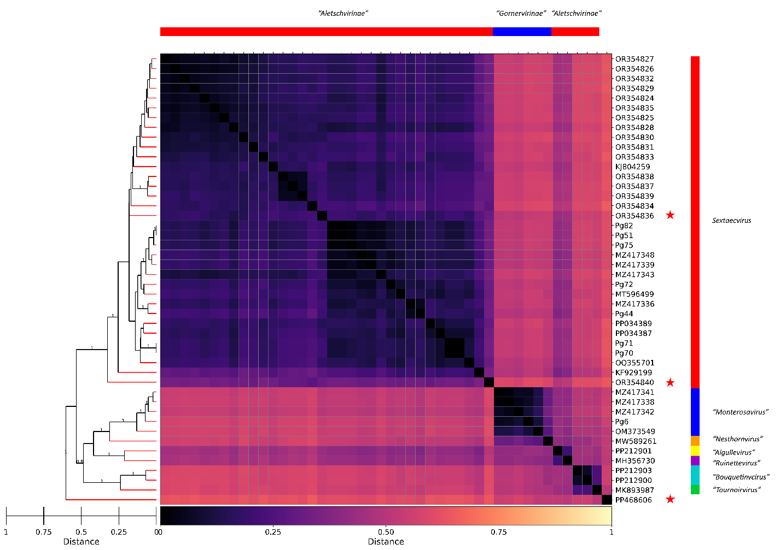
Figure 4. GRAViTy-v2 comparison of 46 bacteriophage genomes. Subfamilies are delineated using horizontal bars at the top of the heatmap, and genera by vertical bars at the left. Genomes were initially selected based on vConTACT3 results [18] using the INPHARED database [8], then subsampled for use as the input to GRAViTy-v2 [17]. Three genomes are marked with red stars: PP468606 is a distant relative of the proposed family; OR354836 exhibits gene products split across multiple coding sequences which may indicate the presence of frameshift assembly errors.

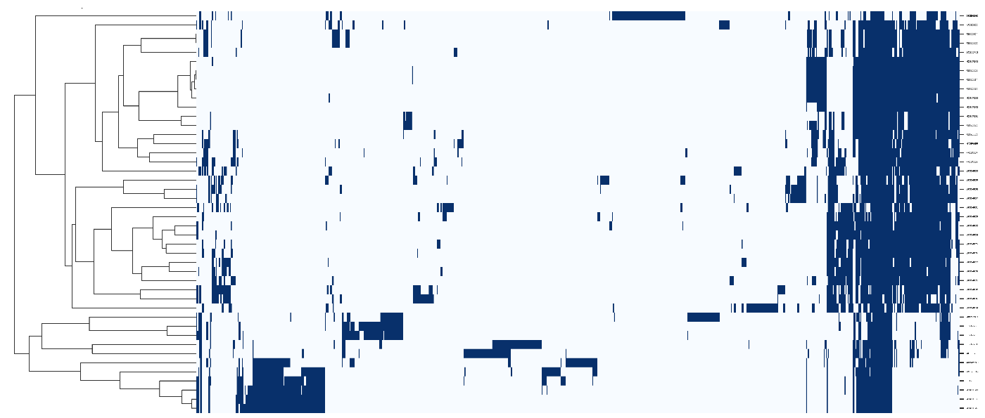
Figure 5. Heatmap displaying the presence (blue) and absence (pale blue) of protein clusters by genome. The matrix was hierarchically clustered using the complete linkage method.

Table 1. Conserved proteins in the proposed family Edelweissviridae
Protein cluster | Putative function | Average size (aa)
1 | Terminase small subunit | 166
2 | Portal vertex protein | 470
3 | Head-tail adaptor | 169
4 | Head-tail adaptor | 114
5 | Tail completion or Neck1 protein | 138
6 | Head maturation protease | 376
7 | Major capsid protein | 386
8 | Head closure protein | 111
9 | Hypothetical protein | 160
10 | Tail protein | 143

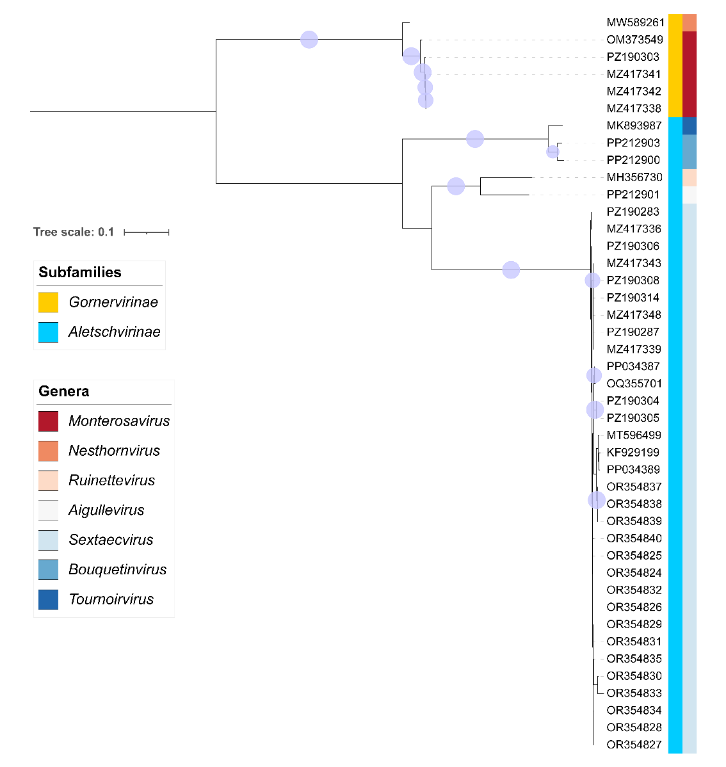

Figure 6. Concatenated maximum-likelihood phylogenetic tree of the ten identified signature genes in the family Edelweissviridae. The tree is mid-point rooted and UFBoot support ≥95% are indicated by filled circles at the branchpoints. OR354836 (Staphylococcus phage S-CoN_Ph13) has been omitted from the tree due to the presence of multiple split coding sequences.

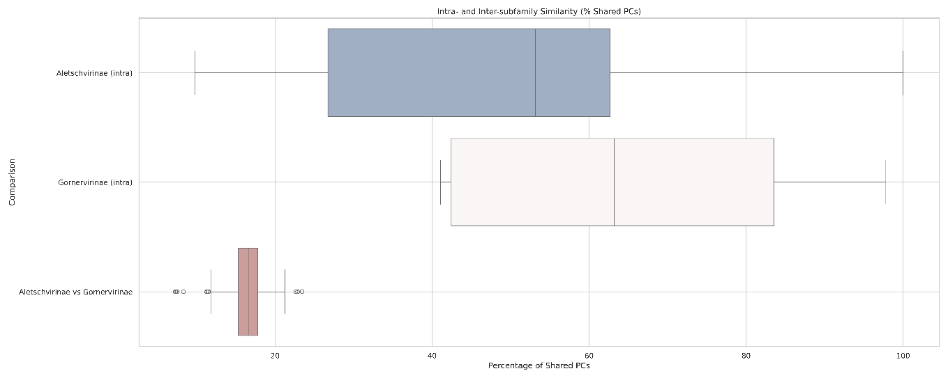
Figure 7. Comparison of shared protein clusters between genomes included in the proposed subfamilies. The box and whisker plot shows the percentage of share protein clusters between pair-wise comparisons of genomes within each subfamily (intra) and between each subfamily. The inclusion of OR354836 and OR354840 has affected the minimum, shown by the error bars, for the proposed subfamily Aletschvirinae.

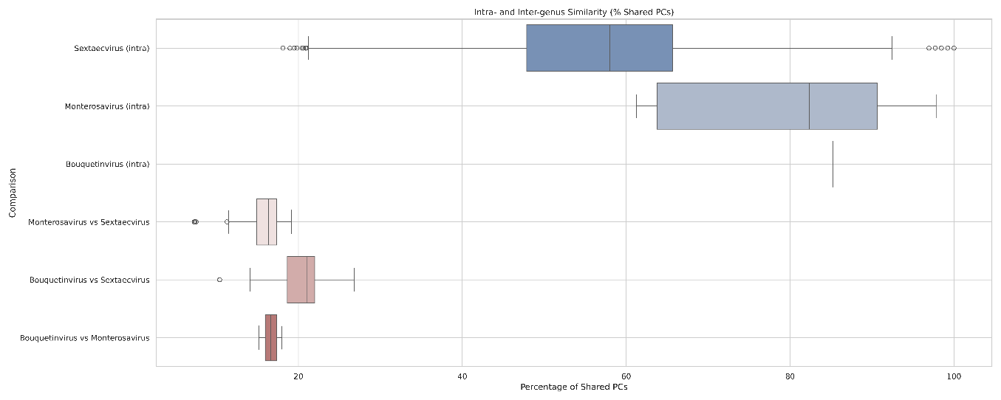
Figure 8. Comparison of shared protein clusters between genomes included in the proposed genera. The box and whisker plot shows the percentage of share protein clusters between pair-wise comparisons of genomes within each subfamily (intra) and between each subfamily.

Supplementary file 1. Heatmap of inter-genomic similarities of existing and proposed species in the family Edelweissviridae, calculated using taxMyPhage. The status column provides information on whether a genome is represented by an existing or proposed species. Genomes that exhibit greater than 95% similarity are described as strains.

