

The International Committee on Taxonomy of Viruses
Taxonomy Proposal Form, 2026

Part 1a: Details of taxonomy proposals

Title: | Create 15 new species in the genus Rockefellervirus (Class: Caudoviricetes)
Code assigned: | 2025.091B.N 2025.091B

Author(s), affiliation and email address(es):
Given name (+middle initial(s)) | Surname | Affiliation | Email address | Corr. author(s)
Elena | Gómez-Sanz | Division of Molecular Bacterial Epidemiology & Infectious Diseases, Institute of Veterinary Bacteriology, University of Bern, Bern, Switzerland | elena.gomezsanz@unibe.ch | X
Sandra | Pérez-Jiménez | Division of Molecular Bacterial Epidemiology & Infectious Diseases, Institute of Veterinary Bacteriology, University of Bern, Bern, Switzerland | sandra.perezjimenez@unibe.ch
Yang | Jingxian | Division of Molecular Bacterial Epidemiology & Infectious Diseases, Institute of Veterinary Bacteriology, University of Bern, Bern, Switzerland | jingxian.yang@unibe.ch
De Rosa | Davide | Division of Molecular Bacterial Epidemiology & Infectious Diseases, Institute of Veterinary Bacteriology, University of Bern, Bern, Switzerland | davide.derosa@unibe.ch
Dann | Turner | School of Applied Sciences, College of Health, Science and Society, University of the West of England, Bristol, UK | dann2.turner@uwe.ac.uk

Part 1b: Taxonomy Proposal Submission
ICTV Subcommittee:
Animal DNA Viruses and Retroviruses |  | Bacterial viruses | X
Animal minus-strand and dsRNA viruses |  | Fungal and protist viruses
Animal positive-strand RNA viruses |  | Plant viruses
Archaeal viruses |  | General -

List the ICTV Study Group(s) that have seen or have been involved in creating this proposal:
Optional – complete only if formally voted on by an ICTV Study Group:
Study Group | Number of members
Study Group | Votes in support | Votes against | No vote

Submission date: | 20/06/2025

Part 1c: Feedback from ICTV Executive Committee (EC) meeting
Executive Committee Meeting Decision code: | X
A – Accept
Ac – Accept subject to revision by relevant subcommittee chair. No further vote required
U – Accept without revision but with re-evaluation and email vote by the EC
Uc – Accept subject to revision and re-evaluation and email vote by the EC
Ud – Deferred to the next EC meeting, with an invitation to revise based on EC comments
J - Reject
W - Withdrawn

Comments from the Executive Committee:

Part 1d: Revised Taxonomy Proposal Submission
Response of proposer:
Revision date:

Part 3: TAXONOMIC PROPOSAL
https://ictv.global/taxonomy/templates

Taxonomic changes proposed:
Establish new taxon | X | Split taxon
Abolish taxon |  | Merge taxon
Move taxon |  | Promote taxon
Rename taxon |  | Demote taxon
Move and rename

Etymology (origin) of proposed taxonomic names:
Taxon name | Etymology of the term

Permission for use of names derived from a living person:
Taxon name | Full name of person from whom the name is derived | Attached

Abstract of Taxonomy Proposal:
Description of current taxonomy:
The genus Rockefellervirus was created in 2020 (2020.135B.R.Rockefellervirus) and currently includes six species.

Proposed taxonomic change(s):
Create fifteen new species in the genus Rockefellervirus.

Demarcation criteria for new taxon/taxa:
Genus and species: Current ICTV BVS demarcation criteria are that species are defined as genomes exhibiting ≤95% similarity and genera as possessing ≥70% similarity over their genome length [12].

Justification:
The genus Rockefellervirus currently includes six species of bacteriophages that exhibit a temperate lifestyle and infect Staphylococcus sp. The fifteen newly proposed species group with existing members of the genus based on intergenomic nucleotide sequence similarity.

- Text of Taxonomy proposal:

Description of current taxonomy:
The genus Rockefellervirus was created in 2020 (2020.135B.R.Rockefellervirus) and currently includes six species.

Proposed taxonomic change(s):
Create fifteen new species in the genus Rockefellervirus.

Demarcation criteria for new taxon/taxa:
Genus and species: Current ICTV BVS demarcation criteria are that species are defined as genomes exhibiting ≤95% similarity and genera as possessing ≥70% similarity over their genome length [12].

Justification:
The genus Rockefellervirus currently includes six species of bacteriophages infecting Staphylococcus species. All of these viruses are either predicted or have been shown to undertake a temperate lifecycle and produce stable lysogens. The fifteen newly proposed species form a cluster based on nucleotide sequence similarity with existing members of the genus (Figure 1) [1-2]. The genus does not strictly fall within the published genus demarcation criteria [12] but instead shows a mosaic of intergenomic similarities between phages. We suggest this is due to higher rates of recombination associated with the temperate lifestyle of these phages. To identify conserved genes for the inference of maximum-likelihood phylogenies, protein clustering using MMSeqs2 [3] was employed, followed by multiple sequence alignment with MAFFT [5] with tree calculation performed with IQTree2 [14] using ModelFinder [16] and ultra-fast bootstrapping [15] (Figure 2). The genus has a total of 16 conserved proteins present in all representative genomes.

Data obtained using GRAViTy-v2 [17] and vConTACT3 [18] suggests that this genus belongs to a larger clade of bacteriophages which might support the creation of a new family and/or order in the future (Figures 3-4).

References:
- Sayers EW, Beck J, Bolton EE, Bourexis D, Brister JR, Canese K, Comeau DC, Funk K, Kim S, Klimke W, Marchler-Bauer A, Landrum M, Lathrop S, Lu Z, Madden TL, O'Leary N, Phan L, Rangwala SH, Schneider VA, Skripchenko Y, Wang J, Ye J, Trawick BW, Pruitt KD, Sherry ST. Database resources of the National Center for Biotechnology Information. Nucleic Acids Res. 2021 Jan 8;49(D1):D10-D17. doi: 10.1093/nar/gkaa892.
- O'Leary NA, Wright MW, Brister JR, Ciufo S, Haddad D, McVeigh R, et al. Reference sequence (RefSeq) database at NCBI: current status, taxonomic expansion, and functional annotation. Nucleic Acids Res. 2016;44(D1):D733-45. doi: 10.1093/nar/gkv1189.
- Steinegger M, Söding J. (2017) MMseqs2 enables sensitive protein sequence searching for the analysis of massive data sets. Nat Biotechnol. 35(11):1026-1028. doi: 10.1038/nbt.3988.
- Nakamura T, Yamada KD, Tomii K, Katoh K. (2018) Parallelization of MAFFT for large-scale multiple sequence alignments. Bioinformatics. 34(14):2490-2492. doi: 10.1093/bioinformatics/bty121.
- Katoh K, Standley DM. (2013) MAFFT multiple sequence alignment software version 7: improvements in performance and usability. Mol Biol Evol. 30(4):772-80. doi: 10.1093/molbev/mst010.
- Steinegger M, Meier M, Mirdita M, Vöhringer H, Haunsberger SJ, Söding J. (2019) HH-suite3 for fast remote homology detection and deep protein annotation. BMC Bioinformatics. 20(1):473. doi: 10.1186/s12859-019-3019-7.
- Van Dongen S. (2008). Graph clustering via a discrete uncoupling process, Siam Journal on Matrix Analysis and Applications 30(1), 121-141.
- Cook R, Brown N, Redgwell T, Rihtman B, Barnes M, Clokie M, Stekel DJ, Hobman J, Jones MA, Millard A. (2021) INfrastructure for a PHAge REference Database: Identification of Large-Scale Biases in the Current Collection of Cultured Phage Genomes. Phage 2(4):214-223. doi: 10.1089/phage.2021.0007.
- Eddy SR. (2011) Accelerated Profile HMM Searches. PLoS Comput Biol. 7(10):e1002195. doi: 10.1371/journal.pcbi.1002195.
- Nishimura Y, Yoshida T, Kuronishi M, Uehara H, Ogata H, Goto S. (2017) ViPTree: The viral proteomic tree server. Bioinformatics. 33(15):2379–80.
- Rohwer F, Edwards R. (2002) The Phage Proteomic Tree: a genome-based taxonomy for phage. Journal of Bacteriology. 184(16):4529–35
- Turner D, Kropinski AM, Adriaenssens EM. (2021) A Roadmap for Genome-Based Phage Taxonomy. Viruses. 13(3):506. doi: 10.3390/v13030506.
- Letunic I, Bork P. (2007) Interactive Tree of Life (iTOL): An online tool for phylogenetic tree display and annotation. Bioinformatics.23(1):127–8.
- Nguyen LT, Schmidt HA, von Haeseler A, and Minh BQ (2015) IQ-TREE: A fast and effective stochastic algorithm for estimating maximum likelihood phylogenies. Molecular Biology and Evolution, 32:268-274. https://doi.org/10.1093/molbev/msu300
- Hoang DT, Chernomor O, von Haeseler A, Minh BQ, Vinh LS (2018) UFBoot2: Improving the ultrafast bootstrap approximation. Molecular Biology and Evolution, 35:518–522. https://doi.org/10.1093/molbev/msx281
- Kalyaanamoorthy S, Minh BQ, Wong TKF, von Haeseler A, and Jermiin JS (2017) ModelFinder: Fast Model Selection for Accurate Phylogenetic Estimates, Nature Methods, 14:587–589. https://doi.org/10.1038/nmeth.4285
- Mayne R, Aiewsakun P, Turner D, Adriaenssens EM, Simmonds P. (2024) GRAViTy-V2: a grounded viral taxonomy application. NAR Genom Bioinform. 2024 Dec 18;6(4):lqae183. doi: 10.1093/nargab/lqae183
- Bolduc B, Zablocki O, Turner D, Jang H, Guo J, Adriaenssens EM, Dutilh B, Sullivan MB (2025) Machine learning enables scalable and systematic hierarchical virus taxonomy. Nat. Biotechnol. https://doi.org/10.1038/s41587-025-02946-9

Accompanying files:
Filename | Description of contents

Tables, Figures:

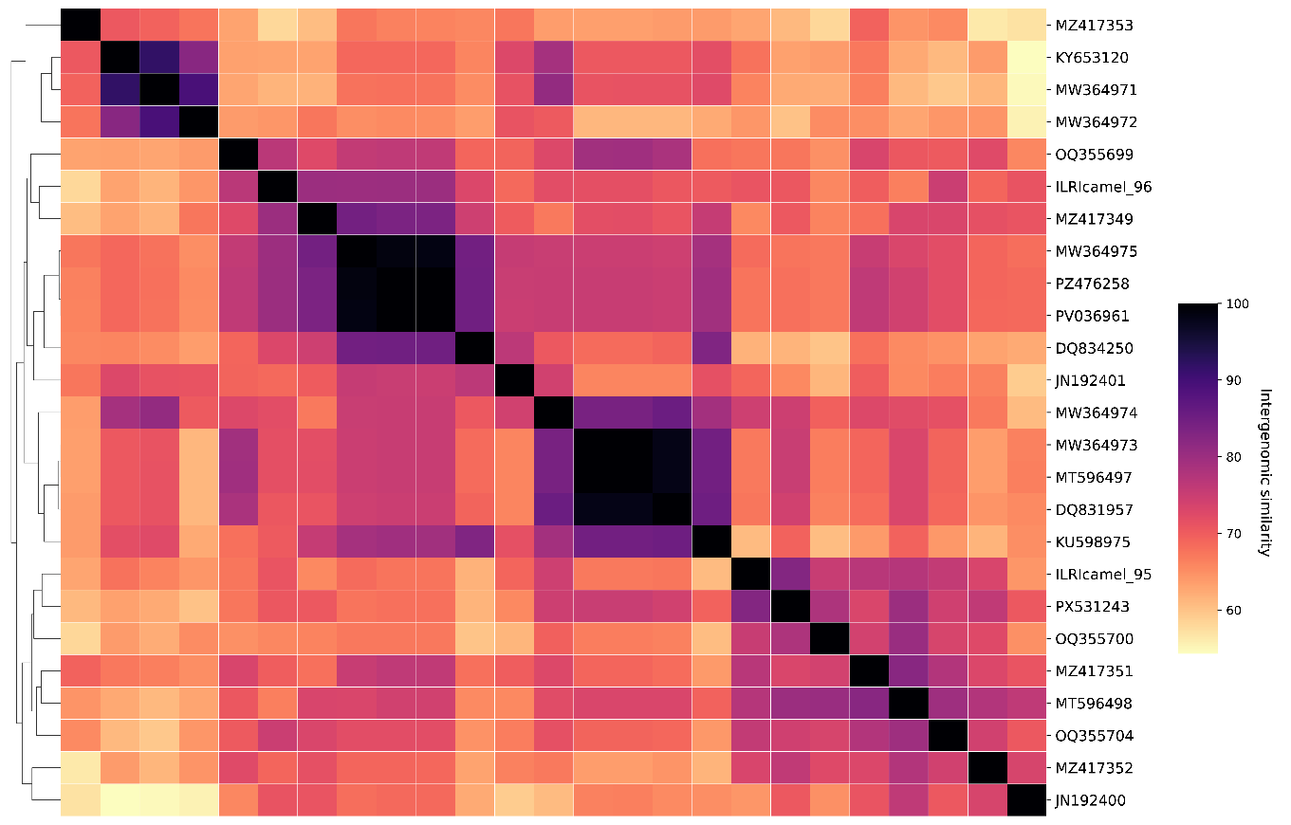
Figure 1. Heatmap of inter-genomic similarities of existing and proposed species in the genus Rockefellervirus, calculated using the similarity function of taxMyPhage.

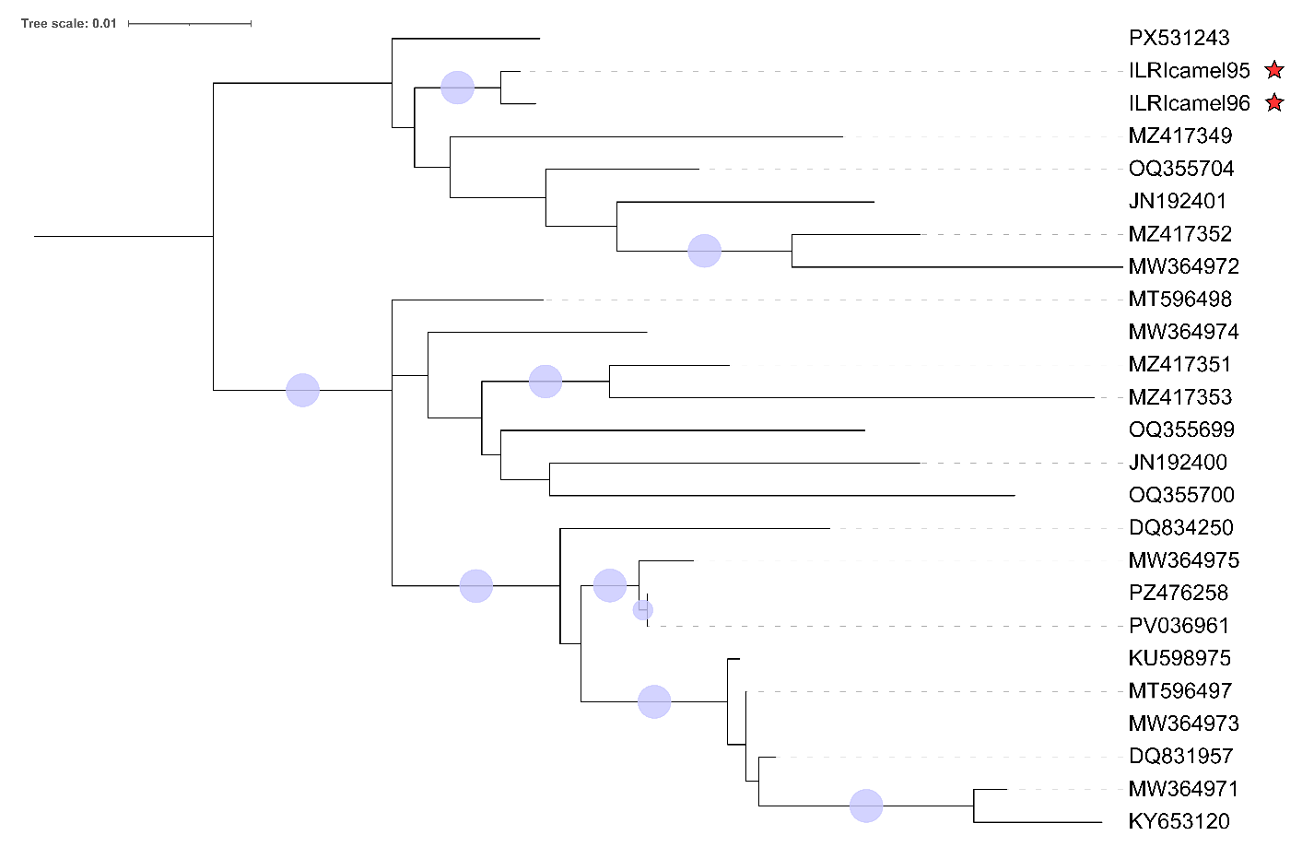

Figure 2. Concatenated core-genome maximum likelihood tree. Protein sequences were individually aligned and trimmed prior to concatenation. Tree inference was performed using IQ-TREE 2 (v2.2.2). A partitioned analysis was conducted, with optimal amino acid substitution models and rate heterogeneity parameters determined independently for each locus via ModelFinder. Statistical support for internal branches was assessed using the SH-approximate likelihood ratio test (SH-aLRT; 1,000 replicates) and Ultrafast Bootstrap approximation (UFBoot; 1,000 replicates). The tree was rooted at the mid-point. The red stars indicate genomes that have been included within the overall analysis but have not yet been released to the INSDC.

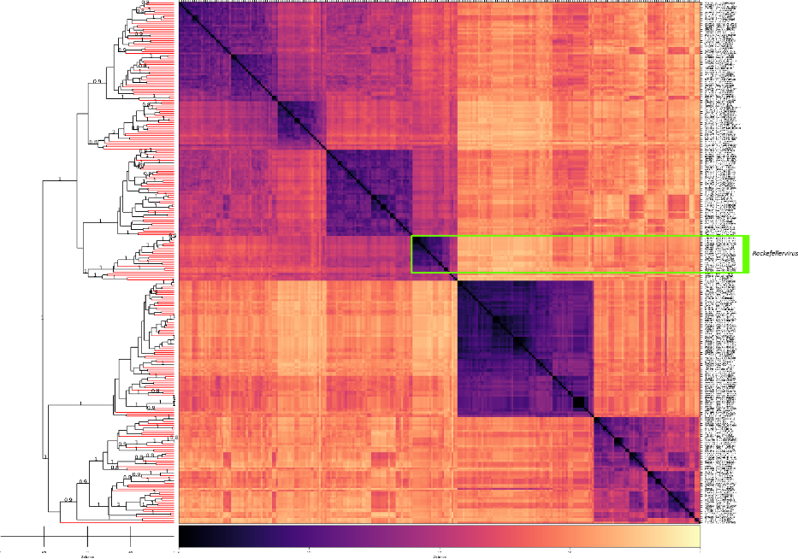
Figure 3. GRAViTy-v2 comparison of 279 bacteriophage genomes. The genus Rockefellervirus is highlighted with a green rectangle. Genomes were initially selected based on vConTACT3 results [18] using the INPHARED database [8], then subsampled for use as the input to GRAViTy-v2 [17].

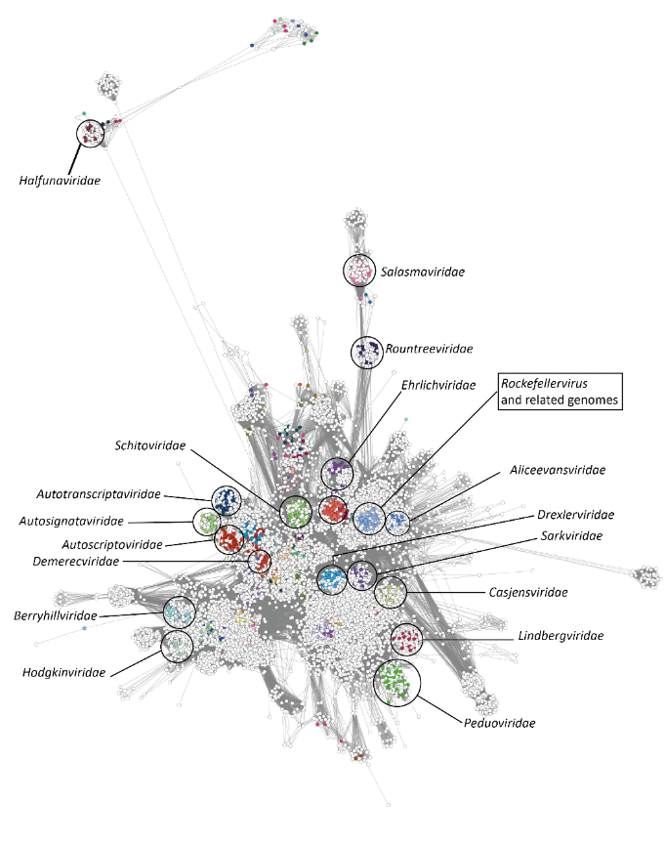
Figure 4. vConTACT3 network. Subset of vConTACT3 network consisting of the major cluster of genomes belonging to the class Caudoviricetes. Genomes are represented as nodes in the network and are coloured according to their classification in the VMR_MSL40.v1. Select classified families of bacterial viruses are annotated by circles and labels on the network.

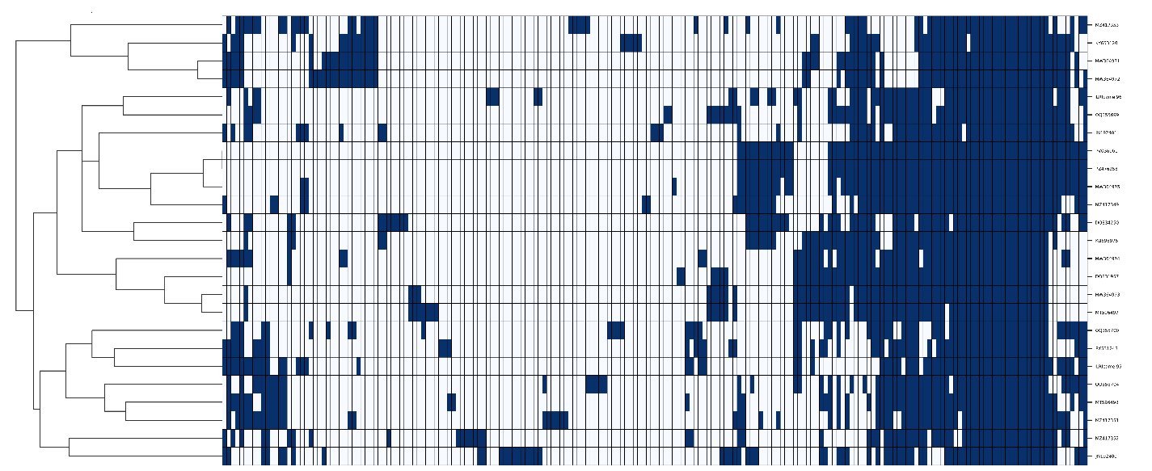

Figure 5. Heatmap of protein presence-absence. Protein sequences were clustered using MMSeqs2 with parameters of 30% minimum sequence identity and 80% minimum coverage.
Table 1. Single-copy genes shared by all genomes in the genus Rockefellervirus.
Core protein | Function | Average length (aa)
1 | Head scaffolding protein | 191
2 | Minor tail protein | 510
3 | Tail-associated cell-wall hydrolase | 612
4 | Major tail protein | 179
5 | Minor head protein | 316
6 | Head closure protein | 109
7 | Tail protein | 312
8 | Tail assembly chaperone | 164
9 | Tail terminator | 145
10 | Portal vertex protein | 478
11 | Minor head protein | 618
12 | Tail protein | 100
13 | Head-tail adaptor protein | 104
14 | Hypothetical protein | 46
15 | Nucleotide kinase | 147
16 | Arc-like repressor | 96

