

The International Committee on Taxonomy of Viruses
Taxonomy Proposal Form, 2026

Part 1a: Details of taxonomy proposals

Title: | Create one new family, “Jinchiviridae”, for classification of viruses associated with Kariarchaeaceae
Code assigned: | 2026.006A.N.v1.Jinchiviridae_1nf

Author(s), affiliation and email address(es):
Given name (+middle initial(s)) | Surname | Affiliation | Email address | Corr. author(s)
Chengxiang | Gu | Institute for Advanced Study, Shenzhen University, Shenzhen, China | guchengxiang2022@email.szu.edu.cn
Rui | Zhang | Institute for Advanced Study, Shenzhen University, Shenzhen, China | ruizhang@szu.edu.cn
Yang-zhi | Rao | Department of Environmental Science and Engineering,  University of Science and Technology of China, Hefei, China | raoyzh7@mail.sysu.edu.cn
Xinxu | Zhang | Institute for Advanced Study, Shenzhen University, Shenzhen, China | newsun@szu.edu.cn
Zhichao | Zhou | Institute for Advanced Study, Shenzhen University, Shenzhen, China | zczhou2017@szu.edu.cn
Yang | Liu | Institute for Advanced Study, Shenzhen University, Shenzhen, China | yangliu@szu.edu.cn
Xiyang | Dong | Key Laboratory of Marine Genetic Resources, Ministry of Natural Resources, Third Institute of Oceanography, Xiamen, China | dongxiyang@tio.org.cn
Long | Wang | Institute for Advanced Study, Shenzhen University, Shenzhen, China | kodragon@szu.edu.cn
Yinzhao | Wang | School of Life Sciences and  Biotechnology, Shanghai Jiao Tong University, Shanghai, China | wyz@sjtu.edu.cn
Zheng-shuang | Hua | Department of Environmental Science and Engineering,  University of Science and Technology of China, Hefei, China | hzhengsh@ustc.edu.cn
Mart | Krupovic | Institut Pasteur, Université de Paris, Cell Biology and Virology of Archaea Unit, Paris, France | mart.krupovic@pasteur.fr
Meng | Li | Institute for Advanced Study, Shenzhen University, Shenzhen, China | limeng848@szu.edu.cn | X

Part 1b: Taxonomy Proposal Submission
ICTV Subcommittee:
Animal DNA Viruses and Retroviruses |  | Bacterial viruses
Animal minus-strand and dsRNA viruses |  | Fungal and protist viruses
Animal positive-strand RNA viruses |  | Plant viruses
Archaeal viruses | X | General -

List the ICTV Study Group(s) that have seen or have been involved in creating this proposal:
Optional – complete only if formally voted on by an ICTV Study Group:
Study Group | Number of members
Study Group | Votes in support | Votes against | No vote

Submission date: | 08/10/2026

Part 1c: Feedback from ICTV Executive Committee (EC) meeting
Executive Committee Meeting Decision code: | X
A – Accept
Ac – Accept subject to revision by relevant subcommittee chair. No further vote required
U – Accept without revision but with re-evaluation and email vote by the EC
Uc – Accept subject to revision and re-evaluation and email vote by the EC
Ud – Deferred to the next EC meeting, with an invitation to revise based on EC comments
J - Reject
W - Withdrawn

Comments from the Executive Committee:

Part 1d: Revised Taxonomy Proposal Submission
Response of proposer:
Revision date:

Part 3: TAXONOMIC PROPOSAL

Taxonomic changes proposed:
Establish new taxon | X | Split taxon
Abolish taxon |  | Merge taxon
Move taxon |  | Promote taxon
Rename taxon |  | Demote taxon
Move and rename

Etymology (origin) of proposed taxonomic names:
Taxon name | Etymology of the term
Jinchiviridae | from Jinchi, referring to Elder Jinchi (Jinchi Zhanglao) in the video game Black Myth: Wukong; the suffix -viridae for family taxa
Youhunvirus | from Youhun, referring to the Yaoguai head (boss) of the Black Wind Mountain in Black Myth: Wukong, whose name is directly used in “pinyin” in the game’s English version; the suffix -virus for genus taxa
xiaoguagua | from xiaoguagua, referring to the minor Yaoguai (small frog spirit) of the Black Wind Mountain in Black Myth: Wukong, whose name is also kept in “pinyin” in the English version
Guangmouvirus | from Guangmou, referring to the Yaoguai head (boss) of the Black Wind Mountain in Black Myth: Wukong, whose name is directly used in “pinyin” in the game’s English version; the suffix -virus for genus taxa
gulinxun | from gulinxun, referring to the minor Yaoguai (bone monster) of the Black Wind Mountain in Black Myth: Wukong, whose name is also kept in “pinyin” in the English version

Permission for use of names derived from a living person:
Taxon name | Full name of person from whom the name is derived | Attached

Abstract of Taxonomy Proposal:
Description of current taxonomy:
Caudoviricetes comprises 129 families among which 47 families include viruses infection diverse archaea.

Proposed taxonomic change(s):
We propose classifying two viruses identified by metagenomics and associated with Asgard archaea of the family Kariarchaeaceae into a new family, “Jinchiviridae”, within class Caudoviricetes.

Demarcation criteria for new taxon/taxa:
We propose using 95% sequence identity as a species demarcation criterion, to be consistent with the classification of other bacterial and archaeal viruses. Membership in the family will be established based on the conservation of the hallmark proteins, including HK97-fold major capsid protein, terminase large subunit and portal protein, and divergence in the global proteomic tree calculated using ViPTree.

Justification:
Based on genome-wide proteomic analysis, members of the proposed family “Jinchiviridae” are not closely related to the previously described and classified viruses.

Text of Taxonomy proposal:
Description of current taxonomy:
Caudoviricetes comprises 129 families among which 47 families include viruses infection diverse archaea.

Proposed taxonomic change(s):
We propose classifying two viruses identified by metagenomics and associated with Asgard archaea of the family Kariarchaeaceae into a new family, “Jinchiviridae”, within class Caudoviricetes.

Demarcation criteria for new taxon/taxa:
We propose using 95% sequence identity as a species demarcation criterion, to be consistent with the classification of other bacterial and archaeal viruses. Membership in the family will be established based on the conservation of the hallmark proteins, including HK97-fold major capsid protein, terminase large subunit and portal protein, and divergence in the global proteomic tree calculated using ViPTree.

Justification:
Asgard archaea were predominantly identified in anoxic sediments [1–3]. Kariarchaeaceae is an Asgard archaeal family spread in marine sediments, and all Kariarchaeaceae species have been discovered through metagenomics so far [4]. Recently, a new viral group associated with Kariarchaeaceae was discovered through metagenomics, with the host assignment based on CRISPR matching [5].

Protein sharing network analysis (Fig .1) showed that this newly identified Kariarchaeaceae viruses do not cluster with other known prokaryotic viruses, forming a distinct group. Genome annotation using sensitive HMM profile-profile comparisons showed that the two viruses with complete genomes (assembled as circular contigs based on the presence of direct terminal repeats), JinchiV1 and JinchiV2, encode all hallmarks of the class Caudoviricetes [6], including the HK97-like major capsid proteins (MCP), portal protein, large subunit of the terminase, capsid maturation protease and several tail proteins (Fig. 2). Genome-wide protein sequence-based comparison of these viruses with previously described Asgard archaeal viruses revealed only distant relationship, with the branch length in VipTree analysis [7] being longer than 0.05 (Fig. 2), which roughly corresponds to the divergence among other archaeal caudoviricetes [6]. These analyses suggest that JinchiV1 and JinchiV2 form a new family level group, which we propose naming “Jinchiviridae”.

Despite obvious regions of homology and synteny (Fig. 4), JinchiV1 and JinchiV2 displayed considerable variation in genome size (33.6 kbp vs 56.9 kbp, Fig. 4) and, accordingly, differences in gene content. For instance, JinchiV1 encodes a site-specific tyrosine recombinase and an anti-repressor (ANT), suggestive of a lysogenic ability, whereas JinchiV2 lacks these genes. Thus, we propose classifying JinchiV1 and JinchiV2 into separate genera, “Youhunvirus” and “Guangmouvirus”. Besides JinchiV1 and JinchiV2, three additional related contigs were recovered, but these are incomplete and are not proposed to be classified.

References:
1. Liu Y, Makarova KS, Huang W-C, Wolf YI, Nikolskaya AN, Zhang X, et al. Expanded diversity of Asgard archaea and their relationships with eukaryotes. Nature. 2021;593:553–7. https://doi.org/10.1038/s41586-021-03494-3
2. Zaremba-Niedzwiedzka K, Caceres EF, Saw JH, Bäckström D, Juzokaite L, Vancaester E, et al. Asgard archaea illuminate the origin of eukaryotic cellular complexity. Nature. 2017;541:353–8. https://doi.org/10.1038/nature21031
3. Spang A, Saw JH, Jørgensen SL, Zaremba-Niedzwiedzka K, Martijn J, Lind AE, et al. Complex archaea that bridge the gap between prokaryotes and eukaryotes. Nature. 2015;521:173–9. https://doi.org/10.1038/nature14447
4. Panagiotou K, Geesink P, Köstlbacher S, De Zwaan GH, Ettema TJG. Diversity, ecology, cell biology and evolution of the Asgard archaea. Nat Rev Microbiol. 2026;24:377–91. https://doi.org/10.1038/s41579-026-01288-w
5. Gu C, Zhang R, Rao Y, Zhang X, Zhou Z, Liu Y, et al. Expansion of the asgard archaeal virome and defensome provides insights into virus-host interactions. Microbiome. 2026; https://doi.org/10.1186/s40168-026-02481-y
6. Liu Y, Demina TA, Roux S, Aiewsakun P, Kazlauskas D, Simmonds P, et al. Diversity, taxonomy, and evolution of archaeal viruses of the class Caudoviricetes. PLoS Biol. 2021;19:e3001442. https://doi.org/10.1371/journal.pbio.3001442
7. Nishimura Y, Yoshida T, Kuronishi M, Uehara H, Ogata H, Goto S. ViPTree: the viral proteomic tree server. Valencia A. Bioinformatics. 2017;33:2379–80. https://doi.org/10.1093/bioinformatics/btx157

Accompanying files:
Filename | Description of contents

Tables, Figures:

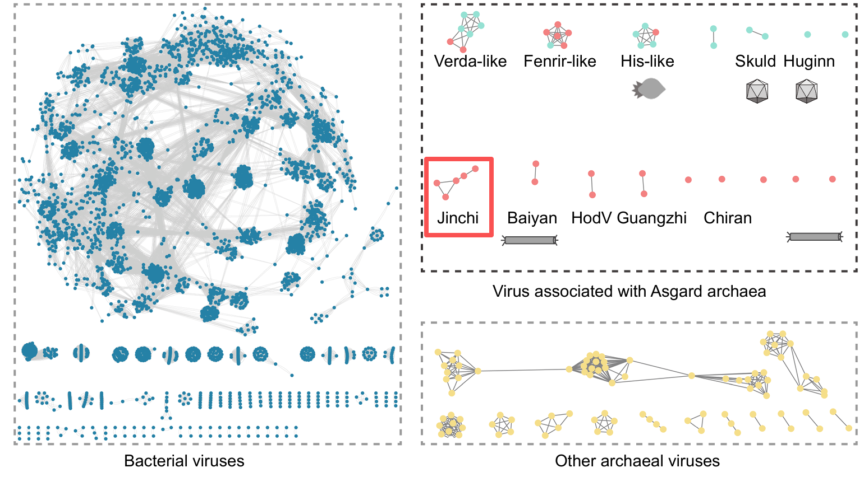

Figure 1. Classification of Asgard archaeal viruses based on the whole-genome protein-sharing network with other prokaryotic viruses. Protein sharing network were conducted based on 24 predicted Asgard archaeal viral contigs in this study and 16 published Asgard archaeal viruses using vContact2 (v0.11.3). The network was visualized using Cytoscape. The “Jinchiviridae” is outlined with a red rectangle.

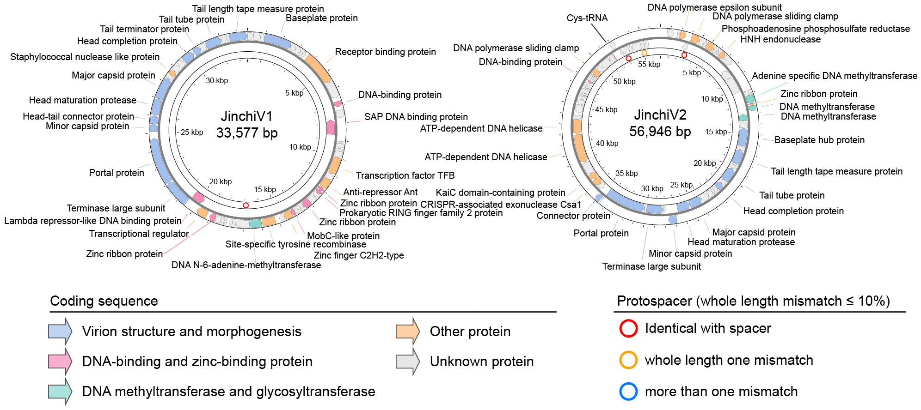

Figure 2. Genomic maps of two complete Jinchiviridae associated with Kariarchaeaceae. viral genomes are shown and genes with different function are colored and labeled. Inner circle shows the position of protospacers which colored based on number of mismatches. The genomic maps were plotted using Proksee.

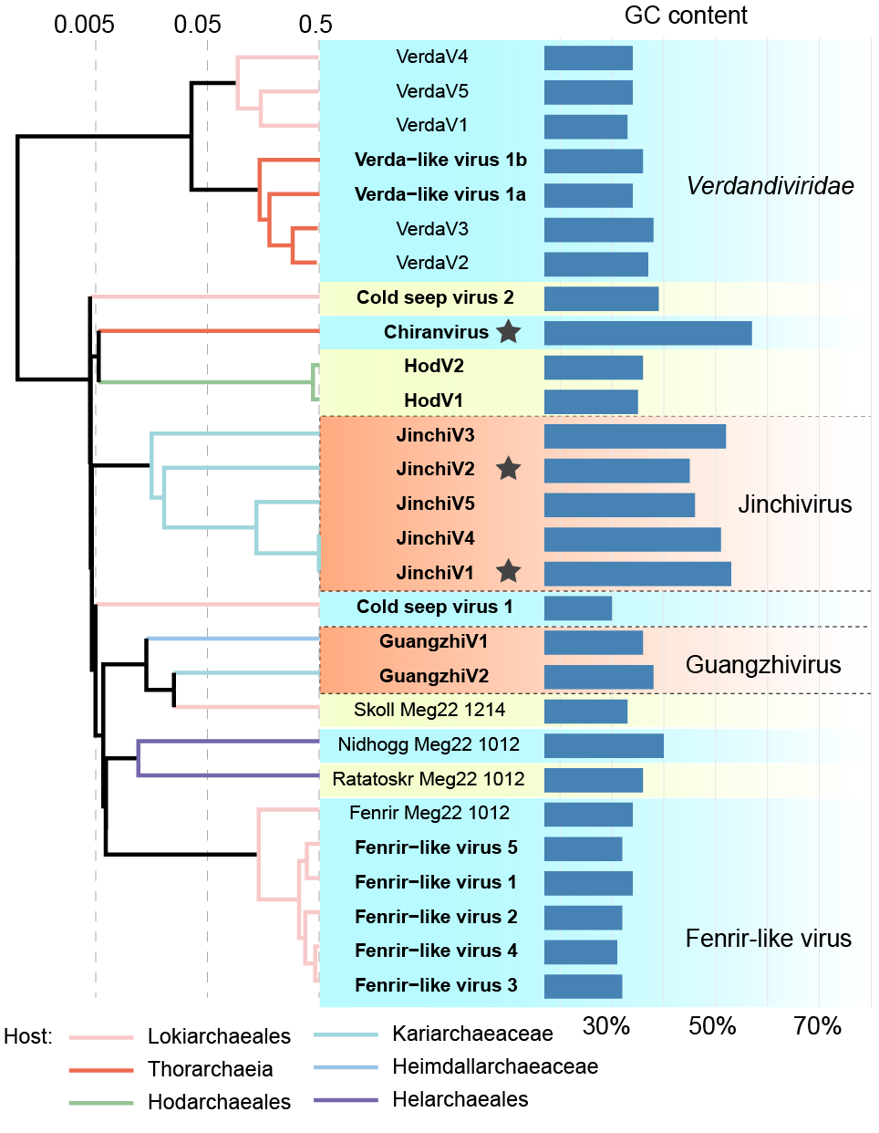

Figure 3. Proteomic tree of Asgard archaeal head-tailed viruses using VIPTree. The bars indicate its GC content. Black stars indicated complete genomes.

Figure 4. Comparative genomics-based synteny analysis of Jinchiviridae. Genes were labeled and colored based on the annotation. Homologous regions are displayed according to tBLASTx identity. It is plotted using DiGAlign.

