
i

The International Committee on Taxonomy of Viruses
Taxonomy Proposal Form, 2026

Part 1a: Details of taxonomy proposals

Title: | Create one new realm (Texereviria) for classification of archaeal viruses that form particles with spindle-shaped and bacilliform morphologies
Code assigned: | 2026.005A.N.v1.Texereviria_1nr

Author(s), affiliation and email address(es):
Given name (+middle initial(s)) | Surname | Affiliation | Email address | Corr. author(s)
Sofia | Medvedeva | Institut Pasteur, Université Paris Cité, Cell Biology and Virology of Archaea Unit, Paris, France | sofia.medvedeva@pasteur.fr
Tomohiro | Mochizuki | Faculty of Pharmacy, Osaka Ohtani University, Osaka, Japan | mochizutomo@osaka-ohtani.ac.jp
Mike | Dyall-Smith | Computational Systems Biochemistry, Max-Planck-Institute of Biochemistry, Martinsried, Germany | mike.dyallsmith@gmail.com
Kenneth M. | Stedman | Center for Life in Extreme Environments, Department of Biology, Portland State University, Portland, Oregon, USA | kstedman@pdx.edu
Virginija | Cvirkaite-Krupovic | Institut Pasteur, Université Paris Cité, Cell Biology and Virology of Archaea Unit, Paris, France | virginija.cvirkaite-krupovic@pasteur.fr
Xiaoyu | Xiang | neoTCR Therapeutics, Ltd, Yizhuang economic-technological development area, Beijing 100176, China | xiangxiaoyu@neo-tcr.com
Susanne | Erdmann | Institute for Microbiology, University of Innsbruck, Technikerstrasse 25d, 6020 Innsbruck, Austria | Susanne.Erdmann@uibk.ac.at
Uri | Gophna | The Shmunis School of Biomedicine and Cancer Research, Tel Aviv University, Tel Aviv, Israel | urigo@tauex.tau.ac.il
Yongjie | Wang | College of Food Science and Technology, Shanghai Ocean University, Shanghai, China | yjwang@shou.edu.cn
Li | Huang | Southern Marine Science and Engineering Guangdong Laboratory (Guangzhou), Nansha, Guangzhou 511458, China | huangl@im.ac.cn
Eugene V. | Koonin | Computational Biology Branch, Division of Intramural Research, National Library of Medicine, National Institutes of Health, Bethesda, Maryland, USA | koonin@ncbi.nlm.nih.gov
Jens H. | Kuhn | Frederick, Maryland, USA
Mart | Krupovic | Institut Pasteur, Université Paris Cité, Cell Biology and Virology of Archaea Unit, Paris, France | mart.krupovic@pasteur.fr | X

Part 1b: Taxonomy Proposal Submission
ICTV Subcommittee:
Animal DNA Viruses and Retroviruses |  | Bacterial viruses
Animal minus-strand and dsRNA viruses |  | Fungal and protist viruses
Animal positive-strand RNA viruses |  | Plant viruses
Archaeal viruses | X | General -

List the ICTV Study Group(s) that have seen or have been involved in creating this proposal:

Optional – complete only if formally voted on by an ICTV Study Group:
Study Group | Number of members
Study Group | Votes in support | Votes against | No vote

Submission date: | 30/09/2026

Part 1c: Feedback from ICTV Executive Committee (EC) meeting
Executive Committee Meeting Decision code: | X
A – Accept
Ac – Accept subject to revision by relevant subcommittee chair. No further vote required
U – Accept without revision but with re-evaluation and email vote by the EC
Uc – Accept subject to revision and re-evaluation and email vote by the EC
Ud – Deferred to the next EC meeting, with an invitation to revise based on EC comments
J - Reject
W - Withdrawn

Comments from the Executive Committee:

Part 1d: Revised Taxonomy Proposal Submission
Response of proposer:
Revision date:

Part 3: TAXONOMIC PROPOSAL
https://ictv.global/taxonomy/templates

Taxonomic changes proposed:
Establish new taxon | x | Split taxon
Abolish taxon |  | Merge taxon
Move taxon | x | Promote taxon | x
Rename taxon |  | Demote taxon
Move and rename | x

Etymology (origin) of proposed taxonomic names:
Taxon name | Etymology of the term
Texereviria | After Latin texere, “to weave”, for the association with spindle and formation of the capsid as seven or five strands
Virgulavirae | After Latin virgula , “small rod”, the shape of virions
Prangishvilivirae | After Prof. David Prangishvili, a pioneer of archaeal virology who has discovered and classified many archaeal viruses, including spindle-shaped viruses
Toupiviricota | After French toupi, the small spinning toy, “spinning top”, for the spindle-shape of virion
Auloviricota | After Greek αὐλός, "pipe", "flute", or "tube"
Doryviricetes | After Greek δόρυ, “spear”, for the pointed shape of virions
Baguettevirales | After French baguette,“rod”, “stick”, for the bacilliform virions
Turbinelloviricetes | After Latin turbinellus, diminutive of turbo, "small spinning top / conical spindle"
Cetoviricetes | After Greek κῆτος (Latinized cetus), "huge sea monster, whale, or great sea creature" (in antiquity referring to massive, elongated, spindle-shaped marine creatures)
Prolatavirales | After Latin prolatus, “extended/lengthened”, for the ability to grow the long tail/tails
Monocaudaviridae | After Latin mono-, “single”, and -cauda, “tail”
Unicaudavirus | After Latin uni-, “one”, and -cauda, “tail”
Unicaudavirus monumentense | Derived from Monument Geyser Basin, place of isolation
Unicaudavirus craterense | Derived from Crater Hills, place of isolation
Unicaudavirus fonticola | After Latin fons/fontis + -cola, “spring dweller”
Unicaudavirus acidicola | After Latin acidum + -cola, “acid dweller”
Alicicaudaviridae | Derived from Alice hot spring, place of isolation and -cauda “tail” in Latin
Alicivirus | Derived from Alice hot spring, place of isolation
Alicivirus thermicola | After Greek θέρμη + -Latin cola, “hot-environment dweller”
Suocaudaviridae | After Chinese 梭 (Suo), a tool for weaving cloth which is thick in the middle and gets thinner at both ends. The character is synonymous to the Chinese character for spindle (Fangcui in Chinese pinyin) when describing shape.
Tengchongvirus | Derived from 腾冲, place of isolation
Tengchongvirus fonticola | After Latin fons/fontis + -cola, “spring dweller”
Tengchongvirus acidicola | After Latin acidum + -cola, “acid dweller”
Bicaudavirus phlegraeiense | Derived from Phlegraean Fields, avolcanic area next to Naples, Italy, the place of isolation
Lomivirales | After Amharic ሎሚ, “lemon”
Gomizaviridae | After Amharic ጎምዛዛ, “sour”
Algomizaviridae | First discovered genus in the family Gomizaviridae. Prefix Al- is a truncation of Greek letter Alpha
Milxoviridae | After Saho ሚልሖ, “salt”
Almilxovirus | First discovered genus in the family Milxoviridae. Prefix Al- is a truncation of Greek letter Alpha.
Nimbuvirales | After Hindi नींबू, “lemon”
Sidrunviridae | After Estonian sidrun, “lemon”
Hamutzviridae | After Hebrew חמוץ, “sour”
Atlitvirus | After Atlit tide pools, source of isolation/sequencing
Atlitvirus litorale | From Latin litoris, “coastal”
Almyrocitroviridae | After Latin almyro, “salty”, and -citro, “lemon”
Altisalvirus | After Latin altus, “high”, and sal, “salt” because a member virus was isolated 2,000 m above sea level
Altisalvirus tebenquichense | Derived from Tebenquiche, place of isolation
Kisliviridae | After Russian кислый, “sourness”
Eltonvirus | Derived from Lake Elton, place of isolation
Eltonvirus dunalillicola | After host association with green algae of genus Dunaliella
Snaeldavirales | After Old Norse ᛋᚿᛅᛚᛦᛆ, “spindle”
Syraviridae | After Old Norse ᛋᚢᚱᛅ, “sourness”
Muninnvirus | Derived from the second raven of Odin, ᛘᚢᚾᛁᚾ
Muninnvirus odinarchaei | After association with odinarchaeian genome
Wyrdviridae | Derived from Urðr, the third Norn from Norse mythology
Thraedvirus | from Old English þrǣd, “thread”
Thraedvirus abyssicola | Derived from abyss, environment of isolation
Thraedvirus sedimenticola | After sediment, environment of isolation
Urthviridae | Derived from Urðr, the third Norn from Norse mythology
Wefanvirus | After Old English wefan, “to weave”
Wefanvirus sumatrense | Derived from Sumatra, place of isolation
Wefanvirus californense | Derived from California, place of isolation
Ningmengviridae | After Chinese 柠檬, “lemon”
Fangvirus | After Chinese 纺, “to spin”
Fangvirus salicola | After Latin sal + -cola, “salt dweller”
Almarefusivirus | Former Marefusivirus, renamed because of the promotion of the genus to the family rank. Prefix Al is a truncation of Greek letter Alpha
Albaiafusivirus | Former Baiafusivirus, renamed because of the promotion of the genus to the family rank. Prefix Al is a truncation of Greek letter Alpha
Alterrafusivirus | Former Terrafusivirus, renamed because of the promotion of the genus to the family rank. Prefix Al is a truncation of Greek letter Alpha
Alyangshanfusivirus | Former Yangshanfusivirus, renamed because of the promotion of the genus to the family rank. Prefix Al is a truncation of Greek letter Alpha

Permission for use of names derived from a living person:
Taxon name | Full name of person from whom the name is derived | Attached
Prangishvilivirae | David Prangishvili | X

Abstract of Taxonomy Proposal:
Description of current taxonomy:
Archaeal viruses that produce spindle-shaped or bacilliform virions are currently distributed among multiple floating families, including Fuselloviridae, Bicaudaviridae, Halspiviridae, Thaspiviridae, Yamazakiviridae, Xigoviridae, Nipumfusiviridae, Lomiviridae, Itzamnaviridae, Huangdiviridae, Eurekaviridae, Basaltiviridae and Clavaviridae, with no higher-rank taxonomy reflecting their evolutionary relationships.

Proposed taxonomic change(s):
Establish realm “Texereviria”, comprising kingdoms “Prangishvilivirae” (spindle-shaped viruses) and “Virgulavirae” (bacilliform viruses). “Prangishvilivirae” will include phylum “Toupiviricota” and classes “Turbinelloviricetes” and “Cetoviricetes”; “Virgulavirae” will include phylum “Auloviricota” and class “Doryviricetes”. New orders, families and genera are proposed, including promotion of Nipumfusiviridae and Lomiviridae to order rank and their constituent genera to family ranks; establishment of 10 new families.

Demarcation criteria for new taxon/taxa:
Membership in “Texereviria” is supported by a conserved virion morphogenesis module comprising a realm-specific major capsid protein and an FtsK–HerA-superfamily assembly ATPase. Species members share <95% overall genome nucleotide identity; genus members share ≥60% of proteins at ≥70% pairwise identity, family members ≥30% of proteins at ≥50% identity, and order members >5% of proteins at ≥30% identity.

Justification:
Sequence-, profile- and structure-based homology, proteome-wide comparisons, and phylogeny of assembly-ATPase reveal common ancestry and hierarchical relationships not represented by the current taxonomy.

Text of Taxonomy proposal:
Description of current taxonomy:
Archaeal viruses that produce particles with spindle-shaped and bacilliform morphologies are currently classified into numerous floating families, i.e., Fuselloviridae, Bicaudaviridae, Halspiviridae, Thaspiviridae, Yamazakiviridae, Xigoviridae, Nipumfusiviridae, Lomiviridae, Itzamnaviridae, Huangdiviridae, Eurekaviridae, Basaltiviridae (spindle-shaped) and Clavaviridae (bacilliform). Viruses within these taxa encompass considerable diversity in genome length and organization, replication strategy, host range and virion morphology (Figure 1A). The lack of higher-rank taxa for spindle-shaped viruses reflects the historical difficulty of establishing homology among their virion proteins. In many cases, conventional sequence comparisons detected little or no similarity between major structural proteins from viruses of different families. Newly characterized spindle-shaped and bacilliform viruses substantially increase the known diversity of this viral group, and some cannot be accommodated within currently established families. Thus, the current taxonomy does not fully represent the hierarchical evolutionary relationships among these archaeal viruses.

Proposed taxonomic change(s):

Establishment of new realm “Texereviria”:
The proposed realm is intended to unify the evolutionarily related archaeal viruses producing virions with spindle-shaped, bacilliform, and related morphologies that are currently unclassified or classified within floating families.

Establishment of two kingdoms “Prangishvilivirae” and “Virgulavirae”:
The kingdom “Prangishvilivirae” will encompass viruses producing spindle-shaped virions and the kingdom “Virgulavirae” will include viruses producing bacilliform virions.

Establishment of new phyla and new classes:
The kingdom “Prangishvilivirae” will include one phylum, “Toupiviricota”, which will include two classes: “Turbinelloviricetes” for small spindle-shaped viruses and “Cetoviricetes” for spindle-shaped viruses with long genomes. The kingdom “Virgulavirae” for bacilliform-shaped viruses will include one phylum “Auloviricota” and one class “Doryviricetes”.

Establishment of new orders within the new realm:
Several presently recognized families form well-supported higher-level groups based on gene sharing analysis, structural similarity of the hallmark proteins, and phylogeny of the putative assembly ATPases. These groupings are consistent with the relatedness of the hosts of the respective viruses. Their placement within common orders is therefore proposed to reflect deeper evolutionary relationships among the corresponding viruses.

Promoting genera to the family rank:
Families Nipumfusiviridae and Lomiviridae include several genera that, according to our analyses, are highly divergent from one another, approximating family rank divergence observed for other groups of spindle-shaped viruses. To better reflect these relationships and ensure consistency of taxonomic ranks across the proposed classification, we propose promoting the genera within Nipumfusiviridae and Lomiviridae to the family rank and the corresponding families to the order rank.

Establishment of 10 new viral families:
A number of spindle-shaped archaeal viruses have been characterized but not classified. These include several spindle-shaped viruses infecting thermoacidophilic archaea of the order Sulfolobales and extremely halophilic archaea as well as viruses associated with Promethearchaeati discovered through metagenomics. To accommodate these viruses, we propose establishing 10 new families.

Demarcation criteria for new taxon/taxa:

The new realm is proposed based on conserved virion morphogenesis module comprising the realm-specific major capsid protein (Figure 2) and an FtsK–HerA-superfamily assembly ATPase (Figure 3), with homology supported by sequence-based, profile-based and structure-based analyses.

New genera, families, and orders are established based on the fraction and average identity of shared proteins, which were determined by considering the divergence within established families of spindle-shaped viruses (Figure 4).
- Species rank – members of different species will share <95% overall genome nucleotide sequence identity.
- Genus rank – members of the same genus will share 60% of proteins with 70% pairwise identity (or VIPtree threshold 0. 2).
- Family rank – members of the same family will share 30% of their proteins with 50% pairwise identity (or VIPtree threshold 0.05).
- Order rank – members of the same order will share >5% of their proteins with 30% pairwise identity (or VIPtree threshold 0.01).

Justification:

New realm “Texereviria”

Recent structural studies have contributed to detailed understanding of how the virions of spindle-shaped archaeal viruses are organized, showing that the virion architecture is different from that of other viruses classified into the 10 established realms [1]. The non-enveloped capsids of spindle-shaped viruses represent a 7-start helical assembly (C7 symmetry), where each of the 7 protofilaments is formed from the highly hydrophobic major capsid protein (MCP) with a characteristic α-helical hairpin fold [2, 3] (Figure 1). The interactions between the MCP subunits within and between the neighboring virion strands are predominantly hydrophobic (Figure 1). Importantly, unlike in most other known helical viruses, the assembly does not involve prominent interactions between the capsid proteins and the nucleic acids. Collectively, these factors enable reversible local changes in the diameter of the helical assembly, which generates the characteristic spindle-shaped morphology of the capsids, with the smaller diameter of the helical capsid at the tips and large diameter in the center, where the genome is believed to be located. Structural data are currently available for fusellovirids, which form tailless compact virions [3], as well as “monocaudavirids” and bicaudavirids, which are characterized by large virions containing one or two tails [2]. Unexpectedly, structural characterization of the bacilliform virion of APBV1, the clavavirid, revealed an MCP structurally similar to that of spindle-shaped viruses, and a similar mode of interaction between neighboring MCP subunits [4] (Figure 1). However, unlike in the case of spindle-shaped viruses, clavavirid virions do not appear to undergo structural rearrangements and represent a 5-start helical assembly (C5 symmetry; Figure 1). Based on structural comparisons, it has been suggested that spindle-shaped capsids originated from ancestral bacilliform capsids through modification of an underlying helical assembly from 5-start to 7-start symmetry, enabling radial expansion of the virion body and accommodation of longer genomes [2].

Members of the proposed realm invariably encode two hallmark proteins:

- The major capsid protein (MCP). The subunits of MCP, exemplified by VP1 of fusellovirid Sulfolobus spindle-shaped virus 1 (SSV1), constitute the principal structural component of the virions and assemble into the characteristic 5-strand (for bacilliform virions) [4] or 7-strand (for spindle-shaped virions) helical capsids [2]. VP1-like MCPs display a characteristic hydrophobicity profile, with two predicted transmembrane helices connected by a hydrophilic loop, often carrying an N-glycosylation site (Figure 2). In many members, one or both hydrophobic helices contain a proline residue, which introduces a kink. Some MCPs contain extended N-terminal sequences, which are proteolytically processed prior to incorporation into the virion. The two adjacent MCP subunits are offset relative to one another and are stacked with the concave surface of one subunit contacting the convex surface of the next.

Members of the proposed realm encode minor structural proteins that resemble the MCP at the sequence and structural levels, suggesting that these minor virion components have evolved through duplication and diversification of the MCP-encoding gene. Notably, the minor capsid proteins sometimes lack the kink, N-glycosylation site and, conversely, contain additional domains inserted in the linker connecting the two hydrophobic helices. For instance, the VP3 protein of clavavirid Aeropyrum pernix bacilliform virus 1 (APBV1) is suggested to form the “cap” that is terminating the bacilliform virion. However, for most members of the realm, the exact function and location within the virion of the minor capsid proteins remain unknown.

- The virion assembly ATPase of the FtsK–HerA superfamily. All members of the proposed realm characterized thus far encode an ATPase of the FtsK–HerA superfamily [5], implicated in virion assembly. The conserved core of the packaging ATPase is a seven-stranded β-sheet, where the last two strands are antiparallel to the rest. Seven strands in the β-sheet and the location of arginine finger between the third and fourth strands are distinguishing characteristics of this family of ATPases, separating them from other types of P-loop ATPases [5]. Most of the ATPases of spindle-shaped viruses contain family-specific C-terminal domains (HTH or single helix), likely involved in DNA recognition and binding (Figure 3). Notably, FtsK-HerA ATPases are also conserved in filamentous bacterial viruses (realm Efunaviria) and most members of the realms Singelaviria and Varidnaviria. Thus, the presence of the ATPase alone cannot be used as the only marker to attribute new viruses to this realm.

New kingdoms “Virgulavirae” and “Prangishvilivirae”
We propose classifying bacilliform viruses with the C5 symmetry and spindle-shaped viruses with the C7 symmetry into separate kingdoms, “Virgulavirae” and “Prangishvilivirae”, respectively. Virions of all members of the realm contain terminal structures implicated in host recognition and attachment. However, these proteins appear to be distinct between members of the two kingdoms and could provide an additional demarcation criterion. It should be noted, however, that at this time kingdom “Virgulavirae” will include a single monotypic family; thus, the information on terminal proteins within this virus group is very limited. In spindle-shaped viruses, the terminal proteins are typically large (often encoded by the longest gene in the viral genome) with the C-terminal hydrophobic anchors, predicted as three transmembrane helices (Z-domain), implicated in attachment of the terminal protein to the capsid. In clavavirids, the terminal protein is a variant of the MCP, with an insertion of the immunoglobulin-like domain in the loop connecting the two hydrophobic helices. The length of terminal proteins varies dramatically from 200 aa (in Clavaviridae) to 2,900 aa (in Marefusivirus). The terminal protein can include multiple receptor-binding domains such as immunoglobulin-like, lectin, β-helix domains as well as catalytic domains for the processing of the host envelope, such as endo-mannanase domain in certain fusellovirids [3]. The homology between terminal proteins from different families of spindle-shaped viruses is only identifiable at the structural level, specifically within the conserved hydrophobic anchor region.

We propose moving family Clavaviridae into the kingdom “Virgulavirae”, and established families Fuselloviridae, Bicaudaviridae, Halspiviridae, Thaspiviridae, Yamazakiviridae, Xigoviridae, Nipumfusiviridae, Lomiviridae, Itzamnaviridae, Huangdiviridae, Eurekaviridae and Basaltiviridae into the kingdom “Prangishvilivirae”. Note that below we propose rearrangement of some of these families as well as classification of several previously described, but unclassified, spindle-shaped viruses infecting diverse archaea.

Spindle-shaped viruses infecting Sulfolobales

Spindle-shaped viruses of Sulfolobales archaea are currently classified into two families: Fuselloviridae and Bicaudaviridae. Fuselloviridae includes 2 genera and 9 species of spindle-shaped viruses with circular genomes of 11–17 kbp. Bicaudaviridae includes a single species with a circular genome of 62 kbp. Since the establishment of Fuselloviridae and Bicaudaviridae families, many spindle-shaped viruses infecting Sulfolobales hosts were discovered. Based on the family demarcation criteria outlined above, three new families need to be established for classification of large spindle-shaped viruses related to bicaudavirids; we also propose establishing an order for unification of the four families of spindle-shaped viruses with relatively long (40–70 kbp) genomes.

New family “Monocaudaviridae”
Sulfolobus monocaudavirus 1 (SMV1) was isolated from the enrichment culture established from the acidic hot spring in Yellowstone National Park. The authors observed tailed-fusiform virions, 200×70 nm with a single tail protruding from the main virion body [6]. The SMV1 genome is circular (48,775 bp) and encodes 51 predicted proteins (Figure 5). Three viruses relatively closely related to SMV1, namely, SMV2, SMV3 and SMV4, were identified in metagenomes from Yellowstone National Park [7]. The genome lengths of SMV2, SMV3 and SMV4 are 50,918 bp, 64,323 bp, and 51,711 bp, encoding 65, 87, and 68 putative proteins, respectively. A comparison of all four SMV1-like genomes revealed two distinct parts, a very well-conserved region between SMV1 gp01 and gp34 and a less conserved region. In total, 35 genes are conserved in all four SMV1-like genomes, including genes encoding the MCP, two putative adhesins, tetratricopeptide repeat protein, two 4 helix-bundle proteins, integrase, and MoxR-like AAA+ ATPase. The aa sequence identities between the homologs range from 25 to 96%. Comparative genomics of spindled-shaped viruses and VipTree analysis suggest that SMV1, SMV2, SMV3, and SMV4 represent a new family, which we propose naming “Monocaudaviridae” (Figure 4).

New family “Alicicaudaviridae”
A partial contig of Acidianus tailed spindle virus (ATSV) was first discovered in metagenomic data from Alice hot spring in 2008. Subsequently, the virus was purified and the complete genome sequence was assembled [8]. ATSV virions averaged 169 nm (±50 nm) in length and 98 nm (±30 nm) in width, with a single tail of highly variable length (35–720 nm) extending from one end. Occasionally, a second short tail extending from the opposite end was observed. ATSV has a circular genome of 70,812 bp and encodes 96 putative proteins (Figure 5). The ATSV genome contains multiple repeat-rich intergenic regions. In addition, a CRISPR locus was found within the ATSV genome (genome positions 11,703 Sulfolobus monocaudavirus 111,967), containing three complete direct repeats (DRs) matching the Acidianus hospitalis W1 Ahos-CRISPR locus. Comparative genomics and VipTree analysis suggest that ATSV represents a new family which we propose naming “Alicicaudaviridae” (Figure 4).

New family “Suocaudaviridae”
Sulfolobus tengchongensis spindle-shaped virus 1 (STSV1) was isolated from hot springs/mud holes in Tengchong, Yunnan Province, China [9]. The spindle-shaped capsid measures 230×107 nm and is extended on one end with a tail of variable length (68 nm on average). STSV1 harbors a circular dsDNA genome of 75,294 bp and encodes 74 putative proteins. Three STSV1 ORFs (ORFs 12, 61, and 66) encode putative DNA methyltransferases. Accordingly, the genome of STSV1 contains some methylated cytosilyl and adenyls. In addition, STSV1 encodes proteins for replacing the target guanine with a specific 7-deazaguanyl derivative (Figure 5) [10]. STSV2 was isolated from a high-temperature acidic hot spring in Hamazui, Tengchong/Rehai, Yunnan, China, using Sulfolobus tengchongensis as the host [11]. STSV2 virions are 220 × 80 nm, with a single tail of 20–100 nm in length. STSV2 has a 76,107-bp circular dsDNA genome. It shares 86% of genes (64 genes) with 81% average identity with STSV1, justifying placing these two viruses into the same family which we propose naming “Suocaudaviridae” (Figure 4).

New order “Prolatavirales”
The spindle-shaped viruses with relatively long genomes (40–70 kbp) described above share distinct morphological and genomic features, which justify their unification within an order, which we propose naming “Prolatavirales”. In particular, the distinctive morphological feature of viruses in this order is the ability to change virion shape, by developing long tails on one or both ends of the spindle-shaped virion body. Notably, the MCP of viruses in this order lacks conserved Pro residue in the N-terminal transmembrane helix, which introduces a characteristic “kink” in the MCPs of other spindle-shaped viruses. The N-terminal part of the MCP is proteolytically cleaved in STSV1, ATSV, and SMV1 viruses (Figure 2). Multiple (1-4) copies of minor capsid proteins (pMCPs) with the predicted structure resembling the MCP are encoded in the genomes of viruses from this order. Two conserved adhesins carry C-terminal “Z-domain”, an anchor consisting of three hydrophobic helixes. The small adhesin (700-800 aa) and large adhesin (1,400-1,600 aa) contain a chain of beta-sandwich domains. The big adhesin protein is one of the most conserved proteins in the proposed order. In addition to MCP, pMCP and adhesins, spindle-shaped viruses of the proposed order encode several conserved structural proteins, identified by proteomics studies. The four-helix bundle protein is the most abundant viral protein in proteomic data and was initially suggested to represent the MCP of the bicaudavirids. In addition, viruses of the proposed order share FtsK-HerA-like ATPase, MoxR-like AAA+ ATPase, integrase of the tyrosine recombinase superfamily, multiple regulators with ribbon-helix-helix (RHH) or winged helix-turn-helix (wHTH) folds (Figure 5).

Spindle-shaped viruses infecting halophilic archaea (class Halobacteria)
Spindle-shaped viruses of halophilic archaea are currently represented by two families: Halspiviridae and Xigoviridae. Several new haloarchaeal viruses, which cannot be accommodated within established families, were isolated recently. We propose establishing four new families, “Amyrocytroviridae”, “Kisliviridae”, “Hamutzviridae” and “Ningmengviridae”, and two new orders, “Sidrunvirales” and “Nimbuvirales” for classification of haloarchaeal spindle-shaped viruses.

New family “Almyrocitroviridae”
Tebenquiche spindle-shaped virus 1 (Tebi-SV1) was isolated from Halorubrum strain TLS-6 [12]. The genome of Tebi-SV1 is circular, 26 kbp in length. Tebi-SV1 encodes two integrases, VP1 and VP13, both belonging to the tyrosine recombinase superfamily. Tebi-SV1 also encodes two ATPases, the virion assembly ATPase (VP18) of the FtsK-HerA superfamily conserved in spindle-shaped viruses and another ATPase of the Cdc6/Orc1 family (VP10). The genome encodes three predicted helix-turn-helix transcriptional regulators (VP6, VP7 and VP8). The adhesin protein (VP30) is one of the six proteins detected in purified viral particles (Figure 6). The putative MCP (VP35) has predicted structure consistent with the MCPs of other spindle-shaped viruses (Figure 2). Comparative genomics and VipTree analysis suggest that Tebi-SV1 represents a new family, which was suggested to be named “Almyrocitroviridae” [12], which we propose here (Figure 4).

New family “Hamutzviridae”
Recently discovered spindle-shaped virus LSV-48N establishes chronic infection in the host archaeon, Haloferax strain Atlit 48N [13]. The virus establishes a chronic infection, but substantially affects gene expression and growth, notably, suppressing CRISPR spacer acquisition machinery and transcription of multiple defense systems. LSV-48N has a circular genome of 24.8 kbp and can integrate into the host genome. Multiple related proviruses have been identified in Haloferax strains. The virus encodes MCP, adhesin, packaging ATPase, integrase, methyltransferase, and multiple transcriptional regulators. Comparative genomics and VipTree analysis suggest that LSV-48N represents a new family, which we propose naming “Hamutzviridae” (Figure 4).

New family “Kisliviridae”
The circular dsDNA genome of V_ICIS4 was identified following the complete genome sequencing of Halorubrum distributum ICIS4, isolated from a laboratory culture of a carotenogenic strain of a halophilic green microalga D. salina BS2 [14]. The viral genome (25,290 bp, 67.5% G+C content) contains 62 predicted protein-coding genes. Annotation with profiles specific for spindle-shaped viruses revealed the presence of the assembly ATPase, adhesin protein and MCP. The genome does not encode identifiable genome replication-related proteins (Figure 6). We performed proteome-wide comparisons of V_ICIS4 with other spindle-shaped viruses using VipTree and diamond blast (Figure 4). This analysis suggested that V_ICIS4 is a representative of a new family, only distantly related the members of the proposed families “Hamutzviridae” and “Almyrocitroviridae”. We propose classifying V_ICIS4 into a new family “Kisliviridae”, new genus, “Eltonvirus”, and species “Eltonvirus dunaliellicola”.

New order “Sidrunvirales”
Tebenquiche spindle-shaped virus 1 (Tebi-SV1) and Haloferax virus LSV-48N (LSV-48N) from families “Almyrocytroviridae” and “Hamutzviridae”, respectively, share 10% proteins with 44% identity (Figure 4), which according to selected demarcation criteria places them in the same order. In particular, these viruses share genes encoding a wHTH protein, ATPase of Cdc6/Orc1 family, MCP, integrase, adhesin and several hypothetical proteins (Figure 6). In the VipTree analysis V_ICIS4 virus (“Kisliviridae”) clusters with Tebi-SV1 and LSV-48N. Despite limited sequence identity, we propose placing V_ICIS4 in the same order. The new order is proposed to be named “Sidrunvirales” (Figure 8).

New family “Ningmengviridae”
Halorubrum spindle-shaped virus-BLv25 (BLv25) was isolated from a salt lake in China (GenBank accession OQ850971). The circular viral genome (13,056 bp) contains 30 predicted protein-coding genes. The genome is organized in two parts, with the genes encoded in the forward or reverse direction. The first part (ORF1–ORF8) encodes virion morphogenesis proteins and contains MCP, FtsK-HerA ATPase, three adhesin proteins (221, 278, and 427 aa in length) with C-terminal “Z domain”, protein with LamG-like jellyroll fold of unknown function, and a potential pMCP protein with the inclusion of a Ig-like domain between two TM helices (Figure 6). The second part of the genome contains potential host-virus interaction genes: SAM methyltransferase, Holliday junction resolvase, Zn ribbon protein, DUF7389 and DUF4479 (tRNA-binding protein), and ribbon-helix-helix protein (Figure 6). Comparative genomics and VipTree analysis suggest that BLv25 represents a new family, which we propose naming “Ningmengviridae” (Figure 4).

New order “Nimbuvirales”
Proteomic and VipTree analyses of all spindle-shaped viruses showed that Danakil Halobacteriales spindle-shaped virus 1 (DHSV1, family Xigoviridae) clusters with Halovirus His1 (His1, family Halspiviridae) and BLv25 (“Ningmengviridae”), suggesting that they are related (Figure 4, Figure 6). Particularly, these viruses share five genes: MCP, FtsK-HerA ATPase, adhesin and two hypothetical proteins. However, whereas His1 has a linear genome, DHSV1 and Blv25 have circular genomes. Accordingly, His1 encodes a protein-primed family B DNA polymerase, whereas DHSV1 land Blv25 lack such a gene, suggesting a distinct mode of genome replication (Figure 6), justifying the classification of the three viruses into distinct families. Based on the selected demarcation criteria, we propose establishing a new order, “Nimbuvirales”, for unification of the three families.

Spindle-shaped viruses associated with ultra-small archaea of the phylum Nanohaloarchaeota

New order “Lomivirales”, families “Gomizaviridae” and “Milxoviridae”
The family Lomiviridae includes one genus with two species, Gomizavirus danakilense and Gomizavirus assalense, that, according to our comparative analyses, are highly divergent from one another and represent distinct families (Figure 4). To better reflect these relationships and ensure consistency of taxonomic ranks across the proposed classification, we propose promoting the family to the order rank and moving the two species into separate families and genera (“Gomizaviridae”, “Algomizavirus” and “Mylxoviridae”, “Almilxovirus”) and corresponding family (Lomiviridae) to the order rank (“Lomivirales”).

Spindle-shaped viruses infecting ammonia-oxidizing archaea (Nitrososphaeria)

Promotion of the family Nipumfusiviridae to order “Nipumfusivirales”
The family Nipumfusiviridae currently includes four genera: Baiafusivirus, Marefusivirus, Terrafusivirus and Yangshanfusivirus. Our proteome-wide comparisons using VipTree and diamond blast showed that these genera are only distantly related: 30–40% identity over 10–20% of proteins (Figure 4). To better reflect these relationships and ensure consistency of taxonomic ranks across the proposed classification, we propose elevating the four genera to the family rank (“Baiafusiviridae”, “Marefusiviridae”, “Terrafusiviridae” and “Yangshanfusiviridae”) and the family Nipumfusiviridae to the order rank (“Nipumfusivirales”).

Spindle-shaped viruses infecting Asgard archaea (Promethearchaeati)

New family “Syraviridae”
The Muninn virus genome was identified as a part of the Promethearchaeati assembly, Candidatus Odinarchaeum yellowstonii LCB_4. The linear genome of 12.7 kbp is flanked by 80-nucleotide-long terminal inverted repeats. The host assignment was further confirmed by CRISPR spacer analysis [15]. Muninn virus encodes MCP, FtsK-HerA superfamily ATPase and adhesin (Figure 7). Comparative genomics and VipTree analysis suggest that this virus represents a new family, which we propose naming “Syraviridae” (Figure 4).

New families “Wyrdviridae” and “Urthviridae”
Exploration of the virome associated with Promethearchaeati revealed a several viruses predicted to have spindle-shaped morphology [16]. All these contigs shared several genes encoding a morphogenetic module, including one or two MCP, FtsK-herA superfamily ATPase and a receptor-binding adhesin. In addition, all these viruses encode a packaging FtsK/HerA ATPase. Among the identified Asgard archaeal viruses, WyrdV2 and WyrdV3 contained terminal inverted repeats, indicating that these are complete or coding complete linear genomes, whereas UrthV4 and UrthV5 contained direct terminal repeats, indicative of the completeness and circular structure of the genomes. Consistent with the different genome structures, WyrdV2 and WyrdV3 encode protein-primed family B DNA polymerases, whereas UrthV4 and UrthV5 encode rolling circle replication initiation endonucleases of the HUH superfamily (Figure 7). Pan-proteomic analysis (Figure 4) suggests that the four viruses are distant from previously classified spindle-shaped viruses and represent two new families. Accordingly, we propose establishment of two viral families:”Wyrdviridae” and “Urthviridae”.

New order “Snaeldavirales“
Spindle-shaped viruses from “Syraviridae”, “Wyrdviridae”, and “Urthviridae” families are predicted to infect Promethearchaeati (Figure 7). The genomes 10-16 kbp in length have different topology: “Muninnviridae” and “Wydviridae” are linear and encode protein-primed polymerase B, “Urthviridae” is circular, with rolling circle replication endonuclease protein. Three families of viruses encode assembly ATPases that form a monophyletic clade in the phylogenetic analysis (Figure 3). In addition, there is a conserved set of genes encoding transmembrane proteins, located between adhesin protein and the ATPase (Figure 7). According to our proteomic analysis the three families belong to one order with 5–25% shared proteins and 40–50% identity (Figure 4). Based on the selected demarcation criteria, we propose establishing a new order, “Snaeldavirales”, for unification of the three families.

The summary of the proposed taxonomy is depicted in Figure 8.

References:
1. Krupovic, M. and E.V. Koonin, Organization and evolution of the virosphere and the replicator space. C R Biol, 2026. 349: p. 35-75.
2. Wang, F., et al., Spindle-shaped archaeal viruses evolved from rod-shaped ancestors to package a larger genome. Cell, 2022. 185(8): p. 1297-1307 e11.
3. Han, Z., et al., Structural insights into a spindle-shaped archaeal virus with a sevenfold symmetrical tail. Proc Natl Acad Sci U S A, 2022. 119(31): p. e2119439119.
4. Ptchelkine, D., et al., Unique architecture of thermophilic archaeal virus APBV1 and its genome packaging. Nat Commun, 2017. 8(1): p. 1436.
5. Iyer, L.M., et al., Comparative genomics of the FtsK-HerA superfamily of pumping ATPases: implications for the origins of chromosome segregation, cell division and viral capsid packaging. Nucleic Acids Res, 2004. 32(17): p. 5260-79.
6. Erdmann, S., S.A. Shah, and R.A. Garrett, SMV1 virus-induced CRISPR spacer acquisition from the conjugative plasmid pMGB1 in Sulfolobus solfataricus P2. Biochem Soc Trans, 2013. 41(6): p. 1449-58.
7. Gudbergsdottir, S.R., et al., Novel viral genomes identified from six metagenomes reveal wide distribution of archaeal viruses and high viral diversity in terrestrial hot springs. Environ Microbiol, 2016. 18(3): p. 863-74.
8. Hochstein, R.A., et al., Acidianus Tailed Spindle Virus: a New Archaeal Large Tailed Spindle Virus Discovered by Culture-Independent Methods. J Virol, 2016. 90(7): p. 3458-68.
9. Xiang, X., et al., Sulfolobus tengchongensis spindle-shaped virus STSV1: virus-host interactions and genomic features. J Virol, 2005. 79(14): p. 8677-86.
10. Cui, L., et al., Four additional natural 7-deazaguanine derivatives in phages and how to make them. Nucleic Acids Res, 2023. 51(17): p. 9214-9226.
11. Erdmann, S., et al., A novel single-tailed fusiform Sulfolobus virus STSV2 infecting model Sulfolobus species. Extremophiles, 2014. 18(1): p. 51-60.
12. Queiss, L., et al., Two coinfecting archaeal viruses provide insights into virus-virus interactions. Commun Biol, 2026. 9(1).
13. Turgeman-Grott, I., et al., A previously undescribed archaeal virus suppresses host immunity. EMBO Rep, 2025. 26(24): p. 6159-6178.
14. Selivanova, E.A., et al., The Genome of a New Halorubrum distributum Strain ICIS4 Isolated from the Culture of a Microalga Dunaliella salina. Microbiology, 2024. 93(4): p. 482-486.
15. Tamarit, D., et al., A closed Candidatus Odinarchaeum chromosome exposes Asgard archaeal viruses. Nat Microbiol, 2022. 7(7): p. 948-952.
16. Medvedeva, S., et al., Three families of Asgard archaeal viruses identified in metagenome-assembled genomes. Nat Microbiol, 2022. 7(7): p. 962-973.

Accompanying files:
Filename | Description of contents
2026.005A.N.v1.Texereviria_1nr_consent_letter.pdf | A letter from David Prangishvili in which he accepts a kingdom of spindle-shaped viruses to be named after him.

Tables, Figures:

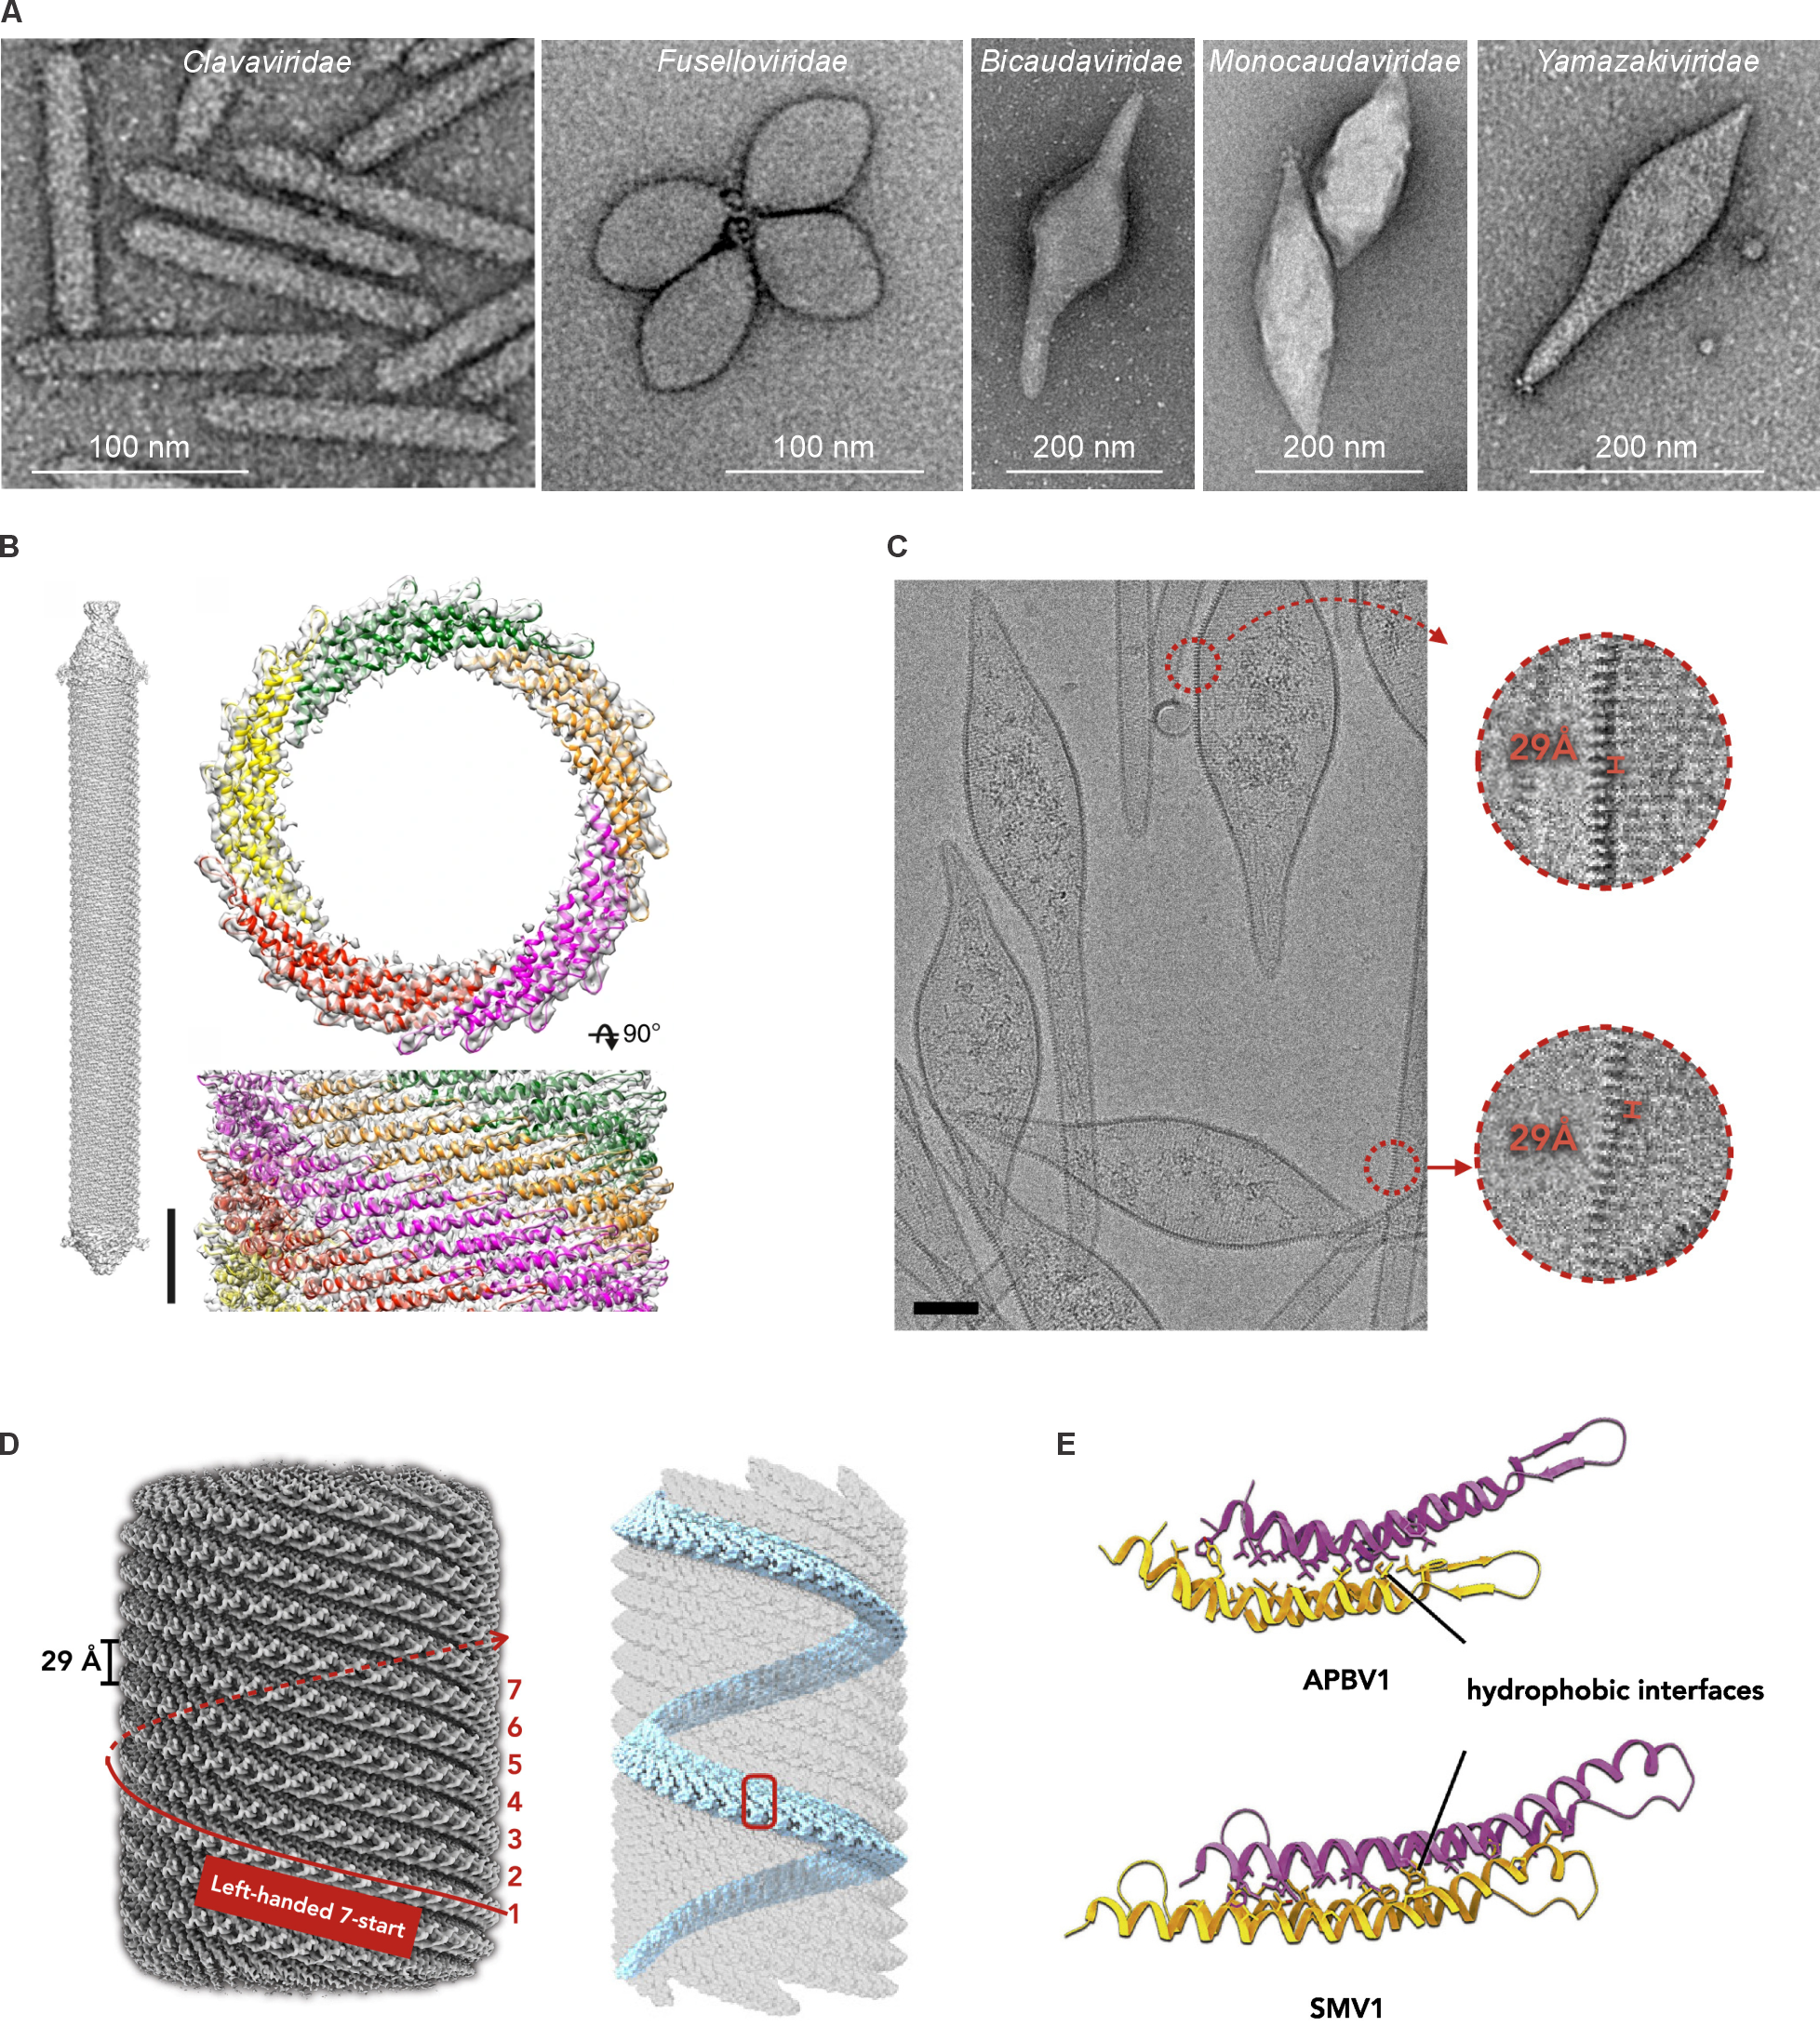

Figure 1. Morphologies and structures of bacilliform and spindle-shaped viruses. A. Electron micrographs of selected negatively stained bacilliform and spindle-shaped virions. Family Clavaviridae is represented by Aeropyrum pernix bacilliform virus 1 (APBV1), Fuselloviridae by Sulfolobus spindle-shaped virus 2, Bicaudaviridae by Acidianus two-tailed virus, “Monocaudaviridae” by Sulfolobus monocaudavirus 1 (SMV1), Yamazakiviridae by Aeropyrum pernix spindle-shaped virus 1. B. Cryo-EM reconstruction of APBV1. Left: 3D model of complete APBV1 particle shown from the side. Scale bar, 10 nm. Right: top and side view of APBV1 map (transparent surface) and model of the major capsid protsein (MCP). MCP subunits related by C5 symmetry are colored in red, yellow, green, orange, and magenta. The panel is reproduced from [4] (Open Access). C. Cryo-EM micrograph of the SMV1 virions. A 29 Å periodicity can be seen in both spindle-shaped bodies and tails. Scale bar, 50 nm. D. A surface of the 3.5 Å resolution reconstruction of the SMV1 virion (left). The left-handed 7-start protofilaments and 29 Å spacing between them are labeled. One protofilament is highlighted (right). E. Comparison of hydrophobic interactions of APBV1 and SMV1. In both cases, two neighboring subunits are shown with different colors. Panels C-E are reproduced from [2] (Open Access).

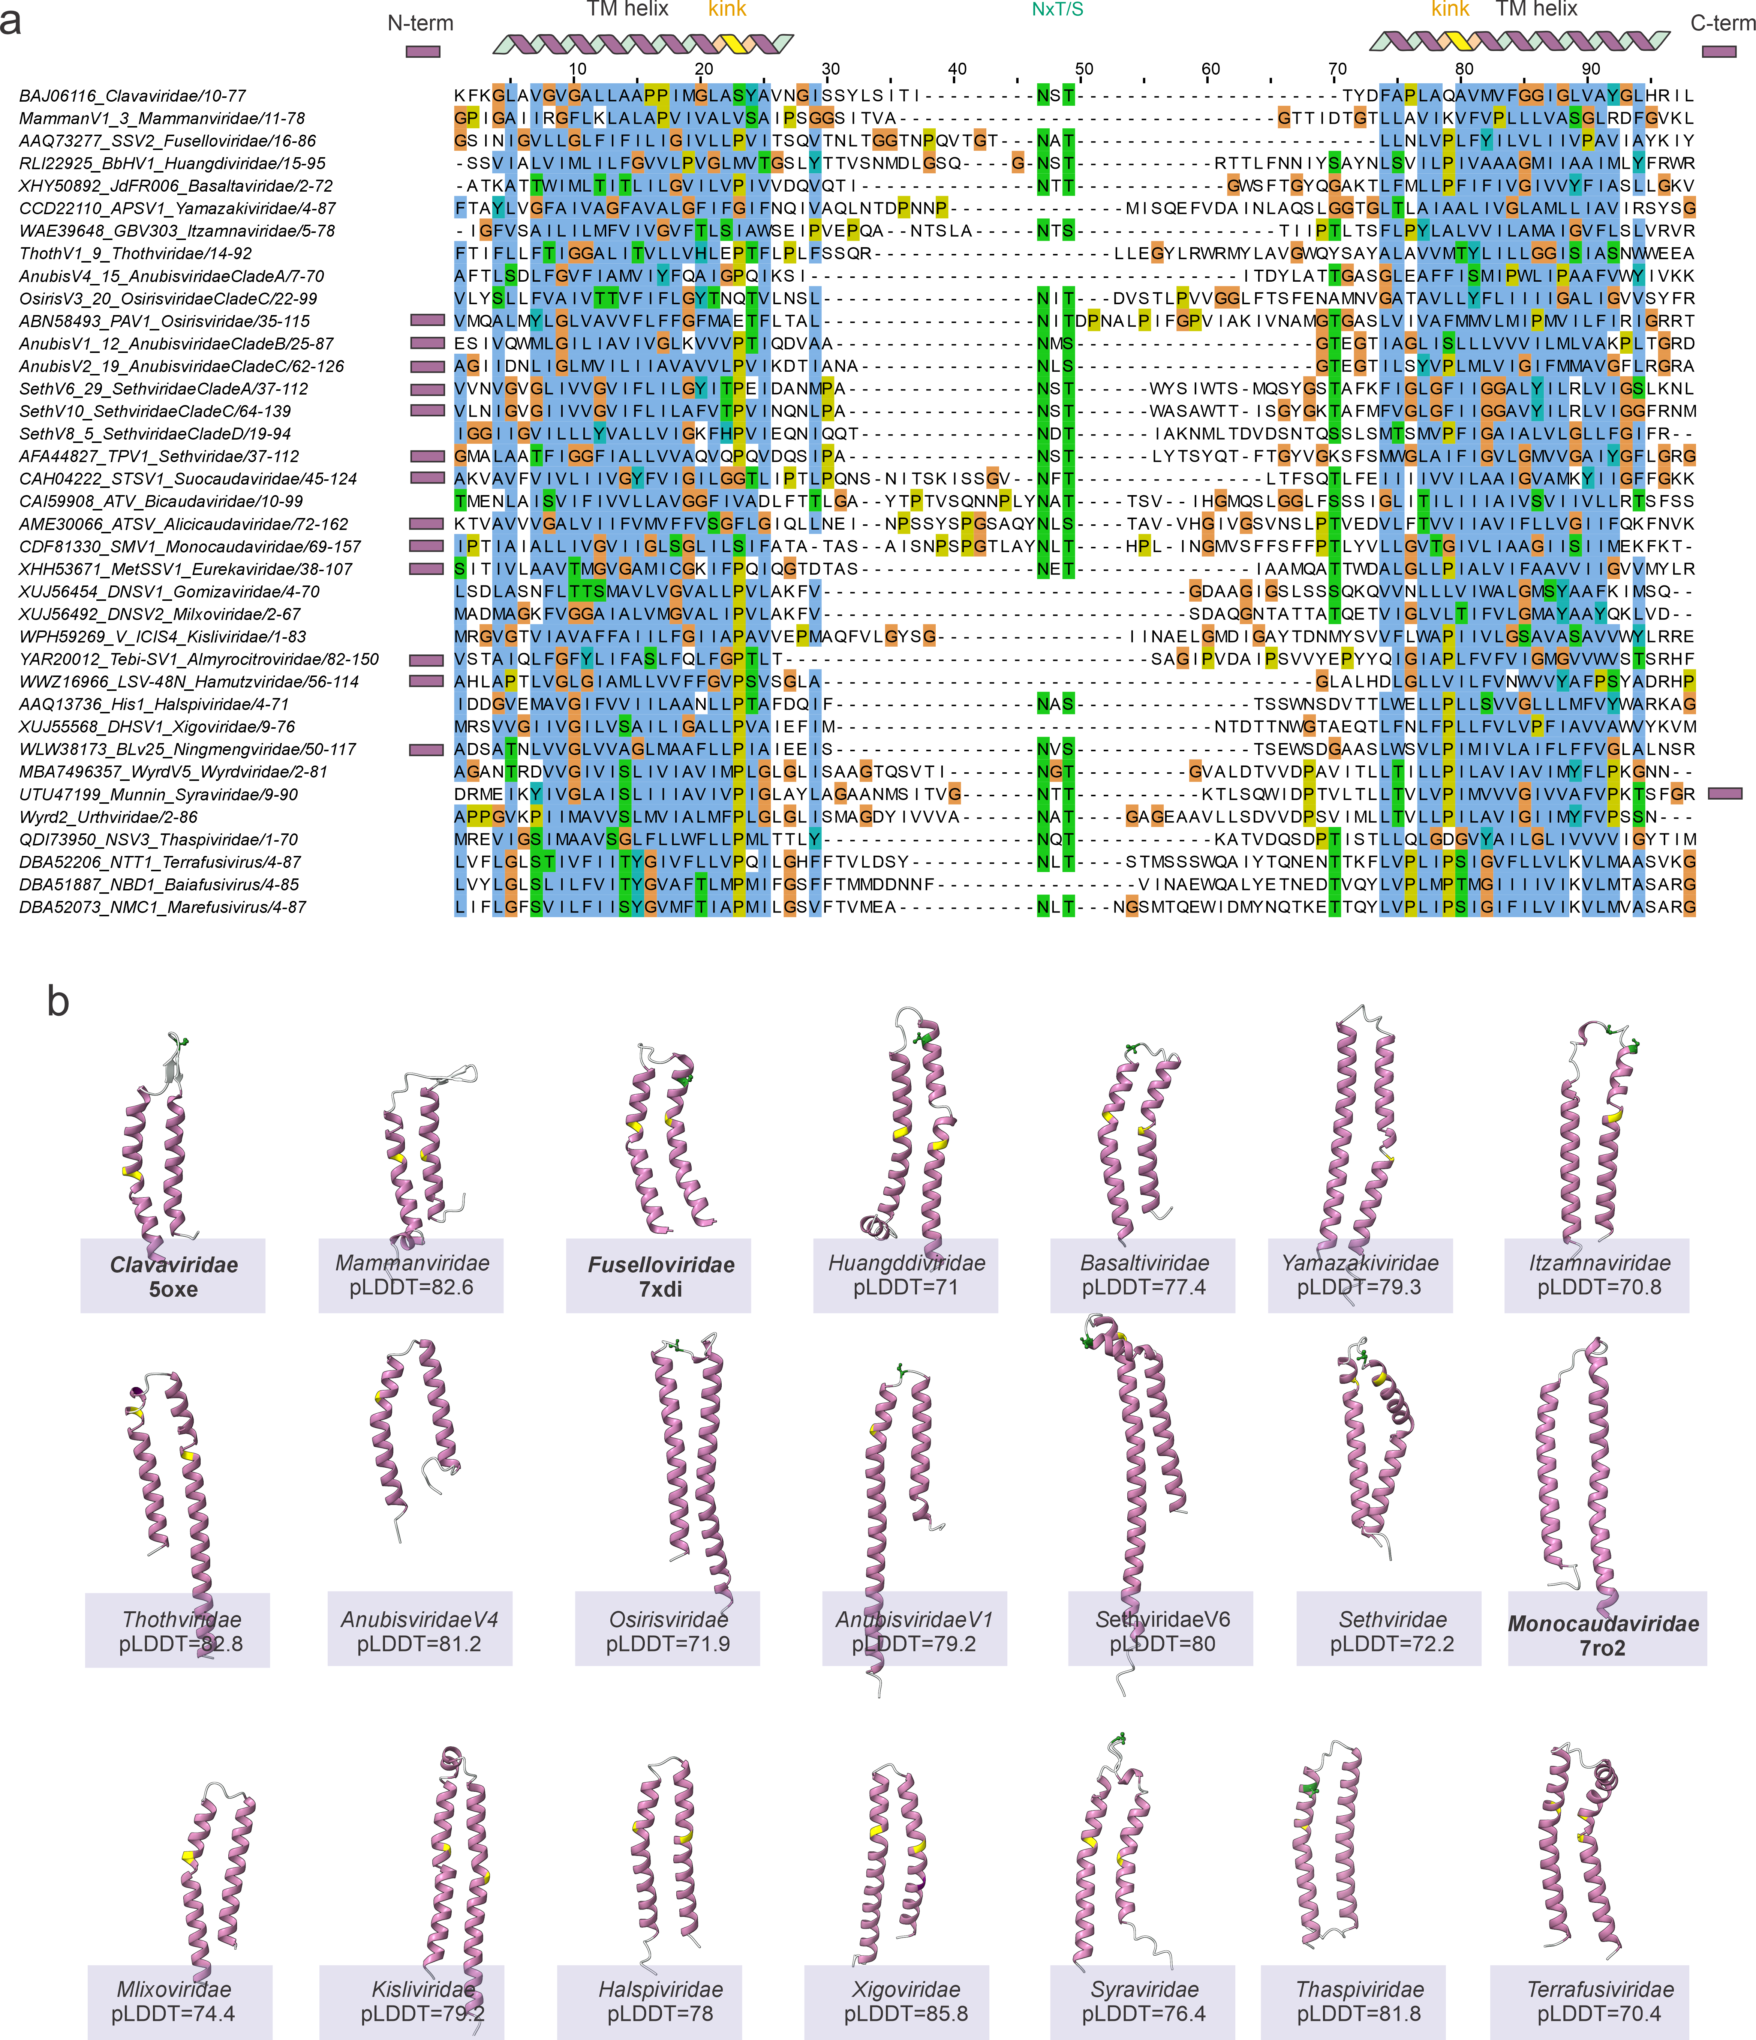
Figure 2. Comparison of sequence (A) and structure (B) of MCP from all known spindle-shaped and bacilliform viruses, one representative per existing or novel family. A. The protein coding for MCP in novel viruses were predicted with hhpred profile of MCP from established families. The alignment was done by MAFFT v7.526 (--auto mode) and manually curated to align possible glycosylation site. The position of TM helix is shown on the top. Some MCP sequences have extensions on the N- or C-terminus, shown with the rectangle. B. Predicted models were obtained with Alphafold2 using alignment of related MCPs from different viral genomes. For the predicted models plDDT is indicated below. For fusellovirids, “monocaudavirids” and clavavirids, experimentally identified structured are shown, the PDB id is indicated.
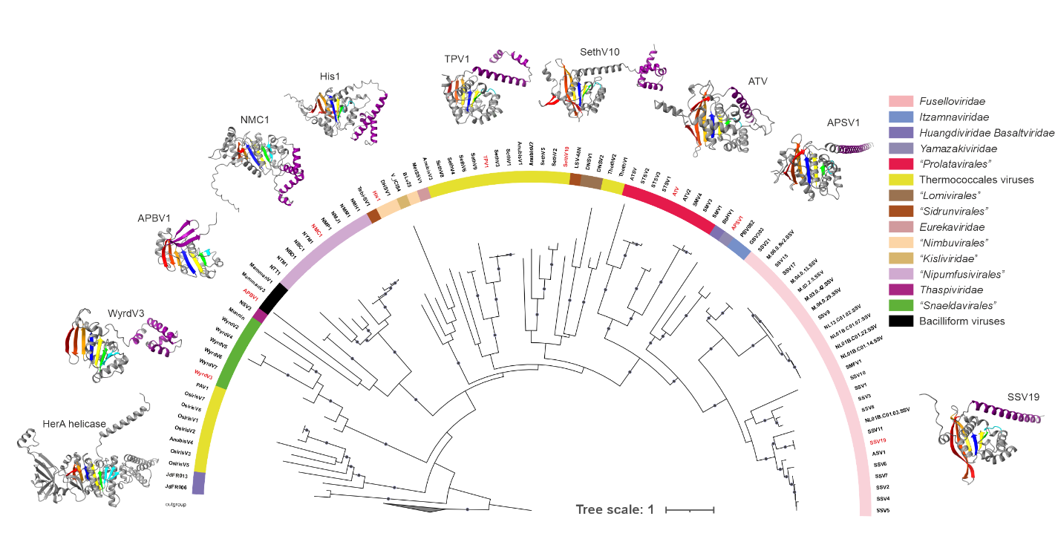Figure 3. Phylogenetic analysis of FtsK-HerA packaging ATPase from spindle-shaped and bacilliform viruses, novel and pre-existing families. Sequences of packaging ATPase were predicted with hmmer, using hmm profile of known packaging ATPase. Archaeal ATPase of HerA family were used as an outgroup. The alignment was made with MAFFT v7.526 (--auto mode) and ML phylogenetic reconstruction performed by IQ-TREE3. The structures of representative sequences (highlighted in red) were predicted with AlphaFold 3. In the structure, seven strands of central beta-sheet are colored in rainbow (blue to red), the C-terminal domain is shown in purple. Branches with >80 fast bootstrap support are marked with dots.
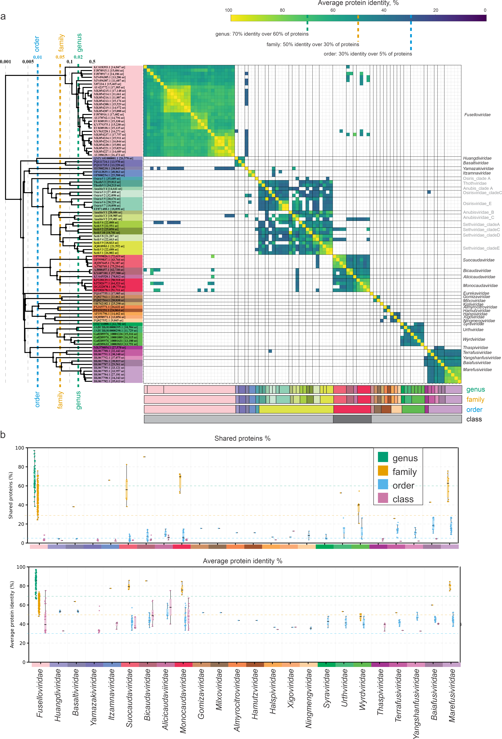Figure 4. Pan-proteomic analysis of spindle-shaped viruses and selection of demarcation criteria. A. The tree on the left is obtained in VipTree. Suggested thresholds for genus, family and order ranks are indicated on the tree. Label colors indicate viruses belonging to the same established or novel family. The heatmap was obtained based on all-vs-all diamond blast result (min identity 30%, max e-value 0.01). The color on the heatmap corresponds to the average protein sequence identity between two viruses. At the bottom, the colored rectangles show suggested genus, family and order assignment. Archaeal virus groups that are not proposed to be classified at this time are indicated with grey font. B. Two boxplots show the distribution of percentage of shared proteins (top) and average protein identity (bottom) for spindle-shaped viruses. Viruses from each proposed or existing families are compared against other spindle-shaped viruses (class rank, purple); viruses from different families within the same order (order rank, blue); viruses from other genera within the same family (family rank, orange), or viruses from the same genus (genus rank, green). Selected thresholds for each rank are shown as dotted lines.

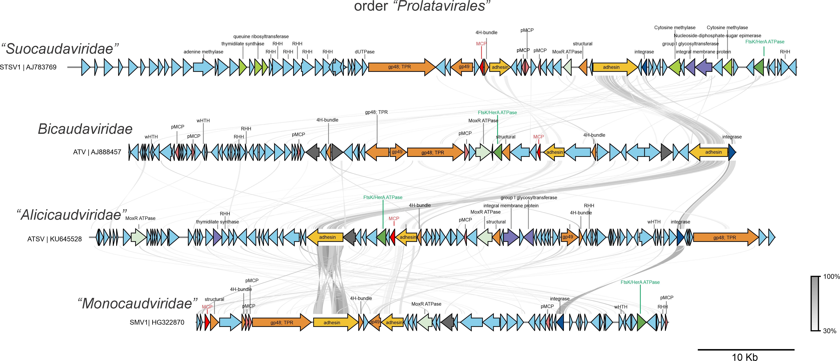
Figure 5. Genome maps of spindle-shaped viruses with relatively long genomes infecting Sulfolobales archaea—proposed family “Prolatavirales”. Genome maps were generated using PyGenomeViz library. The links show blastp hits (min length 50 nt, min identity 30%). Proteins with known annotations are indicated and colored (red—MCP, orange—adhesin and other structural proteins, dark blue—integrase, dark green—packaging ATPase, light green—MoxR AAA+ ATPase, grey—transposons of TnpB family, lime—DNA modification enzymes, purple—glycosylation proteins).

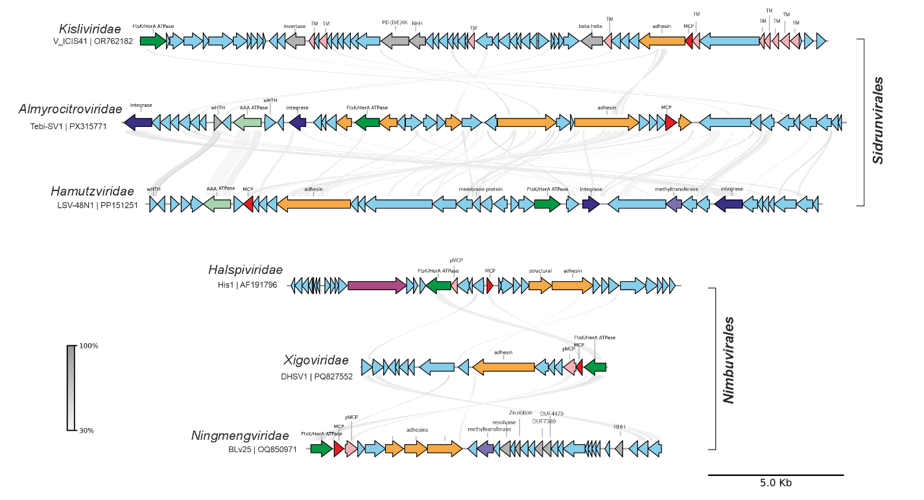
Figure 6. Genome maps of spindle-shaped viruses with infecting Halobacteriales archaea. Genome maps were generated using PyGenomeViz library. The links show blastp hits (min length 50 nt, min identity 30%). Proteins with known annotations are indicated and colored (red—MCP, orange—adhesin and other structural proteins, dark blue—integrase, dark green—packaging ATPase, light green—AAA ATPase, pink—transmembrane proteins, purple— replication proteins, lilac—methyltransferase, grey—proteins with only general predicted function).

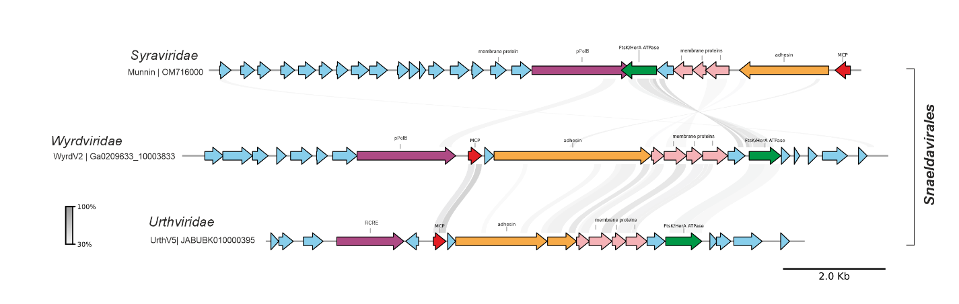
Figure 7. Genome maps of spindle-shaped viruses with infecting Asgardarchaeota archaea (proposed order “Snaeldavirales”). Genome maps were generated using PyGenomeViz library. The links show blastp hits (min length 50 nt, min identity 30%). Proteins with known annotations are indicated and colored (red—MCP, orange—adhesin and other structural proteins, dark blue—integrase, dark green—packaging ATPase, light green—AAA ATPase, pink—transmembrane proteins, purple—replication proteins).

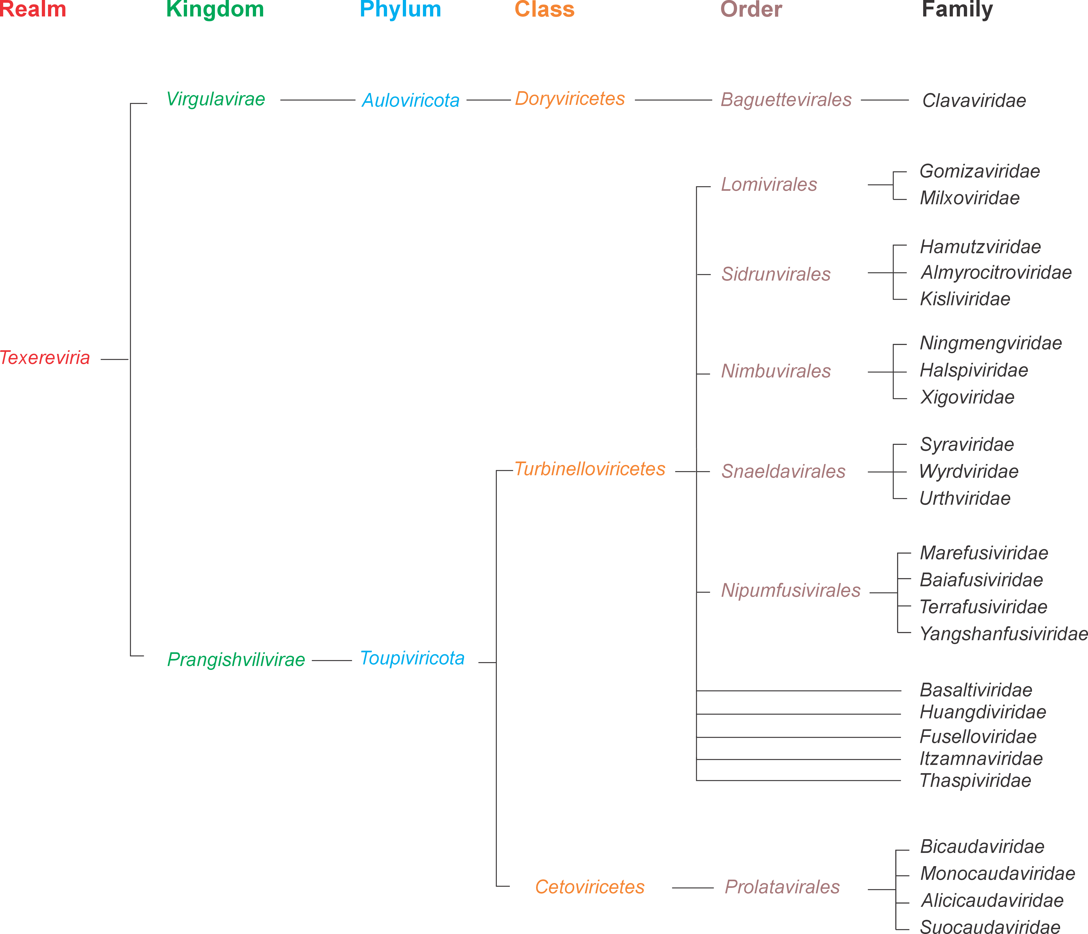
Figure 8. Summary of the proposed taxonomy.

