

The International Committee on Taxonomy of Viruses
Taxonomy Proposal Form, 2026

Part 1a: Details of taxonomy proposals

Title: | Create two new genera and 28 new species in the family Fuselloviridae
Code assigned: | 2026.004A.N.v1.Fuselloviridae_2ng_28ns

Author(s), affiliation and email address(es):
Given name (+middle initial(s)) | Surname | Affiliation | Email address | Corr. author(s)
Sofia | Medvedeva | Institut Pasteur, Université Paris Cité, Cell Biology and Virology of Archaea Unit, Paris, France | sofia.medvedeva@pasteur.fr
Kenneth M. | Stedman | Center for Life in Extreme Environments, Department of Biology, Portland State University, Portland, Oregon, USA | kstedman@pdx.edu
Junxia | Zhang | Guangzhou National Laboratory, Guangzhou 510005, China | zhang_junxia@gzlab.ac.cn
Li | Huang | Southern Marine Science and Engineering Guangdong Laboratory (Guangzhou), Nansha, Guangzhou 511458, China | huangl@im.ac.cn
Mart | Krupovic | Institut Pasteur, Université Paris Cité, Cell Biology and Virology of Archaea Unit, Paris, France | mart.krupovic@pasteur.fr | X

Part 1b: Taxonomy Proposal Submission
ICTV Subcommittee:
Animal DNA Viruses and Retroviruses |  | Bacterial viruses
Animal minus-strand and dsRNA viruses |  | Fungal and protist viruses
Animal positive-strand RNA viruses |  | Plant viruses
Archaeal viruses | X | General -

List the ICTV Study Group(s) that have seen or have been involved in creating this proposal:
Optional – complete only if formally voted on by an ICTV Study Group:
Study Group | Number of members
Study Group | Votes in support | Votes against | No vote

Submission date:

Part 1c: Feedback from ICTV Executive Committee (EC) meeting
Executive Committee Meeting Decision code: | X
A – Accept
Ac – Accept subject to revision by relevant subcommittee chair. No further vote required
U – Accept without revision but with re-evaluation and email vote by the EC
Uc – Accept subject to revision and re-evaluation and email vote by the EC
Ud – Deferred to the next EC meeting, with an invitation to revise based on EC comments
J - Reject
W - Withdrawn

Comments from the Executive Committee:

Part 1d: Revised Taxonomy Proposal Submission
Response of proposer:
Revision date:

Part 3: TAXONOMIC PROPOSAL

Taxonomic changes proposed:
Establish new taxon | X | Split taxon
Abolish taxon |  | Merge taxon
Move taxon |  | Promote taxon
Rename taxon |  | Demote taxon
Move and rename

Etymology (origin) of proposed taxonomic names:
Taxon name | Etymology of the term
Alphafusellovirus rubrum | After Latin ruber, “red”
Alphafusellovirus aureum | After Latin aureus, “golden”
Alphafusellovirus viride | After Latin viridis, “green”
Alphafusellovirus caeruleum | After Latin caeruleus, “blue, azure”
Alphafusellovirus purpureum | After Latin purpureus, “purple”
Alphafusellovirus sanguineum | After Latin sanguineus, “blood-red”
Alphafusellovirus rutilum | After Latin rutilus, “reddish, glowing red”
Alphafusellovirus coccineum | After Latin coccineus, “scarlet”
Alphafusellovirus roseum | After Latin roseus, “rose-colored, rosy”
Alphafusellovirus incarnatum | After Latin incarnatus, “flesh-colored”
Alphafusellovirus aurantiacum | After Neo-Latin aurantiacus, “orange-colored”
Alphafusellovirus luteum | After Latin luteus, “yellow”
Alphafusellovirus olivaceum | After Latin/Neo-Latin olivaceus, “olive-colored”
Alphafusellovirus prasinum | After Latin prasinus, “leek-green, bright green”
Alphafusellovirus cyaneum | After Latin cyaneus, “dark blue, blue”
Alphafusellovirus indicum | After Latin indicus, “indigo-colored”
Alphafusellovirus violaceum | After Latin violaceus, “violet-colored”
Alphafusellovirus lilacinum | After Neo-Latin lilacinus, “lilac-colored”
Alphafusellovirus glaucum | After Latin glaucus, “blue-green, gray-green”
Alphafusellovirus herbaceum | After Latin herbaceus, “grass-green, herb-colored”
Alphafusellovirus smaragdinum | After Latin smaragdinus, “emerald-green”
Alphafusellovirus violaceum | After Latin violaceus, “violet-colored”
Alphafusellovirus puniceum | After Latin puniceus, “crimson, purple-red”
Deltafusellovirus | Greek letter Delta + fusellovirus
Deltafusellovirus naghasoense | referring to Naghaso, Philippines, place of isolation
Deltafusellovirus philippinense | referring to Philippines, place of isolation
Deltafusellovirus acidothermale | After Latin acidus-, “acidic, sour,” and thermalis, “thermal”, referring to an acidic thermal environment
Deltafusellovirus fonticola | After Latin fontis, “spring, fountain,” and -cola
Gammafusellovirus | Greek letter Gamma + fusellovirus
Gammafusellovirus mexicanense | After Mexica – place of isolation

Permission for use of names derived from a living person:
Taxon name | Full name of person from whom the name is derived | Attached

Abstract of Taxonomy Proposal:
Description of current taxonomy:
Family Fuselloviridae currently includes 2 genera, Alphafusellovirus and Betafusellovirus, with 9 species.

Proposed taxonomic change(s):
We propose establishing two new genera, “Gammafusellovirus” (1 species) and “Deltafusellovirus” (4 species), and 23 new species within genus Alphafusellovirus.

Demarcation criteria for new taxon/taxa:
Less than 95% overall genome sequence identity is proposed for species demarcation, that being consistent with the classification of other bacterial and archaeal DNA viruses. Members of different genera share ≤60% of proteins at ≥70% pairwise identity.

Justification:
Multiple viruses related to the classified members of the family Fuselloviridae have been described in the literature over the years but not classified. Here we propose classifying these viruses.

Text of Taxonomy proposal:
Description of current taxonomy:
Family Fuselloviridae comprises archaeal viruses with spindle-shaped virions and circular double-stranded DNA (dsDNA) genomes. The family currently includes 2 genera, Alphafusellovirus and Betafusellovirus, with 9 species.

Proposed taxonomic change(s):
We propose establishing two new genera, “Gammafusellovirus” (1 species) and “Deltafusellovirus” (4 species), and 23 new species within genus Alphafusellovirus.

Demarcation criteria for new taxon/taxa:
Less than 95% overall genome sequence identity is proposed for species demarcation. This similarity threshold is consistent with the classification of other bacterial and archaeal DNA viruses. Members of different genera share ≤60% of proteins at ≥70% pairwise identity.

Justification:
Multiple viruses related to the classified members of the family Fuselloviridae have been described in the literature over the years but not classified. Here we propose classifying these viruses. Viruses in the genus Alphafusellovirus typically display regular lemon-shaped particles, whereas those of betafuselloviruses are more elongated, cigar-like (Redder et al., 2009; Figure 1).

We used 95% overall genome sequence identity, as calculated using VIRIDIC (Moraru et al., 2020), for species demarcation. Of the 41 unclassified genomes, 28 were sufficiently different to be classified into new species (Figure 2). VIRIDIC and full proteome analysis of the 50 previously classified (n=9) and unclassified (n=41) fuselloviruses showed that 23 unclassified spindle-shaped viruses infecting Sulfolobales archaea could be assigned to the established genus Alphafusellovirus (Figure 2). The remaining five virus genomes were more divergent at both nucleotide and protein sequence levels (Figure 2 and 3), suggesting that additional genera need to be created. Below we provide a summary on the new members of family Fuselloviridae.

Expansion of Alphafusellovirus by 23 new species
Twenty-three new species are proposed for classification of viruses infecting different Saccharolobus strains sampled from Nymph Lake area and Norris Geyser Basin, Yellowstone National Park, USA (Pauly et al., 2019), Lassen Volcanic National Park, USA (Goodman and Stedman, 2018), Mutnovsky volcano area, Kamchatka, Russia (Pauly et al., 2019) and Iceland (GenBank accession: KY579375). These viruses share ~60% of proteins with existing members of the genus Alphafusellovirus.

New genus “Gammafusellovirus”, 1 new species
The complete 14,847-bp circular genome of Sulfolobales Mexican fusellovirus 1 (SMF1) was recovered from a metagenomic study of a Mexican hot spring (Servín-Garcidueñas et al., 2013). The SMF1 genome shows exceptional properties, including a coding-strand bias and a high incidence of genes organized in operon structures. VIRIDIC, VIPtree and full proteome analysis showed that SMF1 share only 5-10% nucleotide identity and 35-50% proteins with 40-60% identity with other fusellovirids. These analyses justify placement of SMF1 into a separate genus, which we propose naming “Gammafusellovirus”.

New genus “Deltafusellovirus”, 4 new species
Four fuselloviruses, SSV19, SSV20, SSV21 and SSV22, were isolated from hot spring sediment in Naghaso, Philippines (Zhang et al., 2020). Although the four viruses share overall gene content with other viruses, they displayed higher nucleotide and amino acid sequence divergence from viruses within Alphafusellovirus and Betafusellovirus genera. Notably, the four viruses display chimeric features. Specifically, whereas SSV19 encodes an adhesin protein homologous to that of betafuselloviruses, SSV20, SSV21 and SSV22 encode distinct adhesins homologous to those conserved in alphafuselloviruses (Zhang et al., 2020; Figure 4). Nevertheless, in both genome-wide nucleotide and amino acid sequence comparisons, the four viruses formed a separate cluster (Figures 2 and 3).

References:
Goodman DA, Stedman KM. Comparative genetic and genomic analysis of the novel fusellovirus Sulfolobus spindle-shaped virus 10. Virus Evol. 2018; 4(2):vey022. doi: 10.1093/ve/vey022. PMID: 30094064
Moraru C, Varsani A, Kropinski AM.VIRIDIC-A Novel Tool to Calculate the Intergenomic Similarities of Prokaryote-Infecting Viruses. Viruses. 2020 Nov 6;12(11):1268. doi: 10.3390/v12111268. PMID: 33172115
Pauly MD, Bautista MA, Black JA, Whitaker RJ. Diversified local CRISPR-Cas immunity to viruses of Sulfolobus islandicus. Philos Trans R Soc Lond B Biol Sci. 2019; 374(1772):20180093. doi: 10.1098/rstb.2018.0093. PMID: 30905292
Redder P, Peng X, Brügger K, Shah SA, Roesch F, Greve B, She Q, Schleper C, Forterre P, Garrett RA, Prangishvili D. Four newly isolated fuselloviruses from extreme geothermal environments reveal unusual morphologies and a possible interviral recombination mechanism. Environ Microbiol. 2009; 11(11):2849-62. doi: 10.1111/j.1462-2920.2009.02009.x. PMID: 19638177
Servín-Garcidueñas LE, Peng X, Garrett RA, Martínez-Romero E. Genome sequence of a novel archaeal fusellovirus assembled from the metagenome of a mexican hot spring. Genome Announc. 2013 Apr 25;1(2):e0016413. doi: 10.1128/genomeA.00164-13. PMID: 23618716
Zhang J, Zheng X, Wang H, Jiang H, Dong H, Huang L. Novel Sulfolobus fuselloviruses with extensive genomic variations. J Virol. 2020; 94(4):e01624-19. doi: 10.1128/JVI.01624-19. PMID: 31748395

Accompanying files:
Filename | Description of contents

Tables, Figures:

<Start here>
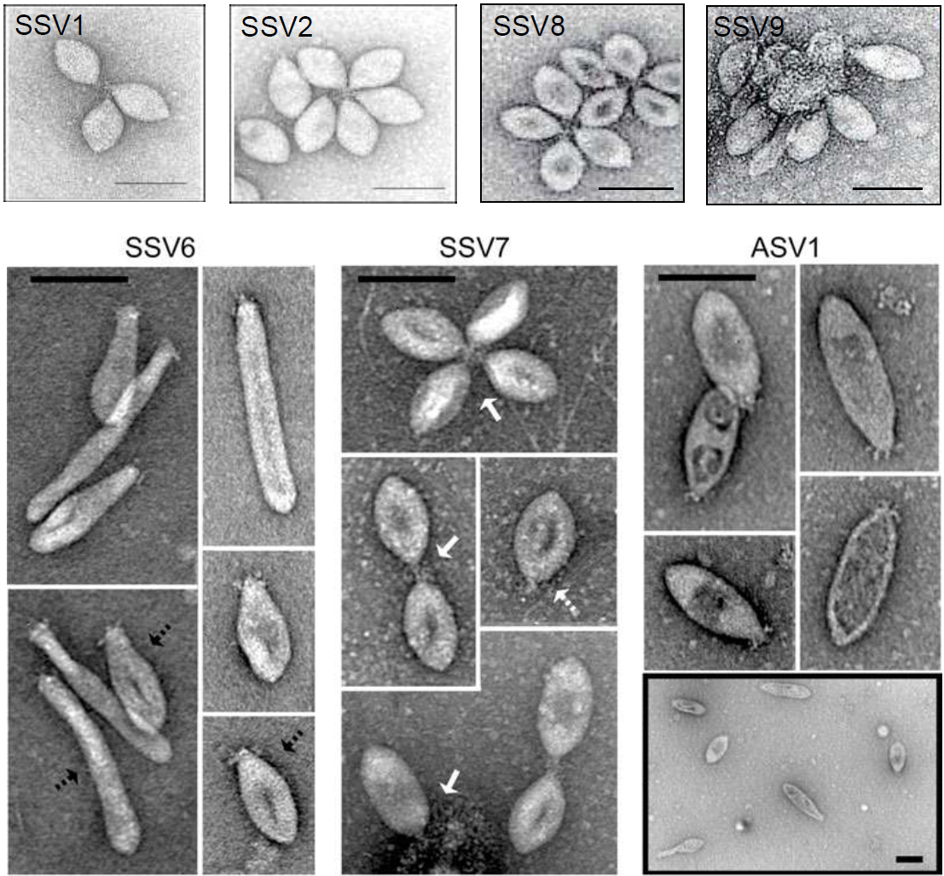

Figure 1. Negative stain electron micrographs of viruses from the two genera of the family Fuselloviridae. Members of the genus Alphafusellovirus: Sulfolobus spindle-shaped virus 1 (SSV1), Sulfolobus spindle-shaped virus 2 (SSV2), Sulfolobus spindle-shaped virus 7 (SSV7), Sulfolobus spindle-shaped virus 8 (SSV8), and Sulfolobus spindle-shaped virus 9 (SSV9). Members of the genus Betafusellovirus: Sulfolobus spindle-shaped virus 6 (SSV6), and Acidianus spindle-shaped virus 1 (ASV1). The bars represent 100 nm (Redder et al., 2009). The figure is reproduced from TaxoProp 2011.001a-fB.A.v3.Betafusellovirus.

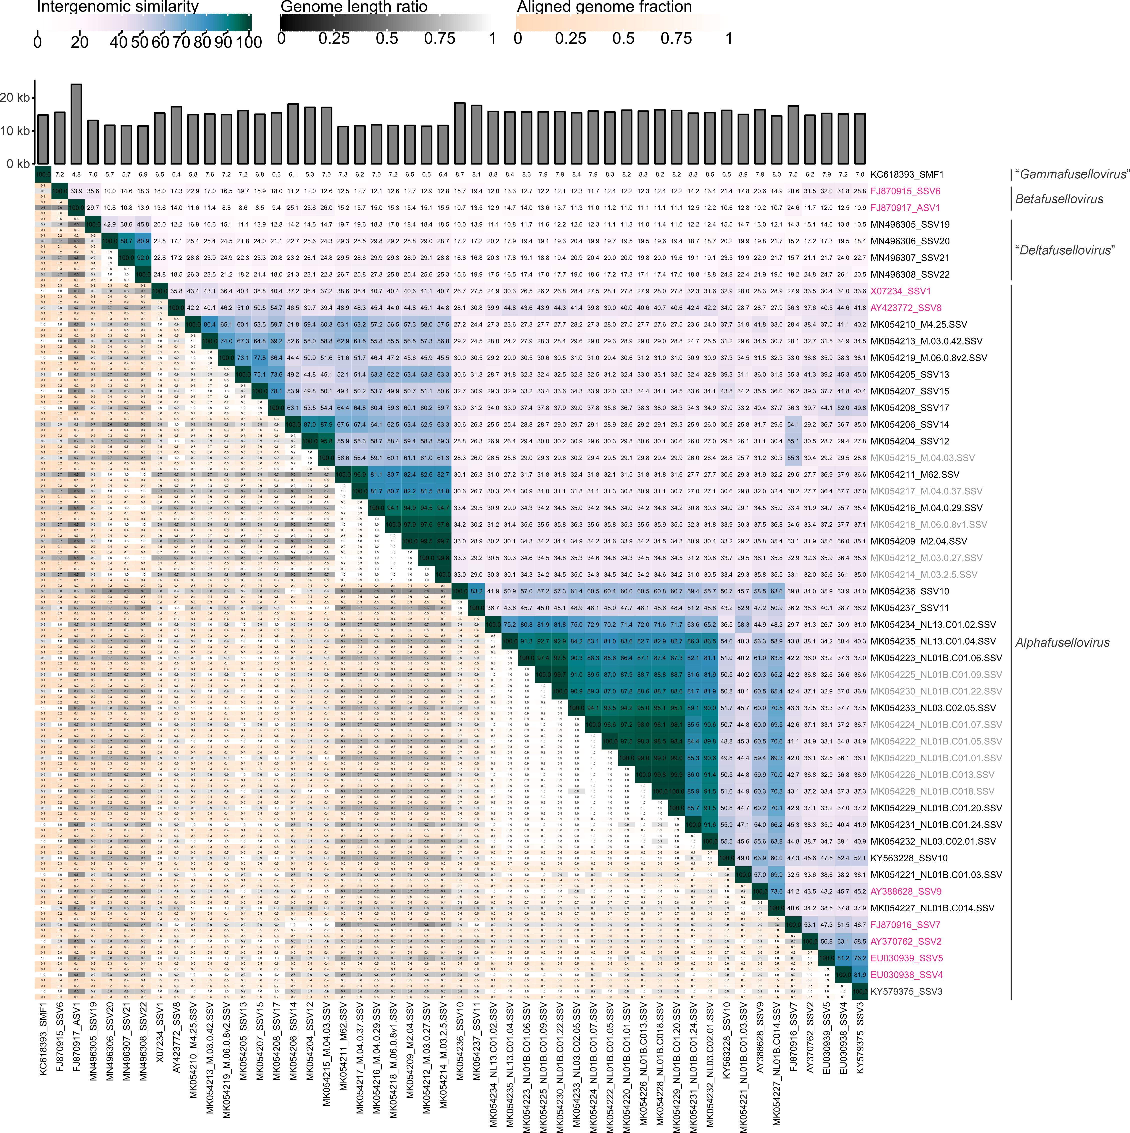

Figure 2. VIRIDIC analysis of new and previously classified viruses of Fuselloviridae family. Color of the labels show previously classified viruses (pink), viruses classified into new species (black), viral sequences representing additional strains of new or existing species (grey).

Figure 3. Pan-proteomic analysis of spindle-shaped viruses. The heatmap was obtained based on all-vs-all diamond blast result (min identity 30%, max e-value 0.01). The color on the heatmap corresponds to the average protein sequence identity between two viruses. The established and proposed genera are indicated on the left.

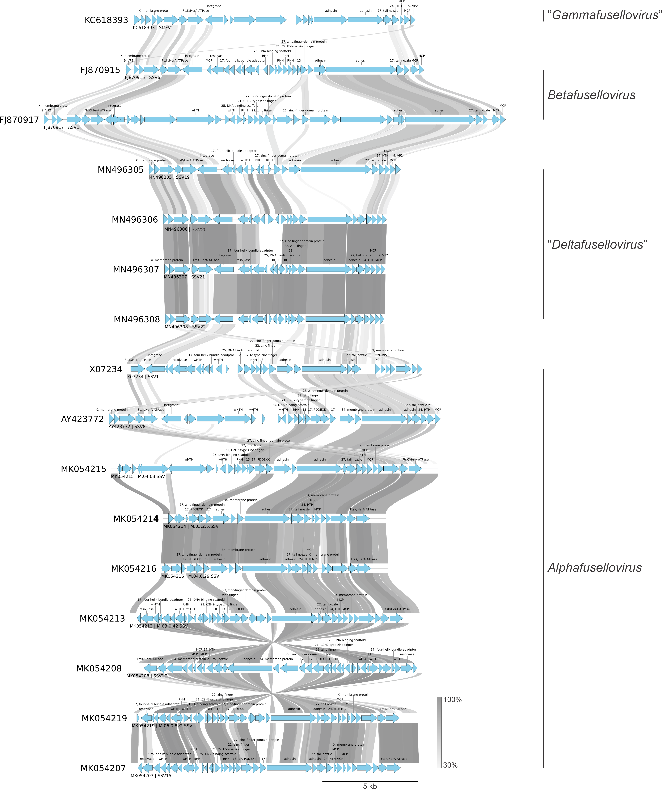

Figure 4. Genome comparison of fusellovirids from established and proposed genera. Genome maps were generated using PyGenomeViz library. The links show blastp hits (min length 50 nt, min identity 30%). Proteins with known annotations are indicated. The established and proposed genera are indicated on the right.

