

The International Committee on Taxonomy of Viruses
Taxonomy Proposal Form, 2026

Part 1a: Details of taxonomy proposals

Title: | Create a new family, “Subterraneaviridae”, in the order Coyopavirales, with a single new genus, “Altivirus”, and a single new species (“Altivirus islingense”)
Code assigned: | 2026.003A.N.v1.Coyopavirales_1nf

Author(s), affiliation and email address(es):
Given name (+middle initial(s)) | Surname | Affiliation | Email address | Corr. author(s)
Pengyao | Zhang | Microbial Systems Ecology, University Duisburg-Essen, Research Center One Health Ruhr, Essen, Germany | pengyao.zhang@uni-due.de
Feriel | Bouderka | Microbial Systems Ecology, University Duisburg-Essen, Research Center One Health Ruhr, Essen, Germany | feriel.bouderka@uni-due.de
Mart | Krupovic | Institut Pasteur, Université Paris Cité, Cell Biology and Virology of Archaeal Virology Unit, Paris, France | mart.krupovic@pasteur.fr
Alexander J. | Probst | Microbial Systems Ecology, University Duisburg-Essen, Research Center One Health Ruhr, Essen, Germany | alexander.probst@uni-due.de
Cristina | Moraru | Microbial Systems Ecology, University Duisburg-Essen, Research Center One Health Ruhr, Essen, Germany | lilianacristina.moraru@uni-due.de | x

Part 1b: Taxonomy Proposal Submission
ICTV Subcommittee:
Animal DNA Viruses and Retroviruses |  | Bacterial viruses
Animal minus-strand and dsRNA viruses |  | Fungal and protist viruses
Animal positive-strand RNA viruses |  | Plant viruses
Archaeal viruses | X | General -

List the ICTV Study Group(s) that have seen or have been involved in creating this proposal:
Optional – complete only if formally voted on by an ICTV Study Group:
Study Group | Number of members
Study Group | Votes in support | Votes against | No vote

Submission date:

Part 1c: Feedback from ICTV Executive Committee (EC) meeting
Executive Committee Meeting Decision code: | X
A – Accept
Ac – Accept subject to revision by relevant subcommittee chair. No further vote required
U – Accept without revision but with re-evaluation and email vote by the EC
Uc – Accept subject to revision and re-evaluation and email vote by the EC
Ud – Deferred to the next EC meeting, with an invitation to revise based on EC comments
J - Reject
W - Withdrawn

Comments from the Executive Committee:

Part 1d: Revised Taxonomy Proposal Submission
Response of proposer:
Revision date:

Part 3: TAXONOMIC PROPOSAL

Taxonomic changes proposed:
Establish new taxon | X | Split taxon
Abolish taxon |  | Merge taxon
Move taxon |  | Promote taxon
Rename taxon |  | Demote taxon
Move and rename

Etymology (origin) of proposed taxonomic names:
Taxon name | Etymology of the term
Subterraneaviridae | from the Latin for “underground”, reflecting the habitat of archaeal virus Altivir_1_MSI
Altivirus | from the name of the Altivir_1_MSI host – Ca. Altiarchaeum hamiconexum
Altivirus islingense | the species epithet reflects the name of the cold sulfidic spring (Mühlbacher Schwefelquelle Spring, Isling) in which Altivir_1_MSI was found

Permission for use of names derived from a living person:
Taxon name | Full name of person from whom the name is derived | Attached

Abstract of Taxonomy Proposal:
Description of current taxonomy:
The order Coyopavirales (realm Varidnaviria, kingdom Abadenavirae, phylum Produgelaviricota, class Belvinaviricetes) currently contains one family, Chaacviridae, comprising two genera and three species.

Proposed taxonomic change(s):
We propose to create a new family “Subterraneaviridae” within order Coyopavirales, containing one new genus “Altivirus” and one new species “Altivirus islingense”, with the species exemplar being the environmental viral genome (EVG) Altivir_1_MSI_2012 (GenBank MW522970).

Demarcation criteria for new taxon/taxa:
Family
A protein supercluster (PSC)-based intergenomic distance (VirClust) cutoff of 0.90 was applied for family-level genome clustering. The family distinction is further supported by differences in conserved protein content.

Genus
Only one genus is included in the proposed family, no numerical demarcation criterion can be derived at this time.

Species
The threshold was ≥95% intergenomic identity (VIRIDIC).

Justification:
Altivir_1_MSI represents a group of five unclassified EVGs, forming a species-level cluster (cluster representative Altivir_1_MSI_BF_2012). These EVGs have a circular dsDNA genome of ~8.9-kb. They infect Candidatus Altiarchaeum hamiconexum. Currently, the members of the Altivir_1_MSI group have no assigned taxonomic affiliation. The major capsid protein (MCP) from Altivir_1_MSI has a double jelly-roll (DJR) fold and is related to the MCPs encoded by members of the order Coyopavirales. Hierarchical clustering of the Altivir_1_MSI EVGs and related viral genomes placed Altivir_1_MSI within the Coyopavirales-associated branch, but in a distinct family-level cluster. Its assignment to Coyopavirales is supported by the conservation of the DJR MCP and by another protein shared with Chaacviridae, whereas the absence of the protein-primed family B DNA polymerase supports the classification into of a separate family.

Text of Taxonomy proposal:
Description of current taxonomy:

Altivir_1_MSI, an unclassified environmental viral genome (EVG)

Altivir_1_MSI represents an EVG recovered from the subsurface biofilms of a cold sulfidic spring. The spring location is the Mühlbacher Schwefelquelle Spring, Isling (MSI), Germany. Altivir_1_MSI has a circular dsDNA genome of approximately 8.9-kb. Using CRISPR spacer–protospacer matches and virusFISH we showed that Altivir_1_MSI infects Candidatus Altiarchaeum hamiconexum, the dominant microorganism in the biolfilm. VirusFISH data showed that Altivir_1 undergoes a lytic reproductive cycle [1]. Four Altivir_1_MSI genomes recovered from samples collected in 2012 and 2018 showed 99.3–99.7% viridic-type intergenomic identities and were proposed to belong to a single species using the 95% species-demarcation threshold [1]. The species cluster representative is available in GenBank under accession MW522970 (Altivir_1_MSI genome recovered from a 2012 sample). Although at the time of the initial publication, structural genes of Altivir_1_MSI could not be identified, the proof that Altivir_1 is a virus came from subsequent experiments, which combined virusFISH, 16S rRNA FISH and scanning electron microscopy to resolve the spatio-functional organization of Altivir_1-infected altiarchaeal virocells. This linked the viral genome to cell-associated virus-like particles [2]. Long-term virusFISH analyses of biofilms sampled annually from 2019 to 2022 showed a recurrent Altivir_1_MSI presence over the four-year period, suggesting a persistent virus-host coexistence [3]. At present, Altivir_1_MSI virus has no assigned any taxonomic classification.

The order Coyopavirales

The order Coyopavirales (realm Varidnaviria, kingdom Abadenavirae, phylum Produgelaviricota, class Belvinaviricetes) includes dsDNA viruses that have major capsid proteins (MCPs) with the double jelly-roll (DJR) fold and infect prokaryotes, distinguished from the eukaryotic preplasmiviricot lineages by comparative genomic and replication-protein analyses [4]. The order currently contains a single family, Chaacviridae. Members of Chaacviridae are archaeal dsDNA viruses with linear dsDNA genomes of approximately 10.2–10.8 kb containing inverted terminal repeats and encoding the DJR MCP and a protein-primed family B DNA polymerase (pPolB) [5]. The family currently contains two genera and three species.

Proposed taxonomic change(s):
We propose to create a new family “Subterraneaviridae” within order Coyopavirales, containing one new genus, “Altivirus”, and one new species, “Altivirus islingense”, represented by Altivir_1_MSI_2012 (GenBank MW522970).

Demarcation criteria for new taxon/taxa:

Family
A protein supercluster (PSC)-based VirClust intergenomic distance cutoff of 0.90 was applied for family-level viral genome clustering, consistent with the recommended range of 0.90–0.925 for Varidnaviria [6]. Family distinction is further supported by differences in conserved protein content.

Genus
No numerical genus demarcation criterion is proposed at this time because only one genus is included in the proposed family.

Species
The threshold used was ≥95% intergenomic identity, as calculated by VIRIDIC [7].

Justification:

Dataset
To find relatives of Altivir_1_MSI, we used protein similarity searches against the NCBI databases (with delta Blast). These searches identified proteins related to those of Altivir_1_MSI in the genomes of Huginn virus [8], representing a larger group of unclassified viruses informally referred to as the Odin group [9], in the genomes of the proposed family “Karaliviridae” [10], and in the genomes of members of Chaacviridae. Therefore, our analysis dataset (91 genomes in total) comprised two members from the candidate family “Karaliviridae”, five from the Odin-group, all members with complete genomes and official taxonomic classification from Abadenavirae, and five Altivir_1_MSI EVGs collected in 2012, 2018 and 2024.

Taxonomic identification with vConTACT3 did not yield any relatives for Altiviri_1_MSI
An attempt to identify Altivir_1_MSI related viruses with vConTACT3 did not yield any results. When we analyzed the above dataset with vConTACT3 (v3.2.4, database 232, default intergenomic distance metric), the 5 Altivir_1_MSI genomes formed at all taxonomic levels a separate cluster from all viruses. This apparent contradiction with our previous results (delta Blast search for relatives) is likely explained by the way vConTACT3 calculates protein clusters. To identify related proteins vConTACT3 uses protein sequence searches based on MMseq2, which has lower sensitivity than delta Blast.

Hierarchical clustering based on shared protein super-clusters with VirClust
The viral genomes in this dataset were clustered hierarchically with VirClust, using intergenomic distances based on shared protein superclusters [6]. To this purpose, proteins were grouped into protein clusters (PCs) using BLASTp (E-value ≤1 × 10⁻⁵, bit score ≥30 and alignment coverage >70%). PCs were subsequently grouped into PSCs based on HMM-HMM similarity (probability ≥90% and coverage ≥60%). Pairwise intergenomic distances based on PSC presence/absence profiles were used for hierarchical genome-content clustering, and the dendrogram was cut at an intergenomic distance of 0.90.
Hierarchical clustering followed the current order-level classification of Abadenavirae (Figure 1). Altivir_1_MSI, Chaacviridae, the candidate “Karaliviridae”, and the selected Odin-group viruses were grouped on the same major branch. Within this branch, at an intergenomic distance cutoff of 0.90, Altivir_1 formed a separate cluster, Chaacviridae and “Karaliviridae” clustered together, and the Odin-group viruses formed another cluster. In terms of PSC sharing, Altivir_1 shared a protein of unknown function (Cons1, see below) with Chaacviridae, the candidate “Karaliviridae” and the Odin-group; and it shared a homologous DJR MCP with members of Chaacviridae.
In contrast with vConTACT3, VirClust was able to assign the five Altivir_1_MSI EVGs into clusters related to Coyopavirales, because VirClust used HMM-profile searches to place more distantly related proteins into clusters.

Sensitive HMM-searches used for Altivir_1_MSI protein annotation
Annotation of Altivir_1_MSI proteins based on more sensitive HMM profile-profile comparisons using HHsearch from the HH-suite v3 package [11] against the Pfam, Protein Data Bank (PDB), Conserved Domain Database (CDD) and viral protein sequence (uniprot_sprot_vir70) databases available from the MPI Bioinformatics Toolkit [12] The analysis revealed that Altivir_1 shares two more proteins with the Huginn virus, bringing the total to thee: conserved protein 1 (Cons1) of unknown function, conserved protein 2 (Cons2) likely encoding single jelly-roll (SJR) minor capsid protein, and conserved protein 3 (Cons3), encoding an EndoMS-like nuclease of the PD-(D/E)XK superfamily (Figure 2). In contrast to Chaacviridae, with which Altivir_1 shares the DRJ-MCP, Altivir_1 lacks the gene for the protein-primed family B DNA polymerase. Accordingly, the genome of Altivir_1 is circular and not linear like in the case of members of the Chaacviridae, further distinguishing the two groups of viruses and justifying the classification of Altivir_1 into a separate new family.

Conclusion
Although three of the Altivir_1_MSI proteins are distantly related to proteins from the unclassified Huginn virus, our analyses did not place the DJR MCPs from Altivir_1_MSI and those from the Odin-group in the same protein super-cluster. However, the shared MCP PSC between Altivi_1 EVGs and Chaacviridae indicate that the Altivir_1_MSI are more closely, albeit distantly, related to Chaacviridae. Therefore, we propose that Altivir_1_MSI is classified within Coyopavirales, but in a separate family. We propose the new family to be named “Subterraneaviridae” (from the Latin for “underground”, reflecting the habitat of Altivir_1).
Within this family, the 5 Altivir_1_MSI EVGs form a species-level cluster, with intergenomic identities between 95.1% and 99.7%, as calculated using VIRIDIC [7] (Figure 3). Thus, we propose classifying the representative EVG of this cluster – Altivir_1_MSI_BF_2012 (GenBank accession number MW522970) – into a new species, named “Altivirus islingense” (the species epithet reflects the name of the cold sulfidic spring were Altivir_1_MSI was found), within a new genus, named “Altivirus” (from the host – Ca. Altiarchaeum hamiconexum).
References:
1. Rahlff J, Turzynski V, Esser SP, et al. Lytic archaeal viruses infect abundant primary producers in Earth’s crust. Nat Commun. 2021;12:4642.
2. Banas I, Esser SP, Turzynski V, et al. Spatio-functional organization in virocells of small uncultivated archaea from the deep biosphere. ISME J. 2023;17:1789–1792.
3. Turzynski V, Griesdorn L, Moraru C, Soares AR, Simon SA, Stach TL, Rahlff J, Esser SP, Probst AJ. Virus-host dynamics in archaeal groundwater biofilms and the associated bacterial community composition. Viruses. 2023;15(4):910.
4. Laso-Pérez R, Wu F, Crémière A, Speth DR, Magyar JS, Krupovic M, Orphan VJ. Create three new orders and 5 new families of viruses associated with methanotrophic archaea. ICTV Taxonomy Proposal 2022.001A. 2022.
5. Koonin EV, Fischer MG, Yutin N, Kuhn JH, Krupovic M. Reorganization of the realm Varidnaviria. ICTV Taxonomy Proposal 2024.010D. 2024.
6. Moraru C. VirClust—a tool for hierarchical clustering, core protein detection and annotation of (prokaryotic) viruses. Viruses. 2023;15(4):1007.
7. Moraru C, Varsani A, Kropinski AM. VIRIDIC—a novel tool to calculate the intergenomic similarities of prokaryote-infecting viruses. Viruses. 2020;12(11):1268.
8. Tamarit D, Caceres EF, Krupovic M, et al. A closed Candidatus Odinarchaeum chromosome exposes Asgard archaeal viruses. Nat Microbiol. 2022;7:948–952.
9. Yutin N, Bäckström D, Ettema TJG, Krupovic M, Koonin EV. Vast diversity of prokaryotic virus genomes encoding double jelly-roll major capsid proteins uncovered by genomic and metagenomic sequence analysis. Virol J. 2018;15(1):67.
10. Catchpole R, McLean J, St John E, Reysenbach AL, Krupovic M, Terns MP. CRISPR spacers reveal diverse and abundant Thermococcales viruses in hydrothermal vents. Res Sq [Preprint]. 2026;rs.3.rs-8799458.
11. Steinegger M, Meier M, Mirdita M, Vöhringer H, Haunsberger SJ, Söding J. HH-suite3 for fast remote homology detection and deep protein annotation. BMC Bioinformatics. 2019;20(1):473.
12. Gabler F, Nam SZ, Till S, Mirdita M, Steinegger M, Söding J, Lupas AN, Alva V. Protein sequence analysis using the MPI Bioinformatics Toolkit. Curr Protoc Bioinformatics. 2020;72(1):e108.

Accompanying files:
Filename | Description of contents

Tables, Figures:
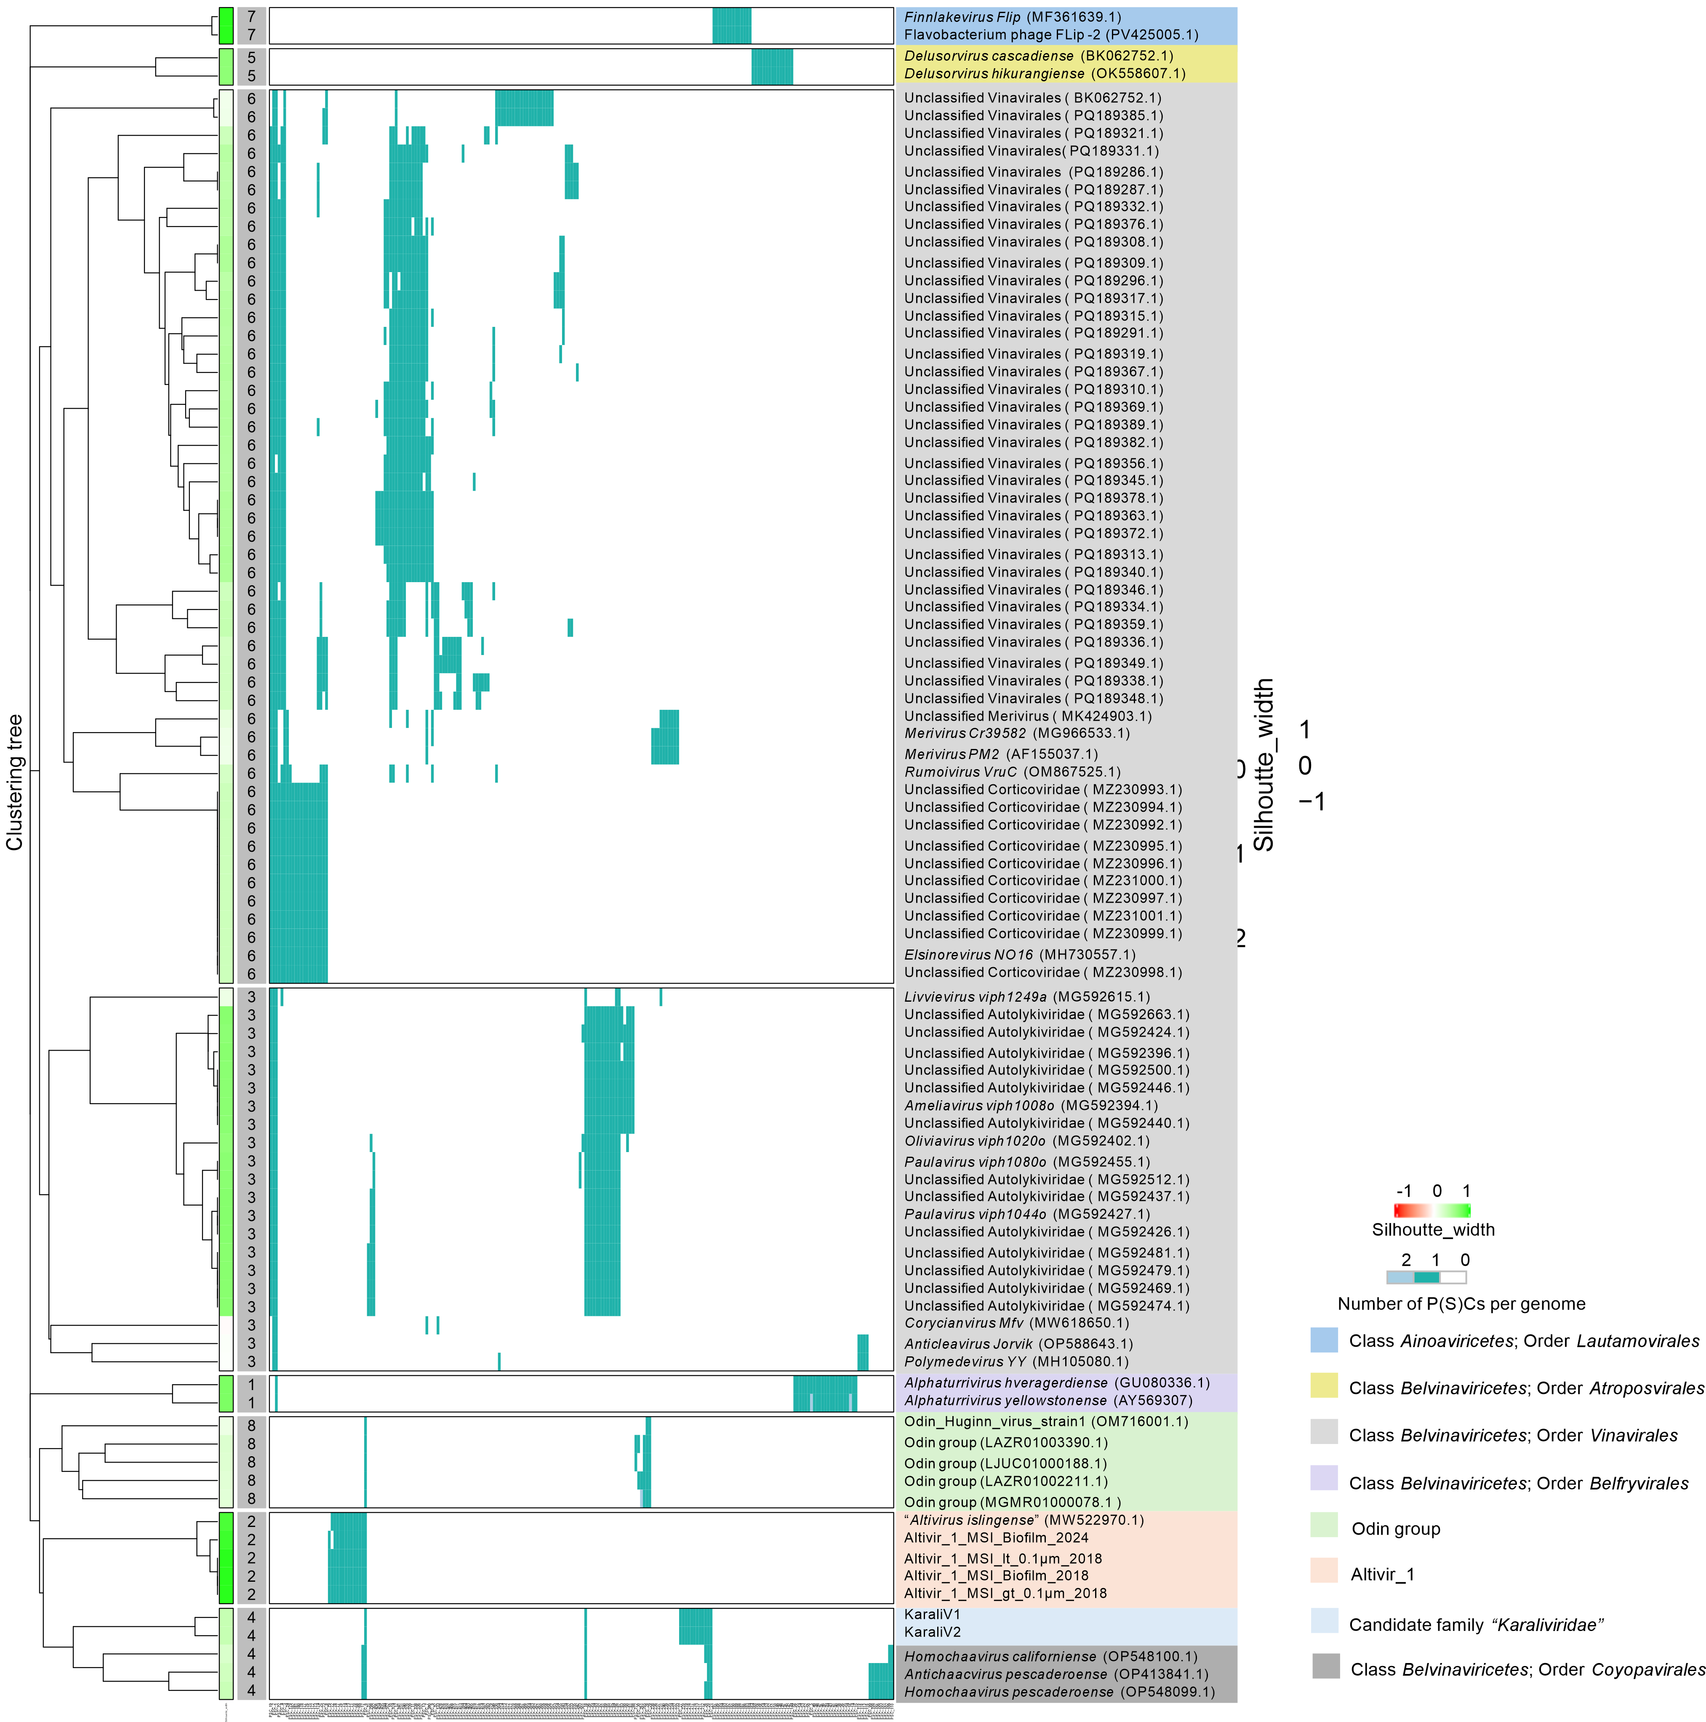

Figure 1. VirClust-based hierarchical genome-content clustering of members of the proposed “Altivirus islingense” (the Altivir_1 group), members of Abadenavirae, and related unclassified DJR-MCP viruses. Pairwise intergenomic distances were calculated from the presence or absence of protein superclusters (PSCs) across 91 viral genomes. Hierarchical clustering was performed using PSC-based intergenomic distances, and genome clusters were defined at an intergenomic distance cutoff of 0.90.
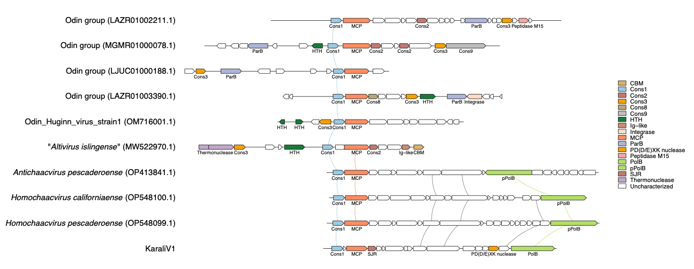
Figure 2. Comparative genome map of “Altivirus islingense” and of related DJR-MCP viruses. Genome maps are shown for Altivir_1_MSI_BF_2012, the exemplar of “Altivirus islingense”, members of Chaacviridae, the candidate family “Karaliviridae”, and Odin-group viruses. Coding sequences are shown as arrows, and curved links connect proteins assigned to the same PSC in the VirClust analysis. “Altivirus islingense” proteins were annotated using the HMM-based analyses described in the Justification section; annotations for “Karaliviridae”, Huginn virus strain 1, and the other Odin-group viruses were taken from references [10], [8], and [9], respectively.

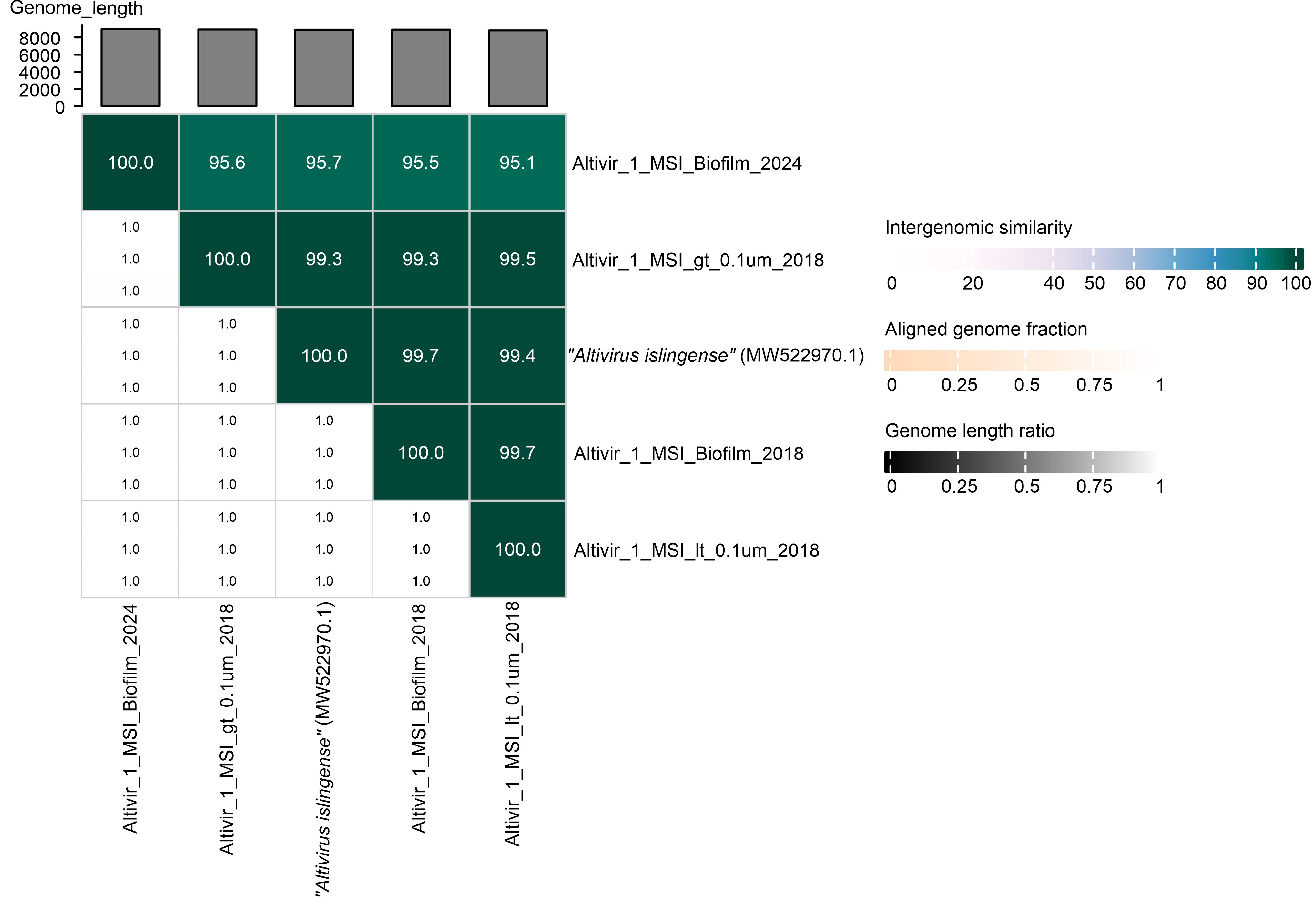
Figure 3. Intergenomic identities of “Altivirus islingense” genomes. Pairwise intergenomic identities among five “Altivirus islingense” genomes recovered from samples collected at the Mühlbacher Schwefelquelle Spring, Isling, Germany in 2012, 2018, and 2024 were calculated using VIRIDIC. Intergenomic identity values are shown in the upper triangle of the matrix, while aligned genome fractions and genome length ratios are shown in the lower triangle. Genome lengths are indicated by the bar plot above the matrix.

