

The International Committee on Taxonomy of Viruses
Taxonomy Proposal Form, 2026

Part 1a: Details of taxonomy proposals

Title: | Create three new families, three new genera, and three new species of tailless icosahedral archaeal viruses
Code assigned: | 2026.002A.N.v1.Coyopavirales_3nf

Author(s), affiliation and email address(es):
Given name (+middle initial(s)) | Surname | Affiliation | Email address | Corr. author(s)
Cherise R | Spotkaeff | College of Computational and Natural Sciences, Hawaii Pacific University, Honolulu, HI, USA | crus@hawaii.edu
Grieg | Steward | Department of Oceanography, University of Hawaii, Honolulu, HI USA
Mart | Krupovic | Institut Pasteur, Université Paris Cité, Cell Biology and Virology of Archaea Unit, Paris, France | mart.krupovic@pasteur.fr
Michael S | Rappé | Hawaii Institute of Marine Biology, University of Hawaii, Kaneohe, HI USA
Olivia D | Nigro | College of Computational and Natural Sciences, Hawaii Pacific University, Honolulu, HI, USA | onigro@hpu.edu | X

Part 1b: Taxonomy Proposal Submission
ICTV Subcommittee:
Animal DNA Viruses and Retroviruses |  | Bacterial viruses
Animal minus-strand and dsRNA viruses |  | Fungal and protist viruses
Animal positive-strand RNA viruses |  | Plant viruses
Archaeal viruses | X | General -

List the ICTV Study Group(s) that have seen or have been involved in creating this proposal:
Optional – complete only if formally voted on by an ICTV Study Group:
Study Group | Number of members
Study Group | Votes in support | Votes against | No vote

Submission date:

Part 1c: Feedback from ICTV Executive Committee (EC) meeting
Executive Committee Meeting Decision code: | X
A – Accept
Ac – Accept subject to revision by relevant subcommittee chair. No further vote required
U – Accept without revision but with re-evaluation and email vote by the EC
Uc – Accept subject to revision and re-evaluation and email vote by the EC
Ud – Deferred to the next EC meeting, with an invitation to revise based on EC comments
J - Reject
W - Withdrawn

Comments from the Executive Committee:

Part 1d: Revised Taxonomy Proposal Submission
Response of proposer:
Revision date:

Part 3: TAXONOMIC PROPOSAL

Taxonomic changes proposed:
Establish new taxon | X | Split taxon
Abolish taxon |  | Merge taxon
Move taxon |  | Promote taxon
Rename taxon |  | Demote taxon
Move and rename

Etymology (origin) of proposed taxonomic names:
Taxon name | Etymology of the term
Corkviridae | Refers to the CORK observatories from which pristine crustal fluid samples were collected
Boreholevirus | Refers to the drilled boreholes where the CORKs were installed
Boreholevirus edwardsae | Latinized binomial species name in honor of Katrina Edwards (1968 – 2014)
  Profundusviridae
  From the latin profundus, meaning “deep”, referring to the deep subsurface environment
Concelovirus | From the latin concelo, meaning “to hide” or “to keep secret”, referring to the microbial community within crustal fluids that remained inaccessible prior to the installation of CORK observatories
Concelovirus amendi | Latinized binomial species name in honor of Jan Amend (1964 – 2024)
Mysticusviridae | From the latin mysticus, meaning “mystic”, referring to the hidden and largely inaccessible environment within the basaltic crust
Ignotusvirus | From the latin ignotus, meaning “unknown”, referring to the unique nature of the proposed viruses
Ignotusvirus onstotti | Latinized binomial species name in honor of Tullis C. Onstott (1955 – 2021)

Permission for use of names derived from a living person:
Taxon name | Full name of person from whom the name is derived | Attached

Abstract of Taxonomy Proposal:
Description of current taxonomy:
The order Coyopavirales currently includes one family, Chaacviridae, of archaea-infecting viruses.

Proposed taxonomic change(s):
Create three new families, three new genera, and three new species in the order Coyopavirales (realm Varidnaviria) for classification of archaea-infecting viruses with predicted icosahedral capsids constructed from major capsid proteins with a double jelly-roll fold.

Demarcation criteria for new taxon/taxa:
We propose a 95% nucleotide sequence identity threshold for species demarcation. The three proposed families are currently monotypic and are distinguished by differences in gene content, genome organization, phylogenetic placement, MCP sequence/structure, and replication strategy. Notably, JdFR119 (“Mysticusviridae”) encodes a protein-primed PolB, whereas JdFR118 (“Corkviridae”) and JdFR003 (“Profundusviridae”) lack PolB, supporting separation of these otherwise related viruses into distinct families.

Justification:
The proposed viruses encode major capsid proteins predicted to adopt the double jelly-roll (DJR) fold, a hallmark of viruses in the realm Varidnaviria. Despite this shared structural feature, the viruses display little genomic similarity to currently classified viruses or to one another. Based on a combination of gene-sharing network analysis, comparisons of genome organization and gene synteny, ViPTree whole-proteome analysis, phylogenetic analysis of the MCP and PolB genes, AlphaFold2 protein structure prediction, and established approaches for the demarcation of prokaryotic virus taxa, we propose classification of these three archaeal viruses, each represented by a complete genome, into three new families within the order Coyopavirales.

Text of Taxonomy proposal:
Description of current taxonomy:
The order Coyopavirales currently includes one family, Chaacviridae, of archaea-infecting viruses.

Create three new families, three new genera, and three new species in the order Coyopavirales (realm Varidnaviria) for classification of archaea-infecting viruses with predicted icosahedral capsids constructed from major capsid proteins with a double jelly-roll fold.

Demarcation criteria for new taxon/taxa:

We propose a 95% nucleotide sequence identity threshold for species demarcation, consistent with commonly used criteria for prokaryotic viruses. The three proposed families are currently monotypic, and no genus-level demarcation criteria are proposed at this time. Family-level assignments are based on concordant differences in gene content, genome organization, phylogenetic relationships, and replication strategy rather than on a single sequence-identity threshold. The three representative genomes occupy distinct clades in the vConTACT2 gene-sharing network and show low overall genomic similarity and differences in gene synteny. In addition, JdFR119, the representative of “Mysticusviridae”, encodes a protein-primed DNA polymerase B, whereas JdFR118, the representative of “Corkviridae”, lacks a PolB, indicating a fundamental difference in replication strategy despite their related major capsid proteins. JdFR003, representing “Profundusviridae”, is further distinguished from JdFR118 and JdFR119 by its placement in a separate genomic clade and by greater divergence of its MCP sequence and structure. Together, these independent genomic, phylogenetic, structural, and replication-associated differences support recognition of three distinct families.

Justification:
The deep subseafloor aquifer is one Earth’s largest and least studied, cycling the entire volume of the global ocean on the order of once every 50 to 100K years [1]. With the installation of CORK (Circulation Obviation Retrofit Kit) borehole observatories, we have been able to gain brief glimpses into divergent microbial communities hosted within the crustal fluids through metagenomic surveys (e.g. [2], [3], [4], [5], [6]). One of these endmember CORK locations at the Juan de Fuca Ridge Flank (JdFR) that features geothermally-heated (>60℃) anoxic crustal fluid, was also found to host diverse archaea-infecting viruses [7], [8].

Expanding on work from a previous proposal for new viral taxonomy, we present three additional viruses with complete genomes and predicted archaeal hosts from the JdFR crustal fluid. These genomes were assembled from metagenomes prepared from CsCl density-gradient fractions (described in [8]). Based on homology searches (NCBI’s BLAST, CDD search and HHPred) and structural predictions (Alphafold2), these genomes are predicted to be distantly related to tailless, icosahedral viruses of the realm Varidnaviria, specifically, order Coyopavirales. Based on vConTACT2 gene-sharing network analysis [9], the three complete genomes form three different clades contained in separate modules consisting mostly of assembled genomes from JdFR (Figure 1).

To further refine family-level taxonomic classification of viruses predicted to be in the class Belvinaviricetes, we constructed viral proteomic trees using ViPTree [10]. We used a combination of all publicly available archaeal virus members of each class-level taxonomic classification and assembled incomplete genomes assigned to the same viral cluster (VC) from vConTACT2 analysis. Viruses used in the major capsid protein (MCP) phylogenetic analysis (Table 2) were also included in the proteome tree.

Based on the ViPTree analysis (Figure 2), clades 1–3 represent new families of viruses which are predicted to have a tailless, icosahedral morphology. These genomes were found to have hallmark genes of the realm Varidnaviria, including the MCP with a double jelly-roll fold and a minor capsid protein. Similar to viruses in the order Coyopavirales [11], structural modeling with AlphaFold2[12] suggests that the MCPs of these viruses also contain an additional beta barrel inserted between the jelly-roll beta-strands (Figure 2C).

In order to further investigate the relationships between these viruses, related candidate MCP amino acid sequences were downloaded from NCBI and aligned using MUSCLE version 5.1[13]. The resulting alignment, containing 14 protein sequences, was used to infer phylogenetic relationships by maximum-likelihood analysis in IQ-TREE-2 [14]. ModelFinder implemented in IQ-TREE 2 identified VT+I+G4 as the best-fitting amino acid substitution model, and the final tree was reconstructed using this model. Branch support was evaluated using 100 standard nonparametric bootstrap replicates. The resulting phylogeny was unrooted and visualized using iTOL [15](Figure 3).

Three-dimensional structures of the focal MCPs were predicted from their amino acid sequences using AlphaFold2[12]. Predicted structures were visualized and qualitatively compared using Foldseek/FoldMason [16] to assess conservation of the overall protein fold and identify structurally conserved regions. Quantitative pairwise structural comparisons were subsequently performed using US-align [17] for all 15 unique pairwise combinations of the six focal proteins: JdFR003, JdFR118, JdFR119, PBV266, PBV304, and PBV305 (Table 3). For each comparison, US-align was used to determine the number of structurally aligned residues, root-mean-square deviation (RMSD), sequence identity among structurally aligned residues, and TM-scores normalized independently to the length of each protein (Figure 4). Structural alignment coverage was calculated as the number of aligned residues divided by the total length of each respective protein. For visualization and comparison among protein pairs, the arithmetic mean of the two length-normalized TM-scores was used as a descriptive summary.

Phylogenetic analysis of the MCPs separated the JdFR viruses from members of the established family Chaacviridae. The three JdFR proteins formed a distinct lineage, while PBV266, PBV304, and PBV305 grouped within a separate Chaacviridae lineage. These two lineages were united only at a deeper node, indicating a more distant evolutionary relationship between them. Overall, the MCP phylogeny supports the JdFR viruses as a coherent lineage distinct from the currently classified Chaacviridae (Figure 3).

Pairwise structural comparisons closely mirrored these phylogenetic relationships. Within the JdFR group, mean pairwise TM-scores ranged from 0.912 to 0.980, with approximately 97–100% of the respective protein sequences structurally aligned and RMSDs ranging from 0.79 to 1.91 Å. JdFR118 and JdFR119 were the most similar pair, with 365 residues aligned, 46.6% sequence identity, an RMSD of 0.79 Å, and a mean TM-score of 0.980. JdFR003 was considerably more divergent at the sequence level, sharing only 18.5–19.6% sequence identity with JdFR119 and JdFR118 across their structural alignments, respectively, but nevertheless retained strong structural similarity to both proteins, with mean TM-scores of 0.919 and 0.912.

Strong structural conservation was likewise observed among the Chaacviridae MCPs. Mean pairwise TM-scores ranged from 0.921 to 0.989, with RMSDs of 0.78–1.57 Å. PBV266 and PBV304 were nearly identical, with all 320 residues structurally aligned, 89.7% sequence identity, an RMSD of 0.78 Å, and a TM-score of 0.989. PBV305 was more divergent in sequence, sharing approximately 42% identity with PBV266 and PBV304, but remained highly structurally conserved with both proteins, with mean TM-scores of 0.921 and 0.922, respectively.

In contrast, comparisons between the JdFR and Chaacviridae MCPs revealed substantial sequence divergence together with a highly consistent but weaker structural relationship. Across all nine cross-group comparisons, sequence identity among structurally aligned residues was only 6.0–11.5%, while RMSDs ranged from 4.47 to 5.06 Å. Approximately 64–81% of the respective protein sequences could nevertheless be structurally aligned, and mean TM-scores fell within a narrow range of 0.537–0.546. The consistency of these values across all cross-group comparisons indicates that the observed similarity reflects a conserved structural core rather than an isolated similarity between individual proteins.

Together, the MCP phylogeny and structural comparisons support the JdFR viruses as a coherent and structurally distinct lineage relative to Chaacviridae. Structural similarity is substantially greater within each group than between groups, while the retained cross-group similarity suggests conservation of a more deeply shared capsid architecture. These findings therefore provide evidence supporting recognition of the JdFR viruses as a distinct lineage, consistent with their proposed placement outside of the family Chaacviridae.

The proposed viruses also share several conserved uncharacterized proteins identified in members of Coyopavirales, including a protein of uncharacterized function with homologues in the unclassified Huginn virus associated with Asgard archaea [18] and a minor structural protein with homologues in filamentous viruses of the family Rudiviridae. In addition, the JdFR viruses also share a conserved uncharacterized protein with no identified function.

Despite the shared features with members of Coyopavirales, phylogenetic analysis of all publicly available members of the class Belvinaviricetes suggests that these viruses are sufficiently distinct from other classified viruses to be placed in separate family-level taxa (Figure 2B) therefore, we propose to create three new families in the order Coyopavirales.

Family “Mysticusviridae”

Clade 1 is a new family in the order Coyopavirales, containing one complete representative genome (predicted to be complete through the presence of 99 bp inverted terminal repeats), JdFR119. This virus has a predicted buoyant density of 1.35 g/ml and a genome of around 12 kbp. Like other proposed members of the order Coyopavirales, JdFR119, the sole proposed member of the family “Mysticusviridae” encodes a protein-primed polymerase B (PolB) (Figure 2A). JdFR119 also encodes a minor structural archaeal virus protein that is conserved in other members of Coyopavirales.

To further investigate the phylogenetic relationship of the family “Mysticusviridae”, PolB amino acid sequences were used to infer a maximum-likelihood phylogeny. Reference family PolB protein sequences representing protein-primed and conventional PolBs were obtained from previously characterized archaeal and bacterial viruses and from publicly available sequence databases [18], [19]. Additional homologous PolB sequences were identified by similarity searches against the NCBI non-redundant protein database and were included to provide broader phylogenetic context. Candidate PolB sequences from the viruses investigated in this study were added to the reference dataset.

Protein sequences were aligned using MUSCLE version 5.1[13], and the alignment was inspected to identify conserved regions of the PolB protein and remove poorly aligned or highly gapped positions. Maximum-likelihood phylogenetic analysis was performed using IQ-TREE 2 [14]. ModelFinder implemented in IQ-TREE 2 identified VT+F+R6 as the best-fitting amino acid substitution model, and the final tree was reconstructed using this model. Branch support was evaluated using 100 standard nonparametric bootstrap replicates. The resulting phylogeny was midpoint-rooted for visualization and annotated in iTOL [15] (Figure 5).

In the PolB phylogeny, sequences were included from multiple previously undescribed viruses recovered from our JdFR metagenomic datasets, together with reference viral and archaeal PolB sequences. Several of the novel JdFR viruses, including JdFR119, clustered within the broader protein-primed PolB radiation. Within this radiation, JdFR119 grouped with additional novel JdFR viral PolB sequences but remained clearly separated from the Chaacviridae representative PBV266, which occupied a distinct sublineage. This separation supports the interpretation that the JdFR viruses represent a distinct evolutionary lineage rather than a divergent subgroup within Chaacviridae. Concordant MCP phylogenetic and structural differences further support recognition of the JdFR viruses as the proposed family “Mysticusviridae”, distinct from Chaacviridae.

Families “Corkviridae” and “Profundusviridae”

Clades 2 and 3 are proposed as two new families within the class Belvinaviricetes, “Corkviridae” and “Profundusviridae”, respectively. Each family is represented by a complete genome, with genome completeness supported by the presence of direct terminal repeats. The viruses have similar genome sizes (approximately 13–14 kbp) and predicted buoyant densities (1.32–1.35 g/ml), and both encode the plasmid-partitioning protein ParB in addition to conserved structural proteins. However, analysis of the major capsid protein does not support grouping JdFR003 and JdFR118 together: JdFR118 is more closely related to JdFR119 in both MCP phylogenetic and structural analyses, whereas JdFR003 forms a more divergent lineage. This distinction, together with their separation into independent genomic clades, supports recognition of “Corkviridae” and “Profundusviridae” as separate families rather than combining the two viruses into a single family.

Clades 1-3 Etymology
All binomial epithets are in honor of former leaders of our deep subsurface community who are deceased. Their vision and leadership laid the crucial foundation for microbial research in the deep biosphere that supported these discoveries.

References:
[1] H. P. Johnson and M. J. Pruis, “Fluxes of fluid and heat from the oceanic crustal reservoir,” Earth Planet. Sci. Lett., vol. 216, no. 4, pp. 565–574, 2003, doi: 10.1016/S0012-821X(03)00545-4.
[2] S. P. Jungbluth, J. P. Amend, and M. S. Rappé, “Metagenome sequencing and 98 microbial genomes from Juan de Fuca Ridge flank subsurface fluids,” Sci. Data, vol. 4, no. 1, p. 170037, Mar. 2017, doi: 10.1038/sdata.2017.37.
[3] S. P. Jungbluth, R. M. Bowers, H.-T. Lin, J. P. Cowen, and M. S. Rappé, “Novel microbial assemblages inhabiting crustal fluids within mid-ocean ridge flank subsurface basalt,” ISME J., vol. 10, no. 8, pp. 2033–2047, Aug. 2016, doi: 10.1038/ismej.2015.248.
[4] J. L. Meyer et al., “A distinct and active bacterial community in cold oxygenated fluids circulating beneath the western flank of the Mid-Atlantic ridge,” Sci. Rep., vol. 6, no. 1, p. 22541, Mar. 2016, doi: 10.1038/srep22541.
[5] B. J. Tully, C. G. Wheat, B. T. Glazer, and J. A. Huber, “A dynamic microbial community with high functional redundancy inhabits the cold, oxic subseafloor aquifer,” ISME J., vol. 12, no. 1, pp. 1–16, Jan. 2018, doi: 10.1038/ismej.2017.187.
[6] L. M. Seyler, E. Trembath-Reichert, B. J. Tully, and J. A. Huber, “Time-series transcriptomics from cold, oxic subseafloor crustal fluids reveals a motile, mixotrophic microbial community,” ISME J., vol. 15, no. 4, pp. 1192–1206, Apr. 2021, doi: 10.1038/s41396-020-00843-4.
[7] O. D. Nigro et al., “Viruses in the Oceanic Basement,” mBio, vol. 8, no. 2, pp. 1–15, 2017.
[8] C. R. Spotkaeff, M. S. Rappé, G. Steward, and O. D. Nigro, “Create 6 new families and 1 new species of viruses infecting archaea found in basalt-hosted crustal fluid.” International Committee on Taxonomy of Viruses (ICTV), Aug. 24, 2025. [Online]. Available: https://ictv.global/system/files/proposals/approved/Archaeal_viruses/2025.001A.Crust_viruses_6nf.docx
[9] H. Bin Jang et al., “Taxonomic assignment of uncultivated prokaryotic virus genomes is enabled by gene-sharing networks,” Nat. Biotechnol., vol. 37, no. 6, pp. 632–639, 2019, doi: 10.1038/s41587-019-0100-8.
[10] Y. Nishimura, T. Yoshida, M. Kuronishi, H. Uehara, H. Ogata, and S. Goto, “ViPTree: the viral proteomic tree server,” Bioinformatics, vol. 33, no. 15, pp. 2379–2380, Aug. 2017, doi: 10.1093/bioinformatics/btx157.
[11] R. Laso-Pérez et al., “Evolutionary diversification of methanotrophic ANME-1 archaea and their expansive virome,” Nat. Microbiol., vol. 8, no. 2, pp. 231–245, Feb. 2023, doi: 10.1038/s41564-022-01297-4.
[12] J. Jumper et al., “Highly accurate protein structure prediction with AlphaFold,” Nature, vol. 596, no. 7873, pp. 583–589, Aug. 2021, doi: 10.1038/s41586-021-03819-2.
[13] R. C. Edgar, “High-accuracy alignment ensembles enable unbiased assessments of sequence homology and phylogeny,” Jun. 21, 2021, Bioinformatics. doi: 10.1101/2021.06.20.449169.
[14] B. Q. Minh et al., “IQ-TREE 2: New Models and Efficient Methods for Phylogenetic Inference in the Genomic Era,” Mol. Biol. Evol., vol. 37, no. 5, pp. 1530–1534, May 2020, doi: 10.1093/molbev/msaa015.
[15] I. Letunic and P. Bork, “Interactive Tree Of Life (iTOL): an online tool for phylogenetic tree display and annotation,” Bioinformatics, vol. 23, no. 1, pp. 127–128, Jan. 2007, doi: 10.1093/bioinformatics/btl529.
[16] M. Van Kempen et al., “Fast and accurate protein structure search with Foldseek,” Nat. Biotechnol., vol. 42, no. 2, pp. 243–246, Feb. 2024, doi: 10.1038/s41587-023-01773-0.
[17] C. Zhang, M. Shine, A. M. Pyle, and Y. Zhang, “US-align: universal structure alignments of proteins, nucleic acids, and macromolecular complexes,” Nat. Methods, vol. 19, no. 9, pp. 1109–1115, Sep. 2022, doi: 10.1038/s41592-022-01585-1.
[18] D. Tamarit et al., “A closed Candidatus Odinarchaeum chromosome exposes Asgard archaeal viruses,” Nat. Microbiol., vol. 7, no. 7, pp. 948–952, Jun. 2022, doi: 10.1038/s41564-022-01122-y.
[19] J.-G. Kim et al., “Spindle-shaped viruses infect marine ammonia-oxidizing thaumarchaea,” Proc. Natl. Acad. Sci., vol. 116, no. 31, pp. 15645–15650, Jul. 2019, doi: 10.1073/pnas.1905682116.

Accompanying files:
Filename | Description of contents

Tables, Figures:

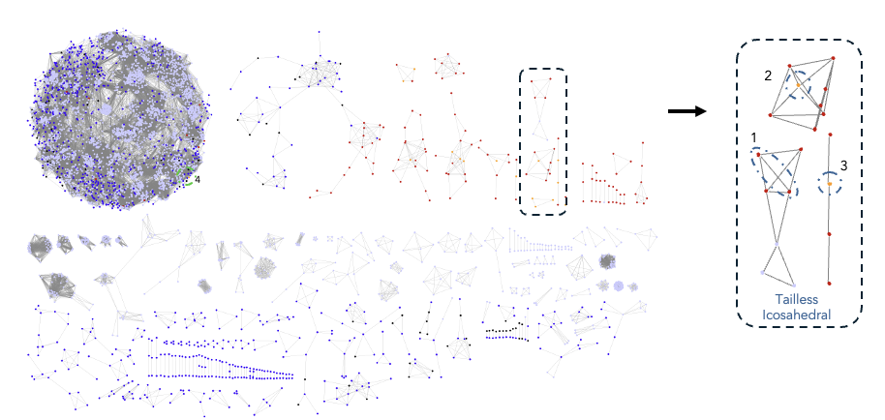
Figure 1. Gene-sharing network constructed with vConTACT2, showing the viral community in the JdFR crustal fluid (red) is distinct from viruses in other crustal fluid environments (North Pond, blue, and North Pond Bottom Water, black) and viruses in the RefSeq database (purple). Subset of vConTACT2 gene-sharing network containing complete genomes for new proposed taxa. Dashed groupings, colored by putative morphology, indicate clades (1-3) of viruses for new proposed taxonomy.

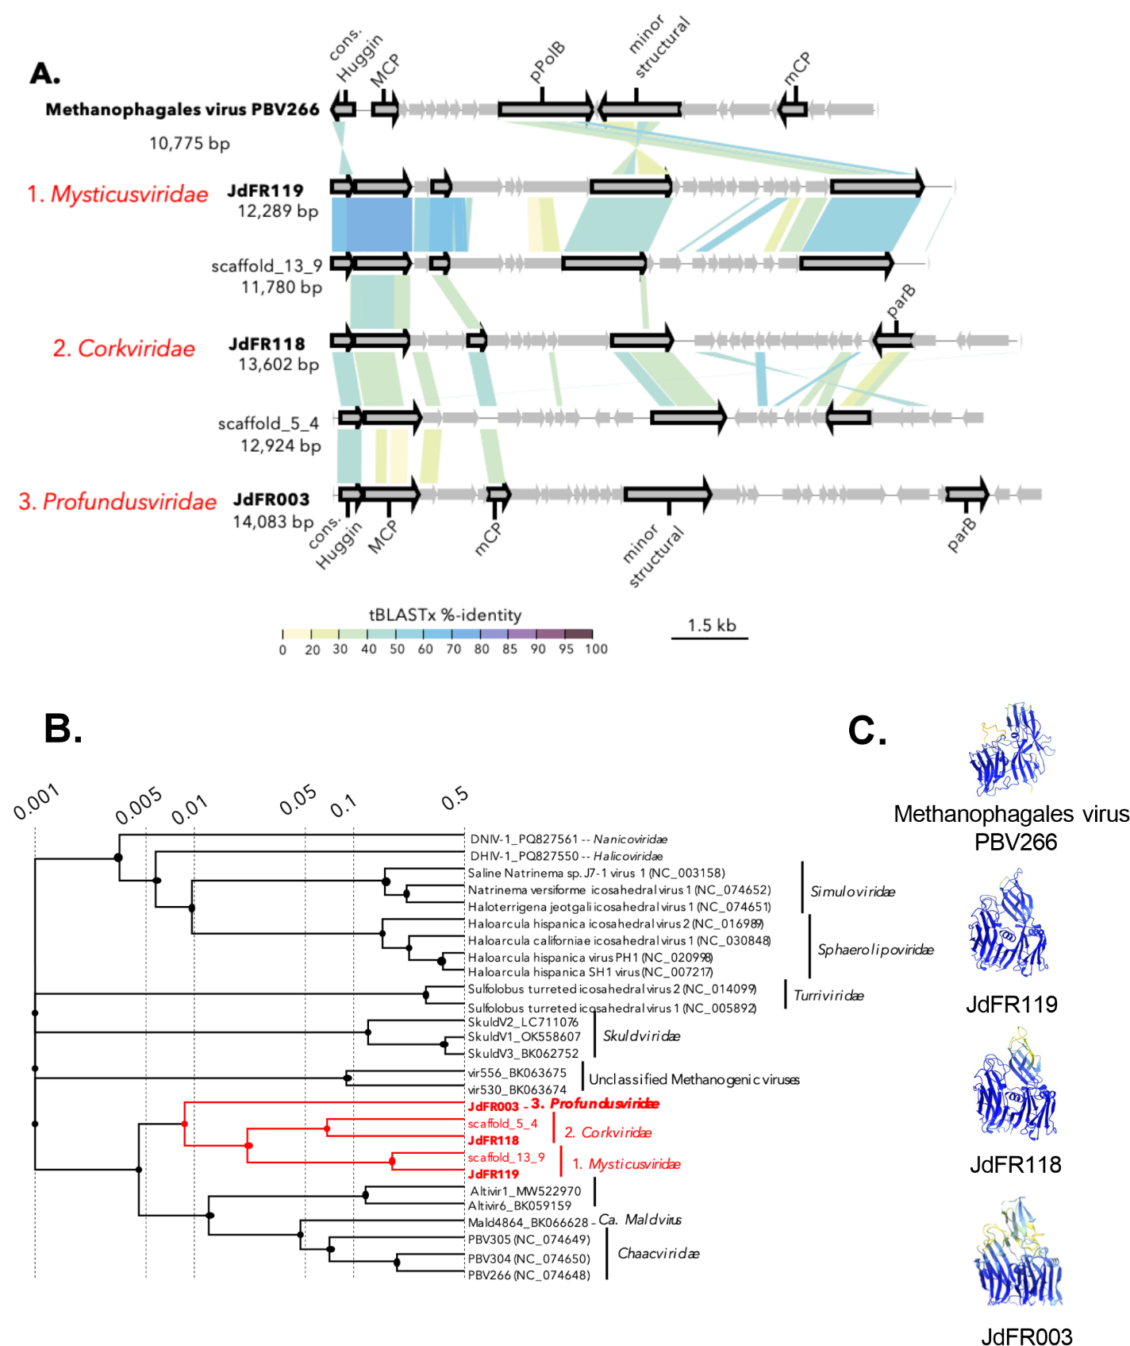
Figure 2. Clades 1-3 containing new taxa of tailless, icosahedral viruses in the realm Varidnaviria A. Genome maps illustrating gene synteny between clades 1-3. Abbreviations: MCP, major capsid protein; mCP, minor capsid protein; pPolB, protein-primed polymerase B; parB, ParB/RepB/Spo0J family partition protein; cons. Huggin, conserved uncharacterized protein with homologues in unclassified Huginn virus in which this family of proteins was first detected. B. VIPTree proteomic analysis of representative classified archaeal tailless icosahedral viruses. Additional unclassified tailless archaeal viruses (e.g. Maldivirus, unclassified Altiarchaea and Methanogenic viruses), were also included based on similar major capsid proteins. C. Alphafold2 predicted protein structures of double jelly-roll-containing major capsid proteins found in complete genomes of newly proposed taxa and reference genomes. The structures are colored based on the pLDDT score from red (bad quality) to blue (good quality).

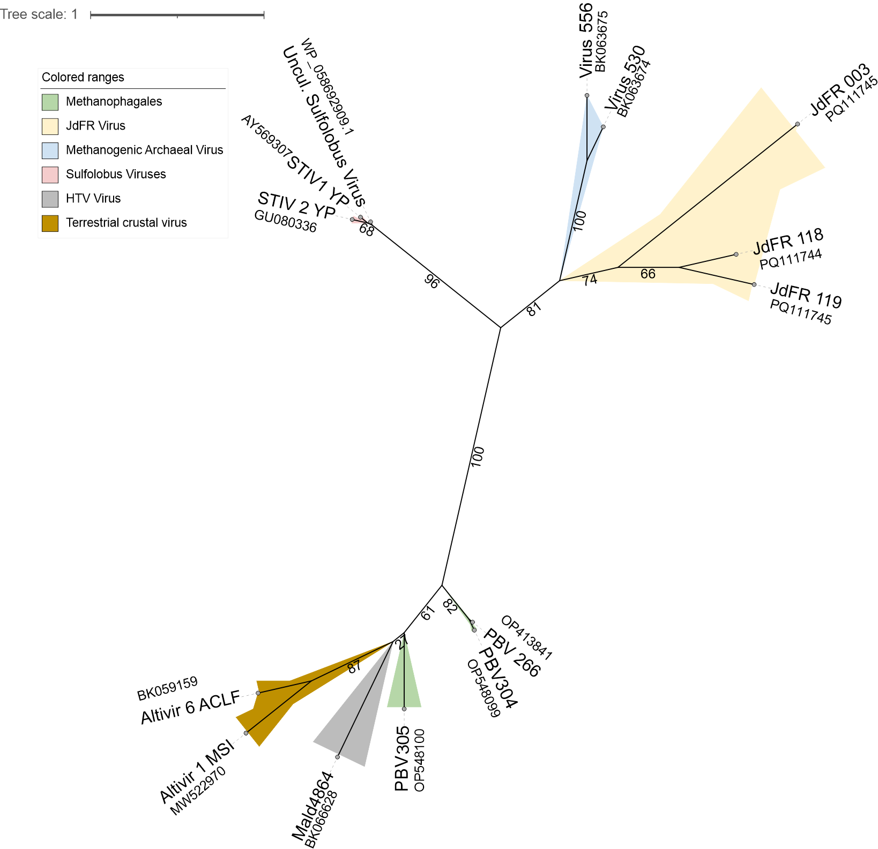
Figure 3. Maximum-likelihood phylogeny of candidate major capsid proteins (MCPs). Numbers at internal nodes indicate bootstrap support values (%) from 100 standard nonparametric bootstrap replicates. The tree was visualized and annotated in iTOL. Additional information for genomes/proteins are listed in Table 2.

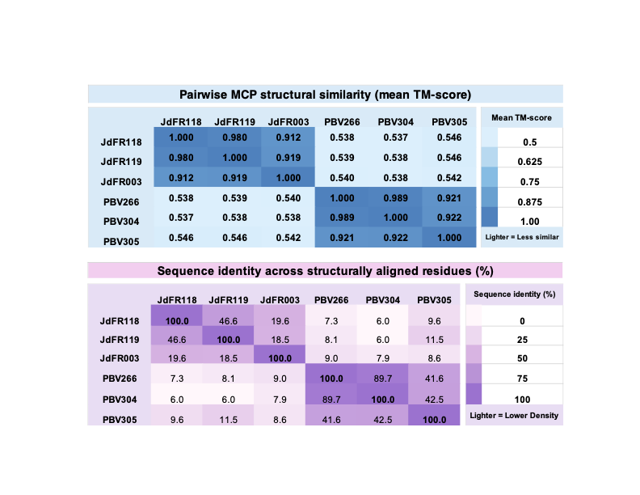

Figure 4. Heatmaps of MCP characteristics of proposed viruses from JdFR and Chaacviridae. Upper: Pairwise structural similarity of folded MCPs determined by US-align. Mean TM-score = arithmetic mean of the two length-normalized TM-scores reported by US-align. Higher values indicate greater structural similarity. Lines are ordered to group the JdFR and Chaacviridae (PBV) proteins. Lower: Sequence identity values of amino acid sequences of MCPs derived from US-align.

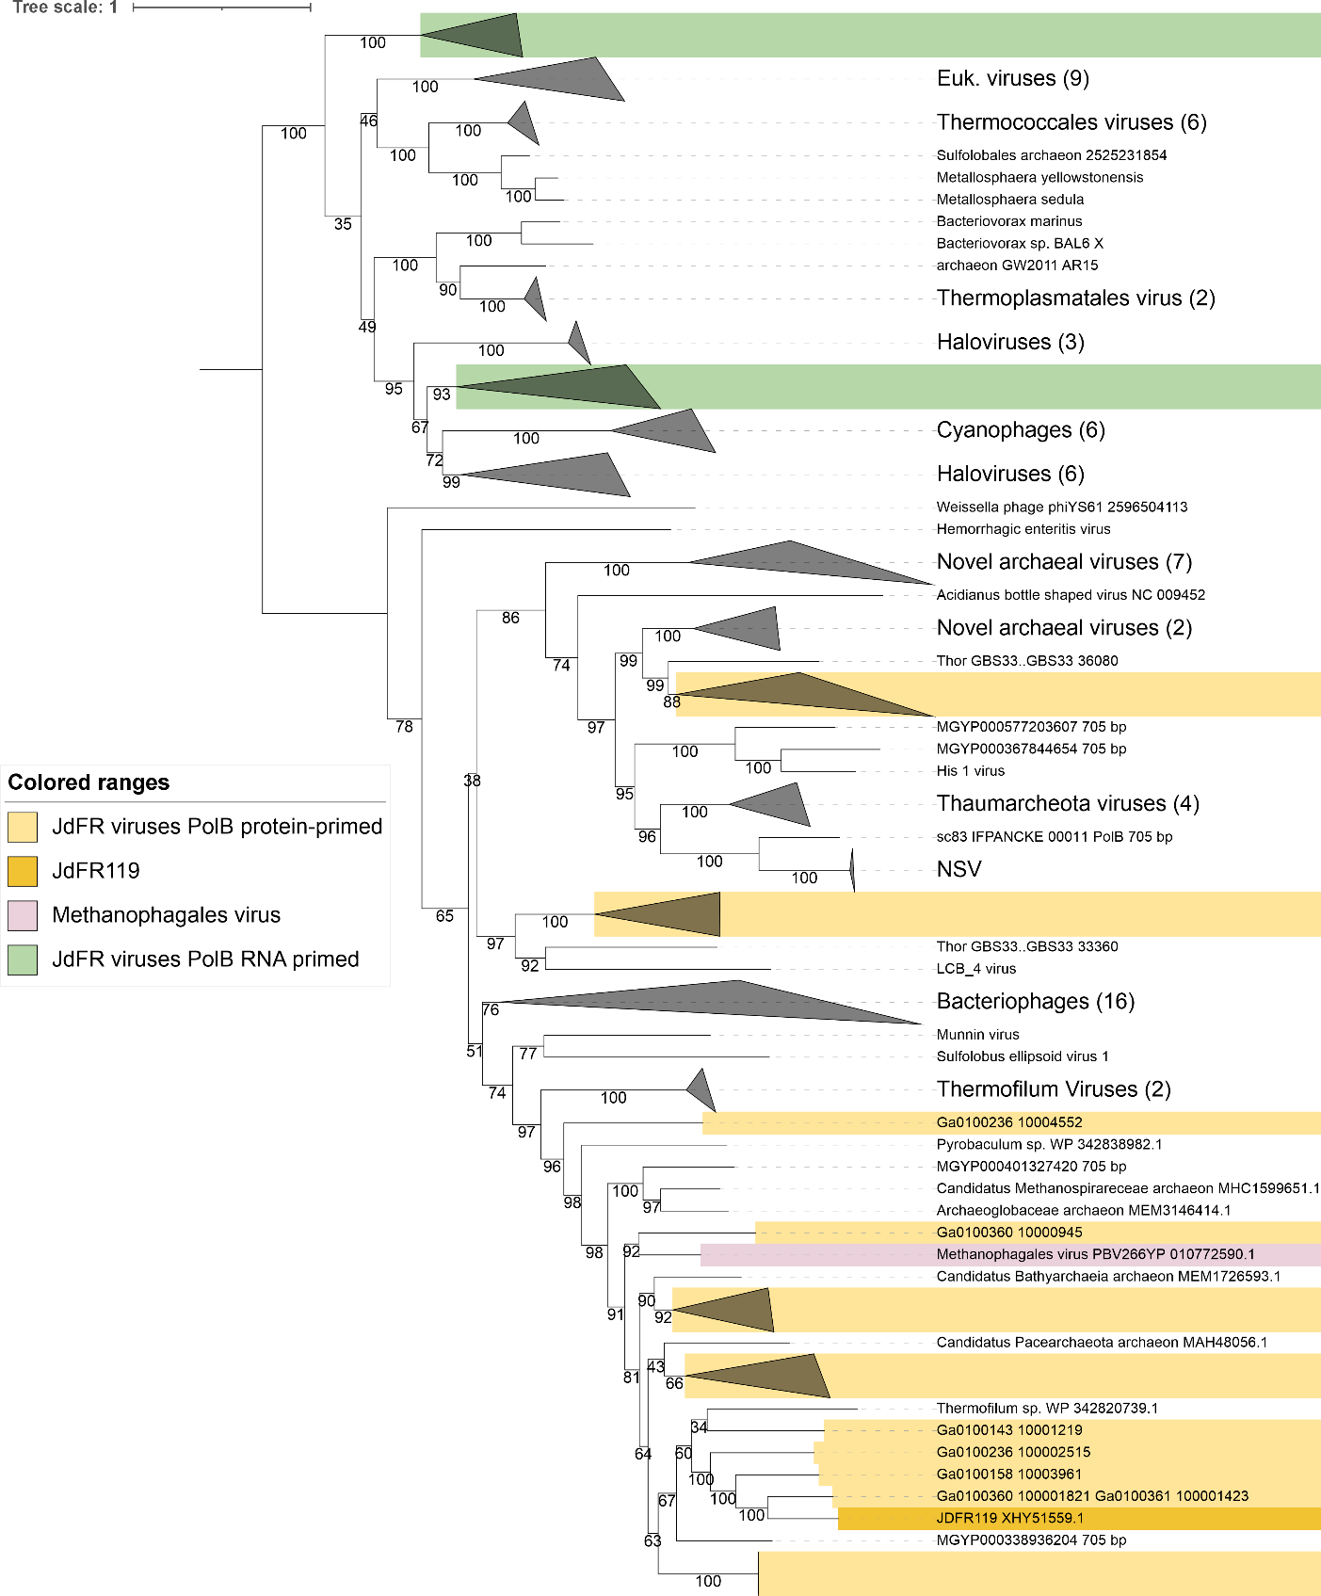

Figure 5. Midpoint-rooted maximum-likelihood phylogeny of DNA polymerase B (PolB) sequences from JdFR viruses and reference PolB sequences[18], [19]. Novel sequences recovered from JdFR metagenomic datasets are highlighted in yellow or green. Yellow sequences cluster with protein-primed PolB lineages, whereas green sequences cluster with RNA-primed PolB lineages. The PolB of JdFR119 is highlighted in dark yellow. PBV266, a member of the family Chaacviridae, is highlighted in pink. NSV denotes Nitrosopumilus spindle-shaped viruses. Numbers at internal nodes indicate bootstrap support values.
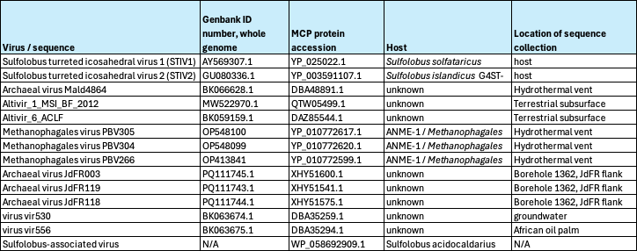
Table 1. Overview of viruses for new proposed taxonomy

Table 2. NCBI accession numbers for viral sequences used in the MCP phylogenetic analysis and VIPTree amendments.
Clade # | Predicted Morphology | Virus  Name | Family | Genus | Species | Size (bp) | Buoyant Density Range (g/ml) | GenBank Accession
1 | Tailless | JdFR119 | Mysticusviridae | Ignotusvirus | Ignotusvirus onstotti | 12,289 | 1.35 | PQ111743
2 | Tailless | JdFR118 | Corkviridae | Boreholevirus | Boreholevirus edwardsae | 13,602 | 1.32-1.35 | PQ111744
3 | Tailless | JdFR003 | Profundusviridae | Concelovirus | Concelovirus amendi | 14,083 | 1.34-1.35 | PQ111745
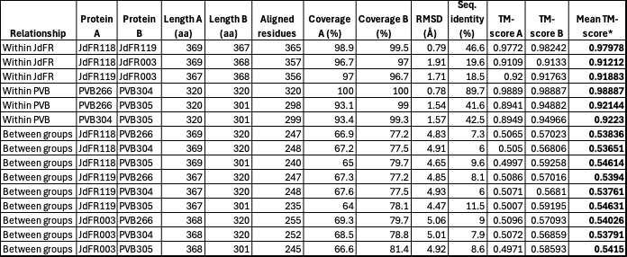
Table 3. Pairwise structural comparisons of candidate major capsid proteins as determined after folding using AlphaFold2 and comparing the folded structures using US-align.

