

The International Committee on Taxonomy of Viruses
Taxonomy Proposal Form, 2026

Part 1a: Details of taxonomy proposals

Title: | Create 4 new species in the family Pleolipoviridae.
Code assigned: | 2026.001A.N.v1.Pleolipoviridae_4ns

Author(s), affiliation and email address(es):
Given name (+middle initial(s)) | Surname | Affiliation | Email address | Corr. author(s)
Mart | Krupovic | Institut Pasteur, Université Paris Cité, Cell Biology and Virology of Archaea Unit, Paris, France | mart.krupovic@pasteur.fr | X
Lauren | Queiss | Max-Planck Institute for Marine Microbiology, Celsiusstrasse 1, 28359 Bremen, Germany | lqueiss@mpi-bremen.de
Tomas | Alarcón-Schumacher | Max-Planck Institute for Marine Microbiology, Celsiusstrasse 1, 28359 Bremen, Germany | talarcon@mpi-bremen.de
Mike | Dyall-Smith | Computational Biology Group, Max-Planck-Institute of Biochemistry, 82152 Martinsried, Germany | mike.dyallsmith@gmail.com
Hanna M. | Oksanen | Department of Molecular and Integrative Biosciences, Faculty of Biological and Environmental Sciences, University of Helsinki, Helsinki, Uusimaa, Finland | hanna.oksanen@helsinki.fi
Tatiana | Demina | Department of Microbiology, Faculty of Agriculture and Forestry, University of Helsinki, Helsinki, Uusimaa, Finland | tatiana.demina@helsinki.fi
Ying | Liu | Department of Microbiology,  College of Life Sciences, Wuhan University, Wuhan, China | liuying@whu.edu.cn

Part 1b: Taxonomy Proposal Submission
ICTV Subcommittee:
Animal DNA Viruses and Retroviruses |  | Bacterial viruses
Animal minus-strand and dsRNA viruses |  | Fungal and protist viruses
Animal positive-strand RNA viruses |  | Plant viruses
Archaeal viruses | X | General -

List the ICTV Study Group(s) that have seen or have been involved in creating this proposal:
Pleolipoviridae SG
Optional – complete only if formally voted on by an ICTV Study Group:
Study Group | Number of members
Study Group | Votes in support | Votes against | No vote

Submission date:

Part 1c: Feedback from ICTV Executive Committee (EC) meeting
Executive Committee Meeting Decision code: | X
A – Accept
Ac – Accept subject to revision by relevant subcommittee chair. No further vote required
U – Accept without revision but with re-evaluation and email vote by the EC
Uc – Accept subject to revision and re-evaluation and email vote by the EC
Ud – Deferred to the next EC meeting, with an invitation to revise based on EC comments
J - Reject
W - Withdrawn

Comments from the Executive Committee:

Part 1d: Revised Taxonomy Proposal Submission
Response of proposer:
Revision date:

Part 3: TAXONOMIC PROPOSAL

Taxonomic changes proposed:
Establish new taxon | X | Split taxon
Abolish taxon |  | Merge taxon
Move taxon |  | Promote taxon
Rename taxon |  | Demote taxon
Move and rename

Etymology (origin) of proposed taxonomic names:
Taxon name | Etymology of the term
Alphapleolipovirus hardyense | hardyense – latinized species epithet derived from Lake Hardy (Australia), place of origin of Halorubrum virus Humcor2.
Alphapleolipovirus siamense | siamense – latinized species epithet derived from Siam, former name of Thailand, place of origin of Halorubrum pleomorphic virus 8.
Betapleolipovirus tebenquichense | tebenquichense – latinized species epithet derived from Laguna Tebenquiche (Chile), place of origin of Tebenquiche pleomorphic virus 1.
Betapleolipovirus alicantense | alicantense – latinized species epithet derived from Alicante (Spain), place of origin of Haloarcula virus Harhisp1.

Permission for use of names derived from a living person:
Taxon name | Full name of person from whom the name is derived | Attached

Abstract of Taxonomy Proposal:
Description of current taxonomy:
Family Pleolipoviridae (realm Pleomoviria) includes haloarchaeal viruses with enveloped pleomorphic virions and single-stranded (ss) or double-stranded (ds) DNA genomes. The family comprises three genera, Alphapleolipovirus, Betapleolipovirus, and Gammapleolipovirus.

Proposed taxonomic change(s):
Classify four viruses into four new species within genera Alphapleolipovirus (n=2) and Betapleolipovirus (n=2).

Demarcation criteria for new taxon/taxa:
Genera are identified by the gene content and well-supported monophyletic groups based on phylogenomic analysis of the whole genome sequences. Viruses with genomes that differ by more than 5% are assigned to different species.

Justification:
The four viruses considered in the proposal differ by more than 5% from all classified pleolipovirids, justifying the creation of four new species. Phylogenomic analysis firmly places 2 of the species into genus Alphapleolipovirus and 2 species into genus Betapleolipovirus.

Text of Taxonomy proposal:
Description of current taxonomy:
Family Pleolipoviridae (realm Pleomoviria) includes haloarchaeal viruses with enveloped pleomorphic virions and single-stranded (ss) or double-stranded (ds) DNA genomes. The family comprises three genera, Alphapleolipovirus, Betapleolipovirus, and Gammapleolipovirus.

Proposed taxonomic change(s):
Classify four viruses into four new species within genera Alphapleolipovirus (n=2) and Betapleolipovirus (n=2).

Demarcation criteria for new taxon/taxa:
Genera are identified by the gene content and well-supported monophyletic groups based on phylogenomic analysis of the whole genome sequences. Viruses with genomes that differ by more than 5% are assigned to different species (Liu et al., 2022).

Justification:
During the past few years several new potential members of the family Pleolipoviridae have been reported. These include Halorubrum pleomorphic virus 8 (HRPV-8; Demina et al., 2026), Halorubrum virus Humcor2 (Humcor2; Dyall-Smith et al., 2021), Haloarcula virus Harhisp1 (Harhisp1; Dyall-Smith et al., 2021) and Tebenquiche pleomorphic virus 1 (Tebi-PV1; Queiss et al., 2025). The four viruses differ by more than 5% from all classified pleolipovirids (Fig. 1), justifying the creation of four new species. Phylogenomic analysis using VICTOR tool (Meier-Kolthoff and Göker, 2017), which has been used previously to classify pleolipovirids, firmly places HRPV-8 and Humcor2 into genus Alphapleolipovirus, whereas Harhisp1 and Tebi-PV1 are placed into genus Betapleolipovirus (Fig. 2). Consistently, Harhisp1 and Tebi-PV1 encode the rolling circle replication initiation endonuclease of the Rep-Arvir family (Wang et al., 2026), which is characteristic of most betapleolipoviruses.

References:
Demina T, Laanto E, Oksanen HM. Complete genome sequence of Halorubrum pleomorphic virus 8. F1000Research. 2026; 15:654. Doi: 10.12688/f1000research.179903.1.
Dyall-Smith M, Pfeiffer F, Chiang PW, Tang SL. The Novel Halovirus Hardycor1, and the Presence of Active (Induced) Proviruses in Four Haloarchaea. Genes (Basel). 2021; 12(2):149. doi: 10.3390/genes12020149. PMID: 33498646
Liu Y, Dyall-Smith M, Oksanen HM. ICTV Virus Taxonomy Profile: Pleolipoviridae 2022. J Gen Virol. 2022; 103(11):001793. doi: 10.1099/jgv.0.001793. PMID: 36374180
Meier-Kolthoff JP, Göker M. VICTOR: genome-based phylogeny and classification of prokaryotic viruses. Bioinformatics. 2017; 33(21):3396-3404. doi: 10.1093/bioinformatics/btx440. PMID: 29036289
Moraru C, Varsani A, Kropinski AM. VIRIDIC-A Novel Tool to Calculate the Intergenomic Similarities of Prokaryote-Infecting Viruses. Viruses. 2020;12(11):1268. doi: 10.3390/v12111268. PMID: 33172115
Queiss et al. Tale of Two viruses: Two coinfecting archaeal viruses provide insights into virus-virus interactions. Research Square. 2025. doi: 10.21203/rs.3.rs-7669873/v1
Wang Y, Duan Z, Chen Z, Li S, Chen H, Chen J, Wang Y, Wang J, An K, Xiang J, Du S, Liu Y, Krupovic M, Chen X. A new family of rolling-circle replication endonucleases widespread in archaeal viruses and plasmids. Nucleic Acids Res. 2026; 54(8):gkag363. doi: 10.1093/nar/gkag363. PMID: 42033218

Accompanying files:
Filename | Description of contents

Tables, Figures:

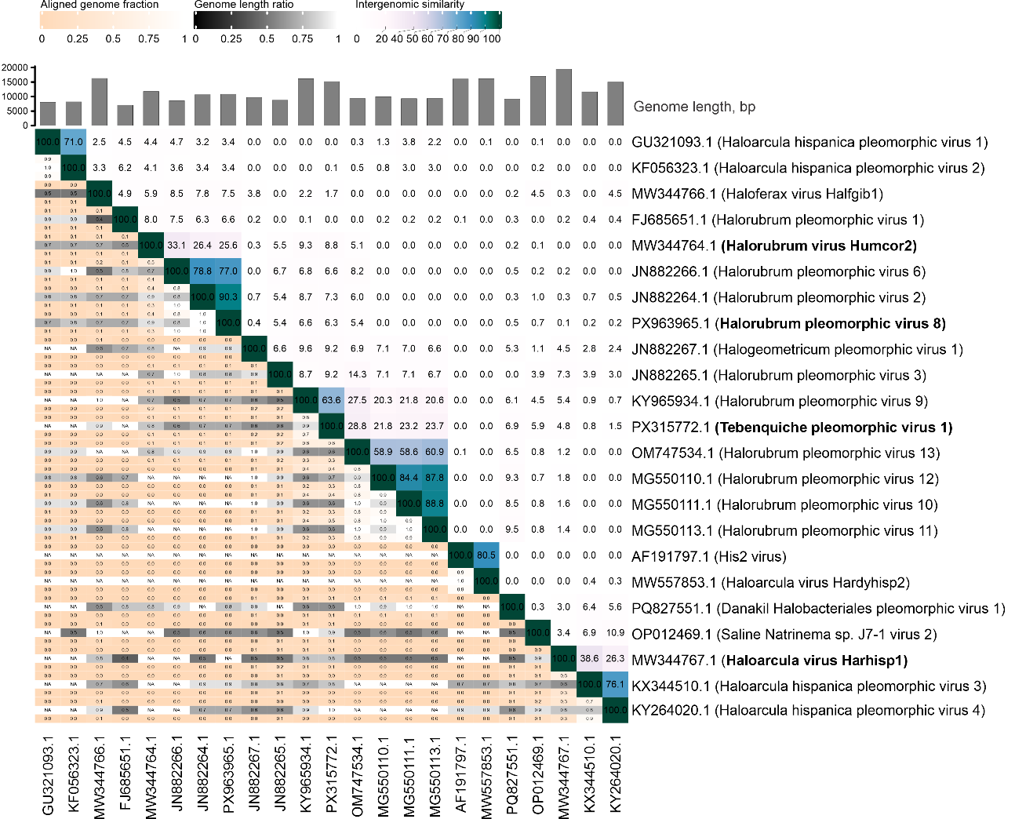

Figure 1. Intergenomic similarities of the members of Pleolipoviridae, as output from the VIRIDIC webserver (Moraru et al., 2020). Virus names are shown on the right. The four viruses considered in the current proposal are highlighted in bold. GenBank accession numbers are given at the lower edge. Genome length, and keys for aligned genome fraction, genome length ratio and intergenomic similarity are shown on the top of the figure.
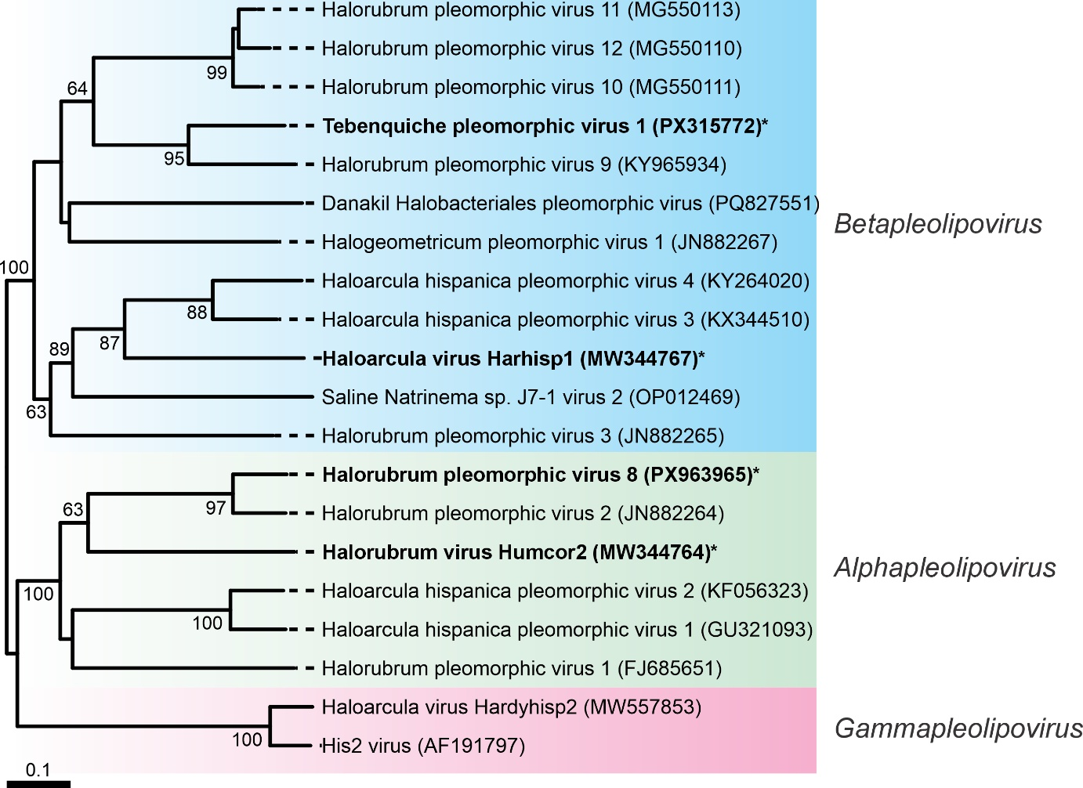

Figure 2. The unrooted phylogenomic tree of pleolipovirids based on the whole genome comparisons at the amino acid level was constructed using VICTOR (Meier-Kolthoff and Göker 2017). The branch lengths are scaled in terms of the Genome BLAST Distance Phylogeny (GBDP) distance formula D6. The numbers at the nodes denote bootstrap support values.

