

The International Committee on Taxonomy of Viruses
Taxonomy Proposal Form, 2026
Part 1a: Details of taxonomy proposals

Title: | Create 1 new species in the genus Orthoreovirus (Reovirales: Spinareoviridae)
Code assigned: | 2026.014M

Author(s), affiliation and email address(es):
Given name (+middle initial(s)) | Surname | Affiliation | Email address | Corr. author(s)
Mathew A M | Fisher | Canadian Food Inspection Agency, National Centre for Foreign Animal Disease, Winnipeg, Canada | mathew.fisher@inspection.gc.ca
Justin P | Hawkins | Canadian Food Inspection Agency, National Centre for Foreign Animal Disease, Winnipeg, Canada | Justin.Hawkins@inspection.gc.ca
Ole | Nielsen | Department of Fisheries and Oceans Canada, Winnipeg, Canada | Ole.Nielsen@dfo-mpo.gc.ca | X
Kathy A | Burek Huntington | Alaska Veterinary Pathology, Eagle River, Alaska, USA | avps.kbh@gmail.com
Natalie M | Rouse | Alaska Veterinary Pathology, Eagle River, Alaska, USA | avps.natalierouse@gmail.com
Vsevolod L | Popov | Institute for Human Infections and Immunity, The University of Texas Medical Branch, Galveston, USA | vpopov@utmb.edu
Oliver | Lung | Canadian Food Inspection Agency, National Centre for Foreign Animal Disease, Winnipeg, Canada | Oliver.Lung@inspection.gc.ca | X

Part 1b: Taxonomy Proposal Submission
ICTV Subcommittee:
Animal DNA Viruses and Retroviruses |  | Bacterial viruses
Animal minus-strand and dsRNA viruses | X | Fungal and protist viruses
Animal positive-strand RNA viruses |  | Plant viruses
Archaeal viruses |  | General -

List the ICTV Study Group(s) that have seen or have been involved in creating this proposal:
Sedoreoviridae Study Group

Optional – complete only if formally voted on by an ICTV Study Group:
Study Group | Number of members
Study Group | Votes in support | Votes against | No vote

Submission date: | 15/09/2026

Part 1c: Feedback from ICTV Executive Committee (EC) meeting
Executive Committee Meeting Decision code: | X
A – Accept
Ac – Accept subject to revision by relevant subcommittee chair. No further vote required
U – Accept without revision but with re-evaluation and email vote by the EC
Uc – Accept subject to revision and re-evaluation and email vote by the EC
Ud – Deferred to the next EC meeting, with an invitation to revise based on EC comments
J - Reject
W - Withdrawn

Comments from the Executive Committee:

Part 1d: Revised Taxonomy Proposal Submission
Response of proposer:
Revision date:

Part 3: TAXONOMIC PROPOSAL

Taxonomic changes proposed:
Establish new taxon | X | Split taxon
Abolish taxon |  | Merge taxon
Move taxon |  | Promote taxon
Rename taxon |  | Demote taxon
Move and rename

Etymology (origin) of proposed taxonomic names:
Taxon name | Etymology of the term
Orthoreovirus marinarum | The first word is the genus and the second word is from the Latin word meaning connected to the sea.

Permission for use of names derived from a living person
Taxon name | Full name of person from whom the name is derived | Attached
NONE

Abstract of Taxonomy Proposal:

Description of current taxonomy:
Currently, the Orthoreovirus genus comprises 10 species, and its members infect only vertebrate hosts.

Proposed taxonomic change(s):
We propose the creation of a new species in the Orthoreovirus genus (Reovirales: Spinareoviridae) based on the sequencing of two recent phocid orthoreovirus 1 (PhRV1) isolates from marine mammals. We suggest the name “Orthoreovirus marinarum” in line with the new binomial species naming guidelines.

Demarcation criteria for new taxon/taxa:
“Orthoreovirus marinarum” complies with the following species demarcation criteria within the genus Orthoreovirus:
- Extensive sequence identity between the proteins encoded by homologous genome segments (for most conserved core proteins, >85% amino acid sequence identity within a species versus <65% identity between species; for most of the more divergent outer capsid proteins, >55% identity within a species and <35% between species). Viruses of the ten species of orthoreovirus represent evolutionarily distinct lineages, as illustrated by phylogenetic analysis using the amino acid sequences of the outer-clamp protein, for which the greatest number of sequences from diverse isolates is available.
- Extensive sequence identity between homologous genome segments (for most genome segments, >75% nucleotide sequence identity within a species versus <60% between species).
- Identification of host species and disease signs

Justification:
The assembled PhRV1 genomes meet the demarcation criteria for the creation of a new species, based on the evidence outlined in this proposal.

Text of Taxonomy proposal
Description of current taxonomy:
Currently, the Orthoreovirus genus comprises 10 species, and its members infect only vertebrate hosts.

Proposed taxonomic change(s):
We propose the creation of a new species in the Orthoreovirus genus (Reovirales: Spinareoviridae) based on two complete genomes from recently sequenced viral isolates identified in marine mammals; phocid orthoreovirus 1 (PhRV1) strain PhRV1/Phoca vitulina/USA/2007-2008, isolated from a harbor seal (GenBank accessions MN820529-MN820538, as described in a previous publication [1]) and PhRV1 strain PhRV1/Enhydra lutris/USA/2015/EL1562, isolated from a sea otter (GenBank accessions PV591111- PV591120, as described in a previous publication [2]). We suggest the name “Orthoreovirus marinarum” in line with the new binomial species naming guidelines.

Demarcation criteria for new taxon/taxa:
“Orthoreovirus marinarum” complies with the following species demarcation criteria within the genus Orthoreovirus:
- Extensive sequence identity between the proteins encoded by homologous genome segments (for most conserved core proteins, >85% amino acid sequence identity within a species versus <65% identity between species; for most of the more divergent outer capsid proteins, >55% identity within a species and <35% between species). orthoreovirus species of represent evolutionarily distinct lineages, as illustrated by phylogenetic analysis using the amino acid sequences of the outer-clamp protein, for which the greatest number of sequences from diverse isolates is available.
- Extensive sequence identity between homologous genome segments (for most genome segments, >75% nucleotide sequence identity within a species versus <60% between species).
- Identification of host species and disease signs.

Justification:
The assembled PhRV1 genomes have the typical Orthoreovirus structure with ten genome segments: three long (L1-L3; ~3.8-3.9 kbp) encoding λ proteins, three medium (M1-M3; ~2.2-2.3 kbp) encoding µ proteins, and four short (S1-S4; 0.9-1.6 kbp) encoding σ proteins (Figure 1). The PhRV1 isolates outlined here satisfy ICTV species demarcation criteria based on the following evidence:

Amino acid sequence identity
A BLASTN homology search of PhRV1 strain PhRV1/Phoca vitulina/USA/2007-2008 (GenBank accessions MN820529-MN820538) was used to identify the closest matches (excluding the other PhRV1 sequence) for each of the ten segments individually. Segment S1 generated no BLASTN matches for both isolates; therefore, we used a BLASTX search to identify the closest matches. Subsequent pairwise alignments showed amino acid identities ranging from 22.7% to 75.8% (Table 1). A similar analysis of PhRV1 strain PhRV1/Enhydra lutris/USA/2015/EL1562 (GenBank accessions PV591111- PV591120) showed amino acid identity values ranging from 26.2% to 76.1% (Table 1).

Based on the pairwise alignment results described above, both PhRV1 isolates showed identical trends in terms of which proteins fell below ICTV amino acid identity cut-off values for species demarcation. Of the five core proteins, three (λ2, μ2, σ2) had amino acid identity values below the 65% cutoff designated for a new species. The two remaining core proteins (λ1, λ3) were below the 85% cut-off designated for members of the same species.

For the outer capsid proteins, 1 protein (σ1) was below the 35% cut-off for species demarcation, 1 protein (μ1) was above the 55% cut-off for members of the same species, and 1 protein (σ3) had an amino acid identity falling between the two cut-off values. The σ1 proteins had identity values of 22.7% and 26.2%, μ1 had 58.4% and 58.6%, and σ3 had 39.9% and 40.2% for the Phoca vitulina and Enhydra lutris-derived isolates, respectively. Of all the proteins, σ1 showed the lowest degree of amino acid identity to the closest publicly available hit from NCBI.

To assess amino acid identity between the two PhRV1 isolates, we performed pairwise alignment of all ten segments, resulting in identity values ranging from 34.3% to 99.3%. The σ1 gene showed the lowest degree of identity, with only 34.3% amino acid identity. All other segments showed ≥79.9% amino acid identity, indicating that these two isolates are likely members of the proposed new species based on current criteria.

Phylogenetic analysis of outer clamp protein (σ3) amino acid sequence
Phylogenetic analysis of the outer clamp protein (σ3) amino acid sequences described in a previous publication [2]. Based on this analysis, the PhRV1 sequences formed a distinct monophyletic clade, separate from the established mammalian orthoreoviruses (Figure 2).

Nucleotide sequence identity
A BLASTN homology search of PhRV1 strain PhRV1/Phoca vitulina/USA/2007-2008 was used to identify the closest matches (excluding the other PhRV1 sequence) for each of the ten segments individually. Segment S1 generated no BLASTN matches for both isolates; therefore, a BLASTX search was used to identify the closest matches. Subsequent pairwise alignments showed nucleotide identities ranging from 39.4% to 68.9% (Table 1). A similar analysis performed on PhRV1 strain PhRV1/Enhydra lutris/USA/2015/EL1562 showed nucleotide identity values ranging from 41.1% to 69.1% (Table 1).

Based on the pairwise alignment results described above, both PhRV1 isolates showed identical trends in terms of which proteins fell below ICTV nucleotide identity cut-off values for species demarcation. Of the ten total segments, seven were below the 60% nucleotide identity cut-off for species demarcation. The L2 proteins had identity values of 53.8% and 54.4%, M1 had 42.6% and 44.2%, M2 had 58.1% and 57.8%, M3 had 54.4% and 53.5%, S1 had 39.4% and 41.1%, S3 had 56.4% and 55.0%, and S4 had 50.4% and 51.4% % for the Phoca vitulina and Enhydra lutris-derived isolates, respectively. The remaining three segments had nucleotide identity values above the cut-off for new species but below the 75% pairwise nucleotide identity cut-off listed for members of the same species. The L1 protein had identity values of 66.3% and 65.9%, L3 had 68.9% and 69.1%, and S2 had 61.3% and 61.6%, for the Phoca vitulina and Enhydra lutris-derived isolates, respectively.

Unique ecological niche as evidenced by differences in hosts
The isolation of these orthoreoviruses from hosts representing a distinct marine ecological niche, relative to those previously described, further supports their classification as a new species.

References:
[1] Nielsen, O., Rodrigues, T. C. S., Popov, V. L., Subramaniam, K., Waltzek, T. B., Lambourn, D. M., & Raverty, S. (2021). A novel orthoreovirus isolated from dead stranded harbor seals from Puget Sound, Washington State, United States. Frontiers in Marine Science, 8, Article 676725. https://doi.org/10.3389/fmars.2021.676725

[2] Hawkins, J. P., Anthony, S., Nielsen, O., Burek Huntington, K. A., Rouse, N. M., Popov, V. L., & Lung, O. (2026). Isolation and phylogenomic characterization of two novel, dissimilar orthoreoviruses from Northern Alaskan Sea otters (Enhydra lutris kenyoni). Scientific reports, 16(1), 3511. https://doi.org/10.1038/s41598-025-33400-0

Accompanying files:
Filename | Description of contents

Tables, Figures:

Table 1.
Pairwise identity values compared to the top BLAST hit for each segment in each of the isolates described. Species demarcation guidelines for each segment are listed with highlight as indicated below to indicate whether values fall above or below the various cut-offs. The S1 segment containing the σ1 protein is the most divergent of all segments or proteins and is underlined and highlighted in yellow for emphasis.

Core Proteins
Cut-off Criteria (nucleotide): >75% identity within a species (gray highlighting)
<60% identity between species (green highlighting)
Cut-off Criteria (amino acid): >85% identity within a species (gray highlighting)
<65% identity between species (green highlighting)

 |  | Harbor Seal (Phoca vitulina)  (Accessions MN820529-MN820538) |  |  | Sea Otter (Enhydra lutris)  (Accessions PV591111- PV591120)
Segment | Protein | Top BLAST hit (Accession) | nt %ID | aa %ID | Top BLAST hit (Accession) | nt %ID | aa %ID
L1 | λ3 | LC482238.1 | 66.3% | 72.1% | MW652775.1 | 65.9% | 71.7%
L2 | λ2 | OR074543.1 | 53.8% | 50.1% | KM087106.1 | 54.4% | 51.9%
L3 | λ1 | PQ442202.1 | 68.9% | 75.8% | PQ442202.1 | 69.1% | 76.1%
M1 | μ2 | MN233059.1 | 42.6% | 35.4% | MN233059.1 | 44.2% | 42.2%
S2 | σ2 | L19775.1 | 61.3% | 64.2% | DQ664190.1 | 61.6% | 63.7%
Outer Capsid Proteins
Cut-off Criteria (nucleotide): >75% identity within a species (gray highlighting)
<60% identity between species (green highlighting)
Cut-off Criteria (amino acid): >55% identity within a species (gray highlighting)
<35% identity between species (green highlighting)

 |  | Harbor Seal (Phoca vitulina)  (Accessions MN820529-MN820538) |  |  | Sea Otter (Enhydra lutris)  (Accessions PV591111- PV591120)
Segment | Protein | Top BLAST hit (Accession) | nt %ID | aa %ID | Top BLAST hit (Accession) | nt %ID | aa %ID
M2 | μ1 | JX204742.1 | 58.1% | 58.4% | MN233052.1 | 57.8% | 58.6%
S1 | σ1 | MW929752.1 | 39.4% | 22.7% | PV855989.1 | 41.1% | 26.2%
S4 | σ3 | JX486066.1 | 50.4% | 39.9% | JX486066.1 | 51.4% | 40.2%
Other Proteins
Cut-off Criteria (nucleotide): >75% identity within a species (gray highlighting)
<60% identity between species (green highlighting)
Cut-off Criteria (amino acid): n/a

 |  | Harbor Seal (Phoca vitulina)  (Accessions MN820529-MN820538) |  |  | Sea Otter (Enhydra lutris)  (Accessions PV591111- PV591120)
Segment | Protein | Top BLAST hit (Accession) | nt %ID | aa %ID | Top BLAST hit (Accession) | nt %ID | aa %ID
M3 | μNS | MT151669.1 | 54.4% | 50.5% | OP963629.1 | 53.5% | 50.4%
S3 | σNS | PZ005674.1 | 56.4% | 50.8% | PQ768063.1 | 55.0% | 51.4%

Figure 1.
Genome organization and segment configuration of sea otter Orthoreovirus. The line graph above each segment represents sequencing fold coverage in the area of the corresponding gene segment in log(10) scale. The scale bar at the bottom represent the total length of nucleotides present for each segment. Arrows indicate sequence within the predicted coding sequence present in each segment, while black lines indicate any potential sequence within 5’ and 3’ non-coding regions.

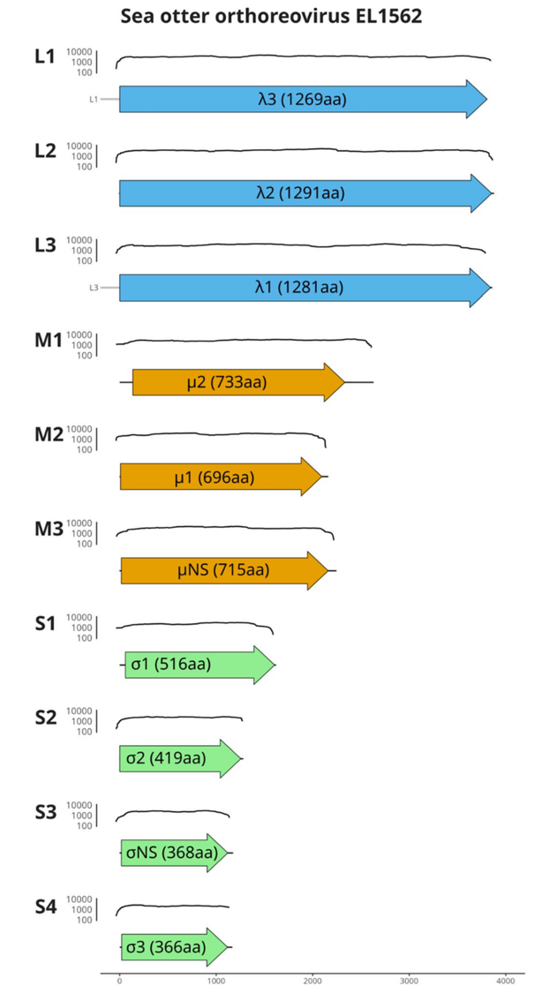

Figure 2.
Phylogenetic typing of σ3 amino acid sequences from sea otter isolates. Maximum likelihood phylogenetic tree of representative strains from representative orthoreovirus species. The tree was constructed based on the amino acid sequence alignment of the outer clamp protein for each indicated strain. Novel sequences belonging to the proposed new species are indicated in bold with yellow highlights. Phylogenetic analysis was performed using IQ-TREE and visualized with iTOL, using piscine orthoreovirus NOR2012 V3621 as the outgroup. The scale bar represents the estimated average number of aa substitutions per site. GenBank accessions numbers for each sequence used are indicated.
