

The International Committee on Taxonomy of Viruses
Taxonomy Proposal Form, 2026

Part 1a: Details of taxonomy proposals

Title: | Create two new genera and eight new species in the family Phenuiviridae
Code assigned: | 2026.011M

Author(s), affiliation and email address(es):
Given name (+middle initial(s)) | Surname | Affiliation | Email address | Corr. author(s)
Yutaro | Neriya | School of Agriculture, Utsunomiya University, Utsunomiya, Japan | neriya@a.utsunomiya-u.ac.jp
Thomas | Briese | Center for Infection and Immunity, and Department of Epidemiology, Columbia University, New York, USA | thomas.briese@columbia.edu
Cécile | Desbiez | Pathologie Végétale, INRAE, Montfavet, France | cecile.desbiez@inrae.fr
Francesco | Di Serio | Institute for Sustainable Plant Protection-CNR, Torino, Italy | francesco.diserio@ cnr.it
Jens H. | Kuhn | Frederick, Maryland, USA | jenshkuhn@comcast.net
Dimitre | Mollov | USDA-APHIS, Plant Protection and Quarantine, Riverdale, Maryland, USA | dimitre.mollov@ars.usda.gov
Jin-Won | Song | Department of Microbiology, Korea University, Seoul, Republic of Korea | jwsong@korea.ac.kr
Massimo | Turina | Institute for Sustainable Plant Protection-CNR, Torino, Italy | massimo.turina@cnr.it
Gustavo | Palacios | Department of Microbiology, Icahn School of Medicine at Mount Sinai, New York, USA | gustavo.palacios@mssm.edu
Takahide | Sasaya | Bio-oriented Technology Research Advancement Institution, NARO, Kawasaki, Japan | sasaya.takahide907@naro.go.jp | X

Part 1b: Taxonomy Proposal Submission
ICTV Subcommittee:
Animal DNA Viruses and Retroviruses |  | Bacterial viruses
Animal minus-strand and dsRNA viruses | X | Fungal and protist viruses
Animal positive-strand RNA viruses |  | Plant viruses
Archaeal viruses |  | General -

List the ICTV Study Group(s) that have seen or have been involved in creating this proposal:
ICTV Phenuiviridae Study Group
Optional – complete only if formally voted on by an ICTV Study Group:
Study Group | Number of members
Study Group | Votes in support | Votes against | No vote
ICTV Phenuiviridae Study Group | 10 | 0 | 0

Submission date: | 26/09/2026

Part 1c: Feedback from ICTV Executive Committee (EC) meeting
Executive Committee Meeting Decision code: | X
A – Accept
Ac – Accept subject to revision by relevant subcommittee chair. No further vote required
U – Accept without revision but with re-evaluation and email vote by the EC
Uc – Accept subject to revision and re-evaluation and email vote by the EC
Ud – Deferred to the next EC meeting, with an invitation to revise based on EC comments
J - Reject
W - Withdrawn

Comments from the Executive Committee:

Part 1d: Revised Taxonomy Proposal Submission
Response of proposer:
Revision date:

Part 3: TAXONOMIC PROPOSAL

Taxonomic changes proposed:
Establish new taxon | X | Split taxon
Abolish taxon |  | Merge taxon
Move taxon |  | Promote taxon
Rename taxon |  | Demote taxon
Move and rename

Etymology (origin) of proposed taxonomic names:
Taxon name | Etymology of the term
Cotylvirus | Named after Kotyle, the Greek word for cup/socket, referencing to ventral sucker of trematodes
Cotylvirus beihaiense | Named after 北海市 [Bĕihăi], China
Cotylvirus japonicum | Named after the host Schistosoma japonicum
Cotylvirus schistojap | Named after the host Schistosoma japonicum
Cotylvirus orientalis | Named after the host Metorchis orientalis
Cotylvirus pseudoglobulus | Named after the host Sphaeridiotrema pseudoglobulus
Tasokuvirus | Named after the Japanese word “多足 [tasoku]”, meaning “myriapods”
Tasokuvirus beihaiens | Named after 北海市 [Bĕihăi], China
Tasokuvirus wuhanense | Named after 武漢市 [Wǔhàn], China

Permission for use of names derived from a living person:
Taxon name | Full name of person from whom the name is derived | Attached
NA | NA

Abstract of Taxonomy Proposal:
Taxonomic rank(s) affected:
Genus and species in the family Phenuiviridae.

Description of current taxonomy:
The family Phenuiviridae currently includes 24 genera and 223 species.

Proposed taxonomic change(s):
Create two new genera “Cotylvirus” and “Tasokuvirus,” including eight new species for phenuivirids detected in flatworms and myriapods.

Justification:
The eight viruses create a well-supported monophyletic clade separated phylogenetically from other existing genera within the family Phenuiviridae.

Text of Taxonomy proposal:
Taxonomic rank(s) affected:
Genus and species in the family Phenuiviridae

Description of current taxonomy:
The family Phenuiviridae (Negarnaviricota: Polyploviricotina: Bunyaviricetes: Hareavirales: Phenuiviridae) harbors viruses with 2–8 segments of negative-sense or ambisense RNA. Phenuivirids infect animals including livestock and humans, birds, and arthropods as well as plants or fungi that serve as single hosts or act as biological vectors for transmission to animals or plants. The family currently includes 24 genera and 223 species for 242 viruses [1].

Proposed taxonomic change(s):
Create two new genera “Cotylvirus” and “Tasokuvirus”, and eight new species in the family Phenuiviridae.

Five viruses were described in high-throughput sequencing or sequence read archive data of flatworms. The virus Bĕihăi bunya-like virus 2 (BBLV2) was detected in the razor shell (Ensis minor (Chenu, 1843)], collected in北海市 [Bĕihăi], 广西壮族自治区 [Guǎngxī Zhuàng Autonomous Region], China [2]. Húběi blood fluke virus 1 (HBFV1) and Húběi blood fluke virus 2 (HBFV2) were detected in the blood flukes (Schistosoma spp.), collected in湖北省 [Húběi Province], China [2]. Metorchi phenuili virus (MPLV) and Sphaeridio phenuili virus (SPLV) were discovered in the sequence read archive data of flatworms (Metorchis orientalis Tanabe, 1920 and Sphaeridiotrema pseudoglobulus McLaughlin, Scott & Huffman, 1993) [3].
Three viruses were described in high-throughput sequencing of myriapods. The virus Bĕihăi bunya-like virus 1 (BBLV1) was detected in the woodlice (Oniscidea spp.), collected in北海市 [Bĕihăi], 广西壮族自治区 [Guǎngxī Zhuàng Autonomous Region], China [2]. Wǔhàn insect virus 1 (WhIV1) and Wǔhàn millipede virus 1 (WhMV1) were detected in the isopods (Asellus spp.) and millipedes (Polydesmidae spp.), collected in武漢市 [Wǔhàn], 湖北省 [Húběi Province], China, respectively [2, 4].
These viruses were shown to be distantly related to currently classified phenuivirids and belong to new genera within the family Phenuiviridae. We propose the creation of the two new genera “Cotylvirus” and “Tasokuvirus” to accommodate the new viruses, and the assignment of BBLV2 to the species “Cotylvirus beihaiense,” HBFV1 to the species “Cotylvirus japonicum,” HBFV2 to the species “Cotylvirus schistojap,” MPLV to the species “Cotylvirus orientalis,” SPLV to the species “Cotylvirus pseudoglobulus.” BBLV1 to the species “Tasokuvirus beihaiense,”” and WhMV1 to the species “Tasokuvirus wuhanense.”

Demarcation criteria for new taxon/taxa:
Species demarcation across all genera of the family Phenuiviridae relies on the phylogenetic relationship of the large protein (L) encoded by the phenuivirid large (L) segment, with <95% identity of the amino acid sequence marking the threshold for new species [1].

Justification:
Phenuivirid genomes are generally composed of three canonical segments, designated Large (L), Medium (M), and Small (S), and have at least three genes encoding structural proteins: L protein, glycoprotein, and nucleocapsid. However, several phenuivirid genomes lack the M segment and the gene encoding glycoprotein. The viruses assigned to the newly proposed genera “Cotylvirus” and “Tasokuvirus” possess bipartite genomes encoding only the L protein and nucleocapsid protein, similar to the viruses assigned to the genus Ixovirus. The eight new viruses are phylogenetically separate from current phenuivirid genera (Figure). These eight new viruses share less than 95% amino acid identity in the L protein (Table), indicating that they represent eight distinct novel species.
References:
- Sasaya T, Palacios G, Briese T, Di Serio F, Groschup M.H, Neriya Y, Song J-W, Tomitaka Y (2023). ICTV Virus Taxonomy Profile: Phenuiviridae 2023. J Gen Virol 104(9):001893. PMID: 37702592 DOI: 10.1099/jgv.0.001893
- Shi M, Lin XD, Tian JH, Chen LJ, Chen X, Li CX, Qin XC, Li J, Cao JP, Eden JS, Buchmann J, Wang W, Xu J, Holmes EC, Zhang YZ (2016). Redefining the invertebrate RNA virosphere. Nature 22;540(7634):539-543.PMID: 27880757. DOI: 10.1038/nature20167.
- Dheilly NM, Lucas P, Blanchard Y, Rosario K (2022). A world of viruses nested within parasites: Unravelingviral diversity within parasitic flatworms (Platyhelminthes). Microbiol Spectr10(3): e0013822. PMID: 35536058. PMCID: PMC9241645. DOI: 10.1128/spectrum.00138-22.
- Li CX, Shi M, Tian JH, Lin XD, Kang YJ, Chen LJ, Qin XC, Xu J, Holmes EC, Zhang YZ (2015). Unprecedented genomic diversity of RNA viruses in arthropods reveals the ancestry of negative-sense RNA viruses. Elife 4: e05378. PMID: 25633976. PMCID: PMC4384744. DOI: 10.7554/eLife.05378.

Accompanying files:
Filename | Description of contents

Tables, Figures:
<Start here>
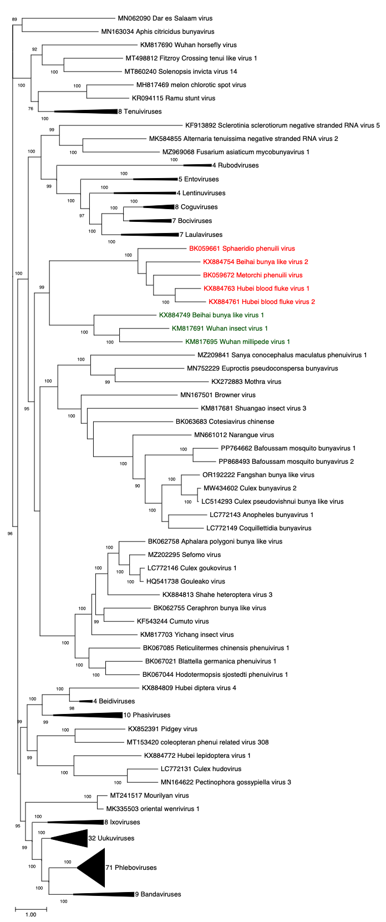
Figure. Maximum likelihood phylogenetic tree of the amino acid sequences of the L protein between the viruses proposed to be classified, and the members of the genera “Cotylvirus” (red colored) and “Tasokuvirus” (green colored). GENETYX-MAC v22.0.5 was used to align the sequences. Phylogenetic trees were constructed using FastTree with the WAG model and gamma-distributed rate variation. Node support was assessed using SH-like local support values. For all taxa shown here, the complete genome or complete coding sequence is available at the GenBank nucleotide sequence database. Accession numbers are shown next to the respective virus.

Table. Highest amino acid sequence identity of the L protein between the proposed virus and viruses assigned to the corresponding genus. Sequences were aligned with MUSCLE and the pairwise p-distance was calculated in MEGA 12.

Proposed virus | Most closely related virus | Dist | % Identity
KX884754_Bĕihăi bunya-like virus 2 | KX884763_Húběi blood fluke virus 1 | 0.564 | 43.6
KX884763_Húběi blood fluke virus 1 | KX884761_Húběi blood fluke virus 2 | 0.426 | 57.4
KX884761_Húběi blood fluke virus 2 | KX884763_Húběi blood fluke virus 1 | 0.426 | 57.4
BK059672_Metorchi phenuili virus | KX884761_Húběi blood fluke virus 2 | 0.558 | 44.2
BK059661_Sphaeridio phenuili virus | BK059672_Metorchi phenuili virus | 0.567 | 43.3
KX884749_Bĕihăi bunya-like virus 1 | KM817695_Wǔhàn millipede virus 1 | 0.648 | 35.2
KM817691_Wǔhàn insect virus 1 | KM817695_Wǔhàn millipede virus 1 | 0.594 | 40.6
KM817695_Wǔhàn millipede virus 1 | KM817691_Wǔhàn insect virus 1 | 0.594 | 40.6

