

The International Committee on Taxonomy of Viruses
Taxonomy Proposal Form, 2026
Part 1a: Details of taxonomy proposals

Title: | Create one new species in the genus Mammarenavirus (Hareavirales: Arenaviridae]
Code assigned: | 2026.009M

Author(s), affiliation and email address(es):
Given name (+middle initial(s)) | Surname | Affiliation | Email address | Corr. author(s)
Barbara | Di Martino | Department of Veterinary Medicine, Università degli Studi di Teramo, Località Piano D'Accio 64100 - Teramo, Italy | bdimartino@unite.it | X
Federica | Di Profio | Department of Veterinary Medicine, Università degli Studi di Teramo, Località Piano D'Accio 64100 - Teramo, Italy | fdiprofio@unite.it
Vittorio | Sarchese | Department of Veterinary Medicine, Università degli Studi di Teramo, Località Piano D'Accio 64100 - Teramo, Italy | vsarchese@unite.it
Fulvio | Marsilio | Department of Veterinary Medicine, Università degli Studi di Teramo, Località Piano D'Accio 64100 - Teramo, Italy | fmarsilio@unite.it
Vito | Martella | Department of Veterinary Medicine,  University Aldo Moro of Bari,  S.p. per Casamassima Km3  70010 - Valenzano – Bari, Italy | vito.martella@uniba.it

Part 1b: Taxonomy Proposal Submission
ICTV Subcommittee:
Animal DNA Viruses and Retroviruses |  | Bacterial viruses
Animal minus-strand and dsRNA viruses X |  | Fungal and protist viruses
Animal positive-strand RNA viruses |  | Plant viruses
Archaeal viruses |  | General

List the ICTV Study Group(s) that have seen or have been involved in creating this proposal:
ICTV Arenaviridae Study Group

Optional – complete only if formally voted on by an ICTV Study Group:
Study Group | Number of members
Study Group | Votes in support | Votes against | No vote

Submission date:

Part 1c: Feedback from ICTV Executive Committee (EC) meeting
Executive Committee Meeting Decision code: | X
A – Accept
Ac – Accept subject to revision by relevant subcommittee chair. No further vote required
U – Accept without revision but with re-evaluation and email vote by the EC
Uc – Accept subject to revision and re-evaluation and email vote by the EC
Ud – Deferred to the next EC meeting, with an invitation to revise based on EC comments
J – Reject
W – Withdrawn

Comments from the Executive Committee:

Part 1d: Revised Taxonomy Proposal Submission
Response of proposer:
Revision date:

Part 3: TAXONOMIC PROPOSAL

Taxonomic changes proposed:
Establish new taxon | x | Split taxon
Abolish taxon |  | Merge taxon
Move taxon |  | Promote taxon
Rename taxon |  | Demote taxon
Move and rename

Etymology (origin) of proposed taxonomic names:
Taxon name | Etymology of the term
Mammarenavirus piedmontense | The species epithet derives from the Piedmont region in northwestern Italy, where the virus was first detected.

Permission for use of names derived from a living person:
Taxon name | Full name of person from whom the name is derived | Attached
NONE

Abstract of Taxonomy Proposal:

Description of current taxonomy: The taxonomic rank affected is the following: Hareavirales: Arenaviridae: Mammarenavirus. The genus Mammarenavirus currently comprises more than 59 species.

Proposed taxonomic change(s): Establishment of a new species within the genus Mammarenavirus for the recently discovered arenaviruses identified through the sequencing of mammarenavirus-positive European hedgehogs (Erinaceus europaeus) samples.

Demarcation criteria for new taxon/taxa: the current Mammarenavirus species demarcation thresholds require less than 76% identity in the L RNA segment and less than 80% nucleotide sequence identity in the S RNA segment to other mammarenaviruses, with >12% amino-acid sequence difference in the nucleoprotein (NP).

Justification: Four mammarenavirus strains detected in liver specimens from 4 necropsied European hedgehogs were fully sequenced. On pairwise sequence comparison, the four genomes meet current demarcation species criteria for genus Mammarenavirus. Accordingly, we propose the four arenaviruses described by Di Martino et al. to represent one new virus named “Pedemontis virus (PDMV)” (see below) and to assign it to a new species “Mammarenavirus piedmontense”.

Text of Taxonomy proposal:
Description of current taxonomy: Mammarenaviruses are classified into the genus Mammarenavirus within the family Arenaviridae, comprising more than 59 species along with recently discovered, still unclassified mammarenaviruses.

Proposed taxonomic change(s): Creation of a new species within the genus Mammarenavirus for the recently discovered Erinaceus Europaeus Arenavirus (EEAV). The novel EEAV, described by Di Martino et al. [2], was detected in tissue samples from 6 of 183 (3.3%) European hedgehogs (Erinaceus europaeus) subjected to necropsy in the Piedmont region (Northwestern Italy) between 2018 and 2022. Detection was performed using genus-specific primers designed to amplify a conserved ~390-nucleotide (nt) region of the L gene [3]. Viral RNA was detected in liver (100%, 6/6), intestine (100%, 6/6), brain (100%, 6/6), spleen (100%, 6/6), kidney (100%, 6/6), and lungs (66.7%, 4/6). The complete genomes of four EEAV strains, designated EEAV/676/22/IT (GenBank L segment PP934155, S segment PP934161), EEAV/1277/19/IT (PP934156 and PP934162), EEAV/403/22/IT (PP934157 and PP934159), and EEAV/1175/19/IT (PP934158 and PP934160), were generated from four positive liver samples. Pairwise sequence comparison (PASC) revealed that the four EEAV strains shared 87.8–93.5% nucleotide (nt) identity in the L segment and 81.8–93.9% in the S segment among each other. Additionally, PASC analyses of the L and S segments showed that the EEAV strains were most closely related to Pannonia mammarenavirus (PANV; proposed species Mammarenavirus pannoniaense) [4], Mecsek Mountains virus (MEMV; species Mammarenavirus mecsekense) [5], and Alxa virus (ALXV; species Mammarenavirus alashanense) [6], sharing 65.1–69.0% and 62.5–72.7% pairwise sequence identities, respectively (Tables 1–2). The NP amino acid (aa) identity ranged from 71.0% to 79.2% (Table3). Maximum likelihood phylogenetic analyses of the L and S segments (Figures 1–2) further confirmed that EEAV strains formed a distinct clade, separate from M. mecsekense, M. alashanense, and the proposed M. pannoniaense.

Demarcation criteria for new taxon/taxa: viruses assigned to distinct species within the genus Mammarenavirus must meet the following species demarcation criteria: A) Less than 76% nt sequence identity in the L RNA segment and less than 80% nt sequence identity in the S RNA segment compared to other viruses; B) At least 12% aa sequence divergence in the NP; C) Association with a distinct primary host or group of sympatric hosts; D) Occurrence within a distinct, defined geographical area; and E) A recognized association (or lack thereof) with human disease.

Justification: Based on the species demarcation criteria for the L segment, S segment, and NP, the four EEAV strains described by Di Martino et al. [2] may represent a novel mammarenavirus. This classification is further supported by its distinct association with west European hedgehogs in northwestern Italy. However, the full geographic distribution of EEAV and its potential association with human disease remain to be established (criteria D and E). Due to the discovery of additional, distinct Erinaceus mammarenaviruses (e.g. PANV and MEMV), we propose to refer to EEAV as “Pedemontis virus (PDMV)”, a reference to the place of detection of the virus (Piedmonte, Italy) and the name of the virus given by the discoverers in the associated GenBank record [2]. We propose the name “Mammarenavirus piedmontense” for the species (after the place of discovery) to accommodate PDMV.

References:
- Radoshitzky SR, Buchmeier MJ, Charrel RN, Gonzalez JJ, Günther S, Hepojoki J, et al. ICTV Virus Taxonomy Profile: Arenaviridae 2023. J Gen Virol. 2023;104:001891.
- Di Martino B, Di Profio F, Capucchio MT, Prandi I, Robetto S, Quaranta G, La Rosa G, Suffredini E, Marsilio F, Martella V, et al. Detection and Genomic Characterization of Novel Mammarenavirus in European Hedgehogs, Italy. Emerg. Infect. Dis. 2025;31:155–159.
- Vieth S, Drosten C, Lenz O, Vincent M, Omilabu S, Hass M, et al. RT-PCR assay for detection of Lassa virus and related Old World arenaviruses targeting the L gene. Trans R Soc Trop Med Hyg. 2007;101:1253-64.
- Takáts K, Pankovics P, Balázs B, Boros Á, Mátics R, Reuter G. Novel relatives of Mecsek Mountains mammarenavirus (family Arenaviridae) in hedgehogs living in different sampling areas in Hungary. Sci Rep. 2025;15(1):2907.
- Reuter G, Boros Á, Takáts K, Mátics R, Pankovics P. A novel mammarenavirus (family Arenaviridae) in hedgehogs (Erinaceus roumanicus) in Europe. Arch Virol. 2023;168:174.
- Wu Z, Du J, Lu L, Yang L, Dong J, Sun L, et al. Detection of Hantaviruses and Arenaviruses in three-toed jerboas from the Inner Mongolia Autonomous Region, China. Emerg Microbes Infect. 2018;7:35.
- Kumar S., Stecher G., Suleski M., Sanderford M., Sharma S., and Tamura K. Molecular Evolutionary Genetics Analysis Version 12 for adaptive and green computing. Molecular Biology and Evolution 2024;41:1-9.

Tables, Figures

Table 1. Percentage nucleotide identities of EEAV full length L sequences to other mammarenaviruses using
the plugin MAFFT alignment implemented in Geneious Prime software v. 2025.2.1 (Biomatters Ltd., Auckland, New Zealand)

 | PP934156 EEAV/1277/19IT | PP934155 EEAV/676/  22IT | PP934158 EEAV/1175/19IT | PP934157 EEAV/403/  22IT | PQ441965  PANV/  ER33/2023/  HUN | PQ441961  PANV/  ER15/2023/  HUN | PQ441967 MEMV/  ER39/  2023/  HUN | OP191655 MEMV/  MR1/  2025/  HUN | KY432892  JEAreV Alxa virus
PP934156
EEAV/1277/19IT
PP934155  EEAV/676/22IT | 90.1
PP934158_  EEAV/1175/19IT | 88.5 | 89.0
PP934157  EEAV/403/22/IT | 87.8 | 89.3 | 93.5
PQ441965  PANV/ER33/2023/HUN | 68.3 | 68.9 | 68.4 | 68.1
PQ441961  PANV/ER15/2023/HUN | 68.8 | 69.0 | 68.7 | 68.5 | 93.3
PQ441967  MEMV/ER39/2023/HUN | 68.1 | 68.3 | 67.7 | 67.8 | 68.4 | 68.6
OP191655  MEMV/MR1/2025/HUN | 68.2 | 68.2 | 67.8 | 67.9 | 68.6 | 68.6 | 94.0
KY432892  JEAreV Alxa virus | 64.9 | 65.2 | 64.9 | 65.1 | 64.3 | 64.6 | 64.3 | 64.7
Other mammarenaviruses | <49.6 | <49.5 | <49.0 | <49.4 | <49.2 | <49.4 | <49.0 | <49.1 | <49.5

Table 2. Percentage nucleotide identities of EEAV full length S sequences to other mammarenaviruses using the plugin MAFFT alignment implemented in Geneious Prime software v. 2025.2.1 (Biomatters Ltd., Auckland, New Zealand)
 | PP934162 EEAV/1277/  19IT | PP934161 EEAV/676/  22IT | PP934160 EEAV/1175/  19IT | PP934159  EEAV/403/  22IT | PQ441966  PANV/  ER33/2023/  HUN | PQ441962  PANV/  ER15/2023/  HUN | PQ441968  MEMV/  ER39/  2023/  HUN | OP191656  MEMV/  MR1/  2025/  HUN | KY432893  JEAreV Alxa virus
PP934162
EEAV/1277/19IT
PP934161  EEAV/676/22IT | 82.3
PP934160  EEAV/1175/19IT | 81.9 | 91.9
PP934159  EEAV/403/22/IT | 81.8 | 92.4 | 93.9
PQ441966  PANV/ER33/2023/HUN | 71.3 | 71.6 | 71.9 | 71.7
PQ441962  PANV/ER15/2023/HUN | 71.0 | 71.1 | 71.5 | 71.6 | 84.1
PQ441968  MEMV/ER39/2023/HUN | 72.3 | 72.7 | 72.2 | 72.2 | 74.6 | 74.9
OP191656  MEMV/MR1/2025/HUN | 71.7 | 71.9 | 71.8 | 71.2 | 73.4 | 73.5 | 92.8
KY432893  JEAreV Alxa virus | 62.3 | 62.0 | 62.2 | 62.5 | 59.5 | 60.1 | 62.4 | 62.0
Other mammarenaviruses | <54.0 | <54.0 | <54.0 | <54.0 | <54.0 | <54.0 | <54.0 | <54.0 | <54.0

Table 3. Percentage of NP amino acid identities to other mammarenaviruses using the plugin MAFFT alignment implemented in Geneious Prime software v. 2025.2.1 (Biomatters Ltd., Auckland, New Zealand)
 | PP934162 EEAV/1277/  19IT | PP934161 EEAV/676/  22IT | PP934160 EEAV/1175/  19IT | PP934159  EEAV/403/  22IT | PQ441966  PANV/  ER33/2023/  HUN | PQ441962  PANV/  ER15/2023/  HUN | PQ441968  MEMV/  ER39/  2023/  HUN | OP191656  MEMV/  MR1/  2025/  HUN | KY432893  JEAreV Alxa virus
PP934162
EEAV/1277/19IT
PP934161  EEAV/676/22IT | 88.9
PP934160  EEAV/1175/19IT | 88.8 | 96.5
PP934159  EEAV/403/22/IT | 89.4 | 96.5 | 97.4
PQ441966  PANV/ER33/2023/HUN | 79.2 | 79.5 | 79.3 | 79.8
PQ441962  PANV/ER15/2023/HUN | 79.2 | 79.2 | 79.1 | 79.4 | 93.0
PQ441968  MEMV/ER39/2023/HUN | 77.5 | 79.0 | 78.5 | 78.8 | 87.0 | 86.7
OP191656  MEMV/MR1/2025/HUN | 77.3 | 79.1 | 78.6 | 79.0 | 86.5 | 87.1 | 97.4
KY432893  JEAreV Alxa virus | 71.3 | 71.0 | 71.6 | 71.6 | 70.4 | 70.2 | 70.6 | 71.4
Other mammarenaviruses | <60.0 | <60.0 | <60.0 | <60.0 | <60.0 | <60.0 | <60.0 | <60.0 | <61.0

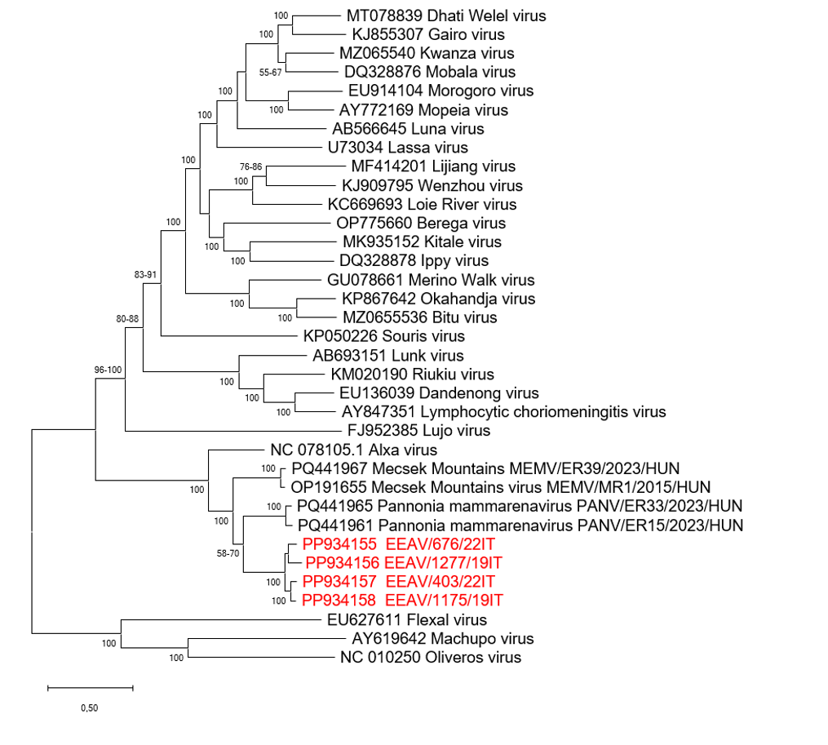
Figure 1: Phylogenetic analysis based on nucleotide sequences of the complete L segments of EEAV strains. Tree was elaborated by using the alignment of the full-length nucleotide L sequences of EEAV strains (in red) and the cognate L sequences of prototype species currently classified within the genus Mammarenavirus. Evolutionary history was inferred by using the Maximum Likelihood method and general time-reversible (GTR) model with a gamma distribution and invariable sites. Initial tree(s) for the heuristic search were selected by choosing the tree with the superior log-likelihood between a Neighbor-Joining NJ tree and a Maximum Parsimony tree. A total of 1,000 bootstrap replicates was used to estimate the robustness of the individual nodes on the phylogenetic tree. Scale bar indicates number of nucleotide substitutions per site. Flexal virus, Machupo virus and Oliveros virus were used as outgroup. Evolutionary analyses were conducted in MEGA12 [7].
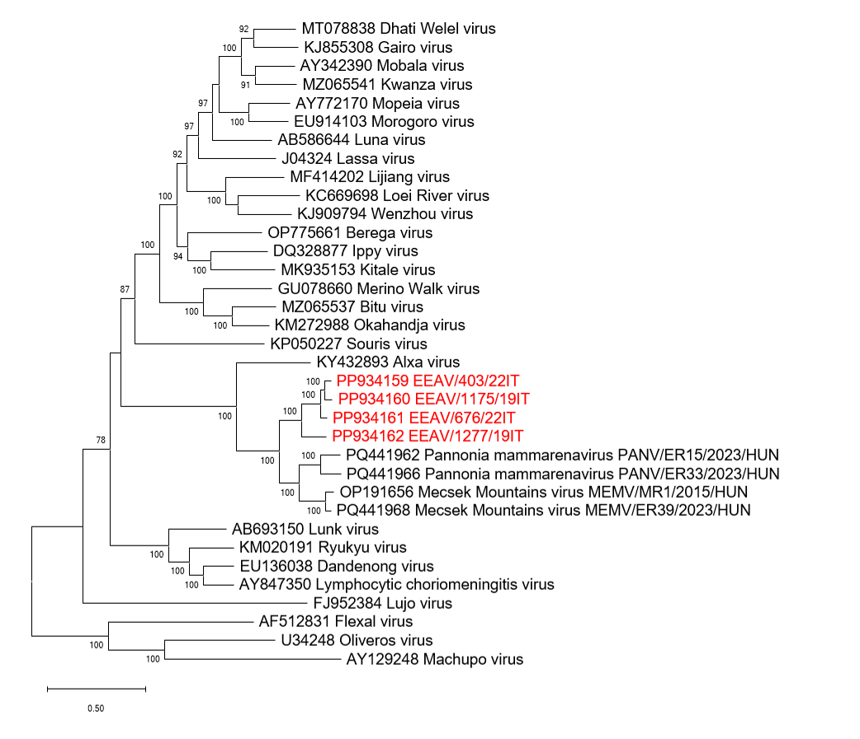Figure 2: Phylogenetic analysis based on nucleotide sequences of the complete S segments of EEAV strains. Tree was elaborated by using the alignment of the full-length nucleotide S sequences of EEAV strains (in red) and the cognate S sequences of prototype species currently classified within the genus Mammarenavirus. Evolutionary history was inferred by using the Maximum Likelihood method and general time-reversible (GTR) model with a gamma distribution and invariable sites. Initial tree(s) for the heuristic search were selected by choosing the tree with the superior log-likelihood between a Neighbor-Joining NJ tree and a Maximum Parsimony tree. A total of 1,000 bootstrap replicates was used to estimate the robustness of the individual nodes on the phylogenetic tree. Scale bar indicates number of nucleotide substitutions per site. Flexal virus, Machupo virus and Oliveros virus were used as outgroup. Evolutionary analyses were conducted in MEGA12 [7].

