

The International Committee on Taxonomy of Viruses
Taxonomy Proposal Form, 2026
Part 1a: Details of taxonomy proposals

Title: | Create one new family, two new genera, and 4 new species in the order Jingchuvirales
Code assigned: | 2026.007M

Author(s), affiliation and email address(es):
Given name (+middle initial(s)) | Surname | Affiliation | Email address | Corr. author(s)
Quan | Liu | Center for Human Immune Defense System Development, Guangdong Laboratory of Traditional Chinese Medicine, Zhuhai, China | liuquan1973@hotmail.com | X
Jun | Zheng | Center for Human Immune Defense System Development, Guangdong Laboratory of Traditional Chinese Medicine, Zhuhai, China | zhengjundk@163.com

Part 1b: Taxonomy Proposal Submission
ICTV Subcommittee
Animal DNA Viruses and Retroviruses |  | Bacterial viruses
Animal minus-strand and dsRNA viruses | X | Fungal and protist viruses
Animal positive-strand RNA viruses |  | Plant viruses
Archaeal viruses |  | General -

List the ICTV Study Group(s) that have seen or have been involved in creating this proposal:
Chuviridae
Optional – complete only if formally voted on by an ICTV Study Group:
Study Group | Number of members
Study Group | Votes in support | Votes against | No vote

Submission date:

Part 1c: Feedback from ICTV Executive Committee (EC) meeting
Executive Committee Meeting Decision code: | X
A – Accept
Ac – Accept subject to revision by relevant subcommittee chair. No further vote required
U – Accept without revision but with re-evaluation and email vote by the EC
Uc – Accept subject to revision and re-evaluation and email vote by the EC
Ud – Deferred to the next EC meeting, with an invitation to revise based on EC comments
J - Reject
W - Withdrawn

Comments from the Executive Committee:

Part 1d: Revised Taxonomy Proposal Submission
Response of proposer:
Revision date:

Part 3: TAXONOMIC PROPOSAL

Taxonomic changes proposed:
Establish new taxon | X | Split taxon
Abolish taxon |  | Merge taxon
Move taxon |  | Promote taxon
Rename taxon |  | Demote taxon
Move and rename

Etymology (origin) of proposed taxonomic names:
Taxon name | Etymology of the term
Brevitavirus | The genus name is derived from the host species name Culicoides brevitarsis, following the naming convention of related genera in the family Chuviridae.
Culicidavirus serrapeladense | The species epithet serrapeladense refers to the sampling location Serra Pelada, Pará state, Brazil, with the suffix -ense denoting geographic origin.
Culicidavirus ouroverdense | The species epithet ouroverdense refers to the sampling location Ouro Verde, Pará state, Brazil, with the suffix -ense denoting geographic origin.
Sarcophiloviridae | The family name is derived from the host genus Sarcophilus (Tasmanian devil, Sarcophilus harrisii), combined with the standard suffix -viridae for virus families.
Sarcophilusvirus | The genus name is derived from the host genus Sarcophilus (Tasmanian devil).
Sarcophilusvirus tasmaniense | The species epithet tasmaniense refers to Tasmania, Australia, the geographic origin of the virus, with the suffix -ense denoting location.

Permission for use of names derived from a living person:
Taxon name | Full name of person from whom the name is derived | Attached
NA | NA

Abstract of Taxonomy Proposal:

The order Jingchuvirales includes five families. Family Chuviridae contains 16 genera, and genus Culicidavirus comprises four approved species.

A new genus Brevitavirus (family Chuviridae) is proposed for Culicoides brevitarsis chu-like virus 1, following the naming convention of related genera. Two new species, Culicidavirus serrapeladense and Culicidavirus ouroverdense, are assigned to the genus Culicidavirus. A new family Sarcophiloviridae (order Jingchuvirales), new genus Sarcophilusvirus, and new species Sarcophilusvirus tasmaniense (TDCV) are also proposed for the highly divergent Tasmanian devil chu-like virus.

Demarcation follows ICTV thresholds for Jingchuvirales: <21% L-protein identity for new family, <31% for new genus, and <90% for new species. Culicoides brevitarsis chu-like virus 1 shows 43.26% L-protein identity to known chuviruses, supporting a new genus Brevitavirus. Serra Pelada and Ouro Verde chu-like viruses share 38.3% RdRP identity with Culicidavirus, placing them in this genus as two new species. Tasmanian devil chu-like virus (TDCV) has only 20% L-protein identity to existing families, justifying a new family Sarcophiloviridae, plus a new genus and species.

A novel chuvirus was identified from Culicoides in Australia, with a complete bipartite genome and conserved chuvirus domains. It shares 43.26% RdRP amino acid identity with the closest relative, above the 31% genus demarcation threshold but below 90% for species, and cannot be assigned to any existing genus, supporting a new genus Brevitavirus.

Two chu-like viruses from Brazilian Psychodidae cluster within Culicidavirus and share 38.3% RdRP identity with Imjin River virus 1, meeting species but not genus demarcation criteria; they are proposed as two new species: Culicidavirus serrapeladense and Culicidavirus ouroverdense.

Tasmanian devil chu-like virus (TDCV) is a highly divergent jingchuvirus from tumor cells of Sarcophilus harrisii, showing only 20% L-protein identity to existing families (≤21% for new family). It forms a distinct monophyletic clade, warranting a new family Sarcophiloviridae, new genus Sarcophilusvirus, and new species Sarcophilusvirus tasmaniense.

Text of Taxonomy proposal
Currently, the order Jingchuvirales comprises five formally recognized families: Aliusviridae, Chuviridae, Crepuscuviridae, Myriaviridae, and Natareviridae. The family Chuviridae encompasses sixteen distinct genera, among which the genus Culicidavirus includes four officially accepted species: Culicidavirus culicis, Culicidavirus culicis, Culicidavirus imjinense, and Culicidavirus quitotaense.

Since Culicoides brevitarsis chu-like virus 1 cannot be formally assigned to any existing genus within the family Chuviridae [1], a novel genus is therefore proposed to accommodate this virus. The new genus “Brevitavirus” is proposed within the family Chuviridae. The genus name derives from the host midge “Culicoides brevitarsis” following the established naming convention adopted by related Chuviridae genera, including Culicidavirus and Doliuvirus.

Serra Pelada Chu-like virus is formally proposed as a new species, designated "Culicidavirus serrapeladense". Ouro Verde Chu-like virus is formally proposed as another distinct new species, designated "Culicidavirus ouroverdense". Both viruses are assigned to the genus Culicidavirus as novel, separate species [2]

It is proposed to establish a new family, Sarcophiloviridae, within the order Jingchuvirales to accommodate the highly divergent virus Tasmanian devil chu-like virus [3]. A new genus and a new species are also proposed under this new family: the new genus is “Sarcophilusvirus”, and the new species is formally designated “Sarcophilusvirus tasmaniense” (previously Tasmanian devil chu-like virus, TDCV).

The demarcation criteria adopt the official thresholds established for the family Chuviridae: <31% amino acid identity of the L protein for new genus delimitation, and <90% identity for new species delimitation. The Culicoides brevitarsis chu-like virus 1 shares 43.26% L-protein amino acid identity with the closest known chu-like virus [1], satisfying the criterion for a new species. Although its identity to Culicidavirus and Doliuvirus is above 31%, the virus exhibits a distinct phylogenetic position, a unique host association with Culicoides brevitarsis, and cannot be assigned to any existing genus [1]. Therefore, we propose the new genus Brevitavirus to accommodate this new viral species according to phylogenetic divergence and host specificity.

Both Serra Pelada Chu-like virus and Ouro Verde Chu-like virus share 38.3% RdRP amino acid identity with Imjin River virus 1, a member of the genus Culicidavirus [2]. This value is above the 31% threshold for establishing a new genus, so both viruses are assigned to the existing genus Culicidavirus. Meanwhile, the identity is well below the 90% criterion for species demarcation, and they form a distinct monophyletic clade in phylogenetic trees [2]. Therefore, each represents a separate novel species within the genus Culicidavirus.

The demarcation criteria follow the thresholds established for the order Jingchuvirales by the International Committee on Taxonomy of Viruses (ICTV). A new family is defined as having ≤ 21% amino acid identity in the conserved L (RdRP) protein relative to all established families in the order. A new genus is indicated by ≤ 31% amino acid identity, and a new species is defined by ≤ 90% amino acid identity in the L protein. Tasmanian devil chu-like virus (TDCV) shares only 20% amino acid identity in the L protein with its closest relatives in existing families of Jingchuvirales [3], meeting the threshold for a new family. TDCV also shows 45% amino acid identity with the related Ciona chu-like virus [3], well below the 90% species cutoff and above the 31% genus cutoff, supporting the establishment of a new genus and a new species within the proposed new family.

As reported by Sharpe et al. [1], specimens of Culicoides spp. were collected overnight in March 2024 during the Australian summer from Casino, New South Wales—a region well known for cattle rearing and beef production. One novel virus belonging to the family Chuviridae was identified, and its full genome was assembled with complete coding sequences and intact untranslated regions (UTRs). Phylogenetic analysis indicated that this virus is most closely related to members of the genera Culicidavirus and Doliuvirus within the Chuviridae (Figure 1) The virus possesses a bipartite genome. CDD domain annotation identified conserved functional domains including the RdRP, mRNA-capping region, glycoprotein, and nucleoprotein, indicating a complete or near-complete genome. Blastp analysis of the RdRP-containing ORF showed the closest homolog to be Turkana Chu-like virus, with 97% query coverage and 43.26% amino acid identity. While the host of Turkana Chu-like virus remains unknown, Culicidavirus is typically associated with Culex mosquitoes, and Doliuvirus has been detected in Culiseta minnesotae. Following the ICTV demarcation criteria for Chuviridae: a L-protein amino acid identity below 31% justifies the establishment of a new genus, and an identity below 90% defines a new species. The newly identified virus shares >31% amino acid identity with both Culicidavirus and Doliuvirus, exceeding the threshold for genus separation, yet satisfies the criterion for a new species. As it cannot be formally assigned to an existing genus, the virus is tentatively designated Culicoides brevitarsis chu-like virus 1 (ENA accession: 3369509).

As reported by Braga et al. [2], two chu-like viral sequences recovered from Psychodidae insects in Brazil are phylogenetically clustered within the monophyletic clade of the genus Culicidavirus (family Chuviridae). Both sequences share 38.3% RdRP amino acid identity with Imjin River virus 1, a recognised member of Culicidavirus (Figure 2). This identity value exceeds the 31% threshold for new genus demarcation defined for Chuviridae, indicating that the two viruses do not warrant the creation of a new genus and should be placed within the existing genus Culicidavirus. In contrast, the amino acid identity is far below the 90% species-level cutoff, satisfying the criteria for establishing two distinct novel species. Each virus exhibits a unique geographical origin, distinct genomic characteristics, and conserved chuvirus protein domains, further supporting their designation as separate new species, herein proposed as Culicidavirus serrapeladense and Culicidavirus ouroverdense.

Tasmanian devil chu-like virus (TDCV) is a highly divergent negative-sense single-stranded RNA virus isolated from facial tumor cells of the endangered Tasmanian devil (Sarcophilus harrisii) [3]. Phylogenetic analyses of the L polymerase, glycoprotein, and nucleoprotein sequences consistently show that TDCV forms a distinct, well-supported monophyletic clade with a tunicate-associated chu-like virus, separate from all established families in the order Jingchuvirales (Figure 3). TDCV exhibits only 20% amino acid identity in the conserved L protein region to members of existing families, satisfying the ICTV criterion of ≤ 21% identity for defining a new virus family in Jingchuvirales. Furthermore, TDCV cannot be assigned to any existing genus or species due to its unique phylogenetic position, distinct mammalian host association, and marked sequence divergence from all known jingchuviruses. Accordingly, we propose the creation of a new family Sarcophiloviridae, a new genus Sarcophilusvirus, and a new species Sarcophilusvirus tasmaniense (formerly Tasmanian devil chu-like virus, TDCV) to formally classify this unique and evolutionarily important virus.

References:
[1] Sharpe SR, Madhav M, Klein MJ, Blasdell KR, Paradkar PN, Lynch SE, Eagles D, López-Denman AJ, Ahmed KA. Characterisation of the virome of Culicoides brevitarsis Kieffer (Diptera: Ceratopogonidae), a vector of bluetongue virus in Australia. J Gen Virol. 2025 Feb; 106(2): 002076. doi: https://doi.org/10.1099/jgv.0.002076.
[2] Braga CM, da Silva SP, Neto JPN, Medeiros DBA, Cruz ACR, Nascimento BLSD, Pinheiro LRS, Martins LC. Viral metagenomics of hematophagous insects collected in the Carajas mining complex, Pará State, Brazil. Acta Trop. 2025 Mar; 263: 107551. doi: ttps://doi.org/10.1016/j.actatropica.2025.107551.
[3] Mélade J, Harvey E, Mahar JE, Grove J, Darby JM, Flies AS, Holmes EC. Isolation of an infectious mammalian chu-like virus from tumor cells of the endangered Tasmanian devil (Sarcophilus harrisii). Curr Biol. 2025 Jul 7;35(13):3278-3285.e5. doi: 10.1016/j.cub.2025.05.070. Epub 2025 Jun 26.

Accompanying files:
Filename | Description of contents

Tables, Figures:

<Start here>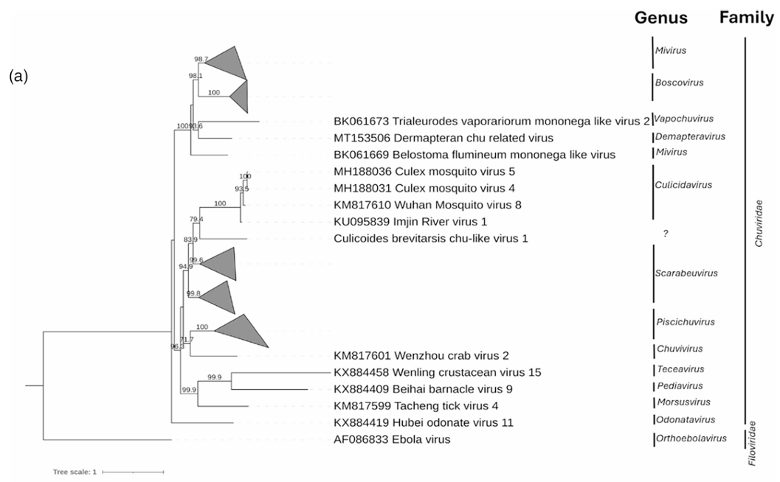Figure 1: Phylogenetic trees for Chuviridae. One novel virus identified in this study belonged to the family Chuviridae and was assembled with both UTRs and a complete coding region. This was found to be closely related to the genera Culicidavirus and Doliuvirus, within the Chuviridae. This virus had >31% amino acid identity to both genera Culicidavirus and Doliuvirus; therefore, it was not formally aligned to a genus, so the virus has been tentatively named Culicoides brevitarsis chu-like virus 1 (Red underline). Maximum likelihood phylogenetic trees based on MAFFT alignments of the conserved RNA-dependent RNA polymerase and RdRP gene region of Chuviridae using the LG+F+I+G4 model. The outgroup is Ebola virus. The support values are presented at the node based on 1000 bootstraps. The scale bars represent the number of amino acid substitutions per site. 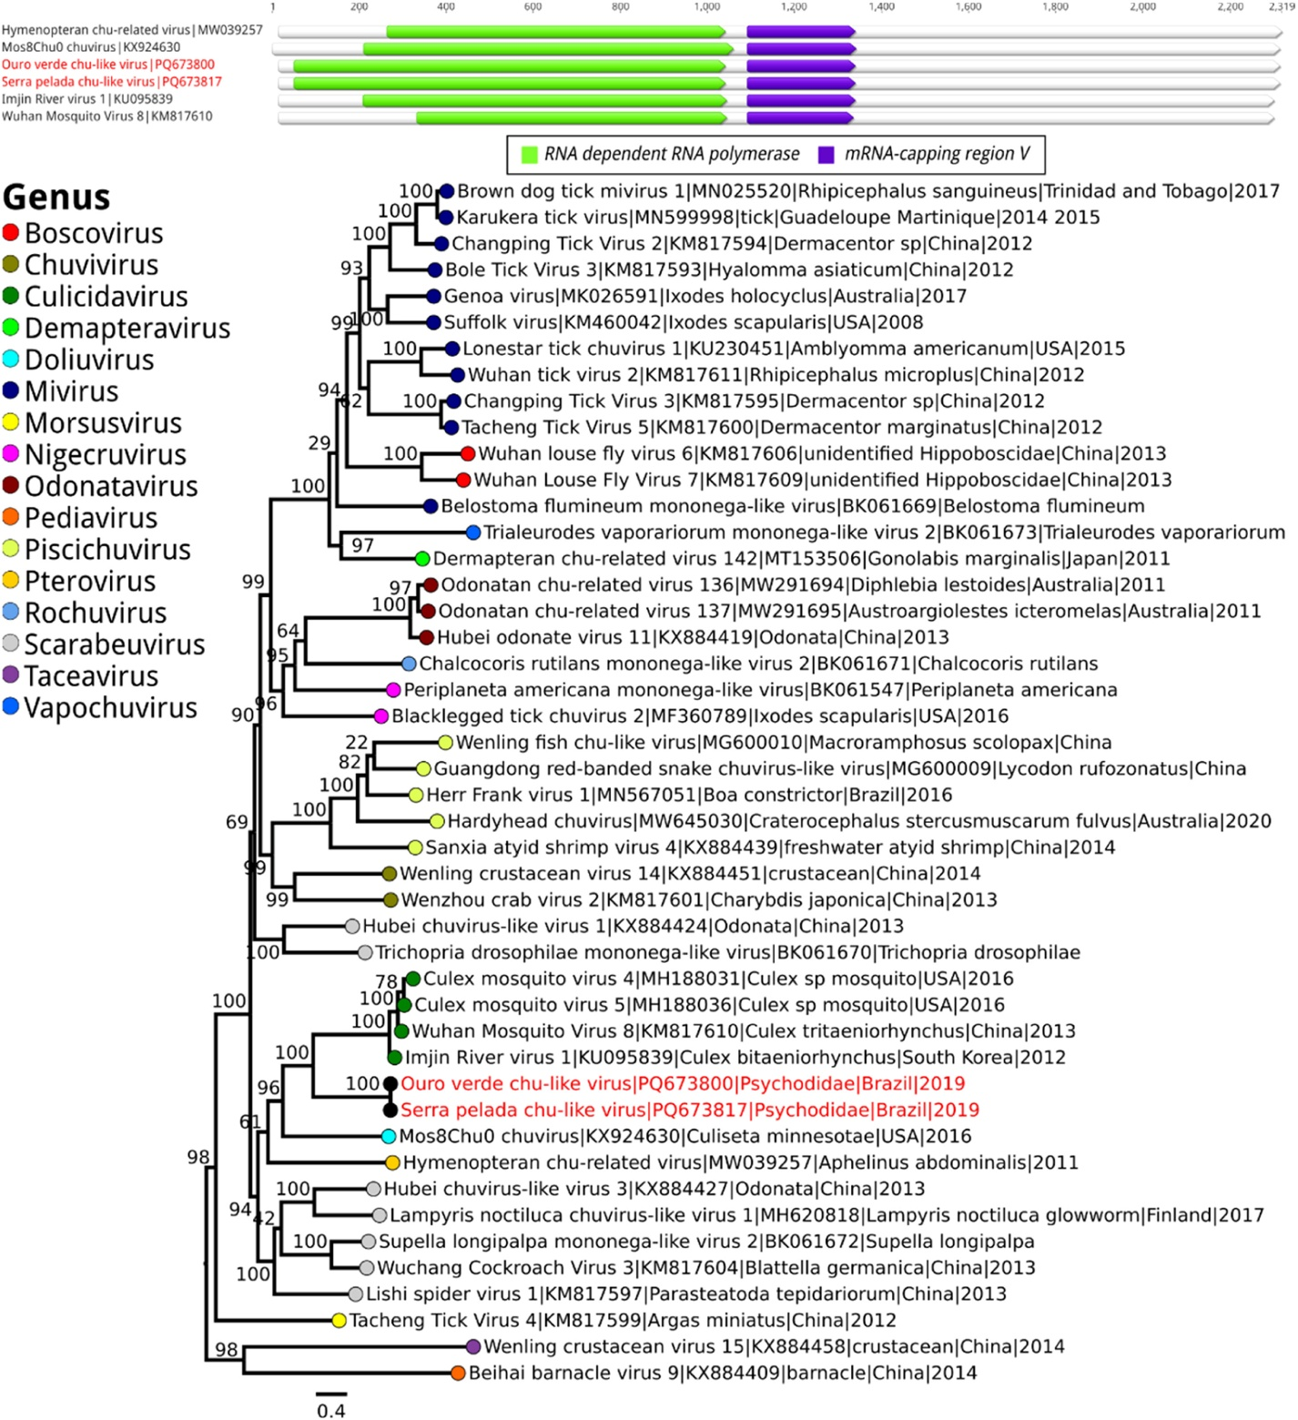
Figure 2: Genomic organization and phylogeny of the Chuviridae family: (A) Domains are shown as colored boxes, with sequence sizes in amino acids. (B) Phylogenetic analysis of RNA polymerase protein sequences used the Maximum Likelihood method (Q.pfam+F+I+R6 model), revealing 90.4 % resolved and 9.6 % unresolved quartets. Genera are color-coded, and bootstrap values (1000 replicates) are shown at major nodes. The scale bar indicates amino acid divergence per site. In the investigation, two sequences closely related to the Chuviridae family were identified. The first, obtained from Psychodidae (AR864930), was named Serra Pelada Chu-like virus (GenBank: PQ673817), with a genome of 11,527 nucleotides. The second sequence, also from Psychodidae (AR862645), was named Ouro Verde Chu-like virus (GenBank: PQ673800), with a genome of 11,530 nucleotides. Both sequences correspond to a region of the gene encoding RNA-dependent RNA polymerase (RdRp) and are 6536 nucleotides in length. These sequences share 38.3 % identity with the RdRp of Imjin River virus 1, detected in Culex bitaeniorhynchus mosquitoes from South Korea. Phylogenetically, the sequences cluster in a monophyletic clade with viruses from the Culicidavirus genus. Additionally, both samples exhibited a protein domain similar to other chuviruses (Red words). 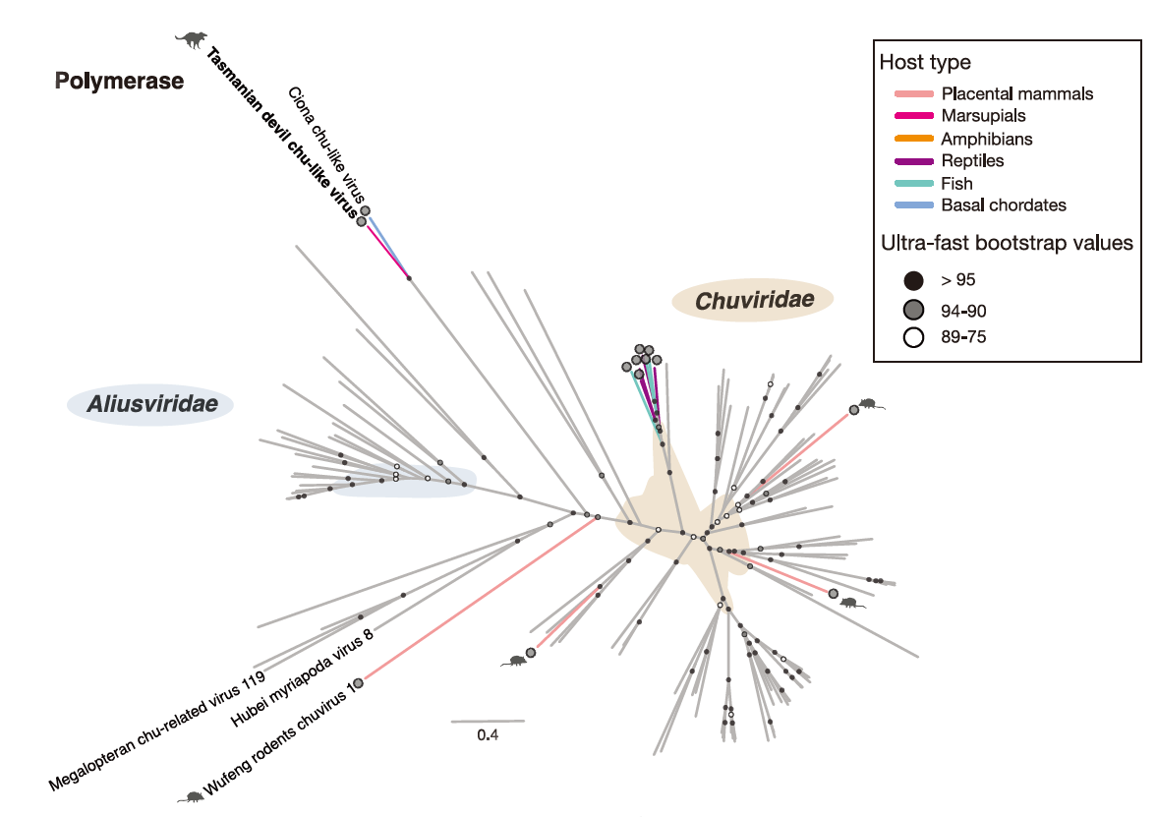Figure 3: Phylogenetic relationships of the Jingchuvirales. Unrooted maximum likelihood trees of the Jingchuvirales polymerase. Chordate-associated viruses are indicated with colored tip branches, and mammalian-associated virus sequences are indicated with animal silhouettes. The taxon name of TDCV is bolded. Viral families with more than one member are indicated with colored shading and labeled in the figure. Exogenous chordate-associated viruses are indicated with a viral particle silhouette at the branch tip, and chordate-associated viruses and EVE sequences are indicated with colored tip branches. The scale bar indicates the number of amino acid substitutions per site.

