

The International Committee on Taxonomy of Viruses
Taxonomy Proposal Form, 2026
Part 1a: Details of taxonomy proposals

Title: | Create two new genera and three new species in the family Lispiviridae (order Mononegavirales)
Code assigned: | 2026.006M

Author(s), affiliation and email address(es):
Given name (+middle initial(s)) | Surname | Affiliation | Email address | Corr. author(s)
Jun-Min | Li | Institute of Plant Virology, Ningbo University, Ningbo, PR China. | lijunmin@nbu.edu.cn | X
Gong-Yin | Ye | Institute of Insect Sciences, Zhejiang University, Hangzhou, PR China. | chu@zju.edu.cn
Fei | Wang | Wuhan Institute of Virology, Chinese Academy of Sciences, Wuhan, PR China. | wangfei@wh.iov.cn
Zhuang-Xin | Ye | Institute of Plant Virology, Ningbo University, Ningbo, PR China. | yezhuangxin@nbu.edu.cn

Part 1b: Taxonomy Proposal Submission
ICTV Subcommittee:
Animal DNA Viruses and Retroviruses |  | Bacterial viruses
Animal minus-strand and dsRNA viruses | X | Fungal and protist viruses
Animal positive-strand RNA viruses |  | Plant viruses
Archaeal viruses |  | General -

List the ICTV Study Group(s) that have seen or have been involved in creating this proposal:
Lispiviridae Study Group

Optional – complete only if formally voted on by an ICTV Study Group:
Study Group | Number of members
Study Group | Votes in support | Votes against | No vote
Lispiviridae Study Group | 4 | 0 | 0

Submission date: | 01/08/2026

Part 1c: Feedback from ICTV Executive Committee (EC) meeting
Executive Committee Meeting Decision code: | X
A – Accept
Ac – Accept subject to revision by relevant subcommittee chair. No further vote required
U – Accept without revision but with re-evaluation and email vote by the EC
Uc – Accept subject to revision and re-evaluation and email vote by the EC
Ud – Deferred to the next EC meeting, with an invitation to revise based on EC comments
J - Reject
W - Withdrawn

Comments from the Executive Committee:

Part 1d: Revised Taxonomy Proposal Submission
Response of proposer:
Revision date:

Part 3: TAXONOMIC PROPOSAL

Taxonomic changes proposed:
Establish new taxon | X | Split taxon
Abolish taxon |  | Merge taxon
Move taxon |  | Promote taxon
Rename taxon |  | Demote taxon
Move and rename

Etymology (origin) of proposed taxonomic names:
Taxon name | Etymology of the term
“Orqtpvirus” | from the host genus Oropsylla and the Qinghai-Tibet plateau of China, where the host was sampled
“huangnanense” | from the geographic origin, Huangnan Tibetan Autonomous Prefecture, China.
“Culspvirus” | from the host genus Culex and São Paulo, where the host was sampled
“didbebense” | from the geographic origin, Diretoria de Biodiversidade e Biotecnologia, Brazil
“wyeconis” | from the host species Wyeomyia confuse

Abstract of Taxonomy Proposal
Description of current taxonomy:
Currently, the family Lispiviridae includes 31 genera and 51 species according to ICTV Master Species List (MSL41.v1).

Proposed taxonomic change(s):
We propose the creation of 2 new genera (“Orqtpvirus” and “Culspvirus”) and 3 new species (“huangnanense”, “didbebense”, and “wyeconis”) to be included in the family Lispiviridae (order Mononegavirales).

Demarcation criteria for new taxon/taxa:
Species and genera are proposed for classification according to the established classification criteria:
• a coding-complete RNA-directed RNA polymerase (RdRp) sequence
• at least 20% amino acid identity of the RdRp sequence
The above criteria are similar to those used for other mononegaviral families.

Justification:
Genus (and species) demarcation is proposed to be based on coding-complete genome sequence analyses, phylogenetic analyses, and pairwise sequence comparisons similar to established genus/species demarcation criteria for other mononegaviral families.

Text of Taxonomy proposal

Description of current taxonomy:
Currently, the family Lispiviridae includes 31 genera and 51 species according to ICTV Master Species List (MSL41.v1).

Proposed taxonomic change(s):
We propose the creation of 2 new genera and 3 new species to be included in the family Lispiviridae (order Mononegavirales).

Demarcation criteria for new taxon/taxa:
Species and genera are proposed for classification according to the established classification criteria:
• a coding-complete RdRp sequence
• at least 20% amino acid identity of the RdRp sequence
The above criteria are similar to those used for other mononegaviral families.

According to ICTV Report of Lispiviridae (https://ictv.global/report/chapter/lispiviridae/lispiviridae), genus demarcation criterion requires a coding-complete RdRp with amino acid identity between 20-49%, and the species demarcation criterion across each genus of the family requires a coding-complete RdRp with amino acid identity 50-84%.
Thus, based on amino acid identity and the present phylogenetic analysis shown in Figure 1, we propose the demarcation of 2 new genera and 3 new species.

Justification:
Etymologies:

•Canmovirus “wyeconis”, represented by Lispiviridae sp. isolate WcLispV (accession: PX992751.1), was identified through metatranscriptomic analysis of Wyeomyia confusa mosquitoes collected in Brazil (Pindamonhangaba, São Paulo). The virus encodes an RdRp that shares 81% amino acid identity with the RdRp of Pedras lispivirus isolate Ar872508 (accession: OQ779241.1), a member of Canmovirus mahaense. The genus name Canmovirus is retained, and the species epithet “wyeconis” is derived from the host species Wyeomyia confusa.

•“Orqtpvirus” “huangnanense”, represented by Ganiavirus Ctenocephalides (accession: PV953191.1), was identified through metatranscriptomic analysis of fleas (Oropsylla silantiewi) sampled on the Qinghai-Tibet plateau of China. The virus encodes an RdRp that shares 44% amino acid identity with the RdRp of Fùyùn tick virus 1 isolate FY19-2 (accession: OP313018.1), a member of Ganiavirus fuyunense. As the amino acid identity falls within the genus demarcation criteria for Lispiviridae (20-49%), a new genus, “Orqtpvirus”, is proposed. The proposed genus name is derived from the host genus Oropsylla and the Qinghai-Tibet plateau of China, where the host was sampled. The species epithet “huangnanense” refers to the geographic origin, “Huangnan Tibetan Autonomous Prefecture” (黄南藏族自治州), China.

•“Culspvirus” “didbebense”, represented by Lispiviridae sp. isolate CxLispV-SP_12 (accession: PX833271.1), was identified through metatranscriptomic analysis of Culex chidesteri mosquitoes collected at the Diretoria de Biodiversidade e Biotecnologia, São Paulo, Brazil. The RdRp of this virus shares 36% amino acid identity with the RdRp of Pedras lispivirus isolate Ar872508 (accession: OQ779241.1), a member of Canmovirus mahaense. As the amino acid identity falls within the genus demarcation criteria for Lispiviridae (20-49%), a new genus, “Culspvirus”, is proposed. The proposed genus name is derived from the host genus Culex and São Paulo, where the host was sampled. The species epithet “didbebense” refers to the geographic origin, Diretoria de Biodiversidade e Biotecnologia, Brazil.

References:
1. Guimarães LO, Couto RDS, Reginato SL, Mucci LF, Pandey RP, de Camargo-Neves VLF, da Costa AC, Kirchgatter K, Leal E. Wyeomyia confusa Lispivirus (WcLispV-SP): a novel neotropical mosquito virus in the Lispiviridae family. Archives of Virology. 171(6):180. doi: 10.1007/s00705-026-06646-w.

2. Zhu W, Pu J, Jin D, Lu S, Yang J, Xu J. RNA virome of ticks and fleas infesting Marmota himalayana from the Qinghai-Tibet plateau. Animal Microbiome. 2025, 7(1):131. doi: 10.1186/s42523-025-00488-8.

3. Guimarães LO, Couto RDS, Ribeiro GO, Telles-de-Deus J, Ramos EDSF, Helfstein VC, Morais VDS, Maia Dos Santos J, Pandey RP, de Camargo-Neves VLF, da Costa AC, Kirchgatter K, Leal É. Putative Novel Viruses in the Families Lispiviridae and Rhabdoviridae Detected in Culex and Anopheles Mosquitoes Collected at the São Paulo Zoo. Advances in Virology. 2026, 8104754. doi: 10.1155/av/8104754.

Accompanying files
Filename | Description of contents
2026.v1.Lispiviridae_2ngen_3nsp_RdRP_tree.pdf | Phylogenetic tree of the 3 proposed new species and other lispivirid species
2026.v1.Lispiviridae_2ngen_3nsp_SDT.pdf | Pairwise identity of the 3 proposed new species with other lispivirid species
2026.v1.Lispiviridae_2ngen_3nsp.xlsx | Proposed the creation of 2 new genera and 3 new species to be included in family Lispiviridae.

Tables, Figures:

<Start here>Figure 1
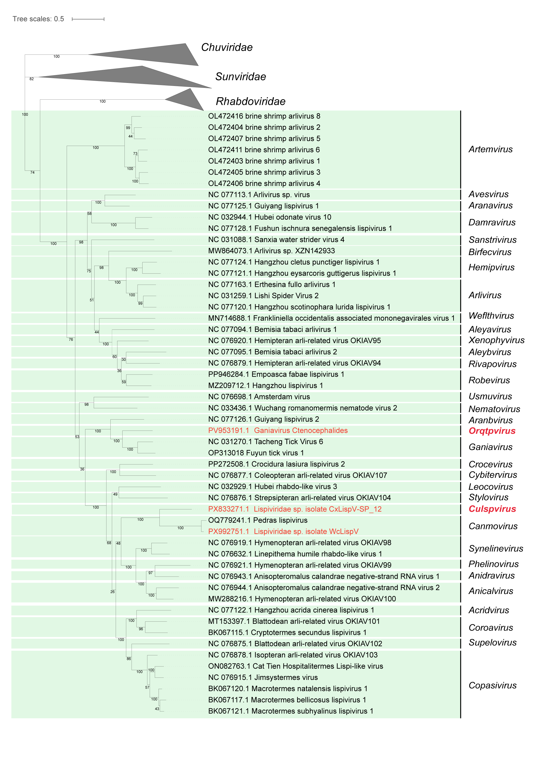Figure 1: Phylogenetic relationships of lispivirids. The phylogenetic tree is based on a MAFFT-alignment of the RdRp amino acid sequences using the L-INS-i algorithm and was inferred using ModelTest-NG and the LG+I+G4+F model. Numbers on branch nodes represent transfer bootstrap expectation values (1,000 replicates). The proposed new genera and representative viruses are highlighted in red. The tree is rooted to the viruses of the family Chuviridae.

