

The International Committee on Taxonomy of Viruses

Taxonomy Proposal Form, 2025

**Part 1a: Details of taxonomy proposals**

|  |  |
| --- | --- |
| **Title:** | Create three (3) new species in the genus *Varicosavirus,* subfamily *Betarhabdovirinae* (*Mononegavirales: Rhabdoviridae*) |
| **Code assigned:** | 2025.026P.Ac.v3.Rhabdoviridae_Varicosavirus_3nsp | |

|  |  |  |  |  |
| --- | --- | --- | --- | --- |
| **Author(s), affiliation and email address(es):** | | | | |
| **Given name (+middle initial(s))** | **Surname** | **Affiliation** | **Email address** | **Corr. author(s)** |
| Nicolas | Bejerman | UFyMA INTA-CONICET, Argentina | bejerman.nicolas@inta.gob.ar | X |
| Humberto | Debat | UFyMA INTA-CONICET, Argentina | debat.humberto@inta.gob.ar |  |
| Ralf G | Dietzgen | QAAFI, UQ, Australia | r.dietzgen@hotmail.com |  |
| Juliana | Freitas- Astúa | EMBRAPA Mandioca e Fruticultura, Brazil | juliana.astua@embrapa.br |  |
| Hideki | Kondo | Okayama University, Japan | hkondo@rib.okayama-u.ac.jp |  |
| Pedro Luis | Ramos- González | Instituto Biológico de São Paulo, Brazil | plrg1970@gmail.com |  |
| Anna E | Whitfield | NC State University, USA | [awhitfi@ncsu.edu](mailto:awhitfi@ncsu.edu) |  |
| Peter J | Walker | School of Chemistry and Molecular Biosciences, The University of Queensland, St Lucia, Australia | [peter.walker@uq.edu.au](mailto:peter.walker@uq.edu.au) |  |

**Part 1b: Taxonomy Proposal Submission**

|  |  |  |  |
| --- | --- | --- | --- |
| **ICTV Subcommittee:** | | | |
| Animal DNA Viruses and Retroviruses |  | Bacterial viruses |  |
| Animal minus-strand and dsRNA viruses |  | Fungal and protist viruses |  |
| Animal positive-strand RNA viruses |  | Plant viruses | **X** |
| Archaeal viruses |  | General |  |

|  |
| --- |
| **List the ICTV Study Group(s) that have seen or have been involved in creating this proposal:** |
| *Rhabdoviridae* study group |

|  |  |  |  |
| --- | --- | --- | --- |
| **Optional – complete only if formally voted on by an ICTV Study Group:** | | | |
| **Study Group** | **Number of members** | | |
| **Votes in support** | **Votes against** | **No vote** |
| *Rhabdoviridae* | 11 | 0 | 3 |
|  |  |  |  |

|  |  |
| --- | --- |
| **Submission date:** | 21/05/2025 |

**Part 1c: Feedback from ICTV Executive Committee (EC) meeting**

|  |  |
| --- | --- |
| **Executive Committee Meeting Decision code:** | **X** |
| A – Accept |  |
| Ac – Accept subject to revision by relevant subcommittee chair. No further vote required | **X** |
| U – Accept without revision but with re-evaluation and email vote by the EC |  |
| Uc – Accept subject to revision and re-evaluation and email vote by the EC |  |
| Ud – Deferred to the next EC meeting, with an invitation to revise based on EC comments |  |
| J - Reject |  |
| W - Withdrawn |  |

|  |
| --- |
| **Comments from the Executive Committee:** |
| The EC voted Ac for this proposal (see the table above for explanation), to allow very minor revisions mainly concerning style issues.  It is suggested to remove the header “novel species” since it is confusing because the following paragraphs start with the virus name. |

**Part 1d: Revised Taxonomy Proposal Submission**

|  |
| --- |
| **Response of proposer:** |
| All proposed changes were accepted, including the removal of the header “novel species” |

|  |  |
| --- | --- |
| **Revision date:** | 19/08/2025 |

**Part 3:** **TAXONOMIC PROPOSAL**

|  |  |  |  |
| --- | --- | --- | --- |
| **Taxonomic changes proposed:** | | | |
| Establish new taxon | **X** | Split taxon |  |
| Abolish taxon |  | Merge taxon |  |
| Move taxon |  | Promote taxon |  |
| Rename taxon |  | Demote taxon |  |
| Move and rename |  |

|  |  |
| --- | --- |
| **Etymology (origin) of proposed taxonomic names:** | |
| **Taxon name** | **Etymology of the term** |
| *“Varicosavirus agastachi”* | The species epithet is derived from *Agastache*, the scientific name of the plant host genera from which the sequence of the virus was obtained. |
| *“Varicosavirus orychophragmi”* | The species epithet is derived from *Orychophragmi,* the scientific name of the plant host genera from which the sequence of the virus was obtained. |
| *“Varicosavirus rubi”* | The species epithet is derived from *Rubus*, the scientific name of the plant host genera from which the sequence of the virus was obtained. |

|  |  |  |
| --- | --- | --- |
| **Permission for use of names derived from a living person:** | | |
| **Taxon name** | **Full name of person from whom the name is derived** | **Attached** |
|  |  |  |
| **Abstract of Taxonomy Proposal:** | | |
| *Taxonomic rank(s) affected*:  Genus *Varicosavirus* in the family *Rhabdoviridae*  *Description of current taxonomy*:  Viruses classified into species in the genus *Varicosavirus* are bi-segmented and infect a wide range of plants. The assignment of viruses to this genus is based on the placement of the viruses on Maximum Likelihood trees inferred from complete L protein sequences.  *Proposed* *taxonomic change(s):*  Create three new species in the genus *Varicosavirus*, subfamily *Betarhabdovirinae*, family *Rhabdoviridae*. These species are proposed to be named “*Varicosavirus agastachi”, “Varicosavirus orychophragmi”* and *“Varicosavirus rubi”*.  *Justification*:  Three novel rhabdoviruses were identified in *Agastache rugosa* [1], *Orychophragmus violaceus* [2] and *Rubus* spp. [3]. The characterization of these three viruses showed that they should be classified into novel species within the genus *Varicosavirus* based on the nucleotide sequence divergence from previously reported varicosaviruses and phylogenetic placement. | | |

|  |
| --- |
| **Text of Taxonomy proposal:** |
| *Taxonomic rank(s) affected*:  Genus *Varicosavirus* in the family *Rhabdoviridae*    *Description of current taxonomy*:  Viruses classified into species in the genus *Varicosavirus* are bi-segmented and infect a wide range of plants. The assignment of viruses to this genus is based on the placement of the viruses on Maximum Likelihood trees inferred from complete L protein sequences.  *Proposed* *taxonomic change(s)*:  Create three new species in the genus *Varicosavirus*, subfamily *Betarhabdovirinae*, family *Rhabdoviridae*.  *Demarcation criteria:*  Viruses assigned to different species within the genus *Varicosavirus* should have several of the following characteristics:   1. nucleotide sequence identity lower than 80% for the *L* ORF 2. nucleotide sequence identity lower than 80% in RNA2 3. occupy different ecological niches as evidenced by differences in hosts   *Justification*:  Three novel rhabdoviruses were identified in *Agastache rugosa* [1], *Orychophragmus violaceus* [2] and *Rubus* spp. [3]. The characterization of these three viruses showed that they should be classified into novel species within the genus *Varicosavirus*, based on the nucleotide sequence divergence from previously reported varicosaviruses and phylogenetic placement (see below).   1. **Agastache rugosa associated varicosavirus (ARaVV)** was identified from Korean mint (*Agastache rugosa*) samples collected in Lianoning, China. ARaVV genome is bi-segmented with a coding-complete genome (CCG) RNA1 of 6,428 nucleotides and RNA2 of 3,862 nucleotides (PP987314 and PP987315) [1]. RNA1 contains one large ORF for the L polymerase protein, while RNA2 contains three ORFs (**Figure 1**). The nucleotide sequence of ARaVV L protein has the highest identity values with that of Centaurea virus 1(CenV1; 56.8%), while the ARaVV RNA2 has the highest nt identities values with that of Raphanus virus 1 with 40.6% [1]. The nucleotide sequence identity between the ARaVV genomic segments and those of the closest relative is below 75%. Based on ML trees generated from complete L protein sequences, ARaVV is placed within a subclade of varicosaviruses with CenV1 (**Figure 2**). 2. **Orychophragmus violaceus varicosavirus (OVVV)** was identified from Chinese violet cress (*Orychophragmus violaceus*) samples collected in Beijing, China. OVVV genome is bi-segmented with a complete genome (CG) RNA1 of 6,795 nucleotides and RNA2 of 5,895 nucleotides [2]. RNA1 contains one large ORF for the L polymerase protein, while RNA2 contains four ORFs (**Figure 1**). The nucleotide sequence of OVVV L protein has the highest identity values with that of Brassica virus 2 (BrV2; 66.5%), while the OVVV RNA2 has the highest nt identities values with that of BrV2 with 42.9%. Based on ML trees generated from complete L protein sequences, OVVV is placed within a subclade of varicosaviruses with BrV2 (**Figure 2**). 3. **Rubus varicosavirus 1(RVV1)** was identified from Rubus samples collected in South Carolina, USA. RVV1 genome is bi-segmented with a coding-complete genome (CCG) RNA1 of 6,480 nucleotides and RNA2 of 5,630 nucleotides (PQ317243 and PQ317244) [3]. RNA1 contains one large ORF for the L polymerase protein, while RNA2 contains five ORFs (**Figure 1**). The nucleotide sequence of RVV1 L protein has the highest identity values with that of Vincetoxicum virus 1(VinV1; 62 %), while the RVV1 RNA2 has the highest nt identities values with that of VinV1 with 53% [2]. Based on ML trees generated from complete L protein sequences, RVV1 is placed within a subclade of varicosaviruses with VinV1 (**Figure 2**).   ARaVV, OVVV and RVV1 meet the demarcation criteria A and B. Thus, we propose to classify ARaVV, OVVV and RVV1 into the new species “*Varicosavirus agastachi”, “Varicosavirus orychophragmi”* and *“Varicosavirus rubi”*. subfamily *Betarhabdovirinae*, family *Rhabdoviridae*. |

|  |
| --- |
| **References:** |
| [1] Yang C, Yang L, Li Y, Cui X, Bai X, Zhang S, Cao M (2024). Molecular identification of a putative novel varicosavirus identified from Agastache rugosa in China. Arch Virol 169:212. PMID: 39365443 DOI: 10.1007/s00705-024-06141-0.  [2] Chen Y, Li Q, Yu J, Zhou Y, Fei S, Wu J, Fu S (2025). A novel varicosavirus associated with Orychophragmus violaceus in China. Arch Virol 170:121. PMID: 40329141 DOI: 10.1007/s00705-025-06283-9  [3] Schnabel E, Diniz Xavier C, Whitfield A, Dubrow Z, Pham G, Cieniewicz E (2025). Exploring the virome of blackberry and wild Rubus spp. in South Carolina. Phytobiomes. doi: <https://doi.org/10.1094/PBIOMES-11-24-0106-R>. |

|  |  |
| --- | --- |
| **Accompanying files:** | |
| **Filename** | **Description of contents** |
| 2025.026P.A.v1.Rhabdoviridae_Varicosavirus_3nsp | Excel sheet |
|  |  |

**Tables, Figures:**

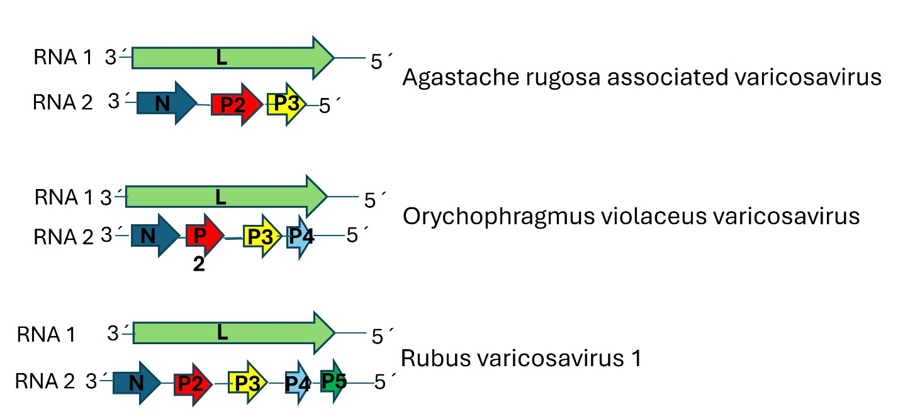

**Figure 1**. Genome graphs depicting the architecture and gene products of viruses proposed to be included in species within the genus *Varicosavirus.* Abbreviations: N: nucleoprotein; P2: protein 2; P3: protein 3; P4: protein 4; P5: protein 5; L: RNA-dependent RNA polymerase.

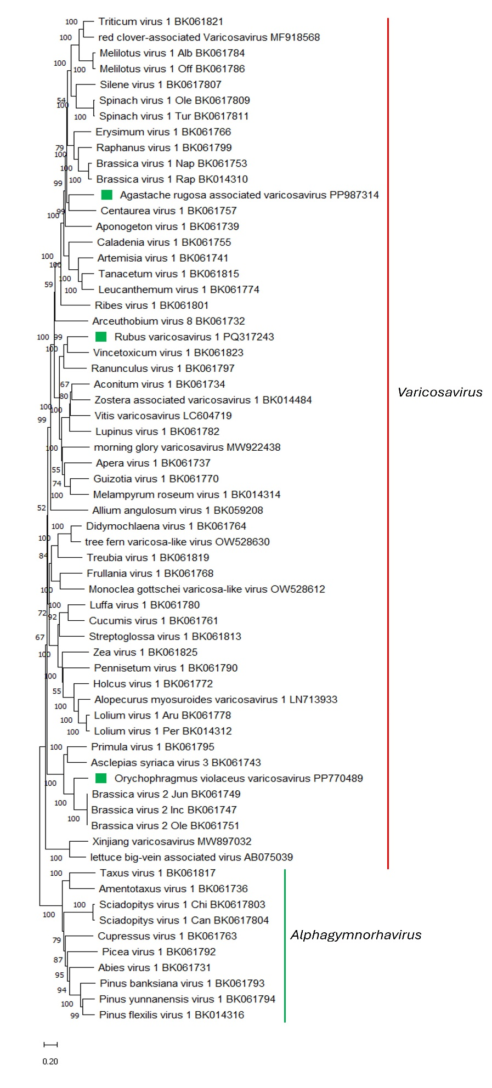

**Figure 2.** Maximum Likelihood (ML) phylogenetic tree of plant-infecting rhabdovirus L polymerase protein sequences. Amino acid sequences were aligned using MUSCLE. The resulting alignment was used to generate a phylogenetic tree using Mega11 with the best-fit model LG + G + I +F. The virus potentially belonging to the new species are indicated with green square. Numbers at the nodes indicate bootstrap support (1000 replicates).