

The International Committee on Taxonomy of Viruses

Taxonomy Proposal Form, 2025

**Part 1a: Details of taxonomy proposals**

|  |  |
| --- | --- |
| **Title:** | Create one species in the genus *Sobemovirus (Sobelivirales:Solemoviridae)* |
| **Code assigned:** | 2025.021P.Solemoviridae_Sobemovirus_1nsp | |

|  |  |  |  |  |
| --- | --- | --- | --- | --- |
| **Author(s), affiliation and email address(es):** | | | | |
| **Given name (+middle initial(s))** | **Surname** | **Affiliation** | **Email address** | **Corr. author(s)** |
| Denis | Fargette | Virus South Data, 16 rue Artaud, Lyon, France | denis.fargette@ird.fr |  |
| Fiona | Filardo | Queensland Department of Primary Industries, Brisbane, Australia | fiona.filardo@dpi.qld.gov.au |  |
| Mahan | Ghafari | Department of Biology,  University of Oxford, Oxford, UK | mahan.ghafari@ndm.ox.ac.uk |  |
| Eugenie | Hebrard | IRD, Institute Agro, Montpellier, France | eugenie.hebrard@ird.fr |  |
| Cecilia | Sarmiento | Department of Chemistry and  Biotechnology, TalTech, Tallinn, Estonia | cecilia.sarmiento@taltech.ee |  |
| Merike | Sõmera | Department of Chemistry and  Biotechnology, TalTech, Tallinn, Estonia | merike.somera@taltech.ee | **X** |
| John | Thomas | The University of Queensland, Brisbane, Australia | j.thomas2@uq.edu.au |  |

**Part 1b: Taxonomy Proposal Submission**

|  |  |  |  |
| --- | --- | --- | --- |
| **ICTV Subcommittee:** | | | |
| Animal DNA Viruses and Retroviruses |  | Bacterial viruses |  |
| Animal minus-strand and dsRNA viruses |  | Fungal and protist viruses |  |
| Animal positive-strand RNA viruses |  | Plant viruses | **X** |
| Archaeal viruses |  | General |  |

|  |
| --- |
| **List the ICTV Study Group(s) that have seen or have been involved in creating this proposal:** |
| Solemoviridae SG |

|  |  |
| --- | --- |
| **Submission date:** | 16/06/2025 |

**Part 1c: Feedback from ICTV Executive Committee (EC) meeting**

|  |  |
| --- | --- |
| **Executive Committee Meeting Decision code:** | **X** |
| A – Accept |  |
| Ac – Accept subject to revision by relevant subcommittee chair. No further vote required |  |
| U – Accept without revision but with re-evaluation and email vote by the EC |  |
| Uc – Accept subject to revision and re-evaluation and email vote by the EC |  |
| Ud – Deferred to the next EC meeting, with an invitation to revise based on EC comments |  |
| J - Reject |  |
| W - Withdrawn |  |

|  |
| --- |
| **Comments from the Executive Committee:** |
|  |

**Part 1d: Revised Taxonomy Proposal Submission**

|  |
| --- |
| **Response of proposer:** |
|  |

|  |  |
| --- | --- |
| **Revision date:** |  |

**Part 3:** **TAXONOMIC PROPOSAL**

|  |  |  |  |
| --- | --- | --- | --- |
| **Taxonomic changes proposed:** | | | |
| Establish new taxon | **X** | Split taxon |  |
| Abolish taxon |  | Merge taxon |  |
| Move taxon |  | Promote taxon |  |
| Rename taxon |  | Demote taxon |  |
| Move and rename |  |

|  |  |
| --- | --- |
| **Etymology (origin) of proposed taxonomic names:** | |
| **Taxon name** | **Etymology of the term** |
| *Sobemovirus OLVS* | Epithet from abbreviation |

|  |
| --- |
| **Abstract of Taxonomy Proposal:** |
| *Taxonomic rank(s) affected*: Species  *Description of current taxonomy*: Currently, the genus *Sobemovirus* consists of 26 members infecting plants from different taxa.  *Proposed* *taxonomic change(s):* Create one new species In the genus *Sobemovirus*  *Justification*: The presence of olive virus S (OlVS), a putative novel member of the family *Solemoviridae,* was determined by HTS in 10 samples of olive leaf petioles collected in the commercial orchards in Stellenbosch, South Africa. The assembled genome of OlVS shared the sequence similarity with sobemoviruses, being most close to southern bean mosaic virus (SBMV) with an average identity of 52.5%. The terminal genomic sequences were determined by Sanger sequencing of RACE cDNA clones. The genome length and organization of OlVS was characteristic of sobemoviruses. The phylogenetic analysis confirmed clustering within the genus *Sobemovirus*. |

|  |
| --- |
| **Text of Taxonomy proposal:** |
| *Taxonomic rank(s) affected*: Species.  *Description of current taxonomy*: *Sobelivirales: Solemoviridae: Sobemovirus*  *Proposed* *taxonomic change(s)*: Create one new species in the genus *Sobemovirus*.  *Demarcation criteria:*  • Sobemovirus species are distinguished by the host range of member viruses combined with analysis of their genome sequences;  • The threshold for species demarcation based on complete genome sequences is <75% nucleotide identity between viruses belonging to different species;  • Serological relatedness between viruses may help in distinguishing species.  *Justification*: The genome of olive virus S (OlVS) was assembled from 10 olive samples collected in Stellenborough, South Africa in 2022. Genome lengths varied between 4,157 and 4165 nt, with nucleotide sequence variability ranging from 96.9 to 99.5%. The presence of four putative genes was predicted. The putative ORF1 product showed no homology to known proteins. The next ORF products P2a, P2b and CP showed 39.5–50.4% amino acid identity to proteins encoded by other sobemoviruses. The presence of non-AUG initiated “hidden” ORF0 was not searched. The genomic sequence of OlVS (GenBank Acc. No. **OR252867**) shared the highest sequence similarity with that of southern bean mosaic virus (SBMV), with an average of 52.5% [1]. This value is below the sequence-based species demarcation guideline of ∼ 75%.  The MUSCLE alignment with the exemplar sobemovirus genome sequences showed the highest identity percentage of 49% between OlVS (OR252867) and SBMV (DQ875594), and OlVS and sesbania mosaic virus (AY004291) (Table 1). The MUSCLE alignment with the translated RNA-directed RNA polymerases (RdRPs) of exemplar sobemoviruses and OlVS RdRP showed the highest identity percentage of 53% between OlVS RdRP and SBMV RdRP, and OlVS RdRP and Southern cowpea mosaic virus (SCPMV) RdRP (Table 2). In the maximum-likelihood phylogenetic tree (Fig. 1), OlVS RdRP clustered together with sobemoviral RdRPs.  The recognition of OlVS as the member of the new species **“*Sobemovirus OLVS”*** is consistent with the species demarcation criteria in genus *Sobemovirus.* |

|  |
| --- |
| **References:** |
| [1] Read DA, Pietersen G, Slippers B, Steenkamp E. Genomic characterization of novel viruses associated with *Olea europaea* L. in South Africa. Arch Virol. 2024 Sep 27;169(10):210. doi: 10.1007/s00705-024-06132-1. |

|  |  |
| --- | --- |
| **Accompanying files:** | |
| **Filename** | **Description of contents** |
| 2025.021P.N.v2.Solemoviridae_Sobemovirus_1nsp.xlsx | Excel module |

|  |
| --- |
| **Tables, Figures:** |

Table 1. Identity percentages between nucleotide sequences of OlVS (OR252867) and sobemovirus genomes retrieved from NCBI GenBank*. Multiple sequence alignment was performed using MUSCLE algorithm in the Geneious Prime ver. 2025.1.2.

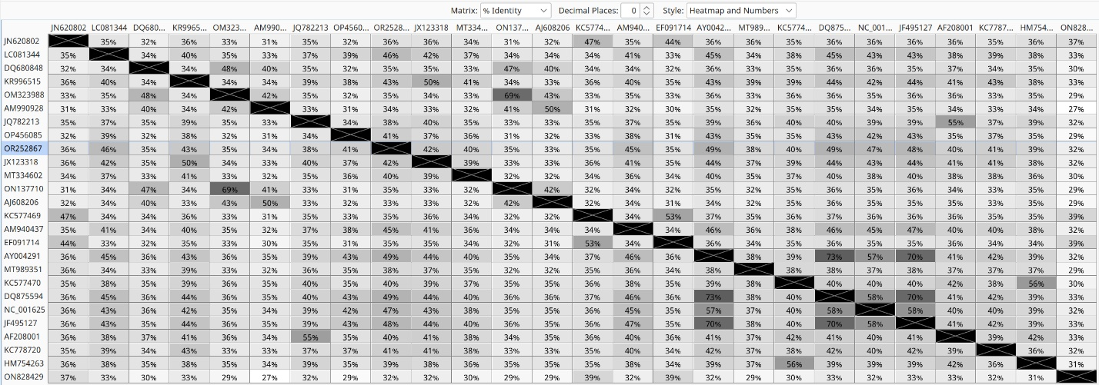

*Artemisia virus A - JN620802.1; blueberry shoestring virus - LC081344.1; cocksfoot mottle virus - Z48630.1; Cymbidium chlorotic mosaic virus - LC019764.1; Imperata yellow mottle virus - AM990928.1; lucerne transient streak virus - JQ782213.1; Mimosa mosaic virus - OP456085.1; papaya lethal yellowing virus - JX123318.1>Physalis rugose mosaic virus - MK681145.1; Pistacia sobemo-like virus - MT334602.1; Poaceae Liege sobemovirus - ON137710.1; rice yellow mottle virus - AJ608206.1; Rottboellia yellow mottle virus - KC577469.1; Sesbania mosaic virus - AY004291.2; snake melon asteroid mosaic virus - MT989351.1; Solanum nodiflorum mottle virus - KC577470.1; southern bean mosaic virus - DQ875594.2; southern cowpea mosaic virus - NC 001625.2; sowbane mosaic virus - AM940437.1; soybean yellow common mosaic virus - JF495127.1; subterranean clover mottle virus - AF208001.1; turnip rosette virus - KC778720.1; velvet tobacco mottle virus - HM754263.2; xufa yellow dwarf virus - ON828429.1.

Table 2. Identity percentages between amino acid sequences of viral RdRPs translated from ORF2b extracted from the genomes of OlVS and recognized sobemoviruses. Multiple sequence alignment was performed using MUSCLE algorithm in the Geneious Prime ver. 2025.1.2.

**Fig. 1. Evolutionary analysis of sobemovirus RdRP aa sequences by the Maximum Likelihood method. Poinsettia latent mottle virus (polemovirus) RdRP was used as an outgroup. Olive virus S RdRP has been marked with green diamond.** The phylogeny was inferred using the Maximum Likelihood method and Le-Gascuel (2008) LG model (+Freq) of amino acid substitutions and the tree with the highest log likelihood (-20 415.86) is shown. The percentage of replicate trees in which the associated taxa clustered together (500 replicates) is shown next to the branches. The initial tree for the heuristic search was selected by choosing the tree with the superior log-likelihood between a Neighbor-Joining (NJ) tree [3] and a Maximum Parsimony (MP) tree. The NJ tree was generated using a matrix of pairwise distances computed using the p-distance. The MP tree had the shortest length among 10 MP tree searches, each performed with a randomly generated starting tree. The evolutionary rate differences among sites were modeled using a discrete Gamma distribution across 5 categories (+G, parameter = 0.4054), with 12.59% of sites deemed evolutionarily invariant (+I). The analytical procedure encompassed 28 amino acid sequences with 723 positions in the final dataset. Evolutionary analyses were conducted in MEGA12.