# 

The International Committee on Taxonomy of Viruses

Taxonomy Proposal Form, 2025

**Part 1a: Details of taxonomy proposals**

|  |  |
| --- | --- |
| **Title:** | Create three new species and three new genera in the family *Geminiviridae* (order *Geplafuvirales*). |
| **Code assigned:** | 2025.016P.N.v2.Geminiviridae_3ng_3nsp | |

|  |  |  |  |  |
| --- | --- | --- | --- | --- |
| **Author(s), affiliation and email address(es):** | | | | |
| **Given name (+middle initial(s))** | **Surname** | **Affiliation** | **Email address** | **Corr. author(s)** |
| Philippe | Roumagnac | CIRAD, UMR PHIM, Montpellier, France | philippe.roumagnac@cirad.fr | X |
| Jose | Ascencio-Ibanez | North Carolina State University, Raleigh, USA | jtascenc@ncsu.edu |  |
| Jean-Michel | Lett | CIRAD, UMR PVBMT, Saint Pierre de la Réunion, France | lett@cirad.fr |  |
| Paola M | López-Lambertini | INTA-CIAP-IPAVE, Universidad Nacional de Córdoba, Córdoba, Argentina | plopezlambertini@gmail.com |  |
| Darren P | Martin | Institute of Infectious Disease and Molecular Medicine, University of Cape Town, Cape Town, South Africa | darrenpatrickmartin@gmail.com |  |
| Jesús | Navas-Castillo | Instituto de Hortofruticultura Subtropical y Mediterránea “La Mayora” (IHSM-UMA-CSIC), Málaga, Spain | jnavas@eelm.csic.es |  |
| Simone G | Ribeiro | Embrapa Recursos Genéticos e Biotecnologia, Brasília, Brazil | simone.ribeiro@embrapa.br |  |
| Cica | Urbino | CIRAD, UMR PHIM, Montpellier, France | cica.urbino@cirad.fr |  |
| Arvind | Varsani | The Biodesign Center for Fundamental and Applied Microbiomics, Center for Evolution and Medicine, School of Life Sciences, Arizona State University, Tempe,Arizona, USA | Arvind.varsani@asu.edu |  |
| F Murilo | Zerbini | Dep. de Fitopatologia, Universidade Federal de Viçosa, Viçosa, Brasil | [zerbini@ufv.br](mailto:zerbini@ufv.br) |  |

**Part 1b: Taxonomy Proposal Submission**

|  |  |  |  |
| --- | --- | --- | --- |
| **ICTV Subcommittee:** | | | |
| Animal DNA Viruses and Retroviruses |  | Bacterial viruses |  |
| Animal minus-strand and dsRNA viruses |  | Fungal and protist viruses |  |
| Animal positive-strand RNA viruses |  | Plant viruses | **X** |
| Archaeal viruses |  | General |  |

|  |
| --- |
| **List the ICTV Study Group(s) that have seen or have been involved in creating this proposal:** |
| *Geminiviridae* and *Tolecusatellitidae* Study Group |

|  |  |  |  |
| --- | --- | --- | --- |
| **Optional – complete only if formally voted on by an ICTV Study Group:** | | | |
| **Study Group** | **Number of members** | | |
| **Votes in support** | **Votes against** | **No vote** |
| Roumagnac, Philippe  Ascencio-Ibanez, Jose  Lett, Jean-Michel  López-Lambertini, Paola M.  Martin, Darren  Navas-Castillo, Jesús  Ribeiro, Simone  Urbino, Cica  Varsani, Arvind  Zerbini, F. Murilo | Y  Y  Y  Y  Y  Y  Y  Y  Y  Y |  |  |

|  |  |
| --- | --- |
| **Submission date:** | 10/06/2025 |

**Part 1c: Feedback from ICTV Executive Committee (EC) meeting**

|  |  |
| --- | --- |
| **Executive Committee Meeting Decision code:** | **X** |
| A – Accept |  |
| Ac – Accept subject to revision by relevant subcommittee chair. No further vote required |  |
| U – Accept without revision but with re-evaluation and email vote by the EC |  |
| Uc – Accept subject to revision and re-evaluation and email vote by the EC |  |
| Ud – Deferred to the next EC meeting, with an invitation to revise based on EC comments |  |
| J - Reject |  |
| W - Withdrawn |  |

|  |
| --- |
| **Comments from the Executive Committee:** |
|  |

**Part 1d: Revised Taxonomy Proposal Submission**

|  |
| --- |
| **Response of proposer:** |
|  |

|  |  |
| --- | --- |
| **Revision date:** |  |

**Part 3:** **TAXONOMIC PROPOSAL**

|  |  |  |  |
| --- | --- | --- | --- |
| **Taxonomic changes proposed:** | | | |
| Establish new taxon | **x** | Split taxon |  |
| Abolish taxon |  | Merge taxon |  |
| Move taxon |  | Promote taxon |  |
| Rename taxon |  | Demote taxon |  |
| Move and rename |  |

|  |  |
| --- | --- |
| **Etymology (origin) of proposed taxonomic names:** | |
| **Taxon name** | **Etymology of the term** |
| ***Cobecusvirus*** | The name of the new genus “***Cobecusvirus”*** is derived from the exemplar isolate of the genus: **Co**mmon **be**an **cu**rly **s**tunt virus |
| ***Oleurovirus*** | The name of the new genus “***Oleurovirus***” is derived from the exemplar isolate of the genus: **Ol**ea **euro**paea geminivirus |
| ***Pylecuvirus*** | The name of the new genus “***Pylecuvirus***” is derived from the exemplar isolate of the genus: **p**arsley **y**ellow **le**af **cu**rl virus |
| ***Cobecusvirus phaseoli*** | Species epithet (*phaseoli*) derived from the host plant: *Phaseolus* *vulgaris* |
| ***Oleurovirus oleae*** | Species epithet (*oleae*) derived from the host plant: *Olea europaea* |
| ***Pylecuvirus petroselini*** | Species epithet (*petroselini*) derived from the host plant: *Petroselinum* *crispum* |

|  |  |  |
| --- | --- | --- |
| **Permission for use of names derived from a living person:** | | |
| **Taxon name** | **Full name of person from whom the name is derived** | **Attached** |
|  |  |  |
|  |  |  |
|  |  |  |
|  |  |  |

|  |
| --- |
| **Abstract of Taxonomy Proposal:** |
| Taxonomic rank(s) affected:  Family *Geminiviridae* in the order *Geplafuvirales*  Description of current taxonomy:  *Monodnaviria* / *Shotokuvirae* / *Cressdnaviricota* / *Repensiviricetes* / *Geplafuvirales* / *Geminiviridae*  Proposed taxonomic change(s):  We proposed to create three new genera into the *Geminiviridae* family: “*Cobecusvirus*, *Oleurovirus* and *Pylecuvirus*. We also propose to create one new species (*Cobecusvirus phaseoli*) in the new *Cobecusvirus* genus, one new species (*Oleurovirus oleae*) in the new *Oleurovirus* genus and one new species (*Pylecuvirus petroselini*) in the new *Pylecuvirus* genus  *Justification*:  We propose to classify new geminiviruses into 3 new species based on species demarcation guidelines already established for the family *Geminiviridae*. Based on the inferred genome organizations of these viruses coupled with phylogenetic analysis, we propose to create 3 new genera in the family *Geminiviridae* to accommodate these 3 new species. |

|  |
| --- |
| **Text of Taxonomy proposal:**  *Taxonomic rank(s) affected:*  Family *Geminiviridae* in the order *Geplafuvirales*  *Description of current taxonomy:*  *Monodnaviria* / *Shotokuvirae* / *Cressdnaviricota* / *Repensiviricetes* / *Geplafuvirales* / *Geminiviridae*  *Proposed taxonomic change(s):*  We proposed to create three new genera into the *Geminiviridae* family: “*Cobecusvirus*”, “*Oleurovirus*” and “*Pylecuvirus*”. We also propose to create one new species (“*Cobecusvirus phaseoli*”) in the new “*Cobecusvirus”* genus, one new species (“*Oleurovirus oleae*”) in the new “*Oleurovirus”* genus and one new species (“*Pylecuvirus petroselini*”) in the new “*Pylecuvirus*” genus  Justification:  **1. A new species, “*Cobecusvirus phaseoli*”*,* in a new genus, “*Cobecusvirus*”**  Common bean curly stunt virus (CBCSV) has been characterized from common bean collected in China showing severe stunt and leaf curling symptoms (Zhang et al., 2020) [1]. Its 2959 nt long nucleotide genome sequence shares less than 65.5% pairwise identity with all other known geminiviruses within currently established species (Figure 1). This virus is clearly related to the geminiviruses, based on genome composition (Figure 2), similarities in the origin of replication (5'-TAATATTAC-3'), and the presence of homologous genes.  The reconstruction of the evolutionary relationships of the complete genome sequences of various major geminivirus lineages reveals that CBCSV groups separately from all other established geminiviruses, with strong phylogenetic support (Figure 3). Interestingly, CBCSV clusters with one new unassigned geminivirus, tomato curly top virus (ToCTV) (Kubota et al., 2023). ToCTV has been characterized from tomato collected in Japan with leaf yellowing or curling and curly top symptoms. Its 2969 nt long nucleotide genome sequence shares less than 64.6% pairwise identity with all other known geminiviruses within currently established species (Figure 1). This virus is also clearly related to the geminiviruses, based on genome composition, similarities in the origin of replication (5'-TAATATTAC-3'), and the presence of homologous genes. The genomes of CBCSV and ToCTV are similar to those of turncurtoviruses and contain seven and six ORFs, respectively (Figure 2). Hence, both viruses have two ORFs in the virion-sense (V1 and V2) and four in the complementary-sense (C1, C2, C3 and C4). Interestingly, CBCSV harbors an ORF, corresponding to V3 and not found in any other geminiviruses, which is absent in the ToCTV genome.  The genomes of CBCSV and ToCTV are chimeric. Their encoded replication-associated proteins (Reps) phylogenetically cluster with those of turncurtoviruses (Figure 4). In addition, the phylogeny based on inferred coat proteins (CP) indicate that CBCSV and ToCTV CPs group separately from all other geminiviruses, with strong phylogenetic support (Figure 5). CBCSV and ToCTV clearly belong to a highly divergent geminivirus lineage and, consequently, we propose here to create a new genus named “*Cobecusvirus*” (derived from **co**mmon **be**an **cu**rly **s**tunt virus) for classifying these two highly divergent geminiviruses.  Finally, genome-wide pairwise analysis shows that CBCSV isolate shares between 86.93% and 87.02% pairwise identity with ToCTV isolates. To align the “*Cobecusvirus*” species demarcation threshold with that of the majority of genera of the family *Geminiviridae*, we propose to adopt a 78% pairwise identity species demarcation threshold. Consequently, we conclude that the CBCSV and ToCTV isolates (Table 1) belong to a single “*Cobecusvirus*” species that we propose to name “*Cobecusvirus* *phaseoli*”, which species epithet (*phaseoli*) is derived from the host plant of CBCSV: *Phaseolus vulgaris*.  **2. A new species, “*Oleurovirus oleae*”*,* in a new genus, “*Oleurovirus*”*.***  Olea europaea geminivirus (OEGV) has been characterized from asymptomatic *Olea europaea* plants (Chiumenti et al., 2021; Ruiz-García et al., 2021) [3, 4]. The virus presents a bipartite genome with peculiar molecular and phylogenetic characteristics, although genome composition and the related genes are homologous to previously recognized geminivirids. DNA-A is 2775-nt long and encode four proteins (AV1, AC1, AC2 and AC3), while DNA-B is 2763-nt-long and code for two proteins, including a MP (BV1) and a protein with an unknown function (BC1) (Figure 2). Both genomic components of this virus present a long-intergenic region (LIR), with a common sequence astride the TATA-box similar to the origin of replication (5'-TAATATT/AC-3') of geminivirids (Figure 2). The common sequence in the LIR, 348-nt-long (CRA and CRB in Figure 2), isolated from the DNAs shares a sequence identity of 99.99% (with only two polymorphisms), suggesting that the two DNAs are components of the same bipartite virus. The DNA-A sequence of OEGV shares less than 60.2% pairwise identity with all other known geminiviruses within currently established species (Figure 1).  The reconstruction of the evolutionary relationships of the DNA-A genomic component, together with full-length genomes of representative geminiviruses belonging to other lineages, reveals that OEGV groups separately from all other established geminivirids with strong phylogenetic support (Figure 3). In addition, phylogenies based on inferred REP and CP amino acid sequences also confirm that OEGV belongs to a divergent well-supported clade within the geminivirus phylogenetic trees (Figures 4 and 5). Therefore, OEGV clearly belong to a highly divergent geminivirus lineage and, consequently, we propose here to create a new genus named “*Oleurovirus*” (derived from **Ol**ea **euro**paea geminivirus) for accommodating this highly divergent geminivirus.  Finally, genome-wide pairwise analysis shows that OEGV isolates (Table 1) share between 99.78% and 100% pairwise identity with each other. To align the *Oleurovirus* species demarcation threshold with that of the majority of genera of the family *Geminiviridae*, we propose to adopt a 78% pairwise identity species demarcation threshold. Consequently, we conclude that all OEGV isolates (Table 1) belong to a single *Oleurovirus* species that we propose to name “*Oleurovirus* *oleae*”*,* which species epithet (*oleae*) is derived from the host plant of CBCSV: *Olea europaea*.  **3. A new species, “*Pylecuvirus petroselini*”*,* in a new genus, “*Pylecuvirus*”*.***  Parsley yellow leaf curl virus (PYLCV) has been characterized from a parsley plant (*Petroselinum crispum* (Mill.) Fuss) collected in Iran showing dwarfing, marginal leaf yellowing and mild leaf curling symptoms [5]. Its 2779 nt long nucleotide genome sequence shares less than 64.7% pairwise identity with all other known geminiviruses within currently established species (Figure 1). This virus is clearly related to the geminiviruses, based on genome composition (Figure 2), similarities in the origin of replication (5'-TAATATTAC-3'), and the presence of homologous genes. PYLCV has a genome organization that is similar to that of monopartitite begomoviruses, maldoviruses, opunviruses, topocuvirus and turncurtoviruses. PYLCV is transmitted by the leafhopper *Austroagallia sinuata* (Nichkerdar et al., 2024).  The reconstruction of the evolutionary relationships of the complete genome sequences of various major geminivirus lineages reveals that PYLCV groups separately from all other established geminiviruses, with strong phylogenetic support (Figure 3). Phylogenetically, the Rep of PYLCV clusters with that encoded by begomoviruses, apple geminivirus, grapevine geminivirus  A, Opuntia virus 1 and Polygala garcinii associated virus (Figure 4) whereas the CP clusters with those encoded by becurtoviruses and curtoviruses (Figure 5). Therefore, PYLCV clearly belong to a highly divergent geminivirus lineage and, consequently, we propose here to create a new genus named “*Pylecuvirus*” (derived from **p**arsley **y**ellow **le**af **cu**rl virus) for classifying this highly divergent geminivirus.  To align the “*Pylecuvirus*” species demarcation threshold with that of the majority of genera of the family *Geminiviridae*, we propose to adopt a 78% pairwise identity species demarcation threshold. Consequently, we conclude that the PYLCV isolate (Table 1) belong to a single “*Pylecuvirus*” species that we propose to name “*Pylecuvirus* *petroselini*”*,* which species epithet (*petroselini*) is derived from the host plant of CBCSV: *Petroselinum crispum*. |

|  |
| --- |
| **References:** |
| [1] Zhang, R., Wu, X., Jiang, X., Wu, X., Luan, X., Cheng, X., 2020. Molecular characterization of common bean curly stunt virus: a novel recombinant geminivirus in China. Arch. Virol. 165, 257-260.  [2] Kubota, K., Tomitaka, Y., Usugi, T., Hamada, H., Ito, H., Kuwana, A., Tsuda, S., 2023. Molecular characterization of a new geminivirus isolated from tomato with curly top symptoms and development of its infectious clone. Journal of General Plant Pathology 89, 100-108.  [3] Chiumenti, M., Greco, C., De Stradis, A., Loconsole, G., Cavalieri, V., Altamura, G., Zicca, S., Saldarelli, P., Saponari, M., 2021. Olea europaea geminivirus: A novel bipartite geminivirid infecting olive trees. Viruses 13, 481.  [4] Ruiz-García, A.B., Canales, C., Morán, F., Ruiz-Torres, M., Herrera-Mármol, M., Olmos, A., 2021. Characterization of Spanish Olive Virome by High Throughput Sequencing Opens New Insights and Uncertainties. Viruses 13.  [5] Hasanvand, V., Heydanejad, J., Massumi, H., Kleinow, T., Jeske, H., Varsani, A., 2020. Isolation and characterization of a novel geminivirus from parsley. Virus Research 286, 198056.  [6] Nichkerdar, K., Heydarnejad, J., Massumi, H., 2024. Vector transmission of parsley yellow leaf curl virus by the leafhopper Austroagallia sinuata. Arch. Virol. 169, 93.  [7] Muhire, B.M., Varsani, A., Martin, D.P., 2014. SDT: a virus classification tool based on pairwise sequence alignment and identity calculation. PLoS One 9, e108277.  [8] Katoh, K., Standley, D.M., 2013. MAFFT multiple sequence alignment software version 7: improvements in performance and usability. Mol Biol Evol 30, 772-780.  [9] Criscuolo, A., Gribaldo, S., 2010. BMGE (Block Mapping and Gathering with Entropy): a new software for selection of phylogenetic informative regions from multiple sequence alignments. BMC Evolutionary Biology 10, 210.  [10] Guindon, S., Dufayard, J.F., Lefort, V., Anisimova, M., Hordijk, W., Gascuel, O., 2010. New algorithms and methods to estimate maximum-likelihood phylogenies: assessing the performance of PhyML 3.0. Syst. Biol. 59, 307-321. |

|  |  |
| --- | --- |
| **Accompanying files:** | |
| **Filename** | **Description of contents** |
| 2025.016P.N.v2.Geminiviridae_3ng_3nsp | spreadsheet |
|  |  |

**Table 1:** Summary of the new proposed species in the three new proposed genera of the *Geminiviridae* family.

|  |  |  |  |  |  |  |  |
| --- | --- | --- | --- | --- | --- | --- | --- |
| **Genus** | **Species** | **Accession #** | **Virus name** | **Acronym** | **Isolate** | **Country** | **Host/Source** |
| *Cobecusvirus* | *Cobecusvirus phaseoli* | MK673513 | common bean curly stunt virus | CBCSV | Harbin-01 | China | *Phaseolus vulgaris* |
|  |  | AB935396 | tomato curly top virus | ToCTV | JP-Fuk-K1-09 | Japan | *Solanum lycopersicum* |
|  |  | AB935397 | tomato curly top virus | ToCTV | JP-Fuk-K2-09 | Japan | *Solanum lycopersicum* |
|  |  | AB935398 | tomato curly top virus | ToCTV | JP-Fuk-K4-09 | Japan | *Solanum lycopersicum* |
|  |  | LC160267 | tomato curly top virus | ToCTV | JP-Fuk-K5-10 | Japan | *Solanum lycopersicum* |
|  |  | LC160268 | tomato curly top virus | ToCTV | JP-Fuk-K6-10 | Japan | *Solanum lycopersicum* |
| *Oleurovirus* | *Oleurovirus oleae* | MW316657 | Olea europaea geminivirus | OEGV |  | Italy | *Olea europaea* |
|  |  | OK475023 | Olea europaea geminivirus | OEGV | OEGV-V64.1 | Spain | *Olea europaea* |
|  |  | OK475021 | Olea europaea geminivirus | OEGV | OEGV-V64.2 | Spain | *Olea europaea* |
|  |  | MZ355666 | Olea europaea geminivirus | OEGV | PT | Portugal | *Olea europaea* |
|  |  | MW560455 | Olea europaea geminivirus | OEGV | CP2-42 | USA | *Olea europaea* |
|  |  | MW560454 | Olea europaea geminivirus | OEGV | CP2-41 | USA | *Olea europaea* |
|  |  | MW560453 | Olea europaea geminivirus | OEGV | CP1-36 | USA | *Olea europaea* |
|  |  | MW560452 | Olea europaea geminivirus | OEGV | CP1-34 | USA | *Olea europaea* |
|  |  | MW560451 | Olea europaea geminivirus | OEGV | Rep2-1-46 | USA | *Olea europaea* |
|  |  | MW560450 | Olea europaea geminivirus | OEGV | Rep2-1-44 | USA | *Olea europaea* |
|  |  | MW560449 | Olea europaea geminivirus | OEGV | Rep2-32 | USA | *Olea europaea* |
|  |  | MW560448 | Olea europaea geminivirus | OEGV | Rep2-29 | USA | *Olea europaea* |
|  |  | MW560447 | Olea europaea geminivirus | OEGV | Rep1-27 | USA | *Olea europaea* |
|  |  | MW560446 | Olea europaea geminivirus | OEGV | Rep1-25 | USA | *Olea europaea* |
| *Pylecuvirus* | *Pylecuvirus petroselini* | MN243534 | parsley yellow leaf curl virus | PYLCV | IR:Ba:39Ba:Par:18 | Iran | *Petroselinum crispum* |

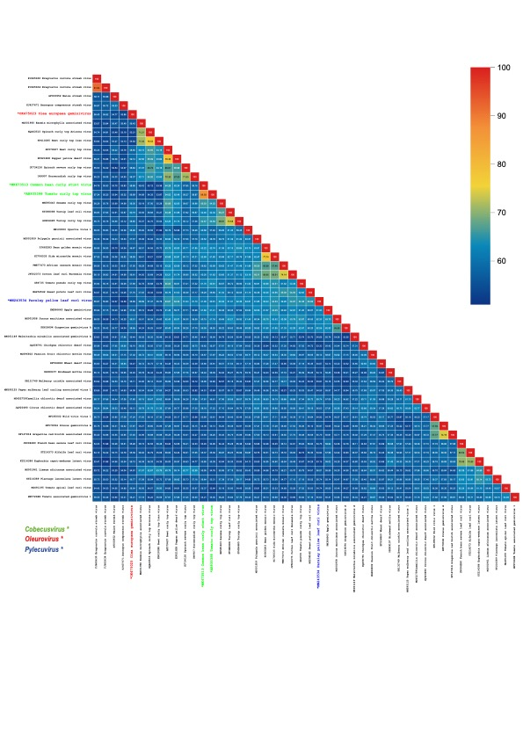

**Figure 1:** Pairwise identity matrix inferred using SDT v1.2 [7]. The genomes of representative members of the three new genera are indicated by asterisks.



**Figure 2:** Illustration of the genome organisation of cobecusviruses, oleuroviruses and pylecuviruses. LIR, long intergenic region; SIR, short intergenic region; CR, common region; *cp*, capsid protein; *mp*, movement protein; *nsp*, nuclear shuttle protein; *reg*, regulatory gene; *ren*, replication enhancer; *rep*, replication-associated protein; *sd*, symptom determinant; *ss*, silencing suppressor; *trap*, transactivator protein.

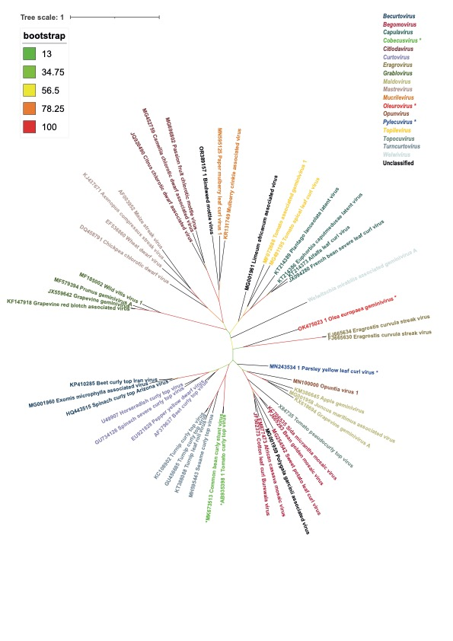

**Figure 3:** Unrooted Maximum-Likelihood tree inferred from aligned full-genome nucleotide sequences of representative isolates from the various geminivirus genera. The genomes were aligned using MAFFT [8]. Block mapping and gathering with entropy [9] was used and and a Maximum-Likelihood tree was inferred by PhyML with 1000 bootstrap iterations [10]. The genomes of representative members of the three new genera are indicated by asterisks.

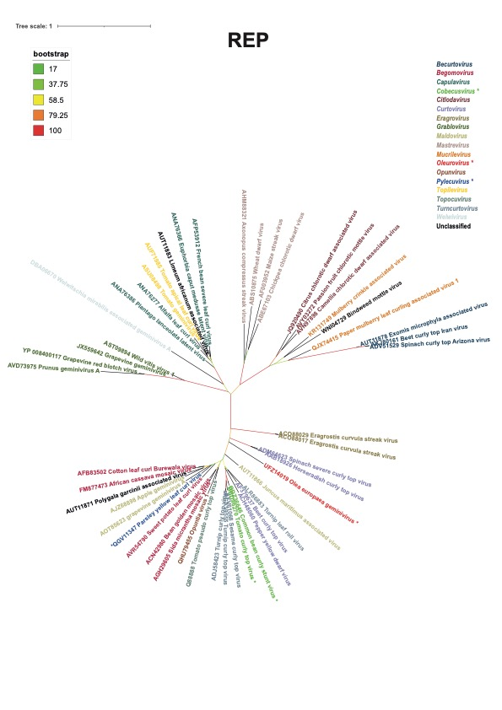

**Figure 4:** Unrooted Maximum-Likelihood tree inferred from aligned REP amino acid sequences of representative isolates from the various geminivirus genera. The REPs were aligned using MAFFT [8]. Block mapping and gathering with entropy [9] was used and and a Maximum-Likelihood tree was inferred by PhyML with 1000 bootstrap iterations (Guindon et al., 2010) [10]. The genomes of representative members of the three new genera are indicated by asterisks.

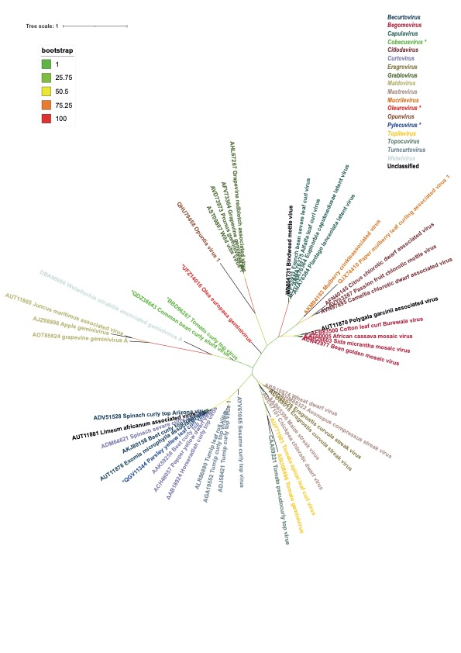

**Figure 5:** Unrooted Maximum-Likelihood tree inferred from aligned CP amino acid sequences of representative isolates from the various geminivirus genera. The CPs were aligned using MAFFT[8]. Block mapping and gathering with entropy [9]was used and a Maximum-Likelihood tree was inferred by PhyML with 1000 bootstrap iterations[10]. The genomes of representative members of the three new genera are indicated by asterisks.