

The International Committee on Taxonomy of Viruses

Taxonomy Proposal Form, 2025

**Part 1a: Details of taxonomy proposals**

|  |  |
| --- | --- |
| **Title:** | Create one new species in the genus *Deltasatellite* (*Tolecusatellitidae)* |
| **Code assigned:** | 2025.015P.Ac.v3.Deltasatellite_1nsp | |

|  |  |  |  |  |
| --- | --- | --- | --- | --- |
| **Author(s), affiliation and email address(es):** | | | | |
| **Given name (+middle initial(s))** | **Surname** | **Affiliation** | **Email address** | **Corr. author(s)** |
| Jesús | Navas-Castillo | IHSM La Mayora, UMA-CSIC, Algarrobo-Costa, Málaga, Spain | jnavas@eelm.csic.es | X |
| Philippe | Roumagnac | CIRAD, UMR PHIM, Montpellier, France | philippe.roumagnac@cirad.fr |  |
| Jose T | Ascencio-Ibáñez | North Carolina State University, Raleigh, USA | jtascenc@ncsu.edu |  |
| Jean-Michel | Lett | CIRAD, UMR PVBMT, Saint Pierre de la Réunion, France | lett@cirad.fr |  |
| Paola M. | López-Lambertini | INTA-CIAP-IPAVE, Universidad Nacional de Córdoba, Córdoba, Argentina | plopezlambertini@gmail.com |  |
| Darren P. | Martin | Institute of Infectious Disease and Molecular Medicine, University of Cape Town, Cape Town, South Africa | darrenpatrickmartin@gmail.com |  |
| Simone | Ribeiro | Embrapa Recursos Genéticos e Biotecnologia, Brasília, Brazil | simone.ribeiro@embrapa.br |  |
| Cica | Urbino | CIRAD, UMR PHIM, Montpellier, France | cica.urbino@cirad.fr |  |
| Arvind | Varsani | The Biodesign Center for Fundamental and Applied Microbiomics, Center for Evolution and Medicine, School of Life Sciences, Arizona State University, Tempe, Arizona, USA | Arvind.varsani@asu.edu |  |
| F. Murilo | Zerbini | Dep. de Fitopatologia, Universidade Federal de Viçosa, Viçosa, Brazil | [zerbini@ufv.br](mailto:zerbini@ufv.br) |  |

**Part 1b: Taxonomy Proposal Submission**

|  |  |  |  |
| --- | --- | --- | --- |
| **ICTV Subcommittee:** | | | |
| Animal DNA Viruses and Retroviruses |  | Bacterial viruses |  |
| Animal minus-strand and dsRNA viruses |  | Fungal and protist viruses |  |
| Animal positive-strand RNA viruses |  | Plant viruses | **X** |
| Archaeal viruses |  | General |  |

|  |
| --- |
| **List the ICTV Study Group(s) that have seen or have been involved in creating this proposal:** |
| *Geminiviridae* and *Tolecusatellitidae* Study Group |

|  |  |  |  |
| --- | --- | --- | --- |
| **Optional – complete only if formally voted on by an ICTV Study Group** | | | |
| **Study Group** | **Number of members** | | |
| **Votes in support** | **Votes against** | **No vote** |
| Roumagnac, Philippe  Ascencio-Ibáñez, Jose T  Lett, Jean-Michel  López-Lambertini, Paola M.  Martin, Darren  Navas-Castillo, Jesús  Ribeiro, Simone  Urbino, Cica  Varsani, Arvind  Zerbini, F. Murilo | Y  Y  Y  Y  Y  Y  Y  Y  Y  Y |  |  |

|  |  |
| --- | --- |
| **Submission date:** | 05/06/2025 |

**Part 1c: Feedback from ICTV Executive Committee (EC) meeting**

|  |  |
| --- | --- |
| **Executive Committee Meeting Decision code:** | **X** |
| A – Accept |  |
| Ac – Accept subject to revision by relevant subcommittee chair. No further vote required | **X** |
| U – Accept without revision but with re-evaluation and email vote by the EC |  |
| Uc – Accept subject to revision and re-evaluation and email vote by the EC |  |
| Ud – Deferred to the next EC meeting, with an invitation to revise based on EC comments |  |
| J - Reject |  |
| W - Withdrawn |  |

|  |
| --- |
| **Comments from the Executive Committee:** |
| The EC voted Ac for this proposal (see the table above for explanation), to allow very minor revisions mainly concerning style issues. |

**Part 1d: Revised Taxonomy Proposal Submission**

|  |
| --- |
| **Response of proposer:** |
| All style-related suggestions were accepted. |

|  |  |
| --- | --- |
| **Revision date:** | 22/08/2025 |

**Part 3:** **TAXONOMIC PROPOSAL**

|  |  |  |  |
| --- | --- | --- | --- |
| **Taxonomic changes proposed:** | | | |
| Establish new taxon | **x** | Split taxon |  |
| Abolish taxon |  | Merge taxon |  |
| Move taxon |  | Promote taxon |  |
| Rename taxon |  | Demote taxon |  |
| Move and rename |  |

|  |  |
| --- | --- |
| **Etymology (origin) of proposed taxonomic names:** | |
| **Taxon name** | **Etymology of the term** |
| *“Deltasatellite brassicae”* | The species epithet (*brassicae*) refers to the begomovirus species to which it was originally associated: *Begomovirus brassicae*. |
|  |  |
|  |  |
|  |  |

|  |  |  |
| --- | --- | --- |
| **Permission for use of names derived from a living person:** | | |
| **Taxon name** | **Full name of person from whom the name is derived** | **Attached** |
|  |  |  |
|  |  |  |
|  |  |  |
|  |  |  |

|  |
| --- |
| **Abstract of Taxonomy Proposal:** |
| *Taxonomic rank affected*:  Genus *Deltasatellite* in the family *Tolecusatellitidae*  *Description of current taxonomy*:  *Tolecusatellitidae /* *Deltasatellite*  The genus *Deltasatellite* consists of 12 species.  *Proposed* *taxonomic change:*  We proposed to create one new species in the genus *Deltasatellite*: “*Deltasatellite brassicae*”.  *Justification*:  Similar to members of the genus *Deltasatellite*, members of the proposed new species “*Deltasatellite brassicae*” have all conserved features of deltasatellites, including an A-rich region, a stem-loop with the TAATATTAC nonanucleotide motif, and a region with identity to betasatellites. The isolates share 100% nucleotide identity among themselves, and ≤73.9% identity with known deltasatellites, below the 91% species demarcation threshold. Phylogenetic analysis shows the group forms a distinct clade within New World deltasatellites. We conclude that “*Deltasatellite brassicae*”represents a new species in the genus *Deltasatellite*. |

|  |
| --- |
| *Taxonomic rank affected:*  Genus *Deltasatellite* in the family *Tolecusatellitidae*  *Description of current taxonomy:*  *Tolecusatellitidae /Deltasatellite*  The genus *Deltasatellite* consists of 12 species.  Twelve species are currently assigned to the *Deltasatellite* genus in the *Tolecusatellitidae* family:  *Deltasatellite codiaeumiflavi, Deltasatellite desmodii, Deltasatellite ipomoeaprimi, Deltasatellite ipomoeasecundi, Deltasatellite ipomoeatertii, Deltasatellite malvastri, Deltasatellite sidaflavusprimi, Deltasatellite sidaflavussecundi, Deltasatellite sidaflavustertii, Deltasatellite solani, Deltasatellite solaniflavusprimi, Deltasatellite solaniflavussecundi.*  *Proposed taxonomic change:*  We proposed to create one new species in the genus *Deltasatellite*: “*Deltasatellite brassicae*”, which was isolated associated to the begomovirus cabbage leaf curl virus (*Begomovirus brassicae*) from black gram (*Vigna mungo*), cowpea (*Vigna unguiculata*), *Desmodium scorpiurus*, and *Rhynchosia minima* collected from Venezuela [1]. The satellite was termed cabbage leaf curl deltasatellite (CabLCD).  *Demarcation criteria:*  A 91% pairwise identity species demarcation threshold has been proposed and adopted for the genus *Deltasatellite* [2].  *Justification:*  The sequences of CabLCD summarized in Table 1 can be classified into one new species sharing ≤73.9% genome-wide pairwise identity with all classified deltasatellites (Figure 1). Furthermore, this is supported by phylogenetic analysis (Figure 2). |

|  |
| --- |
| **References:** |
| [1] Fiallo-Olivé, E., Bastidas, L., Chirinos, D.T., Navas-Castillo, J., 2021. Insights into emerging begomovirus-deltasatellite complex diversity: the first deltasatellite infecting legumes. Biology 10, 1125.  [2] Briddon, R.W., Navas-Castillo, J., Fiallo-Olivé, E., 2016. ICTV taxonomic Proposal 2016.021a-kP.A.v2.Tolecusatellitidae. Create the *Tolecusatellitidae*, a new family of single-stranded DNA satellites with two genera. Available online at: http://www.ictv.global/proposals-16/2016.021a-kP.A.v2.Tolecusatellitidae.pdf (accessed June 1, 2025).  [3] Muhire, B.M., Varsani, A., Martin, D.P., 2014. SDT: a virus classification tool based on pairwise sequence alignment and identity calculation. *PloS one* *9*, e108277. |

|  |  |
| --- | --- |
| **Accompanying files:** | |
| **Filename** | **Description of contents** |
| 2025.015P.A.v1.Deltasatellite_1nsp | spreadsheet |
|  |  |

|  |
| --- |
| **Tables, Figures:** |

**Table 1:** Summary of the new proposed species in the *Deltasatellite* genus of the *Tolecusatellitidae* family. The exemplar isolate is highlighted in red.

|  |  |  |  |  |  |  |  |  |
| --- | --- | --- | --- | --- | --- | --- | --- | --- |
| **Genus** | **Species** | **Accession #** | **Deltasatellite name** | **Acronym** | **Isolate** | **Country** | **Host** | **Associated begomovirus species** |
| *Deltasatellite* | *“Deltasatellite brassicae”* | OK073969 | Cabbage leaf curl deltasatellite | CabLCD | VE-Cp_V1-17 | Venezuela | Cowpea | *Begomovirus brassicae* |
| *Deltasatellite* | *Deltasatellite brassicae* | OK073970 | Cabbage leaf curl deltasatellite | CabLCD | VE-Cp_V2-17 | Venezuela | Cowpea | *Begomovirus brassicae* |
| *Deltasatellite* | *Deltasatellite brassicae* | OK073971 | Cabbage leaf curl deltasatellite | CabLCD | VE-Des_V8-17 | Venezuela | *Desmodium scorpiurus* | *Begomovirus brassicae* |
| *Deltasatellite* | *Deltasatellite brassicae* | OK073972 | Cabbage leaf curl deltasatellite | CabLCD | VE-Rh_V9-17 | Venezuela | *Rhynchosia minima* | *Begomovirus brassicae* |
| *Deltasatellite* | *Deltasatellite brassicae* | OK073973 | Cabbage leaf curl deltasatellite | CabLCD | VE-Rh_V10-17 | Venezuela | *Rhynchosia minima* | *Begomovirus brassicae* |
| *Deltasatellite* | *Deltasatellite brassicae* | OK073974 | Cabbage leaf curl deltasatellite | CabLCD | VE-Bg_V12-17 | Venezuela | Black gram | *Begomovirus brassicae* |
| *Deltasatellite* | *Deltasatellite brassicae* | OK073975 | Cabbage leaf curl deltasatellite | CabLCD | VE-Bg_V13-17 | Venezuela | Black gram | *Begomovirus brassicae* |

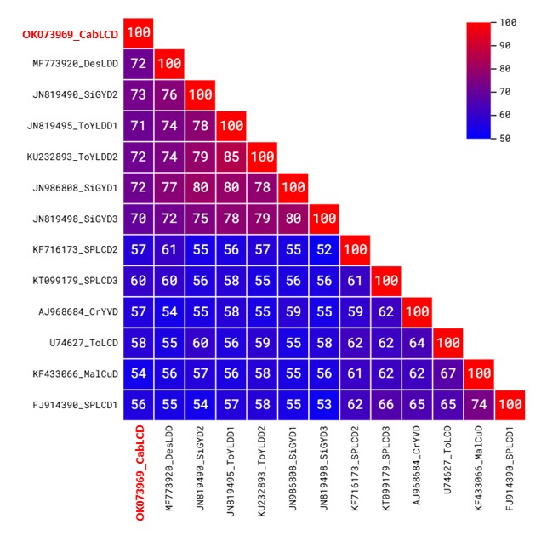

**Figure 1:** Pairwise identity matrix inferred using SDT [3]. A representative sequence of the proposed new species is highlighted in red.

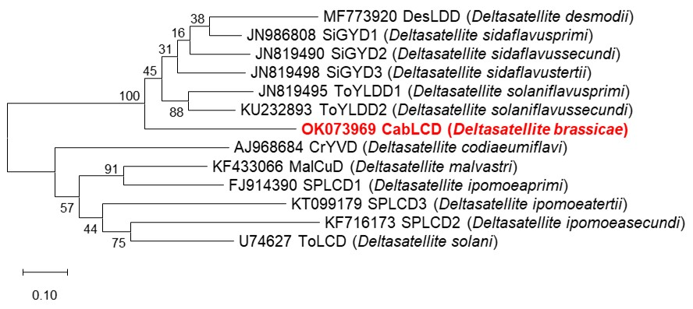

**Figure 2:** Maximum likelihood phylogenetic tree of representative genomes from each deltasatellite species. Bootstrap values are shown at the nodes. A representative sequence of the proposed new species is highlighted in red.