

The International Committee on Taxonomy of Viruses

Taxonomy Proposal Form, 2025

**Part 1a: Details of taxonomy proposals**

|  |  |
| --- | --- |
| **Title:** | Create one new species in the genus *Betasatellite* |
| **Code assigned:** | 2025.014P.Betasatellite_1nsp |

|  |  |  |  |  |
| --- | --- | --- | --- | --- |
| **Author(s), affiliation and email address(es):** | | | | |
| **Given name (+middle initial(s))** | **Surname** | **Affiliation** | **Email address** | **Corr. author(s)** |
| Jesús | Navas-Castillo | IHSM La Mayora, UMA-CSIC, Algarrobo-Costa, Málaga, Spain | jnavas@eelm.csic.es | X |
| José T | Ascencio-Ibañez | North Carolina State University, Raleigh, USA | jtascenc@ncsu.edu |  |
| Cica | Urbino | CIRAD, UMR PHIM, Montpellier, France | cica.urbino@cirad.fr |  |
| Jean-Michel | Lett | CIRAD, UMR PVBMT, Saint Pierre de la Réunion, France | lett@cirad.fr |  |
| Paola | López-Lambertini | INTA-CIAP-IPAVE, Universidad Nacional de Córdoba, Córdoba, Argentina | plopezlambertini@gmail.com |  |
| Darren P | Martin | Institute of Infectious Disease and Molecular Medicine, University of Cape Town, Cape Town, South Africa | darrenpatrickmartin@gmail.com |  |
| Simone G | Ribeiro | Embrapa Recursos Genéticos e Biotecnologia, Brasília, Brazil | simone.ribeiro@embrapa.br |  |
| Philippe | Roumagnac | CIRAD, UMR PHIM, Montpellier, France | philippe.roumagnac@cirad.fr |  |
| Cica | Urbino | CIRAD, UMR PHIM, Montpellier, France | cica.urbino@cirad.fr |  |
| Arvind | Varsani | The Biodesign Center for Fundamental and Applied Microbiomics, Center for Evolution and Medicine, School of Life Sciences, Arizona State University, Tempe, USA | Arvind.varsani@asu.edu |  |
| F Murilo | Zerbini | Dep. de Fitopatologia/BIOAGRO, Universidade Federal de Viçosa, Viçosa, Brazil | zerbini@ufv.br |  |

**Part 1b: Taxonomy Proposal Submission**

|  |  |  |  |
| --- | --- | --- | --- |
| **ICTV Subcommittee:** | | | |
| Animal DNA Viruses and Retroviruses |  | Bacterial viruses |  |
| Animal minus-strand and dsRNA viruses |  | Fungal and protist viruses |  |
| Animal positive-strand RNA viruses |  | Plant viruses | **X** |
| Archaeal viruses |  | General |  |

|  |
| --- |
| **List the ICTV Study Group(s) that have seen or have been involved in creating this proposal:** |
| *Geminiviridae* and *Tolecusatellitidae* |

|  |  |  |  |
| --- | --- | --- | --- |
| **Optional – complete only if formally voted on by an ICTV Study Group:** | | | |
| **Study Group** | **Number of members** | | |
| **Votes in support** | **Votes against** | **No vote** |
| *Geminiviridae* and *Tolecusatellitidae* |  |  |  |

|  |  |
| --- | --- |
| **Submission date:** | 13/06/2025 |

**Part 1c: Feedback from ICTV Executive Committee (EC) meeting**

|  |  |
| --- | --- |
| **Executive Committee Meeting Decision code:** | **X** |
| A – Accept |  |
| Ac – Accept subject to revision by relevant subcommittee chair. No further vote required |  |
| U – Accept without revision but with re-evaluation and email vote by the EC |  |
| Uc – Accept subject to revision and re-evaluation and email vote by the EC |  |
| Ud – Deferred to the next EC meeting, with an invitation to revise based on EC comments |  |
| J - Reject |  |
| W - Withdrawn |  |

|  |
| --- |
| **Comments from the Executive Committee:** |
|  |

**Part 1d: Revised Taxonomy Proposal Submission**

|  |
| --- |
| **Response of proposer:** |
|  |

|  |  |
| --- | --- |
| **Revision date:** |  |

**Part 3:** **TAXONOMIC PROPOSAL**

|  |  |  |  |
| --- | --- | --- | --- |
| **Taxonomic changes proposed:** | | | |
| Establish new taxon | **X** | Split taxon |  |
| Abolish taxon |  | Merge taxon |  |
| Move taxon |  | Promote taxon |  |
| Rename taxon |  | Demote taxon |  |
| Move and rename |  |

|  |  |
| --- | --- |
| **Etymology (origin) of proposed taxonomic names:** | |
| **Taxon name** | **Etymology of the term** |
| *Betasatellite trigonellae* | From the host genus name, *Trigonella foenum-graecum* |

|  |  |  |
| --- | --- | --- |
| **Permission for use of names derived from a living person:** | | |
| **Taxon name** | **Full name of person from whom the name is derived** | **Attached** |
|  |  |  |

|  |
| --- |
| **Abstract of Taxonomy Proposal:** |
| *Taxonomic rank affected*: Genus *Betasatellite*  *Description of current taxonomy*: *Tolecusatellitidae* -> *Betasatellite*  Within the genus *Betasatellite*, DNA satellites are classified into species based on a 91% genome-wide pairwise identity threshold [1].    *Proposed* *taxonomic changes:* Creation of of a new species to classify new betasatellites that has been identified and described in the literature over the past four years.  *Justification*: Member of the proposed new species shares <91% genome-wide pairwise identity with sequences of members of currently established betasatellite species. |

|  |
| --- |
| **Text of Taxonomy proposal:** |
| *Taxonomic rank affected*: Genus *Betasatellite*  *Description of current taxonomy*: *Tolecusatellitidae* -> *Betasatellite*  *Proposed* *taxonomic changes*: Create a new species in the genus *Betasatellite*.  *Demarcation criteria:* 91% genome-wide pairwise identity threshold [1].  *Justification*: The betasatellite summarized in Table 1 can be classified into a new species that shares <91% genome-wide pairwise identity with all classified betasatellites (Figure 1). This is supported by maximum likelihood phylogenetic analysis (Figure 2).  We provide a brief description of the proposed new species below:    ***"Betasatellite trigonellae"*** [2]  - Leaf samples from five fenugreek (*Trigonella foenum-graecum*) plants exhibiting severe curling of leaves, reduction in leaf size and stunted growth were collected in Aurangabad, Maharashtra, India, in 2020.  - Total DNA was extracted and used as a template for PCR with universal primers for betasatellites; PCR products (ca. 1.3 kb) were cloned and Sanger sequenced.  - The cloned betasatellite (1380 nt) showed maximum nt identity of 85.0% (Sequence Demarcation Tool analysis) with tomato leaf curl betasatellite (ToLCB, HM143902) reported previously from papaya in India (Figure 1)  - The authors conclude that the betasatellite identified from severe leaf curl affected fenugreek is a novel one for which they named as fenugreek leaf curl betasatellite. This betasatellite was associated to tomato leaf curl Kerala virus (ToLCKeV) DNA-A and tomato leaf curl New Delhi virus (ToLCNDV) DNA-B.  - The SG proposes the species name "*Betasatellite trigonellae*". |

|  |
| --- |
| **References:** |
| [1] Briddon, R. W., Navas-Castillo, J., Fiallo-Olivé, E. (2016) ICTV taxonomic proposal 2016.021a-kP.A.v2.*Tolecusatellitidae*. Establishment of a family of single-stranded DNA satellites with two genera. Available at: http://www.ictv.global/proposals-16/2016.021a-kP.A.v2.Tolecusatellitidae.pdf.  [2] Ashwathappa, K. V., Venkataravanappa, V., Hiremath, S., Shankarappa, K. S., Reddy, C. L., Reddy, M. K. (2022) Fenugreek plants showing the severe leaf curl disease are associated with tomato leaf curl Kerala virus, DNA-B molecule of tomato leaf curl New Delhi virus and a novel betasatellite. Australasian Plant Disease Notes 17: 24. |

|  |  |
| --- | --- |
| **Accompanying files:** | |
| **Filename** | **Description of contents** |
| 2025.014P.N.v2.Betasatellite_1nsp | spreadsheet |
| **Tables, Figures:** | |

**Table 1.** Summary of the new species in the genus *Betasatellite* and its member.

|  |  |  |  |  |  |  |
| --- | --- | --- | --- | --- | --- | --- |
| Species name | Accession no. | Virus name | Isolate name | Country | Host/source | Ref. |
| *Betasatellite*  *trigonellae* | MZ648030 | fenugreek leaf curl betasatellite (FeLCB) | India:Aurangabad:F-TK:2020 | India | fenugreek (*Trigonella foenum-graecum*) | [2] |

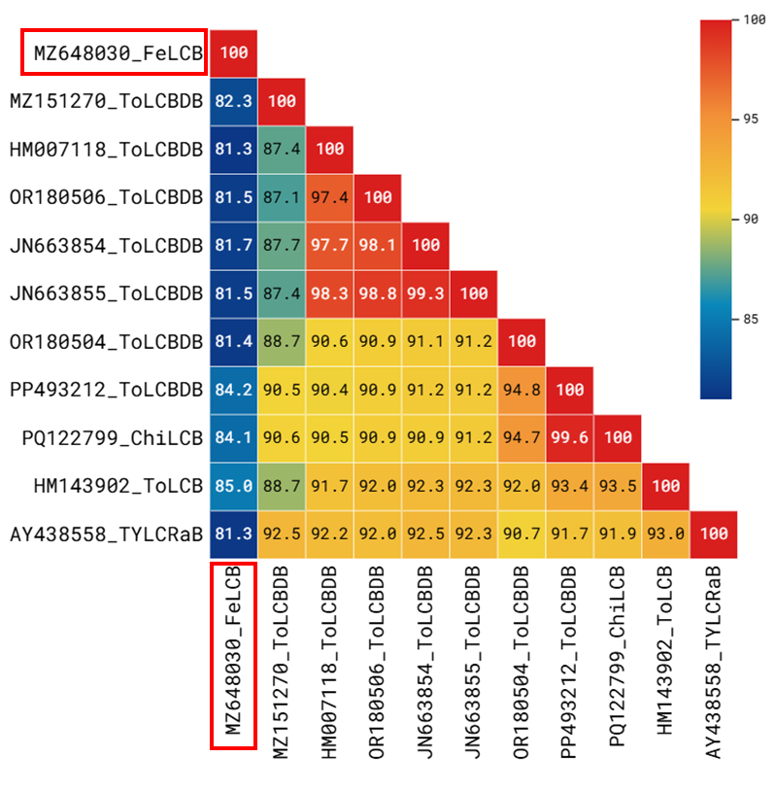

**Figure 1.** Pairwise nucleotide sequence identities (%) for the full-length sequence of fenugreek leaf curl betasatellite (FeLCB; "*Betasatellite trigonellae*") and the most closely related betasatellites.

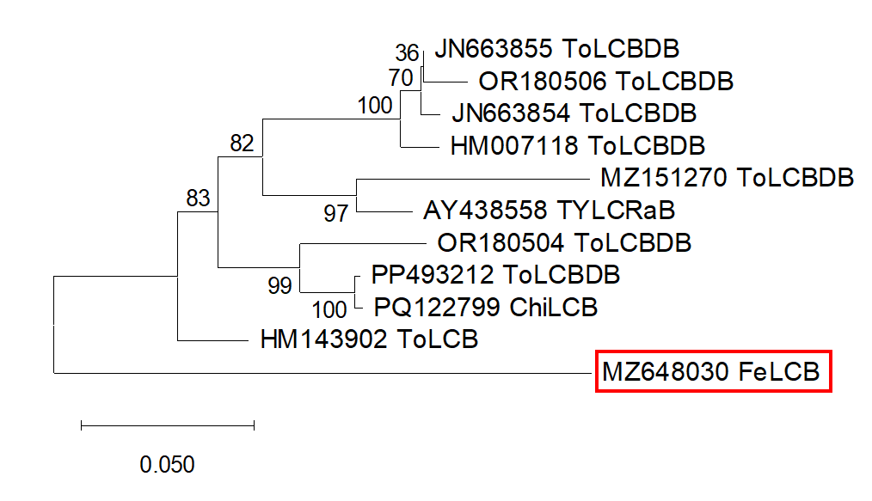

**Figure 2.** Maximum-likelihood phylogenetic tree (substitution model HKY+I) based on the full-length sequence of fenugreek leaf curl betasatellite (FeLCB; "*Betasatellite trigonellae*") and the most closely related betasatellites. The tree was rooted at the midpoint. Bootstrap values are shown (1000 replicates).