

The International Committee on Taxonomy of Viruses

Taxonomy Proposal Form, 2025

**Part 1a: Details of taxonomy proposals**

|  |  |
| --- | --- |
| **Title:** | Create two (2) new genera and 8 new species in the family *Alphasatellitidae* |
| **Code assigned:** | 2025.013P.Alphasatellitidae_2ng_8nsp |

|  |  |  |  |  |
| --- | --- | --- | --- | --- |
| **Author(s), affiliation and email address(es):** | | | | |
| **Given name (+middle initial(s))** | **Surname** | **Affiliation** | **Email address** | **Corr. author(s)** |
| F Murilo | Zerbini | Dep. de Fitopatologia/BIOAGRO, Universidade Federal de Viçosa, Viçosa, Brazil | zerbini@ufv.br | X |
| José T | Ascencio-Ibañez | North Carolina State University, Raleigh, USA | jtascenc@ncsu.edu |  |
| Cica | Urbino | CIRAD, UMR PHIM, Montpellier, France | cica.urbino@cirad.fr |  |
| Jean-Michel | Lett | CIRAD, UMR PVBMT, Saint Pierre de la Réunion, France | lett@cirad.fr |  |
| Jesús | Navas-Castillo | Instituto de Hortofruticultura Subtropical y Mediterránea “La Mayora” (IHSM-UMA-CSIC), Málaga, Spain | jnavas@eelm.csic.es |  |
| Paola | López-Lambertini | INTA-CIAP-IPAVE, Universidad Nacional de Córdoba, Córdoba, Argentina | plopezlambertini@gmail.com |  |
| Darren P | Martin | Institute of Infectious Disease and Molecular Medicine, University of Cape Town, Cape Town, South Africa | darrenpatrickmartin@gmail.com |  |
| Simone G | Ribeiro | Embrapa Recursos Genéticos e Biotecnologia, Brasília, Brazil | simone.ribeiro@embrapa.br |  |
| Philippe | Roumagnac | CIRAD, UMR PHIM, Montpellier, France | philippe.roumagnac@cirad.fr |  |
| Arvind | Varsani | The Biodesign Center for Fundamental and Applied Microbiomics, Center for Evolution and Medicine, School of Life Sciences, Arizona State University, Tempe, USA | Arvind.varsani@asu.edu |  |

**Part 1b: Taxonomy Proposal Submission**

|  |  |  |  |
| --- | --- | --- | --- |
| **ICTV Subcommittee:** | | | |
| Animal DNA Viruses and Retroviruses |  | Bacterial viruses |  |
| Animal minus-strand and dsRNA viruses |  | Fungal and protist viruses |  |
| Animal positive-strand RNA viruses |  | Plant viruses | **X** |
| Archaeal viruses |  | General |  |

|  |
| --- |
| **List the ICTV Study Group(s) that have seen or have been involved in creating this proposal:** |
| *Geminiviridae* and *Tolecusatellitidae* |

|  |  |  |  |
| --- | --- | --- | --- |
| **Optional – complete only if formally voted on by an ICTV Study Group:** | | | |
| **Study Group** | **Number of members** | | |
| **Votes in support** | **Votes against** | **No vote** |
| *Geminiviridae* and *Tolecusatellitidae* |  |  |  |

|  |  |
| --- | --- |
| **Submission date:** | 13/06/2025 |

**Part 1c: Feedback from ICTV Executive Committee (EC) meeting**

|  |  |
| --- | --- |
| **Executive Committee Meeting Decision code:** | **X** |
| A – Accept |  |
| Ac – Accept subject to revision by relevant subcommittee chair. No further vote required |  |
| U – Accept without revision but with re-evaluation and email vote by the EC |  |
| Uc – Accept subject to revision and re-evaluation and email vote by the EC |  |
| Ud – Deferred to the next EC meeting, with an invitation to revise based on EC comments |  |
| J - Reject |  |
| W - Withdrawn |  |

|  |
| --- |
| **Comments from the Executive Committee:** |
|  |

**Part 1d: Revised Taxonomy Proposal Submission**

|  |
| --- |
| **Response of proposer:** |
|  |

|  |  |
| --- | --- |
| **Revision date:** |  |

**Part 3:** **TAXONOMIC PROPOSAL**

|  |  |  |  |
| --- | --- | --- | --- |
| **Taxonomic changes proposed:** | | | |
| Establish new taxon | **X** | Split taxon |  |
| Abolish taxon |  | Merge taxon |  |
| Move taxon |  | Promote taxon |  |
| Rename taxon |  | Demote taxon |  |
| Move and rename |  |

|  |  |
| --- | --- |
| **Etymology (origin) of proposed taxonomic names:** | |
| **Taxon name** | **Etymology of the term** |
| *Banaphisatellite* | From “banana” and “aphid”, the insect vector |
| *Banaphisatellite alphamusae* | From the host genus name *Musa* with prefix |
| *Banaphisatellite betamusae* | From the host genus name *Musa* with prefix |
| *Banaphisatellite gammamusae* | From the host genus name *Musa* with prefix |
| *Whedwasatellite* | Contraction of “wheat” and “dwarf” |
| *Whedwasatellite triticiparvi* | Epithet from the host genus *Triticum* and the symptom |
| *Colecusatellite asystasiae* | From the host genus name *Asystasiae* |
| *Gosmusatellite asystasiae* | From the host genus name *Asystasiae* |
| *Gosmusatellite lactucae* | From the host genus name *Lactuca* |
| *Clecrusatellite solanumbrasiliense* | From the host and the geographic origin |

|  |  |  |
| --- | --- | --- |
| **Permission for use of names derived from a living person:** | | |
| **Taxon name** | **Full name of person from whom the name is derived** | **Attached** |
|  |  |  |

|  |
| --- |
| **Abstract of Taxonomy Proposal:** |
| *Taxonomic rank affected*:  Family *Alphasatellitidae*  *Description of current taxonomy*:  *Alphasatellitidae*  The family is divided into three subfamilies: *Geminialphasatellitinae*, *Nanoalphasatellitinae*, and *Petromoalphasatellitinae*, with 7, 6 and 5 genera, respectively.    *Proposed* *taxonomic changes:*  We propose the creation of 2 new genera (1 in subfamily *Geminialphasatellitinae* and 1 in subfamily *Nanoalphasatellitinae*) and 8 new species (4 in the 2 new genera, 4 in previously existing genera) to classify new alphasatellites that have been identified and described in the literature over the last two years.  *Justification*:  The exemplar members of the 3 proposed new species in the proposed new genus *Banaphisatellite* (subfamily *Nanoalphasatellitinae*) have <67% genome-wide pairwise sequence identity with members of currently established alphasatellite species in this subfamily. The exemplar member of the 1 proposed new species in the proposed new genus *Whedwasatellite* (subfamily *Geminialphasatellitinae*) has <70% genome-wide pairwise sequence identity with members of currently established alphasatellite species in this subfamily. The exemplar members of the 4 proposed new species in the genera *Clecrusatellite*, *Colecusatellite* and *Gosmusatellite* (subfamily *Geminialphasatellitinae*) have <88% genome-wide pairwise sequence identity with members of currently established alphasatellite species in this subfamily. |

|  |
| --- |
| **Text of Taxonomy proposal:** |
| *Taxonomic rank affected*: Family *Alphasatellitidae*  *Description of current taxonomy*: *Alphasatellitidae*  The family is divided into three subfamilies: *Geminialphasatellitinae*, *Nanoalphasatellitinae* and *Petromoalphasatellitinae*, with 7, 6 and 5 genera, respectively.  *Proposed* *taxonomic changes*: We propose the creation of 2 new genera (1 in subfamily *Geminialphasatellitinae* and 1 in subfamily *Nanoalphasatellitinae*) and 8 new species (4 in the 2 new genera, 4 in previously existing genera).  *Demarcation criteria:* Based on genome-wide pairwise sequence identity thresholds. For genera, <70% for members of the subfamily *Geminialphasatellitinae*, <67% for members of subfamily *Nanoalphasatellitinae*, and <68% for members of subfamily *Petromoalphasatellitinae*. For species, <88% for members of the subfamily *Geminialphasatellitinae*, <80% for members of subfamily *Nanoalphasatellitinae*, and <81% for members of subfamily *Petromoalphasatellitinae* [1, 2].  *Justification*: The 8 alphasatellites summarized in Table 1 can be classified into new species that share <88% and <80% genome-wide pairwise sequence identity with all classified alphasatellites in the subfamilies *Geminialphasatellitinae* and *Nanoalphasatellitinae*, respectively (Figure 1). Those classified into new genera share <70% and <67% identity with all classified alphasatellites in the subfamilies *Geminialphasatellitinae* and *Nanoalphasatellitinae*, respectively (Figure 1). This is supported by maximum likelihood phylogenetic analysis (Figure 2).  We provide a brief description of each proposed new taxon below:    **New genus *"Banaphisatellite"* (subfamily *Nanoalphasatellitinae*)** [3, 4]  **New species *"Banaphisatellite alphamusae"*** [4]  **New species *"Banaphisatellite betamusae"*** [4]  **New species *"Banaphisatellite gammamusae"*** [4]   * Banana aphids (*Pentalonia nigronervosa*) were collected in December 2016 on a bunchy top diseased plantain (*Musa* x *paradisiaca* genotype AAB) in the Boko village of the Congo-Central province of the Democratic Republic of Congo (DRC) and were placed on healthy seedlings of Cavendish bananas (*M. acuminata* genotype AAA) for disease transmission under laboratory conditions [3]; all the recipient plants developed characteristic bunchy top symptoms, and PCR analyses with nanovirus DNA-R specific primers confirmed the presence of banana bunchy top virus (BBTV). * One of the infected plants was used as a source plant for BBTV transmission assays; a single aphid placed on a recipient plant leaf was able to transmit the virus. * Complete viral genomes were reconstructed de novo from the infected plants and viruliferous aphids using rolling circle amplification (RCA) followed by Illumina sequencing. * Besides BBTV, 7 of the 11 samples contained contigs representing a 1.1 kb genome of an alphasatellite. * To validate the Illumina sequencing results, the alphasatellite genome was amplified by PCR, cloned and Sanger-sequenced; moreover, the same alphasatellite was found in a banana leaf sample collected in DRC in 2012. * The DRC alphasatellite isolates (2012: OK546212; 2016: OK546211) share 98% identity with each other, and have the highest identities (64-68%) with isolates of faba bean necrotic yellows alphasatellite 2 (FBNYA2; AJ005966) of the subfamily *Nanoalphasatellitinae*; therefore, they are members of a new species in a new genus in this subfamily. * Authors propose the names banana bunchy top alphasatellite 4 (BBTA4) for the new alphasatellite, "*Banaphisatellite*" for the new genus, and "*Banaphisatellite musae1*" for the new species (but see below for the species name). * In a second study [4], samples from wild and cultivated *Musa* with bunchy top symptoms were collected in Northern Vietnam (n = 11), Laos (n = 10) and the Yunnan Province of China (n = 5) in 2018-2019. * Total DNA was extracted and used for RCA amplification followed by Illumina sequencing. * Twenty-eight complete alphasatellite molecules were identified from 16 samples. * Sequence comparisons and phylogenetic analysis indicated the presence of four alphasatellites: BBTA2 and BBTA3 (which are members of previously described species in the genus *Muscarsatellite* of subfamily *Petromoalphasatellitinae*); BBTA4; and two which are related to BBTA4 but with only 65-71% identity amongst the three (Figure1); thus these two new alphasatellites (named banana bunchy top alphasatellite 5, BBTA5, and banana bunchy top alphasatellite 6, BBTA6) are members of two new species in the proposed new genus *Banaphisatellite* (Figure 2). * The authors propose the following names for the three new species:   + *"Banaphisatellite alphamusae*"(BBTA4)   + *"Banaphisatellite betamusae*" (BBTA5)   + *"Banaphisatellite gammamusae*" (BBTA6)   **New genus *"Whedwasatellite"* (family *Geminialphasatellitinae*)** [5]  **New species *"Whedwasatellite triticiparvi"*** [5]   * Barley and wheat plants were sampled in France in 2022 and subjected to high-throughput sequencing (HTS). * A single 1217 nt contig was identified from a winter barley sample collected in Essonne (SW of Paris). * Further analysis produced a 1424 nt circular sequence that is typical for members of the subfamily *Geminialphasatellitinae* (GenBank # PP445014). * Further PCR-based analysis identified the mastrevirus wheat dwarf virus (WDV) in the same sample. * Genome has a CAGTATT//AC sequence stretch at the origin of replication, Rep ORF, and a second ORF completely embedded, in a different frame, within the Rep ORF. * Highest nucleotide identity (66.3%) with tomato leaf curl Anand alphasatellite (MH577036) (Figure 1); since the genus demarcation threshold for the subfamily *Geminialphasatellitinae* is 70% [1, 2], the agent should be classified in a new genus. * The name "*Whedwasatellite*" is proposed by the authors for the new genus. * The name wheat dwarf virus-associated alphasatellite is proposed by the authors; no species name is proposed, so the study group (SG) proposes the species name "*Whedwasatellite triticiparvi*".   **New species *"Colecusatellite asystasiae"*** [6]  **New species** ***"Gosmusatellite asystasiae"*** [6]   * A comprehensive nationwide survey for alternate hosts of cassava mosaic begomoviruses (CMBs) was conducted in 2017 in cassava fields across Côte d’Ivoire. * Samples (n = 306) were tested with CMB-specific primers, with 51% (156) testing positive. * Direct sequencing of amplicons identified the begomoviruses African cassava mosaic virus (ACMV) and East African cassava mosaic Cameroon virus (EACMCMV). * In addition, non-CMBs were detected with the CMB primers in 12 samples: soybean chlorotic blotch virus (SbCBV) in *Centrosema pubescens*, West African Asystasia virus 1 (WAAV1) and West African Asystasia virus 2 (WAAV2) in *Asystasia gangetica*. * Further analysis by RCA confirmed infection of *A. gangetica* by WAAV1 and WAAV2 and revealed the presence of alphasatellites. * Nine complete genomes and one partial genome of alphasatellites were sequenced and the sequences were deposited in GenBank (LC724018-22, LC724060-64) under the name Asystasia yellow mosaic alphasatellite. * Eight sequences (LC724018-20, LC724060-64) are >98% identical to each other and have the highest identity (79%) with tomato leaf curl Cameroon alphasatellite (FN675299) and cotton leaf curl Gezira alphasatellite (EU589450) (Figure 1); therefore, they are members of a new species in the genus *Colecusatellite*. * Two sequences (LC724021-22) are 98% identical to each other and have the highest identity (72%) with Vernonia yellow vein Fujian alphasatellite (KC959931) (Figure 1); therefore, they are members of a new species in the genus *Gosmusatellite*. * Authors do not propose species names; the SG proposes the names "*Colecusatellite asystasiae*" for Asystasia yellow mosaic alphasatellite 1 (LC724062) and "*Gosmusatellite asystasiae*" for Asystasia yellow mosaic alphasatellite 2 (LC724021).   **New species *"Gosmusatellite lactucae"*** [7]   * Lettuce plants exhibiting leaf curl and vein enation symptoms (n = 10) were collected in a farm situated in Yuxi city of the Yunnan province, China, in April 2023. * Total DNA was extracted from each sample and used as a template for PCR with the universal begomovirus primer pair AV494/CoPR; all symptomatic samples were positive, indicating infection by a begomovirus. * One positive sample was randomly selected for RCA; the RCA products were digested with restriction enzymes and bands with ~2.7 and ~1.3 kbp were cloned and Sanger sequenced. * One ~2.7 kbp clone corresponded to a begomovirus, displaying >92% identity with pepper leaf curl Yunnan virus (PepLCYnV) according to Sequence Demarcation Tool (SDT) analysis [9]. * Two ~1.3 kbp clones corresponded to alphasatellites; one satellite displayed 95% nt identity with ageratum yellow vein alphasatellite (AYVA); the other alphasatellite, YN-2023-WJ-alpha2, shared the highest nt identities (75.6%) with gossypium mustelinum symptomless alphasatellite (GMusSLA, FJ218494) and Vernonia yellow vein Fujian alphasatellite (VeYVFA, KC959931), thus representing a new species in the genus *Gosmusatellite*. * The name pepper leaf curl Yunnan alphasatellite (PepLCYnA) was proposed for the new alphasatellite. * As a species name was not proposed by the authors, the SG proposes the name"*Gosmusatellite lactucae*".   **New species** ***"Clecrusatellite solanumbrasiliense"*** [8]   * Total DNA was extracted from 64 symptomatic tomato leaf samples collected in central Brazil from 2003 to 2016 and used as a template for RCA. * RCA products were combined in a single pool and sequenced in the HiSeq 2500 Illumina platform. * Among the 13700+ contigs obtained, one corresponded to an alphasatellite-like genome with 1,321 nucleotides and a putative alpha-Rep ORF with 942 nt (deduced aa sequence with 313 amino acids). * SDT analysis indicated that this alphasatellite shares 69-77% sequence identity with other members of the genus *Clecrusatellite* (Figure 1), thus corresponding to a new species in this genus. * The species name "*Clecrusatellite solanumbrasiliensis*" was proposed by the authors, but the correct genitive form is "*solanumbrasiliense*". * The new alphasatellite was found in mixed infections with five different begomoviruses; tomato golden vein virus (TGVV) was the only begomovirus detected in all six positive samples; thus, the SG proposes the name tomato golden vein alphasatellite (TGVA) for the new alphasatellite. |

|  |
| --- |
| **References:** |
| [1]  Briddon RW, Martin DP, Roumagnac P, Navas-Castillo J, Fiallo-Olive E, Moriones E, et al. *Alphasatellitidae*: A new family with two subfamilies for the classification of geminivirus- and nanovirus-associated alphasatellites. Arch Virol. 2018;163:2587-600.  [2]  Varsani A, Martin DP, Randles JW, Vetten HJ, Thomas JE, Fiallo-Olive E, et al. Taxonomy update for the family *Alphasatellitidae*: New subfamily, genera, and species. Arch Virol. 2021;166:3503-11.  [3]   Guyot V, Rajeswaran R, Chu HC, Karthikeyan C, Laboureau N, Galzi S, et al. A newly emerging alphasatellite affects banana bunchy top virus replication, transcription, siRNA production and transmission by aphids. PLoS Pathogens. 2022;18:e1010448.  [4]  Guyot V, Trieu T-D, Insisiengmay O, Zhang T, Iskra-Caruana M-L, Pooggin MM, et al. A new genus of alphasatellites associated with banana bunchy top virus in Southeast Asia. Virus Evolution. 2023;10:vead076.  [5]  Huang A, Svanella-Dumas L, Vitry C, Marais A, Faure C, Candresse T. A new geminialphasatellite associated with wheat dwarf virus identified in winter barley in France. Arch Virol. 2024;169:162.  [6]  Yoboué AAN, Kouakou BSM, Pita JS, N’Zué B, Amoakon WJ-L, Kouassi KM, et al. Emergence of begomoviruses and DNA satellites associated with weeds and intercrops: A potential threat to sustainable production of cassava in Côte d’Ivoire. Frontiers in Plant Science. 2025;16:1448189.  [7]  Tang Y, Du M, Li Z, Yu L, Lan G, Ding S, Farooq T, He Z, She X. Identification and genome characterization of begomovirus and satellite molecules associated with lettuce (*Lactuca sativa* L.) leaf curl disease. Plants 2025;14:782.  [8]  Reis LNA, Boiteux LS, Fonseca MEN, Pereira-Carvalho RC. Discovery of a novel alphasatellite of the genus *Clecrusatellite* associated with a wide array of New World tomato-infecting begomoviruses. Arch Virol. 2025;170:108.  [9]   Muhire BM, Varsani A, Martin DP. SDT: A virus classification tool based on pairwise sequence alignment and identity calculation. PLOS One 2014;9:e108277.  [10]   Katoh K, Standley DM. MAFFT multiple sequence alignment software version 7: Improvements in performance and usability. Mol Biol Evol. 2013;30:772.  [11]   Nguyen LT, Schmidt HA, von Haeseler A, Minh BQ. IQ-TREE: A fast and effective stochastic algorithm for estimating maximum likelihood phylogenies. Mol Biol Evol. 2015;32:268.  [12]   Kalyaanamoorthy S, Minh BQ, Wong TKF, von Haeseler A, Jermiin LS. ModelFinder: Fast model selection for accurate phylogenetic estimates. Nature Methods. 2017;14:587.  [13]   Hoang DT, Chernomor O, von Haeseler A, Minh BQ, Vinh LS. UFBoot2: Improving the ultrafast bootstrap approximation. Mol Biol Evol. 2018;35:518. |

|  |  |
| --- | --- |
| **Accompanying files:** | |
| **Filename** | **Description of contents** |
| 2025.013P.N.v2.Alphasatellitidae_2ng_8nsp | spreadsheet |
| **Tables, Figures:** | |

**Table 1.** Summary of the 2 new genera and 8 new species (indicated in red font) in the family *Alphasatellitidae* and their members.

|  |  |  |  |  |  |  |  |
| --- | --- | --- | --- | --- | --- | --- | --- |
| Genus | Species name | Accession no. | Alphasatellite name | Isolate name | Country | Host/source | Ref. |
| *Banaphisatellite* | *Banaphisatellite alphamusae* | OK546212 | banana bunchy top alphasatellite 4 | CD:ALYU21:2012 | DRC* | *Musa* sp. | [3,4] |
|  | *Banaphisatellite betamusae* | ON960014 | banana bunchy top alphasatellite 5 | VN:ALYU25:2018 | Vietnam | *Musa* sp. | [4] |
|  | *Banaphisatellite gammamusae* | ON960025 | banana bunchy top alphasatellite 6 | VN:ALYU26:2018 | Vietnam | *Musa* sp. | [4] |
| *Whedwasatellite* | *Whedwasatellite triticiparvi* | PP445014 | wheat dwarf virus-associated alphasatellite | FR:VC95:2022 | France | barley (*Hordeum vulgare*) | [5] |
| *Colecusatellite* | *Colecusatellite asystasiae* | LC724062 | Asystasia yellow mosaic alphasatellite 1 | CI:Bna:CI75:2017 | Côte d’Ivoire | *Asystasia gangetica* | [6] |
| *Gosmusatellite* | *Gosmutatellite asystasiae* | LC724021 | Asystasia yellow mosaic alphasatellite 2 | CI:Bou:CI16-2:2017 | Côte d’Ivoire | *A. gangetica* | [6] |
|  | *Gosmusatellite lactucae* | PQ352199 | pepper leaf curl Yunnan alphasatellite | CN:YN-2023-WJ-alpha2:2023 | China | lettuce  (*Lactuca sativa*) | [7] |
| *Clecrusatellite* | *Clecrusatellite solanumbrasiliense* | MT214093 | tomato golden vein alphasatellite | BR:DF-62-LR-LVV-12:2003 | Brazil | tomato  (*Solanum lycopersicon*) | [8] |

* DRC, Democratic Republic of the Congo

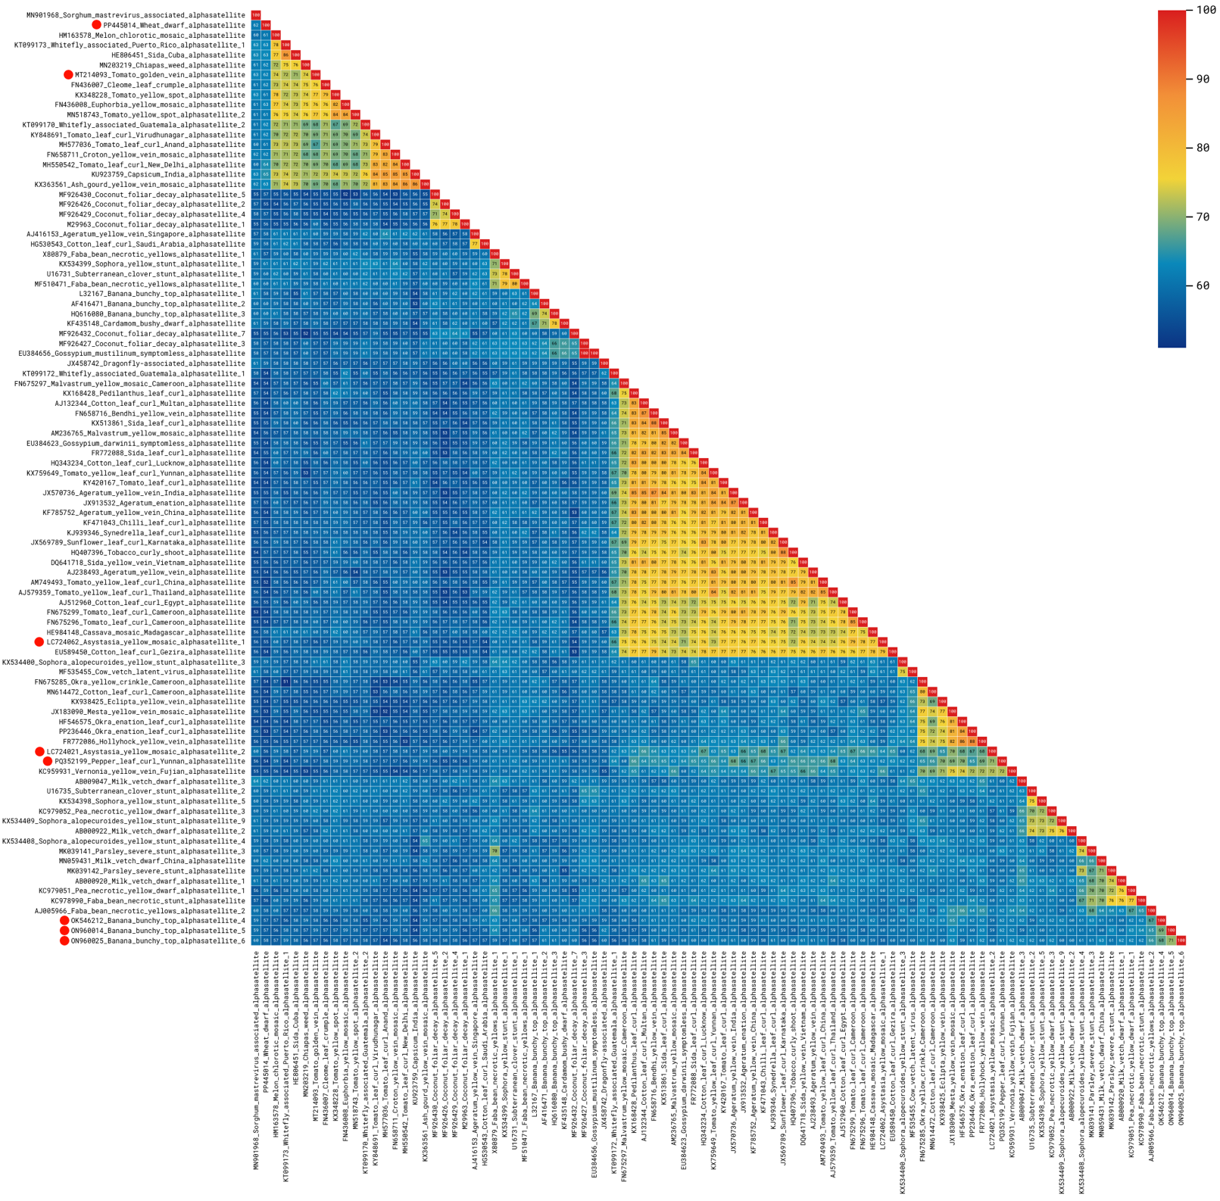

**Figure 1.** Pairwise nucleotide sequence identities (%) for the full-length genomes of alphasatellites, including the members of the 8 new species being proposed (indicated by the red circles). Identities were calculated with SDT [9] v. 2 (github.com/SDT-org/SDT2/releases/tag/v2.0.0.beta4.20250302.2).

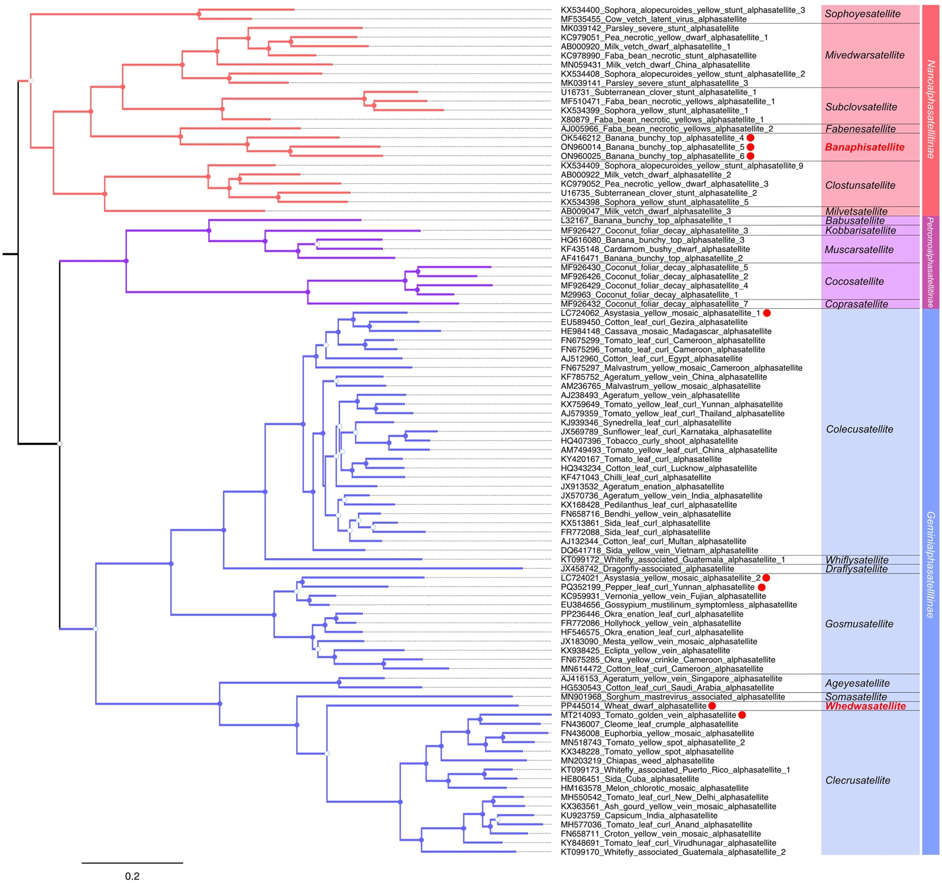

**Figure 2.** Midpoint-rooted, maximum-likelihood phylogenetic tree based on the complete sequences of alphasatellites, including the members of the 8 new species being proposed (indicated by the red circles). New genera are indicated in red bold font. Filled circles at the branches indicate bootstrap values >85%, open circles indicate values between 50 and 84%. The scale bar indicates nucleotide substitutions per site. Sequences were aligned with MAFFT [10] and the tree was constructed with IQ-TREE [11] using the TIM2+F+I+G4 nucleotide substitution model (determined by ModelFinder [12]) and the ultrafast bootstrap option [13]. The tree was edited in FigTree (tree.bio.ed.ac.uk/software/figtree).