

The International Committee on Taxonomy of Viruses

Taxonomy Proposal Form, 2025

**Part 1a: Details of taxonomy proposals**

|  |  |
| --- | --- |
| **Title:** | Create one (1) new species in the genus *Capulavirus (Geplafuvirales*: *Geminiviridae)* |
| **Code assigned:** | 2025.011P.Geminiviridae_Capulavirus_1nsp | |

|  |  |  |  |  |
| --- | --- | --- | --- | --- |
| **Author(s), affiliation and email address(es):** | | | | |
| **Given name (+middle initial(s))** | **Surname** |  | **Email address** | **Corr. author(s)** |
| Philippe | Roumagnac | CIRAD, UMR PHIM, Montpellier, France | philippe.roumagnac@cirad.fr | X |
| Jose | Ascencio-Ibanez | North Carolina State University, Raleigh, USA | jtascenc@ncsu.edu |  |
| Jean-Michel | Lett | CIRAD, UMR PVBMT, Saint Pierre de la Réunion, France | lett@cirad.fr |  |
| Paola M. | López-Lambertini | INTA-CIAP-IPAVE, Universidad Nacional de Córdoba, Córdoba, Argentina | plopezlambertini@gmail.com |  |
| Darren P. | Martin | Institute of Infectious Disease and Molecular Medicine, University of Cape Town, Cape Town, South Africa | darrenpatrickmartin@gmail.com |  |
| Jesús | Navas-Castillo | Instituto de Hortofruticultura Subtropical y Mediterránea “La Mayora” (IHSM-UMA-CSIC), Málaga, Spain | jnavas@eelm.csic.es |  |
| Simone | Ribeiro | Embrapa Recursos Genéticos e Biotecnologia, Brasília, Brazil | simone.ribeiro@embrapa.br |  |
| Cica | Urbino | CIRAD, UMR PHIM, Montpellier, France | cica.urbino@cirad.fr |  |
| Arvind | Varsani | The Biodesign Center for Fundamental and Applied Microbiomics, Center for Evolution and Medicine, School of Life Sciences, Arizona State University, Tempe,Arizona, USA | Arvind.varsani@asu.edu |  |
| F. Murilo | Zerbini | Dep. de Fitopatologia, Universidade Federal de Viçosa, Viçosa, Brasil | [zerbini@ufv.br](mailto:zerbini@ufv.br) |  |

**Part 1b: Taxonomy Proposal Submission**

|  |  |  |  |
| --- | --- | --- | --- |
| **ICTV Subcommittee:** | | | |
| Animal DNA Viruses and Retroviruses |  | Bacterial viruses |  |
| Animal minus-strand and dsRNA viruses |  | Fungal and protist viruses |  |
| Animal positive-strand RNA viruses |  | Plant viruses | **X** |
| Archaeal viruses |  | General |  |

|  |
| --- |
| **List the ICTV Study Group(s) that have seen or have been involved in creating this proposal:** |
| *Geminiviridae* and *Tolecusatellitidae* Study Group |

|  |  |  |  |
| --- | --- | --- | --- |
| **Optional – complete only if formally voted on by an ICTV Study Group:** | | | |
| **Study Group** | **Number of members** | | |
| **Votes in support** | **Votes against** | **No vote** |
| Roumagnac, Philippe  Ascencio-Ibanez, Jose  Lett, Jean-Michel  López-Lambertini, Paola M.  Martin, Darren  Navas-Castillo, Jesús  Ribeiro, Simone  Urbino, Cica  Varsani, Arvind  Zerbini, F. Murilo | Y  Y  Y  Y  Y  Y  Y  Y  Y  Y |  |  |

|  |  |
| --- | --- |
| **Submission date:** | 10/06/2025 |

**Part 1c: Feedback from ICTV Executive Committee (EC) meeting**

|  |  |
| --- | --- |
| **Executive Committee Meeting Decision code:** | **X** |
| A – Accept |  |
| Ac – Accept subject to revision by relevant subcommittee chair. No further vote required |  |
| U – Accept without revision but with re-evaluation and email vote by the EC |  |
| Uc – Accept subject to revision and re-evaluation and email vote by the EC |  |
| Ud – Deferred to the next EC meeting, with an invitation to revise based on EC comments |  |
| J - Reject |  |
| W - Withdrawn |  |

|  |
| --- |
| **Comments from the Executive Committee:** |
|  |

**Part 1d: Revised Taxonomy Proposal Submission**

|  |
| --- |
| **Response of proposer:** |
|  |

|  |  |
| --- | --- |
| **Revision date:** |  |

**Part 3:** **TAXONOMIC PROPOSAL**

|  |  |  |  |
| --- | --- | --- | --- |
| **Taxonomic changes proposed:** | | | |
| Establish new taxon | **x** | Split taxon |  |
| Abolish taxon |  | Merge taxon |  |
| Move taxon |  | Promote taxon |  |
| Rename taxon |  | Demote taxon |  |
| Move and rename |  |

|  |  |
| --- | --- |
| **Etymology (origin) of proposed taxonomic names:** | |
| **Taxon name** | **Etymology of the term** |
| *Capulavirus betae* | Species epithet (*betae*) derived from the host plant: *Beta vulgaris* L. |
|  |  |
|  |  |
|  |  |

|  |  |  |
| --- | --- | --- |
| **Permission for use of names derived from a living person:** | | |
| **Taxon name** | **Full name of person from whom the name is derived** | **Attached** |
|  |  |  |
|  |  |  |
|  |  |  |
|  |  |  |

|  |
| --- |
| **Abstract of Taxonomy Proposal:** |
| *Taxonomic rank(s) affected*:  *Capulavirus* genus in the *Geminiviridae* family  *Description of current taxonomy*:  *Monodnaviria* / Shotokuvirae / *Cressdnaviricota* / *Repensiviricetes* / *Geplafuvirales* / *Geminiviridae* / *Capulavirus*  *Proposed* *taxonomic change(s):*  We proposed to create one new species in the *Capulavirus* genus: “*Capulavirus* *betae*”  *Justification*:  Similar to members of the *Capulavirus* genus, members of the proposed new species “*Capulavirus* *betae*” have the virion-strand origin of replication nonanucleotide motif ‘TAATATTAC’ and show a typical capulavirus organization, with putative multiple overlapping short ORFs (V3 and V4) upstream of the CP gene that encode putative movement proteins. In addition, genome-wide pairwise analysis of the representative genomes of capulaviruses showed that beet capulavirus 1 sequence genome shared less than 78% identity with all representative genomes of capulaviruses. Since 78% nucleotide identity is the genome-wide species demarcation threshold for capulaviruses, we conclude that beet capulavirus 1 can be classified into the species “*Capulavirus* *betae”*, a new species in the genus *Capulavirus*. |

|  |
| --- |
| **Text of Taxonomy proposal:** |
| *Taxonomic rank(s) affected*:  *Capulavirus* genus in the *Geminiviridae* family (Order *Geplafuvirales*)  *Description of current taxonomy*:  *Monodnaviria* / *Shotokuvirae* / *Cressdnaviricota* / *Repensiviricetes* / *Geplafuvirales* / *Geminiviridae* / *Capulavirus*  Five species are currently assigned to the *Capulavirus* genus in the *Geminiviridae* family:   * *Capulavirus euphorbiae* * *Capulavirus medicagonis* * *Capulavirus phaseoli* * *Capulavirus plantagonis* * *Capulavirus trifolii*   *Proposed* *taxonomic change(s)*:  We proposed to create one new species in the *Capulavirus* genus: “*Capulavirus* *betae*”, which was isolated from sugar beet (*Beta vulgaris* L.) collected from France [1]  *Demarcation criteria:*  A 78% pairwise identity species demarcation threshold has been proposed and adopted for the genus *Capulavirus* [2].  *Justification*:  Based on he sequence analysis, beet capulavirus 1 summarized in Table 1 can be classified into one new species that share <78% genome-wide pairwise identity with all classified capulaviruses (Figure 1). Furthermore, this is supported by phylogenetic analysis (Figure 2). |

|  |
| --- |
| **References:** |
| [1] Zhang Z, Faure C, Marais A, Monteiro A, Candresse T, 2025. A new capulavirus infecting sugar beet (Beta vulgaris L.) in France. Arch. Virol. 170, 34.  [2] Varsani, A., Roumagnac, P., Fuchs, M., Navas-Castillo, J., Moriones, E., Idris, A., Briddon, R.W., Rivera-Bustamante, R., Murilo Zerbini, F., Martin, D.P., 2017. Capulavirus and Grablovirus: two new genera in the family Geminiviridae. Arch Virol 162, 1819-1831.  [3] Muhire, B.M., Varsani, A., Martin, D.P., 2014. SDT: a virus classification tool based on pairwise sequence alignment and identity calculation. PLoS One 9, e108277.  [4] Larkin, M.A., Blackshields, G., Brown, N.P., Chenna, R., McGettigan, P.A., McWilliam, H., Valentin, F., Wallace, I.M., Wilm, A., Lopez, R., Thompson, J.D., Gibson, T.J., Higgins, D.G., 2007. Clustal W and Clustal X version 2.0. Bioinformatics 23, 2947-2948. |

|  |  |
| --- | --- |
| **Accompanying files** | |
| **Filename** | **Description of contents** |
| 2025.011P.N.v2.Geminiviridae_Capulavirus_1nsp | spreadsheet |
|  |  |

|  |
| --- |
| **Tables, Figures:** |

**Table 1:** Summary of the new proposed species in the *Capulavirus* genus of the *Geminiviridae* family. The new species is highlighted in red font.

|  |  |  |  |  |  |  |  |
| --- | --- | --- | --- | --- | --- | --- | --- |
| **Genus** | **Species** | **Accession #** | **Virus name** | **Acronym** | **Isolate** | **Country** | **Host/Source** |
| *Capulavirus* | *Capulavirus betae* | PQ682516 | beet capulavirus 1 | BCV1 | 04-24 | France | *Beta vulgaris* L. |

**Figure 1:** Pairwise identity matrix inferred using SDT v1.2 [3].

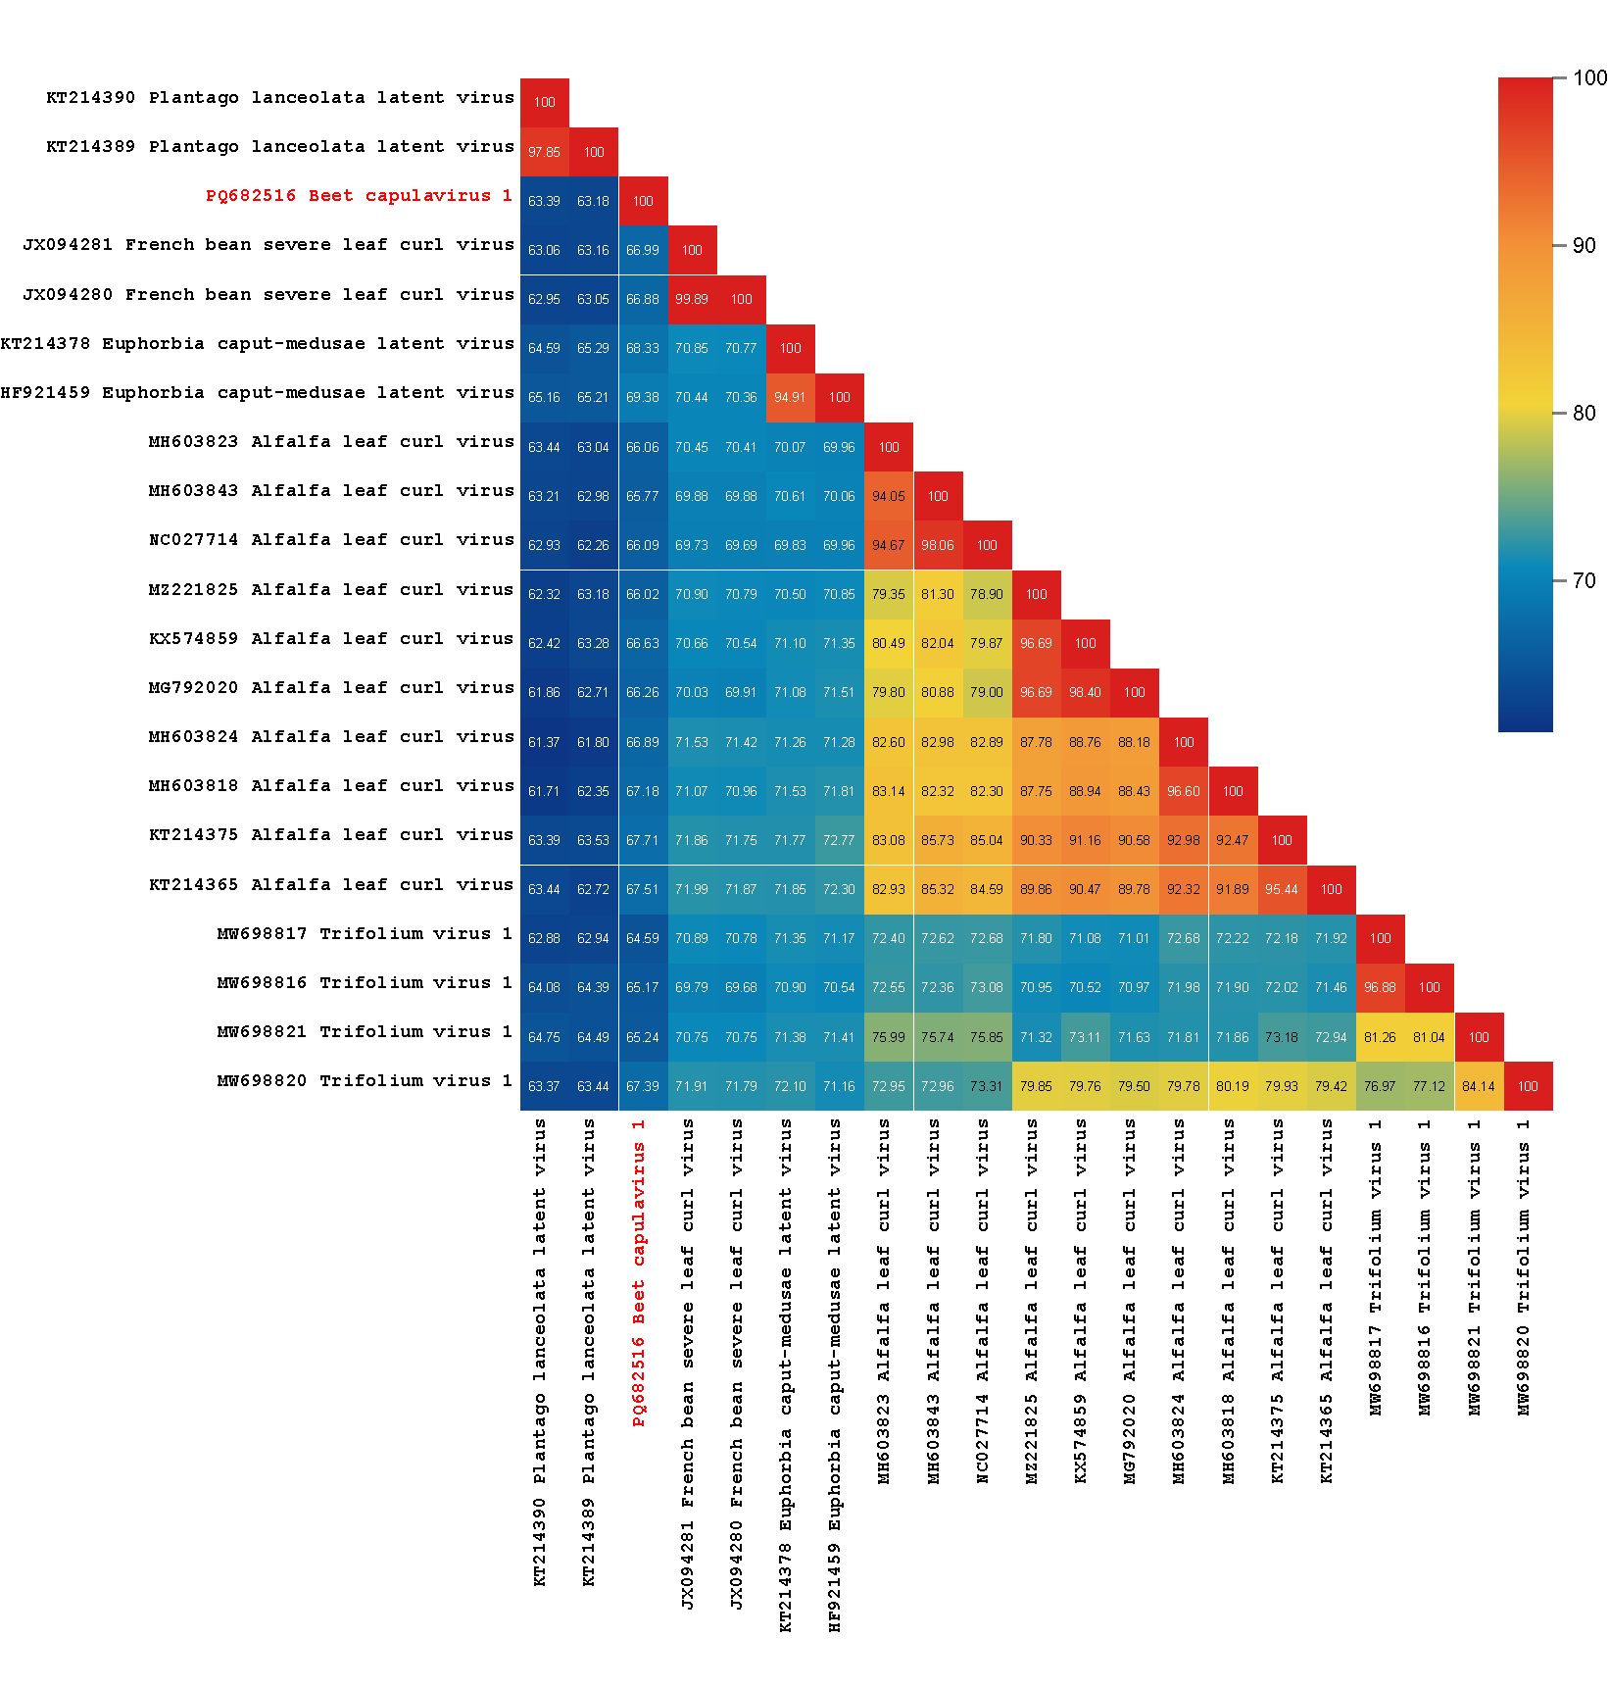

**Figure 2:** Unrooted neighbor-joining tree inferred from aligned full-genome nucleotide sequences of all *Capulavirus* species and *Capulavirus* *betae*. The genomes were aligned using Clustal W [4] and a Neighbor-joining phylogenetic tree was inferred with Jukes Cantor substitution model and 1000 bootstrap iterations.

