

The International Committee on Taxonomy of Viruses

Taxonomy Proposal Form, 2025

**Part 1a: Details of taxonomy proposals**

|  |  |
| --- | --- |
| **Title:** | Create three (3) new species in the genus *Begomovirus* |
| **Code assigned:** | 2025.010P.Begomovirus_3nsp |

|  |  |  |  |  |
| --- | --- | --- | --- | --- |
| **Author(s), affiliation and email address(es):** | | | | |
| **Given name (+middle initial(s))** | **Surname** | **Affiliation** | **Email address** | **Corr. author(s)** |
| F Murilo | Zerbini | Dep. de Fitopatologia/BIOAGRO, Universidade Federal de Viçosa, Viçosa, Brazil | zerbini@ufv.br | X |
| José T | Ascencio-Ibañez | North Carolina State University, Raleigh, USA | jtascenc@ncsu.edu |  |
| Cica | Urbino | CIRAD, UMR PHIM, Montpellier, France | cica.urbino@cirad.fr |  |
| Jean-Michel | Lett | CIRAD, UMR PVBMT, Saint Pierre de la Réunion, France | lett@cirad.fr |  |
| Paola | López-Lambertini | INTA-CIAP-IPAVE, Universidad Nacional de Córdoba, Córdoba, Argentina | plopezlambertini@gmail.com |  |
| Jesús | Navas-Castillo | Instituto de Hortofruticultura Subtropical y Mediterránea “La Mayora” (IHSM-UMA-CSIC), Málaga, Spain | jnavas@eelm.csic.es |  |
| Darren P | Martin | Institute of Infectious Disease and Molecular Medicine, University of Cape Town, Cape Town, South Africa | darrenpatrickmartin@gmail.com |  |
| Simone G | Ribeiro | Embrapa Recursos Genéticos e Biotecnologia, Brasília, Brazil | simone.ribeiro@embrapa.br |  |
| Philippe | Roumagnac | CIRAD, UMR PHIM, Montpellier, France | philippe.roumagnac@cirad.fr |  |
| Arvind | Varsani | The Biodesign Center for Fundamental and Applied Microbiomics, Center for Evolution and Medicine, School of Life Sciences, Arizona State University, Tempe, USA | Arvind.varsani@asu.edu |  |

**Part 1b: Taxonomy Proposal Submission**

|  |  |  |  |
| --- | --- | --- | --- |
| **ICTV Subcommittee:** | | | |
| Animal DNA Viruses and Retroviruses |  | Bacterial viruses |  |
| Animal minus-strand and dsRNA viruses |  | Fungal and protist viruses |  |
| Animal positive-strand RNA viruses |  | Plant viruses | **X** |
| Archaeal viruses |  | General |  |

|  |
| --- |
| **List the ICTV Study Group(s) that have seen or have been involved in creating this proposal:** |
| *Geminiviridae* and *Tolecusatellitidae* |

|  |  |  |  |
| --- | --- | --- | --- |
| **Optional – complete only if formally voted on by an ICTV Study Group** | | | |
| **Study Group** | **Number of members** | | |
| **Votes in support** | **Votes against** | **No vote** |
| *Geminiviridae* and *Tolecusatellitidae* |  |  |  |

|  |  |
| --- | --- |
| **Submission date:** | 05/06/2025 |

**Part 1c: Feedback from ICTV Executive Committee (EC) meeting**

|  |  |
| --- | --- |
| **Executive Committee Meeting Decision code:** | **X** |
| A – Accept |  |
| Ac – Accept subject to revision by relevant subcommittee chair. No further vote required |  |
| U – Accept without revision but with re-evaluation and email vote by the EC |  |
| Uc – Accept subject to revision and re-evaluation and email vote by the EC |  |
| Ud – Deferred to the next EC meeting, with an invitation to revise based on EC comments |  |
| J - Reject |  |
| W - Withdrawn |  |

|  |
| --- |
| **Comments from the Executive Committee:** |
|  |

**Part 1d: Revised Taxonomy Proposal Submission**

|  |
| --- |
| **Response of proposer:** |
|  |

|  |  |
| --- | --- |
| **Revision date:** |  |

**Part 3:** **TAXONOMIC PROPOSAL**

|  |  |  |  |
| --- | --- | --- | --- |
| **Taxonomic changes proposed:** | | | |
| Establish new taxon | **X** | Split taxon |  |
| Abolish taxon |  | Merge taxon |  |
| Move taxon |  | Promote taxon |  |
| Rename taxon |  | Demote taxon |  |
| Move and rename |  |

|  |  |
| --- | --- |
| **Etymology (origin) of proposed taxonomic names:** | |
| **Taxon name** | **Etymology of the term** |
| *Begomovirus clitoriae* | From the host, *Clitoria ternatea* |
| *Begomovirus melochiasecundi* | The second species named after the host, *Melochia tomentosa* |
| *Begomovirus citharexyli* | From the host, *Citharexylum* *spinosum* |

|  |  |  |
| --- | --- | --- |
| **Permission for use of names derived from a living person:** | | |
| **Taxon name** | **Full name of person from whom the name is derived** | **Attached** |
|  |  |  |

|  |
| --- |
| **Abstract of Taxonomy Proposal:** |
| *Taxonomic rank affected*:  Genus *Begomovirus*  *Description of current taxonomy*:  *Monodnaviria* -> *Shotokuvirae* -> *Cressdnaviricota* -> *Repensiviricetes* -> *Geplafuvirales* -> *Geminiviridae* -> *Begomovirus*  Within the genus *Begomovirus*, viruses are classified into species based on a 91% genome-wide (or DNA-A in the case of bipartite viruses) pairwise identity threshold [1].    *Proposed* *taxonomic changes:*  Creation of 3 new species to classify new begomoviruses that have been identified and described in the literature over the past two years.  *Justification*:  Members of all 3 proposed new species share <91% genome-wide (or DNA-A in the case of bipartite viruses) pairwise identity with sequences of members of currently established begomovirus species. |

|  |
| --- |
| **Text of Taxonomy proposal:** |
| *Taxonomic rank affected*:  Genus *Begomovirus*  *Description of current taxonomy*:  *Monodnaviria* -> *Shotokuvirae* -> *Cressdnaviricota* -> *Repensiviricetes* -> *Geplafuvirales* -> *Geminiviridae* -> *Begomovirus*  *Begomovirus* is one of the largest genera in the virosphere, with 464 species.  *Proposed* *taxonomic changes*:  Create 3 new species in the genus *Begomovirus*.  *Demarcation criteria:* 91% genome-wide (or DNA-A in the case of bipartite begomoviruses) pairwise identity threshold [1].  *Justification*: The 3 begomoviruses summarized in Table 1 can be classified into new species that share <91% genome-wide (or DNA-A in the case of bipartite begomoviruses) pairwise identity with all classified begomoviruses. This is supported by maximum likelihood phylogenetic analysis.  We provide a brief description of each proposed new species below:    ***"Begomovirus clitoriae"*** [2]  - Leaf samples from two *Clitoria ternatea* plants exhibiting yellow mosaic symptoms were collected in Kanpur, Uttar Pradesh, India, in August 2023  - Total DNA was extracted and used as a template for rolling circle amplification (RCA); RCA products were digested with restriction enzymes and a band with ~2.7 kb was cloned and Sanger sequenced  - The clone corresponded to a begomovirus, and sequence demarcation tool SDT analysis indicated a maximum nucleotide sequence identity of 82.6% with the DNA-A of Cajanus scarabaeoides yellow mosaic virus (CsYMV, OM397101) (Figure 1)  - A cognate DNA-B was also cloned and sequence, displaying a maximum nt sequence identity of 77.2% with the DNA-B of Rhincosia yellow mosaic virus (RhYMV, KP752091)  - The authors propose to classify the new begomovirus isolate, named butterfly pea yellow mosaic virus (BpYMV), as a new species, for which they propose the name "*Begomovirus clitoriae"*  ***"Begomovirus melochiasecundi"*** [3]  - The virus was isolated from a non-symptomatic *Melochia tomentosa* (family Malvaceae) plant; the plant species was confirmed by sequencing of *matK* and *rbcL* genes  - The sequence was obtained using standard procedures (RFLP-RCA, cloning) and used for percentage nucleotide identity comparisons (SDT)  - The DNA-A-like sequence shared the highest nucleotide sequence similarity with African monopartite begomoviruses, including tomato curly stunt virus (ToLCSV) [MT878443] (74.5% identity) (Figure 2)  - No evidence of recombination events, no DNA-B or satellite DNA sequences were detected in the sample  - The authors propose to classify the new begomovirus isolate, named Melochia associated virus (MeAV), as a new species, for which they initially proposed the name "*Begomovirus melochiae*". However, this species name already exists, and therefore the SG proposes the name "*Begomovirus melochiasecundi*"  ***"Begomovirus citharexyli*** [4]  - The sequence was obtained using standard procedures (RCA, cloning) and used for percentage nucleotide identity comparisons (SDT)  - The DNA-A-like sequence shares 89.46% nucleotide sequence identity with papaya leaf crumple virus (PaLCrV) isolate (KR071789) and 89.54% with rose leaf curl virus (OQ411588) (Figure 3)  - A putative recombination event was identified in CitLCuV genome at nt position 70-2106, with tomato leaf curl Kerala virus (KF551575) as major parent and Chenopodium leaf distortion virus (MN423112) as minor parent (RDP4, 7 detection methods with significant *p* values)  - Phylogenetic tree placed CitLCuV in a sister clade to PaLCrV isolates and these together with rose leaf curl virus isolates formed a distinct subclade  - No satellite DNA sequences were detected in the sample by PCR methods with universal primers  - The authors propose to classify the new begomovirus isolate, named Citharexylum leaf curl virus (CitLCuV), as a new species, but do not propose a species name  - The SG proposes the species name "*Begomovirus* *citharexyli*" |

|  |
| --- |
| **References:** |
| [1] Brown JK, Zerbini FM, Navas-Castillo J, Moriones E, Ramos-Sobrinho R, Silva JC, et al. Revision of Begomovirus taxonomy based on pairwise sequence comparisons. Arch Virol. 2015;160:1593-619.  [2] Akram M, Kumar D, Kamaal N. Complete genome sequence of a novel bipartite begomovirus infecting butterfly pea (*Clitoria ternatea* L.) in India. Arch Virol. 2024;170:7.  [3] Ouattara A, Kéré D, Hoareau M, Koïta K, Lefeuvre P, Lett JM. A new monopartite begomovirus infecting *Melochia tomentosa* in Burkina Faso. Arch Virol. 2024;169:240.  [4] Diksha D, Sidharthan VK, Baranwal VK. Identification of a novel monopartite begomovirus associated with leaf curl disease of *Citharexylum spinosum* in India. Virus Genes 2024;60:568-571. |

|  |  |
| --- | --- |
| **Accompanying files:** | |
| **Filename** | **Description of contents** |
| 2025.010P.N.v2.Begomovirus_3nsp | spreadsheet |
| **Tables, Figures:** | |

**Table 1.** Summary of the 3 new species in the genus *Begomovirus* and their members.

|  |  |  |  |  |  |  |
| --- | --- | --- | --- | --- | --- | --- |
| Species name | Accession no. | Virus name | Isolate name | Country | Host/source | Ref. |
| *Begomovirus clitoriae* | PQ298353 (DNA-A), PQ298354 (DNA-B) | butterfly pea yellow mosaic virus (BpYMV) | India:Kanpur:2024 | India | *Clitoria ternatea* | 2 |
| *Begomovirus melochiasecundi* | PP897773 | melochia associated virus (MeAV) | Burkina Faso:Goue:Melochia:856BB:2016 | Burkina Faso | *Melochia tomentosa* | 3 |
| *Begomovirus citharexyli* | OR437368 | Citharexylum leaf curl virus (CitLCuV) | Hyderabad | India | *Citharexylum spinosum* | 4 |



**Figure 1.** Pairwise nucleotide sequence identities (%) for the full-length DNA-A and DNA-B sequences of butterfly pea yellow mosaic virus (BpYMV; "*Begomovirus clitoriae*") and the most closely related begomoviruses. Reproduced from Akram et al. [2], with permission.

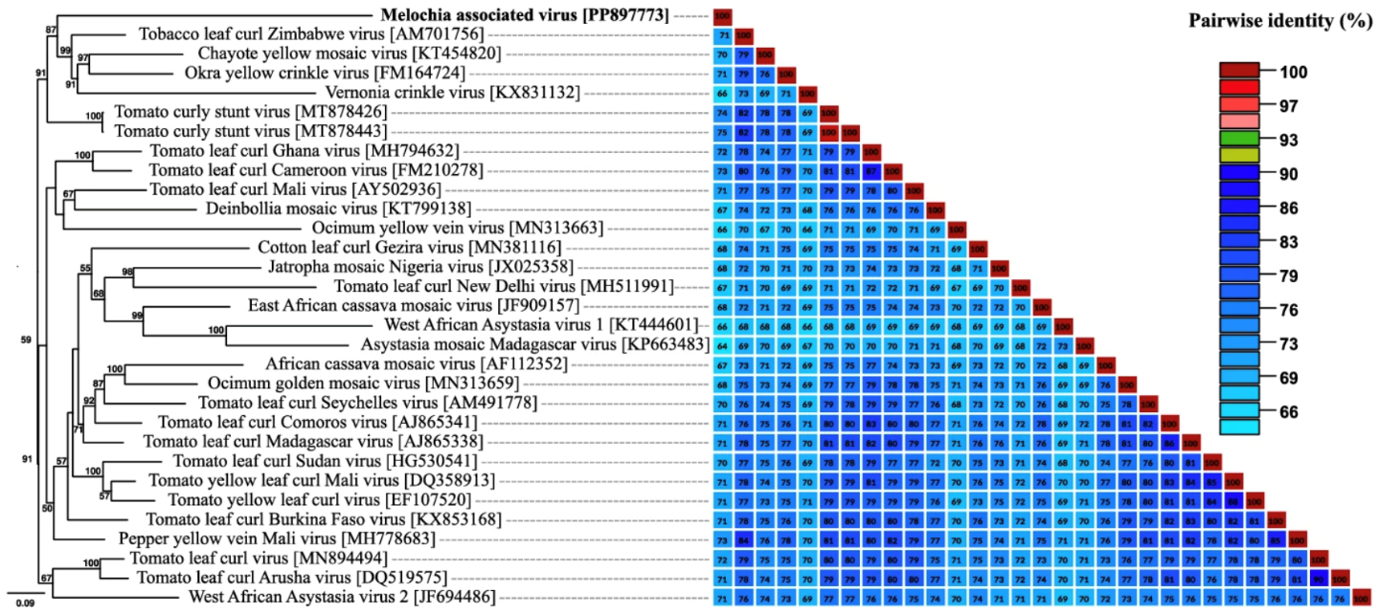

**Figure 2.** Maximum-likelihood phylogenetic tree and pairwise nucleotide sequence identity matrix based on the complete DNA-A-like sequence of Melochia associated virus (MeAV; "*Begomovirus melochiasecundi*") and selected Old World monopartite begomoviruses originating from Africa. The tree was rooted at the midpoint. Only bootstrap values higher than 50% are shown (1000 replicates). Reproduced from Ouatarra et al. [3], with permission.

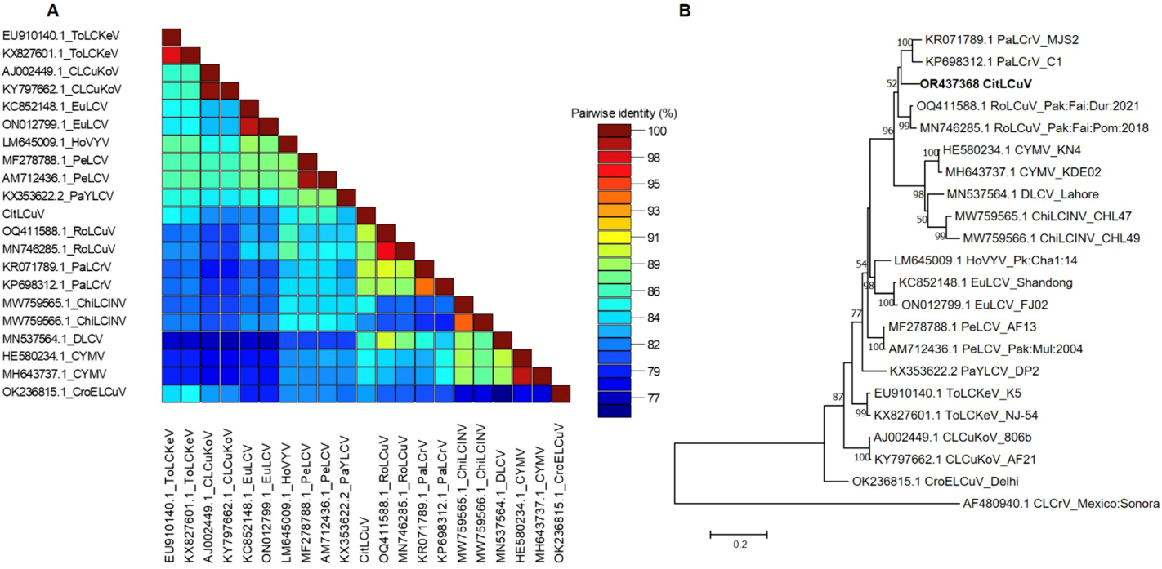

**Figure 3.** (A) Pairwise nucleotide sequence identiy matrix of the complete genome of Citharexylum leaf curl virus (CitLCuV; "*Begomovirus citharexyli*") and the most closely related begomoviruses. (B) Maximum-likelihood phylogenetic tree based on the same data set as in (A). Only bootstrap values more than 50% are indicated. The bipartite begomovruis cotton leaf crumple virus (CLCrV) was used as outgroup. Reproduced from Diksha et al. [4], with permission.