

The International Committee on Taxonomy of Viruses

Taxonomy Proposal Form, 2025

**Part 1a: Details of taxonomy proposals**

|  |  |
| --- | --- |
| **Title:** | Create one (1) new species in the genus *Badnavirus* |
| **Code assigned:** | 2025.003P.Caulimoviridae_Badnavirus_1nsp | |

|  |  |  |  |  |
| --- | --- | --- | --- | --- |
| **Author(s), affiliation and email address(es):** | | | | |
| **Given name (+middle initial(s))** | **Surname** | **Affiliation** | **Email address** | **Corr. author(s)** |
| Marie | **Umber** | INRAE, UR ASTRO, Domaine de Duclos, 97170 Petit Bourg, Guadeloupe, France | [marie.umber@inrae.fr](mailto:marie.umber@inrae.fr) |  |
| Indranil | **Dasgupta** | University of Delhi South Campus, Benito Juarez Road, New Delhi-110021, India | [indranil57@hotmail.com](mailto:indranil57@hotmail.com) |  |
| Andrew D.W. | **Geering** | QAAFI, The University of Queensland, St Lucia QLD 4072, Australia | [a.geering@uq.edu.au](mailto:a.geering@uq.edu.au) |  |
| Anders | **Hafrén** | Swedish University of Agriculture, Almas Allé 5, 75007 Uppsala, Sweden | [anders.hafren@slu.se](mailto:anders.hafren@slu.se) |  |
| Roger | **Hull** | Retired from John Innes Centre | [rogerhull@btinternet.com](mailto:rogerhull@btinternet.com) |  |
| Jan | **Kreuze** | International Potato Center (CIP), Headquarters, P.O. Box 1558, Lima 15024, Peru | [j.kreuze@cgiar.org](mailto:j.kreuze@cgiar.org) |  |
| Scott M. | **Leisner** | University of Toledo, Department of Biological Sciences, Toledo, OH. 43606, USA | [scott.leisner@utoledo.edu](mailto:scott.leisner@utoledo.edu) |  |
| Emmanuelle | **Muller** | CIRAD, UMR AGAP Institut, Avenue Agropolis  34398 Montpellier cedex 5, France | [emmanuelle.muller@cirad.fr](mailto:emmanuelle.muller@cirad.fr) |  |
| Hanu | **Pappu** | Department of Plant Pathology, Washington State University, Pullman, WA, U.S.A | [hrp@wsu.edu](mailto:hrp@wsu.edu) |  |
| Mikhail | **Pooggin** | PHIM Plant Health Institute, Univ Montpellier, INRAE, CIRAD, IRD, Institute Agro, 34980 Montpellier, France | [mikhail.pooggin@inrae.fr](mailto:mikhail.pooggin@inrae.fr) |  |
| Katja | **Richert-Poeggeler** | Julius Kühn-Institut, Messeweg 11-12, D-38104 Braunschweig, Germany | [katja.richert-poeggeler@julius-kuehn.de](mailto:katja.richert-poeggeler@julius-kuehn.de) |  |
| Susan | **Seal** | Natural Resources Institute, University of Greenwich, Central Avenue, Chatham Maritime, Kent ME4 4TB. UK | [S.E.Seal@greenwich.ac.uk](mailto:S.E.Seal@greenwich.ac.uk) |  |
| Livia | **Stavolone** | Institute for Sustainable Plant Protection, National Research Council, via Amendola 165/A I-70126 Bari, Italy | [livia.stavolone@ipsp.cnr.it](mailto:livia.stavolone@ipsp.cnr.it) |  |
| Pierre Yves | **Teycheney** | CIRAD, UMR PVBMT, 7 chemin de l’IRAT, 97410 Saint Pierre, La Réunion, France | [teycheney@cirad.fr](mailto:teycheney@cirad.fr) | x |

**Part 1b: Taxonomy Proposal Submission**

|  |  |  |  |
| --- | --- | --- | --- |
| **ICTV Subcommittee:** | | | |
| Animal DNA Viruses and Retroviruses |  | Bacterial viruses |  |
| Animal minus-strand and dsRNA viruses |  | Fungal and protist viruses |  |
| Animal positive-strand RNA viruses |  | Plant viruses | **X** |
| Archaeal viruses |  | General |  |

|  |
| --- |
| **List the ICTV Study Group(s) that have seen or have been involved in creating this proposal:** |
| *Caulimoviridae* |

|  |  |  |  |
| --- | --- | --- | --- |
| **Optional – complete only if formally voted on by an ICTV Study Group:** | | | |
| **Study Group** | **Number of members** | | |
| **Votes in support** | **Votes against** | **No vote** |
| *Caulimoviridae* | 11 | 0 | 3 |

|  |  |
| --- | --- |
| **Submission date:** | 13/06/2025 |

**Part 1c: Feedback from ICTV Executive Committee (EC) meeting**

|  |  |
| --- | --- |
| **Executive Committee Meeting Decision code:** | **X** |
| A – Accept |  |
| Ac – Accept subject to revision by relevant subcommittee chair. No further vote required |  |
| U – Accept without revision but with re-evaluation and email vote by the EC |  |
| Uc – Accept subject to revision and re-evaluation and email vote by the EC |  |
| Ud – Deferred to the next EC meeting, with an invitation to revise based on EC comments |  |
| J - Reject |  |
| W - Withdrawn |  |

|  |
| --- |
| **Comments from the Executive Committee:** |
|  |

**Part 1d: Revised Taxonomy Proposal Submission**

|  |
| --- |
| **Response of proposer:** |
|  |

|  |  |
| --- | --- |
| **Revision date:** |  |

**Part 3:** **TAXONOMIC PROPOSAL**

|  |  |  |  |
| --- | --- | --- | --- |
| **Taxonomic changes proposed:** | | | |
| Establish new taxon | **X** | Split taxon |  |
| Abolish taxon |  | Merge taxon |  |
| Move taxon |  | Promote taxon |  |
| Rename taxon |  | Demote taxon |  |
| Move and rename |  |

|  |  |
| --- | --- |
| **Etymology (origin) of proposed taxonomic names:** | |
| **Taxon name** | **Etymology of the term** |
| *Badnavirus urticae* | *Urticae* is the genitive of the genus *Urtica* to which NBV1's host plant *Urtica dioica* belongs |

|  |  |  |
| --- | --- | --- |
| **Permission for use of names derived from a living person:** | | |
| **Taxon name** | **Full name of person from whom the name is derived** | Not applicable |

|  |
| --- |
| **Abstract of Taxonomy Proposal:** |
| *Taxonomic rank(s) affected*:  Genus, Species  *Description of current taxonomy*:  The family *Caulimoviridae* [1] currently comprises 11 genera whose members share similar genome organization. The molecular species demarcation criteria is < 80% identity of nucleotide sequences in the reverse transcriptase (RT) / ribonuclease H (RNase H) region of the polymerase. Genus *Badnavirus* [2] currently includes 74 species and is the largest genus within the family *Caulimoviridae*.  *Proposed* *taxonomic change(s):*  We propose the creation of one new species in the genus *Badnavirus*: “*Badnavirus urticae”*  *Justification*:  The complete genomes of nettle badnavirus 1 (NBV1), was sequenced and published recently. Its organization is similar to that of other members of genus *Badnavirus.* Phylogenetic analyses place NBV1 in this genus as distinct representative of a novel species. |

|  |
| --- |
| **Text of Taxonomy proposal:** |
| *Taxonomic rank(s) affected*:  Genus, Species  *Description of current taxonomy*:  The family *Caulimoviridae* [1] currently comprises 11 genera whose members share similar genome organization. Genus *Badnavirus* [2] currently includes 74 species and is the largest genus within the family *Caulimoviridae*.  *Proposed* *taxonomic change(s):*  We propose the creation of one new species in the genus *Badnavirus*: “*Badnavirus urticae”*  *Demarcation criteria:*  The molecular species demarcation criteria is <80% identity of nucleotide sequences in the reverse transcriptase (RT) / ribonuclease H (RNase H) region of the polymerase.  *Justification*:  *“Badnavirus urticae”* can be considered a new species in the genus *Badnavirus* for the following reasons:   1. Its exemplar virus isolate, nettle badnavirus 1 (NBV1, [3]), has a 7 598bp circular double-stranded (ds) DNA genome with an organization typical of members of the genus *Badnavirus*, with 3 putative open reading frames (ORF1 to ORF3). ORF3 encodes a large putative polyprotein with conserved domains of a zinc finger, an aspartate protease, a reverse transcriptase and a ribonuclease H. 2. The genome of NBV1 harbors a putative tRNAMet primer binding site. 3. No endogenous NBV1 sequence was found in the genome of its host plant *Urtica dioica* in Blast analyses using a chromosome-level assembly of *Urtica dioica* 4. In phylogenetic analyses using the RT/RH1 domain nucleotide sequence, NBV1 groups within the genus *Badnavirus* (Fig. 1). Its closest relative is green Sichuan pepper vein clearing-associated virus (GSPVCaV, species *Badnavirus venazanthoxyli*) (Table 1). 5. NBV1 displays only 75.7% nucleotide (nt) sequence identity with GSPVCaV in the RT/RH1 domain (Table 1), which is below the species demarcation threshold of 80% nt sequence identity, justifying the classification of *Badnavirus urticae* as a separate species. 6. Species name complies with the binomial nomenclature, with the free epithet derived from genus *Urtica* to which NBV 1’s host plant *Urtica dioicae* belongs. |

|  |
| --- |
| **References:** |
| [1] Teycheney PY, Geering ADW, Dasgupta I, Hull R, Kreuze JF, Lockhart B, Muller E, Olszewski N, Pappu H, Pooggin MM, Richert-Pöggeler KR, Schoelz JE, Seal S, Stavolone L, Umber M (2020) ICTV Virus Taxonomy Profile: *Caulimoviridae*. J Gen Virol. 101(10):1025-1026. <https://doi.org/10.1099/jgv.0.001497>  [2] Geering, A.D.W. (2021) Badnaviruses (*Caulimoviridae*). In: Bamford, D.H. and Zuckerman, M. (eds.) Encyclopedia of Virology, 4th Edition, vol. 3, pp. 158–168. Oxford: Academic Press. <http://dx.doi.org/10.1016/B978-0-12-814515-9.00147-8>  [3] Motsar E, Sheveleva A, Tsygankova S, Sharko F, Petrova K, Mitrofanova I, Chirkov S. (2025) Complete genome sequence of a new member of the genus *Badnavirus* infecting nettle (*Urtica dioica*). Arch Virol. 170(1):9. <https://doi.org/10.1007/s00705-024-06197-y> |

|  |  |
| --- | --- |
| **Accompanying files:** | |
| **Filename** | **Description of contents** |
| 2025.003P.N.v2.Caulimoviridae_Badnavirus_1nsp | Taxonomic characteristics of the proposed new species |

|  |
| --- |
| **Tables, Figures:** |

**Figure 1: Phylogenetic tree showing placement of nettle badnavirus 1 (NBV1; exemplar virus of species “*Badnavirus urticae”)*.**

Maximum likelihood phylogenetic tree showing the relationships between sequences of viruses from the different genera in the family *Caulimoviridae*. Phylogenetic analyses were performed on the coding part of polymerase gene sequences of exemplar virus isolates of each viral species, corresponding to nucleotide positions 4449–5648 in the genome of cauliflower mosaic virus (V00141). Nucleotide sequence alignment was generated using MAFFT and phylogenetic analyses was done using IQTree v. 1.7 beta with GTR+F+I+G4 model. Support values above 95% from UltraFast bootstrap method with 10,000 replicates are shown above branches. Saccharomyces cerevisiae Ty3 virus (genus *Metavirus,*family *Metaviridae*) was used as an outgroup. Colored dots indicate genera. Type members of the proposed new species are shown with open circles and in red boxes. The phylogenetic placement of NBV1 is shown in a red box.

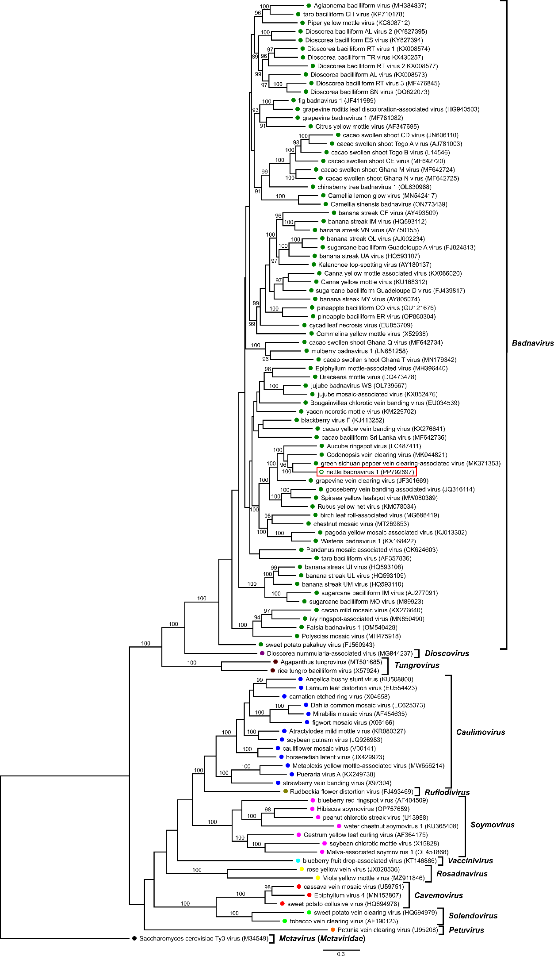

**Table 1: Percent nucleotide identities for the *Caulimoviridae* in *pol* gene nucleotide sequences.**

Figures corresponding to nettle badnavirus 1 (NBV1) are highlighted in red.

