

The International Committee on Taxonomy of Viruses

Taxonomy Proposal Form, 2025

**Part 1a: Details of taxonomy proposals**

|  |  |
| --- | --- |
| **Title:** | Reorganization of the realm *Monodnaviria* by moving three of the four kingdoms to new realms and renaming the realm *Monodnaviria* to “*Floreoviria*” |
| **Code assigned:** | 2025.002G.Ac.v2.Monodnaviria_reorg_4nr | |

|  |  |  |  |  |
| --- | --- | --- | --- | --- |
| **Author(s), affiliation and email address(es):** | | | | |
| **Given name (+middle initial(s))** | **Surname** | **Affiliation** | **Email address** | **Corr. author(s)** |
| Mart | Krupovic | Institut Pasteur, Université Paris Cité, CNRS UMR6047, Cell Biology and  Virology of Archaea Unit, Paris, France | mart.krupovic@pasteur.fr | X |
| Arvind | Varsani | The Biodesign Center for Fundamental and Applied Microbiomics, Center for Evolution and Medicine, School of Life Sciences, Arizona State University, 1001 S. McAllister Ave, Tempe, AZ 85287-5001, USA | arvind.varsani@asu.edu |  |
| Simon | Roux | DOE Joint Genome Institute, Lawrence Berkeley National Laboratory, Berkeley, CA 94720, USA | sroux@lbl.gov |  |
| F. Murilo | Zerbini | Departamento de Fitopatologia/BIOAGRO, Universidade Federal de Viçosa, Viçosa, State of Minas Gerais, Brazil | zerbini@ufv.br |  |
| Jens H. | Kuhn | Frederick, MD 21704m USA | jens_h_kuhn@comcast.net |  |
| Eugene V. | Koonin | Computational Biology Branch, Division of Intramural Research, National Library of Medicine, National Institutes of Health, Bethesda, MD 20894, USA | koonin@ncbi.nlm.nih.gov |  |

**Part 1b: Taxonomy Proposal Submission**

|  |  |  |  |
| --- | --- | --- | --- |
| **ICTV Subcommittee:** | | | |
| Animal DNA Viruses and Retroviruses |  | Bacterial viruses |  |
| Animal minus-strand and dsRNA viruses |  | Fungal and protist viruses |  |
| Animal positive-strand RNA viruses |  | Plant viruses |  |
| Archaeal viruses |  | General - | **X** |

|  |
| --- |
| **List the ICTV Study Group(s) that have seen or have been involved in creating this proposal:** |
| N/A |

|  |  |  |  |
| --- | --- | --- | --- |
| **Optional – complete only if formally voted on by an ICTV Study Group:** | | | |
| **Study Group** | **Number of members** | | |
| **Votes in support** | **Votes against** | **No vote** |
|  |  |  |  |
|  |  |  |  |

|  |  |
| --- | --- |
| **Submission date:** | 02.07.2025 |

**Part 1c: Feedback from ICTV Executive Committee (EC) meeting**

|  |  |
| --- | --- |
| **Executive Committee Meeting Decision code:** | **X** |
| A – Accept |  |
| Ac – Accept subject to revision by relevant subcommittee chair. No further vote required | **X** |
| U – Accept without revision but with re-evaluation and email vote by the EC |  |
| Uc – Accept subject to revision and re-evaluation and email vote by the EC |  |
| Ud – Deferred to the next EC meeting, with an invitation to revise based on EC comments |  |
| J - Reject |  |
| W - Withdrawn |  |

|  |
| --- |
| **Comments from the Executive Committee:** |
| Some concerns about the names of the new realms, but a 12/18 yes, 3 no, 3 abstain vote by the EC in favor of the proposed names.  To update the Word document to remove tracked changes. |

**Part 1d: Revised Taxonomy Proposal Submission**

|  |
| --- |
| **Response of proposer:** |
| Tracked changes were removed. |

|  |  |
| --- | --- |
| **Revision date:** | 25.08.2025 |

**Part 3:** **TAXONOMIC PROPOSAL**

|  |  |  |  |
| --- | --- | --- | --- |
| **Taxonomic changes proposed:** | | | |
| Establish new taxon | **X** | Split taxon |  |
| Abolish taxon |  | Merge taxon |  |
| Move taxon | **X** | Promote taxon |  |
| Rename taxon |  | Demote taxon |  |
| Move and rename |  |

|  |  |
| --- | --- |
| **Etymology (origin) of proposed taxonomic names:** | |
| **Taxon name** | **Etymology of the term** |
| *Efunaviria* | After Latin letter “ef” and Latin “una” for “one”, i.e., a reference to phage f1. |
| *Volvereviria* | After Latin “volvere” for “to roll”, i.e., a reference to rolling circle replication, uniformly used by viruses in this realm. |
| *Floreoviria* | After Latin “floreo” for blossom, bloom, flourish, referring to the bloom of diversity in the virus realm in terms of genome structures and topologies, mechanisms of replication, and virions structures. |
| *Pleomoviria* | After the **pleomo**rphic morphology of the virion in this realm. |

|  |  |  |
| --- | --- | --- |
| **Permission for use of names derived from a living person:** | | |
| **Taxon name** | **Full name of person from whom the name is derived** | **Attached** |
|  |  |  |
|  |  |  |
|  |  |  |
|  |  |  |

|  |
| --- |
| **Abstract of Taxonomy Proposal:** |
| *Taxonomic rank(s) affected*:  Realm  *Description of current taxonomy*:  Realm *Monodnaviria* includes four kingdoms, *Loebvirae*, *Sangervirae*, *Shotokuvirae*, and *Trapavirae*, which comprise bacteria-infecting viruses that form filamentous virions, bacteria-infecting viruses that form small icosahedral capsid, eukaryote-infecting viruses that form icosahedral capsids, and archaea-infecting viruses that produce pleomorphic virions, respectively.  *Proposed* *taxonomic change(s):*  We propose moving three of the four monodnavirian kingdoms, namely, *Loebvirae*, *Sangervirae*, and *Trapavirae*, into three new realms and renaming the realm *Monodnaviria* to “*Floreoviria*”.  *Justification*:  Realm *Monodnaviria* was created to unify viruses with small single-stranded DNA (ssDNA) or double-stranded DNA (dsDNA) genomes that replicate using, in most cases, homologous rolling circle replication initiation endonucleases (Reps) of the HUH superfamily. However, recent comparative sequence and structural analyses showed that Reps encoded by viruses from these different kingdoms are not orthologous and, in some cases, not homologous (that is, some Reps do not belong to the HUH superfamily). Furthermore, the structural modules of these viruses are also unrelated. Thus, grouping of viruses from the four kingdoms within the same realm is unjustified. |

|  |
| --- |
| **Text of Taxonomy proposal:** |
| *Taxonomic rank(s) affected*:  Realm  *Description of current taxonomy*:  Realm *Monodnaviria* includes four kingdoms, *Loebvirae*, *Sangervirae*, *Shotokuvirae*, and *Trapavirae*, which comprise bacteria-infecting viruses that form filamentous virions, bacteria-infecting viruses that form small icosahedral capsid, eukaryote-infecting viruses that form icosahedral capsids, and archaea-infecting viruses that produce pleomorphic virions, respectively.  *Proposed* *taxonomic change(s)*:  We propose moving three of the four monodnavirian kingdoms, namely, *Loebvirae*, *Sangervirae*, and *Trapavirae*, into three new realms and renaming the realm *Monodnaviria* to “*Floreoviria*”.  *Demarcation criteria:*  Realm 1 (*Loebvirae*): Members of the realm “*Efunaviria*” encode related morphogenetic modules centered around the FtsK family ATPase and hydrophobic MCPs that are extruded from the membrane upon virion assembly and egress, or be demonstrably derived from the bona fide members of this realm.    Realm 2 (*Sangervirae*): Members of the realm “*Volvereviria*” have ssDNA genomes and encode SJR MCPs related to those of other members of the class “*Microviricetes*”, or be demonstrably derived from the bona fide members of this realm.    Realm 3(*Shotokuvirae*): Members of the realm “*Floreoviria*” encode the replication module based on the two-domain replication protein comprising the N-terminal HUH superfamily endonuclease domain and the C-terminal S3H domain, or be demonstrably derived from the bona fide members of this realm.  Realm 4 (*Trapavirae*): Members of the realm “*Pleomoviria*” share the morphogenetic module, consisting of the characteristic membrane fusion protein and matrix protein, and virion assembly mechanism with the existing members of the realm, especially, with the more extensively studied viruses of the family *Pleolipoviridae*.  *Justification*:  Realm *Monodnaviria* was created to unify viruses with small single-stranded DNA (ssDNA) or double-stranded DNA (dsDNA) genomes that replicate using homologous rolling circle replication initiation endonucleases (RCREs) of the HUH superfamily (Koonin et al., 2020). Recent comparative sequence and structural analyses showed that replication proteins encoded by viruses from different kingdoms are not orthologous and, in many cases, not homologous. Furthermore, the structural modules, i.e., sets of genes encoding proteins involved in virion morphogenesis and structure, of these viruses are also unrelated. Thus, grouping of viruses from the four kingdoms within the same realm violates the criterion of virus realm monophyly and is therefore unjustified. Below we outline the properties of viruses classified within the four kingdoms and highlight the inter-kingdom differences.  **Kingdom *Loebvirae***  Viruses in the kingdom *Loebvirae* have circular ssDNA genomes that are packed within helically symmetrical filamentous particles. The morphogenetic module of filamentous phages and their virion morphogenesis process itself are unique among ssDNA viruses. The ssDNA replicative intermediate is being extruded through the host cytoplasmic membrane, with the major capsid proteins (MCPs), which are transiently embedded within the membrane, assembling around the rod-shaped DNA in a helical fashion, dissociating from the membrane in the process. The tips of the filamentous particles are decorated with minor capsid proteins, including those involved in host recognition and binding. The FtsK family ATPase plays a key role in ATP-driven genome extrusion through the membrane.  Kingdom *Loebvirae* includes a single order, *Tubulavirales*, with three families, 32 genera and 61 species. However, over 10,000 loebviraen genomes were identified across bacterial diversity and multiple types of ecosystems by mining genomic and metagenomic data (Figure 1a; Roux et al., 2019). Analysis of this greatly expanded set of loebviraen genomes revealed that whereas the morphogenetic module is relatively well conserved across the kingdom, the replication module varies greatly. Although, by definition, all loebviraens produce ssDNA intermediates, this can be achieved using different mechanisms. The rolling circle replication mechanism can be catalyzed by non-homologous endonucleases (nickases). In particular, the most common RCRE among loebviraens belong to the Rep_trans family (Figure 1b), which is structurally and evolutionarily distinct from the HUH superfamily enzymes. Besides the Rep_trans family enzymes, some loebviarens encode RepL family replication proteins (Rep), structurally related to helix-turn-helix DNA-binding proteins and widespread in plasmids of gram-positive bacteria (Hefford et al., 1997). Finally, certain viruses of the *Plectroviridae* family lack dedicated genes for the genome replication and instead appear to produce the ssDNA intermediates during transposition catalyzed by DDE superfamily transposases of the IS*3* and IS*30* families (Krupovic and Forterre, 2015).  Clustering analysis of the HUH superfamily RCRE encoded by loebviraens showed that they are not monophyletic but have rather been acquired from plasmids on multiple independent occasions (Figure 2; Kazlauskas et al., 2019). Based on the above, there is no evidence that the ancestor of loebviraens encoded an HUH superfamily RCRE. Given the extent of gene replacement, the replication module is not an appropriate feature to classify this kingdom within the realm *Monodnaviria*. Instead, the morphogenetic module appears as a more appropriate hallmark of this virus group. Thus, we propose moving *Loebvirae* out of *Monodnaviria* to a new realm, “*Efunaviria*”.  **Kingdom *Sangervirae***  Kingdom *Sangervirae* comprises viruses with small circular ssDNA genomes and icosahedral capsids. Although the kingdom currently includes a single family, *Microviridae*, a taxonomic proposal has been put forward to promote the family to the rank of a class, “*Microviricetes*”. Sangerviraens are genetically vastly diverse but relatively uniform in terms of both morphogenetic and replication modules. The morphogenetic module commonly consists of the MCP with a single jelly-roll (SJR) fold and a pilot protein involved in genome delivery, but may also include scaffolding proteins, spike protein and other minor components of the virion (Doore and Fane, 2016; Kirchberger and Ochman, 2023). The replication module primarily includes the HUH superfamily RCRE. Notably, neither the MCP nor the RCRE of sangerviraens are closely related to homologs from other known viruses, including members of the three other kingdoms within *Monodnaviria*, suggesting an independent origin of this virus group (Figure 2). Thus, we propose moving kingdom *Sangervirae* to a separate realm, which we propose naming “*Volvereviria*”.  **Kingdom** ***Trapavirae***  Kingdom *Trapavirae* comprises archaea-infecting viruses with enveloped pleiomorphic virions and currently includes two monotypic phyla, *Saleviricota* and *Calorviricota*. Phylum *Saleviricota* contains the family *Pleolipoviridae* which includes viruses with linear or circular dsDNA or ssDNA genomes and infecting extremely halophilic archaea (Liu et al., 2022). Phylum *Calorviricota* also includes a single family, *Thalassapleoviridae*, which includes viruses infecting deep-sea hyperthermophilic archaea (Baquero et al., 2024). Membership within *Trapavirae* is based on the morphogenetic module, which consists of an archaea-specific membrane fusion protein and a conserved membrane-embedded matrix protein. By contrast, the replication modules are highly diverse. Alphapleolipoviruses have ssDNA genomes and encode HUH superfamily RCREs, but these are not monoplyletic and have been exchanged with different plasmid families on several independent occasions (Figure 3). For instance, RCREs of HRPV-1 and HHPV-1 cluster with homologs encoded by pTP2-like and pGRB1-like archaeal plasmids, respectively (Figure 2). The viruses of genus *Betapleolipovirus* do not encode a recognizable replication protein, whereas gammapleolipoviruses encode protein-primed family B DNA polymerases and contain linear dsDNA genomes (Liu et al., 2022). Similarly, in *Thalassapleoviridae*, members of only one of the three genera encode RCRE and appear to replicate by the rolling circle mechanism (Baquero et al., 2024).  The evidence presented above shows that neither morphogenetic nor replicative module link trapaviraens to viruses from the other three kingdoms within *Monodnaviria*. Thus, we propose moving the kingdom *Trapavirae* into a separate new realm, “*Pleomoviria*”.  **Kingdom** ***Shotokuvirae***  Kingdom *Shotokuvirae* is currently the largest kingdom within *Monodnaviria*, with three phyla, *Commensaviricota*, *Cossaviricota*, and *Cressdnaviricota*, which collectively include 29 families of eukaryotic viruses with small circular or linear ssDNA or dsDNA genomes. All viruses within *Shotokuvirae* have small icosahedral capsids, usually built based on the T=1 lattice and less commonly, based on the T=3 lattice. The MCPs of all shotokuviraens have the SJR fold, but in some lineages, e.g., family *Bacilladnaviridae*, the ancestral SJR MCP has been replaced by a non-orthologous one, likely through recombination with ssRNA viruses (Kazlauskas et al., 2017; Munke et al., 2022; Roux et al., 2013; de la Higuera et al., 2020). Most shotokuviraens encode a relatively uniformreplication module consisting of a fusion of the HUH superfamily endonuclease domain and a superfamily 3 helicase (S3H) domain. Nevertheless, the replication module of shotokuviraens has undergone dramatic changes on at least three occasions:   1. In members of the class *Papovaviricetes* (kingdom *Cossaviricota*) the HUH endonuclease domain has been inactivated, while retaining the catalytically active S3H domain. As a result, the HUH domain of the replication proteins of papovaviricetes functions as an origin recognition domain rather than an endonuclease and the replication does not proceed through an ssDNA intermediate; Accordingly, papovaviricetes have circular dsDNA genomes, rather than ssDNA genomes. 2. In members of the class *Mouviricetes* (kingdom *Cossaviricota*), the HUH domain of the RCRE was replaced by a protein-primed family B DNA polymerase (but the S3H domain was retained as a separate gene) (Krupovic and Koonin, 2014). 3. The most radical change has apparently happened in members of the phylum *Commensaviricota* (family *Anelloviridae*), which retained the ancestral SJR MCP (Butkovic et al., 2023) but lost the RCRE. Recent preliminary evidence suggests that anellovirids do not encode any enzymes required for the replication of their genomes, which is performed entirely by the host DNA replisomes (Prince et al., 2025).   These changes in the replication and morphogenetic modules notwithstanding, there is sufficient evidence supporting the common ancestry of all shotokuviraens. In particular, the unique two-domain organization of their replication protein has not been observed in Reps of known viruses outside of *Shotokuvirae*. However, homologous Reps, with the same domain architecture, have been described in a particular group of bacterial plasmids (Figure 2). Thus, the ancestor of shotokuviraens is believed to have an independent origin from a distinct group of RCRE plasmids, independent of those of other monodnavirians (Kazlauskas et al., 2019), justifying the movement of *Shotokuvirae* into a separate realm. We consider that it would be confusing to retain the realm name *Monodnaviria* because it implies monophyly of ssDNA viruses, which is not the case. Besides, the name also implies that all members of the realm have ssDNA genomes, whereas this is not true in the case of *Shotokuvirae*,where members have either ssDNA or dsDNA genomes. However, instead of abolishing realm *Monodnaviria*, we propose renaming it to “*Floreoviria*”. This realm will include kingdom *Shotokuvirae*.  Overall, the four kingdoms within the current realm *Monodnaviria* include four distinct assemblages of viruses that are monophyletic within-kingdom, but unrelated to viruses from the other kingdoms. This conclusion was reached through analysis of both the replication and morphogenetic modules, the two principal components of viruses with small genomes. Thus, to ensure the monophyly of the realms, we consider it necessary to reorganize the existing realm *Monodnaviria* by moving three of the four kingdoms into separate new realms and renaming the realm *Monodnaviria*. |

|  |
| --- |
| **References:** |
| Baquero DP, Bignon EA, Krupovic M. Pleomorphic viruses establish stable relationship with marine hyperthermophilic archaea. ISME J. 2024; 18:wrae008. doi: 10.1093/ismejo/wrae008. PMID: 38366050  Butkovic A, Kraberger S, Smeele Z, Martin DP, Schmidlin K, Fontenele RS, Shero MR, Beltran RS, Kirkham AL, Aleamotu'a M, Burns JM, Koonin EV, Varsani A, Krupovic M. Evolution of anelloviruses from a circovirus-like ancestor through gradual augmentation of the jelly-roll capsid protein. Virus Evol. 2023; 9:vead035. doi: 10.1093/ve/vead035. PMID: 37325085  de la Higuera I, Kasun GW, Torrance EL, Pratt AA, Maluenda A, Colombet J, Bisseux M, Ravet V, Dayaram A, Stainton D, Kraberger S, Zawar-Reza P, Goldstien S, Briskie JV, White R, Taylor H, Gomez C, Ainley DG, Harding JS, Fontenele RS, Schreck J, Ribeiro SG, Oswald SA, Arnold JM, Enault F, Varsani A, Stedman KM. Unveiling Crucivirus Diversity by Mining Metagenomic Data. mBio. 2020; 11(5):e01410-20. doi: 10.1128/mBio.01410-20. PMID: 32873755  Doore SM, Fane BA. The *Microviridae*: Diversity, assembly, and experimental evolution. Virology. 2016; 491:45-55. doi: 10.1016/j.virol.2016.01.020. PMID: 26874016  Hefford MA, Kobayashi Y, Allard SE, Forster RJ, Teather RM. Sequence analysis and characterization of pOM1, a small cryptic plasmid from *Butyrivibrio fibrisolvens*, and its use in construction of a new family of cloning vectors for butyrivibrios. Appl Environ Microbiol. 1997; 63(5):1701-11. doi: 10.1128/aem.63.5.1701-1711.1997. PMID: 9143105  Kazlauskas D, Dayaram A, Kraberger S, Goldstien S, Varsani A, Krupovic M. Evolutionary history of ssDNA bacilladnaviruses features horizontal acquisition of the capsid gene from ssRNA nodaviruses. Virology. 2017; 504:114-121. doi: 10.1016/j.virol.2017.02.001. PMID: 28189969  Kazlauskas D, Varsani A, Koonin EV, Krupovic M. Multiple origins of prokaryotic and eukaryotic single-stranded DNA viruses from bacterial and archaeal plasmids. Nat Commun. 2019; 10(1):3425. doi: 10.1038/s41467-019-11433-0. PMID: 31366885  Kirchberger PC, Ochman H. Microviruses: A World Beyond phiX174. Annu Rev Virol. 2023; 10(1):99-118. doi: 10.1146/annurev-virology-100120-011239. PMID: 37774127  Koonin EV, Dolja VV, Krupovic M, Varsani A, Wolf YI, Yutin N, Zerbini FM, Kuhn JH. Global organization and proposed megataxonomy of the virus world. Microbiol Mol Biol Rev. 2020; 84(2):e00061-19. doi: 10.1128/MMBR.00061-19. PMID: 32132243  Krupovic M, Forterre P. Single-stranded DNA viruses employ a variety of mechanisms for integration into host genomes. Ann N Y Acad Sci. 2015; 1341:41-53. doi: 10.1111/nyas.12675. PMID: 25675979  Krupovic M, Koonin EV. Evolution of eukaryotic single-stranded DNA viruses of the *Bidnaviridae* family from genes of four other groups of widely different viruses. Sci Rep. 2014 Jun 18;4:5347. doi: 10.1038/srep05347. PMID: 24939392  Liu Y, Dyall-Smith M, Oksanen HM. ICTV Virus Taxonomy Profile: *Pleolipoviridae* 2022. J Gen Virol. 2022; 103(11). doi: 10.1099/jgv.0.001793. PMID: 36374180  Munke A, Kimura K, Tomaru Y, Wang H, Yoshida K, Mito S, Hongo Y, Okamoto K. Primordial Capsid and Spooled ssDNA Genome Structures Unravel Ancestral Events of Eukaryotic Viruses. mBio. 2022; 13(4):e0015622. doi: 10.1128/mbio.00156-22. PMID: 35856561  Prince C, Bounoutas G, Zhou B, Raja W, Gold I, Pozsgai R, Thakker P, Boisvert N, Reardon C, Thurmond S, Ozturk E, Boggavarapu R, Springer S, Chahal L, Nogalski M, Ong T, Nawandar D, Wright C, Mackey A, Parsons F, Cabral J. A novel functional gene delivery platform based on a commensal human anellovirus demonstrates transduction in multiple tissue types. bioRxiv. doi: 10.1101/2024.03.27.586964.  Roux S, Enault F, Bronner G, Vaulot D, Forterre P, Krupovic M. Chimeric viruses blur the borders between the major groups of eukaryotic single-stranded DNA viruses. Nat Commun. 2013; 4:2700. doi: 10.1038/ncomms3700. PMID: 24193254  Roux S, Krupovic M, Daly RA, Borges AL, Nayfach S, Schulz F, Sharrar A, Matheus Carnevali PB, Cheng JF, Ivanova NN, Bondy-Denomy J, Wrighton KC, Woyke T, Visel A, Kyrpides NC, Eloe-Fadrosh EA. Cryptic inoviruses revealed as pervasive in bacteria and archaea across Earth's biomes. Nat Microbiol. 2019; 4(11):1895-1906. doi: 10.1038/s41564-019-0510-x. PMID: 31332386 |

|  |  |
| --- | --- |
| **Accompanying files:** | |
| **Filename** | **Description of contents** |
|  |  |

|  |
| --- |
| **Tables, Figures:** |

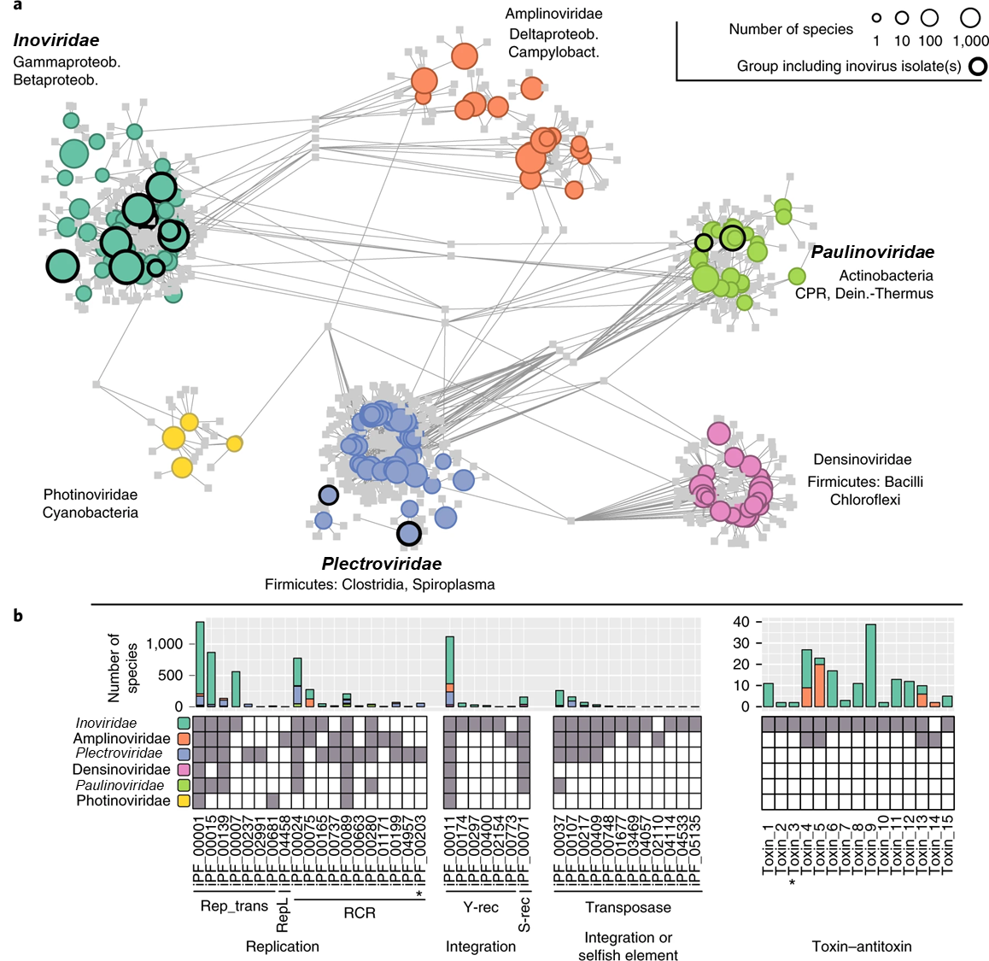

Figure 1. Genome sequence space and gene content of tubulavirals. A) The bipartite network links genes represented as protein clusters (PCs) in squares to proposed subfamilies represented as circles with a size proportional to the number of species in each candidate subfamily (log10 scale), grouped and coloured by proposed family. Putative subfamilies that include viral isolates are highlighted with a black outline. Candidate subfamilies are connected to PCs when ≥50% of the subfamily members contained this PC or ≥25% for the larger proposed subfamilies. The three official families within *Tubulavirales* are highlighted in bold. B) Distribution of inovirid protein families (iPFs) detected in two or more genomes, associated with genome replication, genome integration and toxin–antitoxin systems. The presence of at least one sequence from an iPF (column) in a proposed family (row) is indicated with a grey square. Rolling circle replication (RCR) iPFs include only the RCR endonuclease motif, except for iPF_00203 (highlighted with an asterisk), which also includes the C-terminal S3H motif typical of eukaryotic single-stranded DNA viruses. Transposases used by selfish integrated elements are indistinguishable from transposases domesticated by viral genomes using sequence analysis only; hence, these genes are gathered in a single ‘integration or selfish element’ category. S-rec, serine recombinase; Y-rec, tyrosine recombinase. The figure is reproduced from Roux et al., 2019.

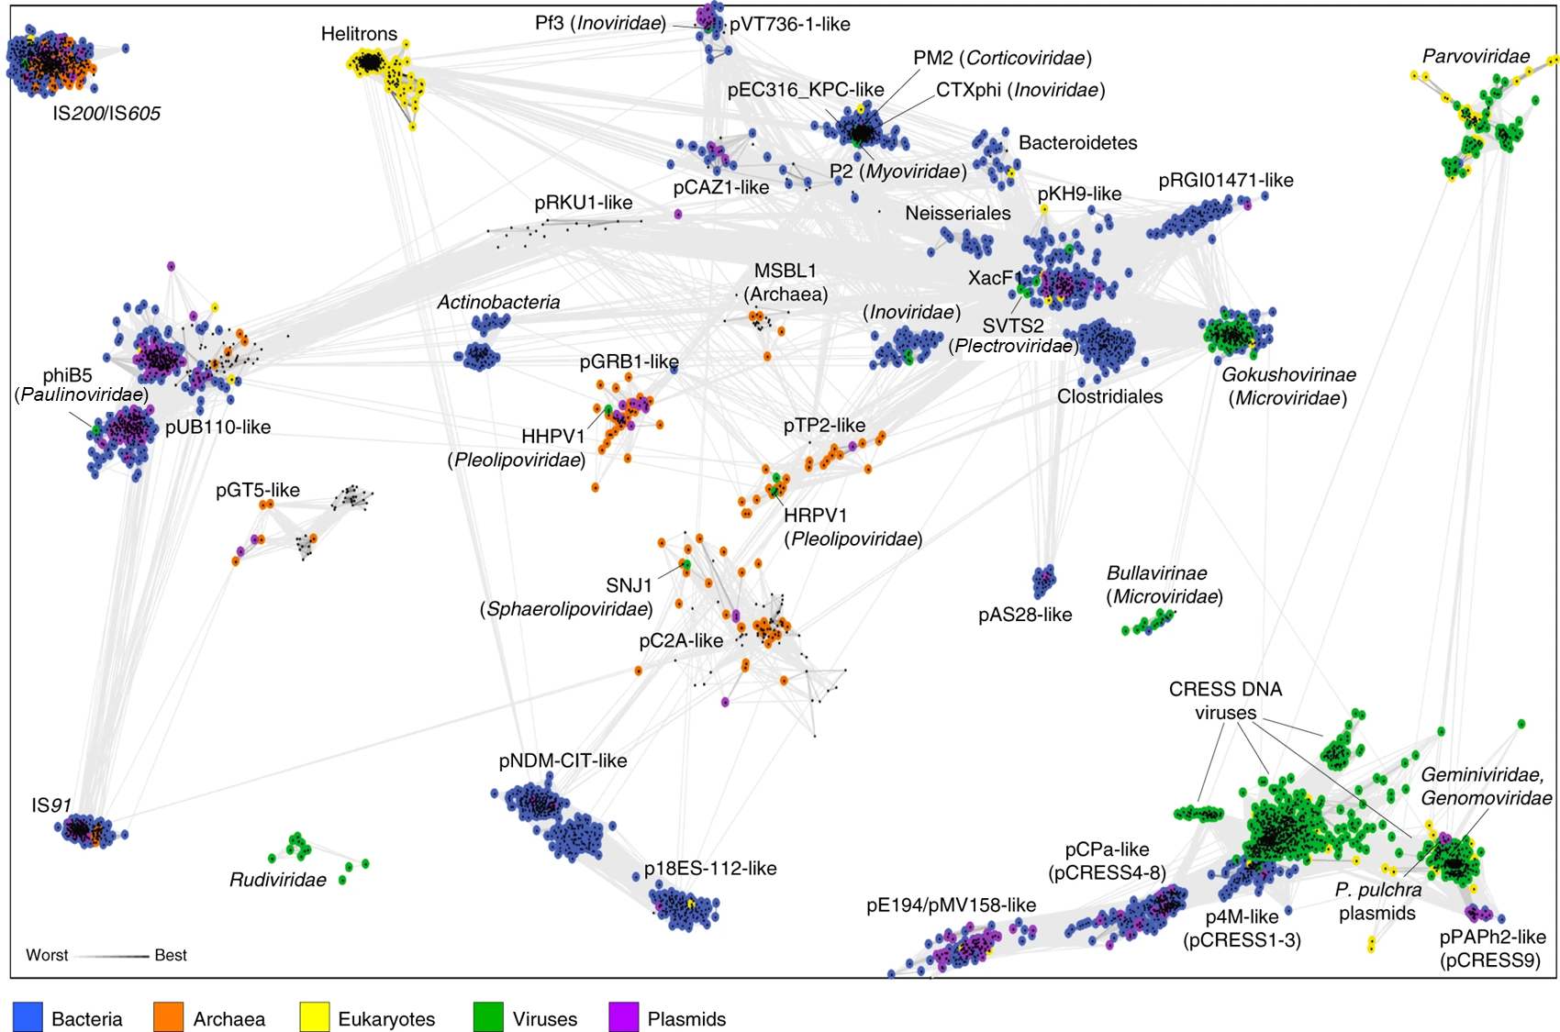

Figure 2. Representative HUH superfamily Reps clustered by their pairwise sequence similarity. Lines connect sequences with *P*-value ≤ 1e−08. Groups were named after well-characterized plasmids, viruses or most frequent taxon. The figure is reproduced from Kazlauskas et al., 2019.

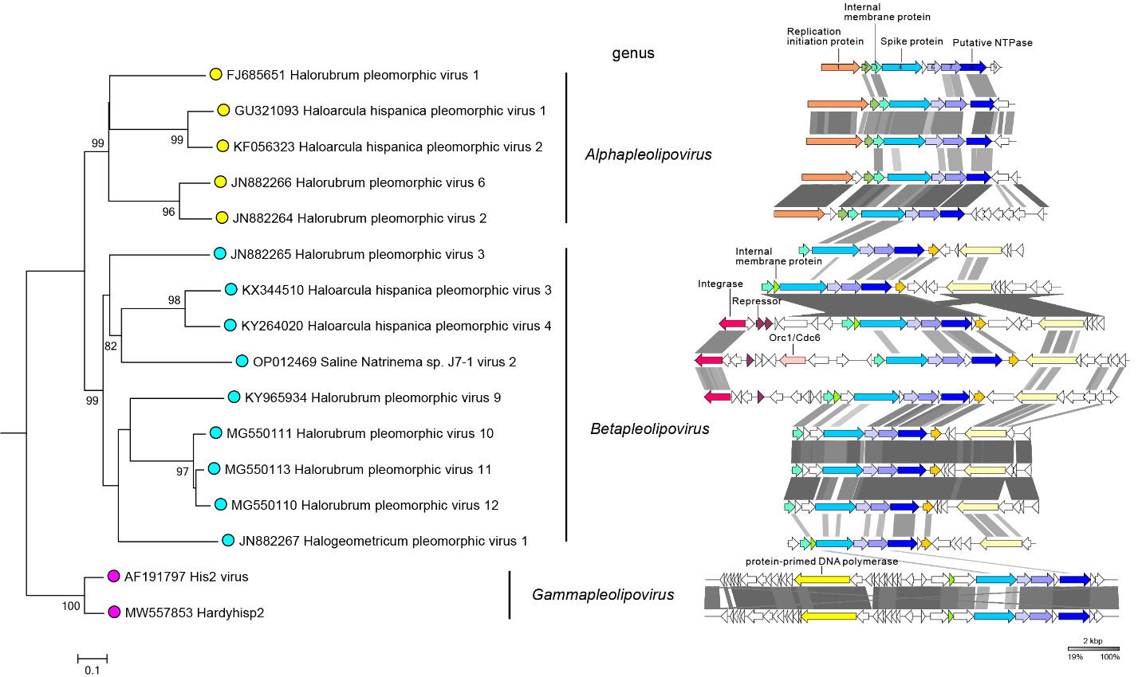

Figure 3. Genomes of pleolipovirids. The phylogenomic tree of pleolipovirids (left panel) based on whole genome analysis at the amino acid level performed using VICTOR. The tree is rooted with gammapleolipoviruses, and the branch length is scaled in terms of the Genome BLAST Distance Phylogeny (GBDP) distance formula D6. The bootstrap support values >80% are shown. The right panel shows the linear representation of the pleolipovirid genomes depicted in the tree. Gammapleolipoviruses have linear genomes. The genomes of other viruses are circular. Genes and ORFs are shown as arrows. Homologous genes are indicted with the same colors and are connected between viruses by shadings of different degrees of grey based on the amino acid sequence identity. Genes and ORFs are named in HRPV-1. HRPV-1 genes 3, 4 and 8, and ORFs 6 and 7 form a group of conserved genes characteristic of pleolipovirid genomes. The figure is reproduced from Liu et al., 2022.