

The International Committee on Taxonomy of Viruses

Taxonomy Proposal Form, 2025

**Part 1a: Details of taxonomy proposals**

|  |  |  |
| --- | --- | --- |
| **Title:** | Create 2 suborders, 4 genera and 9 species within the order *Imitervirales* |  |
| **Code assigned:** | 2025.011.F.N.v2.Imitervirales_newtaxa | |

|  |  |  |  |  |
| --- | --- | --- | --- | --- |
| **Author(s), affiliation and email address(es):** | | | | |
| **Given name (+middle initial(s))** | **Surname** | **Affiliation** | **Email address** | **Corr. author(s)** |
| Victoria F | Queiroz | Department of Biological Sciences, Virginia Tech, Blacksburg, United States of America Departamento de Microbiologia, Instituto de Ciências Biológicas, Universidade Federal de Minas Gerais, Belo Horizonte, Brazil | queirozvictoriaf@gmail.com |  |
| Frank O | Aylward | Department of Biological Sciences, Virginia Tech, Blacksburg, United States of America | faylward@vt.edu | X |
| Jônatas S | Abrahão | Departamento de Microbiologia, Instituto de Ciências Biológicas, Universidade Federal de Minas Gerais, Belo Horizonte, Brazil | jonatas.abrahao@gmail.com |  |
| Corina | Brussaard | Department of Biology, Lund University, Lund, Sweden.  Department of Marine Microbiology and Biogeochemistry, Royal Netherlands Institute for Sea Research (NIOZ), Texel, Netherlands.  Institute for Biodiversity and Ecosystem Dynamics (IBED), University of Amsterdam, Amsterdam, Netherlands. | corina.brussaard@nioz.nl |  |
| Matthias | Fischer | Max Planck Institute for Marine Microbiology in Bremen, Germany | mfischer@mpi.bremen.de |  |
| Rohit | Ghai | Department of Aquatic Microbial Ecology, Institute of Hydrobiology, Biology Centre of the Czech Academy of Sciences, 370 05 České Budějovice, Czech Republic. | ghai.rohit@gmail.com |  |
| Mohammad | Moniruzzaman | Department of Marine Biology and Ecology, University of Miami, Coral Gables, Miami, United States of America | m.monir@miami.edu |  |
| Hiroyuki | Ogata | Bioinformatics Center, Institute for Chemical Research, Kyoto University, Kyoto, Japan | ogata@kuicr.kyoto-u.ac.jp |  |
| Frederik | Schulz | DOE Joint Genome  Institute, Lawrence Berkeley National Laboratory, Alameda, United States of America | fschulz@lbl.gov |  |
| Curtis | Suttle | Departments of Earth, Ocean and Atmospheric Sciences, Botany, Microbiology and Immunology, and the Institute for the Oceans and Fisheries, University of British Columbia, Vancouver, BC, Canada | suttle@science.ubc.ca |  |

**Part 1b: Taxonomy Proposal Submission**

|  |  |  |  |
| --- | --- | --- | --- |
| **ICTV Subcommittee:** | | | |
| Animal DNA Viruses and Retroviruses |  | Bacterial viruses |  |
| Animal minus-strand and dsRNA viruses |  | Fungal and protist viruses | **X** |
| Animal positive-strand RNA viruses |  | Plant viruses |  |
| Archaeal viruses |  | General |  |

|  |
| --- |
| **List the ICTV Study Group(s) that have seen or have been involved in creating this proposal:** |
|  |

|  |  |  |  |
| --- | --- | --- | --- |
| **Optional – complete only if formally voted on by an ICTV Study Group:** | | | |
| **Study Group** | **Number of members** | | |
| **Votes in support** | **Votes against** | **No vote** |
|  |  |  |  |
|  |  |  |  |

|  |  |
| --- | --- |
| **Submission date:** |  |

**Part 1c: Feedback from ICTV Executive Committee (EC) meeting**

|  |  |
| --- | --- |
| **Executive Committee Meeting Decision code:** | **X** |
| A – Accept |  |
| Ac – Accept subject to revision by relevant subcommittee chair. No further vote required |  |
| U – Accept without revision but with re-evaluation and email vote by the EC |  |
| Uc – Accept subject to revision and re-evaluation and email vote by the EC |  |
| Ud – Deferred to the next EC meeting, with an invitation to revise based on EC comments |  |
| J - Reject |  |
| W - Withdrawn |  |

|  |
| --- |
| **Comments from the Executive Committee:** |
|  |

**Part 1d: Revised Taxonomy Proposal Submission**

|  |
| --- |
| **Response of proposer:** |
|  |
| **Revision date:** |  |

**Part 3:** **TAXONOMIC PROPOSAL**

|  |  |  |  |
| --- | --- | --- | --- |
| **Taxonomic changes proposed:** | | | |
| Establish new taxon | **X** | Split taxon |  |
| Abolish taxon |  | Merge taxon |  |
| Move taxon | **X** | Promote taxon |  |
| Rename taxon |  | Demote taxon |  |
| Move and rename |  |  |  |

|  |  |
| --- | --- |
| **Etymology (origin) of proposed taxonomic names:** | |
| **Taxon name** | **Etymology of the term** |
| *“Orthomivirineae”* | Prefix derived from Greek meaning "straight" or "correct" |
| *“Catovirus”* | After the most closely related representative with a name already used in the literature |
| *“Catovirus klosterense”* | After location of isolation: Klosterneuburg, Austria |
| *“Moumouvirus maliense”* | Isolate name modified to Latinized singular form |
| *“Moumouvirus lavasanguinense”* | Isolate name modified to Latinized singular form |
| *“Megavirus caiporense”* | Isolate name modified to Latinized singular form |
| *“Paramivirineae”* | Prefix derived from Greek meaning "related" or "similar" |
| *“Budvirus”* | After location of isolation: Bud, Czechia |
| *“Budvirus rimovense”* | After location of isolation: Rimov reservoir |
| *“Punuivirus”* | After the Incan mythology deity: Puñuy |
| *“Punuivirus latens”* | After the latent infection strategy of this virus |
| *“Criusvirus”* | After Greek titan: Crius |
| *“Criusvirus kaneoense”* | After location of isolation: Kanoehe bay, Hawaii |
| *“Tethysvirus bergenense”* | After location: Bergen, Norway |
| *“Tethysvirus norvegense”* | After location: Norway |

|  |  |  |
| --- | --- | --- |
| **Permission for use of names derived from a living person:** | | |
| **Taxon name** | **Full name of person from whom the name is derived** | **Attached** |
|  |  |  |
|  |  |  |
|  |  |  |
|  |  |  |

|  |
| --- |
| **Abstract of Taxonomy Proposal:** |
| ***Taxonomic rank(s) affected*:**  Order, Suborder, genus and species.  ***Description of current taxonomy*:**  The *Imitervirales* order currently comprises 4 families, 3 subfamilies, 14 genera and 22 species (proposal #2022.004F).  ***Proposed* *taxonomic change(s):***  Here, we propose to create 4 new genera and 9 new species following the currently valid demarcation criteria, and create 2 suborders to accommodate the existing viral families of the order *Imitervirales*.  ***Justification*:**  A new knowledge generated in the past few years require updates in the taxonomy of the order *Imitervirales* by adding new isolates and representatives that had not been previously classified. In order to accurately depict the novel knowledge, we propose to reorganize the order by creating 2 suborders, 4 genera and 9 new species to classify new viruses in this order. |

|  |
| --- |
| **Text of Taxonomy proposal:** |
| ***Taxonomic rank(s) affected*:**  Suborder, genus and species.  Two new suborders: “*Orthomivirineae*” and “*Paramivirineae*”, in the order *Imitervirales*;  Four new genera: “*Catovirus*” in the subfamiliy *Klosneuvirinae*, “*Criusvirus*” in the family *Mesomimiviridae*, “*Budvirus*” and “*Punuivirus*” in the family *Allomimiviridae*;  Nine new species: “*Punuivirus latens*”, “*Budvirus rimovense*”, “*Tethysvirus bergenense*”, “*Tethysvirus norvegense*”, “*Criusvirus kaneoense*”, “*Catovirus klosterense*”, “*Megavirus caiporense*”, “*Moumouvirus maliense*” and “*Moumouvirus lavasanguinense*”.  ***Description of current taxonomy*:**  The order *Imitervirales* currently comprises our families: *Allomimiviridae*, *Mesomimiviridae*, *Mimiviridae*, and *Schizomimiviridae*.  The family *Mimiviridae comprises* three subfamilies: *Aliimimivirinae*, *Klosneuvirinae*, and *Megamimivirinae*. A total of 14 genera and 22 species distributed along these 4 families and 3 subfamilies.  ***Proposed* *taxonomic change(s)*:**  Currently, all large dsDNA viruses, popularly known as ‘giant viruses’, are classified in the phylum *Nucleocytoviricota*. This phylum comprises three recognized classes, namely *Pokkesviricetes*, *Mriyaviricetes* and *Megaviricetes*. Among the orders classified within the latter, the order *Imitervirales* draws attention due to the diversity, abundance and ubiquity of its members. Following the major reorganization of the order *Imitervirales* in 2022 (2022.004F.A.Imitervirales_reorg), additional representatives have been fully sequenced or newly isolated and sequenced [1-10].  To formally incorporate these newly characterized viruses into the existing taxonomy, we analyzed 18 new representatives together with the 43 genomes used in the previous classification. We employed both a concatenated phylogenetic approach and pairwise average nucleotide identity (ANI) analyses, following the previously established methodology and taxonomic demarcation criteria [11, 12]. Based on these results, we propose the establishment of four new genera and nine new species. Additionally, we classified several isolates within already recognized species. The proposed species and their respective isolates are listed in Table 1.  **Proposed taxa:**  **The order *Imitervirales***  We propose the establishment of two new suborders: “*Orthomivirineae*”, comprising the family *Mimiviridae*, and “*Paramivirineae*”, comprising the families *Allomimiviridae*, *Mesomimiviridae*, and *Schizomimiviridae* (Figure 1).  **The family *Mimiviridae***  This family comprises three subfamilies (*Aliimimivirinae*, *Klosneuvirinae* and *Megamimivirinae*).  The subfamily *Klosneuvirinae*  Currently, there are three recognized genera in the subfamily *Klosneuvirinae* (*Fadolivirus*, *Theiavirus* and *Yasminevirus)*. We propose the creation of a fourth genus “*Catovirus”* comprising one new species “*Catovirus klosterense”* (Figures 2, 3), to classify the recent isolate catovirus naegleriensis [7].  The subfamily *Megamimivirinae*  There are five genera (*Cotonvirus*, *Megavirus*, *Mimivirus*, *Moumouvirus*, and *Tupanvirus*) and 11 recognized species within this subfamily.  We propose the creation of two new species within the genus *Moumouvirus*, namely *“Moumouvirus maliense”*, comprising two isolates moumouvirus maliensis and borely moumouvirus, and the species *“Moumouvirus lavasanguinense”*, comprising the isolate moumouvirus lavasanguinem (Figures 2, 3)[8].  We also propose the creation of one species within the genus *Megavirus*, “*Megavirus caiporense*”, comprising the isolated megavirus caiporense (Figures 2, 3) [9].  **The family *Mesomimiviridae***  We propose the creation of two species, “*Tethysvirus bergenense*” and “*Tethysvirus norvegense*”, within the genus *Tethysvirus*, currently the sole genus of this family. The species will comprise the isolates Prymnesium kappa virus (PkV-RF02) and Haptolina ericina virus (HeV-RF02) (Figures 2, 4)[10].  Furthermore, we propose the creation of a second genus within this family, the genus “*Criusvirus”* and the species “*Criusvirus kaneoense”*, to comprise the recent isolate FloV-SA2 (Figures 2, 4) [3].  **The family *Allomimiviridae***  Currently this family comprises two genera: *Heliosvirus* and *Oceanusvirus*. We further propose the creation of the genera “*Budvirus”* and “*Punuivirus”*, with one species each “*Budvirus rimovense”* and “*Punuivirus latens”* respectively, to classify the recent isolates budvirus and punuivirus (Figures 2, 5) [1, 2].  ***Demarcation criteria:***  Following the previously accepted criteria, representatives showing a pairwise ANI greater than 95% across more than 75% of their predicted genes compared to existing species were classified within the same species (2022.004F.A.Imitervirales_reorg). The ones that did not meet this threshold were assigned to new species. Accordingly, five new isolates meet the criteria to be classified within the species *Megavirus chilense*, two within *Mimivirus bradfordmassiliense*, and one within *Mimivirus lagoaense*. Among the species proposed here within already established genera, “*Moumouvirus* *maliense*” includes two isolates that meet the classification criteria, while “*Moumouvirus* *lavasanguinense*”, “*Tethysvirus* *bergenense*”, “*Tethysvirus* *norvegense*”, and “*Megavirus* *caiporense*” each contain a single isolate (Table 1 and Figures 2 and 3).  Using the previously established phylogenetic approach, we constructed a tree based on seven conserved marker genes: DNA polymerase family B (PolB), RNA polymerase large subunit (RNAPL), A32-like packaging enzyme (A32), topoisomerase family II (TopoII), Virus Late Transcription Factor 3 (VLTF3), Transcription Factor IIB (TFIIB), and a superfamily II helicase (SFII), which have been shown to produce high-fidelity phylogenetic trees for the phylum *Nucleocytoviricota* [12]. In accordance with current taxonomic practices, higher taxa are delineated based on approximately equivalent phylogenetic depths (i.e., distance from the root). Applying these criteria, as well as the accepted threshold of >80% bootstrap support [2022.004F.A.Imitervirales_reorg], four newly analyzed isolates did not cluster within any previously established genera. As such, we propose the creation of four new genera, each represented by a single species and its corresponding isolate (see Table 1 and Figures 2–5). We also propose the creation of two suborders, the suborder “*Orthomivirineae*”, comprising the family *Mimiviridae*, and the suborder “*Paramivirineae*”, encompassing the families *Allomimiviridae*, *Mesomimiviridae*, and *Schizomimiviridae* (Figure 1).  ***Justification*:**  A new knowledge generated in the past few years require updates in the taxonomy of the order *Imitervirales* by adding new isolates and representatives that had not been previously classified. In order to accurately depict the novel knowledge, we propose to reorganize the order by creating 2 suborders, 4 genera and 9 new species to classify new viruses in this order of “giant viruses”. |
| **References:** |
| 1- Helena H Vieira, Paul-Adrian Bulzu, Vojtěch Kasalický, Markus Haber, Petr Znachor, Kasia Piwosz, Rohit Ghai, Isolation of a widespread giant virus implicated in cryptophyte bloom collapse, The ISME Journal, Volume 18, Issue 1, January 2024, wrae029, <https://doi.org/10.1093/ismejo/wrae029>  2- Maria P. Erazo-Garcia et al., Cryptic infection of a giant virus in a unicellular green alga. Science 0, eads6303 DOI: [10.1126/science.ads6303](https://www.science.org/doi/10.1126/science.ads6303)  3- Thomy, J., Schvarcz, C.R., McBeain, K.A. *et al.* Eukaryotic viruses encode the ribosomal protein eL40. *npj Viruses* **2**, 51 (2024). <https://doi.org/10.1038/s44298-024-00060-2>  4- Alempic, J.-M.; Lartigue, A.; Goncharov, A.E.; Grosse, G.; Strauss, J.; Tikhonov, A.N.; Fedorov, A.N.; Poirot, O.; Legendre, M.; Santini, S.; et al. An Update on Eukaryotic Viruses Revived from Ancient Permafrost. *Viruses* **2023**, *15*, 564. <https://doi.org/10.3390/v15020564>  5- Isolation of viruses, including mollivirus, with the potential to infect Acanthamoeba from a Japanese warm temperate zone  Morimoto D, Tateishi N, Takahashi M, Nagasaki K (2024) Isolation of viruses, including mollivirus, with the potential to infect Acanthamoeba from a Japanese warm temperate zone. PLOS ONE 19(3): e0301185. <https://doi.org/10.1371/journal.pone.0301185>  6- Azevedo, B.L.d.; Júnior, J.P.A.; Ullmann, L.S.; Rodrigues, R.A.L.; Abrahão, J.S. The Discovery of a New Mimivirus Isolate in Association with Virophage-Transpoviron Elements in Brazil Highlights the Main Genomic and Evolutionary Features of This Tripartite System. Viruses 2022, 14, 206. <https://doi.org/10.3390/v14020206>  7- Arthofer, P., Panhölzl, F., Delafont, V. et al. A giant virus infecting the amoeboflagellate Naegleria. Nat Commun 15, 3307 (2024). <https://doi.org/10.1038/s41467-024-47308-2>  8- Sandra Jeudy, Lionel Bertaux, Jean-Marie Alempic, Audrey Lartigue, Matthieu Legendre, Lucid Belmudes, Sébastien Santini, Nadège Philippe, Laure Beucher, Emanuele G Biondi, Sissel Juul, Daniel J Turner, Yohann Couté, Jean-Michel Claverie, Chantal Abergel, Exploration of the propagation of transpovirons within Mimiviridae reveals a unique example of commensalism in the viral world, The ISME Journal, Volume 14, Issue 3, March 2020, Pages 727–739, <https://doi.org/10.1038/s41396-019-0565-y>  9- de Aquino ILM, Serafim MSM, Machado TB, Azevedo BL, Cunha DES, Ullmann LS, Araújo JP, Abrahão JS.2023.Diversity of Surface Fibril Patterns in Mimivirus Isolates. J Virol97:e01824-22.<https://doi.org/10.1128/jvi.01824-22>  10- Ruth-Anne Sandaa, Haina Wang, Lingjie Meng et al. Discovery from in-depth molecular analyses of giant viruses: Haptophyte-infecting viruses change the genome condensing proteins of dinoflagellates, 30 January 2025, PREPRINT (Version 1) available at Research Square <https://doi.org/10.21203/rs.3.rs-3957437/v1>  11- Aylward, F.O., Abrahão, J.S., Brussaard, C.P. et al. Taxonomic update for giant viruses in the order Imitervirales (phylum Nucleocytoviricota). Arch Virol 168, 283 (2023). <https://doi.org/10.1007/s00705-023-05906-3>  12- Aylward FO, Moniruzzaman M, Ha AD, Koonin EV (2021) A phylogenomic framework for charting the diversity and evolution of giant viruses. PLoS Biol 19:e3001430  13- Minh BQ, Schmidt HA, Chernomor O, et al (2020) IQ-TREE 2: New Models and Efficient Methods for Phylogenetic Inference in the Genomic Era. Mol Biol Evol 37:1530–1534. <https://doi.org/10.1093/MOLBEV/MSAA015>  14- Letunic I, Bork P, Gmbh BS (2021) Interactive Tree Of Life (iTOL) v5: an online tool for phylogenetic tree display and annotation. Nucleic Acids Res 1–4. <https://doi.org/10.1093/nar/gkab301> |

|  |  |
| --- | --- |
| **Accompanying files:** | |
| **Filename** | **Description of contents** |
| 2025.###F.v2.Imitervirales_newtaxa.xlsx | ICTV’s official accompanying Excel module |
|  |  |

|  |
| --- |
| **Tables, Figures:** |

<Start here>**Table 1.** Proposed taxonomy highlighted in yellow

|  |  |  |  |  |  |  |
| --- | --- | --- | --- | --- | --- | --- |
| **Suborder** | **Family** | **Subfamily** | **Genus** | **Species** | **Virus Isolate** | **NCBI Access.** |
| *Paramivirineae* | *Allomimiviridae* | *-* | *Heliosvirus* | *Heliosvirus raunefjordenense* | Pyramimonas orientalis virus 01B | MT663534:  MT663543 |
| *Oceanusvirus* | *Oceanusvirus kaneohense* | Tetraselmis virus 1 | KY322437 |
| *Punuivirus* | *Punuivirus latens* | punuivirus cr2937 | PV354230.1 |
| *-* | *Budvirus* | *Budvirus rimovense* | budvirus | OY749542.1 |
| *Mesomimiviridae* | - | *Tethysvirus* | *Tethysvirus hollandense* | Phaeocystis globosa virus PgV-16T | KC662249 |
| Phaeocystis globosa virus PgV-12T | HQ634147 |
| Phaeocystis globosa virus PgV-14T | HQ634144 |
| *Tethysvirus ontarioense* | Chrysochromulina parva virus BQ2 | MH918795 |
| *Tethysvirus raunefjordenense* | Chrysochromulina ericina virus CeV-01B | KT820662 |
| *Tethysvirus bergenense* | Prymnesium kappa virus isolate RF02 | PV100843 |
| *Tethysvirus norvegense* | Haptolina ericina virus isolate RF02 | PV100843 |
| - | *Criusvirus* | *Criusvirus kaneoense* | Florenciella sp. virus | PP542043.1 |
| *Schizomimiviridae* | *-* | *Biavirus* | *Biavirus raunefjordenense* | Prymnesium kappa virus RF01 | HG999358 |
| *-* | *Kratosvirus* | *Kratosvirus quantuckense* | Aureococcus anophagefferens virus isolate BtV-01 | KJ645900 |
| *Orthomivirineae* | *Mimiviridae* | *Aliimimivirinae* | *Rheavirus* | *Rheavirus sinusmexicani* | Cafeteria roenbergensis virus BV-PW1 | GU244497 |
| *Klosneuvirinae* | *Fadolivirus* | *Fadolivirus algeromassiliense* | fadolivirus FV1/VV64 | MT418680 |
| *Theiavirus* | *Theiavirus salishense* | Bodo saltans virus strain NG1 | MF782455 |
| *Yasminevirus* | *Yasminevirus saudimassiliense* | yasminevirus sp. GU-2018 | UPSH01000001 |
| *Catovirus* | *Catovirus klosterense* | catovirus naegleriensis | OZ003748.1 |
| Megamimivirinae | *Cotonvirus* | *Cotonvirus japonicum* | cotonvirus japonicus | AP024483 |
| *Megavirus* | *Megavirus baoshanense* | megavirus baoshan strain SH | MH046811 |
| *Megavirus chilense* | megavirus chilensis | JN258408 |
| megavirus lba isolate LBA111 | JX885207 |
| megavirus terra1 genome | KF527229 |
| megavirus courdo11 | JX975216 |
| Acanthamoeba polyphaga mimivirus ASM381511v1 | MG602508 |
| Acanthamoeba polyphaga mimivirus ASM381513v1 | MG602507 |
| megavirus vitis isolate vigne | MG807319 |
| megavirus sp. strain Yana14 | OQ411602 |
| megavirus Me1-1 | BTIZ0100000(1-4).1 |
| megavirus Me1-2 | BTJA0100000(1-8).1 |
| mimivirus sp. isolate 2401 | PQ010613.1 |
| mimivirus sp. strain daqing | MT663335.2 |
| *Megavirus powaiense* | Powai lake megavirus isolate 1 | KU877344 |
| *Megavirus caiporense* | megavirus caiporensis | OP925046.1 |
| *Mimivirus* | *Mimivirus bradfordmassiliense* | Acanthamoeba polyphaga mimivirus ViralProj60053 | HQ336222 |
| mimivirus terra2 genome | KF527228 |
| Acanthamoeba castellanii mamavirus Hal-V | JF801956 |
| Acanthamoeba castellanii mimivirus kasaii | AP017644 |
| Acanthamoeba castellanii mimivirus shirakomae | AP017645 |
| Acanthamoeba polyphaga mimivirus M4 | JN036606 |
| Acanthamoeba polyphaga mimivirus Oyster | KM982401 |
| Acanthamoeba polyphaga mimivirus | AY653733 |
| hirudovirus strain Sangsue | KF493731 |
| mimivirus Bombay isolate 1 | KU761889 |
| Niemeyer virus | KT599914 |
| Samba virus | KF959826 |
| Acanthamoeba polyphaga mimivirus strain Amazonia | KM982403 |
| mimivirus reunion isolate Queen | MW004169.1 |
| mimivirus argentum | OL770070.1 |
| *Mimivirus lagoaense* | Acanthamoeba polyphaga mimivirus Kroon | KM982402 |
| mimivirus U306 | LT717347.1 |
| *Moumouvirus* | *Moumouvirus australiense* | moumouvirus australiensis isolate 10A | MG807320 |
| *Moumouvirus goulettemassiliense* | moumouvirus goulette | KC008572 |
| *Moumouvirus moumou* | Acanthamoeba polyphaga moumouvirus | JX962719 |
| Saudi moumouvirus | KY110734 |
| *Moumouvirus maliense* | moumouvirus maliensis | MK978772.1 |
| Borely moumouvirus isolate B60 | MN175499.1 |
| *Moumouvirus lavasanguinense* | moumouvirus lavasanguinem | LC813553 |
| Tupanvirus | *Tupanvirus altamarinense* | tupanvirus deep ocean | MF405918 |
| *Tupanvirus salinum* | tupanvirus soda lake | KY523104 |

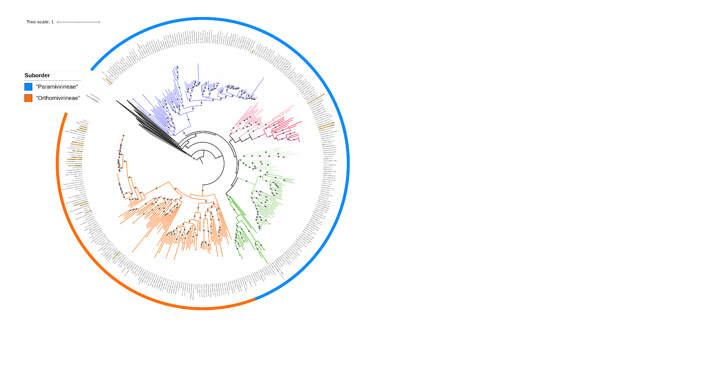

**Figure 1.** Phylogeny of the order *Imitervirales*, based on a concatenated alignment of seven marker genes (RNAPL, A32, VLTF3, TFIIB, SFII, TopoII, DNAPolB)[11]. The tree was constructed using a subset of the Giant Virus Database (<https://faylward.github.io/GVDB/>) and the ncldv_markersearch workflow (<https://github.com/faylward/ncldv_markersearch>) [12]. The Maximum Likelihood based phylogeny (LG+F+R10) was constructed using IQ-TREE multicore version 2.3.6 [13]. The branch supports were computed by 1000 ultrafast bootstrap. The phylogenetic tree was visualized and edited using iTOL, the clades compose only by MAGs were collapsed [14]. The color strip surrounding the tree highlights the proposed suborders: Suborder “*Paramivirineae*” is shown in blue and includes the families *Allomimiviridae*, *Mesomimiviridae*, and *Schizomimiviridae*; Suborder “*Orthomivirineae*” is shown in orange and includes the family *Mimiviridae*. Branches corresponding to *Mimiviridae* are colored orange; branches corresponding to *Schizomimiviridae* are green; branches representing *Allomimiviridae* and related representatives are blue; and branches representing *Mesomimiviridae* and related representatives are pink. Bootstrap values greater than 90 are indicated by gray circles.

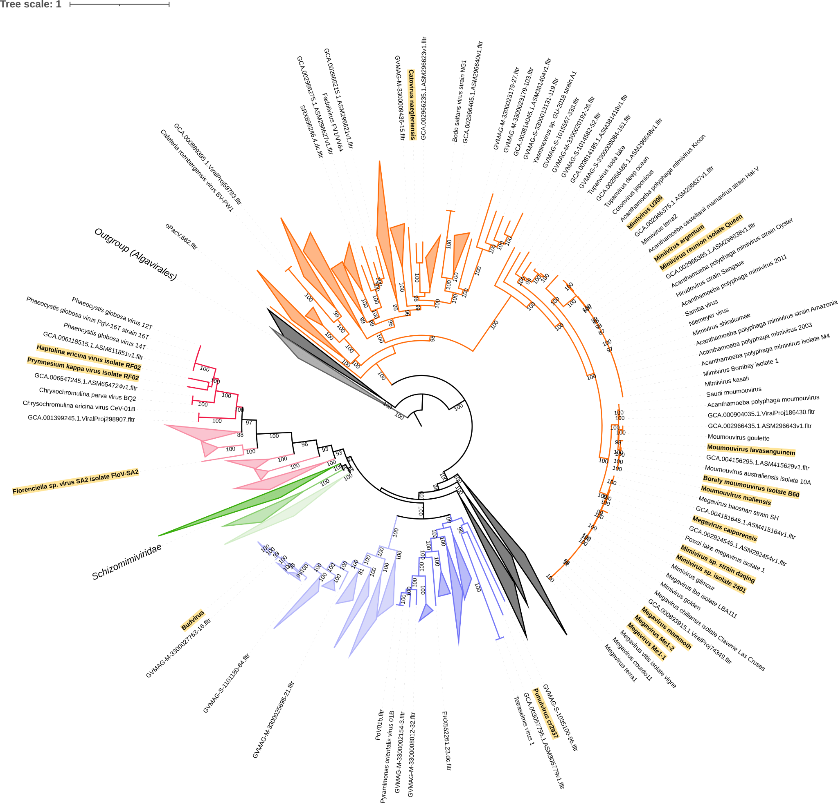

**Figure 2.** Phylogeny of the order *Imitervirales*, based on a concatenated alignment of seven marker genes (see figure one for details). Branches corresponding to *Mimiviridae* are colored orange; branches corresponding to *Schizomimiviridae* are green; branches representing *Allomimiviridae* and related representatives are blue; and branches representing *Mesomimiviridae* and related representatives are pink. Isolates classified in this proposal are highlighted in yellow.

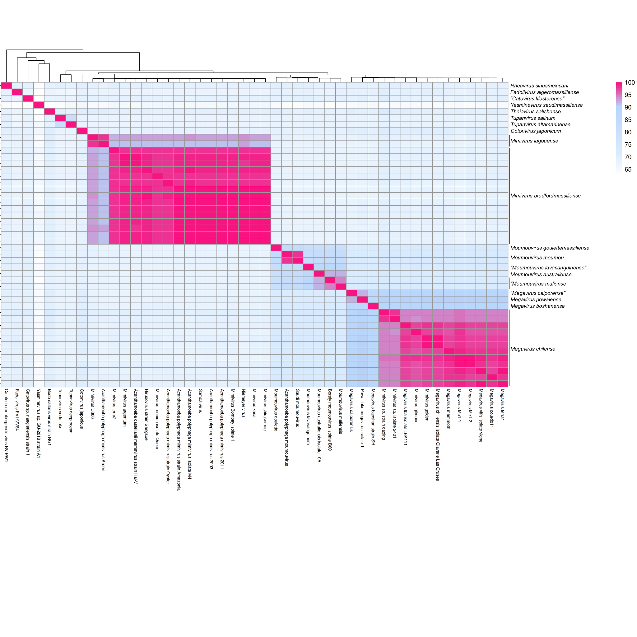

**Figure 3.** Pairwise Average Nucleotide Identity (ANI) of viral isolates in the family *Mimiviridae*. Isolate names are shown in columns and species names are shown in rows.

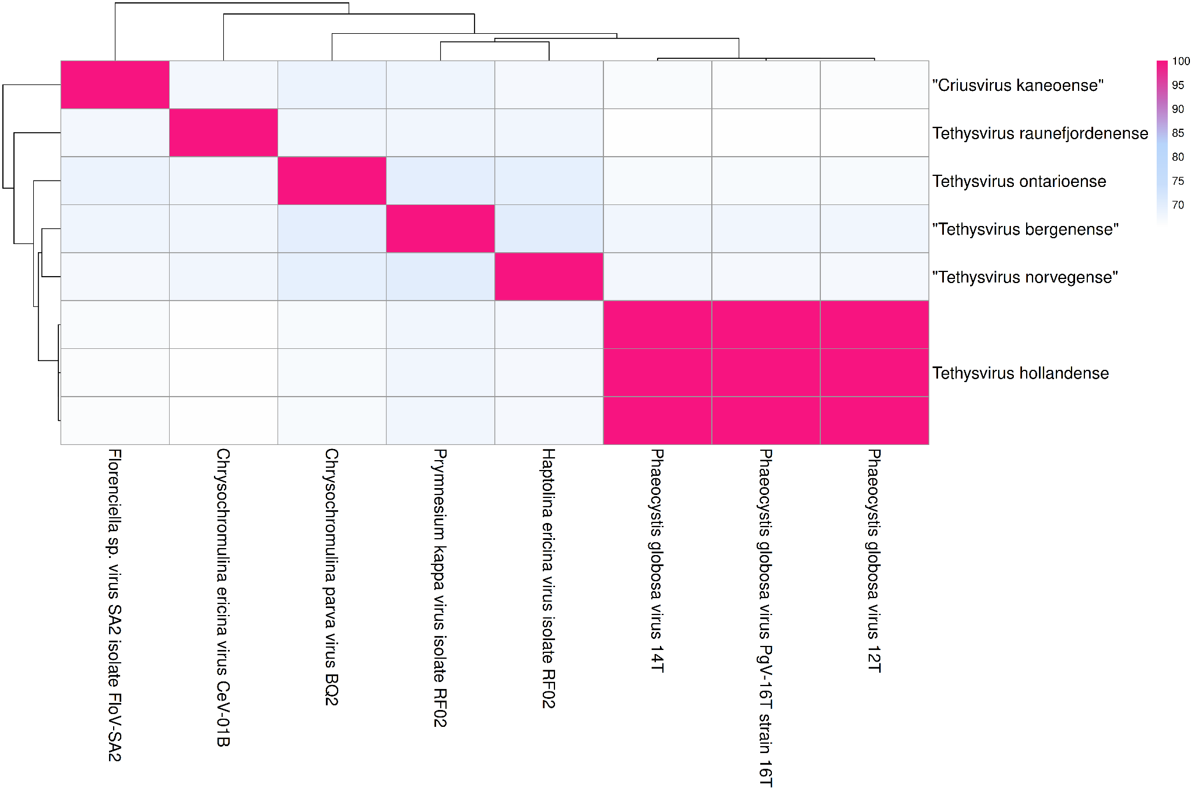

**Figure 4.** Pairwise Average Nucleotide Identity (ANI) of viral isolates in the family *Mesomimiviridae*. Isolate names are shown in columns and species names are shown in rows.

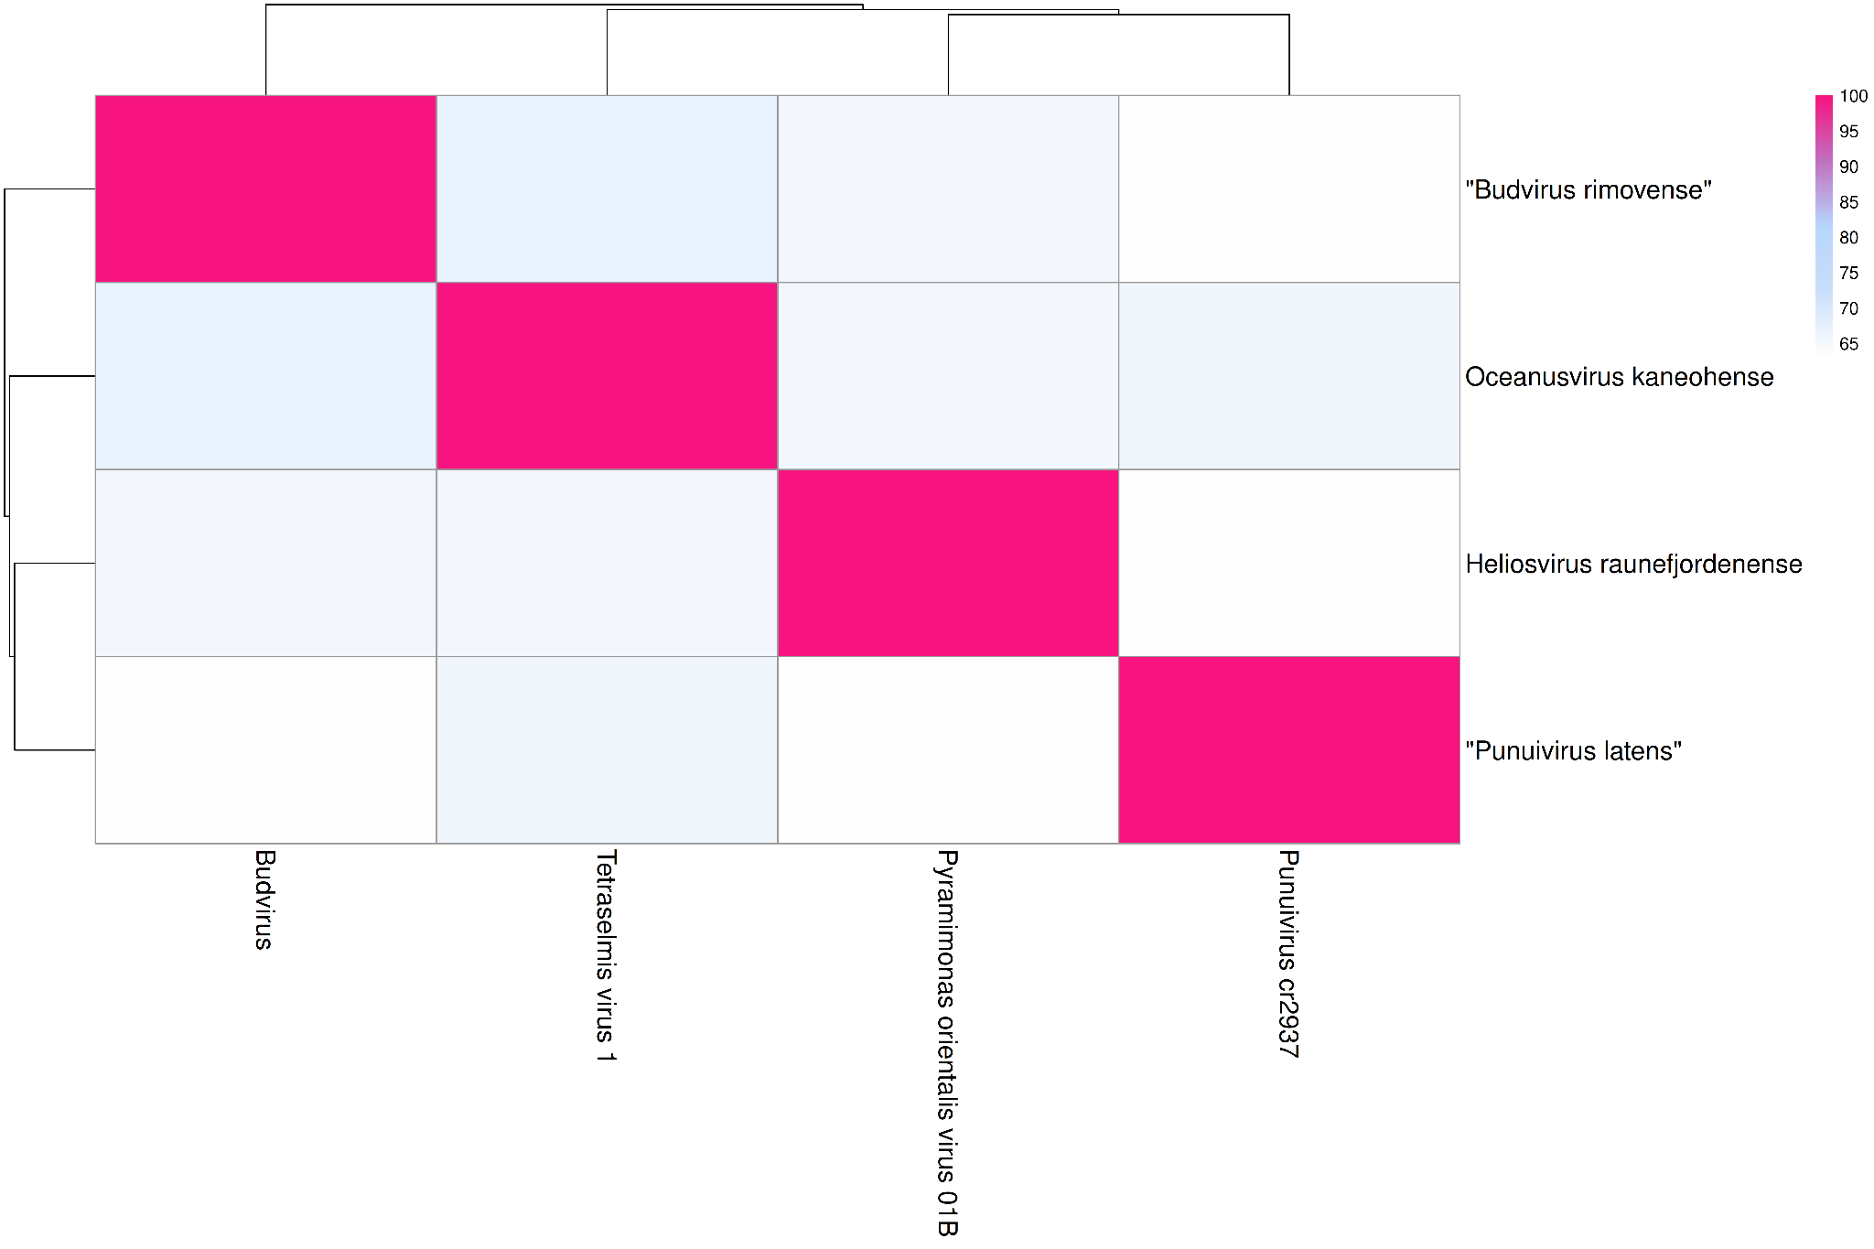

**Figure 5.** Pairwise Average Nucleotide Identity (ANI) of viral isolates in the family *Allomimiviridae*. Isolate names are shown in columns and species names are shown in rows.