

The International Committee on Taxonomy of Viruses

Taxonomy Proposal Form, 2025

**Part 1a: Details of taxonomy proposals**

|  |  |
| --- | --- |
| **Title:** | Create 12 new species in the genus *Rockefellervirus* (Class: *Caudoviricetes*) |
| **Code assigned:** | 2025.091B.Rockefellarvirus_12ns | |

|  |  |  |  |  |
| --- | --- | --- | --- | --- |
| **Author(s), affiliation and email address(es):** | | | | |
| **Given name (+middle initial(s))** | **Surname** | **Affiliation** | **Email address** | **Corr. author(s)** |
| Elena | Gomez Sanz | Division of Molecular Bacterial Epidemiology  &  Infectious Diseases, Institute of Veterinary Bacteriology, University of Bern, Bern, Switzerland | elena.gomezsanz@unibe.ch | X |
| Sandra | Perezjimenez | Division of Molecular Bacterial Epidemiology  &  Infectious Diseases, Institute of Veterinary Bacteriology, University of Bern, Bern, Switzerland | sandra.perezjimenez@unibe.ch |  |
| Yang | Jingxian | Division of Molecular Bacterial Epidemiology  &  Infectious Diseases, Institute of Veterinary Bacteriology, University of Bern, Bern, Switzerland | jingxian.yang@unibe.ch |  |
| Dann | Turner | School of Applied Sciences, College of Health, Science and Society, University of the West of England, Bristol, UK | dann2.turner@uwe.ac.uk |  |
|  |  |  |  |  |
|  |  |  |  |  |
|  |  |  |  |  |
|  |  |  |  |  |

**Part 1b: Taxonomy Proposal Submission**

|  |  |  |  |
| --- | --- | --- | --- |
| **ICTV Subcommittee:** | | | |
| Animal DNA Viruses and Retroviruses |  | Bacterial viruses | **X** |
| Animal minus-strand and dsRNA viruses |  | Fungal and protist viruses |  |
| Animal positive-strand RNA viruses |  | Plant viruses |  |
| Archaeal viruses |  | General - |  |

|  |
| --- |
| **List the ICTV Study Group(s) that have seen or have been involved in creating this proposal:** |
|  |

|  |  |  |  |
| --- | --- | --- | --- |
| **Optional – complete only if formally voted on by an ICTV Study Group:** | | | |
| **Study Group** | **Number of members** | | |
| **Votes in support** | **Votes against** | **No vote** |
|  |  |  |  |
|  |  |  |  |

|  |  |
| --- | --- |
| **Submission date:** | 20/06/2025 |

**Part 1c: Feedback from ICTV Executive Committee (EC) meeting**

|  |  |
| --- | --- |
| **Executive Committee Meeting Decision code:** | **X** |
| A – Accept |  |
| Ac – Accept subject to revision by relevant subcommittee chair. No further vote required |  |
| U – Accept without revision but with re-evaluation and email vote by the EC |  |
| Uc – Accept subject to revision and re-evaluation and email vote by the EC |  |
| Ud – Deferred to the next EC meeting, with an invitation to revise based on EC comments |  |
| J - Reject |  |
| W - Withdrawn |  |

|  |
| --- |
| **Comments from the Executive Committee:** |
|  |

**Part 1d: Revised Taxonomy Proposal Submission**

|  |
| --- |
| **Response of proposer:** |
|  |

|  |  |
| --- | --- |
| **Revision date:** |  |

**Part 2:** **GENERAL PROPOSAL**

|  |
| --- |
| **Abstract for General Proposal:** |
| *Brief description of current situation:*  *Proposed changes:*  *Justification:* |

|  |
| --- |
| **Text of General Proposal:** |
| *Background:*  *Proposed* *changes:*  *Justification:* |

|  |
| --- |
| **References:** |
|  |

|  |  |
| --- | --- |
| **Accompanying files:** | |
| **Filename** | **Description of contents** |
|  |  |
|  |  |

|  |
| --- |
| **Tables, Figures:** |

<Start here>

**Part 3:** **TAXONOMIC PROPOSAL**

<https://ictv.global/taxonomy/templates>

|  |  |  |  |
| --- | --- | --- | --- |
| **Taxonomic changes proposed:** | | | |
| Establish new taxon | **X** | Split taxon |  |
| Abolish taxon |  | Merge taxon |  |
| Move taxon |  | Promote taxon |  |
| Rename taxon |  | Demote taxon |  |
| Move and rename |  |

|  |  |
| --- | --- |
| **Etymology (origin) of proposed taxonomic names:** | |
| **Taxon name** | **Etymology of the term** |
|  |  |
|  |  |
|  |  |
|  |  |

|  |  |  |
| --- | --- | --- |
| **Permission for use of names derived from a living person:** | | |
| **Taxon name** | **Full name of person from whom the name is derived** | **Attached** |
|  |  |  |
|  |  |  |
|  |  |  |
|  |  |  |

|  |
| --- |
| **Abstract of Taxonomy Proposal:** |
| *Taxonomic rank(s) affected*:  Realm *Duplodnaviria*, kingdom *Heunggongvirae*, phylum *Uroviricota*, class *Caudoviricetes*  *Description of current taxonomy*:  The genus *Rockefellervirus* was created in 2020 ([2020.135B.R.Rockefellervirus](https://ictv.global/ictv/proposals/2020.135B.R.Rockefellervirus.zip)) and currently includes six species.  *Proposed* *taxonomic change(s):*  Create twelve new species in the genus *Rockefellervirus*.  *Justification*:  The genus *Rockefellervirus* currently includes six species of bacteriophages that exhibit a temperate lifestyle and infect *Staphylococcus* sp. The twelve newly proposed species form a cluster based on nucleotide sequence similarity with existing members of the genus. |

|  |
| --- |
| * **Text of Taxonomy proposal:** |
| *Taxonomic rank(s) affected*:  Realm *Duplodnaviria*, kingdom *Heunggongvirae*, phylum *Uroviricota*, class *Caudoviricetes*  *Description of current taxonomy*:  The genus *Rockefellervirus* was created in 2020 ([2020.135B.R.Rockefellervirus](https://ictv.global/ictv/proposals/2020.135B.R.Rockefellervirus.zip)) and currently includes six species.  *Proposed* *taxonomic change(s):*  Create twelve new species in the genus *Rockefellervirus*.  *Demarcation criteria:*  **Genus and species** were demarcated from pairwise intergenomic distances calculated using the similarity function of tax_myPhage . Current ICTV BVS demarcation criteria are that species are defined as genomes exhibiting ≤95% similarity and genera as possessing ≥70% similarity over their genome length [12].  *Justification*:  The genus *Rockefellervirus* currently includes six species of bacteriophages infecting *Staphylococcus* species. All of these viruses are either predicted or have been shown to undertake a temperate lifecycle and produce stable lysogens. The twelve newly proposed species form a cluster based on nucleotide sequence similarity with existing members of the genus (Figure 1) [1-2]. The genus does not strictly fall within the published genus demarcation criteria [12] but instead shows a mosaic of similarities between phages. We suggest this is due to higher rates of recombination associated with the temperate lifestyle of these phages. To identify conserved genes for the inference of ML phylogenies, protein clustering using MMSeqs2 [3] was employed, followed by multiple sequence alignment with MAFFT [5] and tree calculation performed with IQTree2 [14] using ModelFinder [16] and ultra-fast bootstrapping [15] (Figure 2). The genus has a total of 22 fully conserved proteins limited to structural and replicon-associated proteins. This represents approximately 32% of the total predicted coding sequences,when using thresholds of 70% sequence identity and 50% coverage with MMSeqs2.  Data obtained using GRAViTy-v2 [17] and vConTACT3 [18] suggests that this genus belongs to a larger clade of bacteriophages which might support the creation of a new family and/or order in the future (Figures 3-4). Work is ongoing to identify hallmark proteins shared between this larger set of 279 genomes. |

|  |
| --- |
| **References:** |
| 1. Sayers EW, Beck J, Bolton EE, Bourexis D, Brister JR, Canese K, Comeau DC, Funk K, Kim S, Klimke W, Marchler-Bauer A, Landrum M, Lathrop S, Lu Z, Madden TL, O'Leary N, Phan L, Rangwala SH, Schneider VA, Skripchenko Y, Wang J, Ye J, Trawick BW, Pruitt KD, Sherry ST. Database resources of the National Center for Biotechnology Information. Nucleic Acids Res. 2021 Jan 8;49(D1):D10-D17. doi: 10.1093/nar/gkaa892. 2. O'Leary NA, Wright MW, Brister JR, Ciufo S, Haddad D, McVeigh R, et al. Reference sequence (RefSeq) database at NCBI: current status, taxonomic expansion, and functional annotation. Nucleic Acids Res. 2016;44(D1):D733-45. doi: 10.1093/nar/gkv1189. 3. Steinegger M, Söding J. (2017) MMseqs2 enables sensitive protein sequence searching for the analysis of massive data sets. Nat Biotechnol. 35(11):1026-1028. doi: 10.1038/nbt.3988. 4. Nakamura T, Yamada KD, Tomii K, Katoh K. (2018) Parallelization of MAFFT for large-scale multiple sequence alignments. Bioinformatics. 34(14):2490-2492. doi: 10.1093/bioinformatics/bty121. 5. Katoh K, Standley DM. (2013) MAFFT multiple sequence alignment software version 7: improvements in performance and usability. Mol Biol Evol. 30(4):772-80. doi: 10.1093/molbev/mst010. 6. Steinegger M, Meier M, Mirdita M, Vöhringer H, Haunsberger SJ, Söding J. (2019) HH-suite3 for fast remote homology detection and deep protein annotation. BMC Bioinformatics. 20(1):473. doi: 10.1186/s12859-019-3019-7. 7. Van Dongen S. (2008). Graph clustering via a discrete uncoupling process, Siam Journal on Matrix Analysis and Applications 30(1), 121-141. 8. Cook R, Brown N, Redgwell T, Rihtman B, Barnes M, Clokie M, Stekel DJ, Hobman J, Jones MA, Millard A. (2021) INfrastructure for a PHAge REference Database: Identification of Large-Scale Biases in the Current Collection of Cultured Phage Genomes. Phage 2(4):214-223. doi: 10.1089/phage.2021.0007. 9. Eddy SR. (2011) Accelerated Profile HMM Searches. PLoS Comput Biol. 7(10):e1002195. doi: 10.1371/journal.pcbi.1002195. 10. Nishimura Y, Yoshida T, Kuronishi M, Uehara H, Ogata H, Goto S. (2017) ViPTree: The viral proteomic tree server. Bioinformatics. 33(15):2379–80. 11. Rohwer F, Edwards R. (2002) The Phage Proteomic Tree: a genome-based taxonomy for phage. Journal of Bacteriology. 184(16):4529–35 12. Turner D, Kropinski AM, Adriaenssens EM. (2021) A Roadmap for Genome-Based Phage Taxonomy. Viruses. 13(3):506. doi: 10.3390/v13030506. 13. Letunic I, Bork P. (2007) Interactive Tree Of Life (iTOL): An online tool for phylogenetic tree display and annotation. Bioinformatics.23(1):127–8. 14. Nguyen LT, Schmidt HA, von Haeseler A, and Minh BQ (2015) IQ-TREE: A fast and effective stochastic algorithm for estimating maximum likelihood phylogenies. Molecular Biology and Evolution, 32:268-274. https://doi.org/10.1093/molbev/msu300 15. Hoang DT, Chernomor O, von Haeseler A, Minh BQ, Vinh LS (2018) UFBoot2: Improving the ultrafast bootstrap approximation. Molecular Biology and Evolution, 35:518–522. <https://doi.org/10.1093/molbev/msx281> 16. Kalyaanamoorthy S, Minh BQ, Wong TKF, von Haeseler A, and Jermiin JS (2017) ModelFinder: Fast Model Selection for Accurate Phylogenetic Estimates, Nature Methods, 14:587–589. <https://doi.org/10.1038/nmeth.4285> 17. Mayne R, Aiewsakun P, Turner D, Adriaenssens EM, Simmonds P. (2024) GRAViTy-V2: a grounded viral taxonomy application. NAR Genom Bioinform. 2024 Dec 18;6(4):lqae183. doi: 10.1093/nargab/lqae183 18. Bolduc B, Zablocki O, Turner D, Jang H, Guo J, Adriaenssens EM, Dutilh B, Sullivan MB (2025) Scalable and systematic hierarchical virus taxonomy with vConTACT3. *Manuscript under review* |

|  |  |
| --- | --- |
| **Accompanying files:** | |
| **Filename** | **Description of contents** |
|  |  |
|  |  |

|  |
| --- |
| **Tables, Figures:** |



Figure 1. Heatmap of inter-genomic similarities of existing and proposed species in the genus *Rockefellervirus*, calculated using tax_myphage. The status column provides information on whether a genome is represented by an existing or proposed species. Genomes that exhibit greater than 95% similarity are described as strains.

Figure 2. Maximum-likelihood phylogenetic tree of the A) major tail protein and B) portal vertex protein. The trees are rooted using proteins from *Staphylococcus* phage IME1318_01 [KY653116]

Figure 3. GRAViTy-v2 comparison of 279 bacteriophage genomes. The genus *Rockefellervirus* is highlighted with a green rectangle. Genomes were initially selected based on vConTACT3 results [18] using the INPHARED database [8], then subsampled for use as the input to GRAViTy-v2 [17].

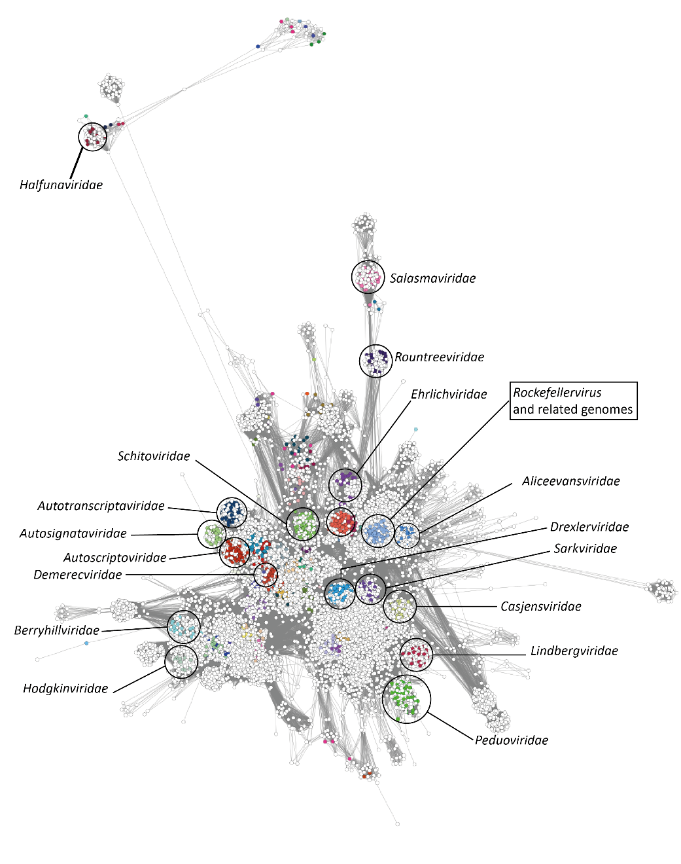

Figure 4. vConTACT3 network. Subset of vConTACT3 network consisting of the major cluster of genomes belonging to the class *Caudoviricetes.* Genomes are represented as nodes in the network and are coloured according to their classification in the VMR_MSL40.v1. Select classified families of bacterial viruses are annotated by circles and labels on the network.