

The International Committee on Taxonomy of Viruses

Taxonomy Proposal Form, 2025

**Part 1a: Details of taxonomy proposals**

|  |  |
| --- | --- |
| **Title:** | Create new family *Hirszfeldviridae* with three genera, *Odravirus*, *Solivirus*, and *Obolenskvirus,* for a group of *Acinetobacter* phages (class *Caudoviricetes*) |
| **Code assigned:** | 2025.088B.Hirszfeldviridae_1nf_2ng_1mg_2ns | |

|  |  |  |  |  |
| --- | --- | --- | --- | --- |
| **Author(s), affiliation and email address(es):** | | | | |
| **Given name (+middle initial(s))** | **Surname** | **Affiliation** | **Email address** | **Corresponding author(s)** |
| Michał J. | Wójcicki | Bacteriophage Laboratory, Department of Phage Therapy, Hirszfeld Institute of Immunology and Experimental Therapy, Polish Academy of Sciences, Wroclaw, Poland | [michal.wojcicki@hirszfeld.pl](mailto:michal.wojcicki@hirszfeld.pl) | X |
| Martyna A. | Cieślik | Bacteriophage Laboratory, Department of Phage Therapy, Hirszfeld Institute of Immunology and Experimental Therapy, Polish Academy of Sciences, Wroclaw, Poland | [martyna.cieslik@hirszfeld.pl](mailto:martyna.cieslik@hirszfeld.pl) |  |
| Edyta | Pawlak | Laboratory of Immunopathology, Department of Experimental Therapy, Hirszfeld Institute of Immunology and Experimental Therapy, Polish Academy of Sciences, Wroclaw, Poland | [edyta.pawlak@hirszfeld.pl](mailto:edyta.pawlak@hirszfeld.pl) |  |
| Andrzej | Górski | Bacteriophage Laboratory, Department of Phage Therapy, Hirszfeld Institute of Immunology and Experimental Therapy, Polish Academy of Sciences, Wroclaw, Poland | [andrzej.gorski@hirszfeld.pl](mailto:andrzej.gorski@hirszfeld.pl) |  |
| Ewa M. | Jończyk-Matysiak | Bacteriophage Laboratory, Department of Phage Therapy, Hirszfeld Institute of Immunology and Experimental Therapy, Polish Academy of Sciences, Wroclaw, Poland | [ewa.jonczyk-matysiak@hirszfeld.pl](mailto:ewa.jonczyk-matysiak@hirszfeld.pl) |  |

**Part 1b: Taxonomy Proposal Submission**

|  |  |  |  |
| --- | --- | --- | --- |
| **ICTV Subcommittee:** | | | |
| Animal DNA Viruses and Retroviruses |  | Bacterial viruses | X |
| Animal minus-strand and dsRNA viruses |  | Fungal and protist viruses |  |
| Animal positive-strand RNA viruses |  | Plant viruses |  |
| Archaeal viruses |  | General |  |

|  |
| --- |
| **List the ICTV Study Group(s) that have seen or have been involved in creating this proposal:** |
| *Caudoviricetes Study Group* |

|  |  |  |  |
| --- | --- | --- | --- |
| **Optional – complete only if formally voted on by an ICTV Study Group:** | | | |
| **Study Group** | **Number of members** | | |
| **Votes in support** | **Votes against** | **No vote** |
|  |  |  |  |
|  |  |  |  |

|  |  |
| --- | --- |
| **Submission date:** | 20/06/2025 |

**Part 1c: Feedback from ICTV Executive Committee (EC) meeting**

|  |  |
| --- | --- |
| **Executive Committee Meeting Decision code:** | **X** |
| A – Accept |  |
| Ac – Accept subject to revision by relevant subcommittee chair. No further vote required |  |
| U – Accept without revision but with re-evaluation and email vote by the EC |  |
| Uc – Accept subject to revision and re-evaluation and email vote by the EC |  |
| Ud – Deferred to the next EC meeting, with an invitation to revise based on EC comments |  |
| J - Reject |  |
| W - Withdrawn |  |

|  |
| --- |
| **Comments from the Executive Committee:** |
|  |

**Part 1d: Revised Taxonomy Proposal Submission**

|  |
| --- |
| **Response of proposer:** |
|  |

|  |  |
| --- | --- |
| **Revision date:** |  |

**Part 3:** **TAXONOMIC PROPOSAL**

|  |  |  |  |
| --- | --- | --- | --- |
| **Taxonomic changes proposed:** | | | |
| Establish new taxon | X | Split taxon |  |
| Abolish taxon |  | Merge taxon |  |
| Move taxon | X | Promote taxon |  |
| Rename taxon |  | Demote taxon |  |
| Move and rename |  |

|  |  |
| --- | --- |
| **Etymology (origin) of proposed taxonomic names:** | |
| **Taxon name** | **Etymology of the term** |
| *“Hirszfeldviridae”* | Family name created in honor of Prof. Ludwik Hirszfeld (b. 1884, d. 1954) – Polish physician, bacteriologist, and immunologist, the founder of the Polish school of immunology and a new scientific discipline – seroanthropology. In 1952, he established the Institute of Immunology and Experimental Therapy of the Polish Academy of Sciences in Wrocław, where the Department of Phage Therapy and the Phage Therapy Unit are located. |
| *“Odravirus”* | Genus name derived from Odra (Latin: Viadrus, Oddera) – river in Central Europe, within the Baltic Sea basin, located in the territories of the Czech Republic, Poland, and Germany. |
| *“Odravirus” Acjo20* | Species name derived from the phage name in the GenBank database – Acinetobacter phage Acjo_20 |
| *“Solivirus”* | Genus name derived from the name of the bacterial host for this phage, which is the only representative of the newly created species – *Acinetobacter soli* (according to the GenBank database). |
| *“Solivirus” phiAC1* | Species name derived from the phage name in the GenBank database – Acinetobacter phage phiAC-1 |

|  |  |  |
| --- | --- | --- |
| **Permission for use of names derived from a living person** | | |
| **Taxon name** | **Full name of person from whom the name is derived** | **Attached** |
|  |  |  |

|  |
| --- |
| **Abstract of Taxonomy Proposal:** |
| *Taxonomic rank(s) affected*:  Realm *Duplodnaviria*, kingdom *Heunggongvirae*, phylum *Uroviricota*, class *Caudoviricetes*  *Description of current taxonomy*:  According to the current taxonomy, the genus *Obolenskvirus* has been classified within the class *Caudoviricetes* without assignment to a family rank. Currently, the *“Obolenskvirus”* genus includes eight species: “*Obolenskvirus” AB1*, “*Obolenskvirus” AB2*, “*Obolenskvirus” AbC62*, “*Obolenskvirus” AbP2*, “*Obolenskvirus” AP22*, “*Obolenskvirus” LZ35*, “*Obolenskvirus” WCHABP1*, and “*Obolenskvirus” WCHABP12.*  *Proposed* *taxonomic change(s):*  Create new family (*“Hirszfeldviridae”*) with three genera (*“Odravirus”*, *“Solivirus”*, *“Obolenskvirus”*) for a group of *Acinetobacter* phages (realm *Duplodnaviria*, kingdom *Heunggongvirae*, phylum *Uroviricota*, class *Caudoviricetes*).  We performed a genomic analysis of several *Acinetobacter*-specific phages deposited in the NCBI database, which have been classified under the genus *“Obolenskvirus”*. Based on our analysis, we propose the creation of a family for these phages along with three distinct genera.  A. To create a new family, “*Hirszfeldviridae”*, with three genera.  B. To create a new single species genus, *“Odravirus”*.  C. To create a new single species genus, “*Solivirus”*.  D. To move the genus “*Obolenskvirus”* to new family, “*Hirszfeldviridae”*.  *Justification*:  After examination of 10 bacteriophages on the basis of nucleotide sequence similarity, tblastx distances and core gene phylogeny, we propose the creation of a new family, *“Hirszfeldviridae”*, with three genera (*“Odravirus”*, *“Solivirus”*, *“Obolenskvirus”*). The proposed taxa confirm to the demarcation criteria employed by the ICTV Bacterial Viruses Subcommittee. |

|  |
| --- |
| **Text of Taxonomy proposal:** |
| *Taxonomic rank(s) affected*:  Realm *Duplodnaviria*, kingdom *Heunggongvirae*, phylum *Uroviricota*, class *Caudoviricetes*  *Description of current taxonomy*:  According to the current taxonomy, the genus *Obolenskvirus* has been classified within the class *Caudoviricetes* without assignment to a family rank. Currently, the *“Obolenskvirus”* genus includes eight species: “*Obolenskvirus” AB1*, “*Obolenskvirus” AB2*, “*Obolenskvirus” AbC62*, “*Obolenskvirus” AbP2*, “*Obolenskvirus” AP22*, “*Obolenskvirus” LZ35*, “*Obolenskvirus” WCHABP1*, and “*Obolenskvirus” WCHABP12.*  *Proposed* *taxonomic change(s)*:  Create new family (*“Hirszfeldviridae”*) with three genera (*“Odravirus”*, *“Solivirus”*, *“Obolenskvirus”*) for a group of *Acinetobacter* phages (realm *Duplodnaviria*, kingdom *Heunggongvirae*, phylum *Uroviricota*, class *Caudoviricetes*).  We performed a genomic analysis of several *Acinetobacter*-specific phages deposited in the NCBI database, which have been classified under the genus *“Obolenskvirus”*. Based on our analysis, we propose the creation of a family for these phages along with three distinct genera.  A. To create a new family, “*Hirszfeldviridae”*, with three genera.  B. To create a new single species genus, *“Odravirus”*.  C. To create a new single species genus, “*Solivirus”*.  D. To move the genus “*Obolenskvirus”* to new family, “*Hirszfeldviridae”*.  *Demarcation criteria:*  **Species demarcation criteria:** Two phages are assigned to the same species if their genomes are more than 95% identical over their genome length for isolates.  These values can be calculated by several tools, such as BLASTn [1] – usually calculated using the intergenomic distance calculator VIRIDIC [2].  **Genus demarcation criteria:** In search for criteria that create cohesive and distinct genera that are reproducible and monophyletic, the Bacterial Viruses Subcommittee has established 70% nucleotide identity of the genome length as the cut-off for genera. Genus-level groupings should always be monophyletic in the signature genes, as tested with a phylogenetic tree [3].  **Family demarcation criteria:** The family is represented by a cohesive and monophyletic group in the main predicted proteome-based clustering tools (ViPTree, GRAViTy dendrogram, vConTACT2 network). Family members share a significant number of orthologous genes (the number will depend on the genome sizes and number of coding sequences of family members) [3].  *Justification*:  After examination of 10 bacteriophages on the basis of nucleotide sequence similarity, tblastx distances and core gene phylogeny, we propose the creation of a new family, *“Hirszfeldviridae”*, with three genera (*“Odravirus”*, *“Solivirus”*, *“Obolenskvirus”*). The proposed taxa confirm to the demarcation criteria employed by the ICTV Bacterial Viruses Subcommittee. |

|  |
| --- |
| **References:** |
| 1. Sayers EW, Beck J, Bolton EE, Bourexis D, Brister JR, Canese K, Comeau DC, Funk K, Kim S, Klimke W, Marchler-Bauer A, Landrum M, Lathrop S, Lu Z, Madden TL, O'Leary N, Phan L, Rangwala SH, Schneider VA, Skripchenko Y, Wang J, Ye J, Trawick BW, Pruitt KD, Sherry ST. Database resources of the National Center for Biotechnology Information. *Nucleic Acids Res.* 2021, 49(D1):D10-D17. 2. Moraru C, Varsani A, Kropinski AM. VIRIDIC - a novel tool to calculate the intergenomic similarities of prokaryote-infecting viruses. *Viruses* 2020, 12(11):1268. 3. Turner D, Kropinski AM, Adriaenssens EM. A roadmap for genome-based phage taxonomy. *Viruses* 2021, 13(3):506. 4. Nishimura Y, Yoshida T, Kuronishi M, Uehara H, Ogata H, Goto S. ViPTree: the viral proteomic tree server. *Bioinformatics* 2017, 33(15):2379-2380. 5. Rohwer F, Edwards R. The Phage Proteomic Tree: a genome-based taxonomy for phage. *J. Bacteriol.* 2002, 184(16):4529-35. 6. Turner D, Reynolds D, Seto D, Mahadevan P. CoreGenes3.5: a webserver for the determination of core genes from sets of viral and small bacterial genomes. *BMC Res. Notes.* 2013, 6:140. |

|  |  |
| --- | --- |
| **Accompanying files:** | |
| **Filename** | **Description of contents** |
| Hirszfeldviridae_1nf_2ng_1mg_2ns.xlsx | To present the proposed taxonomic changes as a comparison of new taxonomic structures. |
| **Tables, Figures:** | |

**Proposals data:**

**A. To create a new family, “*Hirszfeldviridae”*, with three genera.**

**B. To create a new single species genus, *“Odravirus”*.**

**C. To create a new single species genus, “*Solivirus”*.**

**D. To move the genus “*Obolenskvirus”* to new family, “*Hirszfeldviridae”*.**

**Figure 1. VIRIDIC heat map:** VIRIDIC (Virus Intergenomic Distance Calculator [2]; http://rhea.icbm.uni-oldenburg.de/VIRIDIC/) computes pairwise intergenomic distances/similarities amongst phage genomes. The currently distinguished eight species belonging to the genus *“Obolenskvirus”* are marked in **blue**.

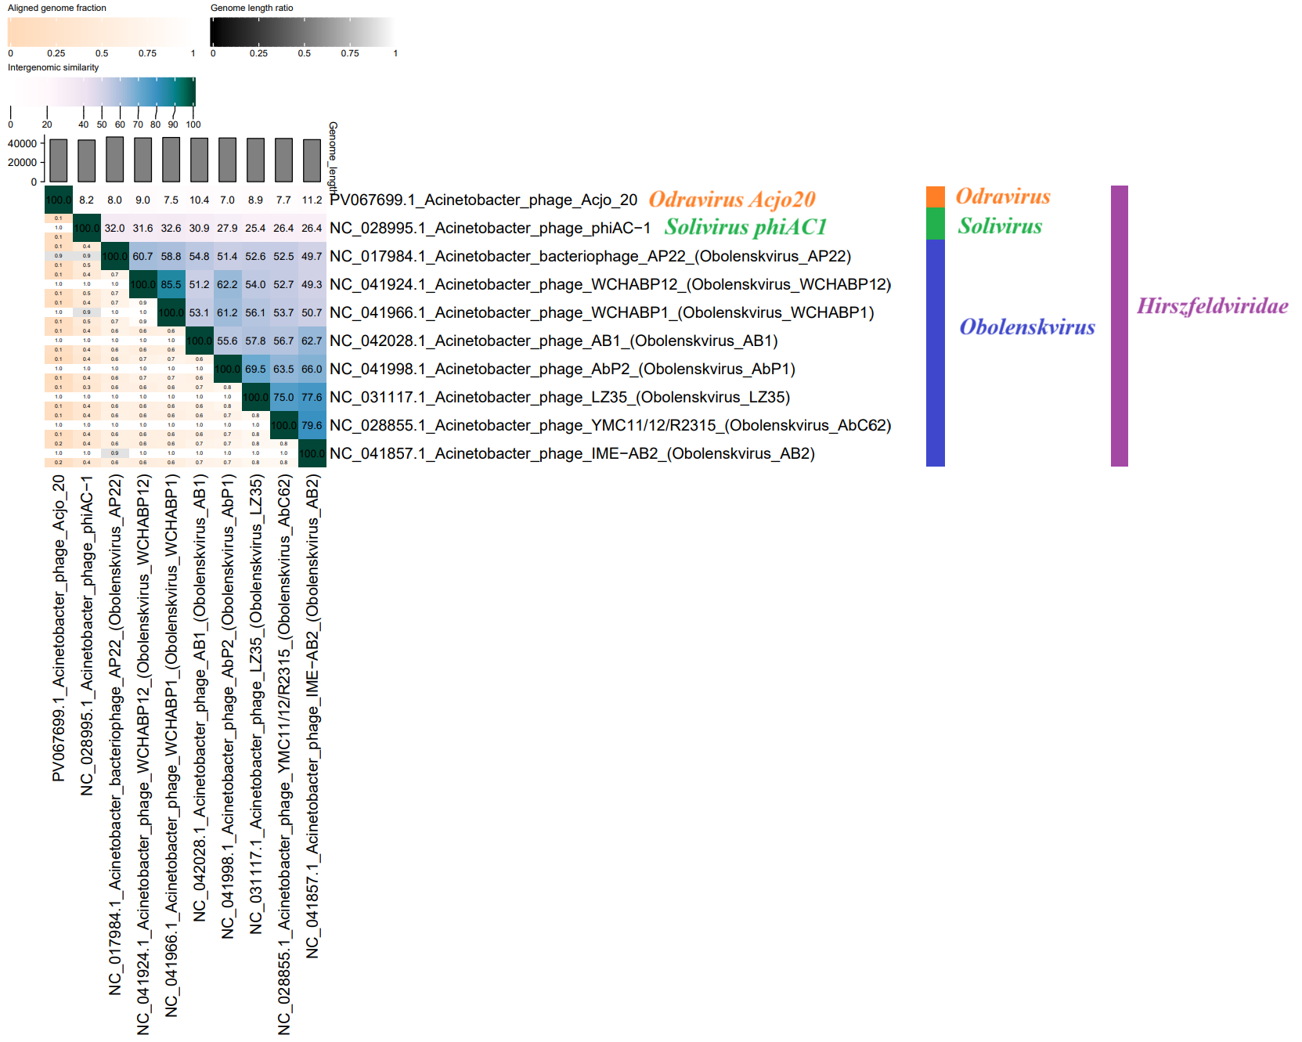

All 10 phages pre-classified in the NCBI database were divided into three groups, based on which we propose the creation of separate genera. Proposed genus names: **orange** – new genus: *“Odravirus”*, **green** – new genus: *“Solivirus”*, and **blue** – genus *“Obolenskvirus”*. Proposed family name: **purple** – new family: “*Hirszfeldviridae*”.

**Figure 2. ViPTree analysis*:** ViPTree analysis (https://www.genome.jp/viptree/; [4]) is based upon Rohwer and Edwards (2002) Phage Proteomic Tree [5]. The phage of interest is indicated with a **red star** and an **orange**, **green**, **blue** and **purple bars**.

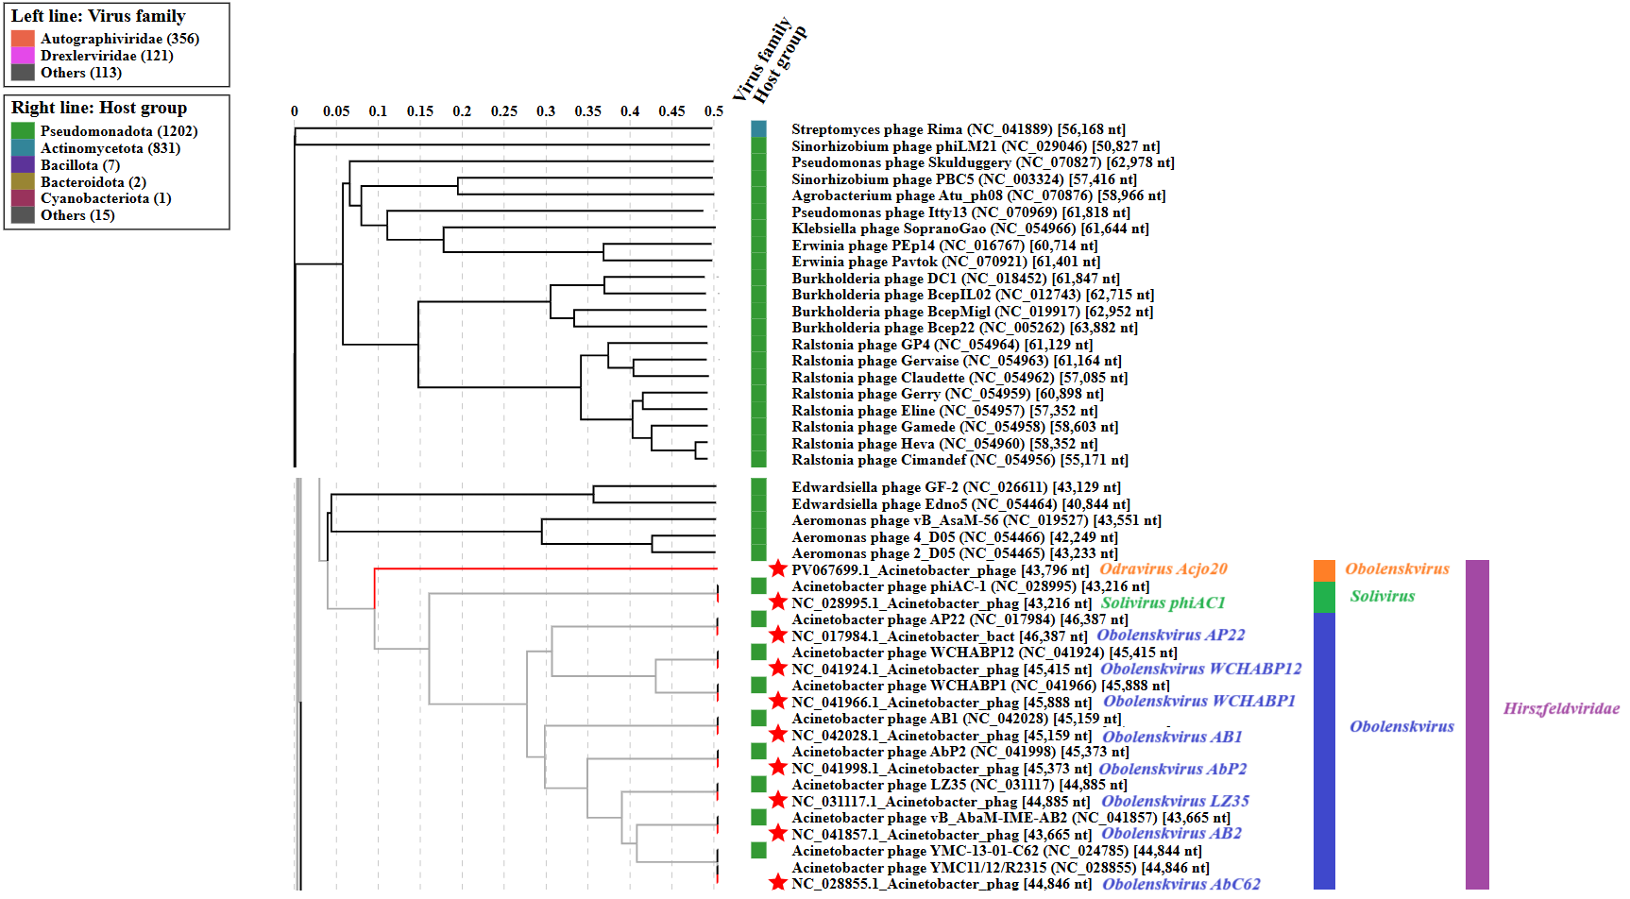

* The *Autographiviridae* family shown in **Figure 2** (automatically labeled by the software) is outdated. In 2025, the *Autographiviridae* family was elevated to the rank of order and renamed *Autographivirales*.

All 10 phages pre-classified in the NCBI database were divided into three groups, based on which we propose the creation of separate genera. Proposed genus names: **orange** – new genus: *“Odravirus”*, **green** – new genus: *“Solivirus”*, and **blue** – genus *“Obolenskvirus”*. Proposed family name: **purple** – new family: “*Hirszfeldviridae*”.

**A. To create a new family, “*Hirszfeldviridae”*, with three genera.**

After examination of 10 bacteriophages on the basis of nucleotide sequence similarity, tblastx distances and core gene phylogeny, we propose the creation of a new family, *“Hirszfeldviridae”*, with three genera; *“Odravirus”*, *“Solivirus”* and *“Obolenskvirus”*.

**B. To create a new single species genus, *“Odravirus”*.**

**Genome summary:**

|  |  |  |  |  |  |  |  |
| --- | --- | --- | --- | --- | --- | --- | --- |
| Phage name | RefSeq No. | INSDC | Size (bp) | GC% | Protein | Overall % DNA sequence identity (*) | Overall % homologous proteins (**) |
| Acinetobacter phage Acjo_20 |  | PV067699 | 43,796 | 40.6 | 71 | 100.0 | 100.0 |

(*) determined using VIRIDIC [2]

(**) determined using CoreGenes 3.5 [6]

**C. To create a new single species genus, “*Solivirus”*.**

**Genome summary:**

|  |  |  |  |  |  |  |  |
| --- | --- | --- | --- | --- | --- | --- | --- |
| Phage name | RefSeq No. | INSDC | Size (bp) | GC% | Protein | Overall % DNA sequence identity (*) | Overall % homologous proteins (**) |
| Acinetobacter phage phiAC-1 | NC_028995.1 | NC_028995 | 43,216 | 38.5 | 82 | 100.0 | 100.0 |

(*) determined using VIRIDIC [2]

(**) determined using CoreGenes 3.5 [6]

**D. To move the genus “*Obolenskvirus”* to new family, “*Hirszfeldviridae”*.**

After examining bacteriophages based on nucleotide sequence similarity, tblastx distance, and core gene phylogeny, we proposed to include the genus *“Obolenskvirus”* in a newly proposed family, *“Hirszfeldviridae”*.

In a separate proposal for 2025, we propose the creation of 41 new species within the genus "*Obolenskvirus*".

**Conclusion:** On the basis of DNA and protein similarity, *“Hirszfeldviridae”* is a cohesive family.