

The International Committee on Taxonomy of Viruses

Taxonomy Proposal Form, 2025

**Part 1a: Details of taxonomy proposals**

|  |  |
| --- | --- |
| **Title:** | Create two new species in the genus *Yuavirus* (class *Caudoviricetes*) |
| **Code assigned:** | 2025.082B.A.v2.Yuavirus_2ns | |

|  |  |  |  |  |
| --- | --- | --- | --- | --- |
| **Author(s), affiliation and email address(es):** | | | | |
| **Given name (+middle initial(s))** | **Surname** | **Affiliation** | **Email address** | **Corr. author(s)** |
| Aaryan | Harshith | Stanford University, Division of Infectious Diseases, Stanford, USA | [**aaryanh@stanford.edu**](mailto:aaryanh@stanford.edu) | X |
| Paul | Bollyky | Stanford University, Division of Infectious Diseases, Stanford, USA | **pbollyky@stanford.edu** |  |
| Jessica C. | Sacher | Stanford University, Department of Biochemistry, Stanford, USA | [**jsacher@stanford.edu**](mailto:jsacher@stanford.edu) |  |
| Carlo | Armijo | Stanford University, Department of Biochemistry, Stanford, USA | **carmijo@stanford.edu** |  |

**Part 1b: Taxonomy Proposal Submission**

|  |  |  |  |
| --- | --- | --- | --- |
| **ICTV Subcommittee:** | | | |
| Animal DNA Viruses and Retroviruses |  | Bacterial viruses | **X** |
| Animal minus-strand and dsRNA viruses |  | Fungal and protist viruses |  |
| Animal positive-strand RNA viruses |  | Plant viruses |  |
| Archaeal viruses |  | General - |  |

|  |
| --- |
| **List the ICTV Study Group(s) that have seen or have been involved in creating this proposal:** <https://ictv.global/sc> |
| Bacterial Viruses Subcommittee |

|  |  |  |  |
| --- | --- | --- | --- |
| **Optional – complete only if formally voted on by an ICTV Study Group:** | | | |
| **Study Group** | **Number of members** | | |
| **Votes in support** | **Votes against** | **No vote** |
|  |  |  |  |
|  |  |  |  |

|  |  |
| --- | --- |
| **Submission date:** | 22/01/2025 |

**Part 1c: Feedback from ICTV Executive Committee (EC) meeting**

|  |  |
| --- | --- |
| **Executive Committee Meeting Decision code:** | **X** |
| A – Accept | **x** |
| Ac – Accept subject to revision by relevant subcommittee chair. No further vote required |  |
| U – Accept without revision but with re-evaluation and email vote by the EC |  |
| Uc – Accept subject to revision and re-evaluation and email vote by the EC |  |
| Ud – Deferred to the next EC meeting, with an invitation to revise based on EC comments |  |
| J - Reject |  |
| W - Withdrawn |  |

|  |
| --- |
| **Comments from the Executive Committee:** |
|  |

**Part 1d: Revised Taxonomy Proposal Submission**

|  |
| --- |
| **Response of proposer:** |
|  |

|  |  |
| --- | --- |
| **Revision date:** |  |

**Part 3:** **TAXONOMIC PROPOSAL**

<https://ictv.global/taxonomy/templates>

|  |  |  |  |
| --- | --- | --- | --- |
| **Taxonomic changes proposed:** | | | |
| Establish new taxon | **X** | Split taxon |  |
| Abolish taxon |  | Merge taxon |  |
| Move taxon |  | Promote taxon |  |
| Rename taxon |  | Demote taxon |  |
| Move and rename |  |

|  |  |
| --- | --- |
| **Etymology (origin) of proposed taxonomic names:** | |
| **Taxon name** | **Etymology of the term** |
| *Yuavirus luminis* | Derived from the name of the bacteriophage *Pseudomonas* phage Luminis |
| *Yuavirus vanta* | Derived from the name of the bacteriophage *Pseudomonas* phage vanta |
|  |  |
|  |  |

|  |  |  |
| --- | --- | --- |
| **Permission for use of names derived from a living person:** | | |
| **Taxon name** | **Full name of person from whom the name is derived** | **Attached** |
|  |  |  |
|  |  |  |
|  |  |  |
|  |  |  |

|  |
| --- |
| **Abstract of Taxonomy Proposal:** |
| *Taxonomic rank(s) affected*:  Species  *Description of current taxonomy*:  The genus *Yuavirus* was established under proposal 2012.008a-dB.A.v3.Yualikevirus. The genus currently consists of five species.  *Proposed* *taxonomic change(s):*  Create two new species in the genus *Yuavirus*.  *Justification*:  VIRIDIC analysis indicates that both phages satisfy the species similarity threshold proposed by the ICTV Bacterial Viruses Subcommittee. Proteomic and phylogenetic evidence further supports the placement of phages Vanta and Luminis in the genus *Yuavirus*. |

|  |
| --- |
| * **Text of Taxonomy proposal:** |
| *Taxonomic rank(s) affected*:  Species  *Description of current taxonomy*:  The genus *Yuavirus* was established under proposal 2012.008a-dB.A.v3.Yualikevirus. The genus currently consists of five species.  *Proposed* *taxonomic change(s):*  Create two new species in the genus *Yuavirus*.  *Demarcation criteria:*  **Species demarcation criteria:** Phages are deemed as distinct species if they exhibit ≤95% sequence similarity (>5% sequence dissimilarity) across the length of their genome. BLASTn was initially used to identify viruses belonging to the same genus as the isolated phage, and similarity scores were evaluated using the Virus Intergenomic Distance Calculator (VIRIDIC) [3,5].  **Genus demarcation criteria:** The Bacterial Viruses Subcommittee has established 70% nucleotide identity of the genome length as the cut-off for genera. Genus-level groupings should always be monophyletic in the signature genes, as tested with a phylogenetic tree [4,6].  *Justification*:  *Pseudomonas* phage Vanta and Luminis were isolated from processed wastewater samples, courtesy of Stanford University’s Codiga Recovery Center. VIRIDIC analysis indicates that both phages satisfy the species similarity threshold proposed by the ICTV (Figure 1). Proteomic and phylogenetic evidence (Figure 2, Figure 3) further supports the placement of Vanta and Luminis in the genus *Yuavirus*. Per ICTV standards, the annotated genome of *Pseudomonas* phages Vanta and Luminis are available for reference in GenBank (PQ628237 and PQ632788). |

|  |
| --- |
| **References:** |
| 1. Anisimova, M., & Gascuel, O. (2006). Approximate likelihood-ratio test for branches: A fast, accurate, and powerful alternative. *Systematic Biology*, *55*(4), 539–552. <https://doi.org/10.1080/10635150600755453> 2. Dereeper A, Guignon V, Blanc G, Audic S, Buffet S, Chevenet F, Dufayard JF, Guindon S, Lefort V, Lescot M, Claverie JM, Gascuel O. [phylogeny.fr](http://phylogeny.fr): robust phylogenetic analysis for the non-specialist. Nucleic Acids Res. 2008 Jul 1;36(Web Server issue):W465-9. doi: 10.1093/nar/gkn180. Epub 2008 Apr 19. PMID: 18424797; PMCID: PMC2447785. 3. Moraru, C., Varsani, A., & Kropinski, A. M. (2020). VIRIDIC—A novel tool to calculate the intergenomic similarities of Prokaryote-Infecting viruses. *Viruses*, *12*(11), 1268. <https://doi.org/10.3390/v12111268> 4. Nishimura, Y., Yoshida, T., Kuronishi, M., Uehara, H., Ogata, H., & Goto, S. (2017). ViPTree: the viral proteomic tree server. *Bioinformatics (Oxford, England)*, *33*(15), 2379–2380. <https://doi.org/10.1093/bioinformatics/btx157> 5. Sayers, E. W., Bolton, E. E., Brister, J. R., Canese, K., Chan, J., Comeau, D. C., Connor, R., Funk, K., Kelly, C., Kim, S., Madej, T., Marchler-Bauer, A., Lanczycki, C., Lathrop, S., Lu, Z., Thibaud-Nissen, F., Murphy, T., Phan, L., Skripchenko, Y., . . . Sherry, S. T. (2021). Database resources of the national center for biotechnology information. *Nucleic Acids Research*, *50*(D1), D20–D26. <https://doi.org/10.1093/nar/gkab1112> 6. Turner, D., Kropinski, A. M., & Adriaenssens, E. M. (2021). A Roadmap for Genome-Based   Phage Taxonomy. *Viruses*, *13*(3), 506. <https://doi.org/10.3390/v13030506> |

|  |  |
| --- | --- |
| **Accompanying files:** | |
| **Filename** | **Description of contents** |
|  |  |
|  |  |

|  |
| --- |
| **Tables, Figures:** |

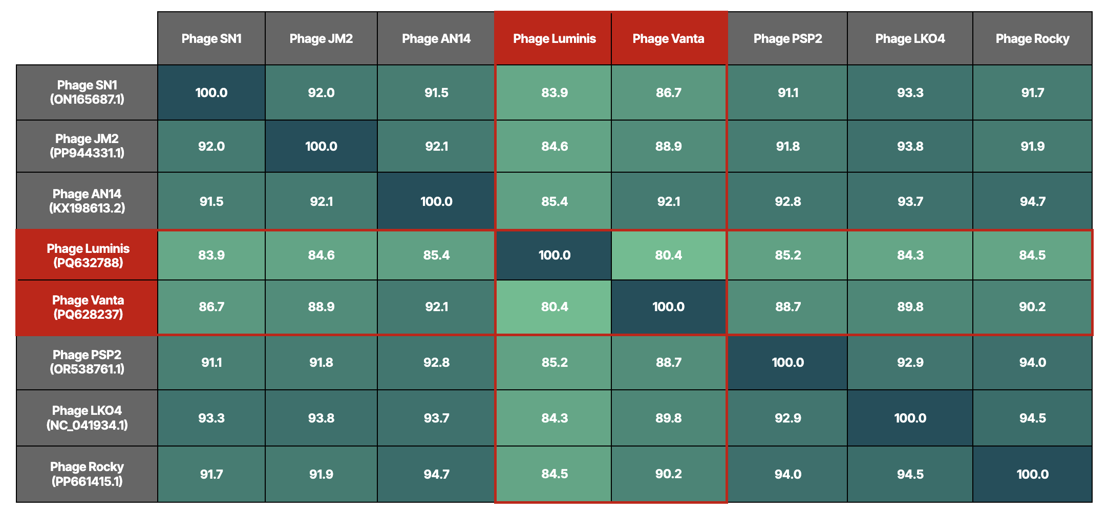

**Figure 1 (VIRIDIC Heatmap):**Cells in gray denote reference species, whereas red boundaries identify the proposed phages. All similarity scores were evaluated using VIRIDIC [3]. For clarity, raw data was expressed to three significant digits and reformatted using Google Sheets.

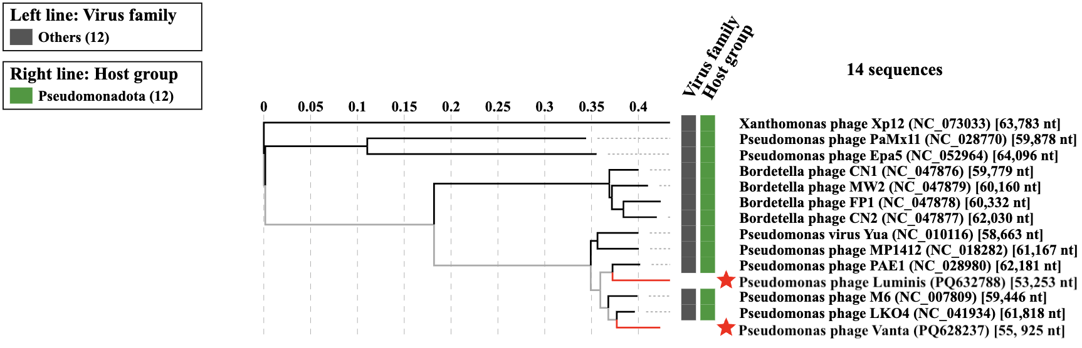

**Figure 2:** TBLASTX distance tree constructed using VIPTree [4]. Branch lengths are linearly proportional to distance, and *Xanthomonas* phage Xp12 is used for phyletic contrast. Phages of interest are identified with red stars.

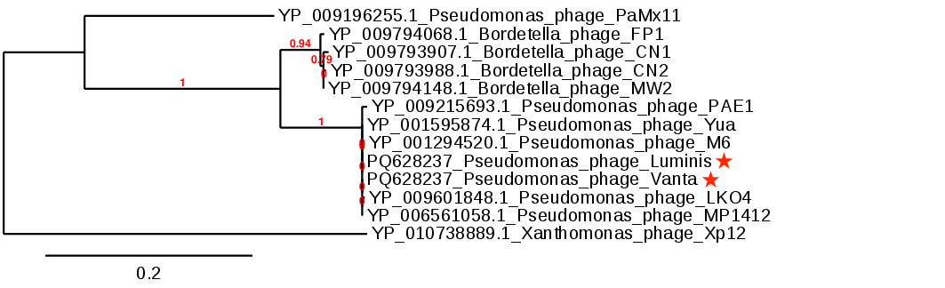

**Figure 3:** Maximum likelihood phylogenetic tree generated using Phylogeny FR (obscured support value is 0.79) [2]. Alignments were automatically performed using MUSCLE, based on amino acid identity of the large subunit of the terminase protein. Phylogeny was resolved using PhyML and support values were evaluated using default aLRT parameters [1]. Phages of interest are identified with red stars, and *Xanthomonas* phage Xp12 is used for phyletic contrast