

The International Committee on Taxonomy of Viruses

Taxonomy Proposal Form, 2025

**Part 1a: Details of taxonomy proposals**

|  |  |
| --- | --- |
| **Title:** | Create four new species in the genus *Justusliebigvirus* (class *Caudoviricetes*, subfamily *Stephanstirmvirinae*) |
| **Code assigned:** | 2025.080B.Justusliebigvirus_4ns | |

|  |  |  |  |  |
| --- | --- | --- | --- | --- |
| **Author(s), affiliation and email address(es):** | | | | |
| **Given name (+middle initial(s))** | **Surname** | **Affiliation** | **Email address** | **Corresponding author(s)** |
| Michał J. | Wójcicki | Bacteriophage Laboratory, Department of Phage Therapy, Hirszfeld Institute of Immunology and Experimental Therapy, Polish Academy of Sciences, Wroclaw, Poland | [michal.wojcicki@hirszfeld.pl](mailto:michal.wojcicki@hirszfeld.pl) | X |
| Iwona | Gientka | Department of Biotechnology and Food Microbiology, Institute of Food Sciences, Warsaw University of Life Sciences (WULS-SGGW), Warsaw, Poland | [iwona_gientka@sggw.edu.pl](mailto:iwona_gientka@sggw.edu.pl) | X |
| Barbara | Sokołowska | Department of Microbiology, Prof. Wacław Dąbrowski Institute of Agricultural and Food Biotechnology - State Research Institute, Warsaw, Poland | [barbara.sokolowska@ibprs.pl](mailto:barbara.sokolowska@ibprs.pl) | X |

**Part 1b: Taxonomy Proposal Submission**

|  |  |  |  |
| --- | --- | --- | --- |
| **ICTV Subcommittee:** | | | |
| Animal DNA Viruses and Retroviruses |  | Bacterial viruses | X |
| Animal minus-strand and dsRNA viruses |  | Fungal and protist viruses |  |
| Animal positive-strand RNA viruses |  | Plant viruses |  |
| Archaeal viruses |  | General |  |

|  |
| --- |
| **List the ICTV Study Group(s) that have seen or have been involved in creating this proposal:** |
| *Caudoviricetes Study Group* |

|  |  |  |  |
| --- | --- | --- | --- |
| **Optional – complete only if formally voted on by an ICTV Study Group:** | | | |
| **Study Group** | **Number of members** | | |
| **Votes in support** | **Votes against** | **No vote** |
|  |  |  |  |
|  |  |  |  |

|  |  |
| --- | --- |
| **Submission date:** | 27/03/2025 |

**Part 1c: Feedback from ICTV Executive Committee (EC) meeting**

|  |  |
| --- | --- |
| **Executive Committee Meeting Decision code:** | **X** |
| A – Accept |  |
| Ac – Accept subject to revision by relevant subcommittee chair. No further vote required |  |
| U – Accept without revision but with re-evaluation and email vote by the EC |  |
| Uc – Accept subject to revision and re-evaluation and email vote by the EC |  |
| Ud – Deferred to the next EC meeting, with an invitation to revise based on EC comments |  |
| J - Reject |  |
| W - Withdrawn |  |

|  |
| --- |
| **Comments from the Executive Committee:** |
|  |

**Part 1d: Revised Taxonomy Proposal Submission**

|  |
| --- |
| **Response of proposer:** |
|  |

|  |  |
| --- | --- |
| **Revision date:** |  |

**Part 3:** **TAXONOMIC PROPOSAL**

|  |  |  |  |
| --- | --- | --- | --- |
| **Taxonomic changes proposed:** | | | |
| Establish new taxon | X | Split taxon |  |
| Abolish taxon |  | Merge taxon |  |
| Move taxon |  | Promote taxon |  |
| Rename taxon |  | Demote taxon |  |
| Move and rename |  |

|  |  |
| --- | --- |
| **Etymology (origin) of proposed taxonomic names:** | |
| **Taxon name** | **Etymology of the term** |
| *Justusliebigvirus UAB1* | species name derived from the phage name in the GenBank database – Salmonella phage UAB_1 |
| *Justusliebigvirus SD2* | species name derived from the phage name in the GenBank database – Escherichia phage SD2 |
| *Justusliebigvirus KKP3264* | species name derived from the phage name in the GenBank database – Serratia phage KKP_3264 |
| *Justusliebigvirus JLBYU50* | species name derived from the phage name in the GenBank database – Escherichia phage JLBYU50 |

|  |  |  |
| --- | --- | --- |
| **Permission for use of names derived from a living person** | | |
| **Taxon name** | **Full name of person from whom the name is derived** | **Attached** |
|  |  |  |

|  |
| --- |
| **Abstract of Taxonomy Proposal:** |
| *Taxonomic rank(s) affected*:  Realm *Duplodnaviria*, kingdom *Heunggongvirae*, phylum *Uroviricota*, class *Caudoviricetes*  *Description of current taxonomy*:  The subfamily *Stephanstirmvirinae* comprises two genera, *Justusliebigvirus* and *Phapecoctavirus,* and 19 species. Currently, the *Justusliebigvirus* genus includes six species: *Justusliebigvirus* VEcB, *Justusliebigvirus PHB05, Justusliebigvirus PD06, Justusliebigvirus alia, Justusliebigvirus phi92,* and *Justusliebigvirus muut.*  *Proposed* *taxonomic change(s):*  We performed a genomic analysis of phages deposited in the NCBI database. We propose to create four new species in the genus *Justusliebigvirus* (class *Caudoviricetes*, subfamily *Stephanstirmvirinae*).  *Justification*:  Based on DNA and protein similarity, the proposed four new species are coherent and together with the six known species (*Justusliebigvirus* VEcB, *Justusliebigvirus PHB05, Justusliebigvirus PD06, Justusliebigvirus alia, Justusliebigvirus phi92,* and *Justusliebigvirus muut*) can be classified in the genus *Justusliebigvirus*. |

|  |
| --- |
| **Text of Taxonomy proposal:** |
| *Taxonomic rank(s) affected*:  Realm *Duplodnaviria*, kingdom *Heunggongvirae*, phylum *Uroviricota*, class *Caudoviricetes*  *Description of current taxonomy*:  The subfamily *Stephanstirmvirinae* comprises two genera (i.e. *Justusliebigvirus* and *Phapecoctavirus*) and 19 species. Currently, the *Justusliebigvirus* genus includes six species: *Justusliebigvirus* VEcB, *Justusliebigvirus PHB05, Justusliebigvirus PD06, Justusliebigvirus alia, Justusliebigvirus phi92,* and *Justusliebigvirus muut.*  *Proposed* *taxonomic change(s)*:  We performed a genomic analysis of phages deposited in the NCBI database. We propose to create four new species in the genus *Justusliebigvirus*.  *Demarcation criteria:*  **Species demarcation criteria:** Two phages are assigned to the same species if their genomes are more than 95% identical over their genome length for isolates.  These values can be calculated by several tools, such as BLASTn [1] – usually calculated using the intergenomic distance calculator VIRIDIC [2].  **Genus demarcation criteria:** In search for criteria that create cohesive and distinct genera that are reproducible and monophyletic, the Bacterial Viruses Subcommittee has established 70% nucleotide identity of the genome length as the cut-off for genera. Genus-level groupings should always be monophyletic in the signature genes, as tested with a phylogenetic tree [3].  *Justification*:  Based on DNA and protein similarity, the proposed four new species are coherent and together with the six known species (*Justusliebigvirus* VEcB, *Justusliebigvirus PHB05, Justusliebigvirus PD06, Justusliebigvirus alia, Justusliebigvirus phi92,* and *Justusliebigvirus muut*) can be classified in the genus *Justusliebigvirus*. |

|  |
| --- |
| **References:** |
| 1. Sayers EW, Beck J, Bolton EE, Bourexis D, Brister JR, Canese K, Comeau DC, Funk K, Kim S, Klimke W, Marchler-Bauer A, Landrum M, Lathrop S, Lu Z, Madden TL, O'Leary N, Phan L, Rangwala SH, Schneider VA, Skripchenko Y, Wang J, Ye J, Trawick BW, Pruitt KD, Sherry ST. Database resources of the National Center for Biotechnology Information. *Nucleic Acids Res.* 2021, 49(D1):D10-D17. 2. Moraru C, Varsani A, Kropinski AM. VIRIDIC - a novel tool to calculate the intergenomic similarities of prokaryote-infecting viruses. *Viruses* 2020, 12(11):1268. 3. Turner D, Kropinski AM, Adriaenssens EM. A roadmap for genome-based phage taxonomy. *Viruses* 2021, 13(3):506. 4. Nishimura Y, Yoshida T, Kuronishi M, Uehara H, Ogata H, Goto S. ViPTree: the viral proteomic tree server. *Bioinformatics* 2017, 33(15):2379-2380. 5. Rohwer F, Edwards R. The Phage Proteomic Tree: a genome-based taxonomy for phage. *J. Bacteriol.* 2002, 184(16):4529-35. 6. Turner D, Reynolds D, Seto D, Mahadevan P. CoreGenes3.5: a webserver for the determination of core genes from sets of viral and small bacterial genomes. *BMC Res. Notes.* 2013, 6:140. |

|  |  |
| --- | --- |
| **Accompanying files:** | |
| **Filename** | **Description of contents** |
| Justusliebigvirus_4ns.xlsx | To present the proposed taxonomic changes as a comparison of new taxonomic structures. |
| **Tables, Figures:** | |

**Figure 1. VIRIDIC heat map:** VIRIDIC (Virus Intergenomic Distance Calculator [2]; http://rhea.icbm.uni-oldenburg.de/VIRIDIC/) computes pairwise intergenomic distances/similarities amongst phage genomes. Phages belonging to the same species (nucleotide similarity above 95%) are marked with a colored frames. The currently distinguished six species belonging to the genus *Justusliebigvirus* are marked with colored species names.

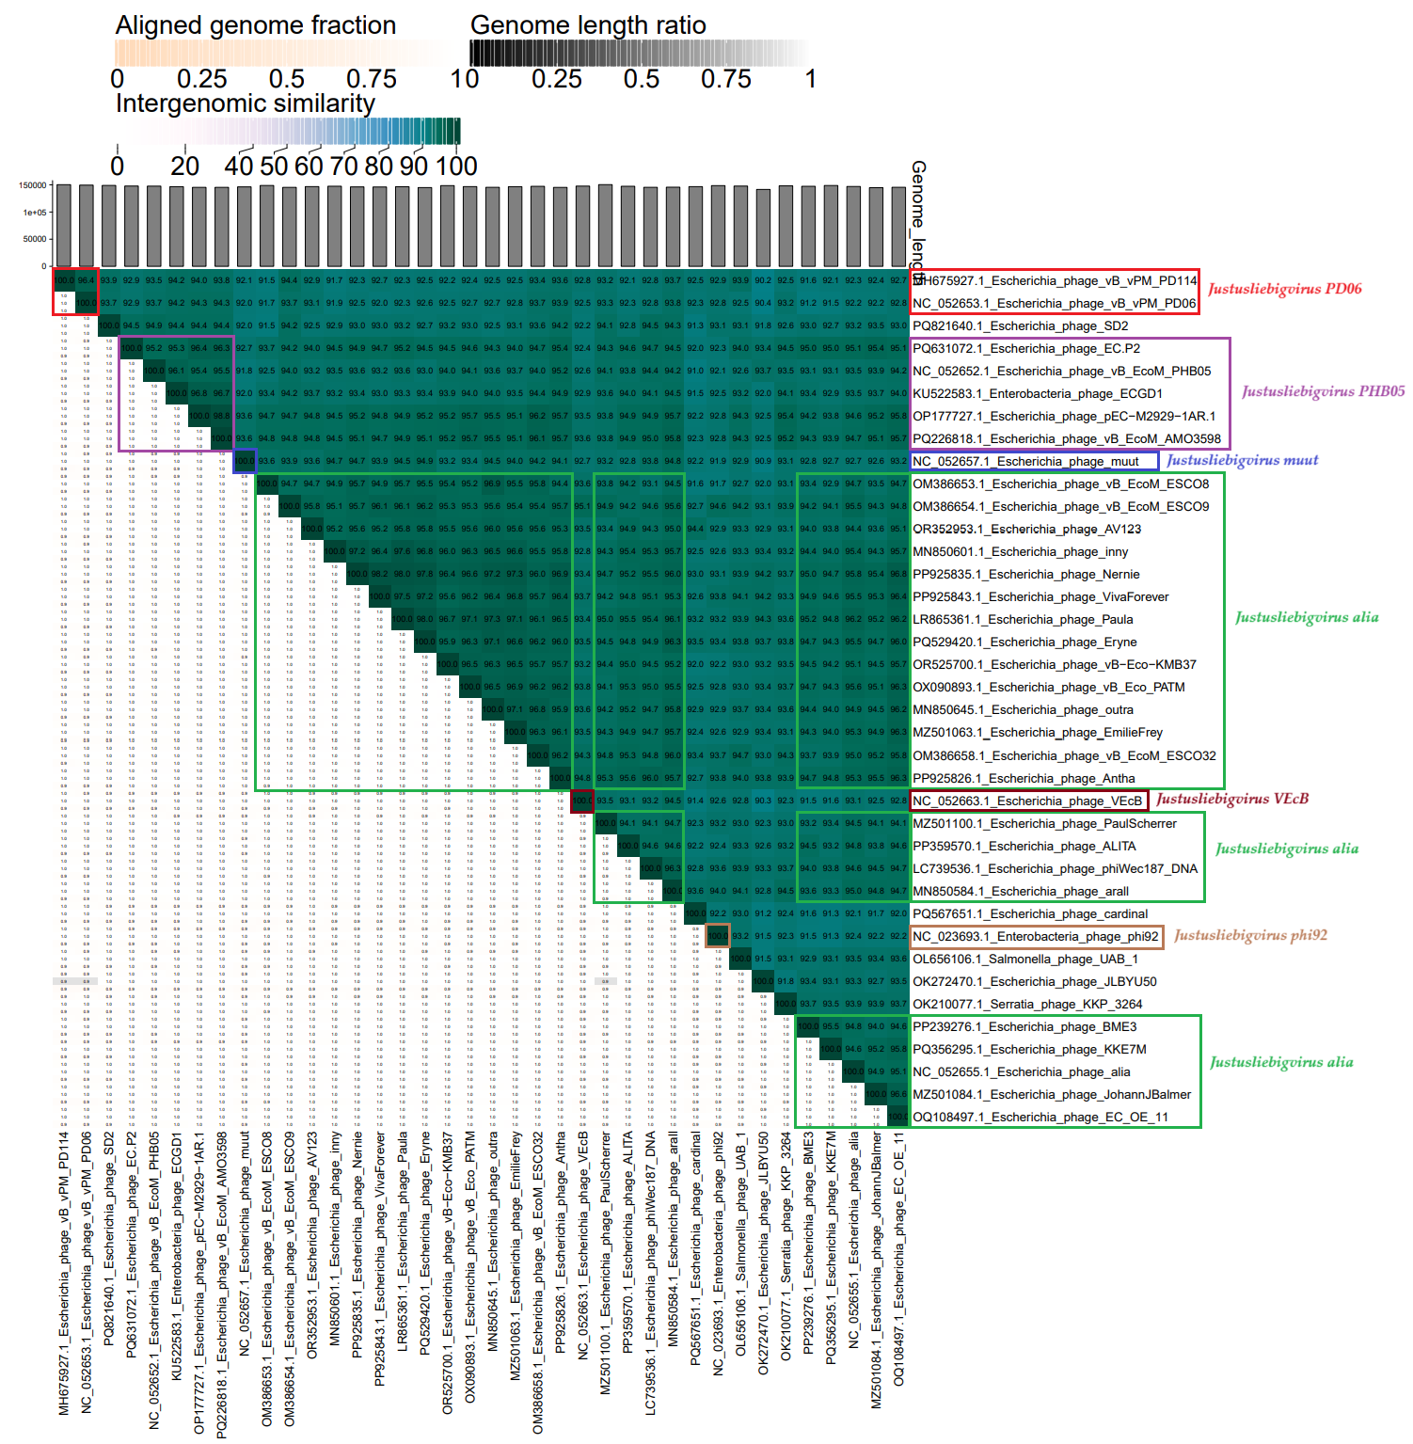

**Figure 2. ViPTree analysis*:** ViPTree analysis (https://www.genome.jp/viptree/; [4]) is based upon Rohwer and Edwards (2002) Phage Proteomic Tree [5]. The phage of interest is indicated with a **red stars** and a colored bars.

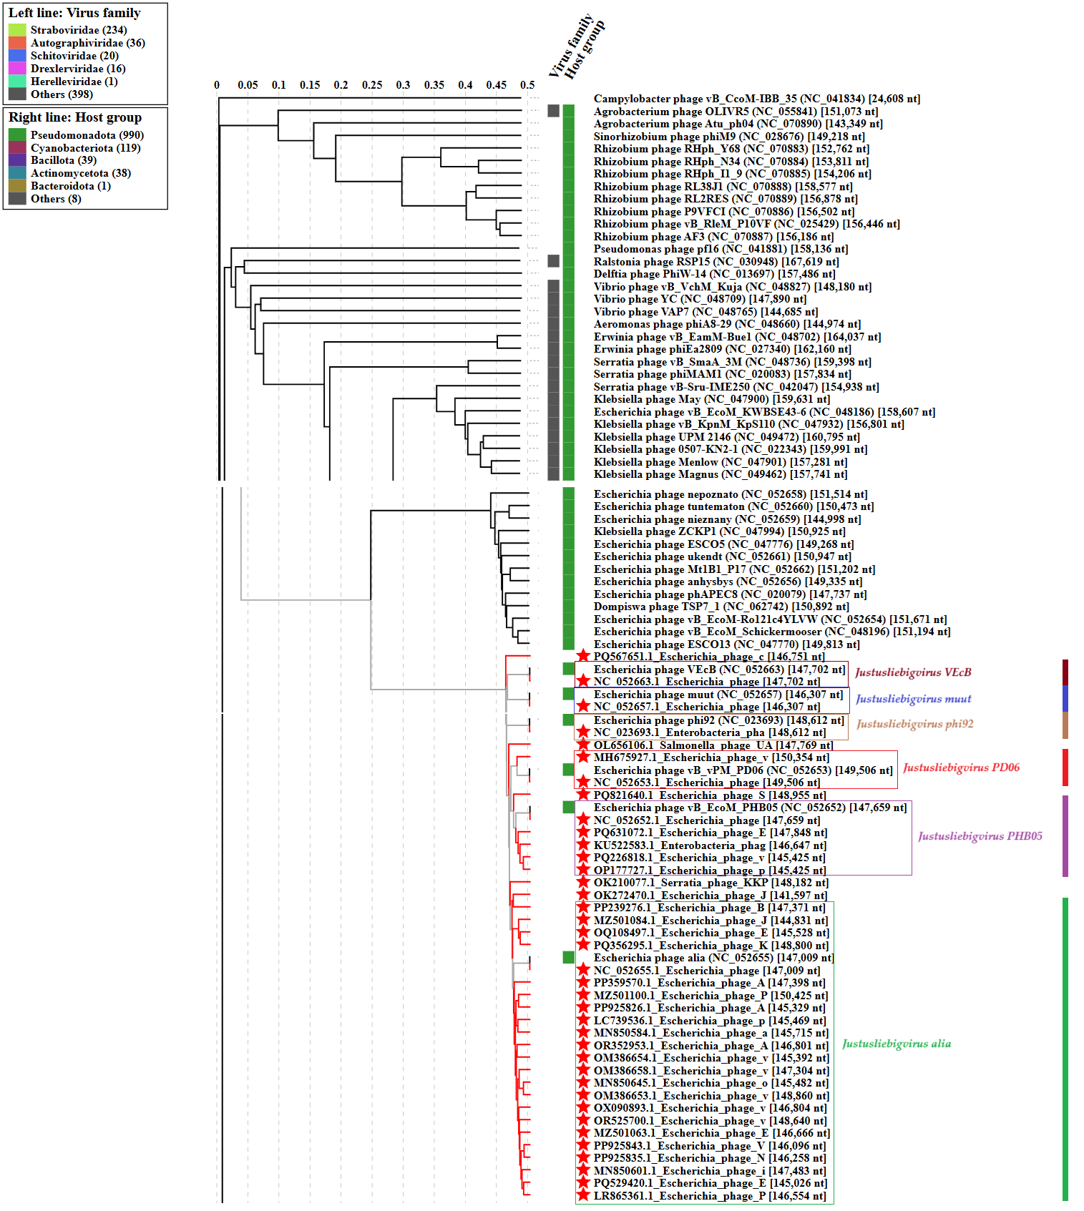

* The *Autographiviridae* family shown in **Figure 2** (automatically labeled by the software) is outdated. In 2025, the *Autographiviridae* family was elevated to the rank of order and renamed *Autographivirales*.

**Genome summary:**

|  |  |  |  |  |  |  |  |
| --- | --- | --- | --- | --- | --- | --- | --- |
| Phage name | RefSeq No. | INSDC | Size (bp) | GC% | Protein | Overall % DNA sequence identity (*) | Overall % homologous proteins (**) |
| **Escherichia phage VEcB (*Justusliebigvirus VEcB*; reference genome)** | **NC_052663.1** | **NC_052663** | **147,702** | **37.6** | **249** | **100.0** | **100.0** |
| Salmonella phage UAB_1 |  | OL656106 | 147,769 | 37.4 | 246 | 92.8 | 93.57 |
| Escherichia phage SD2 |  | PQ821640 | 148,955 | 37.5 | 246 | 92.2 | 92.37 |
| Serratia phage KKP_3264 |  | OK210077 | 148,182 | 37.5 | 236 | 92.3 | 89.96 |
| Escherichia phage JLBYU50 |  | OK272470 | 141,597 | 37.5 | 239 | 90.3 | 90.36 |

(*) determined using VIRIDIC [2]

(**) determined using CoreGenes 3.5 [6]