

The International Committee on Taxonomy of Viruses

Taxonomy Proposal Form, 2024

**Part 1a: Details of taxonomy proposals**

|  |  |  |
| --- | --- | --- |
| **Title:** | Create new genera and species in order *Tubulavirales* – 34 genera and 48 species in the family *Inoviridae* and 1 species in the family *Paulinoviridae* | |
| **Code assigned:** | 2025.077B.Tubulavirales_35ng_48_ns |

|  |  |  |  |
| --- | --- | --- | --- |
| **Author(s), affiliation and email address(es):** | | | |
| **Name** | **Affiliation** | **Email address** | **Corresponding author(s)** X |
| **Knezevic, P** | **Faculty of Sciences, University of Novi Sad** | **petar.knezevic@dbe.uns.ac.rs** | **X** |
| **Gavric, D** | **Faculty of Sciences, University of Novi Sad** | **damir.gavric@dbe.uns.ac.rs** |  |
| **Lavigne, R** | **KU Leuven, Belgium** | [**rob.lavigne@kuleuven.be**](mailto:rob.lavigne@kuleuven.be) |  |
| **Kropinski, AM** | **University of Guelph, Canada** | [**Phage.Canada@gmail.com**](mailto:Phage.Canada@gmail.com) |  |
| **Adriaenssens, EM** | **Quadram Institute Bioscience, UK** | [**Evelien.Adriaenssens@quadram.ac.uk**](mailto:Evelien.Adriaenssens@quadram.ac.uk) |  |
| **Turner, D** | **University of the West of England, UK** | **Dunn2.Turner@uwe.ac.uk** |  |

**Part 1b: Taxonomy Proposal Submission**

|  |  |  |  |
| --- | --- | --- | --- |
| **ICTV Subcommittee:** | | | |
| Animal DNA Viruses and Retroviruses |  | Bacterial viruses | **x** |
| Animal minus-strand and dsRNA viruses |  | Fungal and protist viruses |  |
| Animal positive-strand RNA viruses |  | Plant viruses |  |
| Archaeal viruses |  | General - |  |

|  |
| --- |
| **List the ICTV Study Group(s) that have seen or have been involved in creating this proposal:** |
| *Tubulavirales* study group |

|  |  |  |  |
| --- | --- | --- | --- |
| **Optional – complete only if formally voted on by an ICTV Study Group:** | | | |
| **Study Group** | **Number of members** | | |
| **Votes in support** | **Votes against** | **No vote** |
|  |  |  |  |
|  |  |  |  |

|  |  |
| --- | --- |
| **Submission date:** | DD/MM/YYYY |

**Part 1c: Feedback from ICTV Executive Committee (EC) meeting**

|  |  |
| --- | --- |
| **Executive Committee Meeting Decision code:** | **X** |
| A – Accept |  |
| Ac – Accept subject to revision by relevant subcommittee chair. No further vote required |  |
| U – Accept without revision but with re-evaluation and email vote by the EC |  |
| Uc – Accept subject to revision and re-evaluation and email vote by the EC |  |
| Ud – Deferred to the next EC meeting, with an invitation to revise based on EC comments |  |
| J - Reject |  |
| W - Withdrawn |  |

|  |
| --- |
| **Comments from the Executive Committee:** |
|  |

**Part 1d: Revised Taxonomy Proposal Submission**

|  |
| --- |
| **Response of proposer:** |
|  |

|  |  |
| --- | --- |
| **Revision date:** | DD/MM/YYYY |

**Part 2:** **GENERAL PROPOSAL**

|  |
| --- |
| **Abstract for General Proposal:** |
| *Brief description of current situation:*  *Proposed changes:*  *Justification:* |

|  |
| --- |
| **Text of General Proposal:** |
| *Background:*  *Proposed* *changes:*  *Justification:* |

|  |
| --- |
| **References:** |
|  |

|  |
| --- |
| **Tables, Figures:** |

<Start here>

**Part 3:** **TAXONOMIC PROPOSAL**

|  |
| --- |
| **Name of accompanying Excel module:** |
| *Tubulavirales_TP_Template_Excel_module_2024* |

|  |  |  |  |
| --- | --- | --- | --- |
| **Taxonomic changes proposed:** | | | |
| Establish new taxon | **x** | Split taxon |  |
| Abolish taxon |  | Merge taxon |  |
| Move taxon |  | Promote taxon |  |
| Rename taxon |  | Demote taxon |  |
| Move and rename |  |

|  |  |  |
| --- | --- | --- |
| **Is any taxon name used here derived from that of a living person:** | | **N** |
| **Taxon name** | **Person from whom the name is derived** | **Attached X** |
|  |  |  |
|  |  |  |
|  |  |  |

|  |
| --- |
| **Abstract of Taxonomy Proposal:** |
| *Taxonomic rank(s) affected*:  *Description of current taxonomy*:  *Proposed* *taxonomic change(s):*  *Justification*: |

|  |
| --- |
| * **Text of Taxonomy proposal:** |
| *Taxonomic rank(s) affected*: genuses and species of order *Tubulavirales*, families *Inoviridae* and *Paulinoviridae*  *Description of current taxonomy*: Order *Tubulavirales* currently comprise families *Inoviridae* with 26 genera; *Plectroviridae* with 4 genera and *Paulinoviridae* with 2 genera  *Proposed* *taxonomic change(s)*:   * **To create new genera and new species:**  1. Genus *Nigolovirus* and species *Nigolovirus* 219 (from latin *nigrum olor* – black swan); The DNA sequence, as well as the amino acid sequences of the major coat protein and morphogenesis (assembly) proteins of this phage, differ considerably from those of phages with currently available genome sequences (Table 1, Fig. 1, Fig. 14; also see Tables 2-4). 2. Genus *Phargevirus* and species *Phargevirus 213* (from latin *phasianus argentum* – silver phasant); The DNA sequence, as well as the amino acid sequences of the major coat protein and assembly proteins of this phage, differ considerably from those of phages with currently available genome sequences (Table 2, Fig. 1 and 14; also see Tables 1 and 5). 3. Genus *Ramphavirus* and species *Ramphavirus 80* (from scientific name for toucan – *Ramphastos*); The DNA sequence, as well as the amino acid sequences of the major coat protein and assembly proteins of this phage, differ considerably from those of phages with currently available genome sequences (Table 3, Fig. 1, Fig. 14) 4. Genus *Pilosavirus* and species *Pilosavirus PMBT54* (from latin *pilosus, pilosa* – hairy, shaggy, covered with hair); There are sequences of two strains, which share a high degree of similarity (97.1%) and belong to the same species. The DNA sequence, as well as the amino acid sequences of the major coat protein and assembly proteins of these phages, differ considerably from those of phages with currently available genome sequences (Table 4, Fig. 1, Fig. 14; also see Table 1) 5. Genus *Pythonevirus* and species *Pythonevirus WXY* (from latin *Python, Pythonis* – snake slain at Delphi); The DNA sequence, morphogenesis, and major coat protein of this phage differ considerably from those of phages with currently available genome sequences (Table 5, Fig. 1, Fig. 14; also see Tables 1 and 2). 6. Genus *Serpentivirus* and species *Serpentivirus* *dolos* (from latin *serpens*, *serpentis* – snake); The morphogenesis and major coat protein of this phage show high similarity (approx.. 50%) to those of several other phages, whereas the overall DNA sequence exhibits significantly lower similarity (<27.9%), indicating notable genomic divergence and supporting its classification as a distinct genus. (Table 6, Fig. 1, Fig. 14; ; also see Tables 8-10, 23 and 28). 7. Genus *Scytalavirus* and species *Scytalavirus 6* (from latin *scytala, scytalae* - cylindrical snake, roller, Band, belt, collar (dog)); The morphogenesis and major coat protein of this phage show high similarity (>50%) to those of several other phages, whereas the overall DNA sequence exhibits significantly lower similarity (<27.9%), indicating notable genomic divergence and supporting its classification as a distinct genus (Table 7, Fig. 2, Fig. 14; also see Tables 6, 8, and 9). 8. Genus *Senectutivirus* and species *Senectutivirus 138* (from latin *senectus, senectutis* – gray hairs, shed snake skin); The morphogenesis and major coat protein of this phage exhibit relatively high similarity (>50%) to those of several other phages, while the overall DNA sequence shows significantly lower similarity (<22.4%). Although related to members of the genus *Scytalavirus*, notable genomic divergence supports its classification as a distinct genus (Table 8, Fig. 2, Fig. 14; also see Tables 6, 7, and 9). 9. Genus *Femenvirus* and species *Femenvirus 11* and *Femenvirus 13* (from latin *femen, feminis* – flat vertical band on triglyph); Based on the relatively low DNA sequence similarity (68.3%), the two strains are assigned to different species. The DNA sequences, morphogenesis, and major coat proteins of these phages differ considerably from those of phages with currently available genome sequences, supporting the establishment of a new genus (Table 9, Fig. 2, Fig. 14; also see Tables 6-8 and 23). 10. Genus *Vittavirus* and species *Vittavirus Vaf1* (from latin *vitta, vittae* - band, ribbon); This phage exhibits substantial divergence in both its DNA sequence and the amino acid sequence of the major capsid protein when compared to all known phages. While it shares 62.8% similarity in the assembly protein amino acid sequence with *Saetivirus* *VFJ*, its DNA and major capsid protein sequences show much lower similarity (23.6% and 34.2%, respectively), highlighting its distinct features (Table 10, Fig. 2, Fig. 14; also see Tables 6, 8, 9, and 34). 11. New genus *Amentovirus* and species: *Amentovirus 10, Amentovirus 42, and Amentovirus 39* (from latin amentum, amenti - (shoe) thong/strap); These three species share a relatively high level of DNA sequence similarity (70.5–80.7%). Although the assembly protein shows a high degree of similarity to *Antiavirus* 20, the sequences of the major coat protein and the overall DNA differ substantially (Table 11, Fig. 3, Fig. 14). 12. Genus *Fasceasvirus* and species: *Fasceasvirus 1, Fasceasvirus 25 and Fasceasvirus 30* (from latin *facea, fasceae* - band/strip, headband/filet, ribbon); These three species share a considerable level of DNA sequence similarity (34.7–63.4%). The amino acid sequences of their major coat and assembly proteins are highly similar to each other (>55.6%) but differ significantly from those of related phages, including their DNA sequences, supporting their classification within a distinct genus (Table 12, Fig. 3, Fig. 14; also see Tables 6, 8, 9, 13, 14 and 34). 13. Genus *Adiligaturavirus* and species *Adiligaturavirus 24* (from latin *adiligatura, adilifaturae* - band, binding); The DNA sequence, morphogenesis, and major coat protein of this phage differ considerably from those of phages with currently available genome sequences (Table 13, Fig. 3, Fig. 14; also see Tables 12, 15, and 29). 14. Genus *Antiavirus* and species *Antiavirus* 20 (from latin *antia, antiae* - locks (pl.) of hair that hang down in front, forelock); The DNA sequence shares some similarity with other phages, but the assembly and major coat protein of this phage differ considerably from those of phages with currently available genome sequences (Table 14, Fig. 3, Fig. 14; also see Table 11). 15. Genus *Aclydivirus* and species *Aclydivirus 6* (from latin *aclys, aclydis* - small javelin with a strap); The DNA sequence, morphogenesis, and major coat protein of this phage differ considerably from those of phages with currently available genome sequences (Table 15, Fig. 3, Fig. 14; also see Tables 13, 29 and 30). 16. Genus *Strophivirus* and species: *Strophivirus 33, Strophivirus 31, Strophivirus 32, Strophivirus 36, Strophivirus 37 and Strophivirus 34* (from latin *strophium, strophi(i)* – head-band, twisted breast-band); These six new species share substantial DNA sequence similarity (>51.6%) and a high degree of similarity in key proteins. Although these phages exhibit similarity in their DNA sequences and assembly protein with members of the genus *Maeandervirus*, the amino acid sequence of the major capsid protein differs significantly, supporting their separation from that genus (Table 16, Fig. 4, Fig. 14; also see Tables 18 and 20). 17. Genus *Maeandervirus* and species *Maeandervirus 44* and *Maeandervirus 40* (from latin maeander, maeandri - river famous for winding path, roundabout ways/twists/turnings (pl.), wavy line); These two species share similar DNA sequences (63.4%) and a high degree of similarity in key proteins (>95%). In addition to the aforementioned similarity to members of the genus *Strophivirus*, these phages also share similarity in their assembly protein sequences with other phages. However, the substantial differences in their DNA sequences and major capsid protein sequences support their classification as members of a distinct genus (Table 17, Fig. 4, Fig. 14; also see Tables 3 and 16). 18. Genus *Semitavirus* and species *Semitavirus 43* (from latin *semita, semitae* – path); This virus shares similarity of amino acid sequence in key proteins with certain other viruses (~50%), but possesses a unique DNA sequence, with no more than 13% similarity to those viruses. This pronounced genomic divergence supports its classification as a member of a distinct genus (Table 18, Fig. 4, Fig. 14; also see Tables 16 and 17). 19. Genus *Itinerivirus* and species *Itinerivirus 12* (from latin itiner, itineris – passage, path); This virus shares a high degree of amino acid sequence similarity in major coat protein with certain other phges (~50%), but possesses a unique DNA sequence and morphogenesis protein (Table 19, Fig. 4, Fig. 14; also see Tables 16 and 17). 20. Genus *Actovirus* and two species *Actovirus 41* and *Actovirus 45* (from latin *actus, actus* – path, cart-track, right of way/road for cattle); These two species share a considerable percentage of DNA sequence similarity (53.5%) and exhibit very high similarity in key proteins (>69%). Although their key proteins show >50% similarity to those of other phages, they clearly form a distinct genus due to their unique DNA sequences, which display less than 9.3% similarity to the most closely related phages (Table 20, Fig. 4, Fig. 14; also see Tables 16-19). 21. Genus *Aspidivirus* and species *Aspidivirus 14* and *Aspidivirus 19* (from latin aspis, aspidis - venomous snake of North Africa); These two species share substantial DNA sequence similarity and exhibit very high similarity in both the assembly protein and the major capsid protein. Although they are closely related to the genus *Galbavirus* based on their DNA and major capsid protein sequences, they differ in the amino acid sequence of the assembly protein, showing 43.1% similarity, which supports their separation from that genus (Table 21, Fig. 5, Fig. 14; also see Tables 15 and 22). 22. Genus *Galbavirus* and species *Galbavirus 17* (from latin *galba, galbae* – small worm, ash borer/larva of ash spinner) This virus shows similarity to members of the genus *Aspidivirus*, but exhibits significant differences in the amino acid sequence of the assembly protein (Table 22, Fig. 5, Fig. 14; also see Tables 21, 29 and 30). 23. Genus *Reticulivirus* and species *Reticulivirus 11* (from latin *reticulum, reticuli* – hair net, network, small (fish) net, small mesh bag); This phage shares DNA and amino acid sequences of key proteins to some extent with members of the genera *Serpentivirus* and *Femenvirus* (approx. 30%), but possesses a unique DNA sequence that distinguishes it as a member of a separate genus (Table 23, Fig. 6, Fig. 14). 24. Genus *Pubesvirus* and species *Pubesvirus 29* (from latin *pubes, pubis* – private/pubic parts/hair); This phage shows over 50% similarity in the major capsid protein sequence to some phages (members of genera *Prolivirus* and *Fibrovirus*), but significant differences in both the DNA sequence and the amino acid sequence of the assembly protein distinguish it as a member of a distinct genus (Table 24, Fig. 7, Fig. 14). 25. Genus *Prolivirus* and species *Prolivirus 37* (from latin *proles, prolis* – offspring, descendant); This virus differs from members of the genus *Pubesvirus*, although some similarities exist as described above. It shows 56.8% similarity to the major coat protein of *Fibrovirus* members but differs in the assembly protein and overall DNA sequence. It also shares almost 30% DNA sequence identity with members of the genus *Plantarivirus*. However, the amino acid sequences of both the major capsid protein and the assembly protein differ significantly. Due to the lack of fulfillment of the criteria required for inclusion in any existing genus or species, these findings support the establishment of a new genus and species. (Table 25, Fig. 7, Fig. 14; also see Tables 24 and 26). 26. Genus *Plantarivirus* and species *Plantarivirus 147* (from latin *plantarium, plantarii* – slip, cutting (of plant), hair); This phage shows significant DNA sequence similarity only with *Prolivirus* 37, but differs substantially in the sequences of key genes, which distinguishes it as a member of a new genus (Table 26, Fig. 7, Fig. 14; also see Table 25). 27. Genus *Propagovirus* and species *Propagovirus nuni (*from latin *propago, propagini* – layer or set by which a plant is propagated; from latin *nulla nihil* – zero nothing); This phage shows high similarity in key proteins to phages of the genus *Fibrovirus*, which infect members of the genus *Vibrio*, but its DNA sequence similarity to these phages does not exceed 16%, supporting its classification as a member of a new genus (Table 27, Fig. 7, Fig. 14; also see Tables 2, 25 and 26). 28. Genus *Sarmentivirus* and species *Sarmentivirus 25* (from latin *sarmentum, sarmenti* – twigs (pl.), cut twigs, brushwood); This phage possesses a unique DNA sequence as well as unique sequences of key proteins, which supports its classification into a separate new genus (Table 28, Fig. 8, Fig. 14). 29. Genus *Acontivirus* and species *Acontivirus 21* (from latin *acontias, acontiae* – quick-darting snake); This phage possesses a unique DNA sequence as well as unique sequences of key proteins, which supports its classification into a separate genus and the establishment of a new species (Table 29, Fig. 9, Fig. 14; also see Tables 13-15 and 30) 30. Genus *Abaestuovirus* and species *Abaestuovirus 8* (from latin *abaestuo, abaestuare* v. – wave down); This phage possesses a unique DNA sequence as well as relatively unique sequences of key proteins, which supports its classification into a separate genus (Table 30, Fig. 9, Fig. 14) 31. Genus *Xiphivirus* and species *Xiphivirus 2* (from latin *xiphia, xiphiae* – sward-shaped comet; swardfish); This virus is most closely related to *Psecadovirus* *PSH1*, sharing over 50% similarity in the assembly protein; however, its DNA sequence and major capsid protein differ significantly, supporting the establishment of a new species and a new genus (Table 31, Fig. 10, Fig. 14). 32. Genus *Catenatiovirus* and species *Catenatiovirus 32* (from latin *catenatio, catenationis* – band, clamp, clincher, pin); This phage is most similar in DNA sequence to *Scuticavirus* *SMA6*, but the similarity is low (8.5%), and there are significant differences in the sequences of key proteins. These distinctions support the establishment of a new species and a new genus (Table 32, Fig. 10, Fig. 14). 33. Species *Staminivirus 6*; This bacteriophage is most closely related to *Staminivirus* *SMA9*, sharing significant similarity in DNA sequence (50.7%) and high sequence similarity in key proteins. (Table 33, Fig. 10, Fig. 14). 34. Genus *Circumitovirus* and species *Circumitovirus* *48* (from latin *circumitus, circumitus* – circumference); This phage possesses a unique DNA sequence and shares limited similarity in key proteins (<36%) with phages infecting members of *Vibrio* and enterobacteria, supporting its classification into a separate genus (Table 34, Fig. 11, Fig. 14). 35. Genus *Viscerivirus* and species *Viscerivirus* *525* (from latin *viscus, visceris* – offspring); This phage possesses a unique DNA sequence as well as unique sequences of key proteins, supporting the classification of the novel species into a new and separate genus (Table 35, Fig. 12, Fig. 14; also see Table 3). 36. Species *Thomixvirus zuza;* This species shares 53.1% DNA sequence similarity with *Thomixvirus* OH3 from family *Paulinoviridae*, and a high degree of similarity in key protein sequences, indicating that it represents a new species (Table 36, Fig. 13).   *Demarcation criteria:*  Descriptions of the families *Inoviridae*, as well as demarcation criteria are described in the ICTV Report chapters and profiles [1, 2] (ictv.global/report/plectroviridae; ictv.global/report/inoviridae).  **Species demarcation:** „Phages of the same species share >95% DNA sequence similarity (identity × query coverage) and significant amino-acid sequence similarity of the adhesion protein (CoaA).“  **Genus demarcation:** “For genus demarcation, beside considerable similarity of DNA sequences confirmed by BLASTn, the phage should have significant similarity of both Zot and Coat B (major capsid) proteins. Each of the proposed genera comprise phages with similar DNA sequences; phages in different genera differ from each other by >50% in the amino-acid sequence of the major coat (CoaB; p8) and morphogenesis (Zot; p1) proteins as assessed using the BLASTp algorithm.”  *Justification*:  Based on indicated demarcation criteria, all new genera and species fulfill criteria for proposed classification, as shown in supplementary tables and figures. All tables are prepared using BLASTn and BLASTp algorithms, as well as CoreGenes3.5 [3]. The phylogenetic trees were created using Phylogeny.fr. [4] and MEGA12 [5-8]. |

|  |
| --- |
| **References:** |
| 1. Knezevic P, Adriaenssens EM, ICTV Report Consortium (2021) ICTV Virus Taxonomy Profile: *Plectroviridae*, J Gen Virol https://doi.org/10.1099/jgv.0.001597 2. Knezevic P, Adriaenssens EM, ICTV Report Consortium (2021) ICTV Virus Taxonomy Profile: *Inoviridae*, J Gen Virol *in press* 3. Turner D, Reynolds D, Seto D, Mahadevan P. CoreGenes3.5: a webserver for the determination of core genes from sets of viral and small bacterial genomes. BMC Res Notes. 2013;6:140. doi: 10.1186/1756-0500-6-140. PMID: 23566564. 4. Dereeper A.. Guignon V., Blanc G., Audic S., Buffet S., Chevenet F., Dufayard J.F., Guindon S., Lefort V., Lescot M., Claverie J.M., Gascuel O. (2008). Phylogeny.fr: robust phylogenetic analysis for the non-specialist. Nucleic Acids Res. W465-9. <https://doi.org/10.1186/1756-0500-6-140> 5. Jones D.T., Taylor W.R., and Thornton J.M. (1992). The rapid generation of mutation data matrices from protein sequences. Computer Applications in the Biosciences 8: 275-282. 6. Felsenstein J. (1985). Confidence limits on phylogenies: An approach using the bootstrap. Evolution 39:783-791 7. Saitou N. and Nei M. (1987). The neighbor-joining method: A new method for reconstructing phylogenetic trees. Molecular Biology and Evolution 4: 406-425. 8. Kumar S., Stecher G., Suleski M., Sanderford M., Sharma S., and Tamura K. (2024). Molecular Evolutionary Genetics Analysis Version 12 for adaptive and green computing. Molecular Biology and Evolution 41:1-9. |

|  |
| --- |
| **Tables, Figures:** |

**Table 1.** New genus *Nigolovirus* (member of the genus is highlighted in orange) and new species *Nigolovirus 291* (strain in bold, highlihted in orange) compared with selected most closely related phages

|  |  |  |  |  |  |  |  |  |
| --- | --- | --- | --- | --- | --- | --- | --- | --- |
|  | GenBank Access. No. | Genome lenght (nt) | Mol% G+C | No. CDS | DNA (% seq. Ident) | Proteome (No. of homologous proteins; E<10-3) | Zot | CoaB |
| **Phage blackswan219-1** | [MZ474489.1](https://www.ncbi.nlm.nih.gov/nuccore/MZ474489.1?report=graph) | 7703 | 56.5 | 13 | 100 | 13 | 100 | 100 |
| Phage silverpheasant213 | [MZ474491.1](https://www.ncbi.nlm.nih.gov/nuccore/2080074063) | 7022 | 54.3 | 11 | 3.4 | 2 | 8.8 | 0 |
| Inoviridae sp. isolate ctbd3 | [MH616883.1](https://www.ncbi.nlm.nih.gov/nucleotide/MH616883.1?report=genbank&log$=nucltop&blast_rank=3&RID=58P30KUB016) | 7321 | 48.4 | 10 | 0.9 | 0 | 4.84 | 0 |
| Pseudomonas phage PMBT54 | [OR047306.1](https://www.ncbi.nlm.nih.gov/nucleotide/OR047306.1?report=genbank&log$=nucltop&blast_rank=4&RID=58P30KUB016) | 7320 | 48.4 | 13 | 0.9 | 0 | 4.84 | 0 |
| Pseudomonas phage WX_Y | [OQ354711.1](https://www.ncbi.nlm.nih.gov/nucleotide/OQ354711.1?report=genbank&log$=nucltop&blast_rank=5&RID=58P30KUB016) | 7205 | 57.5 | 11 | 0 | 2 | 14.25 | 0 |
| Xanthomonas phage XacF1 | [NC_074762.1](https://www.ncbi.nlm.nih.gov/nucleotide/NC_074762.1?report=genbank&log$=nucltop&blast_rank=11&RID=58P30KUB016) | 7325 | 58.2 | 13 | 0 | 2 | 24.35 | 0 |
| Pseudomonas phage Pf3 | [NC_001418.1](https://www.ncbi.nlm.nih.gov/nucleotide/NC_001418.1?report=genbank&log$=nucltop&blast_rank=6&RID=5CX02TGS016) | 5833 | 45.4 | 9 | 0 | 1 | 26.2 | 0 |

**Table 2.** New genus *Phargevirus* (member of the genus is highlighted in blue) and new species *Phargevirus 213* (strain in bold, highlihted in blue) compared with selected most closely related phages

|  |  |  |  |  |  |  |  |  |
| --- | --- | --- | --- | --- | --- | --- | --- | --- |
|  | GenBank Access. No. | Genome lenght (nt) | Mol% G+C | No. CDS | DNA (% seq. Ident) | Proteome (No. of homologous proteins; E<10-3) | Zot | CoaB |
| **Phage silverpheasant213** | [MZ474491.1](https://www.ncbi.nlm.nih.gov/nuccore/2080074063) | 7022 | 54.3 | 11 | 100 | 11 | 100 | 100 |
| Phage blackswan219-1 | [MZ474489.1](https://www.ncbi.nlm.nih.gov/nuccore/MZ474489.1?report=graph) | 7703 | 56.5 | 13 | 3.4 | 2 | 8.8 | 0 |
| Enterobacteria phage If1 | [NC_001954.1](https://www.ncbi.nlm.nih.gov/nucleotide/NC_001954.1?report=genbank&log$=nucltop&blast_rank=5&RID=59F5VC16013) | 8454 | 43.7 | 10 | 0 | 1 | 12.5 | 0 |
| Pseudomonas phage WX_Y | [OQ354711.1](https://www.ncbi.nlm.nih.gov/nucleotide/OQ354711.1?report=genbank&log$=nucltop&blast_rank=5&RID=58P30KUB016) | 7205 | 57.5 | 11 | 8.2 | 5 | 19.37 | 0 |
| Inoviridae sp. isolate ctii000 | [MH649021.1](https://www.ncbi.nlm.nih.gov/nucleotide/MH649021.1?report=genbank&log$=nucltop&blast_rank=8&RID=59F5VC16013) | 7006 | 40.3 | 12 | 0.7 | 3 | 32.34 | 70.5 |
| Vibrio phage VP24-2_Ke | [NC_073750.1](https://www.ncbi.nlm.nih.gov/nucleotide/NC_073750.1?report=genbank&log$=nucltop&blast_rank=9&RID=59F5VC16013) | 7180 | 42.5 | 13 | 1.4 | 4 | 31.0 | 63.6 |

**Table 3.** New genus *Ramphavirus* (member of the genus is highlighted in light gray) and new species *Ramphavirus 80* (strain in bold, highlihted in light gray) compared with selected most closely related phages

|  |  |  |  |  |  |  |  |  |
| --- | --- | --- | --- | --- | --- | --- | --- | --- |
|  | GenBank Access. No. | Genome lenght (nt) | Mol% G+C | No. CDS | DNA (% seq. Ident) | Proteome (No. of homologous proteins; E<10-3) | Zot | CoaB |
| **Phage toucan80** | [MZ474490.1](https://www.ncbi.nlm.nih.gov/nuccore/2080073997) | 6761 | 51.4 | 12 | 100 | 12 | 100 | 100 |
| Phage blackswan219-1 | [MZ474489.1](https://www.ncbi.nlm.nih.gov/nuccore/MZ474489.1?report=graph) | 7703 | 56.5 | 13 | 3.3 | 1 | 17.0 | 0 |
| Inoviridae sp. ctbf525 | [MH616815.1](https://www.ncbi.nlm.nih.gov/nucleotide/MH616815.1?report=genbank&log$=nucltop&blast_rank=3&RID=5A706CZJ013) | 5715 | 50.8 | 9 | 2.2 | 2 | 0 | 43.0 |
| Inoviridae sp. ctcj40 | [MH617768.1](https://www.ncbi.nlm.nih.gov/nucleotide/MH617768.1?report=genbank&log$=nucltop&blast_rank=4&RID=5A706CZJ013) | 5095 | 44.5 | 10 | 0.8 | 1 | 21.89 | 43.0 |

**Table 4.** New genus *Pilosavirus* (member of the genus is highlighted in gray) and new species *Pilosavirus PMBT54* (strains in bold, highlihted in gray) compared with selected most closely related phages

|  |  |  |  |  |  |  |  |  |
| --- | --- | --- | --- | --- | --- | --- | --- | --- |
|  | GenBank Access. No. | Genome lenght (nt) | Mol% G+C | No. CDS | DNA (% seq. Ident) | Proteome (No. of homologous proteins; E<10-3) | Zot | CoaB |
| **Pseudomonas phage PMBT54** | [OR047306.1](https://www.ncbi.nlm.nih.gov/nucleotide/OR047306.1?report=genbank&log$=nucltop&blast_rank=4&RID=58P30KUB016) | 7320 | 48.4 | 13 | 100 | 13 | 100 | 100 |
| **Inoviridae sp. isolate ctbd3** | [MH616883.1](https://www.ncbi.nlm.nih.gov/nucleotide/MH616883.1?report=genbank&log$=nucltop&blast_rank=3&RID=58P30KUB016) | 7321 | 48.4 | 10 | 97.1 | 5 | 99.7 | 97.4 |
| Phage blackswan219-1 | [MZ474489.1](https://www.ncbi.nlm.nih.gov/nucleotide/MZ474489.1?report=genbank&log$=nucltop&blast_rank=4&RID=5CX02TGS016) | 7703 | 56.5 | 13 | 0.8 | 0 | 4.84 | 0 |
| Pseudomonas phage Pf3 | [NC_001418.1](https://www.ncbi.nlm.nih.gov/nucleotide/NC_001418.1?report=genbank&log$=nucltop&blast_rank=6&RID=5CX02TGS016) | 5833 | 45.4 | 9 | 1.6 | 1 | 0 | 0 |
| Pseudomonas phage PfAC05 | [OR801193.1](https://www.ncbi.nlm.nih.gov/nucleotide/OR801193.1?report=genbank&log$=nucltop&blast_rank=7&RID=5CX02TGS016) | 12,329 | 55.4 | 21 | 0.7 | 3 | 13.0 | 26.2 |

|  |  |  |  |  |  |  |  |  |
| --- | --- | --- | --- | --- | --- | --- | --- | --- |
|  | GenBank Access. No. | Genome lenght (nt) | Mol% G+C | No. CDS | DNA (% seq. Ident) | Proteome (No. of homologous proteins; E<10-3) | Zot | CoaB |
| **Pseudomonas phage WX_Y** | [OQ354711.1](https://www.ncbi.nlm.nih.gov/nucleotide/OQ354711.1?report=genbank&log$=nucltop&blast_rank=5&RID=58P30KUB016) | 7205 | 57.5 | 11 | 100 | 11 | 100 | 100 |
| Phage silverpheasant213 | [MZ474491.1](https://www.ncbi.nlm.nih.gov/nuccore/2080074063) | 7022 | 54.3 | 11 | 8.2 | 3 | 19.37 | 0 |
| Pseudomonas phage Pf8 | [NC_073756.1](https://www.ncbi.nlm.nih.gov/nucleotide/NC_073756.1?report=genbank&log$=nucltop&blast_rank=5&RID=5D20ATTE013) | 10,061 | 58.1 | 17 | 2.2 | 0 | 15.2 | 16.3 |
| Pseudomonas phage PfAC05 | [OR801193.1](https://www.ncbi.nlm.nih.gov/nucleotide/OR801193.1?report=genbank&log$=nucltop&blast_rank=7&RID=5CX02TGS016) | 12,329 | 55.4 | 21 | 1.6 | 0 | 10.1 | 0 |

**Table 5.** New genus *Pythonevirus* (member of the genus is highlighted in pink) and new species *Pythonevirus WXY* (strain in bold, highlihted in pink) compared with selected most closely related phages

**Figure 1.** Phylogenetic relationships of members of new genera *Nigolovirus* (orange), *Phargevirus* (blue), *Ramphavirus* (yellow)*,* *Pilosavirus* (gray) and *Pythonevirus* (pink) based on amino-acid sequence of assembly protein (A) and major coat protein (B).

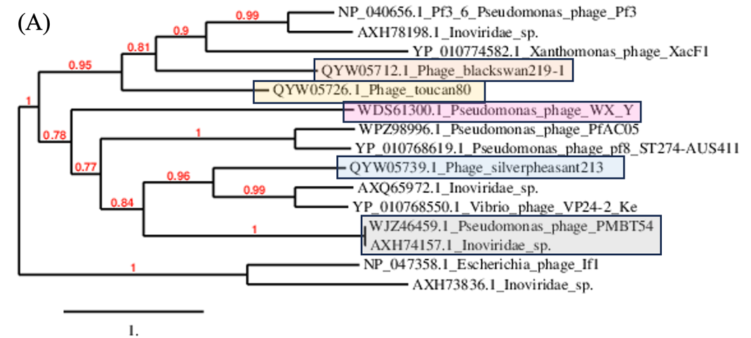

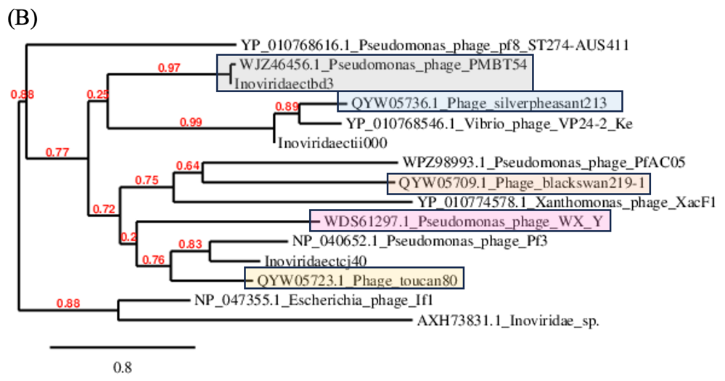

|  |  |  |  |  |  |  |  |  |
| --- | --- | --- | --- | --- | --- | --- | --- | --- |
|  | GenBank Access. No. | Genome lenght (nt) | Mol% G+C | No. CDS | DNA (% seq. Ident) | Proteome (No. of homologous proteins; E<10-3) | Zot | CoaB |
| **Shewanella phage Dolos** | [OP867012.1](https://www.ncbi.nlm.nih.gov/nucleotide/OP867012.1?report=genbank&log$=nucltop&blast_rank=1&RID=5CAU5VD6016) | 6761 | 38.4 | 11 | 100 | 11 | 100 | 100 |
| Inoviridae sp. isolate ctce6 | [MH617040.1](https://www.ncbi.nlm.nih.gov/nucleotide/MH617040.1?report=genbank&log$=nucltop&blast_rank=2&RID=5CAU5VD6016) | 7769 | 40.2 | 7 | 27.9 | 3 | 62.8 | 44.7 |
| Inoviridae sp. isolate ctcf138 | [MH649005.1](https://www.ncbi.nlm.nih.gov/nucleotide/MH649005.1?report=genbank&log$=nucltop&blast_rank=3&RID=5CAU5VD6016) | 6362 | 36.6 | 11 | 24.9 | 6 | 56.7 | 68.1 |
| Inoviridae sp. isolate ctca11 | [MH617673.1](https://www.ncbi.nlm.nih.gov/nucleotide/MH617673.1?report=genbank&log$=nucltop&blast_rank=5&RID=5CAU5VD6016) | 6136 | 33.8 | 7 | 9.5 | 4 | 44.2 | 55.8 |
| Inoviridae sp. isolate ctcg13 | [MH617363.1](https://www.ncbi.nlm.nih.gov/nucleotide/MH617363.1?report=genbank&log$=nucltop&blast_rank=6&RID=5CAU5VD6016) | 6312 | 31.6 | 7 | 6.6 | 3 | 46.0 | 45.8 |
| Vibrio phage Vaf1 | [OP297622.1](https://www.ncbi.nlm.nih.gov/nucleotide/OP297622.1?report=genbank&log$=nucltop&blast_rank=4&RID=5CAU5VD6016) | 10,004 | 44.9 | 13 | 8.4 | 2 | 4.6 | 0 |
| Vibrio phage pre-CTX | [KP972569.1](https://www.ncbi.nlm.nih.gov/nucleotide/KP972569.1?report=genbank&log$=nucltop&blast_rank=7&RID=5CAU5VD6016) | 6722 | 47.1 | 7 | 8.7 | 3 | 10.6 | 0 |

**Table 6.** New genus *Serpentivirus* (member of the genus is highlighted in green) and new species *Serpentivirus* *dolos* (strain in bold, highlihted in green) compared with selected most closely related phages

|  |  |  |  |  |  |  |  |  |
| --- | --- | --- | --- | --- | --- | --- | --- | --- |
|  | GenBank Access. No. | Genome lenght (nt) | Mol% G+C | No. CDS | DNA (% seq. Ident) | Proteome (No. of homologous proteins; E<10-3) | Zot | CoaB |
| **Inoviridae sp. isolate ctce6** | [MH617040.1](https://www.ncbi.nlm.nih.gov/nucleotide/MH617040.1?report=genbank&log$=nucltop&blast_rank=2&RID=5CAU5VD6016) | 7769 | 40.2 | 7 | 100 | 7 | 100 | 100 |
| Inoviridae sp. isolate ctcf138 | [MH649005.1](https://www.ncbi.nlm.nih.gov/nucleotide/MH649005.1?report=genbank&log$=nucltop&blast_rank=3&RID=5CAU5VD6016) | 6362 | 36.6 | 11 | 16.8 | 3 | 63.7 | 62.2 |
| Inoviridae sp. isolate ctca11 | [MH617673.1](https://www.ncbi.nlm.nih.gov/nucleotide/MH617673.1?report=genbank&log$=nucltop&blast_rank=5&RID=5CAU5VD6016) | 6136 | 33.8 | 7 | 8.1 | 3 | 44.3 | 55.1 |
| Inoviridae sp. isolate ctcg13 | [MH617363.1](https://www.ncbi.nlm.nih.gov/nucleotide/MH617363.1?report=genbank&log$=nucltop&blast_rank=6&RID=5CAU5VD6016) | 6312 | 31.6 | 7 | 5.8 | 3 | 44.3 | 61.5 |

**Table 7.** New genus *Scytalavirus* (member of the genus is highlighted in blue) and new species *Scytalavirus 6* (strain in bold, highlihted in blue) compared with selected most closely related phages

**Table 8.** New genus *Senectutivirus* (member of the genus is highlighted in light green) and new species *Senectutivirus 138* (strain in bold, highlihted in light green) compared with selected most closely related phages

|  |  |  |  |  |  |  |  |  |
| --- | --- | --- | --- | --- | --- | --- | --- | --- |
|  | GenBank Access. No. | Genome lenght (nt) | Mol% G+C | No. CDS | DNA (% seq. Ident) | Proteome (No. of homologous proteins; E<10-3) | Zot | CoaB |
| **Inoviridae sp. isolate ctcf138** | [MH649005.1](https://www.ncbi.nlm.nih.gov/nucleotide/MH649005.1?report=genbank&log$=nucltop&blast_rank=3&RID=5CAU5VD6016) | 6362 | 36.6 | 11 | 100 | 11 | 100 | 100 |
| Inoviridae sp. isolate ctce6 | [MH617040.1](https://www.ncbi.nlm.nih.gov/nucleotide/MH617040.1?report=genbank&log$=nucltop&blast_rank=2&RID=5CAU5VD6016) | 7769 | 40.2 | 7 | 22.4 | 3 | 62.4 | 58.1 |
| Enterobacteria If1 | NC_001954.1 | 8454 | 43.7 | 10 | 3.2 | 2 | 11.8 | 0 |
| Inoviridae sp. isolate ctcg13 | [MH617363.1](https://www.ncbi.nlm.nih.gov/nucleotide/MH617363.1?report=genbank&log$=nucltop&blast_rank=6&RID=5CAU5VD6016) | 6312 | 31.6 | 7 | 3.8 | 3 | 40.3 | 50.7 |
| Inoviridae sp. isolate ctca11 | [MH617673.1](https://www.ncbi.nlm.nih.gov/nucleotide/MH617673.1?report=genbank&log$=nucltop&blast_rank=5&RID=5CAU5VD6016) | 6136 | 33.8 | 7 | 2.5 | 4 | 41.2 | 50.7 |
| Shewanella phage Dolos | [OP867012.1](https://www.ncbi.nlm.nih.gov/nucleotide/OP867012.1?report=genbank&log$=nucltop&blast_rank=1&RID=5CAU5VD6016) | 6761 | 51.4 | 12 | 14.9 | 6 | 56.1 | 51.5 |
| Vibrio phage Vaf1 | [OP297622.1](https://www.ncbi.nlm.nih.gov/nucleotide/OP297622.1?report=genbank&log$=nucltop&blast_rank=4&RID=5CAU5VD6016) | 10,004 | 44.9 | 13 | 0 | 0 | 4.9 | 0 |
| Vibrio phage pre-CTX | [KP972569.1](https://www.ncbi.nlm.nih.gov/nucleotide/KP972569.1?report=genbank&log$=nucltop&blast_rank=7&RID=5CAU5VD6016) | 6722 | 47.1 | 7 | 0 | 1 | 8.8 | 0 |

**Table 9.** New species *Femenvirus 11* and *Femenvirus 13* (strain in bold, highlihted in light blue) and the new genus *Femenvirus* (member of the genus is highlighted in light blue) compared with selected most closely related phages

|  |  |  |  |  |  |  |  |  |
| --- | --- | --- | --- | --- | --- | --- | --- | --- |
|  | GenBank Access. No. | Genome lenght (nt) | Mol% G+C | No. CDS | DNA (% seq. Ident) | Proteome (No. of homologous proteins; E<10-3) | Zot | CoaB |
| **Inoviridae sp. isolate ctca11** | [MH617673.1](https://www.ncbi.nlm.nih.gov/nucleotide/MH617673.1?report=genbank&log$=nucltop&blast_rank=5&RID=5CAU5VD6016) | 6136 | 33.8 | 7 | 100 | 7 | 100 | 100 |
| **Inoviridae sp. isolate ctcg13** | [MH617363.1](https://www.ncbi.nlm.nih.gov/nucleotide/MH617363.1?report=genbank&log$=nucltop&blast_rank=6&RID=5CAU5VD6016) | 6312 | 31.6 | 7 | 68.3 | 7 | 81.0 | 69.4 |
| Shewanella phage Dolos | [OP867012.1](https://www.ncbi.nlm.nih.gov/nucleotide/OP867012.1?report=genbank&log$=nucltop&blast_rank=1&RID=5CAU5VD6016) | 6761 | 51.4 | 12 | 3.6 | 4 | 43.7 | 33.3 |
| Inoviridae sp. isolate ctce6 | [MH617040.1](https://www.ncbi.nlm.nih.gov/nucleotide/MH617040.1?report=genbank&log$=nucltop&blast_rank=2&RID=5CAU5VD6016) | 7769 | 40.2 | 7 | 2.4 | 3 | 42.9 | 50 |
| Inoviridae sp. isolate ctcf138 | [MH649005.1](https://www.ncbi.nlm.nih.gov/nucleotide/MH649005.1?report=genbank&log$=nucltop&blast_rank=3&RID=5CAU5VD6016) | 6362 | 36.6 | 11 | 2.5 | 4 | 41.5 | 44.6 |
| Vibrio phage Vaf1 | [OP297622.1](https://www.ncbi.nlm.nih.gov/nucleotide/OP297622.1?report=genbank&log$=nucltop&blast_rank=4&RID=5CAU5VD6016) | 10,004 | 44.9 | 13 | 0 | 1 | 4.3 | 0 |
| Vibrio phage pre-CTX | [KP972569.1](https://www.ncbi.nlm.nih.gov/nucleotide/KP972569.1?report=genbank&log$=nucltop&blast_rank=7&RID=5CAU5VD6016) | 6722 | 47.1 | 7 | 0 | 0 | 7.9 | 0 |

**Table 10.** New genus *Vittavirus* (member of the genus is highlighted in light red) and new species *Vittavirus Vaf1* (strain in bold, highlihted in light red) compared with selected most closely related phages

|  |  |  |  |  |  |  |  |  |
| --- | --- | --- | --- | --- | --- | --- | --- | --- |
|  | GenBank Access. No. | Genome lenght (nt) | Mol% G+C | No. CDS | DNA (% seq. Ident) | Proteome (No. of homologous proteins; E<10-3) | Zot | CoaB |
| **Vibrio phage Vaf1** | [OP297622.1](https://www.ncbi.nlm.nih.gov/nucleotide/OP297622.1?report=genbank&log$=nucltop&blast_rank=4&RID=5CAU5VD6016) | 10,004 | 44.9 | 13 | 100 | 13 | 100 | 100 |
| Vibrio phage VFJ | [NC_021562.1](https://www.ncbi.nlm.nih.gov/nucleotide/NC_021562.1?report=genbank&log$=nucltop&blast_rank=2&RID=5CP9JUFT013) | 8555 | 44.3 | 12 | 23.6 | 9 | 62.8 | 34.2 |
| Shewanella phage Dolos | [OP867012.1](https://www.ncbi.nlm.nih.gov/nucleotide/OP867012.1?report=genbank&log$=nucltop&blast_rank=1&RID=5CAU5VD6016) | 6761 | 51.4 | 12 | 10.3 | 2 | 4.6 | 0 |
| Vibrio phage pre-CTX | [KP972569.1](https://www.ncbi.nlm.nih.gov/nucleotide/KP972569.1?report=genbank&log$=nucltop&blast_rank=7&RID=5CAU5VD6016) | 6722 | 47.1 | 7 | 10.8 | 2 | 0 | 0 |
| Vibrio phage Vf12 | [NC_005949.1](https://www.ncbi.nlm.nih.gov/nucleotide/NC_005949.1?report=genbank&log$=nucltop&blast_rank=8&RID=5CP9JUFT013) | 7965 | 45.7 | 7 | 10.0 | 1 | 0 | 0 |
| Vibrio phage K04M1_VK04M1 | [CP017895.1](https://www.ncbi.nlm.nih.gov/nucleotide/CP017895.1?report=genbank&log$=nucltop&blast_rank=11&RID=5CP9JUFT013) | 7079 | 46.1 | 11 | 7.8 | 2 | 0 | 0 |

**Figure 2.** Phylogenetic relationships of members of new genera *Serpentivirus* (dark green), *Scytalavirus* (blue), *Senectutivirus* (light green)*,* *Femenvirus* (light blue) and *Vittavirus* (light red) based on amino-acid sequence of assembly protein (A) and major coat protein (B).

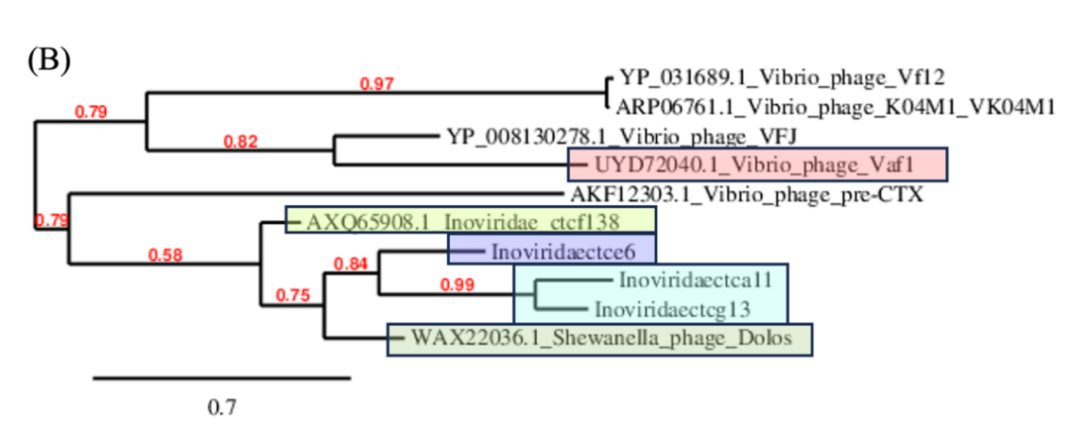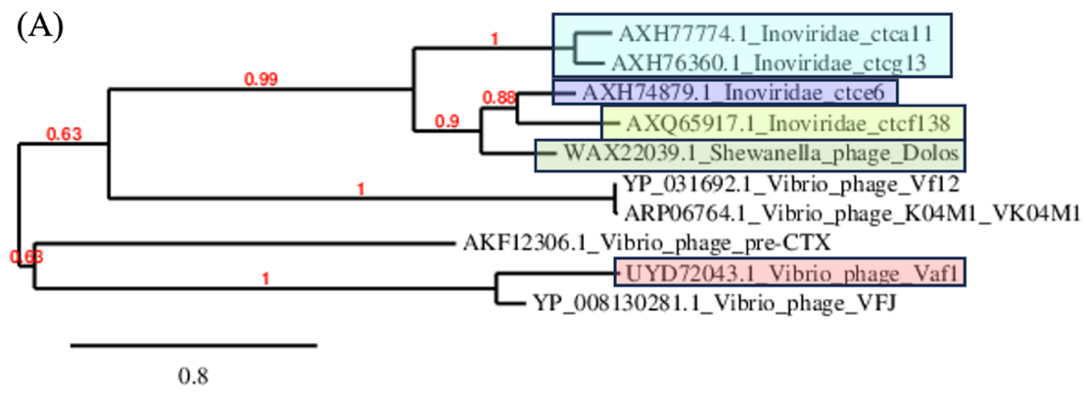

**Table 11.** New genus *Amentovirus* (member of the genus is highlighted in violet) and new species *Amentovirus 10, Amentovirus 42 and Amentovirus 39* (strain in bold, highlihted in violet) compared with selected most closely related phages

|  |  |  |  |  |  |  |  |  |
| --- | --- | --- | --- | --- | --- | --- | --- | --- |
|  | GenBank Access. No. | Genome lenght (nt) | Mol% G+C | No. CDS | DNA (% seq. Ident) | Proteome (No. of homologous proteins; E<10-3) | Zot | CoaB |
| **Inoviridae sp. isolate ctbh10** | [MH593836.1](https://www.ncbi.nlm.nih.gov/nucleotide/MH593836.1?report=genbank&log$=nucltop&blast_rank=1&RID=5NSBXT1V013) | 5166 | 37.7 | 5 | 100 | 5 | 100 | 100 |
| **Inoviridae sp. isolate ctcf42** | [MH617172.1](https://www.ncbi.nlm.nih.gov/nucleotide/MH617172.1?report=genbank&log$=nucltop&blast_rank=2&RID=5NSBXT1V013) | 4949 | 37.8 | 5 | 80.7 | 5 | 95.2 | 100 |
| **Inoviridae sp. isolate ctda39** | [MH617090.1](https://www.ncbi.nlm.nih.gov/nucleotide/MH617090.1?report=genbank&log$=nucltop&blast_rank=3&RID=5NSBXT1V013) | 5096 | 37.7 | 5 | 70.5 | 5 | 92.3 | 100 |
| Inoviridae sp. isolate ctcj20 | [MH617306.1](https://www.ncbi.nlm.nih.gov/nucleotide/MH617306.1?report=genbank&log$=nucltop&blast_rank=5&RID=5NS2C2FV016) | 6009 | 38.8 | 7 | 1.7 | 3 | 92.3 | 0 |
| Escherichia virus M13 | [NC_003287](https://www.ncbi.nlm.nih.gov/nuccore/56718463) | 6407 | 40.7 | 10 | 0.8 | 2 | 25.6 | 0 |

**Table 12.** New genus *Fasceasvirus* (member of the genus is highlighted in green) and new species *Fasceasvirus 1, Fasceasvirus 25* and *Fasceasvirus 39* (strain in bold, highlihted in green) compared with selected most closely related phages

|  |  |  |  |  |  |  |  |  |
| --- | --- | --- | --- | --- | --- | --- | --- | --- |
|  | GenBank Access. No. | Genome lenght (nt) | Mol% G+C | No. CDS | DNA (% seq. Ident) | Proteome (No. of homologous proteins; E<10-3) | Zot | CoaB |
| **Inoviridae sp. isolate ctcf1** | [MH616765.1](https://www.ncbi.nlm.nih.gov/nuccore/MH616765.1?report=graph) | 5826 | 39.5 | 6 | 100 | 6 | 100 | 100 |
| **Inoviridae sp. isolate ctjd25** | [MH617190.1](https://www.ncbi.nlm.nih.gov/nuccore/MH617190.1?report=graph) | 5705 | 40.8 | 6 | 63.4 | 5 | 89.9 | 55.6 |
| **Inoviridae sp. isolate ctgd30** | [MH616730.1](https://www.ncbi.nlm.nih.gov/nuccore/MH616730.1?report=graph) | 5370 | 40.6 | 8 | 34.7 | 4 | 70.0 | 78.8 |
| Inoviridae sp. isolate ctbf24 | [MH617675.1](https://www.ncbi.nlm.nih.gov/nuccore/MH617675.1?report=graph) | 5913 | 35.6 | 7 | 1.8 | 3 | 17.3 | 0 |
| Inoviridae sp. isolate ctci24 | [MH617072.1](https://www.ncbi.nlm.nih.gov/nuccore/MH617072.1?report=graph) | 5723 | 40 | 8 | 3.2 | 4 | 27.3 | 0 |
| Enterobacteria phage Ike | [NC_002014](https://www.ncbi.nlm.nih.gov/nuccore/9626232) | 6883 | 40.5 | 10 | 0.8 | 1 | 3.1 | 0 |

**Table 13.** New genus *Adiligaturavirus* (member of the genus is highlighted in yellow-green) and new species *Adiligaturavirus 24* (strain in bold, highlihted in yellow-green) compared with selected most closely related phages

|  |  |  |  |  |  |  |  |  |
| --- | --- | --- | --- | --- | --- | --- | --- | --- |
|  | GenBank Access. No. | Genome lenght (nt) | Mol% G+C | No. CDS | DNA (% seq. Ident) | Proteome (No. of homologous proteins; E<10-3) | Zot | CoaB |
| **Inoviridae sp. isolate ctbf24** | [MH617675.1](https://www.ncbi.nlm.nih.gov/nuccore/MH617675.1?report=graph) | 5913 | 35.6 | 7 | 100 | 7 | 100 | 100 |
| Inoviridae sp. isolate ctce6 | [MH617507.1](https://www.ncbi.nlm.nih.gov/nucleotide/MH617507.1?report=genbank&log$=nucltop&blast_rank=2&RID=5P3HHNZB013) | 6275 | 35.2 | 6 | 12.5 | 4 | 28.4 | 18.6 |
| Inoviridae sp. isolate ctgd30 | [MH616730.1](https://www.ncbi.nlm.nih.gov/nucleotide/MH616730.1?report=genbank&log$=nucltop&blast_rank=4&RID=5P3HHNZB013) | 5370 | 40.6 | 8 | 10.0 | 5 | 14.9 | 0 |
| Inoviridae sp. isolate ctcg21 | [MH617060.1](https://www.ncbi.nlm.nih.gov/nucleotide/MH617060.1?report=genbank&log$=nucltop&blast_rank=5&RID=5P3HHNZB013) | 5991 | 36.9 | 7 | 10.4 | 5 | 18.7 | 18.9 |
| Escherichia virus M13 | [NC_003287](https://www.ncbi.nlm.nih.gov/nuccore/56718463) | 6407 | 40.7 | 10 | 7.0 | 1 | 5.0 | 0 |

**Table 14.** New genus *Antiavirus* (member of the genus is highlighted in gray) and new species *Antiavirus* 20 (strain in bold, highlihted in gray) compared with selected most closely related phages

|  |  |  |  |  |  |  |  |  |
| --- | --- | --- | --- | --- | --- | --- | --- | --- |
|  | GenBank Access. No. | Genome lenght (nt) | Mol% G+C | No. CDS | DNA (% seq. Ident) | Proteome (No. of homologous proteins; E<10-3) | Zot | CoaB |
| **Inoviridae sp. isolate ctcj20** | [MH617306.1](https://www.ncbi.nlm.nih.gov/nucleotide/MH617306.1?report=genbank&log$=nucltop&blast_rank=2&RID=5PJ51ST8016) | 6009 | 38.8 | 7 | 100 | 7 | 100 | 100 |
| Inoviridae sp. isolate ctci24 | [MH617072.1](https://www.ncbi.nlm.nih.gov/nuccore/MH617072.1?report=graph) | 5723 | 40 | 8 | 31.8 | 6 | 36.1 | 27.8 |
| Inoviridae sp. isolate ctcg21 | [MH617060.1](https://www.ncbi.nlm.nih.gov/nuccore/MH617060.1?report=graph) | 5991 | 36.9 | 7 | 10.4 | 4 | 18.3 | 27.8 |
| Inoviridae sp. isolate ctjd25 | [MH617190.1](https://www.ncbi.nlm.nih.gov/nucleotide/MH617190.1?report=genbank&log$=nucltop&blast_rank=9&RID=5B7G1YA4013) | 5913 | 35.6 | 7 | 2.2 | 3 | 19.3 | 0 |

**Table 15.** New genus *Aclydivirus* (member of the genus is highlighted in red) and new species *Aclydivirus 6* (strain in bold, highlihted in red) compared with selected most closely related phages

|  |  |  |  |  |  |  |  |  |
| --- | --- | --- | --- | --- | --- | --- | --- | --- |
|  | GenBank Access. No. | Genome lenght (nt) | Mol% G+C | No. CDS | DNA (% seq. Ident) | Proteome (No. of homologous proteins; E<10-3) | Zot | CoaB |
| **Inoviridae sp. isolate ctce6** | [MH617507.1](https://www.ncbi.nlm.nih.gov/nucleotide/MH617507.1?report=genbank&log$=nucltop&blast_rank=2&RID=5P3HHNZB013) | 6275 | 35.2 | 6 | 100 | 6 | 100 | 100 |
| Inoviridae sp. isolate ctfi19 | [MH617224.1](https://www.ncbi.nlm.nih.gov/nuccore/MH617224.1?report=graph) | 6043 | 32.7 | 6 | 26.0 | 3 | 18.8 | 20.2 |
| Inoviridae sp. isolate ctcg21 | [MH617060.1](https://www.ncbi.nlm.nih.gov/nucleotide/MH617060.1?report=genbank&log$=nucltop&blast_rank=5&RID=5P3HHNZB013) | 5991 | 36.9 | 7 | 10.5 | 4 | 31.5 | 23.1 |
| Inoviridae sp. isolate ctbf24 | [MH617675.1](https://www.ncbi.nlm.nih.gov/nuccore/MH617675.1?report=graph) | 5913 | 35.6 | 7 | 11.0 | 4 | 29.6 | 24.2 |

**Figure 3.** Phylogenetic relationships of members of new genera *Amentovirus* (violet), *Fasceasvirus* (green)*,* *Adiligaturavirus* (yellowgreen), *Antiavirus* (gray), and *Aclydivirus* (red) based on amino-acid sequence of assembly protein (A) and major coat protein (B).

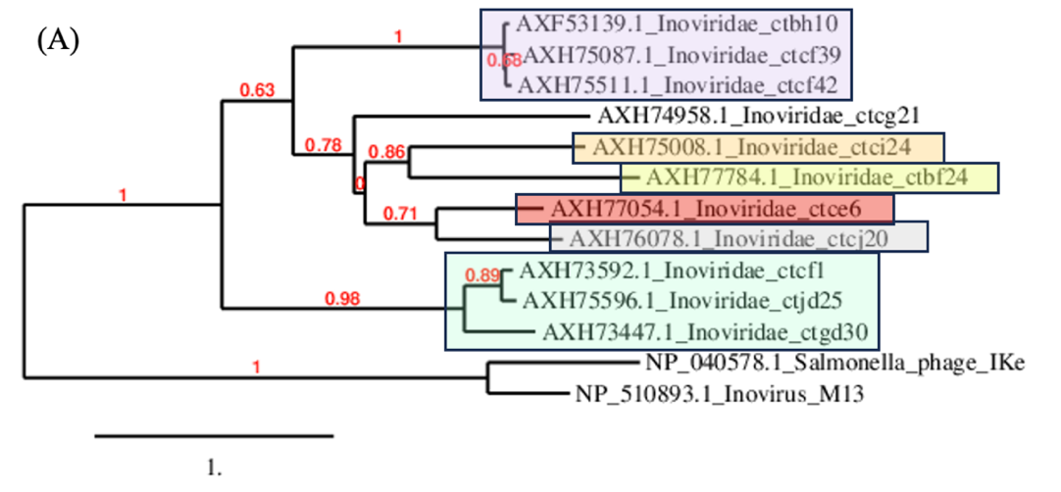

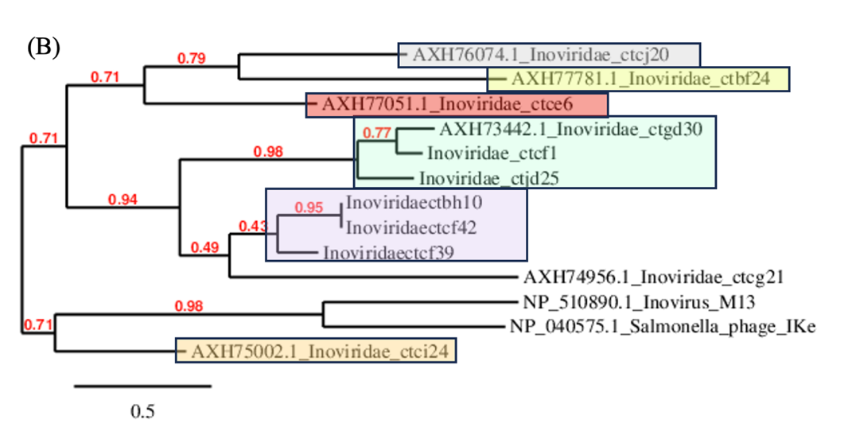

**Table 16.** New genus *Strophivirus* (member of the genus is highlighted in brown) and new species *Strophivirus 33, Strophivirus 31, Strophivirus 32, Strophivirus 36, Strophivirus 37 and Strophivirus 34* (strain in bold, highlihted in brown) compared with selected most closely related phages

|  |  |  |  |  |  |  |  |  |
| --- | --- | --- | --- | --- | --- | --- | --- | --- |
|  | GenBank Access. No. | Genome lenght (nt) | Mol% G+C | No. CDS | DNA (% seq. Ident) | Proteome (No. of homologous proteins; E<10-3) | Zot | CoaB |
| **Inoviridae sp. isolate ctdf33** | [MH616872.1](https://www.ncbi.nlm.nih.gov/nuccore/MH616872.1?report=graph) | 5181 | 44.5 | 10 | 100 | 10 | 100 | 100 |
| **Inoviridae sp. isolate ctbh31** | [MH616838.1](https://www.ncbi.nlm.nih.gov/nuccore/MH616838.1?report=graph) | 5257 | 43.4 | 6 | 51.6 | 6 | 90.4 | 93 |
| **Inoviridae sp. isolate ctch32** | [MH617618.1](https://www.ncbi.nlm.nih.gov/nuccore/MH617618.1?report=graph) | 5205 | 45.4 | 7 | 84.6 | 7 | 98.0 | 100 |
| **Inoviridae sp. isolate ctbi36** | [MH617298.1](https://www.ncbi.nlm.nih.gov/nuccore/MH617298.1?report=graph) | 5178 | 44.3 | 8 | 82.4 | 8 | 96.7 | 100 |
| **Inoviridae sp. isolate ctcc37** | [MH617717.1](https://www.ncbi.nlm.nih.gov/nuccore/MH617717.1?report=graph) | 5180 | 44.8 | 9 | 85.0 | 9 | 97.7 | 97.6 |
| **Inoviridae sp. isolate ctcj34** | [MH617011.1](https://www.ncbi.nlm.nih.gov/nuccore/MH617011.1?report=graph) | 5175 | 44.4 | 8 | 84.9 | 8 | 97.7 | 97.6 |
| Inoviridae sp. isolate cted44 | [MH617219.1](https://www.ncbi.nlm.nih.gov/nuccore/MH617219.1?report=graph) | 4926 | 44.7 | 7 | 51.0 | 7 | 59.0 | 17.1 |
| Inoviridae sp. isolate ctcj40 | [MH617768.1](https://www.ncbi.nlm.nih.gov/nuccore/MH617768.1?report=graph) | 5095 | 44.5 | 10 | 36.0 | 7 | 60 | 36.1 |
| Inoviridae sp. isolate ctda43 | [MH617492.1](https://www.ncbi.nlm.nih.gov/nuccore/MH617492.1?report=graph) | 4948 | 45.5 | 5 | 6.2 | 2 | 51.6 | 43.6 |
| Inoviridae sp. isolate ctda12 | [MH617343.1](https://www.ncbi.nlm.nih.gov/nuccore/MH617343.1?report=graph) | 6346 | 38 | 7 | 12.7 | 3 | 56.0 | 52.3 |
| Inoviridae sp. isolate ctcf41 | [MH616641.1](https://www.ncbi.nlm.nih.gov/nuccore/MH616641.1?report=graph) | 5080 | 38 | 8 | 10.1 | 4 | 63.8 | 53.5 |
| Inoviridae sp. isolate ctbh45 | [MH617617.1](https://www.ncbi.nlm.nih.gov/nuccore/MH617617.1?report=graph) | 4815 | 39 | 7 | 14.5 | 4 | 62.5 | 53.4 |
| Ralstonia phage RSCq | [OR088903.1](https://www.ncbi.nlm.nih.gov/nucleotide/OR088903.1?report=genbank&log$=nucltop&blast_rank=21&RID=5PY170JR016) | 7480 | 61.9 | 11 | 0 | 3 | 24.8 | 0 |
| Pseudomonas phage Pf3 | [NC_001418](https://www.ncbi.nlm.nih.gov/nuccore/9626316) | 5833 | 45.4 | 10 | 6.3 | 3 | 64.0 | 55.8 |

**Table 17.** New genus *Maeandervirus* (member of the genus is highlighted in orange) and new species *Maeandervirus 44 and Maeandervirus 40* (strain in bold, highlihted in orange) compared with selected most closely related phages

|  |  |  |  |  |  |  |  |  |
| --- | --- | --- | --- | --- | --- | --- | --- | --- |
|  | GenBank Access. No. | Genome lenght (nt) | Mol% G+C | No. CDS | DNA (% seq. Ident) | Proteome (No. of homologous proteins; E<10-3) | Zot | CoaB |
| **Inoviridae sp. isolate cted44** | [MH617219.1](https://www.ncbi.nlm.nih.gov/nuccore/MH617219.1?report=graph) | 4926 | 44.7 | 7 | 100 | 7 | 100 | 100 |
| **Inoviridae sp. isolate ctcj40** | [MH617768.1](https://www.ncbi.nlm.nih.gov/nuccore/MH617768.1?report=graph) | 5095 | 44.5 | 10 | 63.4 | 7 | 95.4 | 95.5 |
| Inoviridae sp. isolate ctda43 | [MH617492.1](https://www.ncbi.nlm.nih.gov/nuccore/MH617492.1?report=graph) | 4948 | 45.5 | 5 | 4.8 | 2 | 48.7 | 29.4 |
| Inoviridae sp. isolate ctda12 | [MH617343.1](https://www.ncbi.nlm.nih.gov/nuccore/MH617343.1?report=graph) | 6346 | 38 | 7 | 4.8 | 3 | 42.4 | 50 |
| Inoviridae sp. isolate ctcf41 | [MH616641.1](https://www.ncbi.nlm.nih.gov/nuccore/MH616641.1?report=graph) | 5080 | 38 | 8 | 6.7 | 4 | 53.3 | 42.9 |
| Inoviridae sp. isolate ctbh45 | [MH617617.1](https://www.ncbi.nlm.nih.gov/nuccore/MH617617.1?report=graph) | 4815 | 39 | 7 | 6.6 | 4 | 57.0 | 36.1 |
| Ralstonia phage RSCq | [OR088903.1](https://www.ncbi.nlm.nih.gov/nucleotide/OR088903.1?report=genbank&log$=nucltop&blast_rank=21&RID=5PY170JR016) | 7480 | 61.9 | 11 | 0 | 2 | 24.5 | 0 |
| Pseudomonas phage Pf3 | [NC_001418](https://www.ncbi.nlm.nih.gov/nuccore/9626316) | 5833 | 45.4 | 10 | 5.5 | 3 | 55.8 | 0 |

**Table 18.** New genus *Semitavirus* (member of the genus is highlighted in blue)and new species *Semitavirus 43* (strain in bold, highlihted in blue)compared with selected most closely related phages

|  |  |  |  |  |  |  |  |  |
| --- | --- | --- | --- | --- | --- | --- | --- | --- |
|  | GenBank Access. No. | Genome lenght (nt) | Mol% G+C | No. CDS | DNA (% seq. Ident) | Proteome (No. of homologous proteins; E<10-3) | Zot | CoaB |
| **Inoviridae sp. isolate ctda43** | [MH617492.1](https://www.ncbi.nlm.nih.gov/nuccore/MH617492.1?report=graph) | 4948 | 45.5 | 5 | 100 | 5 | 100 | 100 |
| Pseudomonas phage Pf3 | [NC_001418](https://www.ncbi.nlm.nih.gov/nuccore/9626316) | 5833 | 45.4 | 9 | 19.9 | 3 | 0 | 49.8 |
| Inoviridae sp. isolate ctch32 | [MH617618.1](https://www.ncbi.nlm.nih.gov/nuccore/MH617618.1?report=graph) | 5205 | 45.4 | 7 | 8.5 | 2 | 0 | 52.3 |
| Inoviridae sp. isolate ctbh45 | [MH617617.1](https://www.ncbi.nlm.nih.gov/nuccore/MH617617.1?report=graph) | 4815 | 39 | 7 | 7.0 | 2 | 0 | 65.9 |

**Table 19.** New genus *Itinerivirus* (member of the genus is highlighted in violet)and new species *Itinerivirus 12* (strain in bold, highlihted in violet) compared with selected most closely related phages

|  |  |  |  |  |  |  |  |  |
| --- | --- | --- | --- | --- | --- | --- | --- | --- |
|  | GenBank Access. No. | Genome lenght (nt) | Mol% G+C | No. CDS | DNA (% seq. Ident) | Proteome (No. of homologous proteins; E<10-3) | Zot | CoaB |
| **Inoviridae sp. isolate ctda12** | [MH617343.1](https://www.ncbi.nlm.nih.gov/nuccore/MH617343.1?report=graph) | 6346 | 38 | 7 | 100 | 7 | 100 | 100 |
| Inoviridae sp. isolate ctcf41 | [MH616641.1](https://www.ncbi.nlm.nih.gov/nuccore/MH616641.1?report=graph) | 5080 | 38 | 8 | 5.4 | 3 | 53.1 | 56.8 |
| Inoviridae sp. isolate ctbh45 | [MH617617.1](https://www.ncbi.nlm.nih.gov/nuccore/MH617617.1?report=graph) | 4815 | 39 | 7 | 6.1 | 3 | 52.7 | 54.1 |
| Ralstonia phage RSCq | [OR088903.1](https://www.ncbi.nlm.nih.gov/nucleotide/OR088903.1?report=genbank&log$=nucltop&blast_rank=21&RID=5PY170JR016) | 7480 | 61.9 | 11 | 0 | 3 | 24.5 | 0 |
| Pseudomonas phage Pf3 | [NC_001418](https://www.ncbi.nlm.nih.gov/nuccore/9626316) | 5833 | 45.4 | 10 | 0 | 3 | 51.6 | 47.1 |

**Table 20.** New genus *Actovirus* (member of the genus is highlighted in dark green) and two new species *Actovirus 45* and *Actovirus 41* (strain in bold, highlihted in dark green) compared with selected most closely related phages

|  |  |  |  |  |  |  |  |  |
| --- | --- | --- | --- | --- | --- | --- | --- | --- |
|  | GenBank Access. No. | Genome lenght (nt) | Mol% G+C | No. CDS | DNA (% seq. Ident) | Proteome (No. of homologous proteins; E<10-3) | Zot | CoaB |
| **Inoviridae sp. isolate ctbh45** | [MH617617.1](https://www.ncbi.nlm.nih.gov/nuccore/MH617617.1?report=graph) | 4815 | 39 | 7 | 100 | 7 | 100.0 | 100 |
| **Inoviridae sp. isolate ctcf41** | [MH616641.1](https://www.ncbi.nlm.nih.gov/nuccore/MH616641.1?report=graph) | 5080 | 38 | 7 | 53.5 | 6 | 69.1 | 79.4 |
| Pseudomonas phage Pf3 | [NC_001418](https://www.ncbi.nlm.nih.gov/nuccore/9626316) | 5833 | 45.4 | 10 | 9.3 | 4 | 0 | 70.5 |
| Inoviridae sp. isolate ctcc37 | [MH617717.1](https://www.ncbi.nlm.nih.gov/nuccore/MH617717.1?report=graph) | 5180 | 44.8 | 9 | 8.7 | 4 | 62.8 | 50.1 |

**Figure 4.** Phylogenetic relationships of members of new genera *Strophivirus* (brown), *Maeander* (orange), *Semitavirus* (blue)*,* *Itinerivirus* (violet), *Actovirus* (dark green), and *Pubesvirus* (green)based on amino-acid sequence of assembly protein (A) and major coat protein (B).

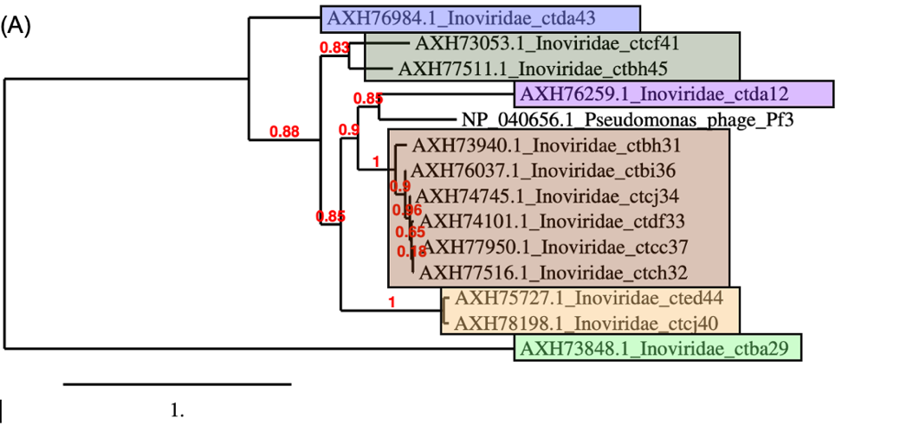

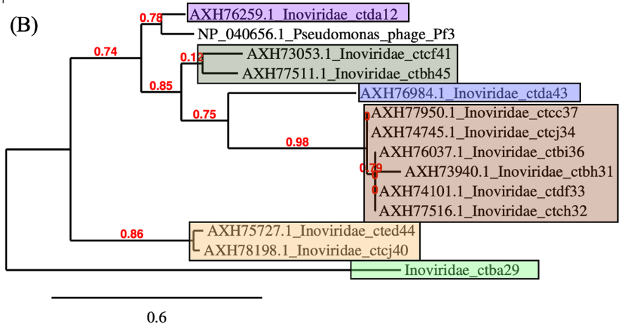

**Table 21.** Newgenus *Aspidivirus* (member of the genus is highlighted in neon green) and new species *Aspidivirus 14* (strain in bold, highlihted in neon green) compared with selected most closely related phages

|  |  |  |  |  |  |  |  |  |
| --- | --- | --- | --- | --- | --- | --- | --- | --- |
|  | GenBank Access. No. | Genome lenght (nt) | Mol% G+C | No. CDS | DNA (% seq. Ident) | Proteome (No. of homologous proteins; E<10-3) | Zot | CoaB |
| **Inoviridae sp. isolate ctbf14** | [MH617742.1](https://www.ncbi.nlm.nih.gov/nuccore/MH617742.1?report=graph) | 6115 | 31.8 | 10 | 100 | 10 | 100 | 100 |
| **Inoviridae sp. isolate ctfi19** | [MH617224.1](https://www.ncbi.nlm.nih.gov/nuccore/MH617224.1?report=graph) | 6043 | 32.7 | 6 | 49.6 | 4 | 84.6 | 76.9 |
| Inoviridae sp. isolate ctba17 | [MH617467.1](https://www.ncbi.nlm.nih.gov/nuccore/MH617467.1?report=graph) | 6062 | 35.1 | 9 | 48.8 | 8 | 43.1 | 59.5 |
| Inoviridae sp. isolate ctcg5 | [MH617262.1](https://www.ncbi.nlm.nih.gov/nuccore/MH617262.1?report=graph) | 6789 | 35.6 | 7 | 1.5 | 3 | 26.1 | 0 |
| Inoviridae sp. isolate ctge7 | [MH616675.1](https://www.ncbi.nlm.nih.gov/nuccore/MH616675.1?report=graph) | 7265 | 37.3 | 7 | 1.5 | 2 | 30.6 | 0 |
| Enterobacteria phage M13 | [NC_003287](https://www.ncbi.nlm.nih.gov/nuccore/56718463) | 6407 | 40.7 | 10 | 0 | 1 | 0 | 0 |
| Enterobacteria phage Ike | [NC_002014](https://www.ncbi.nlm.nih.gov/nuccore/9626232) | 6883 | 40.5 | 10 | 0 | 1 | 2.8 | 0 |

**Table 22.** New genus *Galbavirus* (member of the genus is highlighted in neon pink) and new species *Galbavirus 17* (strain in bold, highlihted in neon pink) compared with selected most closely related phages

|  |  |  |  |  |  |  |  |  |
| --- | --- | --- | --- | --- | --- | --- | --- | --- |
|  | GenBank Access. No. | Genome lenght (nt) | Mol% G+C | No. CDS | DNA (% seq. Ident) | Proteome (No. of homologous proteins; E<10-3) | Zot | CoaB |
| **Inoviridae sp. isolate ctba17** | [MH617467.1](https://www.ncbi.nlm.nih.gov/nuccore/MH617467.1?report=graph) | 6062 | 35.1 | 9 | 100 | 9 | 100 | 100 |
| Inoviridae sp. isolate ctbf14 | MH617742.1 | 6115 | 31.8 | 10 | 48.8 | 8 | 43.1 | 59.5 |
| Enterobacteria phage M13 | [NC_003287](https://www.ncbi.nlm.nih.gov/nuccore/56718463) | 6407 | 40.7 | 10 | 0 | 2 | 3.1 | 0 |
| Enterobacteria phage Ike | [NC_002014](https://www.ncbi.nlm.nih.gov/nuccore/9626232) | 6883 | 40.5 | 10 | 0 | 2 | 7.5 | 0 |

**Figure 5.** Phylogenetic relationships of members of new genera *Aspidivirus* (neon green) and *Galbavirus* (neon pink)based on amino-acid sequence of assembly protein (A) and major coat protein (B).

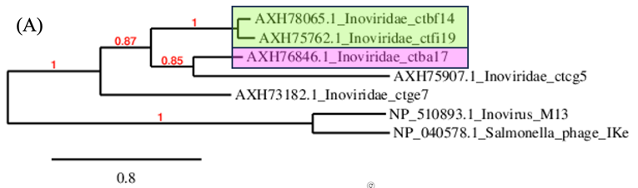

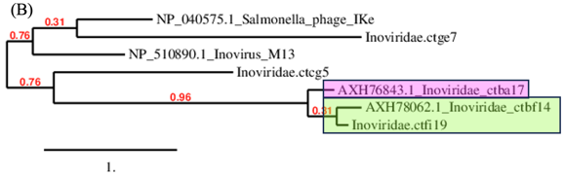

**Table 23.** New species *Reticulivirus 11* (strain in bold, highlihted in yellow) and the new genus *Reticulivirus* (member of the genus is highlighted in yellow) compared with selected most closely related phages

|  |  |  |  |  |  |  |  |  |
| --- | --- | --- | --- | --- | --- | --- | --- | --- |
|  | GenBank Access. No. | Genome lenght (nt) | Mol% G+C | No. CDS | DNA (% seq. Ident) | Proteome (No. of homologous proteins; E<10-3) | Zot | CoaB |
| **Inoviridae sp. isolate ctcb11** | [MH617645.1](https://www.ncbi.nlm.nih.gov/nuccore/MH617645.1?report=graph) | 6372 | 38.2 | 6 | 100 | 6 | 100 | 100 |
| Shewanella phage Dolos | [OP867012.1](https://www.ncbi.nlm.nih.gov/nucleotide/OP867012.1?report=genbank&log$=nucltop&blast_rank=1&RID=5CAU5VD6016) | 8146 | 38.4 | 12 | 2.0 | 2 | 32.1 | 24.6 |
| Inoviridae sp. isolate ctca11 | [MH617673.1](https://www.ncbi.nlm.nih.gov/nuccore/MH617673.1?report=graph) | 6136 | 33.8 | 7 | 1.4 | 3 | 29.4 | 27.8 |

**Figure 6.** Phylogenetic relationships of members of new genus *Reticulivirus* (yellow)and other related viruses, based on amino-acid sequence of assembly protein (A) and major coat protein (B).

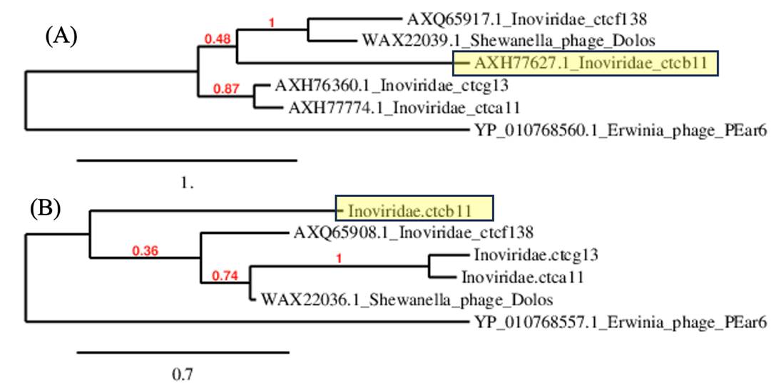

**Table 24.** New genus *Pubesvirus* (member of the genus is highlighted in dark gray) and new species *Pubesvirus 29* (strain in bold, highlihted in dark gray) compared with selected most closely related phages

|  |  |  |  |  |  |  |  |  |
| --- | --- | --- | --- | --- | --- | --- | --- | --- |
|  | GenBank Access. No. | Genome lenght (nt) | Mol% G+C | No. CDS | DNA (% seq. Ident) | Proteome (No. of homologous proteins; E<10-3) | Zot | CoaB |
| **Inoviridae sp. isolate ctba29** | [MH616818.1](https://www.ncbi.nlm.nih.gov/nuccore/MH616818.1?report=graph) | 5419 | 36.2 | 5 | 100 | 5 | 100 | 100 |
| Inoviridae sp. isolate ctce6 | [MH617507.1](https://www.ncbi.nlm.nih.gov/nucleotide/MH617507.1?report=genbank&log$=nucltop&blast_rank=2&RID=5P3HHNZB013) | 6275 | 35.2 | 6 | 1.4 | 4 | 15.9 | 22.7 |
| Inoviridae sp. isolate ctbd37 | [MH617622.1](https://www.ncbi.nlm.nih.gov/nuccore/MH617622.1?report=graph) | 5821 | 37.5 | 5 | 0 | 1 | 39.8 | 54.6 |
| Vibrio phage VP24-2_Ke | [NC_073750.1](https://www.ncbi.nlm.nih.gov/nucleotide/NC_073750.1?report=genbank&log$=nucltop&blast_rank=4&RID=5SP10KPG016) | 7180 | 42.5 | 13 | 0 | 1 | 35.6 | 52.3 |

**Table 25.** New genus *Prolivirus* (member of the genus is highlighted in olive green)andnew species *Prolivirus 37* (strain in bold, highlihted in olive green) compared with selected most closely related phages

|  |  |  |  |  |  |  |  |  |
| --- | --- | --- | --- | --- | --- | --- | --- | --- |
|  | GenBank Access. No. | Genome lenght (nt) | Mol% G+C | No. CDS | DNA (% seq. Ident) | Proteome (No. of homologous proteins; E<10-3) | Zot | CoaB |
| **Inoviridae sp. isolate ctbd37** | [MH617622.1](https://www.ncbi.nlm.nih.gov/nuccore/MH617622.1?report=graph) | 5821 | 37.5 | 5 | 100 | 5 | 100 | 100 |
| Inoviridae sp. isolate ctii000 | [MH649021.1](https://www.ncbi.nlm.nih.gov/nuccore/MH649021.1?report=graph) | 7006 | 40.3 | 12 | 52.5 | 4 | 30.3 | 65.9 |
| Inoviridae sp. isolate ctcb147 | [MH649151.1](https://www.ncbi.nlm.nih.gov/nuccore/MH649151.1?report=graph) | 5999 | 36.7 | 7 | 30.0 | 3 | 4.5 | 0 |
| Vibrio phage VP24-2_Ke | [NC_073750.1](https://www.ncbi.nlm.nih.gov/nucleotide/NC_073750.1?report=genbank&log$=nucltop&blast_rank=4&RID=5SP10KPG016) | 7180 | 42.5 | 13 | 0 | 5 | 31.0 | 56.8 |

**Table 26.** New genus *Plantarivirus* (member of the genus is highlighted in brown) and new species and *Plantarivirus 147* (strain in bold, highlihted in brown) compared with selected most closely related phages

|  |  |  |  |  |  |  |  |  |
| --- | --- | --- | --- | --- | --- | --- | --- | --- |
|  | GenBank Access. No. | Genome lenght (nt) | Mol% G+C | No. CDS | DNA (% seq. Ident) | Proteome (No. of homologous proteins; E<10-3) | Zot | CoaB |
| **Inoviridae sp. isolate ctcb147** | [MH649151.1](https://www.ncbi.nlm.nih.gov/nuccore/MH649151.1?report=graph) | 5999 | 36.7 | 7 | 100 | 7 | 100 | 100 |
| Inoviridae sp. isolate ctbd37 | [MH617622.1](https://www.ncbi.nlm.nih.gov/nuccore/MH617622.1?report=graph) | 5821 | 37.5 | 5 | 29.6 | 3 | 8.0 | 0 |
| Inoviridae sp. isolate ctii000 | [MH649021.1](https://www.ncbi.nlm.nih.gov/nuccore/MH649021.1?report=graph) | 7006 | 40.3 | 12 | 0 | 2 | 10.4 | 0 |

**Table 27.** New genus *Propagovirus* (member of the genus is highlighted in pink) and new species *Propagovirus nuni* (strain in bold, highlihted in pink) and the compared with selected most closely related phage

|  |  |  |  |  |  |  |  |  |
| --- | --- | --- | --- | --- | --- | --- | --- | --- |
|  | GenBank Access. No. | Genome lenght (nt) | Mol% G+C | No. CDS | DNA (% seq. Ident) | Proteome (No. of homologous proteins; E<10-3) | Zot | CoaB |
| **Inoviridae sp. isolate ctii000** | [MH649021.1](https://www.ncbi.nlm.nih.gov/nuccore/MH649021.1?report=graph) | 7006 | 40.3 | 12 | 100 | 12 | 100 | 100 |
| Vibrio phage VP24-2_Ke | [NC_073750.1](https://www.ncbi.nlm.nih.gov/nucleotide/NC_073750.1?report=genbank&log$=nucltop&blast_rank=4&RID=5SP10KPG016) | 7180 | 42.5 | 13 | 15.2 | 7 | 53.0 | 70.5 |

**Figure 7.** Phylogenetic relationships of members of new genera *Pubesvirus* (gray), *Prolivirus* (dark blue), *Plantarivirus* (brown) and *Propagovirus* (pink)based on amino-acid sequence of assembly protein (A) and major coat protein (B).

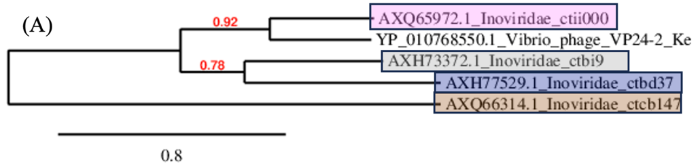

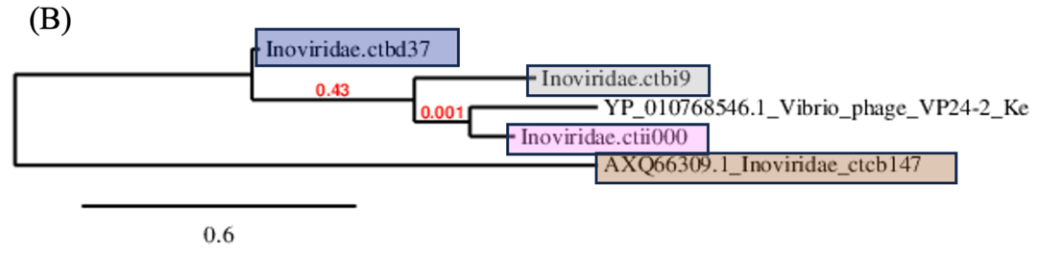

**Table 28.** New genus *Sarmentivirus* (member of the genus is highlighted in dark blue) and new species *Sarmentivirus 25* (strain in bold, highlihted in dark blue) compared with selected most closely related phages

|  |  |  |  |  |  |  |  |  |
| --- | --- | --- | --- | --- | --- | --- | --- | --- |
|  | GenBank Access. No. | Genome lenght (nt) | Mol% G+C | No. CDS | DNA (% seq. Ident) | Proteome (No. of homologous proteins; E<10-3) | Zot | CoaB |
| Inoviridae sp. isolate ctbd25 | [MH616843.1](https://www.ncbi.nlm.nih.gov/nuccore/MH616843.1?report=graph) | 5901 | 41.0 | 8 | 100 | 8 | 100 | 100 |
| Enterobacteria phage M13 | [NC_003287.2](https://www.ncbi.nlm.nih.gov/nucleotide/NC_003287.2?report=genbank&log$=nucltop&blast_rank=4&RID=5SXU0W41013) | 6407 | 40.7 | 10 | 4.1 | 5 | 29.6 | 21.3 |
| Enterobacteria phage I2-2 | [NC_001332.1](https://www.ncbi.nlm.nih.gov/nucleotide/NC_001332.1?report=genbank&log$=nucltop&blast_rank=8&RID=5SXU0W41013) | 6744 | 42.7 | 9 | 3.5 | 4 | 17.9 | 27.7 |
| Shewanella phage Dolos | [OP867012.1](https://www.ncbi.nlm.nih.gov/nucleotide/OP867012.1?report=genbank&log$=nucltop&blast_rank=1&RID=5CAU5VD6016) | 8146 | 38.4 | 12 | 2.1 | 1 | 7.4 | 0 |

**Figure 8.** Phylogenetic relationships of member of new genus *Sarmentivirus* (dark blue) and other related members of family *Inoviridae*, based on amino-acid sequence of assembly protein (A) and major coat protein (B).

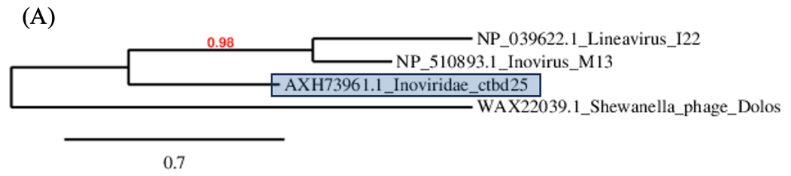

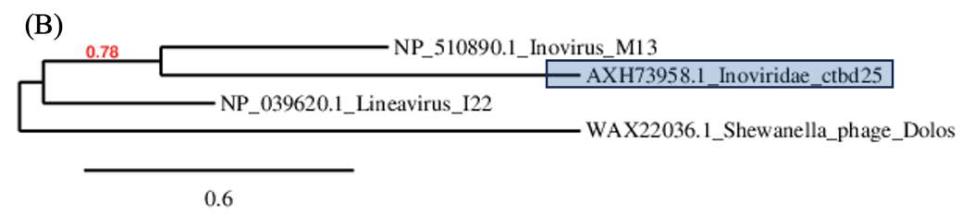

**Table 29.** New genus *Acontivirus* (member of the genus is highlighted in orange) and new species *Acontivirus 21* (strain in bold, highlihted in orange) compared with selected most closely related phages

|  |  |  |  |  |  |  |  |  |
| --- | --- | --- | --- | --- | --- | --- | --- | --- |
|  | GenBank Access. No. | Genome lenght (nt) | Mol% G+C | No. CDS | DNA (% seq. Ident) | Proteome (No. of homologous proteins; E<10-3) | Zot | CoaB |
| **Inoviridae sp. isolate ctcg21** | [MH617060.1](https://www.ncbi.nlm.nih.gov/nuccore/MH617060.1?report=graph) | 5991 | 36.9 | 7 | 100 | 7 | 100 | 100 |
| Inoviridae sp. isolate ctce6 | [MH617507.1](https://www.ncbi.nlm.nih.gov/nucleotide/MH617507.1?report=genbank&log$=nucltop&blast_rank=2&RID=5P3HHNZB013) | 6275 | 35.2 | 6 | 10.5 | 4 | 10.5 | 0 |
| Inoviridae sp. isolate ctbf24 | [MH617675.1](https://www.ncbi.nlm.nih.gov/nuccore/MH617675.1?report=graph) | 5913 | 35.6 | 7 | 10.6 | 5 | 21.1 | 21.1 |
| Inoviridae sp. isolate ctba17 | [MH617467.1](https://www.ncbi.nlm.nih.gov/nuccore/MH617467.1?report=graph) | 6062 | 35.1 | 9 | 2.9 | 3 | 14.7 | 16.6 |

**Table 30.** New genus *Abaestuovirus* (member of the genus is highlighted in blue) and new species *Abaestuovirus 8* (strain in bold, highlihted in blue) compared with selected most closely related phages

|  |  |  |  |  |  |  |  |  |
| --- | --- | --- | --- | --- | --- | --- | --- | --- |
|  | GenBank Access. No. | Genome lenght (nt) | Mol% G+C | No. CDS | DNA (% seq. Ident) | Proteome (No. of homologous proteins; E<10-3) | Zot | CoaB |
| Inoviridae sp. isolate ctbh8 | [MH617292.1](https://www.ncbi.nlm.nih.gov/nuccore/MH617292.1?report=graph) | 6223 | 35.4 | 6 | 100 | 6 | 100 | 100 |
| Inoviridae sp. isolate ctcg21 | [MH617060.1](https://www.ncbi.nlm.nih.gov/nuccore/MH617060.1?report=graph) | 5991 | 36.9 | 7 | 9.7 | 3 | 33.1 | 23.3 |
| Inoviridae sp. isolate ctce6 | [MH617507.1](https://www.ncbi.nlm.nih.gov/nucleotide/MH617507.1?report=genbank&log$=nucltop&blast_rank=2&RID=5P3HHNZB013) | 6275 | 35.2 | 6 | 4.1 | 2 | 14.9 | 18.3 |
| Inoviridae sp. isolate ctba17 | [MH617467.1](https://www.ncbi.nlm.nih.gov/nuccore/MH617467.1?report=graph) | 6062 | 35.1 | 9 | 2.7 | 2 | 34.8 | 24.3 |

**Figure 9.** Phylogenetic relationships of members of new genera *Acontivirus* (orange)and *Abaestuovirus* (blue)based on amino-acid sequence of assembly protein (A) and major coat protein (B).

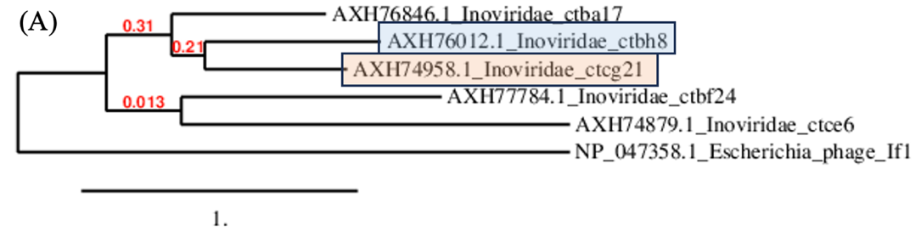

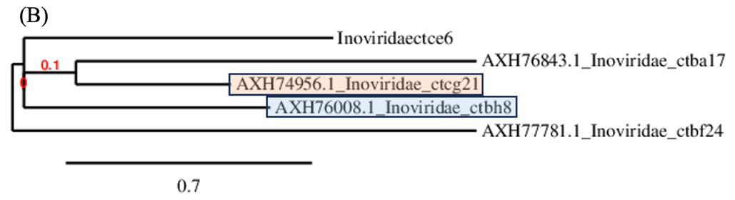

**Table**  **31.** New genus *Xiphivirus* (member of the genus is highlighted in light violet) and new species *Xiphivirus 2* (strain in bold, highlihted in light violet) compared with selected most closely related phages

|  |  |  |  |  |  |  |  |  |
| --- | --- | --- | --- | --- | --- | --- | --- | --- |
|  | GenBank Access. No. | Genome lenght (nt) | Mol% G+C | No. CDS | DNA (% seq. Ident) | Proteome (No. of homologous proteins; E<10-3) | Zot | CoaB |
| **Inoviridae sp. isolate ctcf2** | [MH617445.1](https://www.ncbi.nlm.nih.gov/nuccore/MH617445.1?report=graph) | 7256 | 64.1 | 16 | 100 | 16 | 100 | 100 |
| Stenotrophomonas phage PSH1 | [NC_010429.1](https://www.ncbi.nlm.nih.gov/nucleotide/NC_010429.1?report=genbank&log$=nucltop&blast_rank=2&RID=5T1JM5G9016) | 6867 | 61.1 | 7 | 21.8 | 4 | 54.2 | 0 |
| Stenotrophomonas phage phiSMA6 | [NC_043029.1](https://www.ncbi.nlm.nih.gov/nucleotide/NC_043029.1?report=genbank&log$=nucltop&blast_rank=3&RID=5T1JM5G9016) | 7648 | 62.6 | 10 | 4.6 | 5 | 34.2 | 0 |
| Xanthomonas phage XaF13 | [NC_062737.1](https://www.ncbi.nlm.nih.gov/nucleotide/NC_062737.1?report=genbank&log$=nucltop&blast_rank=4&RID=5T1JM5G9016) | 7045 | 60.3 | 14 | 2.2 | 3 | 31.6 | 0 |

**Table 32.** New genus *Catenatiovirus* (member of the genus is highlighted in orange) and new species *Catenatiovirus 32* (strain in bold, highlihted in orange) compared with selected most closely related phages

|  |  |  |  |  |  |  |  |  |
| --- | --- | --- | --- | --- | --- | --- | --- | --- |
|  | GenBank Access. No. | Genome lenght (nt) | Mol% G+C | No. CDS | DNA (% seq. Ident) | Proteome (No. of homologous proteins; E<10-3) | Zot | CoaB |
| **Inoviridae sp. ctBZ32** | [MN582099.1](https://www.ncbi.nlm.nih.gov/nuccore/MN582099.1?report=graph) | 4924 | 66 | 8 | 100 | 8 | 100 | 100 |
| Stenotrophomonas phage phiSMA6 | [NC_043029.1](https://www.ncbi.nlm.nih.gov/nucleotide/NC_043029.1?report=genbank&log$=nucltop&blast_rank=3&RID=5T1JM5G9016) | 7648 | 62.6 | 10 | 8.5 | 1 | 28.8 | 10.9 |

**Table 33.** New species *Staminivirus 6* (strain in bold, highlihted in green) compared with another member of the genus (highlihted in green)

|  |  |  |  |  |  |  |  |  |
| --- | --- | --- | --- | --- | --- | --- | --- | --- |
|  | GenBank Access. No. | Genome lenght (nt) | Mol% G+C | No. CDS | DNA (% seq. Ident) | Proteome (No. of homologous proteins; E<10-3) | Zot | CoaB |
| Inoviridae sp. isolate ctda6 | [MH552488.1](https://www.ncbi.nlm.nih.gov/nuccore/MH552488.1?report=graph) | 6561 | 61.5 | 11 | 100 | 11 | 100 | 100 |
| Stenotrophomonas phage phiSMA9 | [NC_007189.1](https://www.ncbi.nlm.nih.gov/nucleotide/NC_007189.1?report=genbank&log$=nucltop&blast_rank=4&RID=5TJ15ZV7016) | 6907 | 62.4 | 7 | 50.7 | 7 | 82.1 | 71.3 |
| Stenotrophomonas phage phiSHP2 | [NC_015586.1](https://www.ncbi.nlm.nih.gov/nucleotide/NC_015586.1?report=genbank&log$=nucltop&blast_rank=3&RID=5TJ15ZV7016) | 5819 | 61.5 | 9 | 45.6 | 6 | 16.6 | 0 |
| Stenotrophomonas phage PSH1 | [NC_010429.1](https://www.ncbi.nlm.nih.gov/nucleotide/NC_010429.1?report=genbank&log$=nucltop&blast_rank=6&RID=5TJ15ZV7016) | 6867 | 61.1 | 7 | 24.9 | 5 | 2.6 | 0 |

**Figure 10.** Phylogenetic relationships of member of *Staminivirus* (green) and new genera *Xiphivirus* (violet), *Catenatiovirus* (orange), other related members of family *Inoviridae*, based on amino-acid sequence of assembly protein (A) and major coat protein (B).

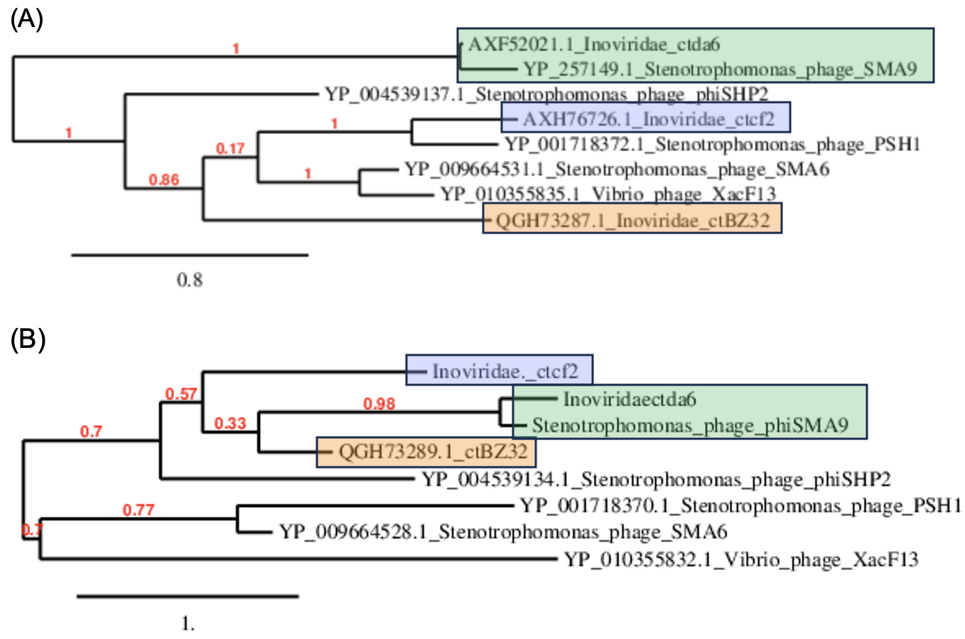

**Table 34.** New genus *Circumitovirus* (member of the genus is highlighted in dark red) and new species *Circumitovirus* *48* (strain in bold, highlihted in dark red) compared with selected most closely related phages

|  |  |  |  |  |  |  |  |  |
| --- | --- | --- | --- | --- | --- | --- | --- | --- |
|  | GenBank Access. No. | Genome lenght (nt) | Mol% G+C | No. CDS | DNA (% seq. Ident) | Proteome (No. of homologous proteins; E<10-3) | Zot | CoaB |
| Inoviridae sp. isolate ctbi48 | [MH617564.1](https://www.ncbi.nlm.nih.gov/nuccore/MH617564.1?report=graph) | 4533 | 44 | 9 | 100 | 9 | 100 | 100 |
| Erwinia phage PEar6 | [NC_073751.1](https://www.ncbi.nlm.nih.gov/nucleotide/NC_073751.1?report=genbank&log$=nucltop&blast_rank=4&RID=5T5T3UYP016) | 6608 | 41.7 | 11 | 1.5 | 4 | 30.5 | 22.3 |
| Vibrio phage fs2 | [NC_001956.1](https://www.ncbi.nlm.nih.gov/nucleotide/NC_001956.1?report=genbank&log$=nucltop&blast_rank=8&RID=5T5T3UYP016) | 8651 | 44.5 | 9 | 2.1 | 3 | 33.6 | 23.7 |
| Enterobacteria phage Ike | [NC_002014](https://www.ncbi.nlm.nih.gov/nuccore/9626232) | 6883 | 40.5 | 10 | 1.5 | 4 | 30.2 | 34.3 |
| Vibrio phage Vaf1 | [OP297622.1](https://www.ncbi.nlm.nih.gov/nucleotide/OP297622.1?report=genbank&log$=nucltop&blast_rank=4&RID=5CAU5VD6016) | 10,004 | 44.9 | 13 | 0 | 3 | 30.0 | 35.2 |
| Escherichia phage M13 | [NC_003287](https://www.ncbi.nlm.nih.gov/nuccore/56718463) | 6407 | 40.7 | 10 | 1.5 | 3 | 26.4 | 25.1 |

**Figure 11.** Phylogenetic relationships of members of new genera *Circumitovirus* (blue)and *Catervavirus* (red)based on amino-acid sequence of assembly protein (A) and major coat protein (B).

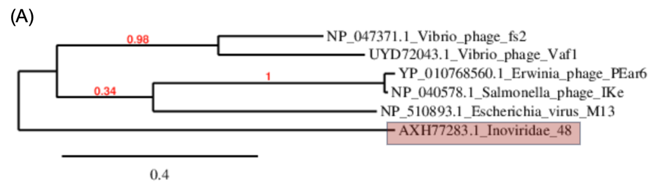

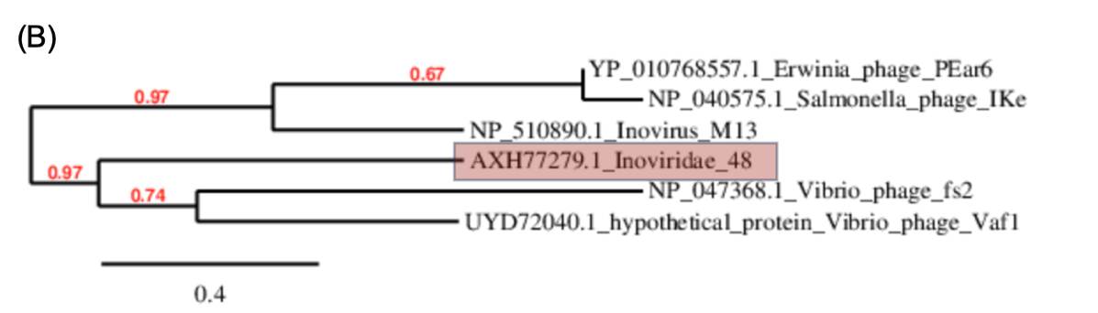

**Table 35.** New species *Viscerivirus* *525* (strain in bold, highlihted in black) and the new genus *Viscerivirus* (member of the genus is highlighted in black) compared with selected most closely related phages

|  |  |  |  |  |  |  |  |  |
| --- | --- | --- | --- | --- | --- | --- | --- | --- |
|  | GenBank Access. No. | Genome lenght (nt) | Mol% G+C | No. CDS | DNA (% seq. Ident) | Proteome (No. of homologous proteins; E<10-3) | Zot | CoaB |
| Inoviridae sp. isolate ctbf525 | [MH616815.1](https://www.ncbi.nlm.nih.gov/nuccore/MH616815.1?report=graph) | 5715 | 50.8 | 9 | 100 | 9 | 100 | 100 |
| Inoviridae sp. isolate ctcf 138 | [MH649005.1](https://www.ncbi.nlm.nih.gov/nucleotide/MH649005.1?report=genbank&log$=nucltop&blast_rank=2&RID=5TDCNPWR013) | 6362 | 36.6 | 11 | 2.8 | 1 | 0 | 0 |
| Enterobacteria phage If1 | [NC_001954.1](https://www.ncbi.nlm.nih.gov/nucleotide/NC_001954.1?report=genbank&log$=nucltop&blast_rank=4&RID=5TDCNPWR013) | 8454 | 43.7 | 10 | 2.9 | 2 | 31.1 | 17.6 |
| Alteromonas phage phiAFP1 | [OP433453.1](https://www.ncbi.nlm.nih.gov/nucleotide/OP433453.1?report=genbank&log$=nucltop&blast_rank=8&RID=5TDCNPWR013) | 5986 | 40.3 | 8 | 1.5 | 2 | 0 | 0 |

**Figure 12.** Phylogenetic relationships of member of new genus *Viscerivirus* (black) and other related members of family *Inoviridae*, based on amino-acid sequence of assembly protein (A) and major coat protein (B).

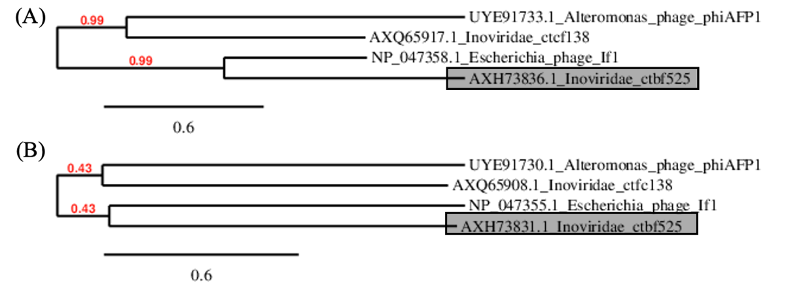

**Table 36.** The new species *Thomixvirus zuza* (strain shown in bold and highlighted in gray-blue) was compared with another species of the same genus (*Thomixvirus OH3*), two representatives of another genus in family *Paulinoviridae*, and a peripherally related member of the family *Inoviridae* (Enterobacteria phage If1).

|  |  |  |  |  |  |  |  |  |
| --- | --- | --- | --- | --- | --- | --- | --- | --- |
|  | GenBank Access. No. | Genome lenght (nt) | Mol% G+C | No. CDS | DNA (% seq. Ident) | Proteome (No. of homologous proteins; E<10-3) | Zot | CoaB |
| **Thermus phage Zuza8** | [PP554188.1](https://www.ncbi.nlm.nih.gov/nucleotide/PP554188.1?report=genbank&log$=nucltop&blast_rank=3&RID=5MXPP50S016) | 6773 | 60.0 | 9 | 100 | 9 | 100 | 100 |
| Thermus phage OH3 | [NC_045425](https://www.ncbi.nlm.nih.gov/nuccore/1784318017) | 5688 | 58 | 8 | 53.1 | 8 | 82.2 | 64.7 |
| Propionobacterium phage B5 | [NC_003460](https://www.ncbi.nlm.nih.gov/nuccore/19718349) | 5804 | 64.3 | 10 | 0 | 1 | 16.5 | 0 |
| Propionobacterium phage Philemon | PP693361.1 | 6312 | 31.6 | 7 | 0 | 1 | 16.3 | 0 |
| Enterobacteria phage If1 | [NC_001954.1](https://www.ncbi.nlm.nih.gov/nucleotide/NC_001954.1?report=genbank&log$=nucltop&blast_rank=5&RID=59F5VC16013) | 8454 | 43.7 | 10 | 0 | 0 | 5.2 | 0 |

**Figure 13.** Phylogenetic relationships of member of new species *Thomixvirus zuza* (gray-blue) and other related members of family *Paulinoviridae*, based on amino-acid sequence of assembly protein (A) and major coat protein (B).

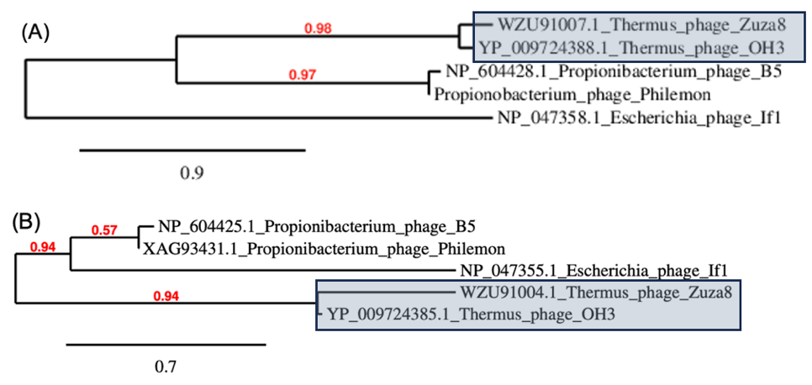

**Figure 14.** The phylogeny was inferred based on aminacid sequences of assebly protein (morphogenesis protein; Zot) using the Maximum Likelihood method and Jones-Taylor-Thornton (1992) model [4] of amino acid substitutions and the tree with the highest log likelihood (-61.371.22) is shown. The percentage of replicate trees in which the associated taxa clustered together (200 replicates) is shown next to the branches [5]. The initial tree for the heuristic search was selected by choosing the tree with the superior log-likelihood between a Neighbor-Joining (NJ) tree [6] and a Maximum Parsimony (MP) tree. The NJ tree was generated using a matrix of pairwise distances computed using the Jones-Taylor-Thornton (1992) model [4]. The MP tree had the shortest length among 10 MP tree searches, each performed with a randomly generated starting tree. The analytical procedure encompassed 107 amino acid sequences with 852 positions in the final dataset. Evolutionary analyses were conducted in MEGA12 [7] utilizing up to 3 parallel computing threads. In the phylogenetic tree, amino acid sequences from newly identified strains and established species and/or genera are highlighted with boxes and shown in distinct colors (as in the detailed comparative analysis). For clarity, sequences from previously known species are not individually labeled, and branches belonging to the same genus are collapsed unless they contain a newly proposed species, in which case the full branching structure is retained.