

The International Committee on Taxonomy of Viruses

Taxonomy Proposal Form, 2025

<https://ictv.global/taxonomy/templates>**Part 1a: Details of taxonomy proposals**

|  |  |
| --- | --- |
| **Title:** | Create four (4) new subfamilies, seventeen (17) new genera and sixty-one (61) new species in the family *Schitoviridae* (Class *Caudoviricetes*) |
| **Code assigned:** | 2025.072B.Schitoviridae_4nsf_17ng_61ns | |

|  |  |  |  |  |
| --- | --- | --- | --- | --- |
| **Author(s), affiliation and email address(es):** | | | | |
| **Given name (+middle initial(s))** | **Surname** | **Affiliation** | **Email address** | **Corr. author(s)** |
| Johannes | Wittmann | Leibniz Institute DSMZ – German Collection of Microorganisms and Cell Cultures GmbH, Braunschweig, Germany | Johannes.Wittmann@dsmz.de | X |
| Dann | Turner | Department of Applied Sciences, University of the West of England, Bristol, UK | Dann2.Turner@uwe.ac.uk |  |

**Part 1b: Taxonomy Proposal Submission**

|  |  |  |  |
| --- | --- | --- | --- |
| **ICTV Subcommittee:** | | | |
| Animal DNA Viruses and Retroviruses |  | Bacterial viruses | **x** |
| Animal minus-strand and dsRNA viruses |  | Fungal and protist viruses |  |
| Animal positive-strand RNA viruses |  | Plant viruses |  |
| Archaeal viruses |  | General - |  |

|  |
| --- |
| **List the ICTV Study Group(s) that have seen or have been involved in creating this proposal:** <https://ictv.global/sc> |
| Schitoviridae Study Group  Caudoviricetes Study Group |

|  |  |  |  |
| --- | --- | --- | --- |
| **Optional – complete only if formally voted on by an ICTV Study Group:** | | | |
| **Study Group** | **Number of members** | | |
| **Votes in support** | **Votes against** | **No vote** |
|  |  |  |  |
|  |  |  |  |

|  |  |
| --- | --- |
| **Submission date:** | 02/06/2025 |

**Part 1c: Feedback from ICTV Executive Committee (EC) meeting**

|  |  |
| --- | --- |
| **Executive Committee Meeting Decision code:** | **X** |
| A – Accept |  |
| Ac – Accept subject to revision by relevant subcommittee chair. No further vote required |  |
| U – Accept without revision but with re-evaluation and email vote by the EC |  |
| Uc – Accept subject to revision and re-evaluation and email vote by the EC |  |
| Ud – Deferred to the next EC meeting, with an invitation to revise based on EC comments |  |
| J - Reject |  |
| W - Withdrawn |  |

|  |
| --- |
| **Comments from the Executive Committee:** |
|  |

**Part 1d: Revised Taxonomy Proposal Submission**

|  |
| --- |
| **Response of proposer:** |
|  |

|  |  |
| --- | --- |
| **Revision date:** |  |

**Part 2:** **GENERAL PROPOSAL**

|  |
| --- |
| **Abstract for General Proposal:** |
|  |

|  |
| --- |
| **Text of General Proposal:** |
|  |

|  |
| --- |
| **References:** |
|  |

|  |  |
| --- | --- |
| **Accompanying files:** | |
| **Filename** | **Description of contents** |
|  |  |
|  |  |

|  |
| --- |
| **Tables, Figures:** |

<Start here>

**Part 3:** **TAXONOMIC PROPOSAL**

<https://ictv.global/taxonomy/templates>

|  |  |  |  |
| --- | --- | --- | --- |
| **Taxonomic changes proposed:** | | | |
| Establish new taxon | **x** | Split taxon |  |
| Abolish taxon |  | Merge taxon |  |
| Move taxon |  | Promote taxon |  |
| Rename taxon |  | Demote taxon |  |
| Move and rename |  |

|  |  |
| --- | --- |
| **Etymology (origin) of proposed taxonomic names:** | |
| **Taxon name** | **Etymology of the term** |
| *Brisouvirinae* | The name derived from French microbiologist Jean Brisou (1909-2006), who has contributed to the understanding of the taxonomy of Acinetobacter. |
| *Gaffkyvirinae* | The name derived from German microbiologist Georg Gaffky (1850-1918). |
| *Gebvirinae* | The name derived from the Egyptian god of Earth, Geb. |
| *Waldeevirinae* | The name derived from Edward Leslie Waldee who did studies on peritrichous phytopathogenic bacteria. |
| *Aracevirus* | The name is derived from the first isolated member, Pseudomonas phage Arace01 |
| *Aquintavirus* | The name is derived from the name of the first isolated phage of this type, Alteromonas phage vB_AemP_PT15-A5 |
| *Atduovirus* | The name is derived from the first isolated member, Acinetobacter phage At2 |
| *Axvirus* | Named after the first isolated member, Sulfitobacter phage vB_SupP_AX |
| *Dongfangvirus* | The name is derived from the city where the first member of this genus, Burkholderia phage vB_BpP_HN01, was isolated from |
| *Dowsonvirus* | Named after Dowson who described Xanthomonas. |
|  |  |
| *Fifivirus* | The name is derived from the name of the first isolated phage of this type, Erwinia phage Fifi067. |
| *Ekoctavirus* | Named after the first isolated member, Escherichia phage EK8 |
| *Geeundevigintivirus* | Derived from the first isolated member, Pantoea phage G19 |
| *Manannanvirus* | Named after the Gaelic sea god Manannan. |
| *Mifoctavirus* | Named after the first isolated member, Erwinia phage MIF8 |
| *Nacbunavirus* | The name is derived from the name of the first isolated phage of this type, Acinetobacter phage nACB1 which infects *A. beijerinckii* |
| *Patisvirus* | Named after the first isolated member, Erwinia phage Pastis |
| *Peegeeundecimvirus* | The name is derived from the name of the first isolated phage of this type, Vibrio phage vB_VhaP_PG11 |
| *Roskoffvirus* | The name is derived from the geographic origin of the first isolated member |
| *Sabivirus* | Named after the first isolated member, Enterobacter phage vB_Ecl_SABI |
| *Viundeviginityvirus* | The name is derived from the name of the first isolated phage of this type, Alteromonas phage vB_AmeP_PT11-V19 |

|  |  |  |
| --- | --- | --- |
| **Permission for use of names derived from a living person:** | | |
| **Taxon name** | **Full name of person from whom the name is derived** | **Attached** |
|  |  |  |
|  |  |  |
|  |  |  |
|  |  |  |

|  |
| --- |
| **Abstract of Taxonomy Proposal:** |
| *Taxonomic rank(s) affected*:  Realm *Duplodnaviria*, kingdom *Heunggongvirae*, phylum *Uroviricota*, class *Caudoviricetes*, family *Schitoviridae*  *Description of current taxonomy*:  The family *Schitoviridae* was created in 2020 (Taxonomy Proposal [2020.146B.R.Schitoviridae](https://ictv.global/ictv/proposals/2020.146B.R.Schitoviridae.zip)). The family is comprised of nine subfamilies, 57 genera and 106 species  *Proposed* *taxonomic change(s):*  Here, we propose to create four (4) new subfamilies:   1. “*Waldeevirinae”*, containing three (3) new genera, “*Mifoctavirus”*, “*Sabivirus”* and “*Ekoctavirus”*, alongside the existing genera *Cbunavirus* and *Efbeekayvirus* 2. *Gaffkyvirinae*, containing two (2) genera, *Pacinivirus* and *Vicoquintavirus* 3. *Gebvirinae*, containing one (1) new genus, “*Dowsonvirus”*,and the existing genera *Riverridervirus*, *Pokkenvirus*, *Philippevirus* and *Cavevirus* 4. *Brisouvirinae*, containing two (2) new genera, “*Nacbunavirus”* and “*Atduovirus”* and the existing genus *Exceevirus*.   Additionally, we intend to create eleven (11) new genera, “*Aracevirus”*, “*Axvirus”*, “*Dongfangvirus”*, “*Aquintavirus”*, “Fifivirus”, “*Geeundevigintivirus”, “Patisvirus”*, “*Peegeeundecimvirus”*, “*Manannanvirus”, “Roskoffvirus” and* “*Viundeviginityvirus”.*  *Justification*:  Using different tools like VIRIDIC [1] or VICTOR [2] (Fig 1. and 2) for pairwise nucleotide identity or whole genome analyses of schitoviruses we propose 4 new subfamilies, *Brisouvirinae, Gaffkyvirinae*, *Gebvirinae*, and *Waldeevirinae* and 17 new genera. We used 95% and 70% nucleotide sequence identity over the entire length of the genome as criteria for delimiting species and genera, respectively. |

|  |
| --- |
| * **Text of Taxonomy proposal:** |
| *Taxonomic rank(s) affected*:  Realm *Duplodnaviria*, kingdom *Heunggongvirae*, phylum *Uroviricota*, class *Caudoviricetes*, family *Schitoviridae*  *Description of current taxonomy*:  The family *Schitoviridae* was created in 2020 (Taxonomy Proposal [2020.146B.R.Schitoviridae](https://ictv.global/ictv/proposals/2020.146B.R.Schitoviridae.zip)). The family is comprised of nine subfamilies, 57 genera and 106 species  *Proposed* *taxonomic change(s):*  Here, we propose to create four (4) new subfamilies:   1. “*Waldeevirinae”*, containing three (3) new genera, “*Mifoctavirus”*, “*Sabivirus”* and “*Ekoctavirus”*, alongside the existing genera *Cbunavirus* and *Effbeekayvirus* 2. *Gaffkyvirinae*, containing two (2) genera, *Pacinivirus* and *Vicoquintavirus* 3. *Gebvirinae*, containing one (1) new genus, “*Dowsonvirus”*,and the existing genera *Riverridervirus*, *Pokkenvirus*, *Philippevirus* and *Cavevirus* 4. *Brisouvirinae*, containing two (2) new genera, “*Nacbunavirus”* and “*Atduovirus”* and the existing genus *Exceevirus*.   Additionally, we intend to create eleven (11) new genera, “*Aracevirus”*, “*Axvirus”*, “*Dongfangvirus”*, “*Aquintavirus”*, “*Gwanakrovirus*”, “*Geeundevigintivirus”, “Patisvirus”*, “*Peegeeundecimvirus”*, “*Manannanvirus”, “Roskoffvirus” and* “*Viundeviginityvirus”.*  *Demarcation criteria:*  With 70% DNA sequence identity and 95% DNA sequence identity as the criterion for demarcation of genera and species, respectively, each of the proposed species differs from the others with more than 5% at the DNA level as confirmed with VIRIDIC.  *Justification:*  Using different tools like VIRIDIC [1] or VICTOR [2] (Fig 1. and 2) for pairwise nucleotide identity or whole genome analyses of schitoviruses we propose 4 new subfamilies, *Brisouvirinae, Gaffkyvirinae*, *Gebvirinae*, and *Waldeevirinae* and 17 new genera. We used 95% and 70% nucleotide sequence identity over the entire length of the genome as criteria for delimiting species and genera, respectively. |

|  |
| --- |
| **References:** |
| 1. Moraru C, Varsani A, Kropinski AM. VIRIDIC-A Novel Tool to Calculate the Intergenomic Similarities of Prokaryote-Infecting Viruses. Viruses. 2020 Nov 6;12(11):1268. doi: 10.3390/v12111268Gomes M, Domingues R, Turner D, Oliveira H. (2023) Genomic Analysis of Two Novel Bacteriophages Infecting *Acinetobacter beijerinckii* and *halotolerans* Species. Viruses.15(3):643. doi: 10.3390/v15030643. 2. Meier-Kolthoff JP, Göker M. VICTOR: genome-based phylogeny and classification of prokaryotic viruses. Bioinformatics. 2017 Nov 1;33(21):3396-3404. doi: 10.1093/bioinformatics/btx440. PMID: 29036289; PMCID: PMC5860169. 3. Wee SK, Yan B, Mustaffa SB, Yap EPH. Genome sequences of *Acinetobacter* phage At2 and its host *Acinetobacter tandoii* W4-4-4. Microbiol Resour Announc. 2025 May 22:e0000925. doi: 10.1128/mra.00009-25. 4. Roh E, Duffy ME, Ewool LM, Grose JH. Whole genome sequences of eight *Erwinia amylovora* phages isolated from South Korea. Microbiol Resour Announc. 2025 Apr 10;14(4):e0106224. doi: 10.1128/mra.01062-24. 5. Liu Y, Zhu C, Liang Y, McMinn A, Zheng K, Wang Z, Wang H, Ren L, Shao H, Sung YY, Mok WJ, Wong LL, Wang M. Genome analysis of vB_SupP_AX, a novel N4-like phage infecting Sulfitobacter. Int Microbiol. 2024 Aug;27(4):1297-1306. doi: 10.1007/s10123-023-00476-5. 6. Feltin C, Garneau JR, Morris CE, Bérard A, Torres-Barceló C. Novel phages of *Pseudomonas syringae* unveil numerous potential auxiliary metabolic genes. J Gen Virol. 2024 Jun;105(6):001990. doi: 10.1099/jgv.0.001990. |

|  |  |
| --- | --- |
| **Accompanying files:** | |
| **Filename** | **Description of contents** |
|  |  |
| **Schitoviridae_VIRIDIC.docx** | **VIRIDIC analysis of new subfamilies** |
| **Schitoviridae_VIRIDIC.xlsx** | **VIRIDIC analysis of schitoviruses** |

|  |
| --- |
| **Tables, Figures:** |

Using different tools like VIRIDIC [1] or VICTOR [2] (Fig 1. and 2) for pairwise nucleotide identity or whole genome analyses of schitoviruses we propose 4 new subfamilies, *Brisouvirinae, Gaffkyvirinae*, *Gebvirinae*, and *Waldeevirinae* and 17 new genera. We used 95% and 70% nucleotide sequence identity over the entire length of the genome as criteria for delimiting species and genera, respectively.

The newly proposed subfamily “Brisouvirinae” consists of three genera, *Exceevirus* and the two new genera “Nacbunavirus” and “Atduovirus” (Tab. 1). The name of “Nacbunavirus” is derived from the name of the first isolated phage of this type, Acinetobacter phage nACB1 which infects *A. beijerinckii*. Its genome consists of 80,130 bp with 95 CDS and 4 tRNA genes [3]. “Atduovirus” is named after phage At2 [4]. All phages of this subfamily infect the genus *Acinetobacter*.

The new subfamily “Gaffkyvirinae” consists of the two genera *Vicoquintavirus* and *Pacinivirus* that both contain phages infecting *Vibrio* species (Tab. 2), while the “Gebvirinae” subfamily with its genera *Cavevirus*, *Philippevirus*, *Pokkenvirus*, *Riverridervirus* and the new genus “Dowsonvirus” covers phages mainly infecting *Stenotrophomonas* and *Xanthomonas* species (Tab. 3). The first member of this genus, Xanthomonas phage PB119 was isolated in Czech Republic and infects *Xanthomonas euversicatoria*. Its genome reveals 84 CDS and 9 tRNA genes.

The “Waldeevirinae” subfamily consists of the already established genera *Efbeekayvirus* covering *Klebsiella* phages and *Cbunavirus* mainly consisting of *Pectobacterium* phages and the three newly proposed genera “Mifoctavirus”, “Ekoctavirus” and “Sabivirus” adding further host genera like *Erwinia, Escherichia* and *Enterobacter* to this group of phages (Tab. 4). The name of “Mifoctavirus” derived from Erwinia phage Mif8 that has a genome size of 74,857 bp with 94 CDS. It was originally isolated from dung in Germany. Escherichia phage EK8 is the first member of the “Ekoctavirus” with a genome size of 75,084 bp and 80 CDS and one tRNA gene, it was isolated from hospital wastewater in Turkey. Enterobacter phage vB_Ecl_SABI is the only member of the “Sabivirus” so far and has a genome size of 76,175 bp.

Additionally, we proposed several new genera. For the *Erskinevirinae* subfamily we proposed the new genus “Fifivirus”. Together with the already existing genera Johnsonvirus and Yonginvirus all cover Erwinia phages (Tab. 5). The name “Fifivirus” is derived from the name of the first isolated phage of this type, Erwinia phage Fifi067. Phage Fifi067 was isolated from stream water in South Korea. Its genome consists of 75,307 bp with 85 CDS and 7 tRNA genes [5].

The newly proposed genus “Axvirus” was named after the first member, Sulfitobacter phage vB_SupP_AX, and is a new genus within the *Rhodovirinae* subfamily. It was isolated in China and revealed a genome size of 75,445 bp with 79 CDS and 4 tRNA genes [6].

Pantoea phage G19 is the first schitovirus isolated against *Pantoea* and gives the new genus “Geeundevigintivirus” its name. It infects *Pantoea agglomerans* and was isolated in China.

The name of “Aquintavirus” is derived from the name of the first isolated phage of this type, Alteromonas phage vB_AemP_PT15-A5. It was isolated in Spain and infects *Alteromonas mediterranea*. Its genome consists of 75,104 bp with 91 CDS.

The newly proposed genus “Pastisvirus” has only one member, Erwinia phage Pastis, which was isolated from soil in France. It revealed a genome size of 74,269 bp with 112 CDS.

The name of “Dongfangvirus” is derived from the city where the first member of this genus, Burkholderia phage vB_BpP_HN01, was isolated from. It was isolated from farm soil and infects *Burkholeria pseudomallei*. Its genome consists of 71,398 bp with 93 CDS and one tRNA gene.

Pseudomonas phage Arace01 is the first isolated member of “Aracevirus”. It infects *P. syringae* and was isolated from soil [5]. It revealed a genome size of 76,815 bp with 84 CDS and 2 tRNA genes.

The name for “Viundeviginityvirus” is derived from the name of the first isolated phage of this type, Alteromonas phage vB_AmeP_PT11-V19. It was isolated in Spain and infects *Alteromonas mediterranea*. Its genome consists of 71,326 bp with 93 CDS.

Regarding the new genus “Peegeeundecimvirus”, the name is derived from the name of the first isolated phage of this type, Vibrio phage vB_VhaP_PG11. It was isolated from seawater in China and infects *Vibrio hangzhouensis*. Its genome consists of 71,841 bp with 107 CDS.

Vibrio phage D456 g1 is the first member of the new genus “Manannanvirus*”* named after a Gaelic sea god. It was isolated from seawater and oysters mix and revealed a genome size of 72,254 bp.

For the genus “Roskoffvirus” the name was derived from the geographic origin of the first isolated member, Vibrio phage D500. It was isolated from seawater and oysters mix and revealed a genome size of 78,341 bp.

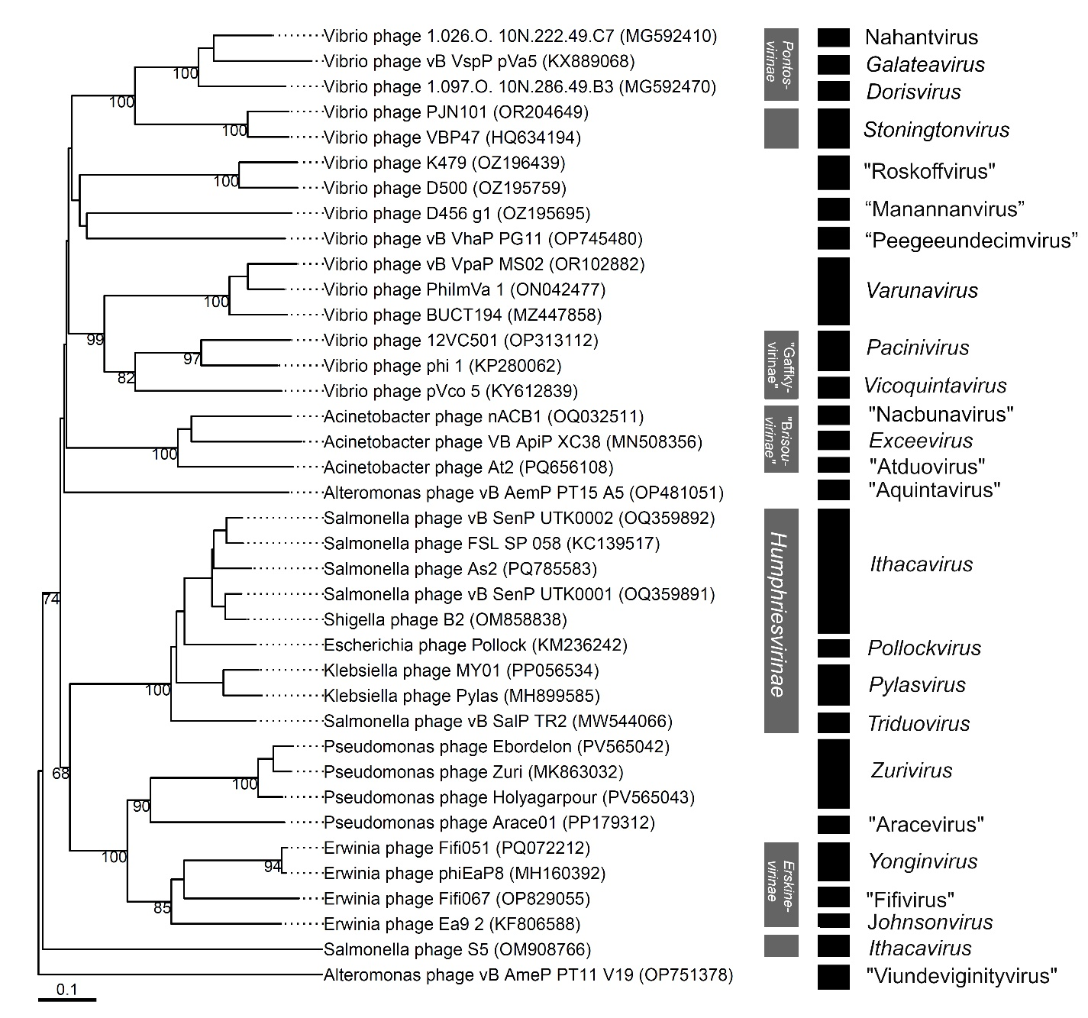

Fig. 1 Phylogenomic GBDP trees inferred using the formula D6 and yielding average support of 62 %. The numbers above branches are GBDP pseudo-bootstrap support values from 100 replications. The branch lengths of the resulting VICTOR trees are scaled in terms of the respective distance formula used.

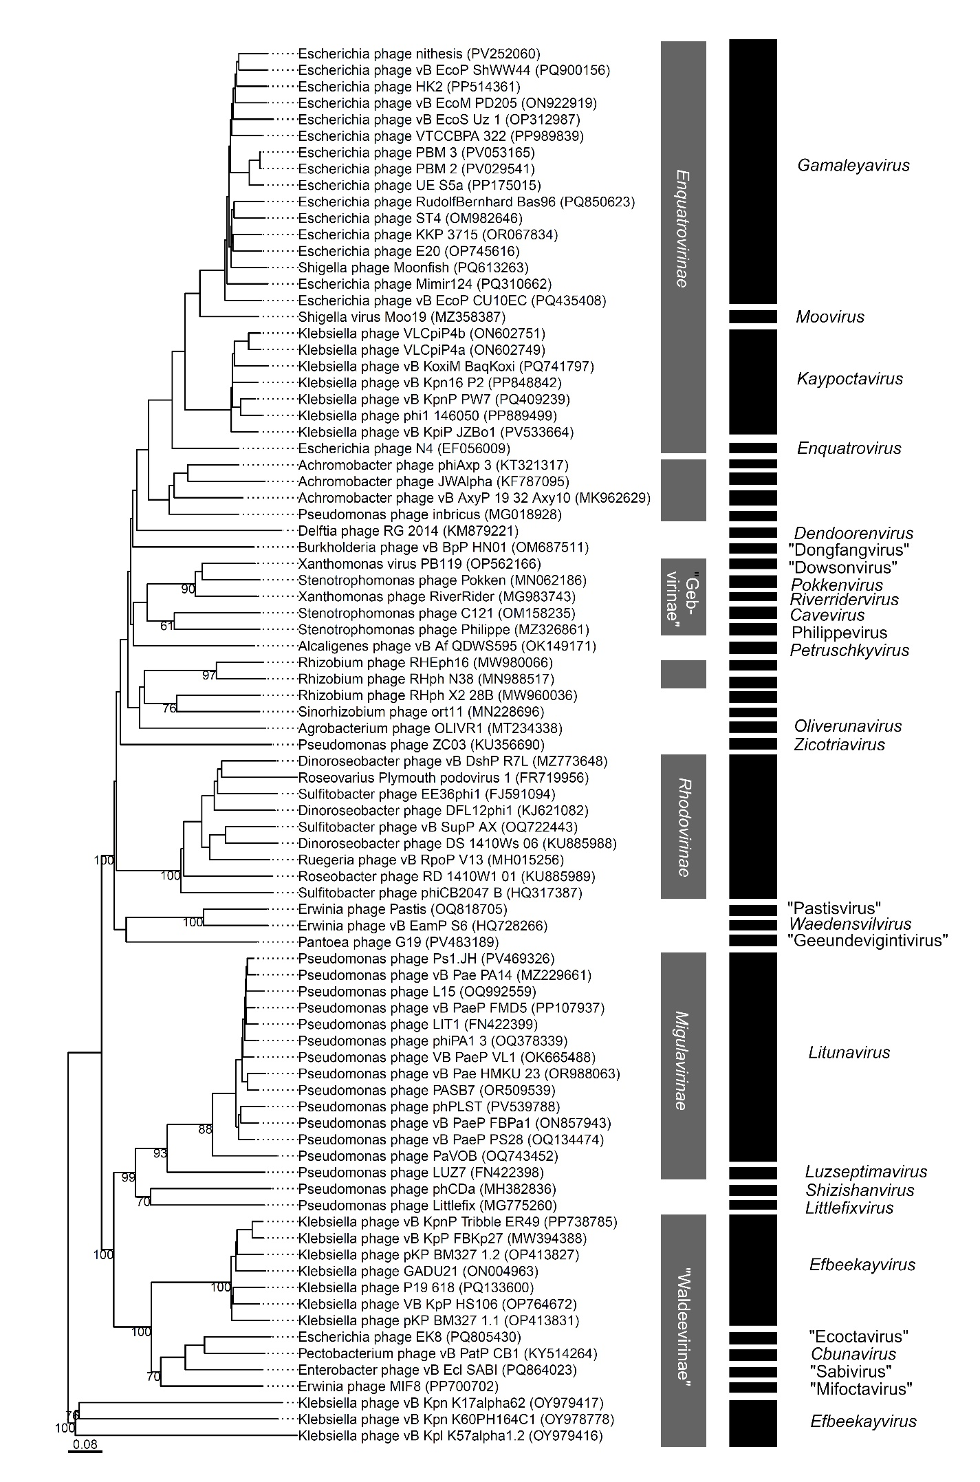

Fig. 2 Phylogenomic GBDP trees inferred using the formula D6 and yielding average support of 34%. The numbers above branches are GBDP pseudo-bootstrap support values from 100 replications. The branch lengths of the resulting VICTOR trees are scaled in terms of the respective distance formula used.