

The International Committee on Taxonomy of Viruses

Taxonomy Proposal Form, 2025

<https://ictv.global/taxonomy/templates>**Part 1a: Details of taxonomy proposals**

|  |  |
| --- | --- |
| **Title:** | Create a new phage family, *Pituviridae* including one new genus and one new species (Class *Caudoviricetes*) |
| **Code assigned:** | 2025.061B.Pituviridae_1nf_1ng_1ns | |

|  |  |  |  |  |
| --- | --- | --- | --- | --- |
| **Author(s), affiliation and email address(es):** | | | | |
| **Given name (+middle initial(s))** | **Surname** | **Affiliation** | **Email address** | **Corr. author(s)** |
| Michael Angelou L. | Nada | Industrial Technology Development Institute, Department of Science and Technology, DOST Compound, Taguig, 1630, Philippines | [mikeangelounada@gmail.com](mailto:mikeangelounada@gmail.com) | **X** |
| Marel Jan G. | Joloro | Industrial Technology Development Institute, Department of Science and Technology, DOST Compound, Taguig, 1630, Philippines | [mgjoloro.dostvip@gmail.com](mailto:mgjoloro.dostvip@gmail.com) |  |
| Ruth Antoinette D. | Chin | Industrial Technology Development Institute, Department of Science and Technology, DOST Compound, Taguig, 1630, Philippines | [chinruthantoinette@gmail.com](mailto:chinruthantoinette@gmail.com) |  |
| Mark Christian C. | Reterta | Industrial Technology Development Institute, Department of Science and Technology, DOST Compound, Taguig, 1630, Philippines | [mcreterta@gmail.com](mailto:mcreterta@gmail.com) |  |
| Janna Ysabelle O. | Casidsid | Industrial Technology Development Institute, Department of Science and Technology, DOST Compound, Taguig, 1630, Philippines | [jannaysabelle28@gmail.com](mailto:jannaysabelle28@gmail.com) |  |
| Anton Roi G. | Collado | Industrial Technology Development Institute, Department of Science and Technology, DOST Compound, Taguig, 1630, Philippines | [colladoantonr@gmail.com](mailto:colladoantonr@gmail.com) |  |
| Aubrey Joy P. | Tejada | Industrial Technology Development Institute, Department of Science and Technology, DOST Compound, Taguig, 1630, Philippines | [ajptejada.dostvip@gmail.com](mailto:ajptejada.dostvip@gmail.com) |  |
| Sharmen C. | Berlin | Industrial Technology Development Institute, Department of Science and Technology, DOST Compound, Taguig, 1630, Philippines | [scberlin@up.edu.ph](mailto:scberlin@up.edu.ph) |  |
| Joseph B. | Ancla | Industrial Technology Development Institute, Department of Science and Technology, DOST Compound, Taguig, 1630, Philippines | [anclajoseph8492@gmail.com](mailto:anclajoseph8492@gmail.com) |  |
| Arra B. | Asejo | Industrial Technology Development Institute, Department of Science and Technology, DOST Compound, Taguig, 1630, Philippines | [abasejo.dost@gmail.com](mailto:abasejo.dost@gmail.com) |  |
| Rommel J. | Gestuveo | S&T Fellows Program, Department of Science and Technology, DOST Compound, Taguig, 1630, Philippines | [rjgestuveo@gmail.com](mailto:rjgestuveo@gmail.com) |  |

**Part 1b: Taxonomy Proposal Submission**

|  |  |  |  |
| --- | --- | --- | --- |
| **ICTV Subcommittee:** | | | |
| Animal DNA Viruses and Retroviruses |  | Bacterial viruses | **X** |
| Animal minus-strand and dsRNA viruses |  | Fungal and protist viruses |  |
| Animal positive-strand RNA viruses |  | Plant viruses |  |
| Archaeal viruses |  | General - |  |

|  |
| --- |
| **List the ICTV Study Group(s) that have seen or have been involved in creating this proposal:** <https://ictv.global/sc> |
| Caudoviricetes Study Group |

|  |  |  |  |
| --- | --- | --- | --- |
| **Optional – complete only if formally voted on by an ICTV Study Group:** | | | |
| **Study Group** | **Number of members** | | |
| **Votes in support** | **Votes against** | **No vote** |
|  |  |  |  |
|  |  |  |  |

|  |  |
| --- | --- |
| **Submission date:** | 30/05/2025 |

**Part 1c: Feedback from ICTV Executive Committee (EC) meeting**

|  |  |
| --- | --- |
| **Executive Committee Meeting Decision code:** | **X** |
| A – Accept |  |
| Ac – Accept subject to revision by relevant subcommittee chair. No further vote required |  |
| U – Accept without revision but with re-evaluation and email vote by the EC |  |
| Uc – Accept subject to revision and re-evaluation and email vote by the EC |  |
| Ud – Deferred to the next EC meeting, with an invitation to revise based on EC comments |  |
| J - Reject |  |
| W - Withdrawn |  |

|  |
| --- |
| **Comments from the Executive Committee:** |
|  |

**Part 1d: Revised Taxonomy Proposal Submission**

|  |
| --- |
| **Response of proposer:** |
|  |

|  |  |
| --- | --- |
| **Revision date:** |  |

**Part 3:** **TAXONOMIC PROPOSAL**

<https://ictv.global/taxonomy/templates>

|  |  |  |  |
| --- | --- | --- | --- |
| **Taxonomic changes proposed:** | | | |
| Establish new taxon | **X** | Split taxon |  |
| Abolish taxon |  | Merge taxon |  |
| Move taxon |  | Promote taxon |  |
| Rename taxon |  | Demote taxon |  |
| Move and rename |  |

|  |  |
| --- | --- |
| **Etymology (origin) of proposed taxonomic names:** | |
| **Taxon name** | **Etymology of the term** |
| Family *Pituviridae* | named after the VIP project team (P2) who isolated and characterized *Klebsiella* phage vB_VIPKPNMC05 |
|  |  |
|  |  |
|  |  |

|  |  |  |
| --- | --- | --- |
| **Permission for use of names derived from a living person:** | | |
| **Taxon name** | **Full name of person from whom the name is derived** | **Attached** |
|  |  |  |
|  |  |  |
|  |  |  |
|  |  |  |

|  |
| --- |
| **Abstract of Taxonomy Proposal:** |
| *Taxonomic rank(s) affected*:  Realm *Duplodnaviria*, kingdom *Heunggongvirae*, phylum *Uroviricota*, class *Caudoviricetes*  *Description of current taxonomy*:  *Klebsiella* phages are currently classified in the order *Autographivirales* and the families *Ackermannviridae*, *Casjensviridae*, *Demerecviridae*, *Drexlerviridae*, *Peduoviridae*, *Schitoviridae*, and *Straboviridae.* Our taxonomic analysis revealed that *Klebsiella* phage vB_VIPKPNMC05 does not belong to the existing phage families, thus, remains unclassified.  *Proposed* *taxonomic change(s):*   1. Create a new family, *Pituviridae* 2. Create a new single species genus*, Pituvirus,* within the proposed family. 3. Add one new species (*Pituvirus akira)* to the proposed genus   *Justification*:  As a result of detailed genomic, proteomic, and phylogenetic analyses using VIRIDIC, ViPTree, VirClust, we propose to create a new phage family, *Pituviridae*, named after the project team who isolated and characterized *Klebsiella* phage vB_VIPKPNMC05. |

|  |
| --- |
| **Text of Taxonomy proposal:** *Klebsiella* phage vB_VIPKPNMC05 were isolated from Masalasa creek, Tarlac, Philippines. Our taxonomic analysis revealed thatVIPKPNMC05 do not belong to any of the existing *Klebsiella* phage families indicating that VIPKPNMC05 remain unclassified. Here, we proposed to create a new phage family, *Pituviridae*, under Class *Caudoviricetes.* The proposed phage family will be represented by *Klebsiella* phage vB_VIPKPNMC05. The genome is complete with DTR based on checkV [1] analysis and is publicly available in NCBI Genbank database. |
| ***Taxonomic rank(s) affected*:**  Realm *Duplodnaviria*, kingdom *Heunggongvirae*, phylum *Uroviricota*, class *Caudoviricetes*  ***Description of current taxonomy*:**  *Klebsiella* phages are currently classified into eight families: *Ackermannviridae*, *Autographiviridae*, *Casjensviridae*, *Demerecviridae*, *Drexlerviridae*, *Peduoviridae*, *Schitoviridae*, and *Straboviridae.* Our taxonomic analysis revealed that *Klebsiella* phage vB_VIPKPNMC05 does not belong to the existing phage families, thus, remains unclassified.  ***Proposed* *taxonomic change(s)*:**   1. Create a new family, *Pituviridae* 2. Create a new single species genus*, Pituvirus,* within the proposed family. 3. Add one new species (*Pituvirus akira)* to the proposed genus.   ***Demarcation criteria:***  Two phages are assigned to the same species if their genomes are more than **95% identical** over their genome length using VIRIDIC [2].  In search for criteria that create cohesive and distinct genera that are reproducible and monophyletic, the Bacterial Viruses Subcommittee has established **70% nucleotide identity**of the genome length as the cut-off for genera. Genus-level groupings should always be monophyletic in the signature genes, as tested with a phylogenetic tree [2].  Subfamilies are to be created when two or more genera are related below the family level. In practical terms, this usually means that they share a low degree of sequence similarity (usually about 40-50%) and that the genera form a clade in a marker tree phylogeny [2].  The family is represented by a cohesive and monophyletic group in the main predicted proteome-based clustering tools (VirClust, ViPTree, GRAViTy dendrogram, vConTACT2 network). Members of the family share a significant number of orthologous genes (the number will depend on the genome sizes and number of coding sequences of members of the family) [2].  ***Justification*:**  As a result of detailed genomic, proteomic and phylogenetic analyses using VIRIDIC, ViPTree, VirClust, we propose to create a new phage family, *Pituviridae*.  ***Origin of the name of this taxon:***  The proposed phage family, *Pituviridae*, is named after the VIP project team (P2) that isolated and characterized *Klebsiella* phage vB_VIPKPNMC05. The proposed binomial name (*Pituvirus akira*) was after this sweet baby girl, akira.  The Project 2 (P2) team of the Virology Institute Research Program and the senior researchers’ dog, Akira. |

|  |
| --- |
| **References:** |
| 1. Nayfach, S., Camargo, A. P., Schulz, F., Eloe-Fadrosh, E., Roux, S., & Kyrpides, N. C. (2021). CheckV assesses the quality and completeness of metagenome-assembled viral genomes. *Nature biotechnology*, *39*(5), 578-585. 2. Turner, D., Kropinski, A. M., & Adriaenssens, E. M. (2021). A roadmap for genome-based phage taxonomy. *Viruses*, *13*(3), 506. 3. Millard, A. D., Denise, R., Lestido, M., Thomas, M., Webster, D., Turner, D., & Sicheritz-Ponten, T. (2024). taxmyPHAGE: Automated taxonomy of dsDNA phage genomes at the genus and species. *bioRxiv*, 2024-08. 4. Nishimura, Y., Yoshida, T., Kuronishi, M., Uehara, H., Ogata, H., & Goto, S. (2017). ViPTree: the viral proteomic tree server. *Bioinformatics*, *33*(15), 2379-2380. 5. Moraru, C. (2023). VirClust—A tool for hierarchical clustering, core protein detection and annotation of (prokaryotic) viruses. *Viruses*, *15*(4), 1007. 6. Ondov, B. D., Treangen, T. J., Melsted, P., Mallonee, A. B., Bergman, N. H., Koren, S., & Phillippy, A. M. (2016). Mash: fast genome and metagenome distance estimation using MinHash. *Genome biology*, *17*, 1-14. 7. Cook, R., Brown, N., Redgwell, T., Rihtman, B., Barnes, M., Clokie, M., ... & Millard, A. (2021). INfrastructure for a PHAge REference database: identification of large-scale biases in the current collection of cultured phage genomes. *Phage*, *2*(4), 214-223. 8. Moraru, C., Varsani, A., & Kropinski, A. M. (2020). VIRIDIC—A novel tool to calculate the intergenomic similarities of prokaryote-infecting viruses. *Viruses*, *12*(11), 1268. 9. Tamura, K., Stecher, G., & Kumar, S. (2021). MEGA11: molecular evolutionary genetics analysis version 11. *Molecular biology and evolution*, *38*(7), 3022-3027. 10. Edgar, R. C. (2004). MUSCLE: multiple sequence alignment with high accuracy and high throughput. *Nucleic acids research*, *32*(5), 1792-1797. 11. Letunic, I., & Bork, P. (2021). Interactive Tree Of Life (iTOL) v5: an online tool for phylogenetic tree display and annotation. *Nucleic acids research*, *49*(W1), W293-W296. |

|  |  |
| --- | --- |
| **Accompanying files:** | |
| **Filename** | **Description of contents** |
| Pituviridae_ICTVproposal2025.xlsx | Name of accompanying Excel module. |
|  |  |

|  |
| --- |
| **Tables, Figures:** |

<Start here>

|  |  |  |  |  |  |
| --- | --- | --- | --- | --- | --- |
| **Phage name** | **NCBI accession no** | **Genome length (bp)** | **GC content** | **CDS** | **tRNA** |
| Klebsiella phage vB_VIPKPNMC05 | PQ351753 | 34,476 | 51.0% | 58 | 0 |

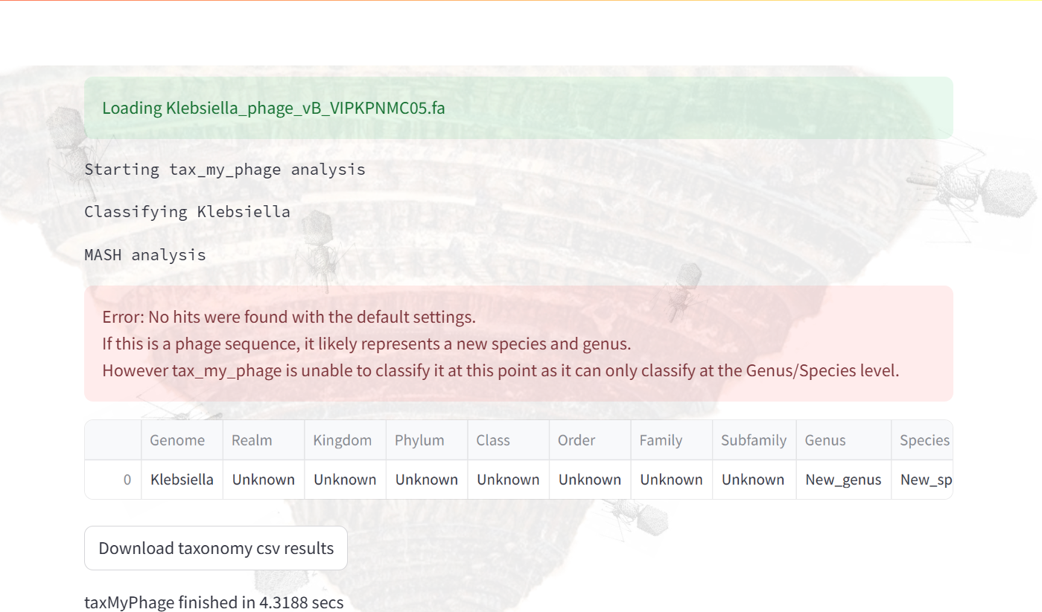

**Figure 1**. Initial taxonomic identification of VIPKPNMC05 at genus and species level using taxmyphage [3]. Taxmyphage cannot assigned VIPKPNMC05 using the ICTV registered genomes suggesting that this isolate is still unclassified.

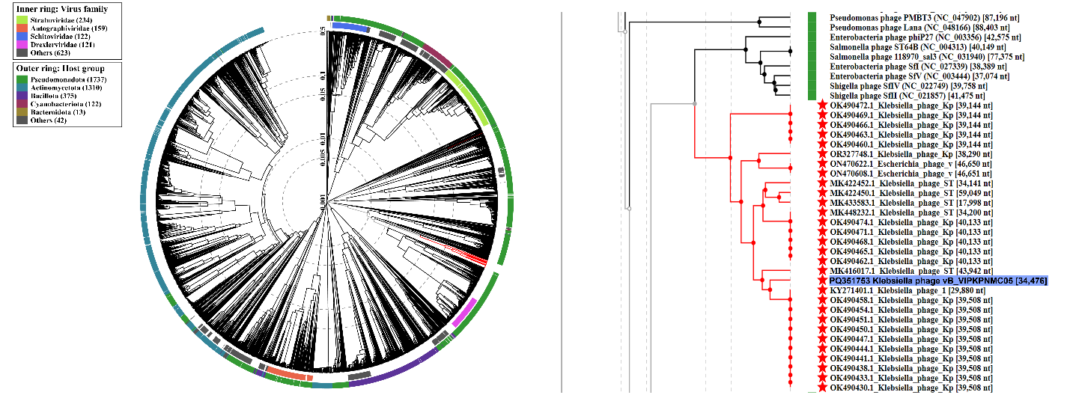

**Figure 2**. The phage proteomic tree consisting of 3,724 bacterial viruses were built using the ViPTree [4]. First, the closest relative of VIPKPNMC05 were identified using mash [5] and INPHARED database [6] following the 0.20 distance cutoff. Then, closely related genomes marked by the red star symbol were downloaded from NCBI nucleotide database and submitted to the VIPTree webserver. The tree is based on a dissimilarity matrix generated by pairwise tBLASTx scores between each of the genomes. Isolate VIPKPNMC05 was highlighted in blue.

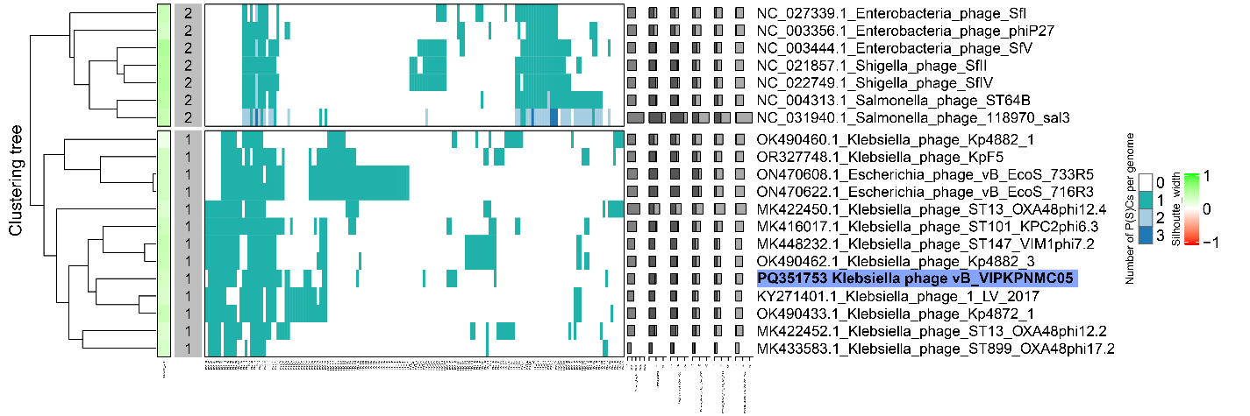

**Figure 3**. Protein heatmap of VIPKPNMC05 and closely related genomes at two different level. On the first level, proteins were grouped into protein clusters (PC) based on their reciprocal BLASTP similarities. On the second level, PCs are grouped into protein superclusters, or PSCs, based on their Hidden Markov Model (HMM) similarities. The top group are the phages identified by VIPTree while the bottom group were genomes previously identified using mash. VIPKPNMC05 grouped together with Klebsiella phage LV-2-17 and Klebsiella phage Kp4872. Protein clustering was determined using VirClust [7]. Isolate VIPKPNMC05 was highlighted in blue.



**Figure 4**. VIRIDIC heatmap of VIPKPNMC05 and closely related genomes. Our analysis showed that genome similarities between VIPKPNMC05, *Klebsiella* phage 1 LV−2017 (52.2%), and *Klebsiella* phage Kp4872 (53.8%) were relatively low. Genome similarities were calculated using VIRIDIC (Virus Intergenomic Distance Calculator) [8]. Isolate VIPKPNMC05 was highlighted in blue

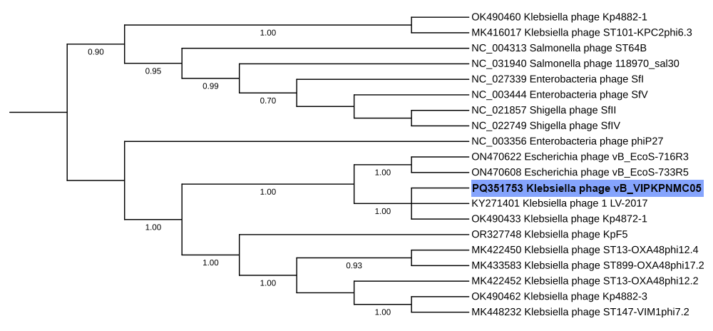

**Figure 5**. Phylogenetic tree based on terL genes was constructed using MEGA v11 [9]. To do this, terL genes were aligned with MUSCLE [10] and a Maximum-Likelihood (ML) tree were constructed with 1,000 iterations. Phylogenetic tree was rooted at midpoint and visualized using iTOL [11]. Isolate VIPKPNMC05 was highlighted in blue.

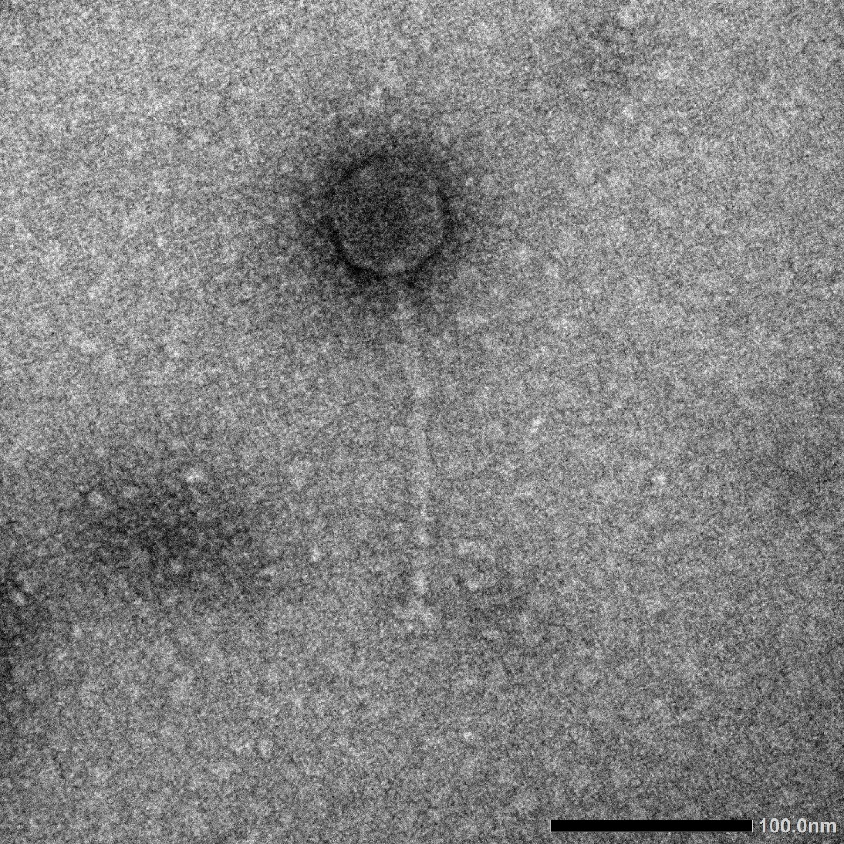

**Figure 6**. TEM image of Klebsiella phage vB_VIPKPNMC05 showing a siphoviridae morphology.