

The International Committee on Taxonomy of Viruses

Taxonomy Proposal Form, 2025

<https://ictv.global/taxonomy/templates>**Part 1a: Details of taxonomy proposals**

|  |  |
| --- | --- |
| **Title:** | Create a new subfamily, *Pearlrivervirinae,* with two genera and 16 species (*Caudoviricetes*) |
| **Code assigned:** | 2025.057B.Pearlrivervirinae_1nsf_2ng_16ns | |

|  |  |  |  |  |
| --- | --- | --- | --- | --- |
| **Author(s), affiliation and email address(es):** | | | | |
| **Given name (+middle initial(s))** | **Surname** | **Affiliation** | **Email address** | **Corr. author(s)** |
| Andrew M. | Kropinski | Department of Pathobiology, University of Guelph, Guelph, Ontario, Canada | Phage.Canada@gmail.com | x |
| Cristina | Moraru | Carl von Ossietzky Universität Oldenburg, Germany | liliana.cristina.moraru@uol.de |  |
| Juntao | Shen | Center for Synthetic Microbiome,  Shenzhen Institute of Advanced Technology, Chinese Academy of Sciences, China |  |  |

**Part 1b: Taxonomy Proposal Submission**

|  |  |  |  |
| --- | --- | --- | --- |
| **ICTV Subcommittee:** | | | |
| Animal DNA Viruses and Retroviruses |  | Bacterial viruses | **x** |
| Animal minus-strand and dsRNA viruses |  | Fungal and protist viruses |  |
| Animal positive-strand RNA viruses |  | Plant viruses |  |
| Archaeal viruses |  | General - |  |

|  |
| --- |
| **List the ICTV Study Group(s) that have seen or have been involved in creating this proposal:** <https://ictv.global/sc> |
| Caudoviricetes Study Group |

|  |  |  |  |
| --- | --- | --- | --- |
| **Optional – complete only if formally voted on by an ICTV Study Group:** | | | |
| **Study Group** | **Number of members** | | |
| **Votes in support** | **Votes against** | **No vote** |
|  |  |  |  |
|  |  |  |  |

|  |  |
| --- | --- |
| **Submission date:** | 15/06/2025 |

**Part 1c: Feedback from ICTV Executive Committee (EC) meeting**

|  |  |
| --- | --- |
| **Executive Committee Meeting Decision code:** | **X** |
| A – Accept |  |
| Ac – Accept subject to revision by relevant subcommittee chair. No further vote required |  |
| U – Accept without revision but with re-evaluation and email vote by the EC |  |
| Uc – Accept subject to revision and re-evaluation and email vote by the EC |  |
| Ud – Deferred to the next EC meeting, with an invitation to revise based on EC comments |  |
| J - Reject |  |
| W - Withdrawn |  |

|  |
| --- |
| **Comments from the Executive Committee:** |
|  |

**Part 1d: Revised Taxonomy Proposal Submission**

|  |
| --- |
| **Response of proposer:** |
|  |

|  |  |
| --- | --- |
| **Revision date:** |  |

**Part 2:** **GENERAL PROPOSAL**

|  |
| --- |
| **Abstract for General Proposal:** |
| *Brief description of current situation:*  *Proposed changes:*  *Justification:* |

|  |
| --- |
| **Text of General Proposal:** |
| *Background:*  *Proposed* *changes:*  *Justification:* |

|  |
| --- |
| **References:** |
|  |

|  |  |
| --- | --- |
| **Accompanying files:** | |
| **Filename** | **Description of contents** |
|  |  |
|  |  |

|  |
| --- |
| **Tables, Figures:** |

<Start here>

**Part 3:** **TAXONOMIC PROPOSAL**

<https://ictv.global/taxonomy/templates>

|  |  |  |  |
| --- | --- | --- | --- |
| **Taxonomic changes proposed:** | | | |
| Establish new taxon | **x** | Split taxon |  |
| Abolish taxon |  | Merge taxon |  |
| Move taxon |  | Promote taxon |  |
| Rename taxon |  | Demote taxon |  |
| Move and rename |  |

|  |  |
| --- | --- |
| **Etymology (origin) of proposed taxonomic names:** | |
| **Taxon name** | **Etymology of the term** |
| *Pearlrivervirinae* | Since most of these phages were identified in China, we have chosen to name the taxa after Chinese river – subfamily named after the Pearl River in Guangdong Province where these phages were studied at the Shenzhen Institute of Synthetic Biology |
| *Xijiangvirus* | Named after Xijiang River (West River), the western primary tributary of the Pearl River system in Guangdong Province. |
| *Dongjiangvirus* | Named after Dongjiang River (East River), the eastern major tributary of the Pearl River system in Guangdong Province. |

|  |  |  |
| --- | --- | --- |
| **Permission for use of names derived from a living person:** | | |
| **Taxon name** | **Full name of person from whom the name is derived** | **Attached** |
|  |  |  |
|  |  |  |
|  |  |  |
|  |  |  |

|  |
| --- |
| **Abstract of Taxonomy Proposal:** |
| *Taxonomic rank(s) affected*: subfamily, two genera and 35 species  *Description of current taxonomy*: there is no current taxonomy for these lytic phages isolated against *Phocaeicola*  *Proposed* *taxonomic change(s):* Add two new genera and 16 new species to a new subfamily (*Pearlrivervirinae*)  *Justification*: In accord with our definition of what constitutes a new subfamily, genus and species [3] these *Phocaeicola* phages, isolated in China, fall into two new genera (*Xijiangvirus* and *Dongjiangvirus*) in a new subfamily which we have chosen to call *Pearlrivervirinae*. |

|  |
| --- |
| * **Text of Taxonomy proposal:** |
| *Taxonomic rank(s) affected*: subfamily, genera and species  *Description of current taxonomy*: there is no current taxonomy for these lytic phages isolated against *Phocaeicola*  *roposed* *taxonomic change(s)*: Add two new genera and 16 new species to a new subfamily (*Pearlrivervirinae*)  *Demarcation criteria*: The Bacterial and Archaeal Virus Subcommittee established 70% average nucleotide identity (ANI) threshold for genus classification or 95% ANI for species [8]. Subfamilies are to be created when two or more genera are related below the family level. In practical terms, this usually means that they share a low degree of sequence similarity (usually about 40-50%) and that the genera form a clade in a marker tree phylogeny [8].  *Justification*: In accord with our definition of what constitutes a new subfamily, genus and species [3] these *Phocaeicola* phages, isolated in China, fall into two new genera (*Xijiangvirus* and *Dongjiangvirus*) in a new subfamily which we have chosen to call *Pearlrivervirinae*. |

|  |
| --- |
| **References:** |
| 1. Sayers EW, Beck J, Bolton EE, Bourexis D, Brister JR, Canese K, Comeau DC, Funk K, Kim S, Klimke W, Marchler-Bauer A, Landrum M, Lathrop S, Lu Z, Madden TL, O'Leary N, Phan L, Rangwala SH, Schneider VA, Skripchenko Y, Wang J, Ye J, Trawick BW, Pruitt KD, Sherry ST. Database resources of the National Center for Biotechnology Information. Nucleic Acids Res. 2021 Jan 8;49(D1):D10-D17. doi: 10.1093/nar/gkaa892. PMID: 33095870  2. O'Leary NA, Wright MW, Brister JR, Ciufo S, Haddad D, McVeigh R, et al. Reference sequence (RefSeq) database at NCBI: current status, taxonomic expansion, and functional annotation. Nucleic Acids Res. 2016;44(D1):D733-45. doi: 10.1093/nar/gkv1189. PMID: 26553804.  3. Moraru C, Varsani A, Kropinski AM. VIRIDIC-A Novel Tool to Calculate the Intergenomic Similarities of Prokaryote-Infecting Viruses. Viruses. 2020 Nov 6;12(11):1268. doi: 10.3390/v12111268. PMID: 33172115; PMCID: PMC7694805. http://kronos.icbm.uni-oldenburg.de/viridic/  4. Nishimura Y, Yoshida T, Kuronishi M, Uehara H, Ogata H, Goto S. ViPTree: the viral proteomic tree server. Bioinformatics. 2017; 33(15):2379-2380. doi:10.1093/bioinformatics/btx157. PubMed PMID: 28379287. https://www.genome.jp/viptree/  5. Rohwer F, Edwards R. The Phage Proteomic Tree: a genome-based taxonomy for phage. J Bacteriol. 2002 Aug;184(16):4529-35. PubMed PMID: 12142423  6. Turner D, Reynolds D, Seto D, Mahadevan P. CoreGenes3.5: a webserver for the determination of core genes from sets of viral and small bacterial genomes. BMC Res Notes. 2013;6:140. doi: 10.1186/1756-0500-6-140. PMID: 23566564.  7. Davis P, Seto D, Mahadevan P. CoreGenes5.0: An Updated User-Friendly Webserver for the Determination of Core Genes from Sets of Viral and Bacterial Genomes. Viruses. 2022 Nov 16;14(11):2534. doi: 10.3390/v14112534. PMID: 36423143; PMCID: PMC9693508.  8. Turner D, Kropinski AM, Adriaenssens EM. A Roadmap for Genome-Based Phage Taxonomy. Viruses. 2021 Mar 18;13(3):506. doi: 10.3390/v13030506. PMID: 33803862; PMCID: PMC8003253.  Lemoine F, Correia D, Lefort V, Doppelt-Azeroual O, Mareuil F, Cohen-Boulakia S, Gascuel O. NGPhylogeny.fr: new generation phylogenetic services for non-specialists. Nucleic Acids Res. 2019 Jul 2;47(W1):W260-W265. doi: 10.1093/nar/gkz303. PMID: 31028399; PMCID: PMC6602494.  9. Letunic I, Bork P. Interactive Tree Of Life (iTOL): an online tool for phylogenetic tree display and annotation. Bioinformatics. 2007 Jan 1;23(1):127-8. doi: 10.1093/bioinformatics/btl529. Epub 2006 Oct 18. PMID: 17050570.  10. Zhou T, Xu K, Zhao F, Liu W, Li L, Hua Z, Zhou X. itol.toolkit accelerates working with iTOL (Interactive Tree of Life) by an automated generation of annotation files. Bioinformatics. 2023 Jun 1;39(6):btad339. doi: 10.1093/bioinformatics/btad339. PMID: 37225402; PMCID: PMC10243930 |

|  |  |
| --- | --- |
| **Accompanying files:** | |
| **Filename** | **Description of contents** |
| Pearlrivervirinae_VIRIDIC_heatmap.xlsx | Data for this proposal |
|  |  |

|  |
| --- |
| **Tables, Figures:** |

<Start here>

|  |  |  |  |
| --- | --- | --- | --- |
| **Accession No.** | **Phage name** | **Taxon** | **Host taxon** |
|  |  |  |  |
| OP172694.1 | Phocaeicola phage BM127P1 | *Xijiangvirus BM127P1* | *Phocaeicola massiliensis* |
| OP172745.1 | Phocaeicola phage BV737P2 | *Dongjiangvirus BV737P2* | *Phocaeicola vulgatus* |
| OP172748.1 | Phocaeicola phage BV741P1 | *Dongjiangvirus BV741P1* | *Phocaeicola vulgatus* |
| OP172744.1 | Phocaeicola phage BV674P5 | *Dongjiangvirus BV674P5* | *Phocaeicola vulgatus* |
| OP172750.1 | Phocaeicola phage BV741P4 | *Dongjiangvirus BV741P4* | *Phocaeicola vulgatus* |
| OP172737.1 | Phocaeicola phage BV57P2 | *Dongjiangvirus BV57P2* | *Phocaeicola vulgatus* |
| OP172746.1 | Phocaeicola phage BV737P3 | *Dongjiangvirus BV737P3* | *Phocaeicola vulgatus* |
| OP172747.1 | Phocaeicola phage BV739P1 | *Dongjiangvirus BV739P1* | *Phocaeicola vulgatus* |
| OP172739.1 | Phocaeicola phage BV185P1 | *Dongjiangvirus BV185P1* | *Phocaeicola vulgatus* |
| OP172740.1 | Phocaeicola phage BV200P1 | *Dongjiangvirus BV200P1* | *Phocaeicola vulgatus* |
| OP172743.1 | Phocaeicola phage BV283P3 | *Dongjiangvirus BV283P3* | *Phocaeicola vulgatus* |
| OP172749.1 | Phocaeicola phage BV741P2 | *Dongjiangvirus BV741P2* | *Phocaeicola vulgatus* |
| OP172736.1 | Phocaeicola phage BV57P1 | *Dongjiangvirus BV57P1* | *Phocaeicola vulgatus* |
| OP172652.1 | Phocaeicola phage BD26P1 | *Dongjiangvirus BD26P1* | *Phocaeicola vulgatus* |
| OP172657.1 | OM05-12 phage BD166P1 | *Dongjiangvirus BD166P1* | OM05-12 sp003438995 DA166 |
| OP172738.1 | Phocaeicola phage BV57P3 | *Dongjiangvirus BV57P3* | *Phocaeicola vulgatus* |
|  |  |  |  |

**Specific reference:** Shen J, Zhang J, Mo L, Li Y, Li Y, Li C, Kuang X, Tao Z, Qu Z, Wu L, Chen J, Liu S, Zeng L, He Z, Chen Z, Deng Y, Zhang T, Li B, Dai L, Ma Y. Large-scale phage cultivation for commensal human gut bacteria. Cell Host Microbe. 2023 Apr 12;31(4):665-677.e7. doi: 10.1016/j.chom.2023.03.013. PMID: 37054680.

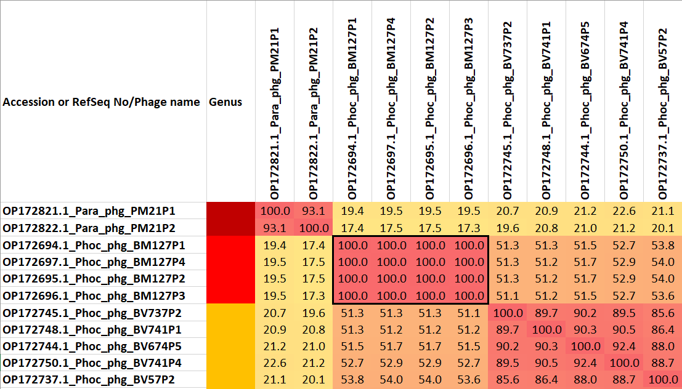

**Figure 1.** Partial VIRIDIC heatmap of this group of phages. VIRIDIC (Virus Intergenomic Distance Calculator; VIRIDIC (Virus Intergenomic Distance Calculator; [3]; http://rhea.icbm.uni-oldenburg.de/VIRIDIC/) computes pairwise intergenomic distances/similarities amongst phage genomes. Data values which are bordered in black correspond to strains. Abbreviations: phg = phage Para = *Parabacteroides*; Phoc = *Phocaeicola*. The complete VIRIDIC heatmap accompanies this proposal as Pearlrivervirinae_VIRIDIC heatmap.xlsx.

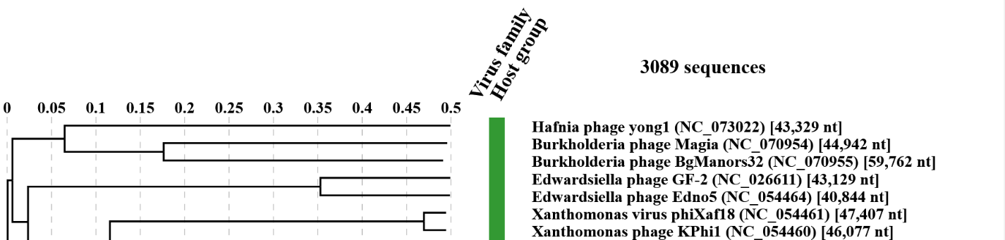

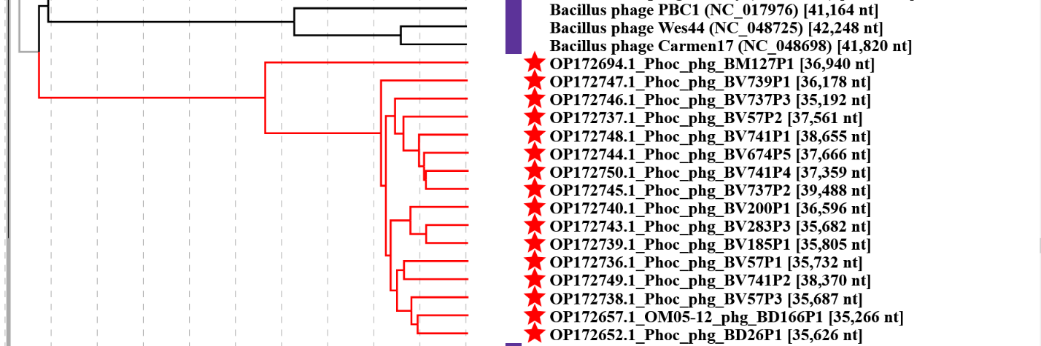

**Figure 2.** ViPTree analysis: ViPTree analysis (https://www.genome.jp/viptree/; [4]) is based upon Rohwer and Edwards (2002) Phage Proteomic Tree [5]. The taxon under discussion is indicated with a **red bar**. Abbreviations: phg = phage; Phoc = *Phocaeicola*.

**CoreGenes 5 Analysis [7]**: revealed that the phages listed in Table 1 share 33 protein homologs, all listed as hypothetical proteins. This indicates that approximately 69% of the phage-encodes proteins are conserved.