

The International Committee on Taxonomy of Viruses

Taxonomy Proposal Form, 2025

**Part 1a: Details of taxonomy proposals**

|  |  |
| --- | --- |
| **Title:** | Create 41 new species in the genus *Obolenskvirus* (class *Caudoviricetes*) |
| **Code assigned:** | 2025.054B.Obolenskvirus_41_ns | |

|  |  |  |  |  |
| --- | --- | --- | --- | --- |
| **Author(s), affiliation and email address(es):** | | | | |
| **Given name (+middle initial(s))** | **Surname** | **Affiliation** | **Email address** | **Corresponding author(s)** |
| Michał J. | Wójcicki | Bacteriophage Laboratory, Department of Phage Therapy, Hirszfeld Institute of Immunology and Experimental Therapy, Polish Academy of Sciences, Wroclaw, Poland | [michal.wojcicki@hirszfeld.pl](mailto:michal.wojcicki@hirszfeld.pl) | X |
| Martyna A. | Cieślik | Bacteriophage Laboratory, Department of Phage Therapy, Hirszfeld Institute of Immunology and Experimental Therapy, Polish Academy of Sciences, Wroclaw, Poland | [martyna.cieslik@hirszfeld.pl](mailto:martyna.cieslik@hirszfeld.pl) |  |
| Edyta | Pawlak | Laboratory of Immunopathology, Department of Experimental Therapy, Hirszfeld Institute of Immunology and Experimental Therapy, Polish Academy of Sciences, Wroclaw, Poland | [edyta.pawlak@hirszfeld.pl](mailto:edyta.pawlak@hirszfeld.pl) |  |
| Andrzej | Górski | Bacteriophage Laboratory, Department of Phage Therapy, Hirszfeld Institute of Immunology and Experimental Therapy, Polish Academy of Sciences, Wroclaw, Poland | [andrzej.gorski@hirszfeld.pl](mailto:andrzej.gorski@hirszfeld.pl) |  |
| Ewa M. | Jończyk-Matysiak | Bacteriophage Laboratory, Department of Phage Therapy, Hirszfeld Institute of Immunology and Experimental Therapy, Polish Academy of Sciences, Wroclaw, Poland | [ewa.jonczyk-matysiak@hirszfeld.pl](mailto:ewa.jonczyk-matysiak@hirszfeld.pl) |  |

**Part 1b: Taxonomy Proposal Submission**

|  |  |  |  |
| --- | --- | --- | --- |
| **ICTV Subcommittee:** | | | |
| Animal DNA Viruses and Retroviruses |  | Bacterial viruses | X |
| Animal minus-strand and dsRNA viruses |  | Fungal and protist viruses |  |
| Animal positive-strand RNA viruses |  | Plant viruses |  |
| Archaeal viruses |  | General |  |

|  |
| --- |
| **List the ICTV Study Group(s) that have seen or have been involved in creating this proposal:** |
| *Caudoviricetes Study Group* |

|  |  |  |  |
| --- | --- | --- | --- |
| **Optional – complete only if formally voted on by an ICTV Study Group:** | | | |
| **Study Group** | **Number of members** | | |
| **Votes in support** | **Votes against** | **No vote** |
|  |  |  |  |
|  |  |  |  |

|  |  |
| --- | --- |
| **Submission date:** | 20/06/2025 |

**Part 1c: Feedback from ICTV Executive Committee (EC) meeting**

|  |  |
| --- | --- |
| **Executive Committee Meeting Decision code:** | **X** |
| A – Accept |  |
| Ac – Accept subject to revision by relevant subcommittee chair. No further vote required |  |
| U – Accept without revision but with re-evaluation and email vote by the EC |  |
| Uc – Accept subject to revision and re-evaluation and email vote by the EC |  |
| Ud – Deferred to the next EC meeting, with an invitation to revise based on EC comments |  |
| J - Reject |  |
| W - Withdrawn |  |

|  |
| --- |
| **Comments from the Executive Committee:** |
|  |

**Part 1d: Revised Taxonomy Proposal Submission**

|  |
| --- |
| **Response of proposer:** |
|  |

|  |  |
| --- | --- |
| **Revision date:** |  |

**Part 3:** **TAXONOMIC PROPOSAL**

|  |  |  |  |
| --- | --- | --- | --- |
| **Taxonomic changes proposed:** | | | |
| Establish new taxon | X | Split taxon |  |
| Abolish taxon |  | Merge taxon |  |
| Move taxon |  | Promote taxon |  |
| Rename taxon |  | Demote taxon |  |
| Move and rename |  |

|  |  |
| --- | --- |
| **Etymology (origin) of proposed taxonomic names:** | |
| **Taxon name** | **Etymology of the term** |
| *Obolenskvirus XC1* | species name derived from the phage name in the GenBank database – Acinetobacter phage XC1 |
| *Obolenskvirus QH4* | species name derived from the phage name in the GenBank database – Acinetobacter phage vB_Aba_QH4 |
| *Obolenskvirus IME284* | species name derived from the phage name in the GenBank database – Acinetobacter phage vB_AbaM_IME284 |
| *Obolenskvirus AB3P2* | species name derived from the phage name in the GenBank database – Acinetobacter phage vB_AbaM_AB3P2 |
| *Obolenskvirus BUCT628* | species name derived from the phage name in the GenBank database – Acinetobacter phage BUCT628 |
| *Obolenskvirus IMEAp7* | species name derived from the phage name in the GenBank database – Acinetobacter phage vB_ApiM_IME-Ap7 |
| *Obolenskvirus A8321* | species name derived from the phage name in the GenBank database – Acinetobacter phage A832.1 |
| *Obolenskvirus R2919* | species name derived from the phage name in the GenBank database – Acinetobacter phage Bphi-R2919 |
| *Obolenskvirus R1888* | species name derived from the phage name in the GenBank database – Acinetobacter phage Bphi-R1888 |
| *Obolenskvirus IME285* | species name derived from the phage name in the GenBank database – Acinetobacter phage vB_AbaM_IME285 |
| *Obolenskvirus BP10* | species name derived from the phage name in the GenBank database – Acinetobacter phage vB_AbaM_BP10 |
| *Obolenskvirus Abp95* | species name derived from the phage name in the GenBank database – Acinetobacter phage Abp95 |
| *Obolenskvirus Brutus* | species name derived from the phage name in the GenBank database – Acinetobacter phage Brutus |
| *Obolenskvirus WUPSU* | species name derived from the phage name in the GenBank database – Acinetobacter phage vB_AbM_WUPSU |
| *Obolenskvirus Scipio* | species name derived from the phage name in the GenBank database – Acinetobacter phage Scipio |
| *Obolenskvirus Acb75* | species name derived from the phage name in the GenBank database – Acinetobacter phage VB_AB_Acb75 |
| *Obolenskvirus P1068* | species name derived from the phage name in the GenBank database – Acinetobacter phage P1068 |
| *Obolenskvirus Arbor* | species name derived from the phage name in the GenBank database – Acinetobacter phage Arbor |
| *Obolenskvirus MRABphi22* | species name derived from the phage name in the GenBank database – Acinetobacter phage MRABphi22 |
| *Obolenskvirus Aba01* | species name derived from the phage name in the GenBank database – Acinetobacter phage HN_Aba_01 |
| *Obolenskvirus A72* | species name derived from the phage name in the GenBank database – Acinetobacter phage vB_AbaM_A72 |
| *Obolenskvirus HZY2308* | species name derived from the phage name in the GenBank database – Acinetobacter phage HZY2308 |
| *Obolenskvirus phi1092006* | species name derived from the phage name in the GenBank database – Acinetobacter phage phi1_092006 |
| *Obolenskvirus BUCT629* | species name derived from the phage name in the GenBank database – Acinetobacter phage BUCT629 |
| *Obolenskvirus NJ02* | species name derived from the phage name in the GenBank database – Acinetobacter phage NJ02 |
| *Obolenskvirus IME512* | species name derived from the phage name in the GenBank database – Acinetobacter phage vB_AbaM_IME512 |
| *Obolenskvirus Ab69* | species name derived from the phage name in the GenBank database – Acinetobacter phage Ab69 |
| *Obolenskvirus YNAF* | species name derived from the phage name in the GenBank database – Acinetobacter phage vB_AbaM_YNAF |
| *Obolenskvirus Acba21* | species name derived from the phage name in the GenBank database – Acinetobacter phage Acba_21 |
| *Obolenskvirus 01KEN01* | species name derived from the phage name in the GenBank database – Acinetobacter phage vB_Ab_01_KEN_01 |
| *Obolenskvirus RMA1* | species name derived from the phage name in the GenBank database – Acinetobacter phage RM_A1 |
| *Obolenskvirus RMA2* | species name derived from the phage name in the GenBank database – Acinetobacter phage RM_A2 |
| *Obolenskvirus fThrA* | species name derived from the phage name in the GenBank database – Acinetobacter phage vB_AbaM_fThrA |
| *Obolenskvirus AQ1* | species name derived from the phage name in the GenBank database – Acinetobacter phage vB_AQ1 |
| *Obolenskvirus ZC3* | species name derived from the phage name in the GenBank database – Acinetobacter phage vB_Aba_ZC3 |
| *Obolenskvirus 02KEN02* | species name derived from the phage name in the GenBank database – Acinetobacter phage vB_Ab_02_KEN_02 |
| *Obolenskvirus SPA* | species name derived from the phage name in the GenBank database – Acinetobacter phage vB_AbaM-SPA |
| *Obolenskvirus Abp9* | species name derived from the phage name in the GenBank database – Acinetobacter phage Abp9 |
| *Obolenskvirus SR* | species name derived from the phage name in the GenBank database – Acinetobacter phage SR |
| *Obolenskvirus Cato* | species name derived from the phage name in the GenBank database – Acinetobacter phage Cato |
| *Obolenskvirus SPB* | species name derived from the phage name in the GenBank database – Acinetobacter phage vB_AbaM-SPB |

|  |  |  |
| --- | --- | --- |
| **Permission for use of names derived from a living person** | | |
| **Taxon name** | **Full name of person from whom the name is derived** | **Attached** |
|  |  |  |

|  |
| --- |
| **Abstract of Taxonomy Proposal:** |
| *Taxonomic rank(s) affected*:  Realm *Duplodnaviria*, kingdom *Heunggongvirae*, phylum *Uroviricota*, class *Caudoviricetes*.  *Description of current taxonomy*:  Currently, the *Obolenskvirus* genus includes eight species: *Obolenskvirus AB1*, *Obolenskvirus AB2*, *Obolenskvirus AbC62*, *Obolenskvirus AbP2*, *Obolenskvirus AP22*, *Obolenskvirus LZ35*, *Obolenskvirus WCHABP1*, and *Obolenskvirus WCHABP12*.  *Proposed* *taxonomic change(s):*  We performed a genomic analysis of phages deposited in the NCBI database. We propose to create 41 new species in the genus *Obolenskvirus*.  *Justification*:  Based on DNA and protein similarity, the 41 proposed new species are coherent and together with the eight known species (*Obolenskvirus AB1*, *Obolenskvirus AB2*, *Obolenskvirus AbC62*, *Obolenskvirus AbP2*, *Obolenskvirus AP22*, *Obolenskvirus LZ35*, *Obolenskvirus WCHABP1*, and *Obolenskvirus WCHABP12*) can be classified in the genus *Obolenskvirus*. |

|  |
| --- |
| **Text of Taxonomy proposal:** |
| *Taxonomic rank(s) affected*:  Realm *Duplodnaviria*, kingdom *Heunggongvirae*, phylum *Uroviricota*, class *Caudoviricetes*.  *Description of current taxonomy*:  Currently, the *Obolenskvirus* genus includes eight species: *Obolenskvirus AB1*, *Obolenskvirus AB2*, *Obolenskvirus AbC62*, *Obolenskvirus AbP2*, *Obolenskvirus AP22*, *Obolenskvirus LZ35*, *Obolenskvirus WCHABP1*, and *Obolenskvirus WCHABP12*.  *Proposed* *taxonomic change(s)*:  We performed a genomic analysis of phages deposited in the NCBI database. We propose to create 41 new species in the genus *Obolenskvirus*.  *Demarcation criteria:*  **Species demarcation criteria:** Two phages are assigned to the same species if their genomes are more than 95% identical over their genome length for isolates.  These values can be calculated by several tools, such as BLASTn [1] – usually calculated using the intergenomic distance calculator VIRIDIC [2].  **Genus demarcation criteria:** In search for criteria that create cohesive and distinct genera that are reproducible and monophyletic, the Bacterial Viruses Subcommittee has established 70% nucleotide identity of the genome length as the cut-off for genera. Genus-level groupings should always be monophyletic in the signature genes, as tested with a phylogenetic tree [3].  *Justification*:  Based on DNA and protein similarity, the 41 proposed new species are coherent and together with the eight known species (*Obolenskvirus AB1*, *Obolenskvirus AB2*, *Obolenskvirus AbC62*, *Obolenskvirus AbP2*, *Obolenskvirus AP22*, *Obolenskvirus LZ35*, *Obolenskvirus WCHABP1*, and *Obolenskvirus WCHABP12*) can be classified in the genus *Obolenskvirus*. |

|  |
| --- |
| **References:** |
| 1. Sayers EW, Beck J, Bolton EE, Bourexis D, Brister JR, Canese K, Comeau DC, Funk K, Kim S, Klimke W, Marchler-Bauer A, Landrum M, Lathrop S, Lu Z, Madden TL, O'Leary N, Phan L, Rangwala SH, Schneider VA, Skripchenko Y, Wang J, Ye J, Trawick BW, Pruitt KD, Sherry ST. Database resources of the National Center for Biotechnology Information. *Nucleic Acids Res.* 2021, 49(D1):D10-D17. 2. Moraru C, Varsani A, Kropinski AM. VIRIDIC - a novel tool to calculate the intergenomic similarities of prokaryote-infecting viruses. *Viruses* 2020, 12(11):1268. 3. Turner D, Kropinski AM, Adriaenssens EM. A roadmap for genome-based phage taxonomy. *Viruses* 2021, 13(3):506. 4. Nishimura Y, Yoshida T, Kuronishi M, Uehara H, Ogata H, Goto S. ViPTree: the viral proteomic tree server. *Bioinformatics* 2017, 33(15):2379-2380. 5. Rohwer F, Edwards R. The Phage Proteomic Tree: a genome-based taxonomy for phage. *J. Bacteriol.* 2002, 184(16):4529-35. 6. Turner D, Reynolds D, Seto D, Mahadevan P. CoreGenes3.5: a webserver for the determination of core genes from sets of viral and small bacterial genomes. *BMC Res. Notes.* 2013, 6:140. |

|  |  |
| --- | --- |
| **Accompanying files:** | |
| **Filename** | **Description of contents** |
|  |  |

|  |
| --- |
| **Tables, Figures:** |

**Figure 1. VIRIDIC heat map:** VIRIDIC (Virus Intergenomic Distance Calculator [2]; http://rhea.icbm.uni-oldenburg.de/VIRIDIC/) computes pairwise intergenomic distances/similarities amongst phage genomes. Phages belonging to the same species (nucleotide similarity above 95%) are marked with a **red** frame.

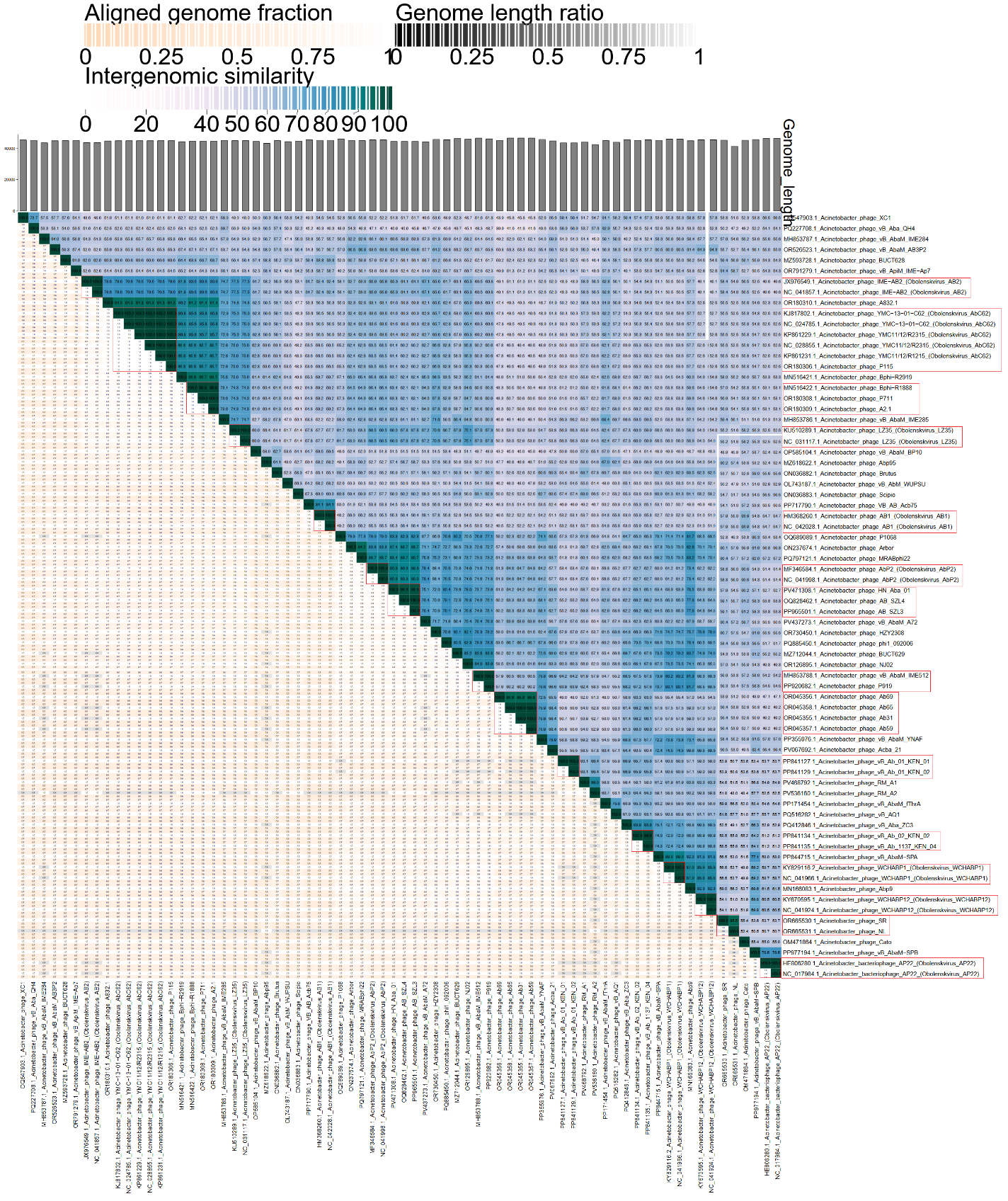

**Figure 2. ViPTree analysis*:** ViPTree analysis (https://www.genome.jp/viptree/; [4]) is based upon Rohwer and Edwards (2002) Phage Proteomic Tree [5]. The phages of interest are indicated with a **red stars**.

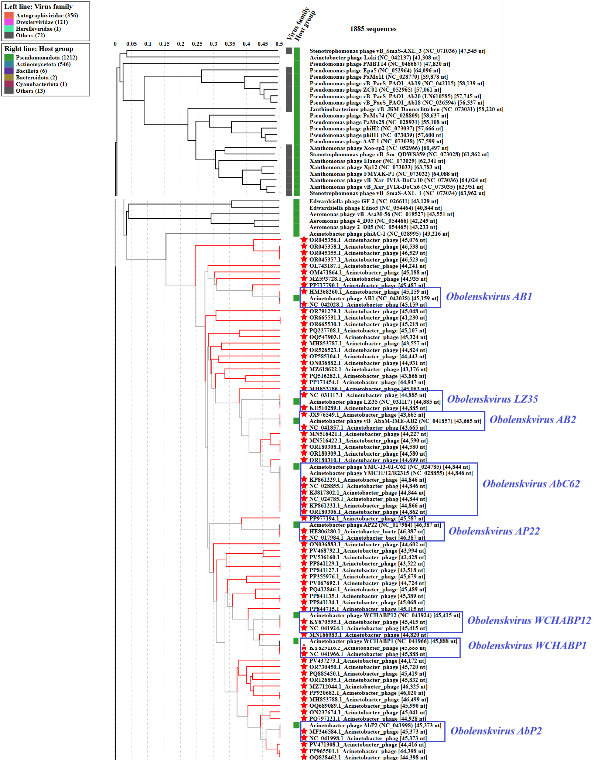

* The *Autographiviridae* family shown in **Figure 2** (automatically labeled by the software) is outdated. In 2025, the *Autographiviridae* family was elevated to the rank of order and renamed *Autographivirales*.

**Genome summary:**

|  |  |  |  |  |  |  |  |
| --- | --- | --- | --- | --- | --- | --- | --- |
| Phage name | RefSeq No. | INSDC | Size (bp) | GC% | Protein | Overall % DNA sequence identity (*) | Overall % homologous proteins (**) |
| **Acinetobacter phage AB1**  **(*Obolenskvirus AB1*; reference genome)** | **NC_042028.1** | **NC_042028** | **45,159** | **37.7** | **85** | **100.0** | **100.00** |
| Acinetobacter phage XC1 |  | OQ547903 | 45,324 | 37.4 | 84 | 54.5 | 65.88 |
| Acinetobacter phage vB_Aba_QH4 |  | PQ227708 | 45,107 | 37.3 | 84 | 49.3 | 64.71 |
| Acinetobacter phage vB_AbaM_IME284 |  | MH853787 | 43,557 | 38.3 | 84 | 55.7 | 69.41 |
| Acinetobacter phage vB_AbaM_AB3P2 |  | OR526523 | 44,824 | 37.8 | 94 | 56.7 | 69.41 |
| Acinetobacter phage BUCT628 |  | MZ593728 | 44,935 | 37.5 | 86 | 63.8 | 70.59 |
| Acinetobacter phage vB_ApiM_IME-Ap7 |  | OR791279 | 45,048 | 37.9 | 92 | 58.7 | 62.35 |
| Acinetobacter phage A832.1 |  | OR180310 | 44,699 | 37.8 | 86 | 56.3 | 67.06 |
| Acinetobacter phage Bphi-R2919 |  | MN516421 | 44,227 | 37.8 | 80 | 59.7 | 68.24 |
| Acinetobacter phage Bphi-R1888 |  | MN516422 | 44,590 | 37.9 | 78 | 59.2 | 65.88 |
| Acinetobacter phage vB_AbaM_IME285 |  | MH853786 | 45,063 | 37.9 | 85 | 52.2 | 63.53 |
| Acinetobacter phage vB_AbaM_BP10 |  | OP585104 | 44,443 | 37.3 | 88 | 59.5 | 69.41 |
| Acinetobacter phage Abp95 |  | MZ618622 | 43,176 | 37.8 | 57 | 58.2 | 50.59 |
| Acinetobacter phage Brutus |  | ON036882 | 44,931 | 37.4 | 86 | 55.1 | 68.24 |
| Acinetobacter phage vB_AbM_WUPSU |  | OL743187 | 44,241 | 37.2 | 83 | 58.2 | 64.71 |
| Acinetobacter phage Scipio |  | ON036883 | 44,602 | 37.6 | 81 | 60.0 | 65.88 |
| Acinetobacter phage VB_AB_Acb75 |  | PP717790 | 45,487 | 38.0 | 42 | 84.1 | 47.06 |
| Acinetobacter phage P1068 |  | OQ689089 | 45,990 | 37.4 | 102 | 49.2 | 64.71 |
| Acinetobacter phage Arbor |  | ON237674 | 45,041 | 37.4 | 83 | 56.0 | 65.88 |
| Acinetobacter phage MRABphi22 |  | PQ797121 | 44,928 | 37.9 | 83 | 56.2 | 65.88 |
| Acinetobacter phage HN_Aba_01 |  | PV471308 | 44,416 | 37.9 | 85 | 55.3 | 68.24 |
| Acinetobacter phage vB_AbaM_A72 |  | PV437273 | 44,172 | 37.7 | 90 | 58.1 | 64.71 |
| Acinetobacter phage HZY2308 |  | OR730450 | 45,720 | 37.9 | 87 | 57.8 | 69.41 |
| Acinetobacter phage phi1_092006 |  | PQ885450 | 45,419 | 37.6 | 101 | 55.8 | 68.24 |
| Acinetobacter phage BUCT629 |  | MZ712044 | 46,325 | 37.6 | 89 | 52.6 | 67.06 |
| Acinetobacter phage NJ02 |  | OR126895 | 45,832 | 37.9 | 86 | 54.2 | 68.24 |
| Acinetobacter phage vB_AbaM_IME512 |  | MH853788 | 46,499 | 37.6 | 91 | 53.5 | 65.88 |
| Acinetobacter phage Ab69 |  | OR045356 | 45,076 | 38.0 | 159 | 49.5 | 49.41 |
| Acinetobacter phage vB_AbaM_YNAF |  | PP355976 | 45,379 | 37.6 | 85 | 54.2 | 65.88 |
| Acinetobacter phage Acba_21 |  | PV067692 | 44,724 | 37.8 | 85 | 51.1 | 64.71 |
| Acinetobacter phage vB_Ab_01_KEN_01 |  | PP841127 | 43,518 | 37.8 | 91 | 53.2 | 64.71 |
| Acinetobacter phage RM_A1 |  | PV468792 | 43,994 | 38.0 | 84 | 53.7 | 64.71 |
| Acinetobacter phage RM_A2 |  | PV536160 | 42,428 | 37.8 | 84 | 50.3 | 58.82 |
| Acinetobacter phage vB_AbaM_fThrA |  | PP171454 | 44,947 | 37.6 | 98 | 54.8 | 68.24 |
| Acinetobacter phage vB_AQ1 |  | PQ516282 | 43,868 | 37.4 | 103 | 55.8 | 62.35 |
| Acinetobacter phage vB_Aba_ZC3 |  | PQ412846 | 45,489 | 37.3 | 88 | 53.0 | 64.71 |
| Acinetobacter phage vB_Ab_02_KEN_02 |  | PP841134 | 45,068 | 37.7 | 90 | 55.9 | 63.53 |
| Acinetobacter phage vB_AbaM-SPA |  | PP844715 | 45,115 | 37.4 | 70 | 52.7 | 57.65 |
| Acinetobacter phage Abp9 |  | MN166083 | 44,820 | 37.7 | 81 | 52.3 | 61.18 |
| Acinetobacter phage SR |  | OR665530 | 45,218 | 38.0 | 87 | 57.9 | 67.06 |
| Acinetobacter phage Cato |  | OM471864 | 45,188 | 37.4 | 85 | 63.9 | 75.29 |
| Acinetobacter phage vB_AbaM-SPB |  | PP977194 | 45,587 | 37.7 | 70 | 54.8 | 52.94 |

(*) determined using VIRIDIC [2]

(**) determined using CoreGenes 3.5 [6]