

The International Committee on Taxonomy of Viruses

Taxonomy Proposal Form, 2025

**Part 1a: Details of taxonomy proposals**

|  |  |
| --- | --- |
| **Title:** | Create one new species *Mosigvirus lindsay* (Class *Caudoviricetes*, Order *Pantevenvirales*, Family *Straboviridae*) |
| **Code assigned:** | 2025.045B.Mosigvirus_1ns | |

|  |  |  |  |  |
| --- | --- | --- | --- | --- |
| **Author(s), affiliation and email address(es):** | | | | |
| **Given name (+middle initial(s))** | **Surname** | **Affiliation** | **Email address** | **Corr. author(s)** |
| Aubrey Joy P. | Tejada | Industrial Technology Development Institute, Department of Science and Technology (DOST – ITDI), DOST Compound, Taguig, 1631, Philippines | [ajptejada@gmail.com](mailto:ajptejada@gmail.com) | X |
| Michael Angelou L. | Nada | Industrial Technology Development Institute, Department of Science and Technology (DOST – ITDI), DOST Compound, Taguig, 1631, Philippines | [mikeangelounada@gmail.com](mailto:mikeangelounada@gmail.com) |  |
| Ruth Antoinette D. | Chin | Industrial Technology Development Institute, Department of Science and Technology (DOST – ITDI), DOST Compound, Taguig, 1631, Philippines | chinruthantoinette@gmail.com |  |
| Janna Ysabelle O. | Casidsid | Industrial Technology Development Institute, Department of Science and Technology (DOST – ITDI), DOST Compound, Taguig, 1631, Philippines | jycasidsid@gmail.com |  |
| Joseph B. | Ancla | Industrial Technology Development Institute, Department of Science and Technology (DOST – ITDI), DOST Compound, Taguig, 1631, Philippines | anclajoseph8492 |  |
| Marel Jan G. | Joloro | Industrial Technology Development Institute, Department of Science and Technology (DOST – ITDI), DOST Compound, Taguig, 1631, Philippines | mgjoloro.dostvip@gmail.com |  |
| Mark Christian C. | Reterta | Industrial Technology Development Institute, Department of Science and Technology (DOST – ITDI), DOST Compound, Taguig, 1631, Philippines | mcreterta@gmail.com |  |
| Anton Roi G. | Collado | Industrial Technology Development Institute, Department of Science and Technology (DOST – ITDI), DOST Compound, Taguig, 1631, Philippines | colladoantonr@gmail.com |  |
| Sharmen C. | Berlin | Industrial Technology Development Institute, Department of Science and Technology (DOST – ITDI), DOST Compound, Taguig, 1631, Philippines | scberlin@up.edu.ph |  |
| Arra B. | Asejo | Industrial Technology Development Institute, Department of Science and Technology (DOST – ITDI), DOST Compound, Taguig, 1631, Philippines | nmry.dostvip@gmail.com |  |
| Nikka Marie R. | Yadao | Industrial Technology Development Institute, Department of Science and Technology (DOST – ITDI), DOST Compound, Taguig, 1631, Philippines | abasejo.dost@gmail.com |  |
| Virgilio Jr. P. | De Paz | Industrial Technology Development Institute, Department of Science and Technology (DOST – ITDI), DOST Compound, Taguig, 1631, Philippines | [virgdepazimperial@gmail.com](mailto:virgdepazimperial@gmail.com) |  |
| Ursela G. | Bigol | Industrial Technology Development Institute, Department of Science and Technology (DOST – ITDI), DOST Compound, Taguig, 1631, Philippines | [ugbigol@itdi.dost.gov.ph](mailto:ugbigol@itdi.dost.gov.ph) |  |
| Rommel J. | Gestuveo | Industrial Technology Development Institute, Department of Science and Technology (DOST – ITDI), DOST Compound, Taguig, 1631, Philippines | rjgestuveo@gmail.com |  |
|  |  |  |  |  |

**Part 1b: Taxonomy Proposal Submission**

|  |  |  |  |
| --- | --- | --- | --- |
| **ICTV Subcommittee:** | | | |
| Animal DNA Viruses and Retroviruses |  | Bacterial viruses | **x** |
| Animal minus-strand and dsRNA viruses |  | Fungal and protist viruses |  |
| Animal positive-strand RNA viruses |  | Plant viruses |  |
| Archaeal viruses |  | General - |  |

|  |
| --- |
| **List the ICTV Study Group(s) that have seen or have been involved in creating this proposal:** |
| Caudoviricetes Study Group |

|  |  |  |  |
| --- | --- | --- | --- |
| **Optional – complete only if formally voted on by an ICTV Study Group:** | | | |
| **Study Group** | **Number of members** | | |
| **Votes in support** | **Votes against** | **No vote** |
|  |  |  |  |
|  |  |  |  |

|  |  |
| --- | --- |
| **Submission date:** | 12/04/2025 |

**Part 1c: Feedback from ICTV Executive Committee (EC) meeting**

|  |  |
| --- | --- |
| **Executive Committee Meeting Decision code:** | **X** |
| A – Accept |  |
| Ac – Accept subject to revision by relevant subcommittee chair. No further vote required |  |
| U – Accept without revision but with re-evaluation and email vote by the EC |  |
| Uc – Accept subject to revision and re-evaluation and email vote by the EC |  |
| Ud – Deferred to the next EC meeting, with an invitation to revise based on EC comments |  |
| J - Reject |  |
| W - Withdrawn |  |

|  |
| --- |
| **Comments from the Executive Committee:** |
|  |

**Part 1d: Revised Taxonomy Proposal Submission**

|  |
| --- |
| **Response of proposer:** |
|  |

|  |  |
| --- | --- |
| **Revision date:** |  |

**Part 3:** **TAXONOMIC PROPOSAL**

<https://ictv.global/taxonomy/templates>

|  |  |  |  |
| --- | --- | --- | --- |
| **Taxonomic changes proposed:** | | | |
| Establish new taxon | **X** | Split taxon |  |
| Abolish taxon |  | Merge taxon |  |
| Move taxon |  | Promote taxon |  |
| Rename taxon |  | Demote taxon |  |
| Move and rename |  |

|  |  |
| --- | --- |
| **Etymology (origin) of proposed taxonomic names:** | |
| **Taxon name** | **Etymology of the term** |
| *Mosigvirus lindsay* | From the first name of Lindsay Sydney Fajardo |

|  |  |  |
| --- | --- | --- |
| **Permission for use of names derived from a living person:** | | |
| **Taxon name** | **Full name of person from whom the name is derived** | **Attached** |
| *Mosigvirus lindsay* | Lindsay Sydney Fajardo | deceased |

|  |
| --- |
| **Abstract of Taxonomy Proposal:** |
| ***Taxonomic rank(s) affected*:**  Realms *Duplodnaviria*, Kingdom H*eunggongvirae*, Phylum *Uroviricota*, Class *Caudoviricetes*, Order *Pantevenvirales*, Family *Straboviridae*, Subfamily *Tevenvirinae*, Genus *Mosigvirus*  *Description of current taxonomy*:  The genus *Mosigvirus* currently includes 13 ICTV listed species.  *Proposed* *taxonomic change(s):*  Create one new species, “*Mosigvirus lindsay”*  *Justification*:  Escherichia phage vB_VIPECOMC06 was isolated from Masalasa Creek, Tarlac, Philippines. The genome is complete with direct terminal repeats based on an analysis with checkV [1] and is publicly available in NCBI Genbank database. Comparison to members of the genus *Mosigvirus* using VIRIDIC indicates that vB_VIPECOMC06 represents a new species in the genus., |

|  |
| --- |
| **Text of Taxonomy proposal:** The Escherichia phage vB_VIPECOMC06 was isolated from Masalasa Creek, Tarlac, Philippines. Our  taxonomic analyses revealed that Escherichia phage vB_VIPECOMC06 remain unclassified at the  species level. Here, we proposed the creation of a new species, *Mosigvirus lindsay,* under theRealms *Duplodnaviria*, Kingdom H*eunggongvirae*, Phylum *Uroviricota*, Class *Caudoviricetes*, Order *Pantevenvirales*, Family *Straboviridae*, Subfamily *Tevenvirinae*, Genus *Mosigvirus.* The genome is complete with DTR based on checkV [1] analysis and is publicly available in NCBI Genbank database. |
| ***Taxonomic rank(s) affected*:**  Realms *Duplodnaviria*, Kingdom H*eunggongvirae*, Phylum *Uroviricota*, Class *Caudoviricetes*, Order *Pantevenvirales*, Family *Straboviridae*, Subfamily *Tevenvirinae*, Genus *Mosigvirus*  ***Description of current taxonomy*:**  The genus *Mosigvirus* currently includes 13 ICTV listed species.  ***Proposed* *taxonomic change(s)*:**  Create a new species, *Mosigvirus lindsay*  ***Demarcation criteria:***  Species demarcation criteria: A demarcation value of 95% intergenomic similarity was used to define different species according to intergenomic similarity. Members of the same species have >95% intergenomic similarity.  *Justification*:  As a result of detailed genomic characterization using VIRIDIC (Figure 1), we propose the addition of new species, *Mosigvirus lindsay.* The species is named in honor of Lindsay Sydney Fajardo, the late Chief Project Technical Specialist of the Virology and Vaccine Institute of the Philippines (VVIP) Program, who passed away on October 17, 2024. Chief Fajardo's significant contributions were instrumental to the success of the VVIP. This species is dedicated as a tribute to her invaluable support and lasting impact on our team. |

|  |
| --- |
| **References:** |
| 1. Nayfach, S., Camargo, A. P., Schulz, F., Eloe-Fadrosh, E., Roux, S., & Kyrpides, N. C. (2021). CheckV assesses the quality and completeness of metagenome-assembled viral genomes. *Nature biotechnology*, *39*(5), 578-585. 2. Turner, D., Kropinski, A. M., & Adriaenssens, E. M. (2021). A roadmap for genome-based phage taxonomy. *Viruses*, *13*(3), 506. 3. Millard, A. D., Denise, R., Lestido, M., Thomas, M., Webster, D., Turner, D., & Sicheritz-Ponten, T. (2024). taxmyPHAGE: Automated taxonomy of dsDNA phage genomes at the genus and species. *bioRxiv*, 2024-08. 4. Nishimura, Y., Yoshida, T., Kuronishi, M., Uehara, H., Ogata, H., & Goto, S. (2017). ViPTree: the viral proteomic tree server. *Bioinformatics*, *33*(15), 2379-2380. 5. Moraru, C. (2023). VirClust—A tool for hierarchical clustering, core protein detection and annotation of (prokaryotic) viruses. *Viruses*, *15*(4), 1007. 6. Ondov, B. D., Treangen, T. J., Melsted, P., Mallonee, A. B., Bergman, N. H., Koren, S., & Phillippy, A. M. (2016). Mash: fast genome and metagenome distance estimation using MinHash. *Genome biology*, *17*, 1-14. 7. Cook, R., Brown, N., Redgwell, T., Rihtman, B., Barnes, M., Clokie, M., ... & Millard, A. (2021). INfrastructure for a PHAge REference database: identification of large-scale biases in the current collection of cultured phage genomes. *Phage*, *2*(4), 214-223. 8. Moraru, C., Varsani, A., & Kropinski, A. M. (2020). VIRIDIC—A novel tool to calculate the intergenomic similarities of prokaryote-infecting viruses. *Viruses*, *12*(11), 1268. 9. Tamura, K., Stecher, G., & Kumar, S. (2021). MEGA11: molecular evolutionary genetics analysis version 11. *Molecular biology and evolution*, *38*(7), 3022-3027. 10. Edgar, R. C. (2004). MUSCLE: multiple sequence alignment with high accuracy and high throughput. *Nucleic acids research*, *32*(5), 1792-1797. |

|  |  |
| --- | --- |
| **Accompanying files:** | |
| **Filename** | **Description of contents** |
| *Mosigvirus_1ns_v3*.xlsx | An excel file containing the taxonomic classification for new species |
|  |  |

|  |
| --- |
| **Tables, Figures:** |

<Start here>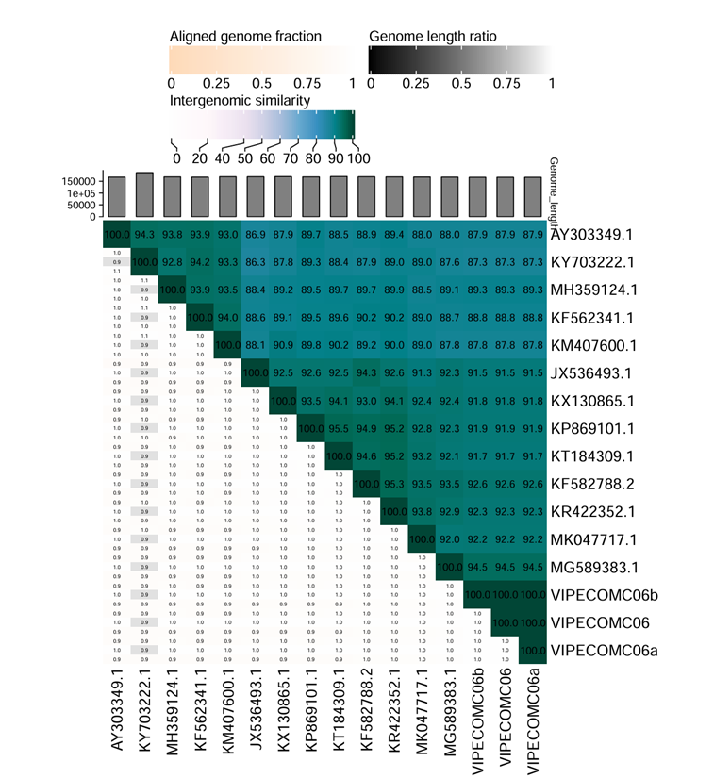Figure 1. Heatmap of intergenomic similarities between Escherichia phage VIPECOM06 and members of the genus *Mosigvirus*.