

The International Committee on Taxonomy of Viruses
Taxonomy Proposal Form, 2025

Part 1a: Details of taxonomy proposals

Title: | Revision of the microvirus taxonomy
Code assigned: | 2025.043B.Ac.v3.Microviricetes

Author(s), affiliation and email address(es):
Given name (+middle initial(s)) | Surname | Affiliation | Email address | Corr. author(s)
Cristina | Moraru | Institute for Chemistry and Biology of the Marine Environment, Carl-von-Ossietzky-Str. 9-11, 26111 Oldenburg, Germany | lilianacristina.moraru@uni-due.de
Paul | Kirchberger | Department of Microbiology & Molecular Genetics, Oklahoma State University, US | paul.kirchberger@okstate.edu
Simon | Roux | Department of Energy - Joint Genome Institute. Lawrence Berkeley National Laboratory, 1 Cyclotron Road, Berkeley, CA 94720, United States | sroux@lbl.gov
Arvind | Varsani | The Biodesign Center for Fundamental and Applied Microbiomics, Center for Evolution and Medicine, School of Life Sciences, Arizona State University, 1001 S. McAllister Ave, Tempe, AZ 85287-5001, USA | Arvind.Varsani@asu.edu
Mart | Krupovic | Institut Pasteur, Université Paris Cité, CNRS UMR6047, Archaeal Virology Unit, 25 rue du Dr Roux, 75015 Paris, France | mart.krupovic@pasteur.fr
Eric | Olo Ndela | Department of Energy - Joint Genome Institute. Lawrence Berkeley National Laboratory, 1 Cyclotron Road, Berkeley, CA 94720, United States | eolondela@lbl.gov
Francois | Enault | LMGE, UMR CNRS 6023, Clermont-Ferrand, France | francois.enault@uca.fr | X

Part 1b: Taxonomy Proposal Submission
ICTV Subcommittee:
Animal DNA Viruses and Retroviruses |  | Bacterial viruses | X
Animal minus-strand and dsRNA viruses |  | Fungal and protist viruses
Animal positive-strand RNA viruses |  | Plant viruses
Archaeal viruses |  | General -

List the ICTV Study Group(s) that have seen or have been involved in creating this proposal: https://ictv.global/sc

Microviridae Study Group

Optional – complete only if formally voted on by an ICTV Study Group:
Study Group | Number of members
 | Votes in support | Votes against | No vote

Submission date: | 20/06/2025

Part 1c: Feedback from ICTV Executive Committee (EC) meeting
Executive Committee Meeting Decision code: | X
A – Accept
Ac – Accept subject to revision by relevant subcommittee chair. No further vote required | x
U – Accept without revision but with re-evaluation and email vote by the EC
Uc – Accept subject to revision and re-evaluation and email vote by the EC
Ud – Deferred to the next EC meeting, with an invitation to revise based on EC comments
J - Reject
W - Withdrawn

Comments from the Executive Committee:
Can you make the description of the current taxonomy more succinct? There is no need to list all species names.

Part 1d: Revised Taxonomy Proposal Submission
Response of proposer:
The description of the current taxonomy has been modified, listing only the single family, the two subfamilies, and the seven genera

Revision date: | 29/08/2025

Part 3: TAXONOMIC PROPOSAL
https://ictv.global/taxonomy/templates
Taxonomic changes proposed:
Establish new taxon | X | Split taxon
Abolish taxon |  | Merge taxon
Move taxon | X | Promote taxon
Rename taxon |  | Demote taxon
Move and rename

Etymology (origin) of proposed taxonomic names:
Taxon name | Etymology of the term
Amoyvirales | from the romanized name of Xiamen University where the first virus of this group was isolated
Alpavirales | Meaning small in Sanskrit
Gokushovirales | Already existing
Reekeekeevirales | Meaning small in french
Roodoodoovirales | Meaning small sweet in french
Bullavirales | Already existing
Secretvirales | Contains “Tainaviridae” and “Occultatumviridae”, termed according to ‘secret’ and ‘hidden’
Kidogoviridae | Small in Swahili (Kenya,Uganda, Tanzania)
Osikeviridae | Small in Molengue (Equatorial Guinea, Gabon)
Chicoviridae | Small in Spanish
Pequenoviridae | Small in Spanish
Pichoviridae | Small in Occitan
Piccoloviridae | Small in Italian
Pieniviridae | Small in Finnish
Pikkuviridae | Small in Finnish
Piticuviridae | Small in Sardinian
Lilleviridae | Small in Danish
Litenviridae | Small in Norwegian
Litilviridae | Small in Islandic
Mazaviridae | Small in Lithuanian
Alphagokushoviridae | Subdivision of the “Gokushovirales”
Betagokushoviridae | Subdivision of the “Gokushovirales”
Sukshmaviridae | Meaning small in Sanskrit
Groupodiviridae | A clade initially named GroupD
Eubullaviridae | The previously established Bullaviridae family (Eu for True)
Liberviridae | A group whose representative virus infect Liberibacter
Tainaviridae | Meaning “secret” in Romanian, inside the “Secretvirales” a group of virus discovered lately
Occultatumviridae | Meaning “hidden” in Latin, inside the “Secretvirales” a group of virus discovered lately

Permission for use of names derived from a living person:
Taxon name | Full name of person from whom the name is derived | Attached

Abstract of Taxonomy Proposal:
Taxonomic rank(s) affected:
Class, order, family, subfamily, genus, species

Description of current taxonomy:
Phylum Phixviricota currently includes a monotypic family Microviridae with two subfamilies (Bullavirinae and Gokushovirinae).

Proposed taxonomic change(s):
We propose to elevate family Microviridae to the level of a class, the “Microviricetes”, within phylum Sangervirae (realm Monodnaviria). Inside this new class, we propose seven orders and 21 families. We also propose to abolish the subfamilies Gokushovirinae and Bullavirinae

Justification:
Metagenomic studies from the past decade have revealed many new microvirus genomes across ecosystems. Phylogenetic assessment confirmed that the established taxonomic structure of two existing subfamilies of Microviridae cannot adequately represent the diversity of this viral group. Thus, we propose a reorganization of the established taxonomy of microviruses by assessing the relationships between 21 previously classified and 137 new representative complete microvirus genome sequences obtained from either cultivated viruses or from metagenomic datasets. Orders and families were defined by their separation on the major capsid protein phylogeny.

- Text of Taxonomy proposal:

Taxonomic rank(s) affected:
Class, order, family, subfamily, genus, species

Description of current taxonomy:
The phylum Phixviricota includes bacterial viruses classified in the class Malgrandaviricetes, order Petitvirales and a single family, Microviridae. The family includes two subfamilies, the Bullavirinae and Gokushovirinae, and seven genera.

Proposed taxonomic change(s):
- Abolish species Bdellovibrio virus MAC1 in the genus Bdellomicrovirus as there is no associated sequence associated with this in GenBank.
- Abolish the family Microviridae
- Abolish the subfamilies Gokushovirinae and Bullavirinae
- Establish a new class “Microviricetes“
- Establish seven new orders :
  - “Alpavirales“
  - “Amoyvirales“
  - “Bullavirales“
  - “Gokushovirales“
  - “Reekeekeevirales“
  - “Roodoodoovirales“
  - “Secretvirales“

A summary of the new taxonomy in the class “Microviricetes“ is provided in table 1

Demarcation criteria:
Species and genus demarcation criteria
No established species and genus demarcation criteria were previously defined. Thus, here we used thresholds for the VIRIDIC intergenomic scores of 80 and 50 for species and genus demarcations, respectively (Moraru et al. 2020). Considering the 158 genomes (from 21 previously classified viruses + 137 new viruses), a total of 131 species and 115 genera were proposed and named.

Justification
Elevation of family Microviridae to class “Microviricetes”, with seven orders and 21 families
Microviridae is an iconic virus family which includes bacteriophages with single-stranded DNA (ssDNA) genomes and small icosahedral capsids. The best known representative of the family is Escherichia coli bacteriophage phiX174, whose genome was the first DNA-based genome to be sequenced. Currently, the family includes 22 species, which are distributed into 7 genera, within 2 subfamilies. However, during the past 10 years, thousands of complete genomes of microviruses have been sequenced, primarily using metagenomics approaches. This vastly expanded diversity of microviruses is associated with a wide range of bacterial hosts, spanning multiple phyla, highlighting their diversity, likely ancient origin and importance across ecosystems. However, all of these viruses remain unclassified.
Comparison of the genome and protein sequences of microviruses showed that the single family Microviridae is insufficient to adequately reflect the evolutionary relationships among microviruses (Roux et al. 2012; Wang et al. 2019; Kirchberger et al. 2022). Thus, we propose here the reorganization and elevation of the current family Microviridae to the rank of a class, which we propose naming “Microviricetes”, within the phylum Phixviricota and kingdom Sangervirae.

To establish a new taxonomic framework for the classification of microviruses, genomes of microviruses were identified in GenBank and retained if associated with a publication. Recent isolates were also retrieved. The final dataset consisted of 158 genomes, including 137 new complete microvirus genomes (circular and encoding the characteristic capsid and replication proteins) and 21 genomes of already classified microviruses. The two proteins conserved in all microviruses, namely, major capsid protein (MCP) and replication-initiation protein (Rep), were considered as markers for establishing the taxonomic framework. Even though preliminary tests revealed the overall congruency between phylogenies of the two core proteins, cases of potential incongruence were identified, suggesting occasional recombination. Furthermore, individual MCP phylogeny and phylogeny based on the concatenated alignment of the MCP and Rep yielded largely congruent results. Thus, to avoid potential artefacts due to recombination, we decided to base the taxonomic framework on the MCP alone. Based on this phylogeny, seven major MCP clades were identified (Figure 1). We propose assigning microviruses from these seven clades to order level taxa (Table 1).

To ascertain that the proposed taxonomic framework can withstand influx of additional microvirus genomes, we mined the GenBank and IMG/VR4 databases for additional microvirus genomes and repeated the phylogenetic analysis with the expanded dataset. Despite massive expansion of the dataset (from 158 to 1065 genomes), the seven order-level groups remained stable and monophyletic. Analysis of the topologies of the order-specific trees allowed us to further delineate 21 well-supported monophyletic clades, which we define as families (Table 1, Figures 2-6). Notably, as described in Kirchberger et al. 2022, the genomic architecture and gene content are also congruent with the MCP-based phylogeny.

To define species and genera within the 21 proposed families, we used thresholds for the VIRIDIC intergenomic scores of 80 and 50, respectively. Considering the 158 genomes (from 21 previously classified viruses + 137 new viruses), a total of 131 species and 115 genera were proposed (Figure 1).

Notably, the two previously established subfamilies of the Microviridae, namely, Bullavirinae and Gokushovirinae, were elevated to order level taxa, “Bullavirales“ and “Gokushovirales”, respectively. Furthermore, using the new species and genus demarcation criteria, the four existing species in the Chlamydiamicrovirus genus (Chlamydiamicrovirus Chp1, Chlamydiamicrovirus Chp2, Chlamydiamicrovirus CPAR39 and Chlamydiamicrovirus CPG1) were separated into two new genera, “Chlamydiaunovirus” (Chlamydiamicrovirus Chp1) and “Chlamydiaduovirus” (Chlamydiamicrovirus Chp2, Chlamydiamicrovirus CPAR39 and Chlamydiamicrovirus CPG1).

To sum up, based on the comprehensive phylogenetic and comparative genomics analysis of the 158 reference genomes, the class “Microviricetes” is proposed to comprise seven distinct orders, with 21 families, 115 genera and 131 species.

Genus and species name generation
The generation of genus names for the 108 proposed genera and of the latinized binomial virus species names were performed by using locations, source or host of the representative virus, following the previously proposed guidelines (Postler et al. 2022). The proposed taxon names were checked against the ICTV Species Master List 2024.v1 to ensure the uniqueness of the name word stems.
References:
Kirchberger PC, Martinez ZA, Ochman H. Organizing the Global Diversity of Microviruses. mBio. 2022;13(3):e0058822. doi: 10.1128/mbio.00588-22.
Moraru C, Varsani A, Kropinski AM. VIRIDIC—A Novel Tool to Calculate the Intergenomic Similarities of Prokaryote-Infecting Viruses. Viruses 2020, 12, 1268. https://doi.org/10.3390/v12111268
Postler TS, Rubino L, Adriaenssens EM, Dutilh BE, Harrach B, Junglen S, Kropinski AM, Krupovic M, Wada J, Crane A, Kuhn JH, Mushegian A, Rūmnieks J, Sabanadzovic S, Simmonds P, Varsani A, Zerbini FM, Callanan J, Draper LA, Hill C, Stockdale SR. Guidance for creating individual and batch latinized binomial virus species names. J Gen Virol. 2022 ;103(12):001800. doi: 10.1099/jgv.0.001800.
Roux S, Krupovic M, Poulet A, Debroas D, Enault F. Evolution and diversity of the Microviridae viral family through a collection of 81 new complete genomes assembled from virome reads. PLoS One. 2012;7(7):e40418. doi: 10.1371/journal.pone.0040418.
Wang H, Ling Y, Shan T, Yang S, Xu H, Deng X, Delwart E, Zhang W. Gut virome of mammals and birds reveals high genetic diversity of the family Microviridae. Virus Evol. 2019 Jun 8;5(1):vez013. doi: 10.1093/ve/vez013.

Accompanying files:
Filename | Description of contents
Microviricetes.pdf

Tables, Figures:
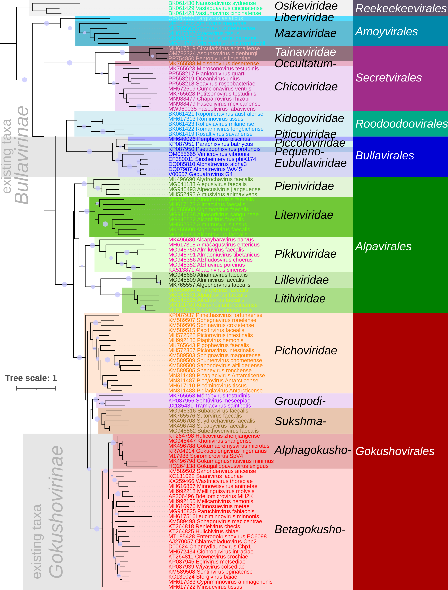
Figure 1 : Phylogeny of the capsid protein for one representative for all genera proposed here. All proposed orders and families here displayed. Multiple sequence alignment was produced by MAFFT, trimmed with Trimal (-gappyout option) and used to generate the Maximum likelihood phylogenetic tree using iqtree2 with the best model selection (with the option -alrt 1000). Branches supported by SH-aLRT>90 are indicated by circles. The same approach was used for generating phylogenies shown in all other figures.
Table 1: Summary of the viruses classified in the order Microviricetes
class | order | family | genus | species | Representative genome accession
Microviricetes | Alpavirales | Lilleviridae | Algophervirus | Algophervirus faecalis | MK765557
Microviricetes | Alpavirales | Lilleviridae | Alnafnavirus | Alnafnavirus faecalis | MG945680
Microviricetes | Alpavirales | Lilleviridae | Alnifnivirus | Alnifnivirus faecalis | MG945509
Microviricetes | Alpavirales | Litenviridae | Alcanfavirus | Alcanfavirus faecalis | MG945253
Microviricetes | Alpavirales | Litenviridae | Alcanivirus | Alcanivirus faecalis | MG945572
Microviricetes | Alpavirales | Litenviridae | Algomorvirus | Algomorvirus faecalis | MK765608
Microviricetes | Alpavirales | Litenviridae | Algopmovirus | Algopmovirus faecalis | MK765590
Microviricetes | Alpavirales | Litenviridae | Alimacvirus | Alimacvirus faecalis | MH617173
Microviricetes | Alpavirales | Litenviridae | Almumusvirus | Almumusvirus tissus | MH552557
Microviricetes | Alpavirales | Litenviridae | Alnoufnouvirus | Alnoufnouvirus faecalis | MG945831
Microviricetes | Alpavirales | Litenviridae | Alpecorivirus | Alpecorivirus sanguineae | MG945638
Microviricetes | Alpavirales | Litilviridae | Alcafavirus | Alcafavirus faecalis | MG945515
Microviricetes | Alpavirales | Litilviridae | Alciorovirus | Alciorovirus intestinalis | MH572526
Microviricetes | Alpavirales | Litilviridae | Alcryvirus | Alcryvirus antarcticaense | MN311493
Microviricetes | Alpavirales | Litilviridae | Alhyhydvirus | Alhyhydvirus faecalis | MK496694
Microviricetes | Alpavirales | Litilviridae | Alpaglavirus | Alpaglavirus faecalis | MG945641
Microviricetes | Alpavirales | Pieniviridae | Alepusivirus | Alepusivirus faecalis | MG641188
Microviricetes | Alpavirales | Pieniviridae | Almusivirus | Almusivirus animavivens | MH552492
Microviricetes | Alpavirales | Pieniviridae | Alpecusivirus | Alpecusivirus jiangsuense | MG945493
Microviricetes | Alpavirales | Pieniviridae | Alydrochavirus | Alydrochavirus faecalis | MK496690
Microviricetes | Alpavirales | Pikkuviridae | Alcapybaravirus | Alcapybaravirus parvus | MK496680
Microviricetes | Alpavirales | Pikkuviridae | Almacaqusvirus | Almacaqusvirus entericus | MH617318
Microviricetes | Alpavirales | Pikkuviridae | Almaoniuvirus | Almaoniuvirus tibetanicus | MG945791
Microviricetes | Alpavirales | Pikkuviridae | Almiluvirus | Almiluvirus faecalis | MG945750
Microviricetes | Alpavirales | Pikkuviridae | Alpacinvirus | Alpacinvirus sinensis | KX513871
Microviricetes | Alpavirales | Pikkuviridae | Alzhudosvirus | Alzhudosvirus choerus | MG945356
Microviricetes | Alpavirales | Pikkuviridae | Alzhuvirus | Alzhuvirus porcinus | MG945352
Microviricetes | Amoyvirales | Liberviridae | Largivirus | Largivirus asiaticus | CP045566
Microviricetes | Amoyvirales | Mazaviridae | Aminivirus | Aminivirus ruegeriae | MF101922
Microviricetes | Amoyvirales | Mazaviridae | Avacavirus | Avacavirus tissus | MH617327
Microviricetes | Amoyvirales | Mazaviridae | Minimarinivirus | Minimarinivirus citromicrobii | MG214764
Microviricetes | Amoyvirales | Mazaviridae | Piticivirus | Piticivirus americanense | MN988485
Microviricetes | Amoyvirales | Mazaviridae | Sonoravirus | Sonoravirus desertense | MK765605
Microviricetes | Bullavirales | Eubullaviridae | Alphatrevirus | Alphatrevirus alpha3 | DQ085810
Microviricetes | Bullavirales | Eubullaviridae | Alphatrevirus | Alphatrevirus ID21 | DQ079870
Microviricetes | Bullavirales | Eubullaviridae | Alphatrevirus | Alphatrevirus ID32 | DQ079871
Microviricetes | Bullavirales | Eubullaviridae | Alphatrevirus | Alphatrevirus ID62 | DQ079876
Microviricetes | Bullavirales | Eubullaviridae | Alphatrevirus | Alphatrevirus NC28 | DQ079875
Microviricetes | Bullavirales | Eubullaviridae | Alphatrevirus | Alphatrevirus NC29 | DQ079879
Microviricetes | Bullavirales | Eubullaviridae | Alphatrevirus | Alphatrevirus NC35 | DQ079872
Microviricetes | Bullavirales | Eubullaviridae | Alphatrevirus | Alphatrevirus phiK | X60323
Microviricetes | Bullavirales | Eubullaviridae | Alphatrevirus | Alphatrevirus St1 | GQ149088
Microviricetes | Bullavirales | Eubullaviridae | Alphatrevirus | Alphatrevirus WA45 | DQ079874
Microviricetes | Bullavirales | Eubullaviridae | Gequatrovirus | Gequatrovirus G4 | V00657
Microviricetes | Bullavirales | Eubullaviridae | Gequatrovirus | Gequatrovirus ID52 | DQ079877
Microviricetes | Bullavirales | Eubullaviridae | Gequatrovirus | Gequatrovirus talmos | DQ079869
Microviricetes | Bullavirales | Eubullaviridae | Sinsheimervirus | Sinsheimervirus phiX174 | EF380011
Microviricetes | Bullavirales | Eubullaviridae | Vimicrovirus | Vimicrovirus vibrionis | OK338687
Microviricetes | Bullavirales | Pequenoviridae | Pseudophixvirus | Pseudophixvirus profundis | KP087950
Microviricetes | Bullavirales | Piccoloviridae | Paraphixvirus | Paraphixvirus bathycus | KP087951
Microviricetes | Bullavirales | Piticuviridae | Periphixvirus | Periphixvirus piscinus | MH649026
Microviricetes | Gokushovirales | Alphagokushoviridae | Gokucipiengivirus | Gokucipiengivirus nigerianus | KR704914
Microviricetes | Gokushovirales | Alphagokushoviridae | Gokugallopavovirus | Gokugallopavovirus exiguus | HQ264138
Microviricetes | Gokushovirales | Alphagokushoviridae | Gokumacromysvirus | Gokumacromysvirus microtus | MK496788
Microviricetes | Gokushovirales | Alphagokushoviridae | Gokumagnusmusvirus | Gokumagnusmusvirus minimus | MK496798
Microviricetes | Gokushovirales | Alphagokushoviridae | Huficovirus | Huficovirus zhenjiangense | KT264798
Microviricetes | Gokushovirales | Alphagokushoviridae | Khonivirus | Khonivirus shangense | MG945447
Microviricetes | Gokushovirales | Alphagokushoviridae | Spiromicrovirus | Spiromicrovirus SpV4 | M17988
Microviricetes | Gokushovirales | Betagokushoviridae | Bdellomicrovirus | Bdellomicrovirus MH2K | AY769964
Microviricetes | Gokushovirales | Betagokushoviridae | Chlamydiaduovirus | Chlamydiaduovirus Chp2 | AJ270057
Microviricetes | Gokushovirales | Betagokushoviridae | Chlamydiaduovirus | Chlamydiaduovirus CPAR39 | AE002163
Microviricetes | Gokushovirales | Betagokushoviridae | Chlamydiaduovirus | Chlamydiaduovirus CPG1 | U41758
Microviricetes | Gokushovirales | Betagokushoviridae | Chlamydiaunovirus | Chlamydiaunovirus Chp1 | D00624
Microviricetes | Gokushovirales | Betagokushoviridae | Cionrobuvirus | Cionrobuvirus intraciae | MH572434
Microviricetes | Gokushovirales | Betagokushoviridae | Crownevirus | Crownevirus crochiae | KT264811
Microviricetes | Gokushovirales | Betagokushoviridae | Cypriminnovirus | Cypriminnovirus animagenonis | MH617083
Microviricetes | Gokushovirales | Betagokushoviridae | Eelrivirus | Eelrivirus metsediae | KP087945
Microviricetes | Gokushovirales | Betagokushoviridae | Enterogokushovirus | Enterogokushovirus EC6098 | MT185428
Microviricetes | Gokushovirales | Betagokushoviridae | Hulichivirus | Hulichivirus shiae | KT264825
Microviricetes | Gokushovirales | Betagokushoviridae | Leuciminnovirus | Leuciminnovirus minnonis | MH617516
Microviricetes | Gokushovirales | Betagokushoviridae | Mellcarnivirus | Mellcarnivirus hemonis | MH992155
Microviricetes | Gokushovirales | Betagokushoviridae | Melllinguisvirus | Melllinguisvirus molysis | MH992218
Microviricetes | Gokushovirales | Betagokushoviridae | Minnosuevirus | Minnosuevirus metae | MH616976
Microviricetes | Gokushovirales | Betagokushoviridae | Minnowtisvirus | Minnowtisvirus animetae | MH616867
Microviricetes | Gokushovirales | Betagokushoviridae | Minsuevirus | Minsuevirus tissus | MH617722
Microviricetes | Gokushovirales | Betagokushoviridae | Paruchinvirus | Paruchinvirus fabiaonis | MG945835
Microviricetes | Gokushovirales | Betagokushoviridae | Renleivirus | Renleivirus checis | KT264818
Microviricetes | Gokushovirales | Betagokushoviridae | Saanivirus | Saanivirus lacunae | KC131022
Microviricetes | Gokushovirales | Betagokushoviridae | Sahondenvirus | Sahondenvirus ancense | KM589502
Microviricetes | Gokushovirales | Betagokushoviridae | Sbenevirus | Sbenevirus ronchense | KM589505
Microviricetes | Gokushovirales | Betagokushoviridae | Shuntenvirus | Shuntenvirus chomettense | KM589509
Microviricetes | Gokushovirales | Betagokushoviridae | Sontinvirus | Sontinvirus epinatense | KM589508
Microviricetes | Gokushovirales | Betagokushoviridae | Sphagnuvirus | Sphagnuvirus macicentrae | KM589498
Microviricetes | Gokushovirales | Betagokushoviridae | Sphignavirus | Sphignavirus magoutense | KM589503
Microviricetes | Gokushovirales | Betagokushoviridae | Storgivirus | Storgivirus baiae | KC131024
Microviricetes | Gokushovirales | Betagokushoviridae | Wastmicvirus | Wastmicvirus thoreclae | KX259466
Microviricetes | Gokushovirales | Betagokushoviridae | Wiyavirus | Wiyavirus colsediae | KP087939
Microviricetes | Gokushovirales | Groupodiviridae | Mohgevirus | Mohgevirus testudinis | MK765653
Microviricetes | Gokushovirales | Groupodiviridae | Sehtuvirus | Sehtuvirus meseepiae | KP087956
Microviricetes | Gokushovirales | Groupodiviridae | Tramlacvirus | Tramlacvirus saintpetis | JX185431
Microviricetes | Gokushovirales | Pichoviridae | Pacdirvirus | Pacdirvirus facealis | KM589515
Microviricetes | Gokushovirales | Pichoviridae | Piapivirus | Piapivirus hemonis | MH992186
Microviricetes | Gokushovirales | Pichoviridae | Picaglacivirus | Picaglacivirus Antarcticense | MN311489
Microviricetes | Gokushovirales | Pichoviridae | Picionavirus | Picionavirus intestinalis | MH572367
Microviricetes | Gokushovirales | Pichoviridae | Piciorovirus | Piciorovirus intestinalis | MH572522
Microviricetes | Gokushovirales | Pichoviridae | Picominovirus | Picominovirus tissus | MH617110
Microviricetes | Gokushovirales | Pichoviridae | Picryovirus | Picryovirus Antarcticense | MN311487
Microviricetes | Gokushovirales | Pichoviridae | Piglaglavirus | Piglaglavirus Antarcticense | MN311488
Microviricetes | Gokushovirales | Pichoviridae | Pigophevirus | Pigophevirus faecalis | MK765643
Microviricetes | Gokushovirales | Pichoviridae | Pimethasivirus | Pimethasivirus fortunaense | KP087937
Microviricetes | Gokushovirales | Pichoviridae | Sahondevirus | Sahondevirus altiligeriense | KM589500
Microviricetes | Gokushovirales | Pichoviridae | Sphegnavirus | Sphegnavirus ronelense | KM589507
Microviricetes | Gokushovirales | Pichoviridae | Sphinavirus | Sphinavirus crozetense | KM589506
Microviricetes | Gokushovirales | Sukshmaviridae | Subabevirus | Subabevirus faecalis | MG945316
Microviricetes | Gokushovirales | Sukshmaviridae | Subethovenvirus | Subethovenvirus faecalis | MG945562
Microviricetes | Gokushovirales | Sukshmaviridae | Sucapyvirus | Sucapyvirus faecalis | MK496748
Microviricetes | Gokushovirales | Sukshmaviridae | Sutorvirus | Sutorvirus faecalis | MK765576
Microviricetes | Gokushovirales | Sukshmaviridae | Suydrochavirus | Suydrochavirus faecalis | MK496708
Microviricetes | Reekeekeevirales | Osikeviridae | Nanosedivirus | Nanosedivirus sydnense | BK061430
Microviricetes | Reekeekeevirales | Osikeviridae | Vastaquavirus | Vastaquavirus cincinatense | BK061429
Microviricetes | Reekeekeevirales | Osikeviridae | Vastumavirus | Vastumavirus cincinatense | BK061428
Microviricetes | Roodoodoovirales | Kidogoviridae | Rofluviavirus | Rofluviavirus milanense | BK061423
Microviricetes | Roodoodoovirales | Kidogoviridae | Romarinivirus | Romarinivirus longbichense | BK061422
Microviricetes | Roodoodoovirales | Kidogoviridae | Rominovirus | Rominovirus tissus | MH617313
Microviricetes | Roodoodoovirales | Kidogoviridae | Roporiferavirus | Roporiferavirus australense | BK061421
Microviricetes | Roodoodoovirales | Kidogoviridae | Rosaltivirus | Rosaltivirus savanense | BK061419
Microviricetes | Secretvirales | Chicoviridae | Chaparrovirus | Chaparrovirus phaseoli | MN988464
Microviricetes | Secretvirales | Chicoviridae | Chaparrovirus | Chaparrovirus rhizobi | MN988477
Microviricetes | Secretvirales | Chicoviridae | Chaparrovirus | Chaparrovirus tepoztlanense | MN988476
Microviricetes | Secretvirales | Chicoviridae | Cumcionavirus | Cumcionavirus ventris | MH572519
Microviricetes | Secretvirales | Chicoviridae | Faseolivirus | Faseolivirus fabavivens | MW960035
Microviricetes | Secretvirales | Chicoviridae | Faseolivirus | Faseolivirus mexicanense | MN988460
Microviricetes | Secretvirales | Chicoviridae | Microsonovirus | Microsonovirus testudinis | MK765623
Microviricetes | Secretvirales | Chicoviridae | Oceanivirus | Oceanivirus unius | PP558219
Microviricetes | Secretvirales | Chicoviridae | Petitsonovirus | Petitsonovirus testudinis | MK765628
Microviricetes | Secretvirales | Chicoviridae | Planktonivirus | Planktonivirus quarti | PP558217
Microviricetes | Secretvirales | Chicoviridae | Seavirus | Seavirus roseobacteriae | PP558214
Microviricetes | Secretvirales | Occultatumviridae | Micisonovirus | Micisonovirus desertense | MK765588
Microviricetes | Secretvirales | Tainaviridae | Ascunsovirus | Ascunsovirus oldenburgi | OM782324
Microviricetes | Secretvirales | Tainaviridae | Circularivirus | Circularivirus animaliense | MH617319
Microviricetes | Secretvirales | Tainaviridae | Pentonivirus | Pentonivirus florentiae | PP754850

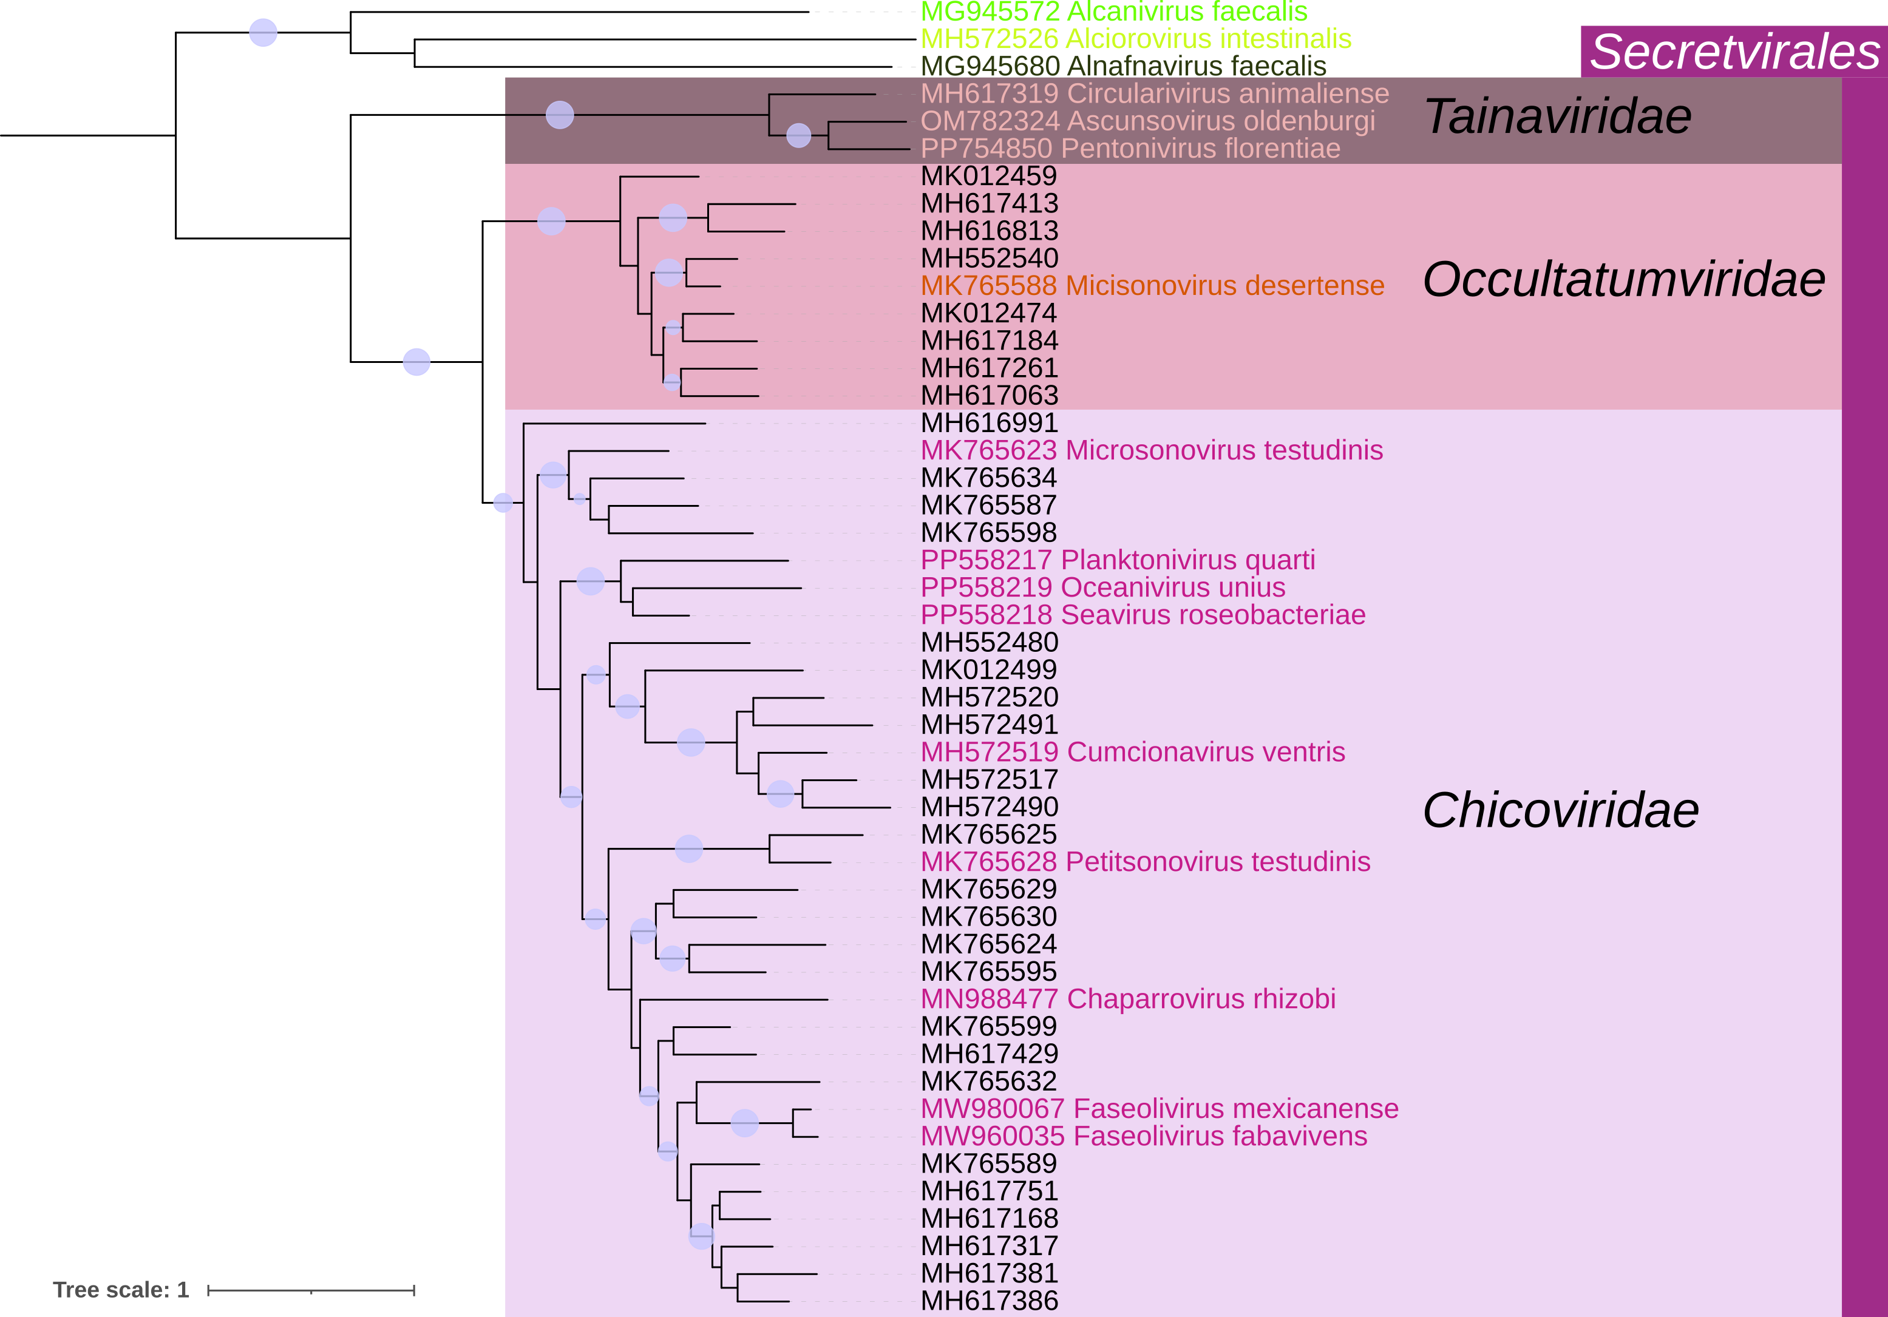

Figure 2 : Phylogeny of the major capsid protein sequences of “Secretvirales”, using new references and additional complete genomes retrieved in GenBank. The “Secretvirales” order includes three families. The tree was rooted with sequences from “Alpavirales”.

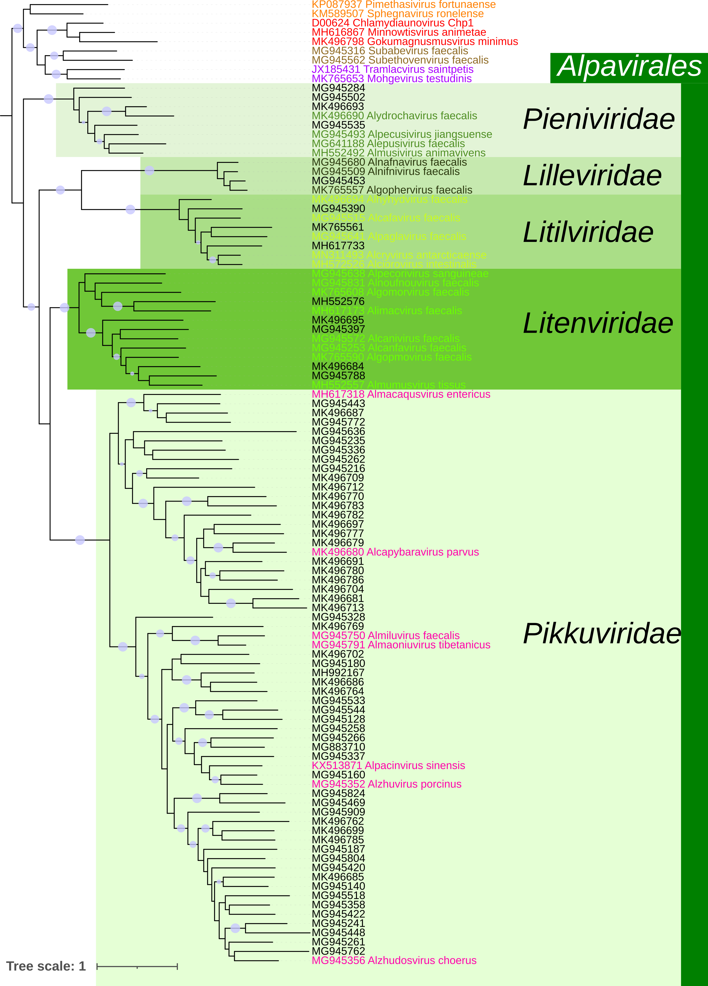
Figure 3 : Phylogeny of the major capsid protein of “Alpavirales”, using new references and additional complete genomes retrieved in GenBank. The “Alpavirales” order includes five families. The tree was rooted with sequences from “Gokushovirales”.
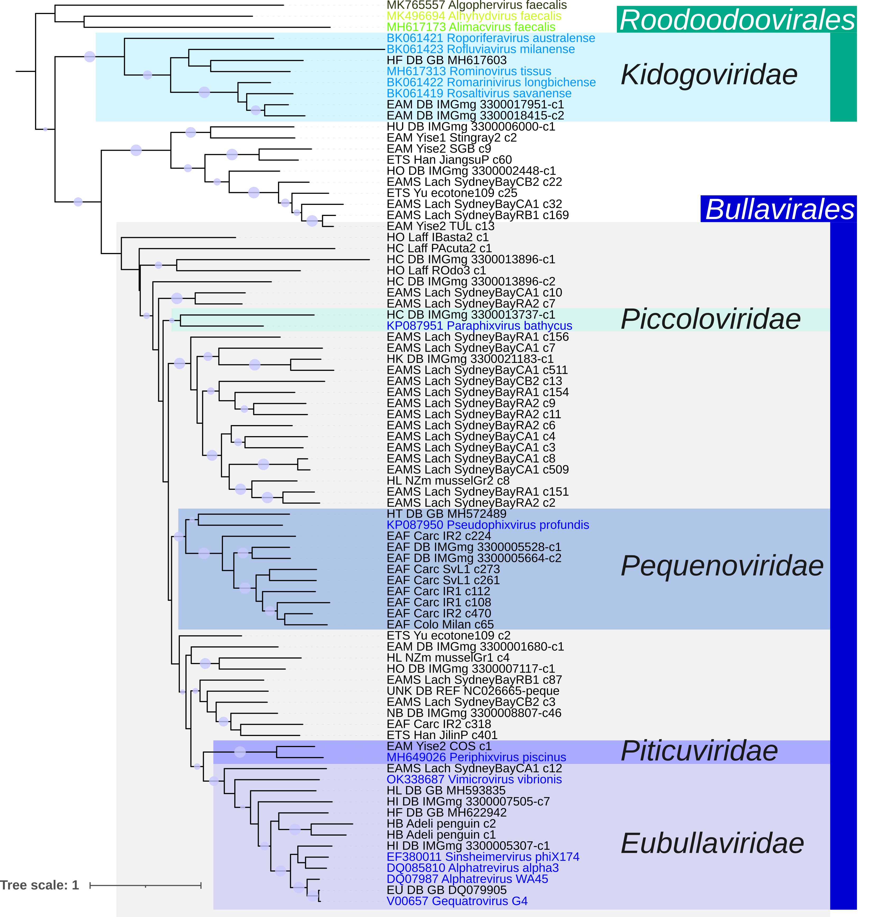
Figure 4 : Phylogeny of the major capsid protein sequences of “Roodoodoovirales” and “Bullavirales”, using new references in color and additional complete genomes from GenBank and metagenomic datasets. “Roodoodoovirales” includes only one family, the “Kidogoviridae”. Bullavirales contains four families : “Eubullaviridae”, “Piticuviridae”, “Pequenoviridae” and “Piccoloviridae”. The tree was rooted with three sequences from “Alpavirales”.

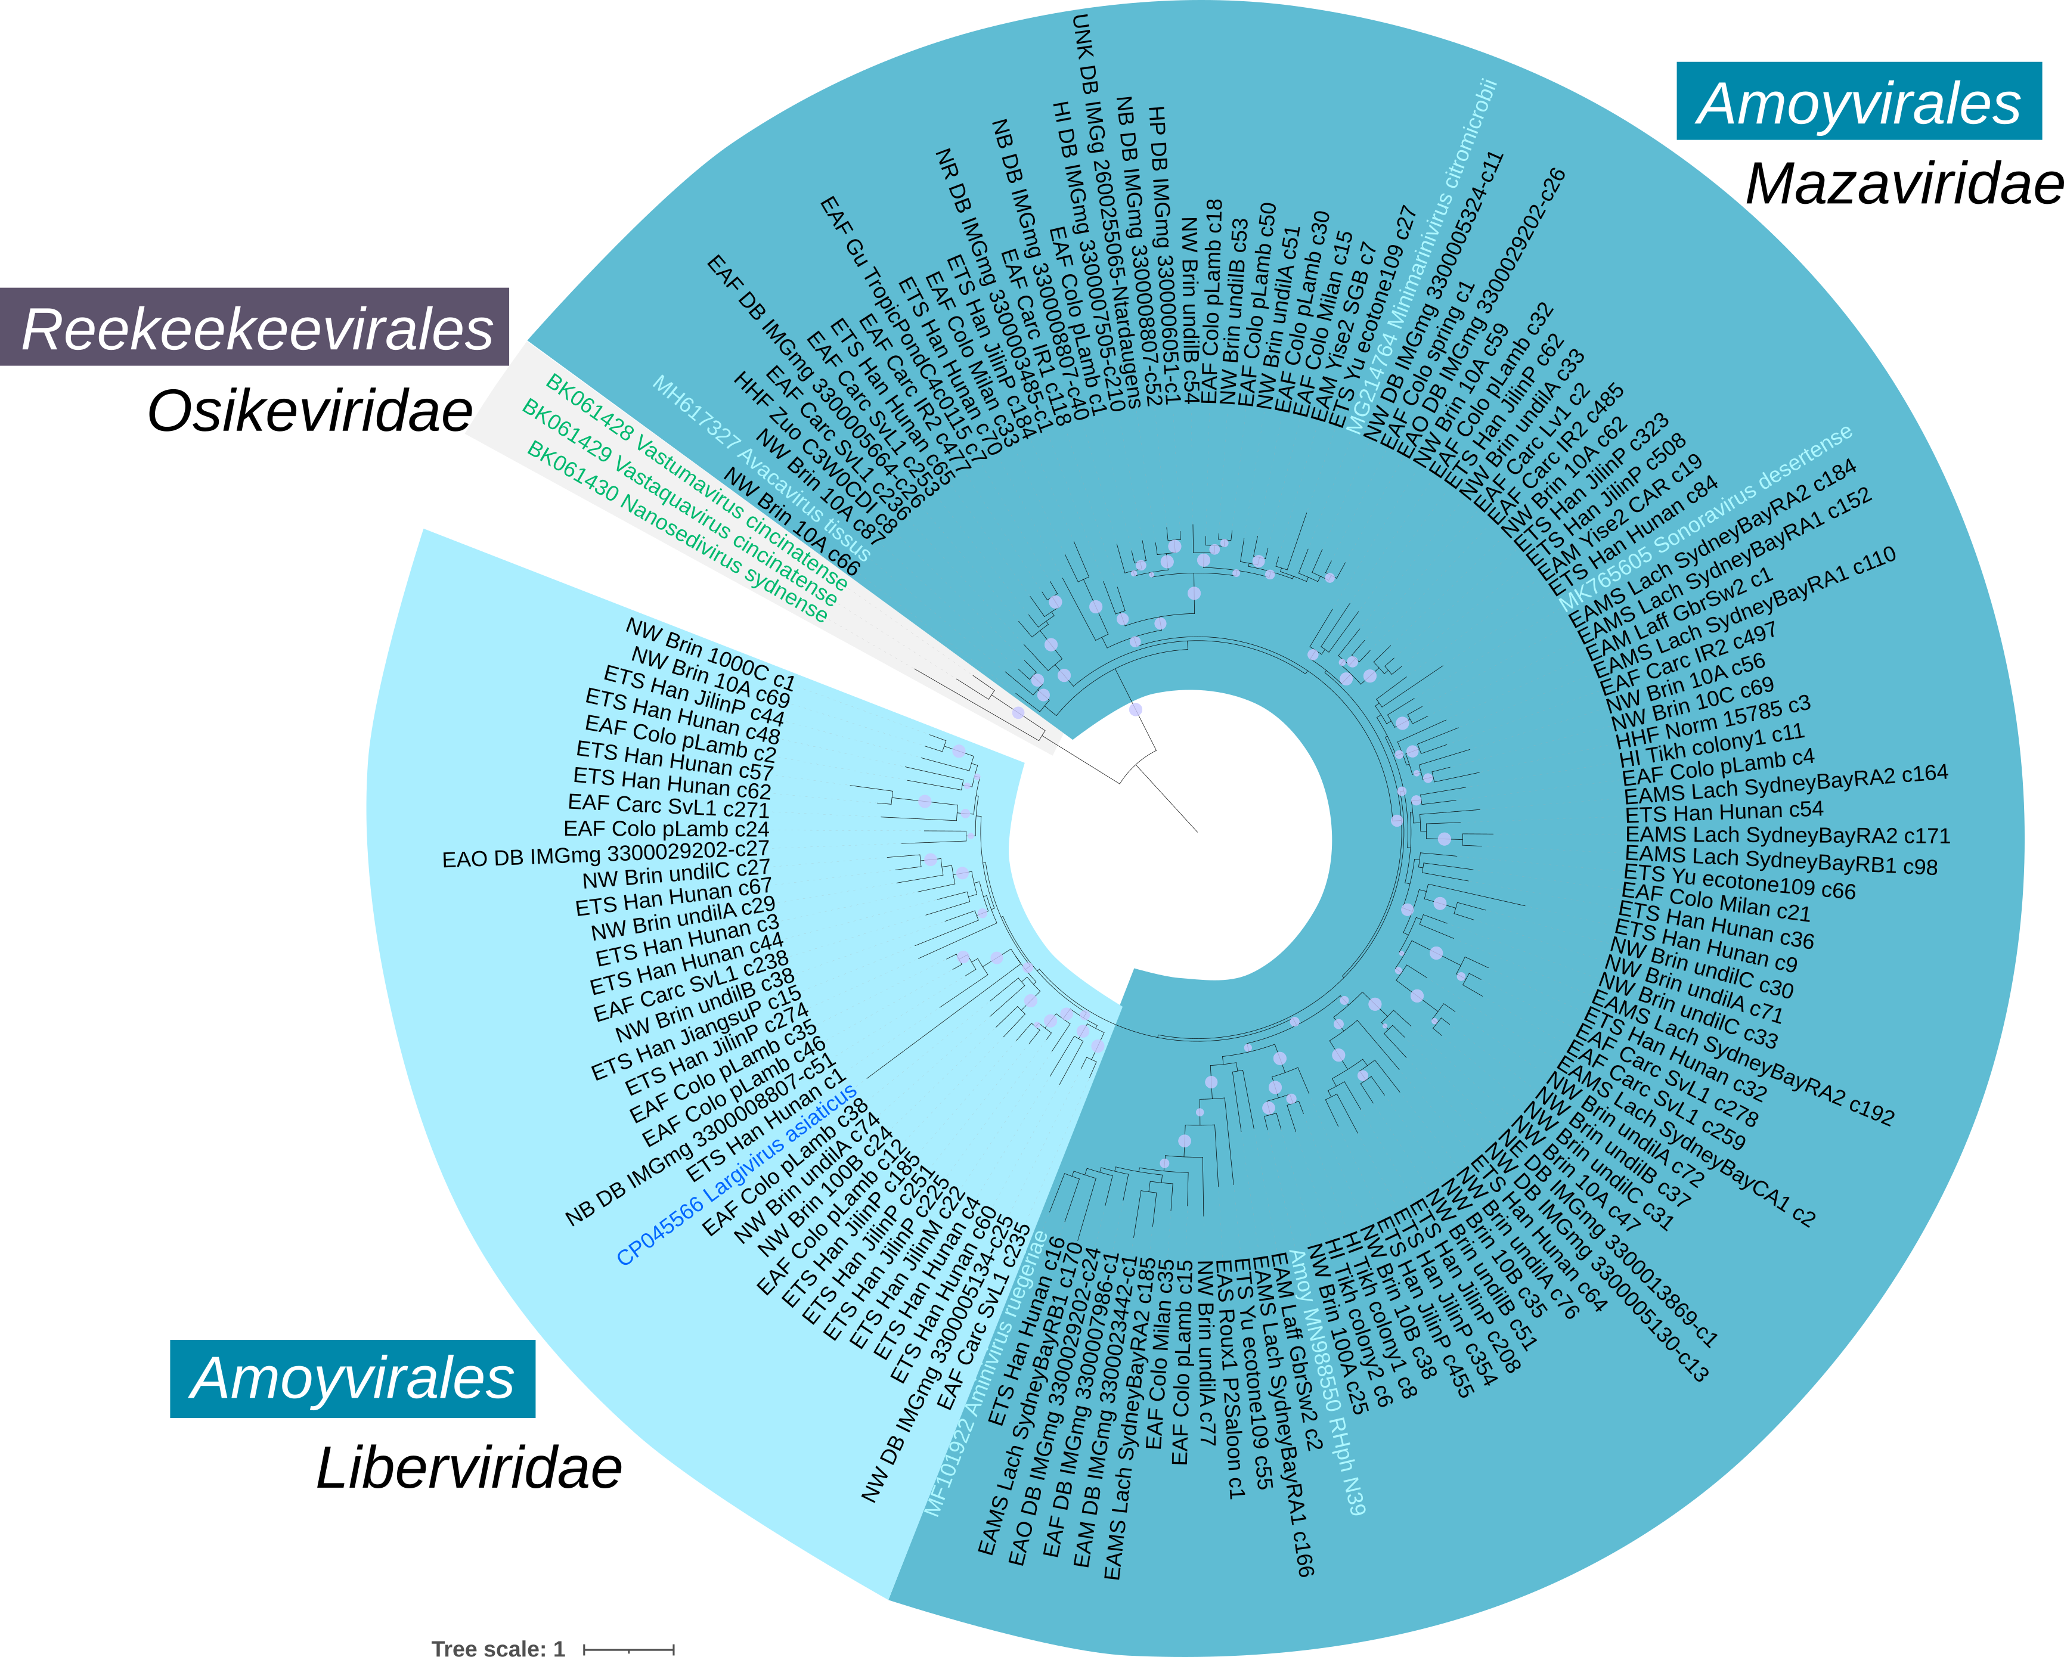
Figure 5 : Phylogeny of the major capsid protein of “Amoyvirales” and “Reekeekeevirales” using new references in color and additional complete genomes from GenBank and metagenomic datasets. The order “Reekeekeevirales” contains one family, the “Osikeviridae”. The “Amoyvirales” contains two families, the “Mazaviridae” and the “Liberviridae”.

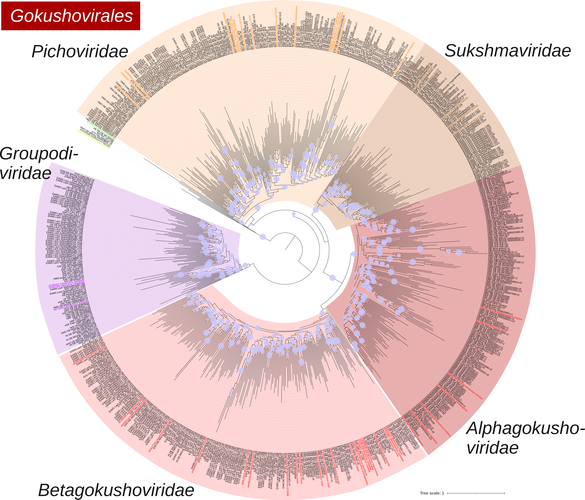
Figure 6 : Phylogeny of the major capsid protein of “Gokushovirales”, using new references in color and additional complete genomes from GenBank and metagenomic datasets. The order “Gokushovirales” contains five families : “Pichoviridae”, “Sukshmaviridae”, “Alphagokushoviridae”, “Betagokushoviridae”, and “Groupodiviridae”. The tree was rooted with sequences from Alpavirales.

Figure 7 : Matrix containing intergenomic distances between all 158 microvirus genomes, computed using VIRIDIC.

