

The International Committee on Taxonomy of Viruses

Taxonomy Proposal Form, 2025

**Part 1a: Details of taxonomy proposals**

|  |  |
| --- | --- |
| **Title:** | Create a new family, *Mariniviridae,* including one new genus and species |
| **Code assigned:** | 2025.042B.Ac.v3.Mariniviridae_1nf | |

|  |  |  |  |  |
| --- | --- | --- | --- | --- |
| **Author(s), affiliation and email address(es):** | | | | |
| **Given name (+middle initial(s))** | **Surname** | **Affiliation** | **Email address** | **Corr. author(s)** |
| Manuel | Martinez-Garcia | Department of Physiology, Genetics, and Microbiology, University of Alicante, Carretera San Vicente del Raspeig, San Vicente del Raspeig, Alicante, 03690, Spain | m.martinez@ua.es | x |
| Mart | Krupovic | Institut Pasteur, Université Paris Cité, CNRS UMR6047, Cell Biology and Virology of Archaea Unit, Paris, France | mart.krupovic@pasteur.fr |  |

**Part 1b: Taxonomy Proposal Submission**

|  |  |  |  |
| --- | --- | --- | --- |
| **ICTV Subcommittee:** | | | |
| Animal DNA Viruses and Retroviruses |  | Bacterial viruses | **x** |
| Animal minus-strand and dsRNA viruses |  | Fungal and protist viruses |  |
| Animal positive-strand RNA viruses |  | Plant viruses |  |
| Archaeal viruses |  | General - |  |

|  |
| --- |
| **List the ICTV Study Group(s) that have seen or have been involved in creating this proposal:** |
| Bacterial viruses |

|  |  |  |  |
| --- | --- | --- | --- |
| **Optional – complete only if formally voted on by an ICTV Study Group:** | | | |
| **Study Group** | **Number of members** | | |
| **Votes in support** | **Votes against** | **No vote** |
|  |  |  |  |
|  |  |  |  |

|  |  |
| --- | --- |
| **Submission date:** | 20/06/2025 |

**Part 1c: Feedback from ICTV Executive Committee (EC) meeting**

|  |  |
| --- | --- |
| **Executive Committee Meeting Decision code:** | **X** |
| A – Accept |  |
| Ac – Accept subject to revision by relevant subcommittee chair. No further vote required | **X** |
| U – Accept without revision but with re-evaluation and email vote by the EC |  |
| Uc – Accept subject to revision and re-evaluation and email vote by the EC |  |
| Ud – Deferred to the next EC meeting, with an invitation to revise based on EC comments |  |
| J - Reject |  |
| W - Withdrawn |  |

|  |
| --- |
| **Comments from the Executive Committee:** |
| Genus name was already in use. |

**Part 1d: Revised Taxonomy Proposal Submission**

|  |
| --- |
| **Response of proposer:** |
| There was a confusion. The genus name was already corrected prior to the submission to the EC. The current proposed genus name, “*Pelagimarinivirus*”, is unique. |

|  |  |
| --- | --- |
| **Revision date:** | 25.08.2025 |

**Part 3:** **TAXONOMIC PROPOSAL**

<https://ictv.global/taxonomy/templates>

|  |  |  |  |
| --- | --- | --- | --- |
| **Taxonomic changes proposed:** | | | |
| Establish new taxon | **x** | Split taxon |  |
| Abolish taxon |  | Merge taxon |  |
| Move taxon |  | Promote taxon |  |
| Rename taxon |  | Demote taxon |  |
| Move and rename |  |

|  |  |
| --- | --- |
| **Etymology (origin) of proposed taxonomic names:** | |
| **Taxon name** | **Etymology of the term** |
| *Pelagimarinivirus* | Referring to the habitat (“marine” and “pelagic”) of the virus, |
| *Pelagimarinivirus ubique* | species epithet “ubique” refers to the global distribution of the virus across the oceans. |
| *Mariniviridae* | from *marinus*, which means “sea” in Latin. |

|  |  |  |
| --- | --- | --- |
| **Permission for use of names derived from a living person:** | | |
| **Taxon name** | **Full name of person from whom the name is derived** | **Attached** |
| - | - | - |

|  |
| --- |
| **Abstract of Taxonomy Proposal:** |
| *Taxonomic rank(s) affected*:  Family, genus, species  *Description of current taxonomy*:  The virus vSAG-37-F6 is not closely related to other known members of the class *Caudoviricetes.*  *Proposed* *taxonomic change(s):*  We propose classifying uncultured marine virus vSAG-37-F6 into a new species, “*Pelagimarinivirus ubique*”, within a new genus, “*Pelagimarinivirus*”, and a new family, “*Mariniviridae*”, within the class *Caudoviricetes*.  *Justification:*  The virus vSAG-37-F6 encodes signature proteins conserved in tailed viruses of the class *Caudoviricetes,* but is not closely related to any classified member of this class. Thus, it is proposed to classify vSAG-37-F6 into a separate new family, “*Mariniviridae*”. |

|  |
| --- |
| * **Text of Taxonomy proposal:** |
| *Taxonomic rank(s) affected*:  Family, genus, species  *Description of current taxonomy*:  The virus vSAG-37-F6 is not closely related to other known members of the class *Caudoviricetes.*  *Proposed* *taxonomic change(s)*:  We propose classifying uncultured marine virus vSAG-37-F6 into a new species, “*Pelagimarinivirus ubique*”, within a new genus, “*Pelagimarinivirus*”, and a new family, “*Mariniviridae*”, within the class *Caudoviricetes*.  *Demarcation criteria:*  We propose using 95% sequence identity as a species demarcation threshold, to be consistent with the classification of other bacterial and archaeal viruses in the class *Caudoviricetes*.  *Justification*:  vSAG-37-F6 is an uncultured virus which infects the marine *Pelagibacter* spp., a group of bacteria that are through to be the most abundant in pelagic environments. Initially, this virus was discovered by single virus genomics applied to natural marine samples in the Mediterranean Sea, which yielded a partial virus genome. Subsequently, it has been confirmed that vSAG-37-F6 is one of the most abundant and widespread viruses in subtropical, tropical and temperate marine ecosystems, from surface to the deep waters. Attempts for cultivation have been unsuccessful and cultivation-free methods have been used to characterize the diel cycle, seasonal patterns, evolution, and many other ecogenomic features of vSAG-37-F6 (Martinez-Hernandez *et al.*, 2017; Martinez-Hernandez, Fornas, *et al.*, 2019, 2022; Martinez-Hernandez, Garcia-Heredia, *et al.*, 2019; McMullen *et al.*, 2019; Martínez Martínez *et al.*, 2020; Martinez-Hernandez, Diop, *et al.*, 2022; Vila-Nistal *et al.*, 2024). Remarkably, despite its abundance, the complete genome of vSAG-37-F6 could not be obtained until recently ((Vila-Nistal et al., 2025)due to high level of microdiversity, which precluded productive assembly of metagenomics data. The complete, closed genome of vSAG-37-F6 could be obtained only through a combination of short and long read sequencing and single cell genomics approaches. The complete genome of vSAG-37-F6 is 59,799 bp-long and encodes signature proteins of phages in the class *Caudoviricetes* (Martinez-Hernandez et al., 2019)*,* including HK97-fold major capsid protein, large subunit of the terminase, portal protein, etc (Martinez-Hernandez et al., 2019)indicating that it is a genuine member of this virus class. Different approaches have been used to compare genetically this virus with other caudoviricetes viruses including ANI, viral clustering, and phylogenetic analysis of hallmark capsid protein (see **Fig. 1**; (Martinez-Hernandez et al., 2019)).    To assess the relationship between vSAG-37-F6 and other reference bacterial and archaeal viruses, we performed proteome-wide comparative analysis using VipTree, with the final dataset including 5632 virus genomes. The results showed that vSAG-37-F6 is not closely related to any of the other phage genomes in the dataset (**Fig. 2**; for full tree see <https://www.genome.jp/viptree/u/EDNj7A6NIYaE5M7PEAj-bw/tree?highlight=PQ625738.1>). Notably, the virus clustered with phages associated with bacteria of the phylum Pseudomonadota, and specifically with members of Alphaproteobacteria (e.g., *Sulfitobacter* and *Ochrobactrum*), a class which also includes *Pelagibacter* spp. Nevertheless, alignment of the corresponding genomes did not reveal appreciable similarity using tblastx comparison (**Fig. 3**).  The log-scaled branch lengths of around 0.05 in the VipTree analyses were previously concluded to correspond to family-level groupings for members of *Caudoviricetes*. Based on VipTree analysis and the lack of close similarity to classified phages, vSAG-37-F6 should be considered a member of a new family. Thus, we propose classifying this virus into a new species, “*Pelagimarinivirus ubique*”, within a new genus, “*Pelagimarinivirus*”, and a new family, “*Mariniviridae*”, within the class *Caudoviricetes*.  Although at this time we propose classifying only a single virus, surveys of metagenomics data have shown that vSAG-37-F6-like viruses are highly diverse, forming a well-separated, large cluster comprising uncultured viruses (**Fig. 4**), which remain to be classified. |

|  |
| --- |
| **References:** |
| Martínez Martínez, J., Martinez-Hernandez, F., and Martinez-Garcia, M. (2020) Single-virus genomics and beyond. *Nature Reviews Microbiology 2020 18:12* 18: 705–716.  Martinez-Garcia, M., Martinez-Hernandez, F., Gomez, M.L., Vila-Nistal, M., Roux, S., and Fornas, O. (2024) Limited consensus of marine viral diversity observed across techniques.  Martinez-Hernandez, F., Diop, A., Garcia-Heredia, I., Bobay, L.M., and Martinez-Garcia, M. (2022) Unexpected myriad of co-occurring viral strains and species in one of the most abundant and microdiverse viruses on Earth. *ISME J* 16: 1025–1035.  Martinez-Hernandez, F., Fornas, O., Lluesma Gomez, M., Bolduc, B., de la Cruz Peña, M.J., Martínez, J.M., et al. (2017) Single-virus genomics reveals hidden cosmopolitan and abundant viruses. *Nat Commun* 8: 15892.  Martinez-Hernandez, F., Fornas, Ò., Lluesma Gomez, M., Garcia-Heredia, I., Maestre-Carballa, L., López-Pérez, M., et al. (2019) Single-cell genomics uncover Pelagibacter as the putative host of the extremely abundant uncultured 37-F6 viral population in the ocean. *ISME Journal* 13: 232–236.  Martinez-Hernandez, F., Fornas, O., and Martinez-Garcia, M. (2022) Into the Dark: Exploring the Deep Ocean with Single-Virus Genomics. *Viruses* 14: 1589.  Martinez-Hernandez, F., Garcia-Heredia, I., Lluesma Gomez, M., Maestre-Carballa, L., Martínez Martínez, J., and Martinez-Garcia, M. (2019) Droplet Digital PCR for Estimating Absolute Abundances of Widespread Pelagibacter Viruses. *Front Microbiol* 10: 1226.  McMullen, A., Martinez-Hernandez, F., and Martinez-Garcia, M. (2019) Absolute quantification of infecting viral particles by chip-based digital polymerase chain reaction. *Environ Microbiol Rep* 11: 855–860.  Vila-Nistal, M., Logares, R., Gasol, J.M., and Martinez-Garcia, M. (2024) Time Series Data Provide Insights into the Evolution and Abundance of One of the Most Abundant Viruses in the Marine Virosphere: The Uncultured Pelagiphages vSAG 37-F6. *Viruses 2024, Vol 16, Page 1669* 16: 1669.  Zhao, Y., Temperton, B., Thrash, J.C., Schwalbach, M.S., Vergin, K.L., Landry, Z.C., et al. (2013) Abundant SAR11 viruses in the ocean. *Nature* 494: 357–360. |

|  |  |
| --- | --- |
| **Accompanying files:** | |
| **Filename** | **Description of contents** |
| **-** | **-** |
| **-** | **-** |

|  |
| --- |
| **Tables, Figures:** |

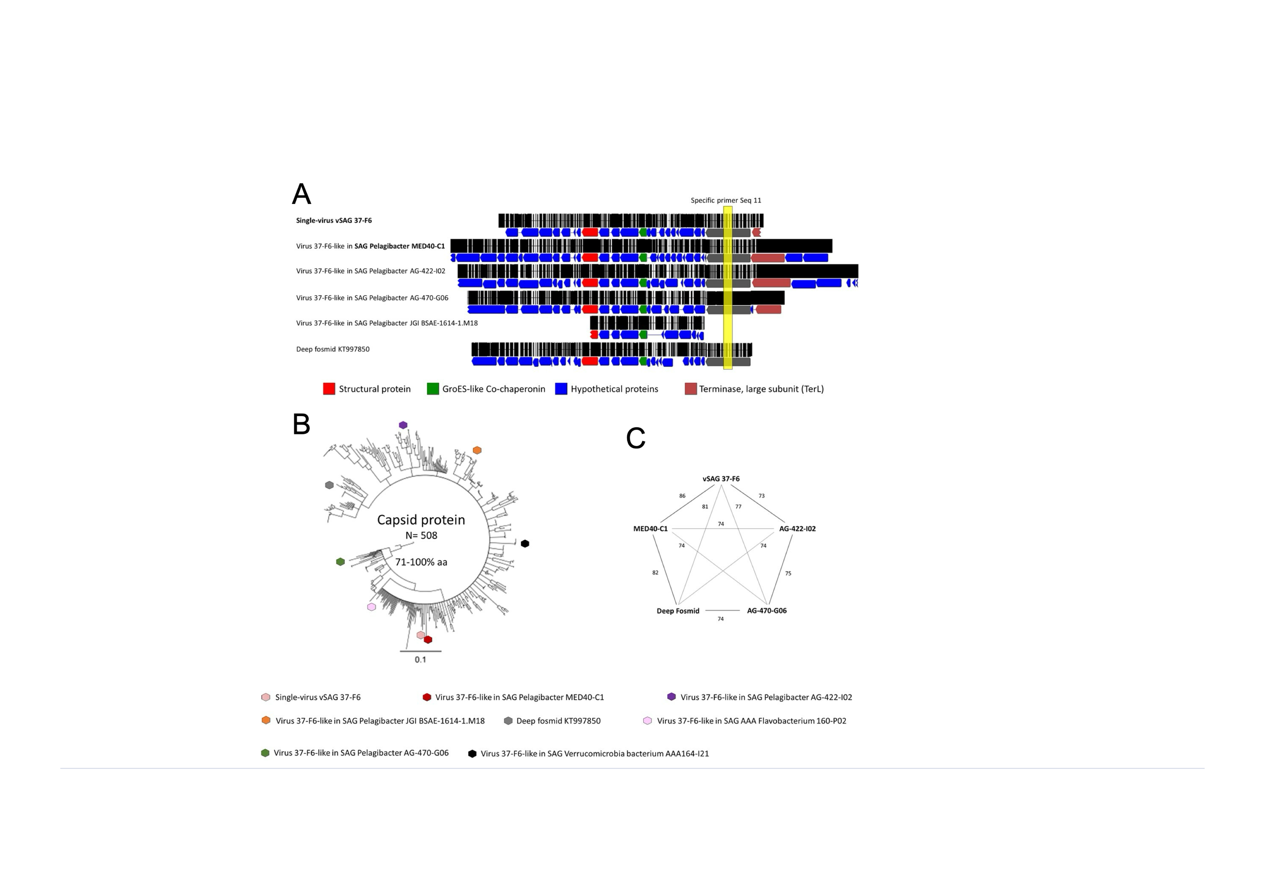

**Fig. 1** Genetic analysis comparison of uncultured virus vSAG 37-F6. A) Genome comparison is shown for the viral members belonging to the uncultured pelagiphage population vSAG 37-F6 recovered by single-cell and single-virus genomics. Other caudoviricetes have been incuded. Black lines in whole-genome alignment denotes homologous genomic regions shared among all viral members. Genomic region (encoding a hypothetical protein) targeted by PCR with the specific viral primer set Seq11 used for SAGs screening is highlighted in yellow. B) Consensus phylogenetic tree based on neighbor-joining (bootstrapping = 1000) of the signature capsid protein found in the uncultured vSAG 37-F6 and other caudoviricetes. This viral capsid protein has been shown to be the most abundant in viral marine proteomes from the Tara expedition (Martinez-Hernandez *et al.*, 2017). Other homologous proteins (n = 502) from other caudoviricetes have been detected in the viral database released by IMG-VR and have been included in the analyses. Protein names are omitted in branches for convenience, except for those capsid proteins from vSAG 37-F6 viral population that are indicated as colored hexagons. vSAG 37-F6 and the genome variant found in the Pelagibacter SAG MED40 contained nearly identical capsid protein sequences. None of the previously reported pelagiphage isolates (Zhao *et al.*, 2013) have that above mentioned gene encoding a structural capsid protein. Branches with bootstrap values 50% bootstrap value (numbers are omitted for convenience). C) Average amino acid similarity was calculated by considering 12 orthologous genes shared and present in all genomes. Higher values indicate a closer relationship between the compared viral pairs

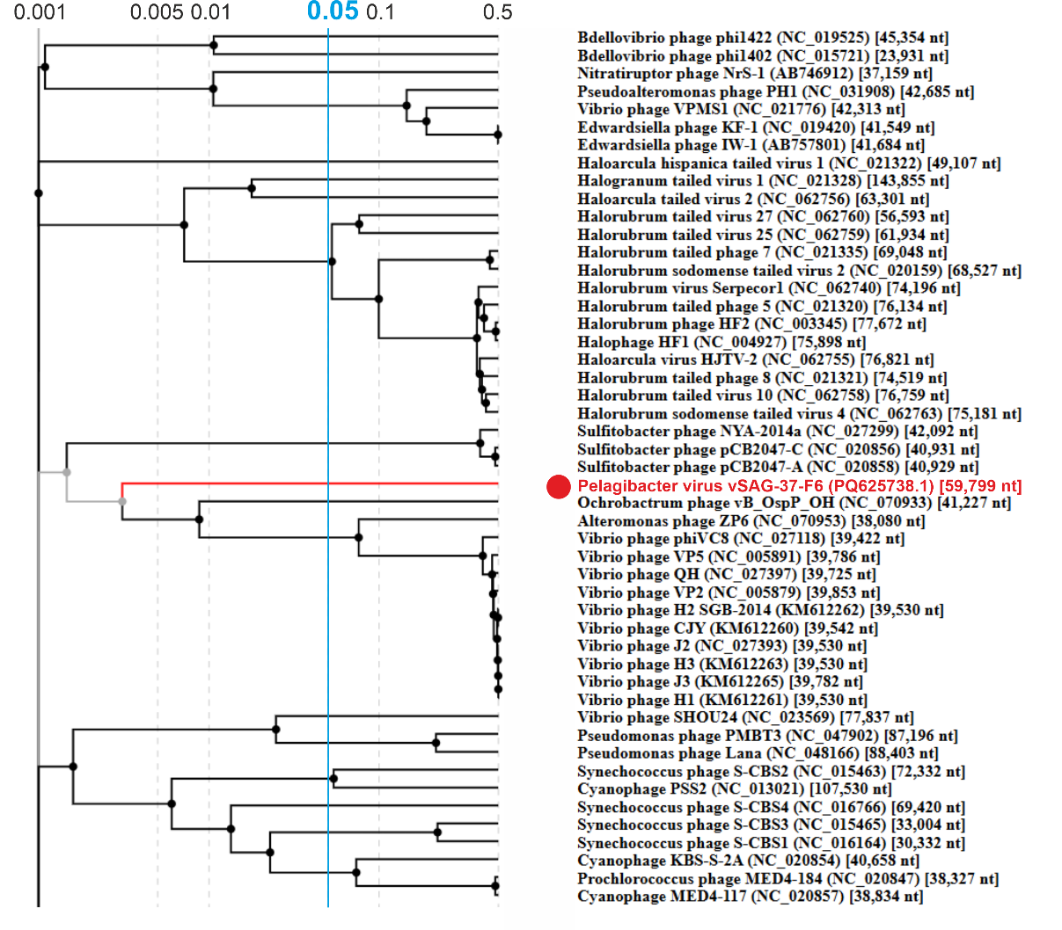

**Fig. 2**. A fragment of the VipTree proteomic tree including vSAG-37-F6 and the more closely related viruses of the class *Cadoviricetes*. vSAG-37-F6 is indicated with a red circle. The proteomic tree is based on all-versus-all proteomic similarity matrix. Branch lengths are log-scaled and the branch length for family-level demarcation is around 0.05. The full tree can be accessed at <https://www.genome.jp/viptree/u/EDNj7A6NIYaE5M7PEAj-bw/tree?highlight=PQ625738.1>

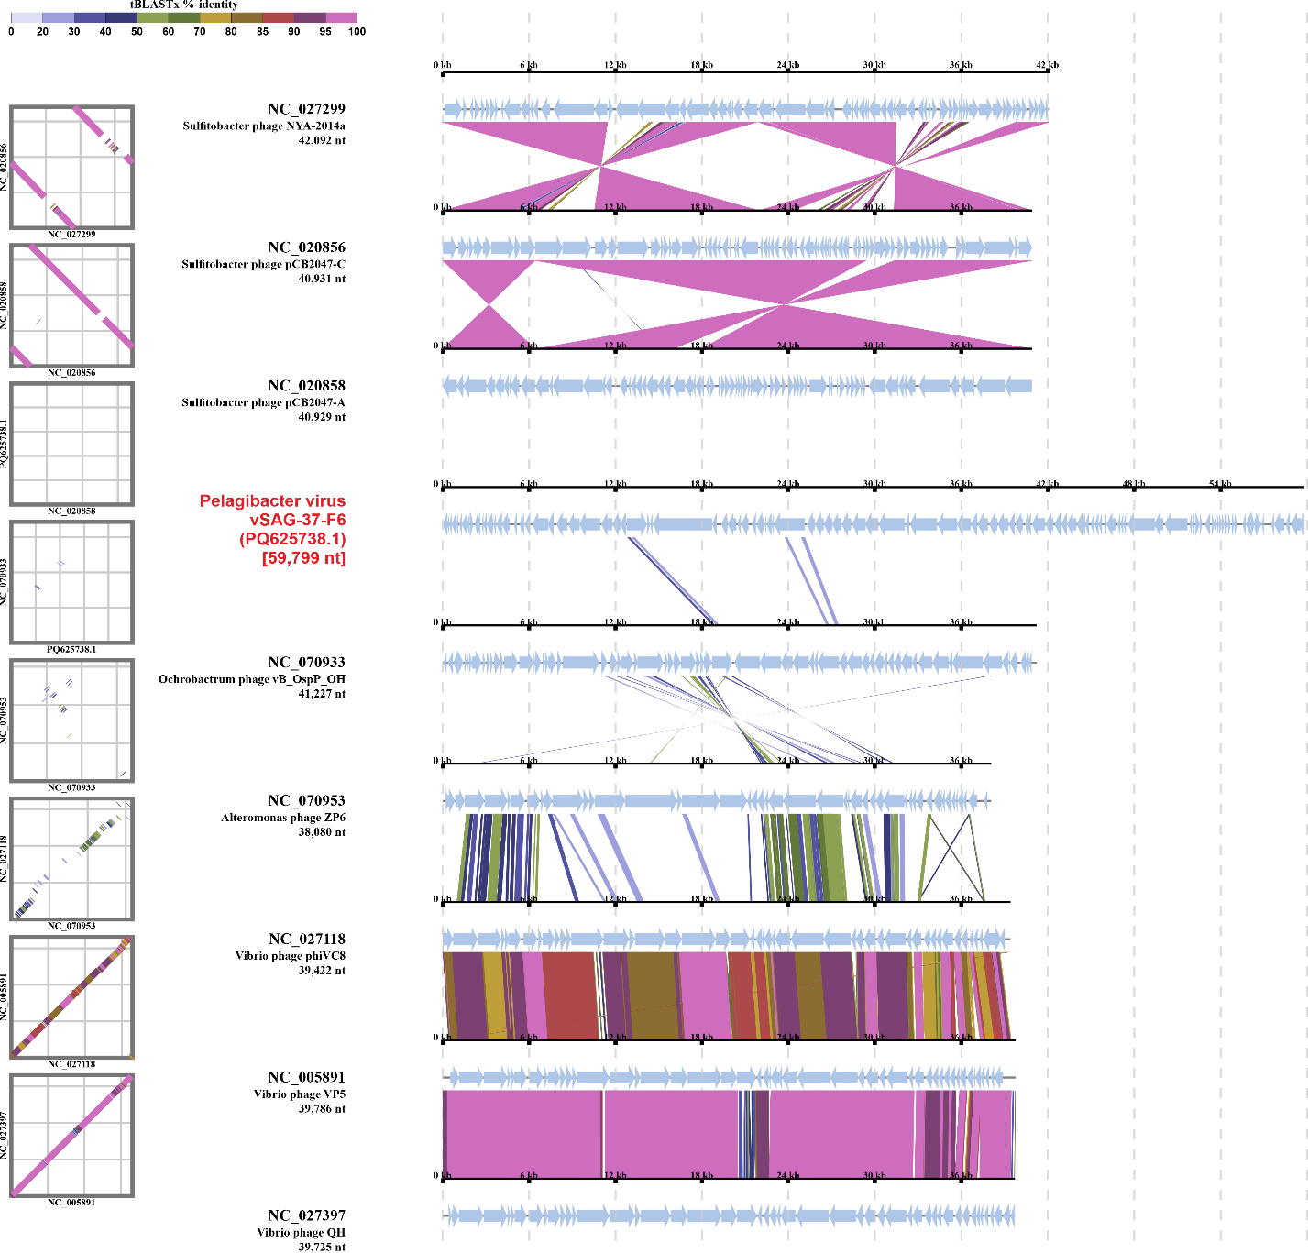

**Fig. 3.** Comparison of the genome maps of viruses from the VipTree cluster (see Fig. 1) which includes vSAG-37-F6. Note that vSAG-37-F6 shares almost no genes with the neighboring viruses. Dot-plot comparisons of the neighboring viruses are shown on the left.

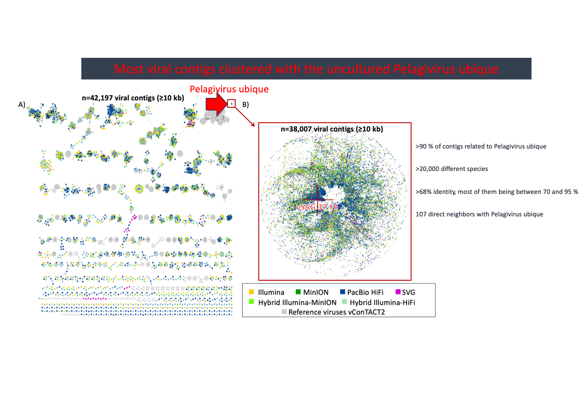

**Fig. 4**. vConTACT2 network of prokaryotic viruses. The red arrow points to a cluster formed by multiple co-occurring genomes present in the same sample all related with different degree of similarity from 68 to 95% of nucleotide identity to the genome of vSAG-37-F6. This cluster includes a considerable diversity of vSAG-37-F6-like viruses.